- Double-click ASFTClassic.exe to open the main tool interface.
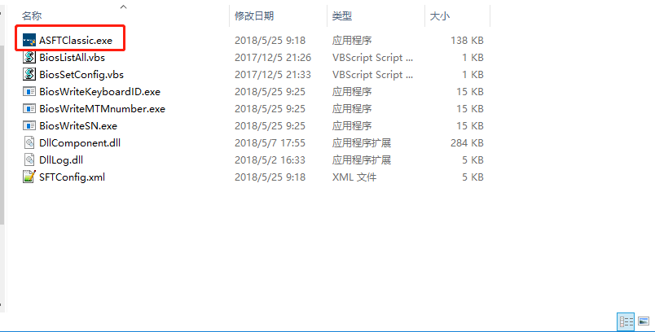

- The main interface of the tool is as follows:
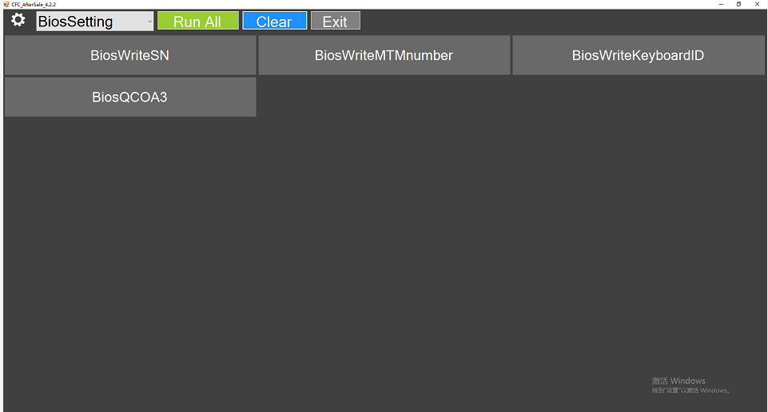

BiosWriteSN Options
- After clicking on the "BiosWriteSN" option,Enter the SN number to be written:
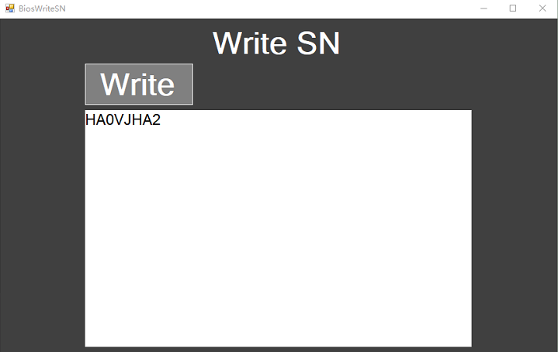

- Click "Write" button to write SN number, it will prompt:LenovoSN Write Success!
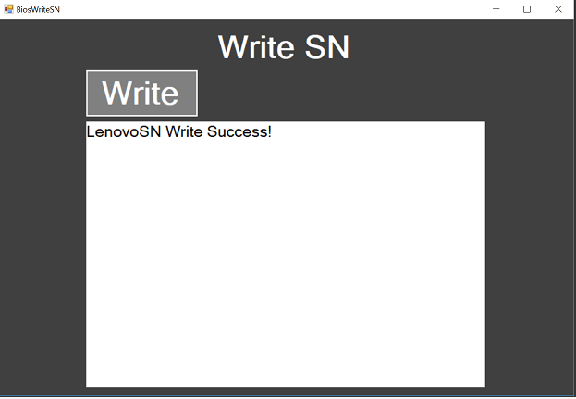

- After the SN number is successfully written, you can close the form and click the close button in the upper right corner of the form.
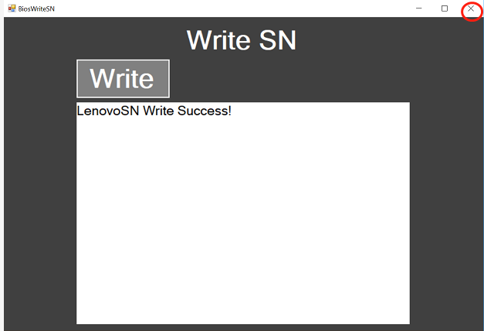

BiosWriteMTMnumber Options
- After clicking on the "BiosWriteMTMnumber" option, enter the MTM number to be written:
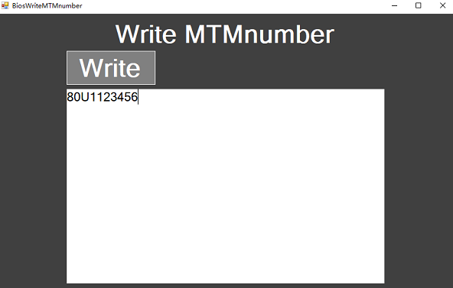
- Click "Write" button to write MTM number, it will prompt:MTMnumber Write Success!
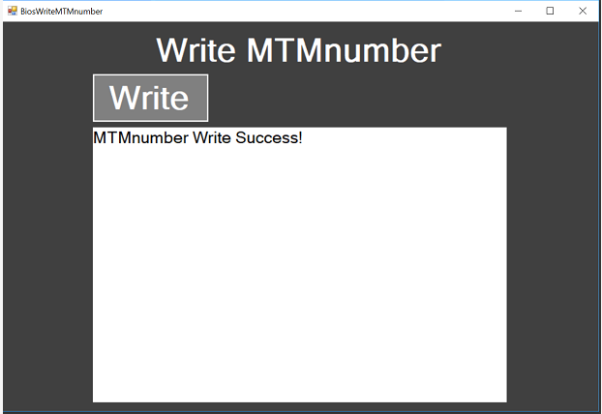

- After the MTM number is successfully written, you can close the form and click the close button in the upper right corner of the form.
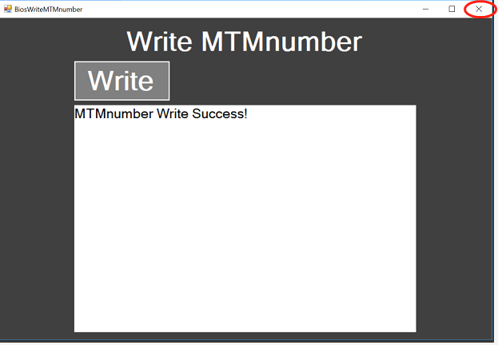
BiosWriteKeyboardID Options
- After clicking on the "BiosWriteKeyboardID" option, enter the KeyboardID number to be written:
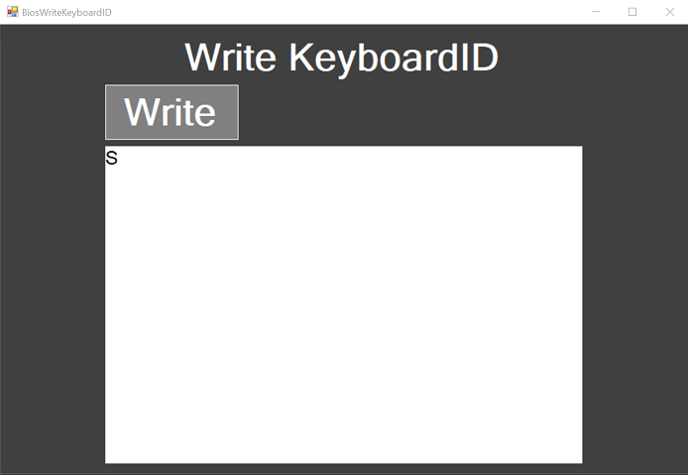

- Click "Write" button to write KeyboardID number, it will prompt: KeyboardID Write Success!
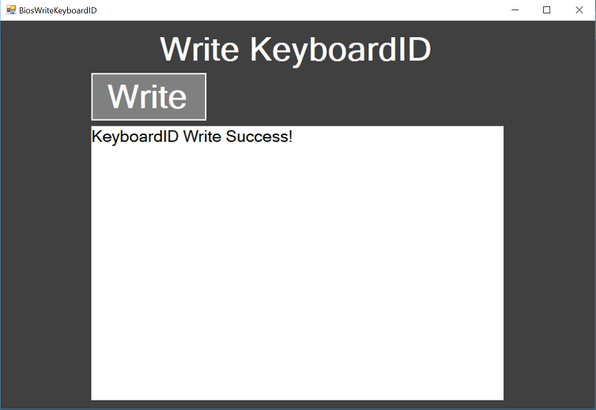
- After the KeyboardID number is successfully written, you can close the form and click the close button in the upper right corner of the form.
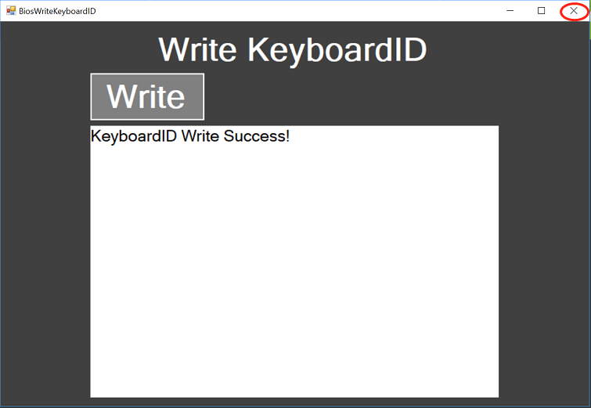

BiosQCOA3 Options

- First, the oa3.bin file needs to be stored in the CFC_AfterSale_4.2.2\DFCXACT\MTSN directory, After clicking on the "BiosQCOA3" option to be written. Click "Write" button to write OA3, it will prompt: Write OA3 Success!
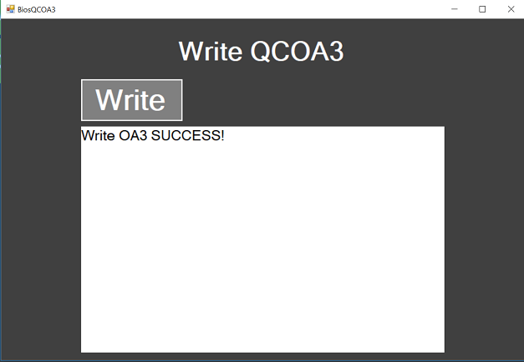

- After the OA3 is successfully written, you can close the form and click the close button in the upper right corner of the form.
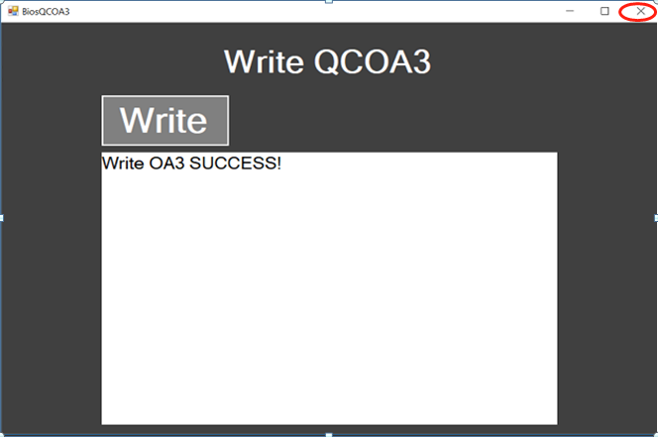
The main interface shows a green background. The SN number, MTM number, and KeyboardID number, OA3.bin are successfully written. If the write fails, a red background is displayed.
