European
curriculum vitae

Personal information

Name |  | Agostino Manzato | 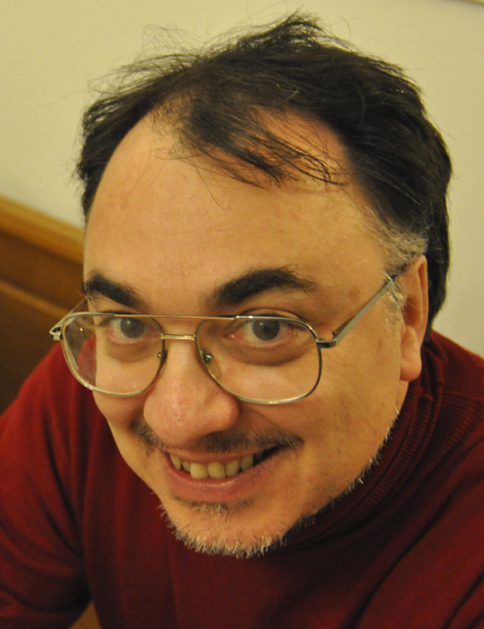
Personal address |  | via Michelstaedter, 6  I-34170 Gorizia (GO)  Italy
Office address |  | via Oberdan, 18/a  I-33040 Visco (UD)  Italy
Telephone |  | +39 0432 934163
E-mail |  | agostino.manzato at osmer.fvg.it
Nationality |  | Italian
Civil Status |  | married
Date of birth |  | 16.08.1968

Work experience

• Dates (from – to) |  | 01.07.2000 - now
• Name of organization |  | Agenzia Regionale per la Protezione dell'Ambiente - Osservatorio Meteorologico Regionale  Regional Agency for Environmental Protection - Regional Meteorological Observatory
• Type of organization |  | Public agency
• Organization addresses |  | OSMER – ARPA FVG  via Oberdan, 18/a  I-33040 Visco (UD)  Italy  Tel. +39 432 922111  FAX +39 432 922100
• Type of business or sector |  | Meteorology
• Position held |  | Meteorologist in permanent position
• Main activities |  | - radio-sounding analysis and atmosphere instability evaluation;  - satellite analysis and instability evaluation of IASI vertical retrievals;  - thunderstorm, rain and hail forecasting using Neural Networks;  - linear and non-linear downscaling and statistical adaptation;  - forecast verification for binary and continuous variables;  - visualization of meteorological data for real time and case studies.

• Dates (from – to) |  | 20.11.1996 - 30.06.2000
• Name of organization |  | Centro Servizi Agrometeorologici  Center for Agrometeorological Services
• Organization addresses |  | CSA  Via Carso, 3  I-33052 Cervignano del Friuli (UD)  Italy
• Type of organization |  | Public agency
• Type of business or sector |  | Meteorology, weather forecasts
• Position held |  | Meteorologist in permanent position
• Note |  | I started working in the “Thunderstorm and Hail Prevention Research Center”, under the scientific direction of dr. Griffith Morgan. “CSA” became “OSMER – ARPA FVG” on 01.07.2000

Education and training

• Dates |  | 23.02.1994
• Name of organization |  | Università degli Studi di Padova  Padua University - Italy
• Subject |  | Laurea in fisica  Degree in physics
• Title of qualification awarded |  | Dottore in fisica (104/110)  Italian university degree in Physics (104/110)
• Further information |  | Thesis titled: Numerical simulations of the origin of the structures in the large scale universe, prof. Sabino Matarrese relator and dr. Lauro Moscardini co-relator.

Schools and Workshops

Dates |  |  |  |  |  | October 1997
Name of organization |  |  |  |  |  | HMZ - EUMETSAT - Ljubljana - Slovenia
Subject |  |  |  |  |  | Satellite meteorology and numerical weather prediction workshop
Dates |  |  |  |  |  | April - May 1998
Name of organization |  |  |  |  |  | NSSL, SPC and Oklahoma State University in Norman OK and NCAR in Boulder CO - USA
Subject |  |  |  |  |  | I made a one month long "training visit" to these important US Meteorological Centers where I met many researchers (H. Brooks, C. Doswell, D. Zrnic; J. Dye, C. Knight, J. Corbet,...)
Dates |  |  |  |  |  | June 1998
Name of organization |  |  |  |  |  | International Centre for Theoretical Physics - Trieste - Italy
Subject |  |  |  |  |  | Summer colloquium on the physics of the weather and climate “The effect of the topography on the atmospheric circulation” (featuring also prof. F. Mesinger)
Dates |  |  |  |  |  | June 1999
Name of organization |  |  |  |  |  | NCAR, Boulder CO - USA
Subject |  |  |  |  |  | Summer Colloquium on Ice formation in the Atmosphere (featuring also prof. W. Al Cooper)
Dates |  |  |  |  |  | February 2000
Name of organization |  |  |  |  |  | Meteo France – Toulouse, France
Subject |  |  |  |  |  | First Conference on European Tornadoes and Severe Storms
Dates |  |  |  |  |  | December 2000
Name of organization |  |  |  |  |  | ZAMG, EUMETNET, Vienna - Austria
Subject |  |  |  |  |  | First Short-range numerical weather prediction workshop on Statistical Adaptation
 | Dates |  |  |  |  |  | June - July 2002
 | Name of organization |  |  |  |  |  | ISAC, CIMA, University of Genoa and Basilicata University, Saint-Oyen (Aosta) - Italy
 | Subject |  |  |  |  |  | Grand Combin Summer School on Physics and Predictability of Rainfall and Floods (featuring also prof. K. Emanuel)
 | Dates |  |  |  |  |  | August 2002
 | Name of organization |  |  |  |  |  | CHMI, EMS, Prague – Czech Republic
 | Subject |  |  |  |  |  | Second European Conference on Severe Storms
 | Dates |  |  |  |  |  | July 2004
 | Name of organization |  |  |  |  |  | University of Trento, Trento - Italy
 | Subject |  |  |  |  |  | Summer School on Mountain Meteorology "Orographic Effects on Precipitation" (featuring also dr. R. Rotunno)
 | Dates |  |  |  |  |  | November 2004
 | Name of organization |  |  |  |  |  | University of León, INM, EMS, León - Spain
 | Subject |  |  |  |  |  | Third European Conference on Severe Storms,
 | Dates |  |  |  |  |  | June 2005
 | Name of organization |  |  |  |  |  | ZAMG, EUMETNET, Vienna - Austria
 | Subject |  |  |  |  |  | Third Short-range numerical weather prediction workshop on Statistical Adaptation
 | Dates |  |  |  |  |  | July 2005
 | Name of organization |  |  |  |  |  | CISM, OSMER, Udine - Italy
 | Subject |  |  |  |  |  | CISM Advanced School on Atmospheric Convection: Research and Operational Forecasting Aspects (featuring also prof. P. Markowsky)
 | Dates |  |  |  |  |  | January 2006
 | Name of organization |  |  |  |  |  | American Meteorological Society, Atlanta (GE) - USA
 | Subject |  |  |  |  |  | Short Course on Artificial Intelligence Applications to Environmental Science (featuring also prof. C. Marzban)
 | Dates |  |  |  |  |  | January 2006
 | Name of organization |  |  |  |  |  | American Meteorological Society, Atlanta (GE) - USA
 | Subject |  |  |  |  |  | 86th AMS Annual Meeting
 | Dates |  |  |  |  |  | September 2007
 | Name of organization |  |  |  |  |  | EUMETSAT, ICTP, Trieste - Italy
 | Subject |  |  |  |  |  | EUMETSAT Training Workshop on Interpretation of Satellite Images/Products of Convective Storms (featuring also prof. D. Rosenfeld)
 | Dates |  |  |  |  |  | September 2007
 | Name of organization |  |  |  |  |  | OSMER, ICTP, EMS, Trieste - Italy
 | Subject |  |  |  |  |  | Fourth European Conference on Severe Storms
 | Dates |  |  |  |  |  | May 2008
 | Name of organization |  |  |  |  |  | SAR, ARPA Sardegna, ISAC, Alghero - Italy
 | Subject |  |  |  |  |  | Third Mediterranean School on Mesoscale Meteorology: "Fundamentals and applications of probabilistic forecasts and Ensemble Prediction Systems" (featuring also dr. T. Hamill)
Dates |  |  |  |  |  |  |  | November 2008
Name of organization |  |  |  |  |  |  |  | ICTP, Trieste - Italy
Subject |  |  |  |  |  |  |  | Conference on Teleconnections in the Atmosphere and Oceans
Dates |  |  |  |  |  |  |  | October 2009
Name of organization |  |  |  |  |  |  |  | EUMETSAT, Landshut - Germany
Subject |  |  |  |  |  |  |  | Convection Working Group Workshop
Dates |  |  |  |  |  |  |  | October 2009
Name of organization |  |  |  |  |  |  |  | ESSL, Landshut - Germany
Subject |  |  |  |  |  |  |  | Fifth European Conference on Severe Storms
Dates |  |  |  |  |  |  |  | June 2010
Name of organization |  |  |  |  |  |  |  | ISAC - CNR, Bologna - Italy
Subject |  |  |  |  |  |  |  | Fourth HyMeX workshop
Dates |  |  |  |  |  |  |  |  | July 2010
Name of organization |  |  |  |  |  |  |  |  | ZAMG, Wien - Austria
Subject |  |  |  |  |  |  |  |  | INCA-CE Workshop
Dates |  |  |  |  |  |  |  |  | March 2011
Name of organization |  |  |  |  |  |  |  |  | EUMETSAT, Darmstadt - Germany
Subject |  |  |  |  |  |  |  |  | Evaluating atmospheric instability from high spectral resolution IR  satellite observations (featuring dr. P. Antonelli)
Dates |  |  |  |  |  |  |  |  | October 2011
Name of organization |  |  |  |  |  |  |  |  | Baleari University, Palma de Mallorca - Spain
Subject |  |  |  |  |  |  |  |  | Six European Conference on Severe Storms
Dates |  |  |  |  |  |  |  |  | March 2012
Name of organization |  |  |  |  |  |  |  |  | EUMETSAT, Prague – Czech Republic
Subject |  |  |  |  |  |  |  |  | Convection Working Group Meeting

Personal skills
and competences

Mother tongue |  | ITALIAN

Other languages

 |  | ENGLISH
• Reading skills |  | Very good
• Writing skills |  | good
• Verbal skills |  | good

 |  | SLOVENIAN
• Reading skills |  | Sufficient
• Writing skills |  | Sufficient
• Verbal skills |  | Sufficient

Organizational skills  and competences |  | In September 2002 I have organized Seminar on Orographic Precipitations with dr. R. Rotunno and prof. R. Steinacker at OSMER;  I have made reviews of scientific papers for Theoretical and Applied Climatology, Atmospheric Research and International Journal of Climatology.
Teaching experience |  | Lecturer for the Applied Meteorology course at the University of Udine - Italy in the frame of the Computational Physics laurea (Master degree).  Tutor of a student during his thesis work in the frame of the master degree in Mathematics at the University of Udine - Italy.

Technical skills  and competences |  | Computer knowledge at good level (like system administrator):  Linux (RedHat, SuSe, Ubuntu), Unix (SGI Irix), Windows (98, XP, Vista).  Programming languages at good level:  Python, Shell Script (BASH, TCSH), R (statistical language). I used to program in Fortran and C many years ago.  Software tools and packages:  ZEBRA (NCAR visualization tool for GRIB and NetCDF data), SatSignal (for MeteoSat and MSG data), MSG_RGB, HTDIG (search engine), LaTeX, OpenOffice, GIMP, PhotoShop.  I have experience on stepwise regression and Artificial Intelligence techniques (Neural Networks, regression trees,...) applied to meteorological forecast problems.  I manage the data format conversion in GRIB (using Lats library) and NetCDF.  I manage the OSMER internal Intranet. I'm a skilled photograph (analog and digital).

Selection of recent publications |  | Manzato, A., 2012: Hail in NE Italy: Climatology and bivariate analysis with the sounding--derived indices, Journal of Applied Meteorology and Climatology, 51, 449-467.  Manzato, A., 2008: A Verification of Numerical Model Forecasts for Sounding-Derived Indices above Udine, NE Italy, Weather and Forecasting, 23, n3 477-495.  Manzato, A., 2007: A Note on the Maximum Peirce Skill Score, Weather and Forecasting, 22, n5, 1148-1154.  Manzato, A., 2007: The 6 Hours Climatology of Thunderstorms and Rainfalls in the Friuli Venezia Giulia Plain, Atmos. Res. ECSS 2004 special issue, 83, 336-348.  Manzato, A., 2005: An odds ratio parameterization for ROC diagram and skill score indices, Weather and Forecasting, 20, n6, 918-930.  Manzato, A., 2005: The use of sounding derived indices for a neural network short-term thunderstorm forecast, Weather and Forecasting, 20, n6, 896-917.  Manzato, A. and G. M. Morgan, 2003: Evaluating the sounding instability with the Lifted Parcel Theory, Atmos. Res., 67-68, 455-473.  Not lead authored:  Antonelli, P., Manzato, A., Puca, S. and F. Zauli, 2011: Evaluating atmospheric instability from high spectral resolution IR satellite observations, Eumetsat Technical Report PA/IIS/FR/2010/01, available at http://www.eumetsat.int/groups/ops/documents/document/pdf_mtg_rep41.pdf

Further details of the current activity |  | Forecasting with sounding-derived indices and Artificial Neural Network:  I have used the sounding-derived indices as input of ANN ensemble for short-range forecast of thunderstorm and rain occurrence and intensity. Recently I have applied the same methodology to ECMWF model-derived pseudo-indices and also to the hail problem. I have evaluated also the thunderstorm forecasting skill of a system based on IASI satellite-derived data.  Downscaling:  I have supervised a mathematic student during his thesis on downscaling of maximum and minimum daily temperatures from ECMWF data using a linear multiregression (MOS).  Forecast Verification:  I'm particularly interested in verification of the binary (or multi-categorical) classifiers using the Signal Detection Theory and in particular the maximum Pierce Skill Score. I'm also interested in combining classifiers in ensemble (bagging, boosting, MV,...).

Further interests |  | Classical music, Hi-Fi, electronics, photography.

Additional information |  | I have a 5-year old daughter.

Date |  | 10 July 2012

Signature |  | Agostino Manzato  _______________________________________

