Vacancy No.  VN20-15  Scientist for Machine Learning | European Centre for Medium Range Weather Forecasts  Shinfield Park, Reading, Berkshire RG2 9AX, England.  Telephone: + 44 (0) 118 949 9000  Fax: + 44 (0) 0118 986 9450 | 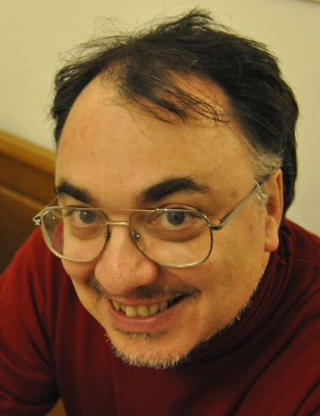
APPLICATION FORM

Ref.: VN20-15/20000
________________________________________________________________________

Mr Agostino Manzato

Address Telephone Nos.
Via Michelstaedter, 6 Work: +390432926843
34170 Gorizia Home:
Italy Mobile: +393293774715

Email address: agostino.manzato@osmer.fvg.it

Gender: Male
Marital status: Married since 13/05/1995
Place of birth: Palmanova
Date of birth: 20/08/1968
Nationality at birth: Italian
Present nationality: Italian
Military Service Commitment: No
________________________________________________________________________

Spouse/Dependants:
Name Date of Birth Relation
Mihaela Kavcic Spouse
Mateja Manzato 20/08/2007 Daughter

Languages:
Mother Tongue: Italian
Reading Writing Speaking
English Excellent Very Good Very Good
Slovenian Good Limited Fair

Education:
Name and place Years attended Qualification Obtained
ARPA Friuli Venezia Giulia -
OSMER SOC 2000-2020 meteorologist

Description:
I'm working as senior researcher in our regional metoffice, in particular developing automatic tools for forecasting thunderstors, hail and heavy rain.
________________________________________________________________________
Centro Servizi
Agrometeorologici - Hail
Research and Prevention Center 1996-2000 junior researcher

Description:
I started studying hail and hailstorms under the guide of dr Griffith Morgan. In 2000 our Institute (CSA) was moved into ARPA FVG by a regional law.

Computer experience:
O.S.: Linux, Irix, Windows (7, 8, 10)
programming languages: I continuosly work programming in Python, R and shell-scripts.
When I was young I used programming in Fortran and C.
Applications: Latex, Emacs, Office (Excell, Word), Photoshop, Zebra (NCAR vizualization tool), MSG-RGB (application to merge different satellite channels).

Other skills:
I'm specialized in forecast verification, in particular for deterministic forecasts.

List of publications:
No list of publications was provided

Professional societies that you are a member of:
I'm member of the Eumetsat Convective Working Group since 2009.

Summary of experience:
I started working on AI applied in meteorology in 2005, publishing on WAF my first paper on thunderstorm forecasting with Neural Networks. In 2006 I followed the AMS "Short Course on Artificial Intelligence Applications to Environmental Science" (featuring also prof. C. Marzban). In 2018 I published on Atmos. Res. a work for improving ECMWF rain forecast using Neural Netwoks, while in 2020 I submitted a paper for forecasting lightning strikes using Convolutional Neural Networks.

Current Employment:
Period From: July 2000
Name of employer: ARPA (Agenzia Protezione Ambiente) del Friuli Venezia Giulia
Address: Via Cairoli, 14, 33057 Palmanova UD

Title of post: meteorologist
Gross Salary: 32000 Euro
Reason for leaving: To go in a place where I can learn more.
Employment Details:
level DS5

Can we contact your present employer? Yes

No Comments provided

Employment History:
References:
Name Organisation/Job Title

Prof Caren Marzban Washington University
E-mail: marzban@u.washington.edu

Prof Richard Rotunno NCAR
E-mail: rotunno@ucar.edu

Prof Ian Jolliffe Honorary Visiting Professor Exeter University
E-mail: iansandloch@gmail.com

________________________________________________________________________

If selected, how much notice would you need to give your present employer before taking up appointment at ECMWF? one month

How did you hear about this position? OtherWebsite

Publication or newspaper:

Attachments:
application.xml
photo.jpg
cover_ML.pdf
publications_scholar_2020.pdf
CV.pdf

Do you want to join a mailing list: No

