INTRODUCTION:
Organic dye pollution in water has turned into a serious environmental concern across the world, and the rapid growth of textile, cosmetics and pharmaceutical industries is largely responsible for it [1]. About 700,000 tonnes of synthetic dyes are produced globally each year, out of which the textile sector alone discharges 200,000 to 280,000 tonnes as effluent [2], [3], [4]. Around 80% of this dye containing wastewater goes to the waterways without any treatment or is used directly for irrigation, which damages the ecosystem severely [5], [6], [7]. Toxicity, skin irritation and allergy are the common health hazards of synthetic textile dyes, and they also create pollution problems, workplace hazards and regulatory issues [8]. Among the dye classes, reactive dyes need special attention. A notable portion of the applied reactive dye does not fix on the fibre and goes to the effluent, and even a small residual amount makes the wastewater strongly coloured [92].
Different treatment technologies have been developed to reduce this pollution, which are mainly grouped as chemical, biological and physical methods [7], [9], [10]. Coagulation and flocculation can remove the bulk pollutant, though a huge amount of hazardous sludge is produced and the chemical and energy demand is high [9], [11]. Biological degradation by microorganisms is eco-friendly, but the reaction kinetics is slow, the treatment takes long time and a specific environmental condition is required to keep the microbial activity alive [5]. Physical routes like adsorption, membrane filtration and sedimentation never break the dye down. They just move it out of the water and onto a solid, so a second waste stream is left behind [7], [9].
Among these, adsorption is still practiced widely because the operation is simple, the cost is low, and it works even when the dye concentration is low [93]. The problem is that the exhausted adsorbent turns into a solid waste itself, and powdered adsorbents are also difficult to separate from the treated water. For this reason the recent attention has moved to Integrated Photocatalyst Adsorbents (IPCAs), where the same material first holds the pollutant on its surface and then breaks it down [12]. In this way the captured dye is mineralized into CO₂ and H₂O, and the adsorbent gets regenerated instead of being thrown away [13]. Titanium dioxide (TiO2) is the most used semiconductor for this purpose because of its chemical stability, non-toxic nature and strong oxidizing power under UV light [7], [14], [15], [16]. Its wide bandgap (~3.2 eV for anatase) is the main limitation, as the activity remains confined mostly within the UV region. Getting the TiO2 slurry back out of the treated water, and using it again, is a further headache [15], [17]. Immobilizing TiO2 on a suitable polymeric matrix is therefore a sustainable and energy efficient route for water purification, since the film can be lifted out of the treated water manuallyt and used again [7], [13].
PVA has been selected widely as the host polymer for TiO2 because it is transparent, biodegradable and hydrophilic, and its hydroxyl (-OH) groups are able to bond with the TiO2 surface [18], [19], [20], [21]. Because the matrix is transparent, light is not obstructed appreciably while passing through the film and can reach the TiO2 particles. Furthermore, the hydroxyl groups carried along the PVA chain also behave as hole scavengers, by which the rate of the photocatalytic reaction is raised [22], [23]. PVA does have a durability problem, though. The very same hydroxyl groups let the film soak up water and swell, so it falls apart after it has been used a few times [24]. This limitation is commonly overcome by crosslinking the PVA chains, and citric acid is a suitable candidate for this purpose because it is non-toxic, inexpensive and esterifies with the hydroxyl groups of PVA under mild thermal treatment [23].
PVA/TiO2 composite films have already been fabricated in several recent works and their capability for dye removal is well reported. Saini et al. prepared PVA films loaded with activated charcoal and TiO2, where 99.3% of methylene blue (MB) was removed under sunlight, and the authors explained this performance by the combined action of adsorption and photocatalysis [14]. In another work, Sampath and Charles cast a PVA/graphite/TiO2 hydrogel membrane which degraded 84% MB under natural light, and the conductive filler was reported to improve both the structural stability of the membrane and the charge separation [12]. Naveenkumar et al. put lotus fiber into PVA/TiO2 nanocomposites. They got 91.18% of crystal violet degraded and better heat stability too, which they put down to how much cellulose the fiber holds [10].
Agglomeration of TiO2 nanoparticles inside the polymer matrix, however, remains a common difficulty in all these systems. Once the particles aggregate, the effective surface area drops, light cannot penetrate properly and fewer active sites are left for adsorption as well as catalysis, so the overall efficiency of the film goes down [25]. Adding cellulose nanocrystals (CNC) or cellulose microcrystals (CMC) is one way round this dispersion problem [17], [26]. Both take up water readily, break down naturally and come from renewable sources, which is why they count as green substrates [27]. CMC offers a large surface for anchoring the nanoparticles and it also forms strong hydrogen bonds with the PVA matrix, which strengthens the thin film; on the other hand these bonds restrict the mobility of the molecular chains and hence the water uptake or swelling of the film is reduced [28], [29]. In the work of Ng and Leo, a 237% gain in tensile strength was recorded for microfibrillated cellulose (MFC), and 91.45% of MB was taken up within only 10 minutes. Their film kept working for 10 cycles without losing efficiency, and light transmittance showed close to 50% decolorization [1]. For a cellulose/carrageenan/TiO2 nanocomposite the MB uptake was 19 times that of pure cellulose, which was credited to the sulfated and carboxylated groups of the polysaccharide capturing the cationic dye electrostatically [30]. Another report combined ZnO/TiO2 heterojunctions with N-doped porous biochar obtained from chitosan, degrading 94.5% Rhodamine B within 25 minutes, the biochar serving as an electron transport medium that suppressed charge recombination [31].
It is noticeable from the above studies that most of the reported cellulose-reinforced films were assessed against cationic dyes such as methylene blue, crystal violet and Rhodamine B, whereas the anionic reactive dyes that dominate cotton dyeing effluent have received far less attention. In addition, the cellulose used in these composites is generally sourced from wood pulp, sugarcane bagasse or fruit peels, and the recovery of the adsorbed dye is rarely considered, so the captured colour is ultimately lost with the exhausted film.
A significant research gap therefore exists in utilizing CMC derived specifically from Saccharum spontaneum (wild sugarcane). Saccharum spontaneum is a perennial grass that grows abundantly as a weed on riverbanks and wastelands across the Indian subcontinent, and its flower is not used for any commercial purpose at present [32]. The flower of this plant produces a unique, hollow, cellulosic fiber with remarkable properties. Rahman et al. have shown that Saccharum spontaneum flower fibre possesses a high holocellulose content (90.9%), a crystallinity of about 75%, and a hollow structure that is promising for high adsorption capacity [32]. To the best of our knowledge, cellulose microcrystals extracted from Saccharum spontaneum flower fibre have not yet been employed as a reinforcing and dispersing agent in a PVA/TiO₂ adsorptive film for the removal of reactive dye from water. Converting this unused flower fibre into a value-added adsorbent is attractive from a sustainability point of view, as the raw material is locally available at almost no cost and the resulting film remains biodegradable.
Therefore, the present study was undertaken to develop a composite biofilm from PVA, TiO2 nanoparticles and cellulose microcrystals extracted from Saccharum spontaneum flower fibre, using citric acid as the crosslinking agent. The alpha cellulose was isolated from the flower fibre and hydrolyzed into cellulose microcrystals, and the biofilm was fabricated by solution casting. The developed biofilm was characterized by FTIR, XRD, particle size analysis, FE-SEM with EDX, DSC, swelling study, tensile testing and UV-visible spectroscopy to confirm the successful incorporation of the components and to evaluate the structural, thermal, mechanical and optical behaviour of the composite. Finally, a simple heating route was explored to recover the adsorbed dye and to reuse the biofilm, which allows both the film and the removed colour to be returned to the process instead of being discarded. In parallel, a physics-informed neural network was developed to jointly model the pseudo-second-order kinetics and Freundlich isotherm behaviour of the biofilm through a single set of physically-constrained parameters, so that adsorption performance could be estimated under combinations of contact time, initial concentration and adsorbent dosage that were not directly tested experimentally. The novelty of this work lies in the use of an abundant but unexploited flower fibre as the cellulose source, the fabrication of a citric acid crosslinked PVA/TiO2/CMC biofilm from it, and the demonstration of dye recovery together with film reuse, which together offer a low-cost and circular approach for the treatment of reactive dye effluent, further supported by a physics-informed machine learning model capable of estimating adsorption performance under experimental conditions that were not directly tested. The film was then tested on Avitera Light Red SE, an anionic reactive dye. Contact time and starting dye concentration were both varied, and the data were fitted to the pseudo first order and pseudo second order kinetic models and to the Langmuir and Freundlich isotherms.

MATERIALS AND METHODS:
The cellulose extraction, film fabrication, and characterisation procedures reported here were carried out alongside a companion study on cellulose microcrystals derived from waste cotton fabric [94]. The two studies share a common protocol, and the procedures are described here in full so that the present work can be followed independently.
Materials:
TiO₂ nP was purchased from the local market name Hatkhola. Poly vinyl Alcohol (PVA with average molecular weight of 31,000 to 50000, 87–89 % hydrolyzed) were acquired from the same place, and citric acid (CA, ≥99%) sodium chlorite and acetic acid were collected from Dyes and Chemicals Engineering Lab, BUTEX. Avitera Light Red SE was selected for the preferable dye solution which was collected from the Dyes and Chemicals Engineering Lab.
Methods:
Extraction of Cellulose Microcrystals (CMC)
Preprocessing of Raw Materials
Fresh flower-containing parts of the S. spontaneum were sourced from Ghatacchor, Dhaka, Bangladesh (latitude 23.73505° longitude 90.33544°). Then, the flowers of S. spontaneum which is basically the fiber, were separated from stems and dry them at 35±2℃ in air. Further they were stored at ambient conditions prior to chemical process.
Isolation of α-Cellulose from S. Spontaneum
The isolation process of alpha cellulose was conducted by biomass analytical method (LAPS) [33,34]. One gram of dried S. spontaneum fiber was immersed into 200 mL distilled water continuing the vigorous stirring at 70–75℃ for an hour. Meanwhile, four separate portions of 0.2 mL glacial acetic acid and 0.5gm sodium chlorite were added at two-minute intervals. After completing the heating process, the mixture was cooled to room temperature, filtered, and the residue was washed thoroughly with distilled water to remove all traces of acid and neutral the pH. At 105℃, the residue was oven-dried for 2h and measured the weight of residue until the constant value was obtained which was the holocellulose. Afterwards, the holo cellulose was treated by 12 mL of 17.5% sodium hydroxide and left the mixture for 5 minutes. The sample was then macerated over 10 minutes, and 14 mL of alkali was introduced in 3.5 mL portions at intervals of two minutes during this stage. After spending total 45 min the mixture was filtered, washed and soaked for 5 minutes in 14 mL of 10% acetic acid, followed by washing with water until acid-free. Finally, the residue was dried at 105℃ and weighed continuously until the constant weight was obtained.
Preparation of Cellulose Microcrystals (CMC)
Cellulose micro crystal (CMC) was prepared by following the study with slightly modifications [35]. The dried α-cellulose was subjected to hydrolysis in 40% H2SO4 for 60 min at 40℃, keeping the liquor ratio at 1:10 (w/v). Subsequently, the solution was centrifuged several times at 3800 rpm for 10minutes. Additionally, the suspension was washed with distilled water multiple times to control the pH and keep the CMC at the bottom via gravitational force. Thereafter, the supernatant was discarded from the beaker until the residual sample became neutral. After that, the sample was sonicated for 1 hour and dried at 100℃ until constant weight was obtained [36]. Later, CMC was collected and kept in a refrigerator until use. [37]
Preparation of PVA/TiO₂/Citric Acid Matrix
Casting solution for the Catkin based biofilm was developed by following this previous study [1]. To begin with, the TiO₂ nP was dispersed in a distilled water with the ratio of 0.25:100 (M:L)/0.9wt% under continuous stirring at 90℃. Correspondingly, 15gm of PVA was added gradually to the solution and dissolved it completely. A non-transparent viscose solution was observed which occurred due to addition of TiO₂. Afterwards, the 10gm citric was added to the mixture, maintaining the ratio of 3:2 and heating continued for 3 hours to yield a viscose polymeric matrix suitable for film formation.
Fabrication of Bio-composite Film
Two grams of CMC which was previously obtained, was dispersed in 10 mL deionized water and stirred at 600 rpm for 10 min. This dispersion was then mixed with the PVA/TiO2/citric acid solution and sonicated for 30 min so that a homogeneous mixture was obtained. Entrapped air bubbles were removed by slow stirring at 80 rpm for 5 minutes followed by another 30 minutes of sonication. A 30 cm2 uniform surface glass plate was used to prepare the thin film. Before using the glass plate, it was washed by ethanol. After cleaning the surface, the place was margined by the tape. Then, the dispersed solution was poured onto the glass plate, and a large sharp blade was used to settle the solution by providing reciprocal motion manually. After finishing the process, the film was kept at room temperature and left for 48 hours. After drying, the film was peeled off from the glass plate and used for further application. The S. spontaneum-derived composite was designated as Catkin biofilm. The whole synthesis route, starting from the collected S. spontaneum sample to the dye adsorbed biofilm, is illustrated in Fig. 1. In detail, figure 1 displayed the separation of fresh stems and flowers from the collected sample, the obtained holo cellulose and α-cellulose after chemical treatment, the prepared cellulose micro-crystal, the casting solution developed for the biofilm and finally the fabricated Catkin biofilm before and after dye adsorption.

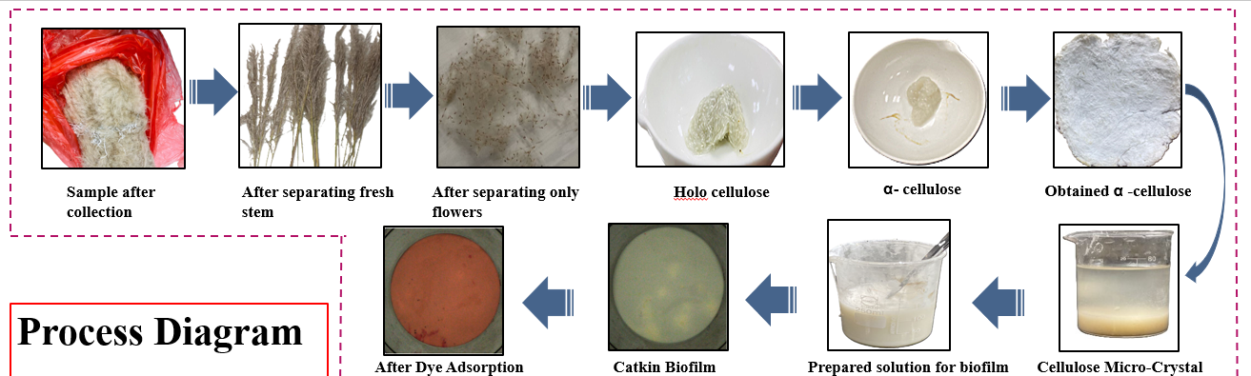
Figure 1: Process diagram of Catkin based biofilm synthesis process
Note: Reproduced from the companion WCF/Catkin comparative manuscript's process-diagram figure, cropped to the Catkin-only synthesis pathway (the original standalone figure for this manuscript could not be located in any saved revision).
Characterization of Catkin Biofilm:
Fourier transform infrared (FTIR) spectroscopy
The Fourier-transform infrared (FTIR) was employed to characterize the α-cellulose derived from S. spontaneum. Correspondingly, this analysis helped to identify the changes in functional group after dye adsorption. Moreover, the Fourier-transform infrared (FTIR) spectra of the thin bio-film were characterized using the PerkinElmer Spectrum-4600(Model: Spectrum 2) at the Dyes and Chemical Engineering lab, Bangladesh University of Textiles. The wave-number range was ranging from 4000 to 400 cm⁻¹, covering the mid infrared range.
X-Ray Diffraction
To characterize the crystalline structure of the biofilm, X-ray diffraction analysis was carried out. Malvern Panalytical Empyrean X-ray diffractor was equipped with Cu Kα radiation(λ=15406Å). An accelerating voltage of 45kV and a tube current of 40mA were applied to operate the instrument. Continuous scanning mode was used and the patterns were collected from 2θ = 10° to 90°, the step size being 0.01°.
Particle Size analyzer
The particle size analysis was employed to measure the particles of crystal micro-cellulose (CMC) derived from S. spontaneum as claimed. FRITSCH ANALYSETTE 22 NeXT (FRITSCH Asia-Pacific Pte. Ltd, Singapore) with a measuring range of 0.01µm to 3800µm was used to assess the particle distribution of CMC.
Field-emission scanning electron microscopy (FE-SEM) and Energy Dispersive X-ray (EDX)
The surface morphologies of untreated and treated Catkin biofilm were examined by using a field emission scanning electron microscopy (FE-SEM) (ZEISS Field Emission Scanning Electron Microscope, Germany). The samples were attached to double-sided adhesive carbon tape, vacuum dried, sputter coated with gold and scanned at an accelerating voltage of 3kV under different magnifications.
Energy Dispersive X-Ray spectroscopy (EDX) detector integrated with FE-SEM was used to measure the elemental composition present on the surface of the untreated biofilm sample. In addition, this analysis was conducted to confirm the presence of TiO₂ on the surface of the biofilm. This FESEM-EDX analysis enabled to provide comprehensive morphological and compositional insight into the surface of the biofilm.
Differential Scanning Calorimetry
Differential scanning calorimetry (DSC) was carried out on the biofilm using a DSC-PerkinElmer's DSC 4000, single furnace DSC. The machine was periodically calibrated with two-point calibration using indium and zinc at 10 ˚C/min. Approximately 9 mg of the sample was taken in a hermetically sealed DSC pan, heated from 20℃ to 350℃ at a rate of 19.8℃/min under N₂ atmosphere against an empty reference pan. The glass transition temperature: T_{g}, melting temperature: T_{m} and decomposition temperature: T_{d} was recorded from the obtained curve.
Swelling Study
The swelling study of the biofilm was carried out by determining the weight changes of sample after hydration. To measure the swelling study, the biofilm was dipped into 50mL distilled water and weighted after 10 minutes of interval, starting from 5 min. This process was continued until a constant weight was obtained. Before taking the weight, excess water was blotted out. The swelling percentage was determined by using the equation which is given below [1,38],
Swelling Percentage =
Where, W and Wo represent as swelled weight of biofilm and the dry weight of biofilm.
Mechanical Properties
The mechanical properties of the biofilm were carried out by a Universal Testing machine (UTM), Model 1410 Titans, combined with a 5000N load cell (U.K). ASTM D 882- standard method was followed with slightly modification. The Catkin (100×78) samples were tested with a grip separation of 50mm where the test speed was 50mm/min. When the samples were broken, maximum stress was determined [1].
Film Band Gap
The UV-visible spectrophotometer was employed to measure the transmittance value of the biofilm which helped to determine the band gap of the biofilm. The band gap of the prepared biofilm was calculated by using Tauc's relation which is given as [39],

Where, d represents the thickness of the sample, T denotes as Transmission and hν is the photon energy. Equation 3 can also be written as

Adsorption Studies
Absorbance was measured by PerkinElmer Lambda 365 UV/Vis spectrophotometer at the Dyes and Chemical Engineering Lab, BUTEX. To calculate the dye removal%, Avitera Light Red SE dye was chosen and sourced from the lab. 1g/L concentration of stock solution was prepared to build a calibration curve. From this solution, 6 sample data was prepared which were 0.01g/L, 0.02g/L, 0.04g/L, 0.06g/L, 0.08g/L, 0.1g/L, and all the solution were analyzed to measure the absorbance of the solution through UV-VIS spectrophotometer at the range of 400-700nm. An absorbance vs concentration calibration curve was prepared from the absorbance value (X axis referred to conc.(gm/L) and Y axis referred to absorbance). Unknown concentration of dye solution was determined with help of this curve. Additionally, the dye removal% was calculated by the following equation [40]:

Where,
Co = Concentration of dye before treatment, and C = Concentration of dye after treatment
Two different weights of samples (1.2gm and 0.5gm) were used to evaluate the effect of time(0-170min) and concentration(20-60ppm) respectively. The amounts of dye removed at (t) and equilibrium (170 min), expressed as q_{t}(mg/gm) and q_{e} (mg/gm), were determined. The amount of dye adsorbed at any given time (t) and at equilibrium was calculated using the following expressions [35,40]:

Where, q_{t}=Absorption capacity (mg/gm), q_{e}=Adsorptive capacitive in mg/gm (at equilibrium time=170min), C_{o}= The initial concentration of dye (mg/L),C_{t} = Concentration of dye after treatment(at time) (mg/L), C_{e}= Concentration of dye after treatment (at equilibrium time) (mg/L), V = (L) Volume of the solution, M= Mass of the biofilm used as an adsorbent in gm
Adsorption Isotherm
Equilibrium data were analyzed using the Langmuir and Freundlich isotherm models to study the adsorption behavior. The linearized equations for the Langmuir isotherms are given in Eq. (7) [41-44].

Where K_{L} is the adsorption coefficient, and q_{max} is the saturated adsorptive capacity (mg/gm).
The linearized equations for the Freundlich isotherms can be expressed as follows and are represented by Eq. (8) [45,46].

Where K_{f} is the Freundlich constant (representing the adsorption capacity) and n represents the intensity of adsorption
Adsorption Kinetics
The adsorption mechanisms were determined by applying the pseudo-first-order and pseudo-second-order kinetic models, as shown in Equations and, respectively, to describe the attachment and interaction between Avitera Light Red SE and the biofilm. [47,48]

where, q_{t}= adsorption capacity, k= 1st order kinetic constant and 2nd order kinetic constant
Physics-Informed Neural Network Modeling (PINN3D)
In addition to the classical kinetic and isotherm regressions described above, a physics-informed neural network (PINN) [95] was also developed to model the kinetics and isotherm data of the biofilm together, within one framework. A conventional neural network only tries to minimize the gap between its output and the measured data. A PINN goes a step further: it also penalizes the network whenever it violates a known governing equation at collocation points, meaning combinations of contact time, initial dye concentration and adsorbent dosage that were never actually measured. Four loss terms were combined into a single weighted objective (Eqs. 1-5): a data-fitting loss on the experimental kinetics and isotherm points (Eq. 1); a pseudo-second-order (PSO) kinetics loss that enforces dqt/dt = k2(qe − qt)² at the collocation points, computed via automatic differentiation of the network output (Eq. 2); an initial-condition loss that enforces qt(0) = 0 (Eq. 3); and an equilibrium loss that anchors the network's prediction at a long contact time (400 min) to the analytic Freundlich equilibrium value at each collocation point (Eq. 4).
For each collocation point, the equilibrium value qe used in the equilibrium loss was found by solving the Freundlich isotherm (qe = Kf·Ceⁿ) together with the mass-balance equation (Ce = C0 − qe/dosage) self-consistently, through damped fixed-point iteration (Eq. 6), since no closed-form solution exists when n is not an integer. Rather than fixing k2, Kf and n as constants, we treated them as trainable parameters of the network, an inverse-PINN formulation. They were reparameterized through a softplus transform (to keep k2 and Kf positive) and a bounded sigmoid (to keep n within [0.05, 2.0], a range wide enough to allow both sub-linear and super-linear Freundlich behaviour), so gradient descent could never push them outside physically valid values. Because the same k2, Kf and n had to satisfy the kinetics and the isotherm data at the same time, through one shared mass-balance relation, this joint formulation constrains the fit more tightly than fitting the two classical models separately, which is how it is conventionally done.
All inputs (time, concentration, dosage) and the output (adsorption capacity) were standardized before training. Since the physics loss terms are written in real physical units, the network's standardized output had to be converted back to real units before each physics-equation evaluation. The four loss terms were combined using fixed weights of 180, 1, 35 and 8 for the data, PSO, initial-condition and equilibrium terms respectively (Eq. 5). These weights were set from the relative size of each raw loss term at convergence, so that no single term would dominate the shared gradient during training with the Adam optimizer. Figure 18 summarizes the full architecture and information flow, including how the loss terms feed back into both the network weights and the learnable physical parameters through backpropagation. The network itself is small, three input neurons, one hidden layer of 32 neurons and one output neuron, and was trained for 8000 epochs. Training was repeated for four random weight initializations (seeds 42, 43, 44 and 45) to form a small ensemble. The ensemble mean was taken as the point prediction, and the ensemble standard deviation as an estimate of epistemic uncertainty at every queried input.

Film Appearance
The film appearance was measured by using X-Rite ci7530 spectrophotometer in the Dyes and Chemical Engineering Lab, BUTEX. In addition, CIE L* a* b* and CIE L* c* h* were determined to check the color attributes of the biofilm samples [49,50]. Moreover, this analysis was conducted on before and after treated biofilm samples developed from CMC of Catkin.

RESULTS AND DISCUSSIONS:
Fourier Transform Infrared (FTIR)
FTIR spectroscopy was carried out on the α-cellulose isolated from S. spontaneum and on the PVA/citric acid/TiO2 biofilm containing Catkin CMC, taking the spectra of the film both before and after it had adsorbed the dye. In addition, this technique was employed due to its convenient use for obtaining rapid information about the chemical structure and crystallinity of cellulose samples. Three curves are plotted in figure 2, one for each sample. The α-cellulose whose spectrum is given in Figure 2 was the one obtained from Catkin fiber through the modified TAPPI route. Stretching of the -OH groups gave rise to the absorption at 3291 cm⁻¹, while the band at 2925 cm⁻¹ came from C-H stretching [51]. A number of peaks belonging to α-cellulose appeared within the fingerprint region. CH₂ symmetric bending vibration was held responsible for the band at 1430 cm⁻¹, a band usually linked to the crystalline portion of cellulose [52]. Skeletal vibrations of C–C and C–O along the polysaccharide backbone produced the band at 1330 cm⁻¹ [51]. Two further bands were resolved at 1176 and 1111 cm⁻¹; the first arose from antisymmetric C–O bridge stretching in the glycosidic framework and the second from asymmetric stretching of the anhydroglucose ring [52,53]. A strong peak sat at 1050 cm⁻¹ as well. It comes from the C–O–C skeletal vibration of the pyranose ring in cellulose [54]. The sharp peak located at 910 cm⁻¹, representing the C1 ring vibration frequency, was a characteristic indicator of β-glycosidic linkages connecting the sugar units in cellulose [55]. Bands near 1512, 1240 and 1735 cm⁻¹, which would have indicated leftover lignin and hemicellulose, were absent [56,57], confirming the extraction of cellulose was successfully optimized.
The Catkin biofilm gave a set of peaks that differed considerably from those of the cellulose alone. Over the scanned window of 4000–400 cm⁻¹, the micro-crystal cellulose based film gave a broad envelope. Within 3400-3200 cm⁻¹, and centred at 3291 cm⁻¹, a broad band marked the −OH functional groups, the abundant hydroxyls of PVA being their source [57]. A weak peak also came at 2925 cm⁻¹, which stood for Sp3 hybridization of the aromatic C-H [58]. The most intense of all the peaks fell at 1710 cm⁻¹ and belonged to C=O ester and carboxyl C=O groups, from which proper crosslinking between PVA and citric acid could be inferred. Another broad region extended from 1150 to 1300 cm⁻¹, and symmetric C=C stretching was located at 1208 cm⁻¹ within it [59]. Cellulose micro-crystals and TiO2 nanoparticles were both present in the film, but their proportion was small beside that of PVA and citric acid [58,60]. For this reason no band belonging to the Ti-O bond could be traced. Separating cellulose from PVA by FTIR also remained difficult, since the functional groups of the two and their characteristic bands fall on one another. TiO2 and the cellulose microcrystals did alter the behaviour of the biofilm, though this change was not reflected in the FTIR result.
Once the film had taken up the dye, its spectrum looked noticeably different, as Figure 2 shows. An absorption peak came at 1642 cm⁻¹ in the treated film, which established the N=N azo bond [61,62], which directly confirms dye adsorption onto the surface. The curve also altered near 1380 cm−1, where the S=O stretching vibration appears [63,64], which originates from the sulfonate groups (–SO₃⁻) of Avitera Light Red SE engaged in electrostatic interaction with the protonated TiO2 surface. The C=O ester band retained at 1710 cm⁻¹ in the untreated film stands for the permanent ester crosslink formed between citric acid and PVA. Taken together, these bonds establish that the dye had been adsorbed.

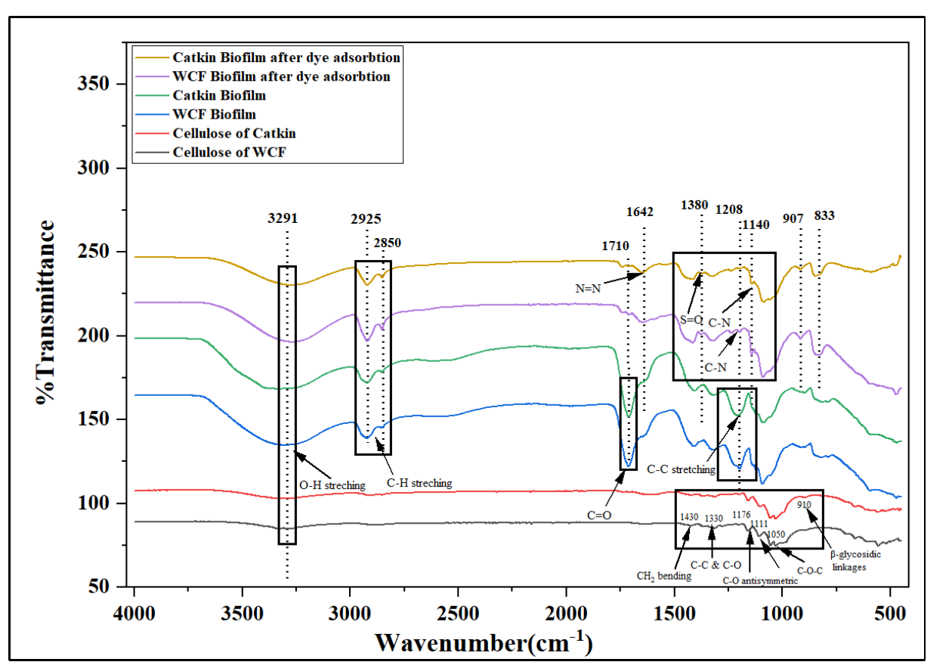
Figure 2: FTIR spectra of a) cellulose of Catkin b) Catkin biofilm c) Catkin biofilm after dye adsorption
Note: Reproduced from the companion WCF/Catkin comparative manuscript. This plot currently overlays both materials (Catkin traces: cellulose = red, biofilm = green, biofilm after dye adsorption = gold; WCF traces: black/blue/purple). A Catkin-only FTIR plot should be redrawn from the raw spectral data before submission.
X-Ray Diffraction Analysis
The X-Ray diffraction analysis of the biofilm was carried-out to understand the crystalline structure of α-cellulose, PVA and TiO2 present in the biofilm. A semi-crystalline nature is typical for α-cellulose, and this is reflected by a diffraction peak near 22.5-23°. A peak of prominent intensity was found at 22-23° in figure 3, which indicated that the (200) lattice plane of cellulose was retained in a highly crystalline form inside the biofilm matrix [65,66]. A broad feature also came up at 19-20°, which belongs to the lattice parameter of polyvinyl alcohol (PVA) [67,68]. This feature fell partly on the cellulose peaks, and such overlapping was taken as evidence that the composite structure had formed. The film also gave weaker peaks overall, and adding micro-crystal cellulose is the likely reason. On the other hand, the distinct diffraction peaks at 27.4°(110) and 54.3°(201) shown in Fig. 3 corresponded to the crystalline planes of TiO₂ [69-71]. These TiO₂ reflections agreed with JCPDS no. 88-1175 and 84-1286, by which the proper loading of TiO₂ in the biofilm was established. Taken together, the XRD data show that the micro-crystal cellulose-PVA-TiO₂ film from S. spontaneum had been made properly.

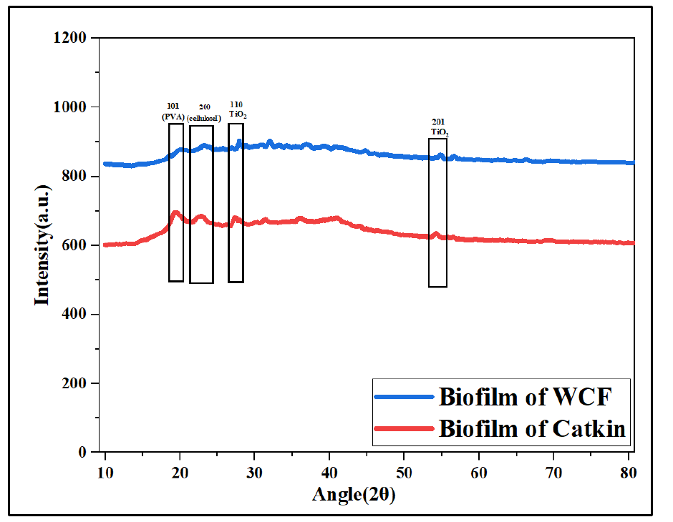
Figure 3: XRD pattern of Catkin biofilm.
Note: Reproduced from the companion WCF/Catkin comparative manuscript. This plot currently overlays both materials (Catkin = red curve, WCF = blue curve). A Catkin-only XRD plot should be redrawn from the raw diffraction data before submission.
Particle Size Analyzer
Size distribution of the micro-crystal cellulose produced from catkin was assessed by particle size analysis. Fig. 4 illustrates the cumulative distribution curve of catkin-based micro-crystal cellulose.
The Catkin-based micro-crystal cellulose (M1–M3) unveiled a relatively coarse and wide range of particle size distribution, as demonstrated by the gradual increment in percentile diameters from D5 = 6.89 µm to D90 = 68.41 µm., depicted in Fig. 4. In addition, the median particle size was 23.98 µm, affirming that 50% particle were less than 23.98 µm. Moreover, 5%, 10%, 25%, 50%, 75%, and 90% particles were less than 6.89, 7.63, 11.72, 23.98, 43.42, and 68.41 µm, respectively, illustrated in Table 1. The catkin CMC spanned a wide range, yet 90% of it stayed below 68.41 µm, which indicated that the CMC had been well produced although its distribution was not uniform [72,73]. The analysis was undertaken because the product had been claimed as CMC.

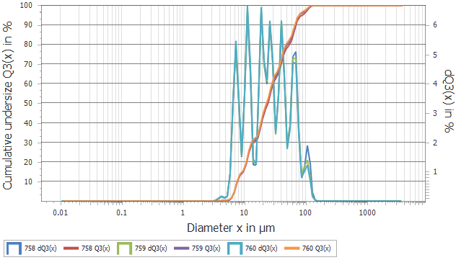
Figure 4: Particle Size distribution of cellulose micro-crystals of Catkin
Note: Catkin-only panel (originally labelled A) cropped from the companion WCF/Catkin comparative manuscript's particle-size distribution figure.
Table 1: Particle Size distribution of CMC derived from Catkin
% < | mean µm | CV [%] | M1 (Catkin) | M2 (Catkin) | M3 (Catkin)
5 | 6.89 | 0.13 | 6.9 | 6.88 | 6.87
10 | 7.63 | 0.29 | 7.65 | 7.61 | 7.58
25 | 11.72 | 0.6 | 11.79 | 11.65 | 11.57
50 | 23.98 | 1.53 | 24.34 | 23.61 | 23.04
75 | 43.42 | 1.88 | 44.24 | 42.61 | 41.73
90 | 68.41 | 1.35 | 69.33 | 67.49 | 66.3
Morphological analysis and EDX
Surface morphology was studied to see what the film looked like and how it changed once the dye had been taken up. Fig. 5 (A) showed the FE-SEM micrograph of the Catkin-based biofilm, taken at different magnifications. In Fig. 5 (A) the surface came out smooth and even, carrying few irregularities, so the roughness of the film was low. Even with this smooth texture, a small number of irregularities could still be traced. CMC that had not spread evenly is probably what caused them. The micro-crystal cellulose could nonetheless be seen sitting on the film surface, and the Catkin-derived CMC is shown in Figure 5(B). The thin film also carried a dense surface without pores [74]. The picture altered considerably once the film had adsorbed the dye. The surface lost its evenness, and dye particles could be seen stuck to it in patches. Figure 5(C) illustrates the surface of catkin biofilm after dye adsorption. This is clear support for what was claimed earlier. In addition, Figure 5(D) shows the dye particles. It has been reported earlier that loading TiO₂ heavily may bring about agglomeration, upsetting the uniformity of the structure and leaving a discontinuous, heterogeneous surface [75,76]. Because so little TiO₂ nP went in, much of it stayed hidden in the FE-SEM images.

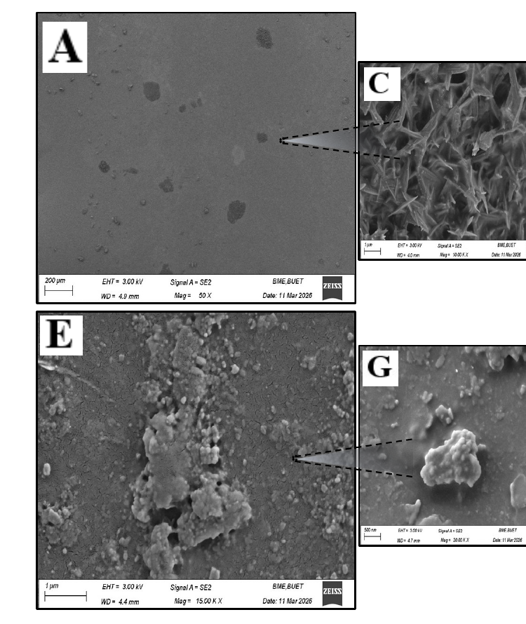
Figure 5: SEM image of the surfaces of A) Catkin biofilm B) CMC of Catkin C) Surface of Catkin biofilm after dye adsorption D) Dye particle on the surface of Catkin biofilm.
Note: Catkin-only SEM panels (originally labelled A, C, E, G) cropped from the companion WCF/Catkin comparative manuscript's SEM figure and relabelled A-D to match this caption.
Energy dispersive X-ray spectroscopy (EDX) was therefore used to trace the TiO₂ in the sample, the spectrum being given in Figure 6. The EDX spectra analysis showed a peak at 0.45 keV, which confirms the presence of Ti. An O peak came at 0.52 keV as well, and both elements point to TiO₂, which establishes that TiO₂ was sitting on the composite surface [77,78]. Figure 7 carries the elemental analysis together with the mapping of the Catkin biofilm. From this SEM-EDS mapping the loading and spreading of TiO₂ through the biofilm could be established firmly. FE-SEM together with EDX thus supported the proper formation of the biofilm, TiO2 having spread over the whole of its surface.

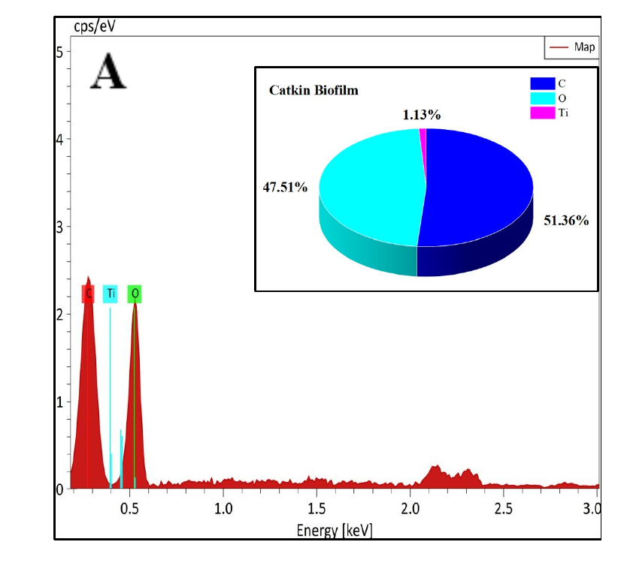
Figure 6: EDX spectra of investigated sample: Catkin Biofilm
Note: Catkin-only panel (originally labelled A) cropped from the companion WCF/Catkin comparative manuscript's EDX spectra figure.

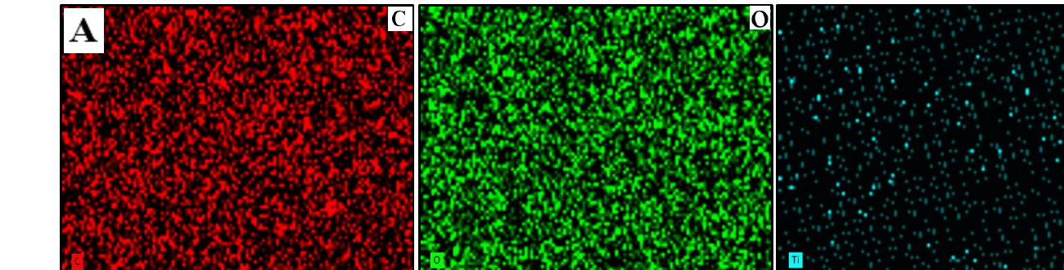
Figure 7: Corresponding EDS elemental mapping of C, O, Ti of Catkin Biofilm
Note: Catkin-only row (originally labelled A: C, O, Ti maps) cropped from the companion WCF/Catkin comparative manuscript's EDS elemental-mapping figure.
Mechanical Strength Analysis
Figure 8 (A) demonstrated the stress–strain behavior of the developed biofilm. However, the biofilm showed quite relevant results as the previous study claimed [1]. In this study, the tensile strength of catkin biofilm was 5.5 MPa and elongation at break was 296.47%. This analysis disclosed that considerable tensile strength and elongation at break were exhibited by the Catkin Biofilm, confirming the improvement in toughness and deformation capability. Such a gain on both counts left the film better balanced between flexibility and strength, which opens up uses demanding mechanical durability along with tolerance to deformation. Loading CMC and TiO₂ in high proportion has been shown in earlier work to weigh heavily on the tensile strength [1,60,79]. The two fillers also raise the viscosity of the casting solution, from which a denser film results. So even though our film was thinner, it came out stronger than the ones reported before.

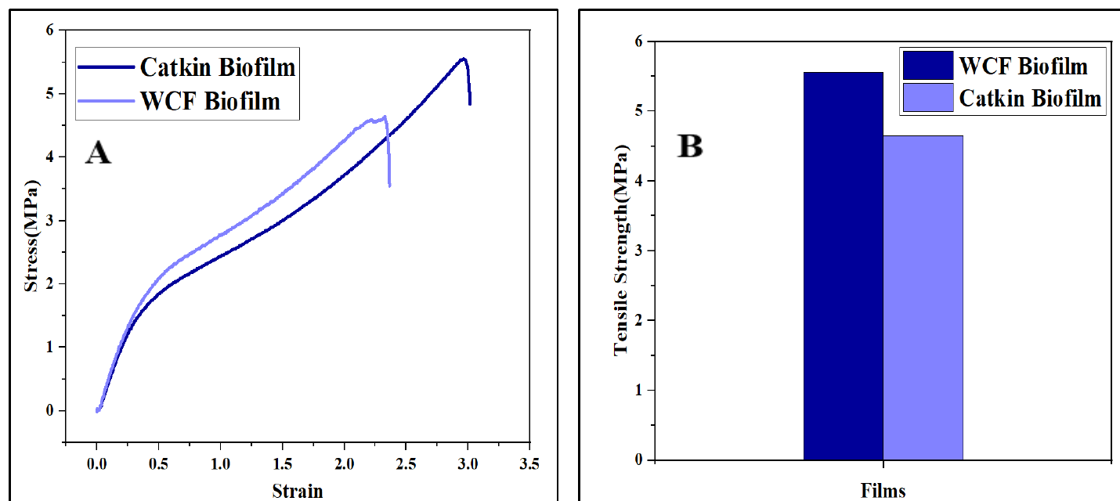
Figure 8: (A) Stress-Strain Curve of Catkin biofilm (B) Tensile strength of Catkin biofilm.
Note: Reproduced from the companion WCF/Catkin comparative manuscript. Both panels currently show WCF alongside Catkin (Panel A: dark blue = Catkin, light blue = WCF; Panel B bars: left = WCF, right = Catkin). Catkin-only stress-strain and tensile-strength figures should be redrawn from the raw mechanical-testing data before submission.
Differential Scanning Calorimetry
Thermal behaviour of the prepared biofilm was followed by differential scanning calorimetry (DSC), and Figure 9 carries the thermogram, in which endothermic transitions run upward.

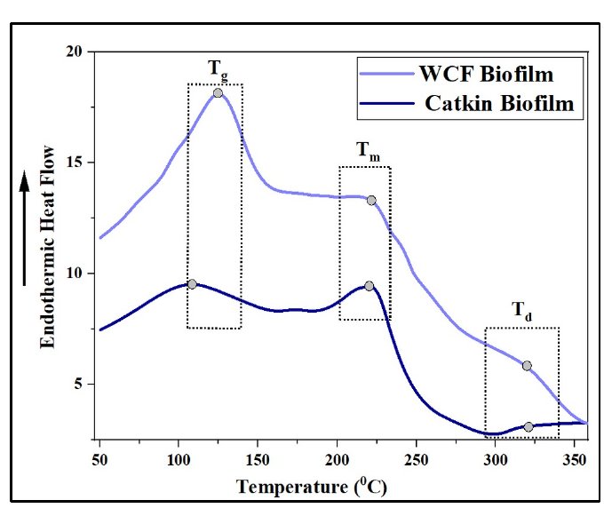
Figure 9: DSC Curve of Catkin biofilm
Note: Reproduced from the companion WCF/Catkin comparative manuscript, currently overlaying WCF (light blue) and Catkin (dark blue) thermograms. A Catkin-only DSC curve should be redrawn from the raw thermogram data before submission.
The glass transition temperature (Tg) appeared broadened and slightly shifted toward higher temperatures, ranging from 100 to 140℃, suggesting restricted polymer chain mobility. For comparison, the Tg of neat PVA lies within 78–85℃, whereas cellulose and citric acid undergo their transitions at much higher temperatures of about 200–230℃ [80,81]. Broadening of this Tg peak in the biofilm pointed towards ester crosslinking taking place between PVA and citric acid, on which the TiO₂ nanoparticles exerted a further influence. For the Catkin biofilm this transition settled at 105℃. How the Tg peak was shaped, and the area it covered, may be traced to the crystallinity present in the biofilm [82]. Tg further depends on how freely the polymer segments can move; here the PVA chains were held tightly by CMC through hydrogen bonding, their segmental motion was curtailed and the Tg accordingly rose [83,84]. The melting transition (Tm), which lies at 227.08℃ for neat PVA [81], had likewise shifted in the composite. However, the sample displayed a relatively low endothermic peak at 221.79 compared to the PVA melting point. Loading of TiO₂ nP was behind this disturbance, since spherulites of lower surface free energy are then formed and the melting temperature Tm is pulled down [85,86]. CMC loading was found to weigh on this behaviour as well. That the melting point dropped a little suggests CMC interferes with the ordered packing of the PVA molecules [82]. Sulphuric acid had been used to hydrolyse the CMC, and this may have told upon the thermal behaviour of both the CMC and the composite [87]. The Td of the sample was found in the range of 318-321℃. Td had nonetheless risen above the decomposition point of PVA, which follows from the intermolecular interaction between PVA and TiO₂ nP [81]. The departures of Tg and Tm from the values of neat PVA therefore establish that cellulose, citric acid and TiO2 had all entered the polymer matrix, changing its crystallinity, raising the crosslink density and shifting its thermal stability, which shows how strongly a bio-based filler tells upon the thermal behaviour of such a film [88,89].
Swelling study
Water uptake of the prepared composite was followed through the swelling study given in Fig. 10. PVA and TiO₂ both like water, and that is chiefly why the film soaks up so much of it [1]. An earlier report put the swelling of CMC-based PVA@TiO₂ films at 60%-80% at best. In contrast, a previous study proposed that the catkin fiber is hydrophobic in nature [32]. However, the alpha cellulose, later CMC, was produced to convert the hydrophobic fiber into a hydrophilic nature, resulting in an almost 100% swelling ratio at 35min. However, a previous study stated that the CMC creates hydrogen bonds with PVA, which basically limits the hydroxyl group, restricting the mobility of the molecular chain as well as resulting in lower water uptake [28,29]. In addition, after reaching the highest amount of swelling ratio, it showed its equilibrium state at 45 min by showing a 93% swelling ratio. Several factors such as the thickness of the biofilm, sonication time, and degree of crystallinity might influence for getting different swelling ratio [82]. Furthermore, the catkin-based biofilm exhibited a notable swelling percentage, suggesting controlled CMC loading may produce more applications area of this biofilm.

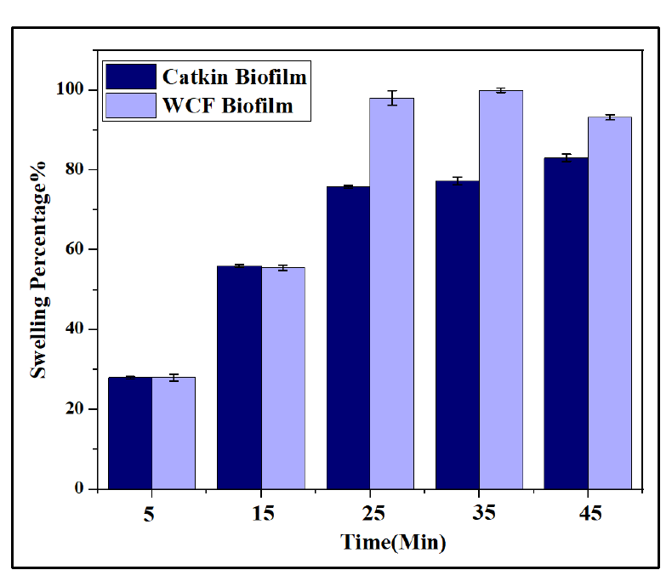
Figure 10: Swelling percentage of Catkin biofilm
Note: Reproduced from the companion WCF/Catkin comparative manuscript's grouped bar chart (dark navy = Catkin, light blue = WCF). A Catkin-only swelling plot should be redrawn from the raw swelling data before submission.
Band Gap
The UV-visible absorption spectra was conducted to understand the electronic structure of the material through the evaluation of its optical band constants. The band gap of the biofilm was calculated by Tauc's relation, which is already given in equation-4 and depicted in Figure 11. From 11, the y-axis was denoted as (αhν)² and hν on the x-axis. The energy band gap values were determined by extrapolation of the straight line of the curves to zero absorption coefficient. Neat PVA has been reported to carry a band gap of 3 eV, and loading the composite with TiO₂ was said to widen it. In our study, the obtained band gap for the biofilm was 4.8 eV. With so wide a band gap, this PVA/TiO₂/CMC film may serve as an anti-reflection coating for solar cells [39] or in food packaging meant to screen UV [90].

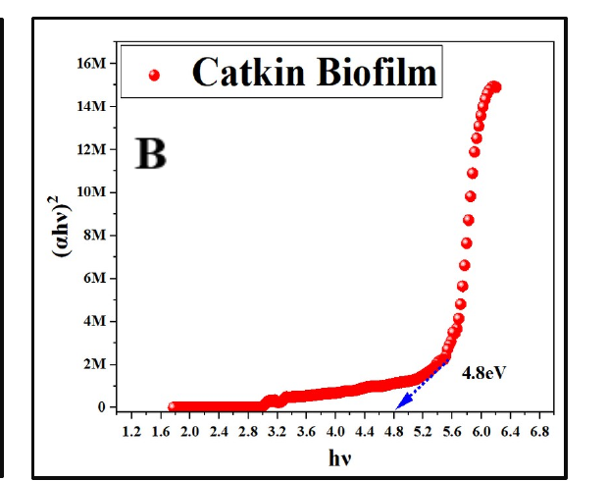
Figure 11: Plot of (αhυ)² versus hυ of Catkin biofilm
Note: Catkin-only panel (originally labelled B) cropped from the companion WCF/Catkin comparative manuscript's Tauc-plot figure.
Calibration Curve
A calibration curve was constructed so that unknown dye concentrations could be read off. Our curve came out with an R² of 0.9938, plotted in Figure 12. Table 2 sets the known concentrations (gm/L) beside the absorbance readings taken at λmax= 520nm.
Table 2: The value of absorbance against concentration found at λmax = 520nm.
Concentration (gm/L) | Absorbance
0.01 | 0.1628
0.02 | 0.2568
0.04 | 0.633
0.06 | 1.0092
0.08 | 1.3653
0.1 | 1.5869

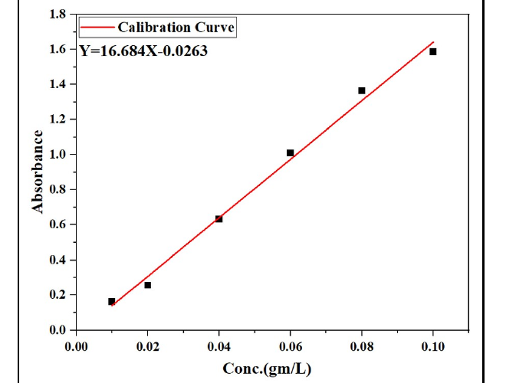
Figure 12: Calibration curves of Absorbance vs. concentration for anionic dye (Avitera light red SE). The regression line was forced through the origin, zero concentration being taken to give zero absorbance. High R2 values confirm the linearity of the dye system
Note: Reproduced from the companion WCF/Catkin comparative manuscript. This calibration curve is shared dye/instrument data (not a WCF-vs-Catkin comparison), so it applies directly to this manuscript.
Adsorption Kinetics Mechanism
The pseudo-first-order model and pseudo-second-order model of dye adsorption for Catkin biofilm were determined by using non-linearized curves, depicted in Figure 13. Table 3 lists the kinetic parameters together with the correlation coefficients (R²) obtained from both models. Figure 13 illustrates the absorbance spectra of the dye solution at different contact times, where the gradual decrease of the absorbance peak at λ_{max}= 520nm confirmed the progressive removal of Avitera Light Red SE by the biofilm. Table 3 lists the kinetic parameters together with the correlation coefficients (R2) obtained from both models.
Table 3 shows PSO fitting the catkin film better than PFO, with qe coming out near the measured value. In addition, the correlation value (R²) for PSO was 0.96577, providing a significantly better fit than the PFO model, which exhibited an R² value of 0.91921. Moreover, the experimental data closely matched with qe= 1.15845 value of PSO model, suggesting the well fit of the experimental data in the PSO model. PFO, by contrast, returned nothing close to the measured figures, so this model is not the suitable one for the present data [35].
Since PSO fits so well, chemisorption must be what mainly drives the uptake [47]. It is the speed at which bonds form on the active sites, and not the diffusion of dye, that sets the uptake rate, which accounts for equilibrium not being attained within 170 minutes. The kinetics thus place the removal of Avitera Light Red SE under the control of the active functional groups of the film, namely the PVA hydroxyls, the carboxylate of citric acid, and the TiO₂ surface sites [47,48].

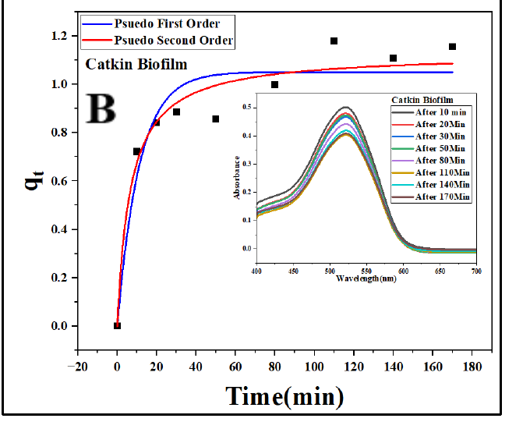
Figure 13: The non-linear curve of PFO and PSO kinetics of adsorption of Catkin biofilm.
Note: Catkin-only panel (originally labelled B) cropped from the companion WCF/Catkin comparative manuscript's kinetics-curve figure.
Table 3: The kinetic model parameters for Catkin biofilm.
Kinetics Model (Catkin Biofilm) | Parameters | Values
Pseudo First Order (PFO) | q_{e} | 1.05503
Pseudo First Order (PFO) | K₁ | 0.08638
Pseudo First Order (PFO) | R² | 0.91921
Pseudo Second Order (PSO) | q_{e} | 1.15845
Pseudo Second Order (PSO) | K₂ | 0.10934
Pseudo Second Order (PSO) | R² | 0.96577
Adsorption Isotherm
The adsorption equilibrium data for the Catkin biofilm were analyzed by using two different isotherm model: Langmuir Isotherm and Freundlich Isotherm, depicted in Figure 14. In Figure 14, linear plot of Langmuir model (C_{e}/q_{e} vs C_{e}) and the linear plot of Freundlich (ln(q_{e}) vs ln(C_{e}))- A and B indicated the Langmuir Curve for Catkin biofilm and Freundlich Curve for Catkin biofilm respectively. KL and q_{max} were obtained from the slope and the intercept of the straight-line Langmuir plot. In the same way the intercept and slope of the linear Freundlich plot gave k_{f} together with n, the intensity of adsorption. All these values are presented in Table 4.
Langmuir fitted the biofilm data poorly, as its correlation coefficient stayed comparatively low (R²=0.92461 for Catkin biofilm), as shown in Figure 14(A). KL and q_{max} moreover came out negative, which rules the model out for the present data.
Freundlich, on the other hand, followed the measured points closely and returned R²=0.9966 for the Catkin biofilm, as Figure 14(B) shows. Uptake therefore appears to take place over a heterogeneous surface carrying several kinds of active site spread unevenly [41]. Both k_{f} stayed low, most likely because the starting dye concentration was small and few active sites were thereby engaged, whereas n (1.182) exceeded unity, indicating that adsorption intensity increased more steeply than linearly with the equilibrium concentration over the tested range. On the whole, our data sit comfortably on the Freundlich isotherm [45,46].

Table 4: Isotherm model parameter values of Catkin biofilm.
Isotherm Model (Catkin Biofilm) | Parameters | Values
Langmuir Isotherm | q_{max} (mg/gm) | -7.63
Langmuir Isotherm | K_{L} | -0.00705
Langmuir Isotherm | R² | 0.92416
Freundlich Isotherm | n | 1.182
Freundlich Isotherm | K_{f} | 0.0368
Freundlich Isotherm | R² | 0.9966

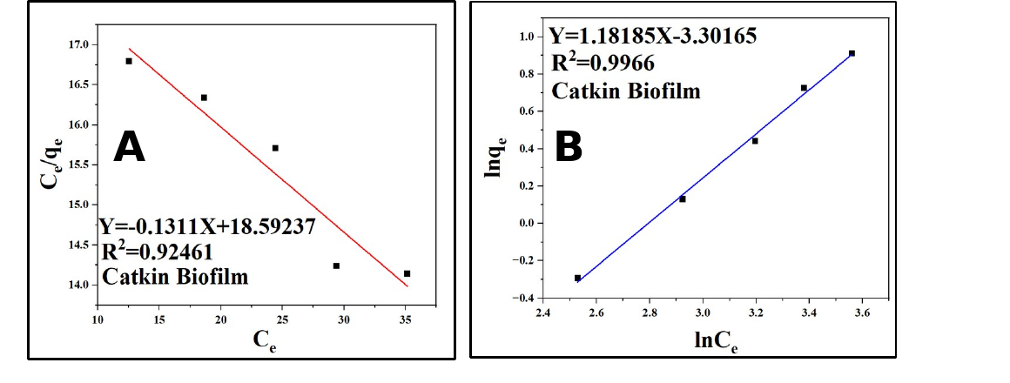
Figure 14: Isotherm model for Avitera light red se adsorption by (A) Catkin biofilm (Langmuir model) (B) Catkin biofilm (Freundlich model).
Note: Catkin-only panels (originally labelled C, D) cropped from the companion WCF/Catkin comparative manuscript's isotherm figure and relabelled A, B to match this caption.
Effect of contact time and initial dye concentration on dye removal
Uptake of the dye by the Catkin biofilm was examined against contact time and against the starting dye concentration. Figure 15 (A) and (B) illustrate the effect of contact time and concentration of dye for dyes removal from the solution. Contact time matters in any adsorption study, because it tells you how much chance the film surface and the dye particles have had to interact. In this study, the highest dye was adsorbed at 110min by catkin biofilm, which was almost 55%, as shown in Figure 15(A). Though the highest adsorption occurred at 110min, the equilibrium phase was determined approximately 170min, where dye removal was almost 53%. However, without this change in dye adsorption, catkin biofilm showed gradual and better performance in dye removal, as shown in Figure 15 (A). Our test ran at only 40ppm, yet the film still did well against what had been reported earlier [91].
Starting dye concentration mattered too, and this comes out in Figure 15(B). Figure 15(B) illustrates the removal% of Avitera light red SE dye from a 50 mL solution by 0.5 of the prepared sample at 170 min, which was assumed as the equilibrium for each dye solution. The more concentrated the dye, the more of it was taken out. At 20 ppm, the Catkin biofilm removed 37% of the dye from the solution. The response stayed steady, so nearly 40% of the dye may be taken up by 0.5 gm of the catkin film. The trend further implies that raising the dye concentration would have pushed the removal percentage higher.

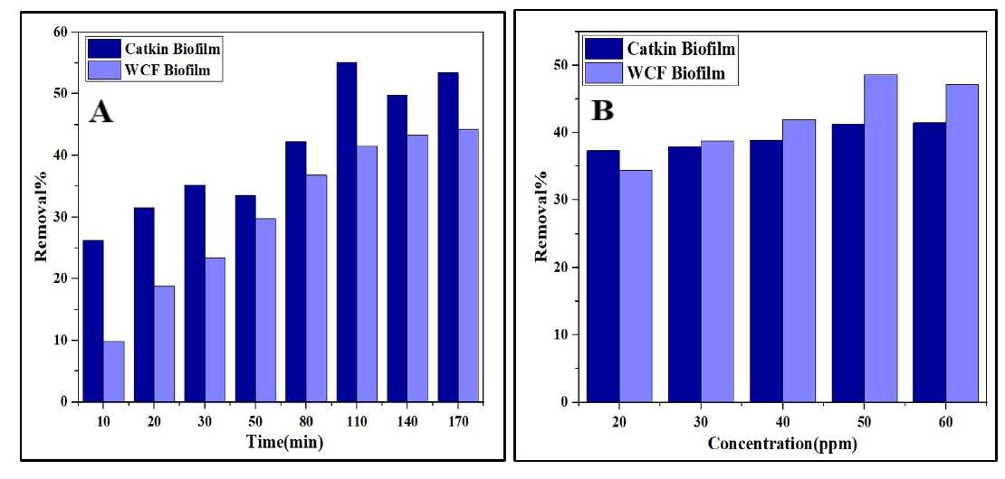
Figure 15: The effect of (A) Contact time and (B) Initial dye concentration on removal% of dye by Catkin biofilm.
Note: Reproduced from the companion WCF/Catkin comparative manuscript's grouped bar charts (dark navy = Catkin, light blue = WCF). Catkin-only removal% plots should be redrawn from the raw removal-percentage data before submission.
Film appearance
Colour measurement was taken up to record the original shade of the biofilm and to follow how its colour attributes moved after the dye had been adsorbed, as given in Figure 16. It also served as a check on whether the dye had really been taken up, since that is what turns the film a different colour. The analyzed information is given in Table 5. The initial biofilm was nearly white, as the L* value was found to be 78.38. Similarly, the value of a* was 0.17, and the b* value was 7.59, indicating the slight yellow tint of the biofilm. After dye adsorption, the sample changed its L*, a*, b* values. The value of L* dropped to 39.23. This change indicated that the film adsorbed red color. Likewise, the Catkin biofilm became orange red as the a* and b* values were found to be 21.21 and 15.73. The hue angle h* was found to be 36.56, which also confirmed the color was changed to reddish orange. Moreover, the value of c* indicated that the intensity was 26.4. In short, a pale film came out coloured once it had been treated, which shows the dye does stick to it.
Table 5: Color parameters and appearance of a) Catkin biofilm (before treatment) b) Catkin biofilm (after treatment)
Sample | L* | a* | b* | c* | h* | Appearance
(a) Catkin Biofilm | 78.38 | 0.17 | 7.59 | 7.59 | 88.69 | 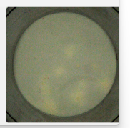
(b) Catkin Biofilm After Dye adsorption | 39.23 | 21.21 | 15.73 | 26.4 | 36.56 | 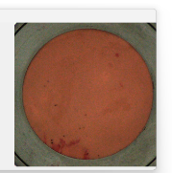

Figure 16: Color properties of the samples a) Catkin biofilm (before treated) b) Catkin biofilm (after treated)
Dye Recovery and Reuse
Since the reuse of biofilms is quite familiar by using TiO_{2,} which helps in photocatalytic activity to regain the biofilm as before. Hence, no such application was seen to recover the dye from these types of composites. This study explored an alternate way to recover the dye from the treated biofilm and discussed some potential applications of this recovered dye. Figure 17(A) illustrated a simple heating process to recover the dye and reuse the biofilm. In elaboration, the treated biofilm was placed in 100 mL of water. Afterwards, the biofilm with water was heated at 80°C with slow stirring. This slow stirring was maintained carefully as high stirring may tear the composite which may decrease the chance to recover the biofilm. The heating was continued until the biofilm appeared as white in color and the color change was observed. After that, the biofilm was separated from the dye solution and placed on the same glass plate in room temperature. After one day of drying in room temperature, the biofilm was obtained. Subsequently, the dye solution was recovered and could be used in various applications such as textile printing, low-cost fabric dyeing, non-aesthetic material dyeing, etc. Fig. 17 (A) illustrates the treated biofilm(a), after the heating process, the obtained biofilm without dye(b), and the reused biofilm in dye solution(c). To understand the reusability of the biofilm, it was soaked in 100ppm of dye solution. After one day, the color change was observed, as shown in Fig. 17 (c), confirming the composite can adsorb the color as well as it can be reused. The schematic diagram of this heating process is shown in Fig. 17(B)
The dye recovery process and reuse process emphasize a sustainable model for the textile industry, which may reduce the dye effluent and control water pollution. Additionally, the biofilm was biodegradable in nature and can easily be disposed of after its use. Correspondingly, using this biofilm for dye adsorption creates a circular approach within a textile factory [72]. (Fig. 17 (C))
While this study demonstrates the reuse and recovery of the dye, there are some drawbacks as well. For instance, the potential application of recovered dye should be examined. As it was unknown how much dye was recovered, it may create a problem in recipe preparation for dyeing. Further research should be conducted on recovered biofilm and how many cycles it can be used should be studied. A column study can be carried out to evaluate the performance of biofilm under continuous flow conditions, which may bridge the gap between laboratory research and industry-scale applications [72].
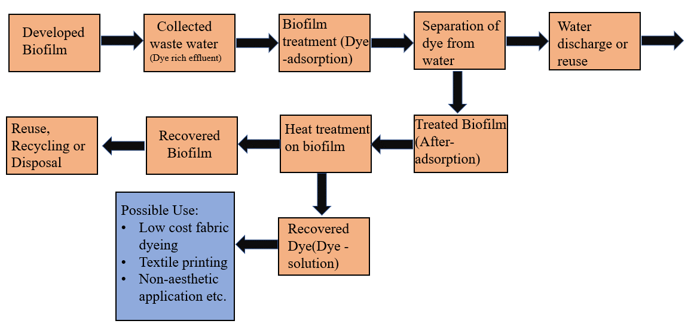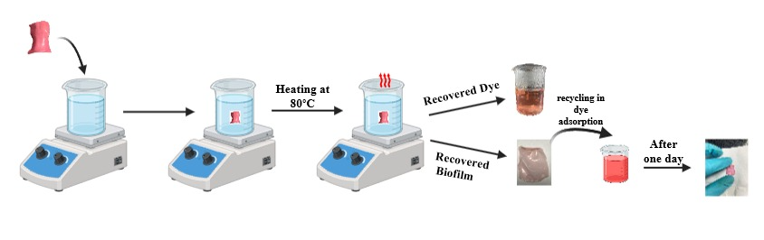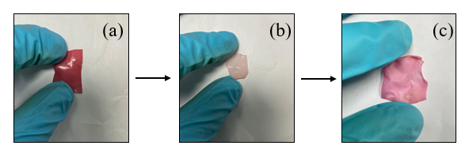
Figure 17: (A) The recycling process biofilm (a) Treated (b) Heating process applied and remove the color (c) Re-treated; (B) Schematic diagram of heating process; (C) Process flow diagram for dye recovery and reuse of biofilm.
Machine Learning-Based Prediction of Untested Conditions (PINN3D)
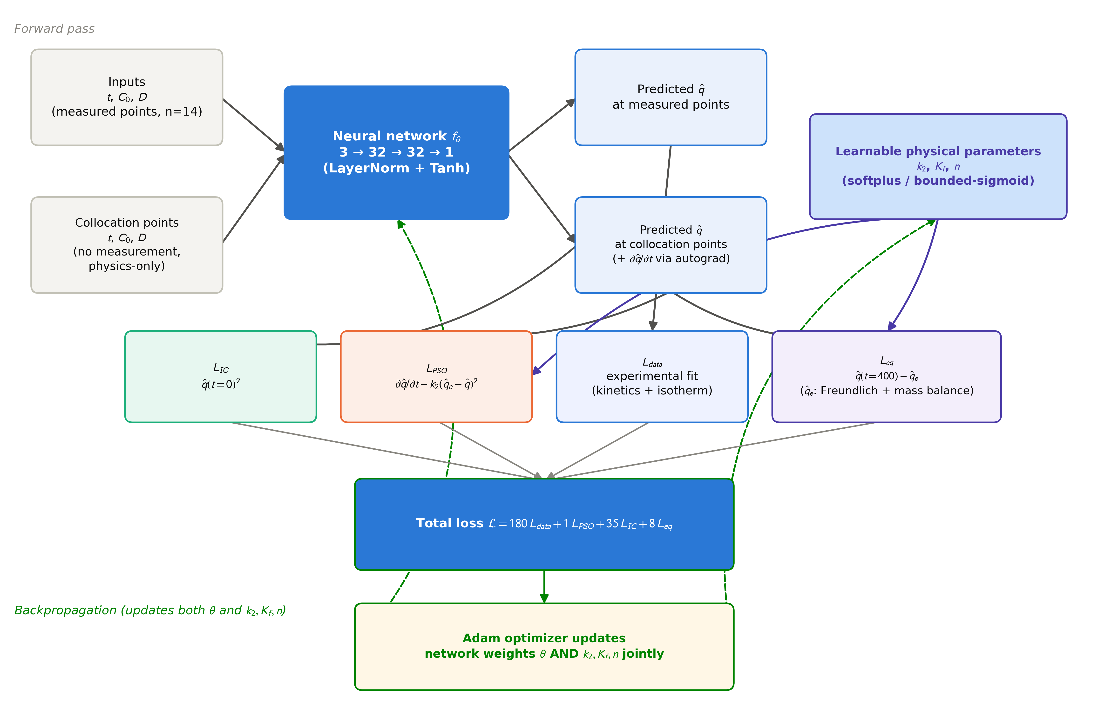
Figure 18: PINN3D architecture and information flow. Measured points and physics-only collocation points are passed through the shared network f_theta; the collocation-point output and its automatic-differentiation time derivative feed the PSO, initial-condition and equilibrium losses alongside the learnable physical parameters (k2, Kf, n), which are reparameterized via softplus/bounded-sigmoid; all four losses are combined into the total weighted loss and backpropagated (dashed green) to update both the network weights and the physical parameters jointly.

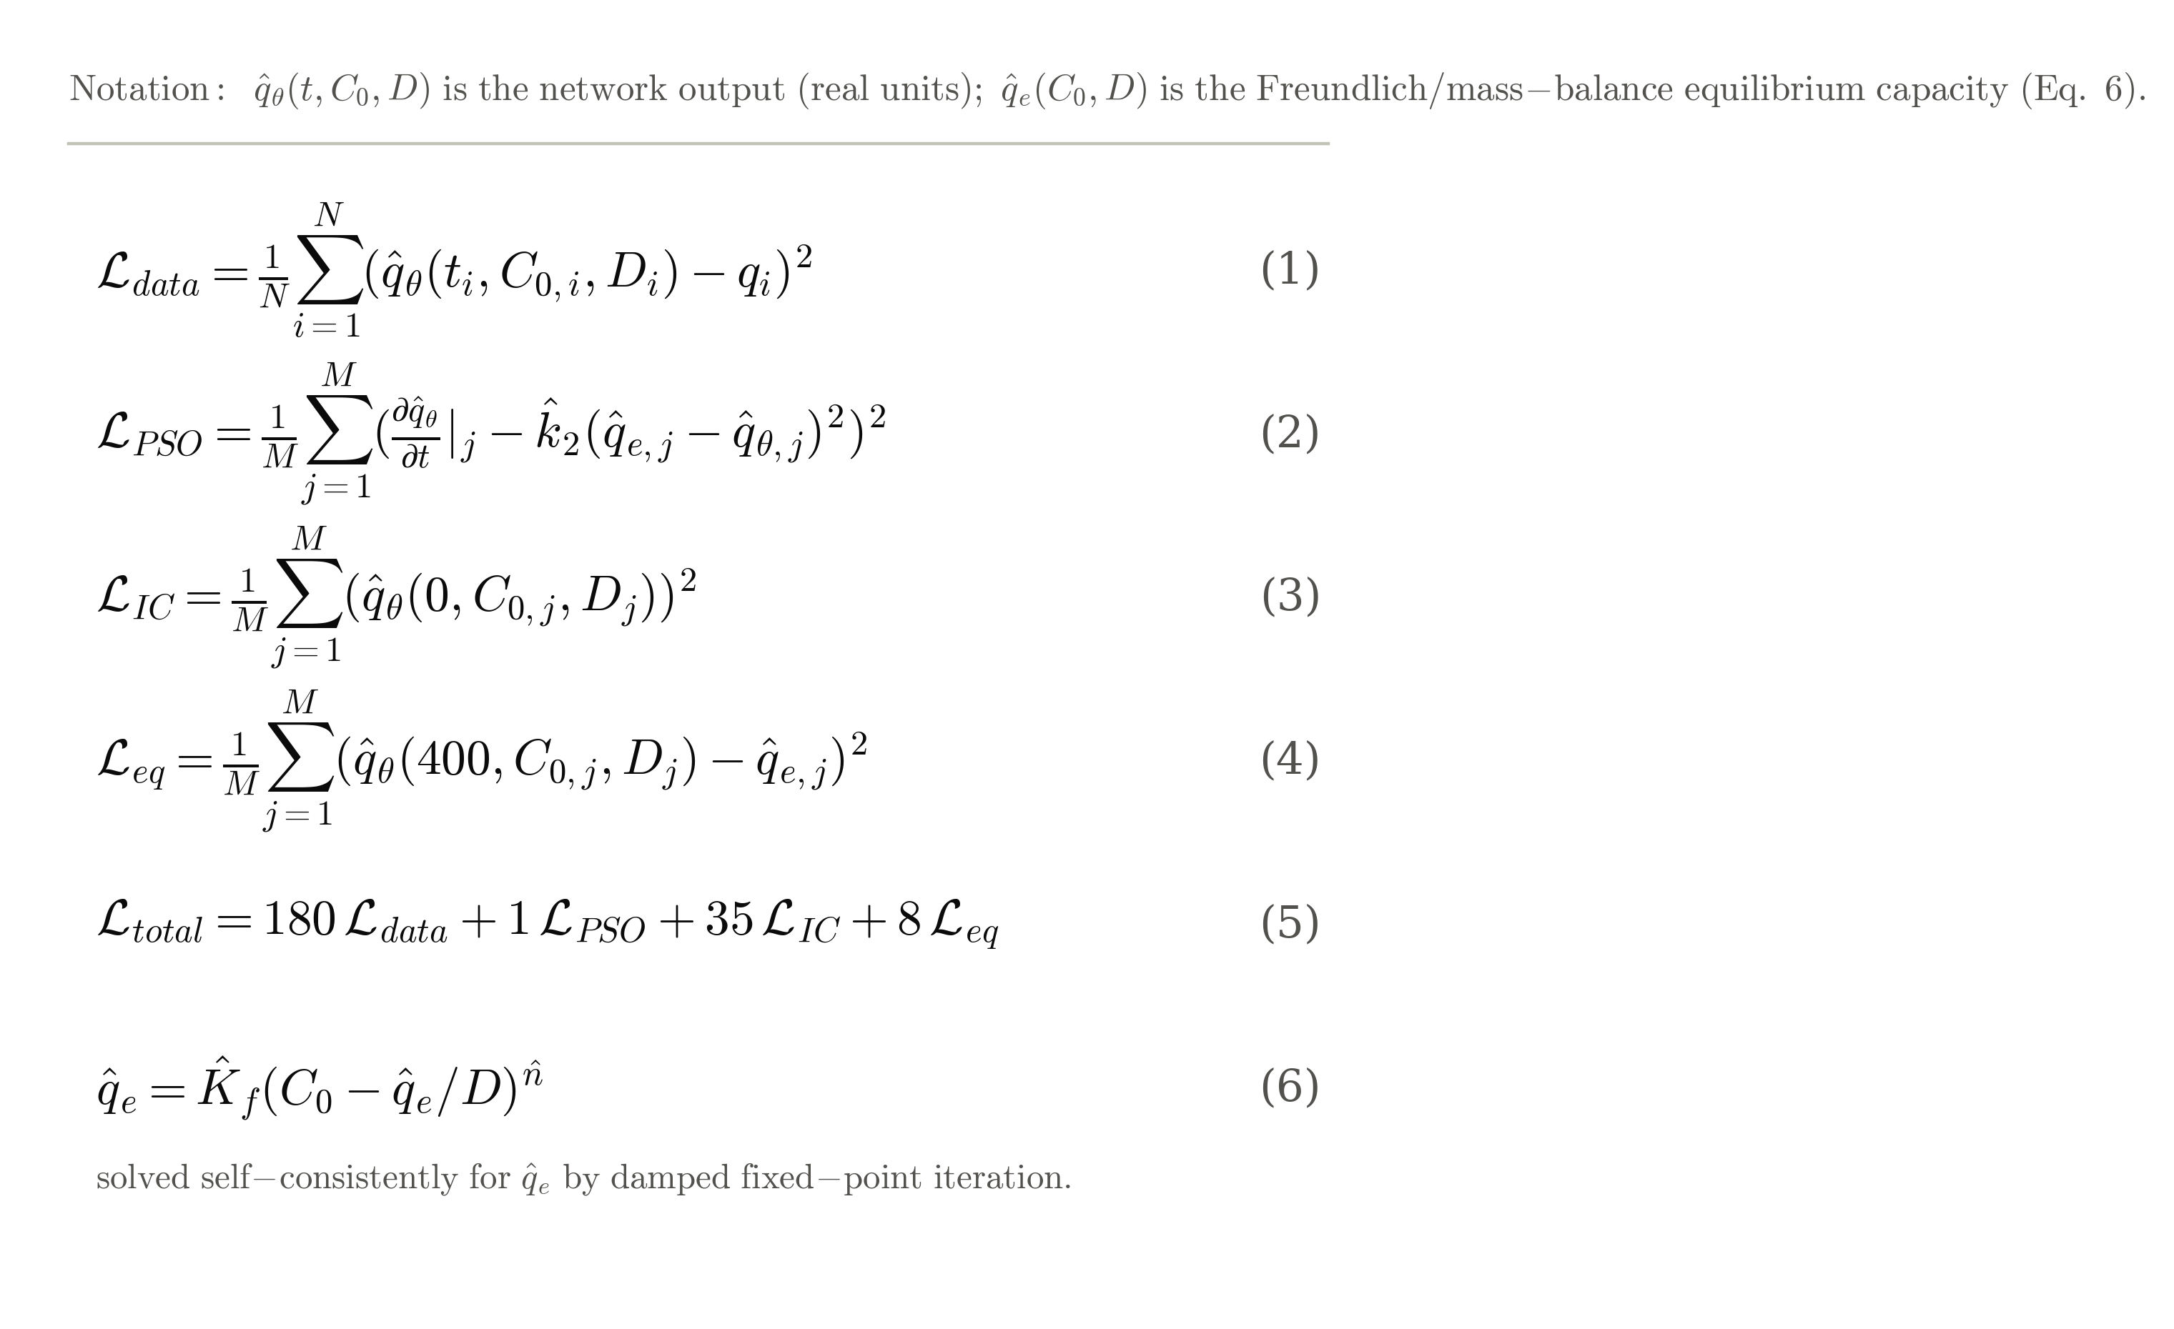
Equations 1-6: PINN3D loss formulation (referenced from the Methods section above). Eqs. 1-4 define the four loss terms; Eq. 5 the combined weighted objective; Eq. 6 the Freundlich/mass-balance equilibrium closure solved at every collocation point.

The trained PINN3D ensemble reproduced the experimental kinetics and isotherm data closely: R² = 0.99995 (RMSE = 0.0024 mg/g) on the kinetics subset and R² = 0.99999 (RMSE = 0.0022 mg/g) on the isotherm subset (Figures 19 and 20), against R² = 0.966 for the classical PSO fit and R² = 0.997 for the classical Freundlich fit obtained by log-log linearization (Table 6). The physically-constrained parameters recovered by the ensemble (K2 = 0.00175 ± 0.00008; Kf = 0.296 ± 0.023; n = 0.979 ± 0.033, mean ± SD across the four seeds) differ substantially in magnitude from the classical values fitted independently. This difference is expected: the PINN3D parameters must satisfy the kinetics and isotherm equations at the same time, through one shared mass-balance relation, while the classical PSO and Freundlich fits come from two separate, unconstrained regressions that are never required to agree with each other. The much tighter in-sample fit of PINN3D also reflects that it simply has far more free parameters than the two-parameter classical models, so Table 6 is best read as a consistency check rather than as proof of better generalization. It is reported on an in-sample basis because that is the same comparison conventionally used for PINN-based adsorption models in the recent literature.
The main reason for building PINN3D was to estimate adsorption performance under combinations of contact time, initial concentration and adsorbent dosage that were never directly measured. The kinetics and isotherm experiments were each run at a single fixed dosage, and dosage itself was tested at only two mass:volume ratios (1/24 and 0.10). Figure 21 therefore presents the ensemble's predictions in two parts. The left and centre panels show time-resolved concentration maps at the two dosages that were actually measured, across the full 0-200 min experimental time range. The right panel shows the predicted equilibrium adsorption capacity across the whole tested dosage range (0.03-0.12) at the t = 400 min contact time used to anchor the equilibrium loss term. This is the only region of the dosage axis where the model's behaviour is directly constrained by the governing equations rather than by the network's unconstrained interpolation. A systematic scan of the ensemble's dosage response away from this anchor showed that the physically required monotonicity of adsorption capacity with dosage (capacity cannot fall as more adsorbent is added at a fixed dye load) held reliably only within roughly 20 minutes of the t = 400 min anchor. Predicted dosage effects at earlier, experimentally covered contact times (0-170 min) were not reliably monotonic, so they are not reported here as a dosage-extrapolation result. We state this openly as a present limitation of the single-anchor equilibrium constraint used in this work, since it directly affects how far the model's dosage predictions can be trusted.
The ensemble standard deviation, used as a proxy for epistemic uncertainty, stayed low (0.002-0.004 mg/g) at and near the experimentally measured concentrations and contact times, then rose sharply with distance from them, reaching 0.070 mg/g at the concentration extrapolation limit of 65 ppm and 0.038 mg/g at the t = 400 min equilibrium anchor (Figure 22). This shows that the ensemble's confidence tracks its actual distance from the training data in a physically sensible way. At the t = 400 min anchor, predicted removal efficiency (the percentage of dye removed per unit adsorbent) fell monotonically as dosage increased, at all three initial concentrations tested (20, 40 and 60 ppm), while the absolute adsorption capacity rose roughly linearly with dosage over the tested range (Figure 23), with no interior diminishing-returns elbow. We also found a boundary artefact, reported here for transparency: at the lowest tested dosage (0.03), predicted removal efficiency exceeded 100% by up to about 8% at the higher initial concentrations, a physically impossible result caused by the model extrapolating at the extreme edge of its collocation grid. This artefact is confined to a narrow region near the dosage lower bound and does not affect the qualitative trends described above.

Model Comparison (Catkin Biofilm) | Parameters | Values
Pseudo Second Order (PSO) – Classical | qe | 1.15845
Pseudo Second Order (PSO) – Classical | K2 | 0.10934
Pseudo Second Order (PSO) – Classical | R² | 0.96577
PINN3D (Kinetics) | K2 | 0.00175 ± 0.00008
PINN3D (Kinetics) | R² (in-sample) | 0.99995
Freundlich Isotherm – Classical (log-log) | n | 1.18186
Freundlich Isotherm – Classical (log-log) | Kf | 0.03682
Freundlich Isotherm – Classical (log-log) | R² | 0.99660
PINN3D (Isotherm) | Kf | 0.29600 ± 0.02274
PINN3D (Isotherm) | n | 0.97870 ± 0.03294
PINN3D (Isotherm) | R² (in-sample) | 0.99999

Table 6: Classical kinetic/isotherm parameters compared with PINN3D ensemble parameters (mean ± SD across 4 seeds) for Catkin biofilm.

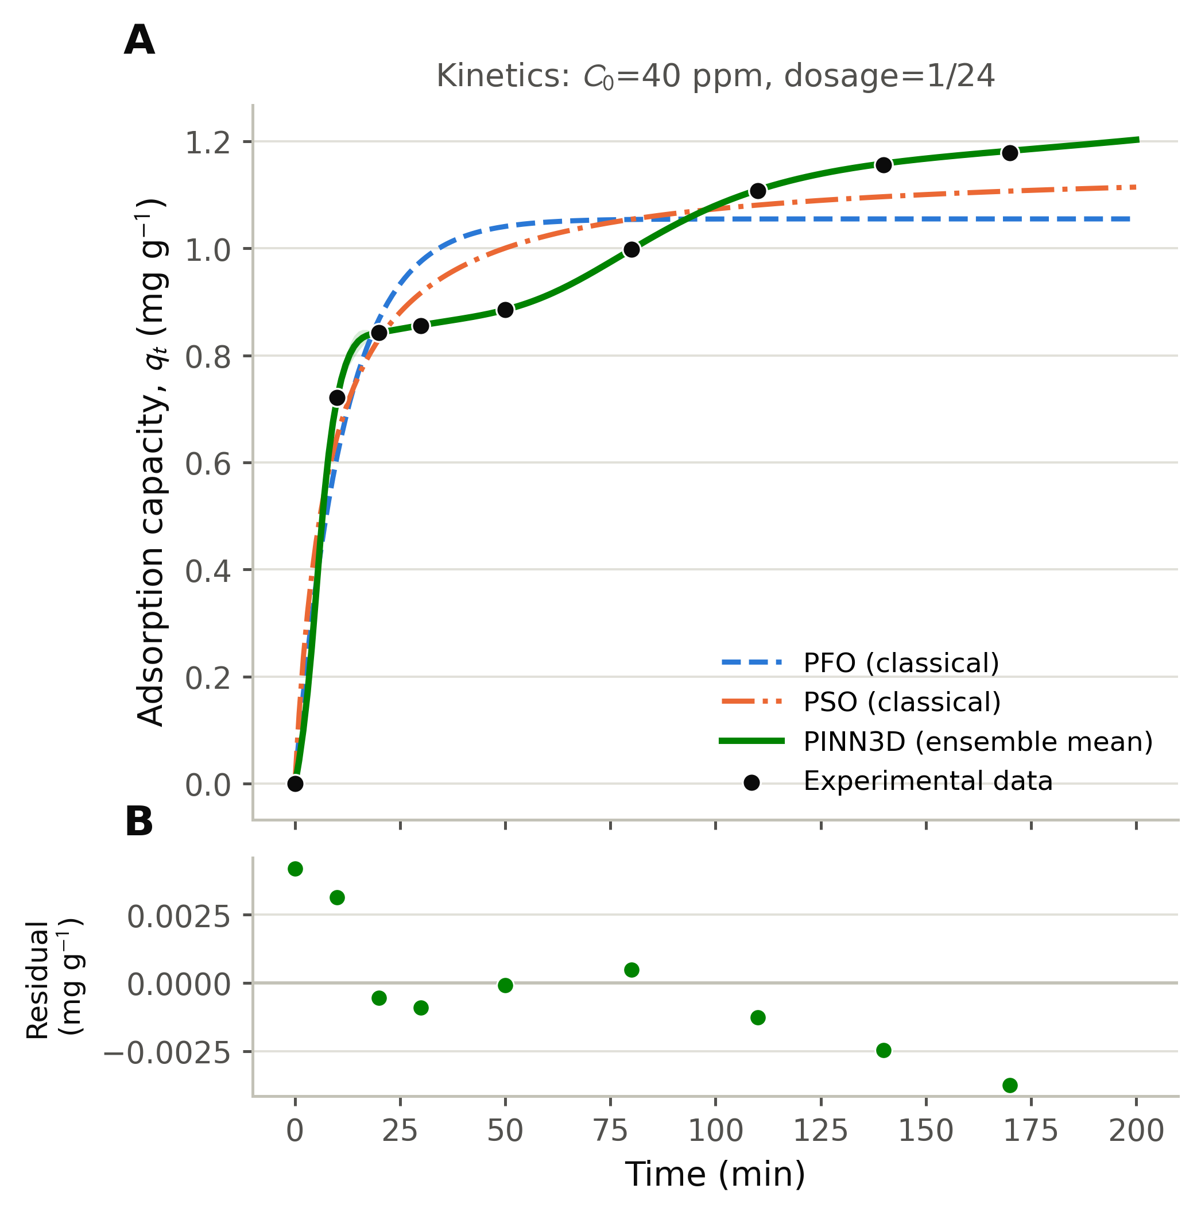
Figure 19: PINN3D ensemble fit to the kinetics data (Concentration=40 ppm, Dosage=1/24), compared with the classical PFO and PSO fits, with residuals.

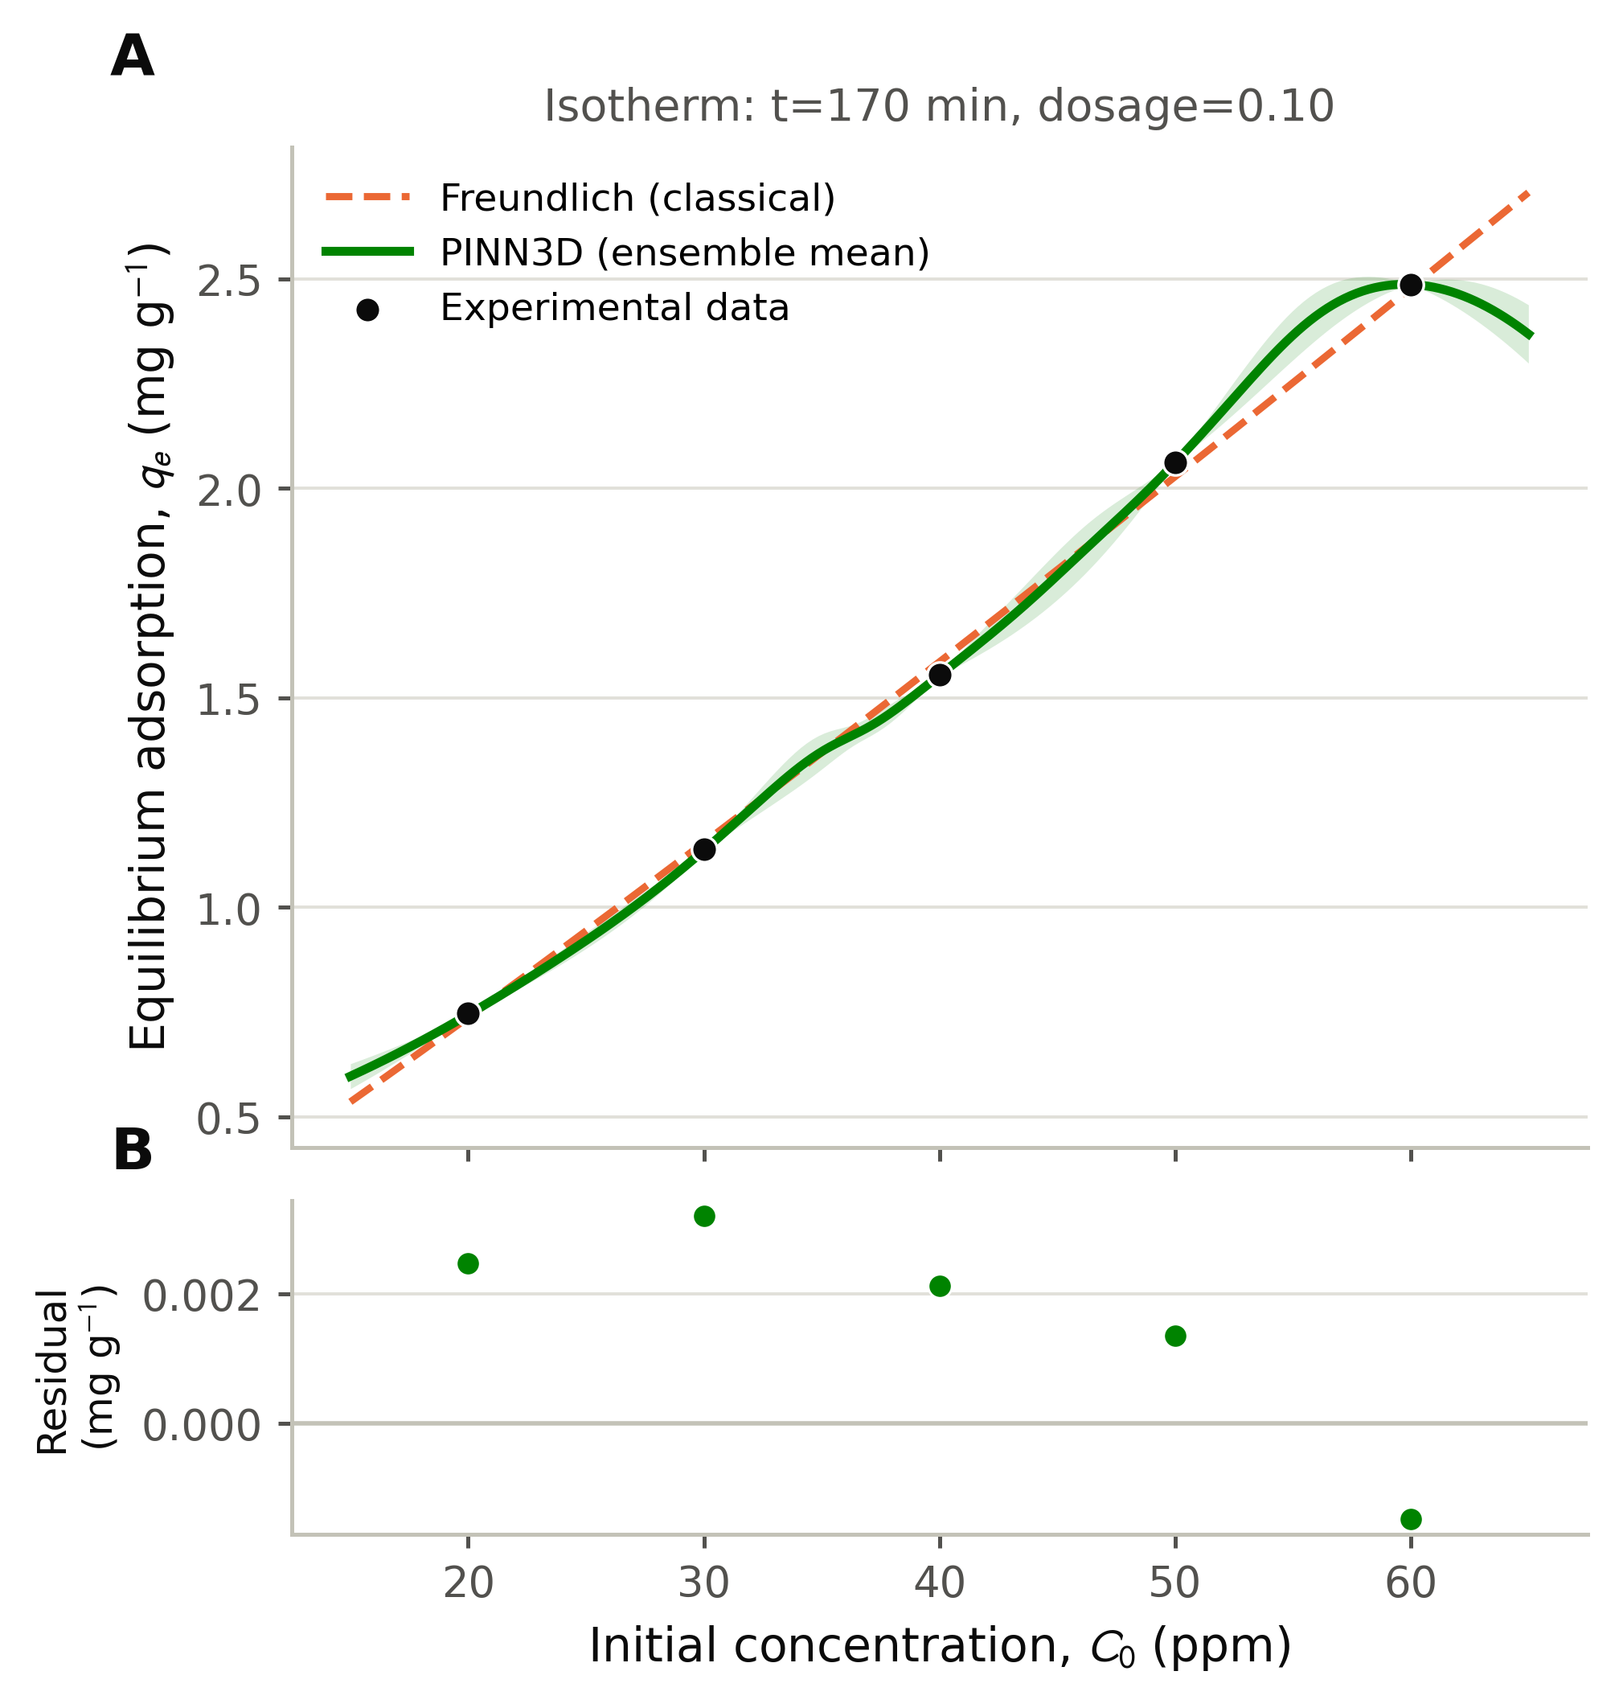
Figure 20: PINN3D ensemble fit to the isotherm data (Time=170 min, Dosage=0.10), compared with the classical Freundlich fit (mass-balance Ce), with residuals.

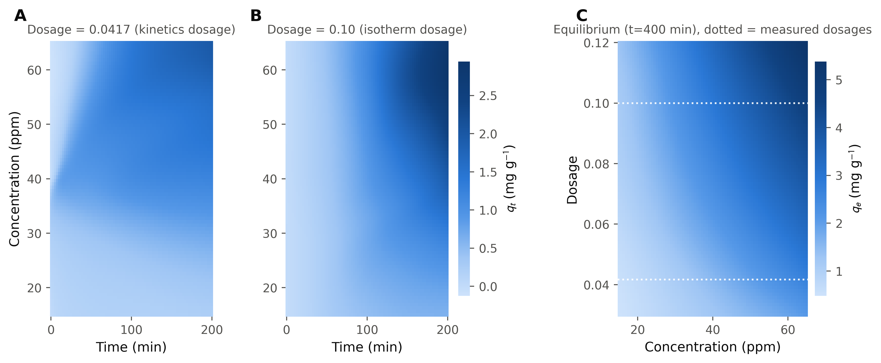
Figure 21: PINN3D ensemble predictions across untested conditions. Left and centre: Time × Concentration maps at the two measured dosages (1/24, 0.10). Right: predicted equilibrium capacity across the full tested dosage range (0.03–0.12) at the t=400 min anchor; dotted lines mark the two measured dosages.

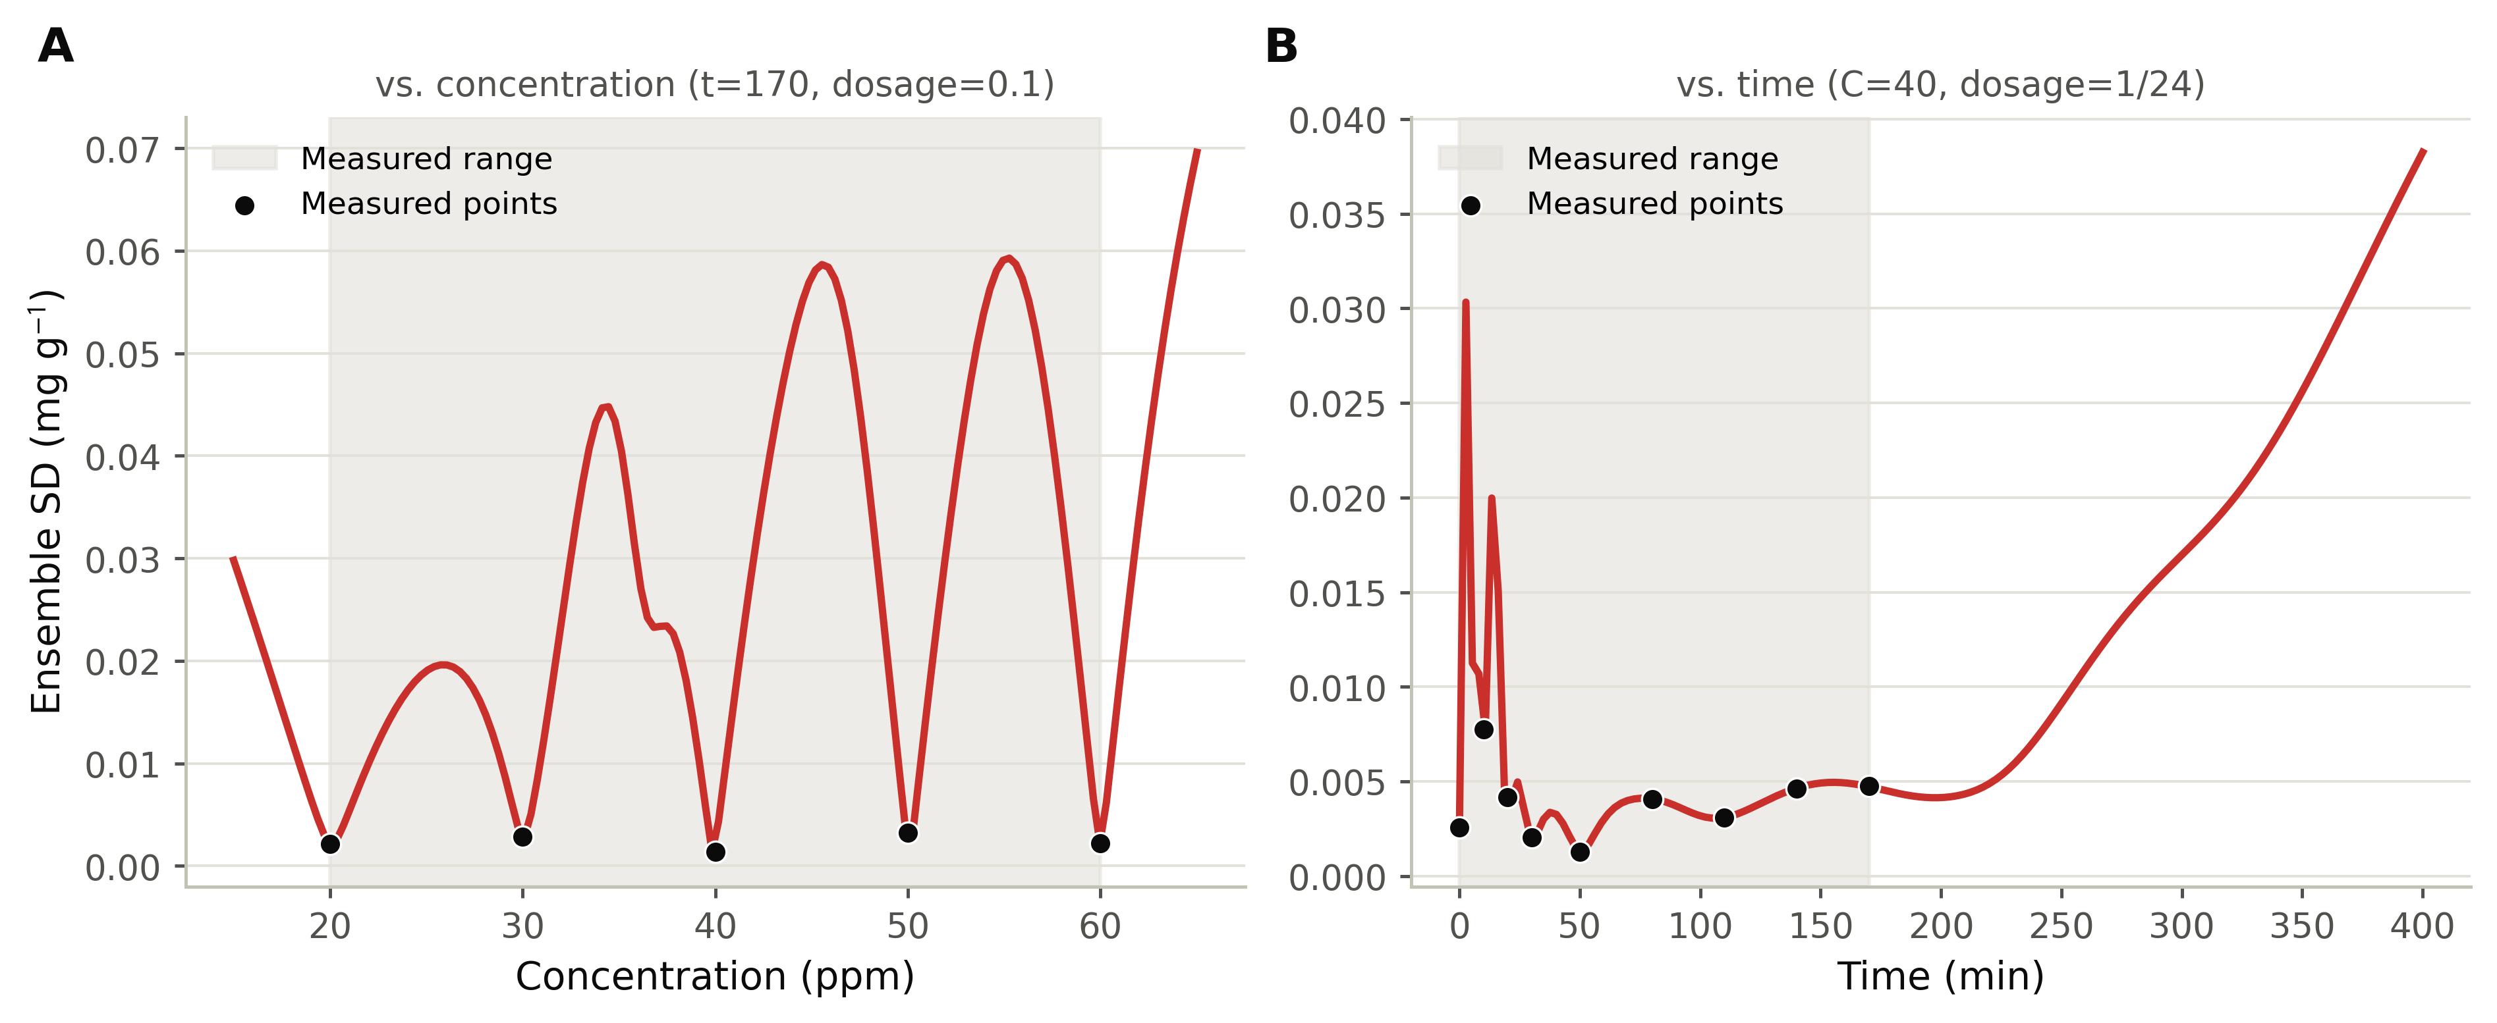
Figure 22: PINN3D four-seed ensemble standard deviation (epistemic uncertainty proxy) as a function of concentration and contact time, showing low uncertainty near measured points and growth with extrapolation distance.

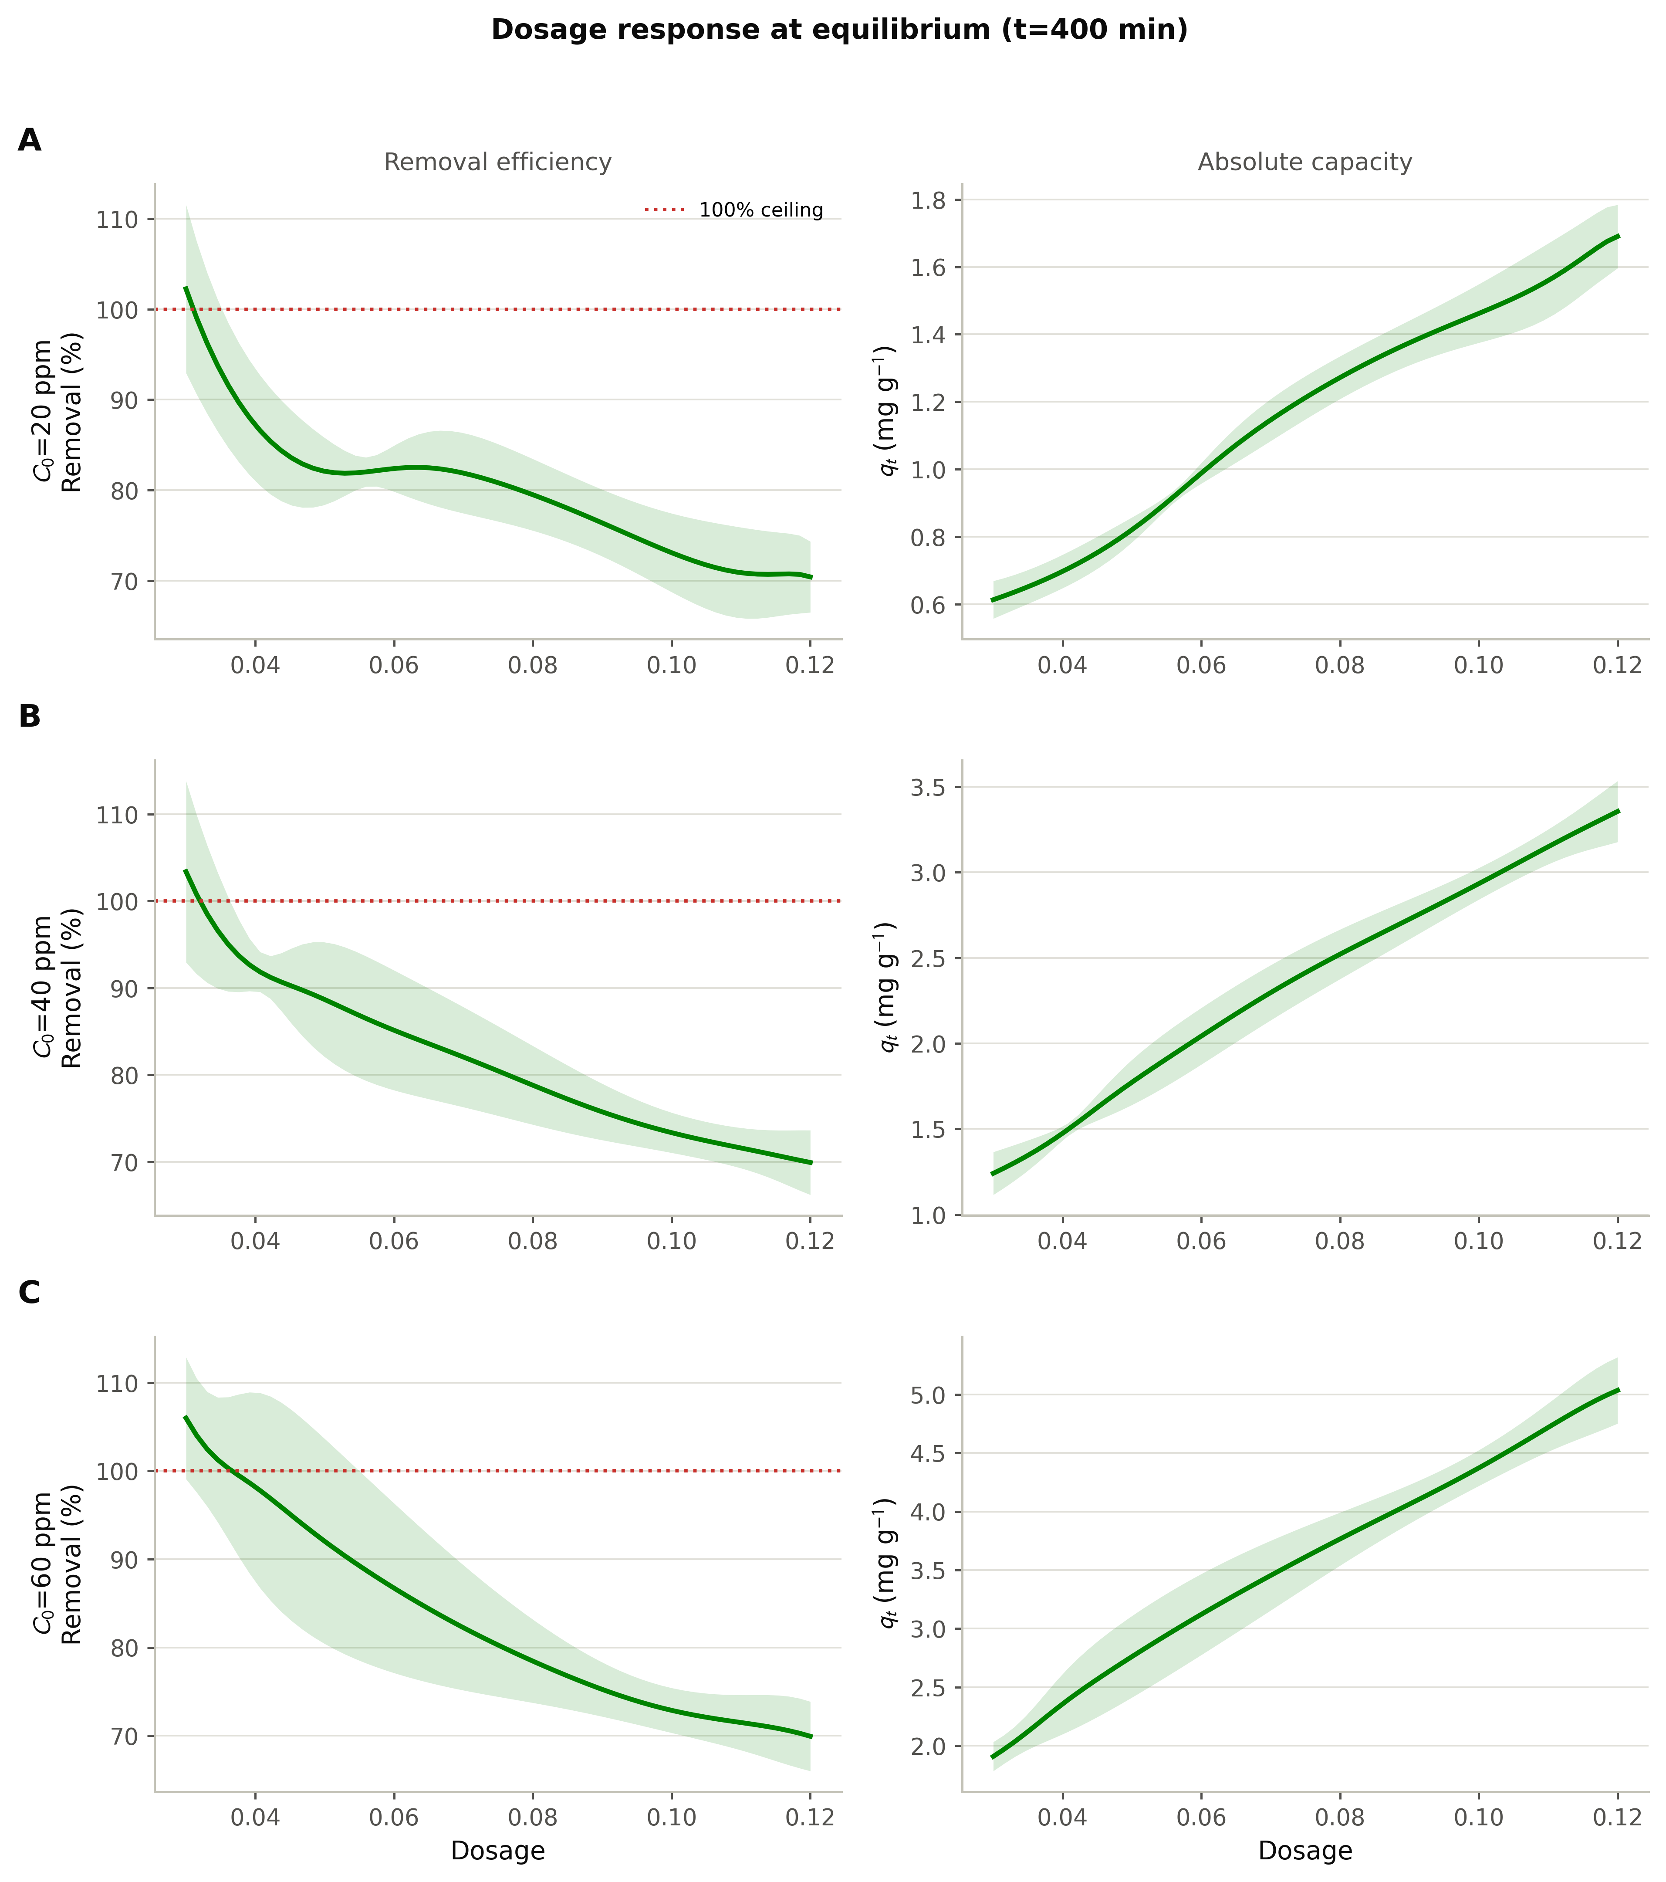
Figure 23: Predicted removal efficiency (%) and absolute adsorption capacity (qt) versus adsorbent dosage at C0 = 20, 40 and 60 ppm (t=400 min anchor). The dotted line in the removal-efficiency panels marks the 100% physical ceiling; values above it near dosage=0.03 are a boundary-extrapolation artefact (see text).

To get a genuine held-out estimate of generalization, rather than relying on the in-sample fit reported above, the same PINN3D model was evaluated by leave-one-out cross-validation (LOO-CV) across all 14 experimental points (9 kinetics, 5 isotherm). For each fold, a single-seed model was retrained from scratch, with the input/output standardization refit on the remaining points each time to avoid leakage. Each fold used a reduced schedule of 4000 epochs, half of the 8000 used for the final reported ensemble, to keep the computation manageable; the physics-only constraints (the collocation grid, the initial condition, and the t = 400 min equilibrium anchor) were kept unchanged across folds, since they do not depend on which experimental point is withheld. Table 7 and Figure 24 report the results. Held-out performance was markedly weaker than the in-sample fit above, which is expected for a 14-point dataset and a model with far more free parameters than data points: overall LOO R² = 0.538 (MAE = 0.214 mg/g, RMSE = 0.395 mg/g, n = 14). The kinetics arm generalized reasonably well (LOO R² = 0.739, MAE = 0.083 mg/g, n = 9). Its largest error occurred at the t = 0 point, predicted at 0.484 mg/g against an actual value of 0 mg/g, even though the initial condition is separately enforced by the initial-condition loss term in every fold. This shows that the constraint alone does not fully anchor the network once the earliest measured point is itself withheld. The isotherm arm generalized poorly (LOO R² = 0.014, MAE = 0.450 mg/g, n = 5). Removing the highest tested concentration (60 ppm) left that fold without the isotherm's high-concentration anchor, and the retrained model underestimated the point by 49% (1.264 mg/g predicted against 2.485 mg/g measured), while the next-highest point (50 ppm) was over-predicted when it was held out instead. This matches the known instability of LOO-CV on very small samples, an effect the companion WCF study on this same class of biofilm also reported, most strongly on its own five-point isotherm arm [94]. It suggests that PINN3D's isotherm-arm predictions, and any dosage- or concentration-dependent extrapolation built on them, should be treated with caution until the experimental isotherm dataset is expanded beyond five points. This cross-validated estimate, not the in-sample fit reported above, is the number that should be cited as evidence of the model's predictive reliability.

PINN3D LOO-CV Performance (Catkin Biofilm) | n | LOO R² | MAE (mg/g) | RMSE (mg/g)
Kinetics arm | 9 | 0.7388 | 0.0829 | 0.1728
Isotherm arm | 5 | 0.0142 | 0.4497 | 0.6186
Combined | 14 | 0.5375 | 0.2139 | 0.3948

Table 7: PINN3D leave-one-out cross-validation performance (single seed, 4000 epochs per fold, standardization refit per fold).

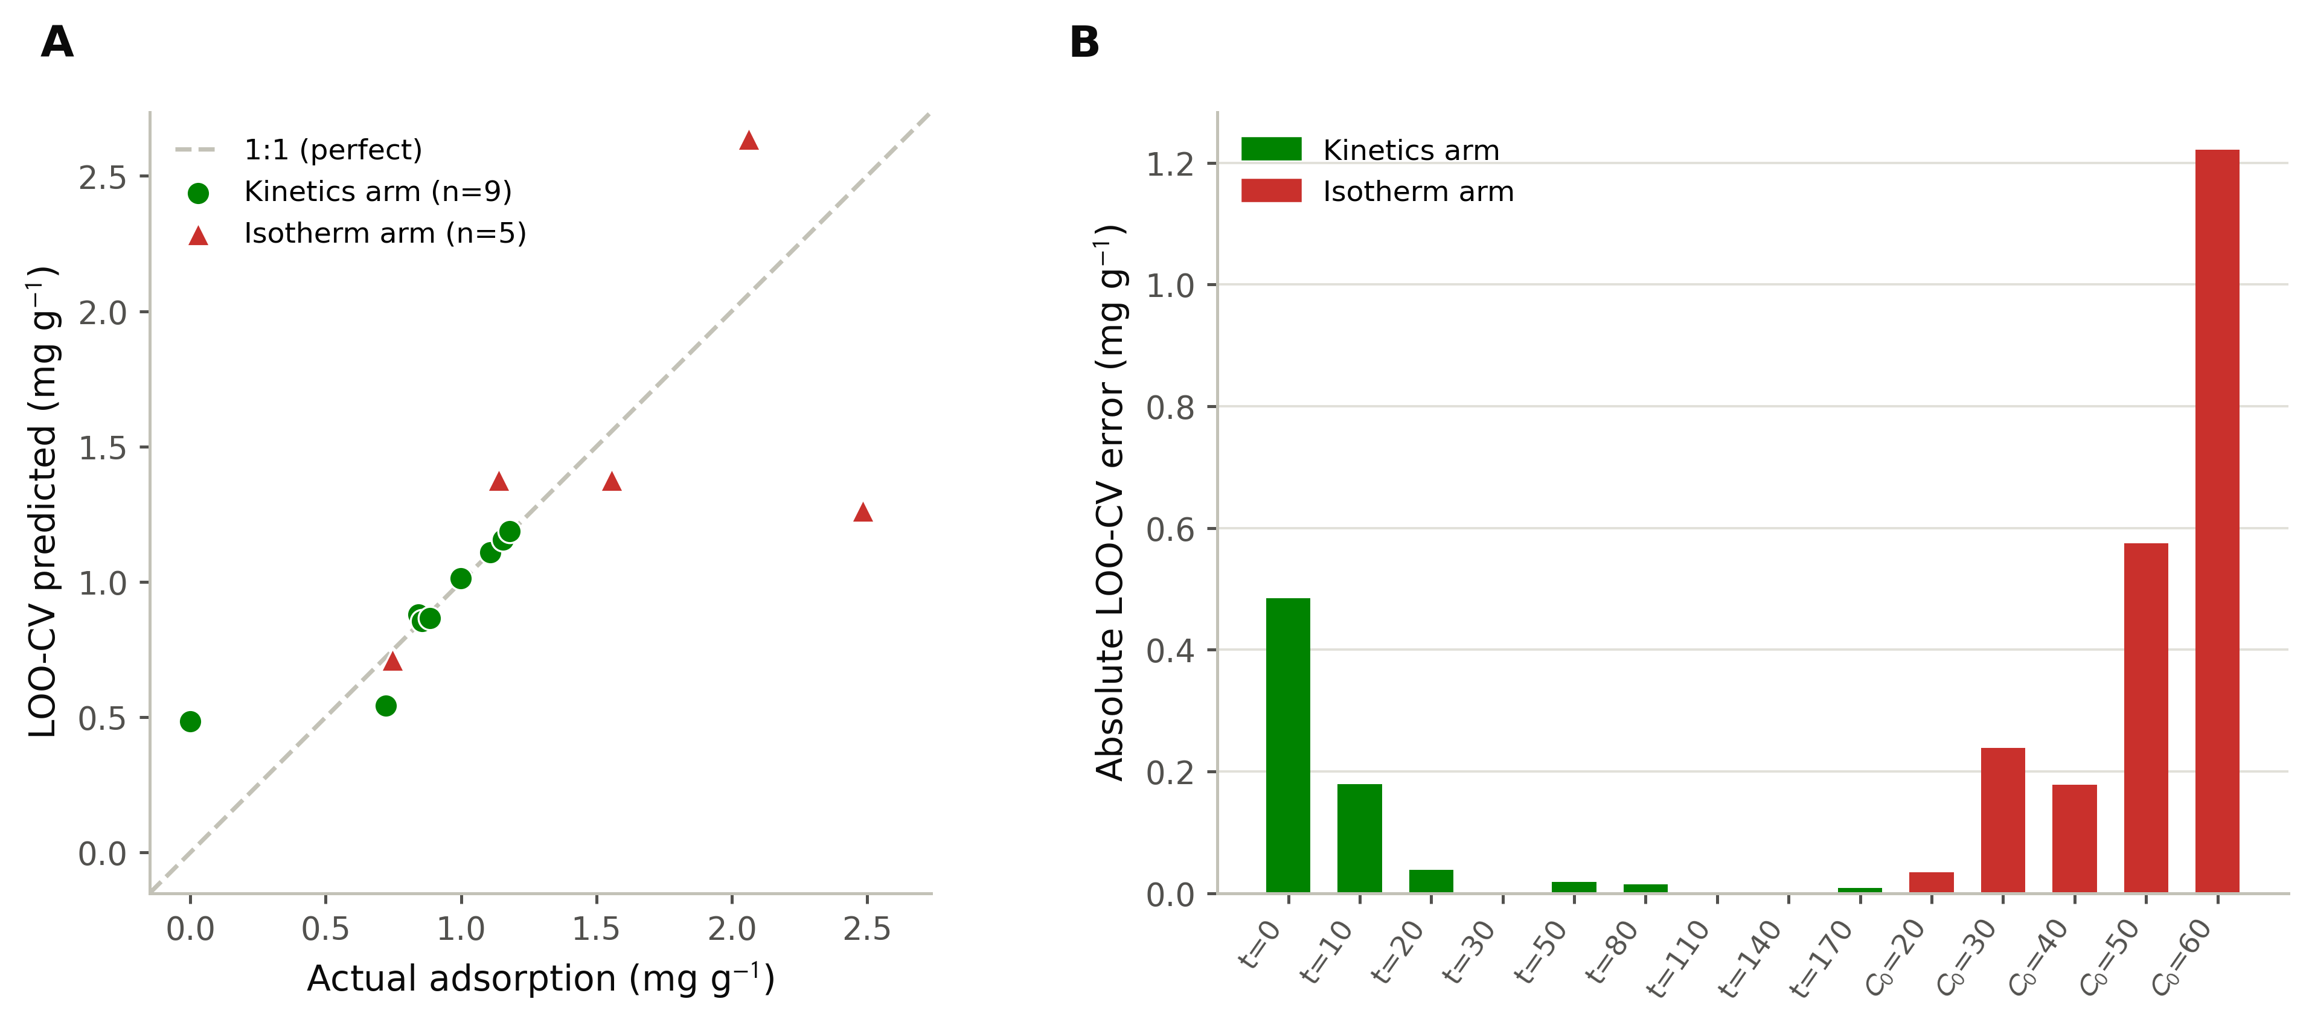
Figure 24: PINN3D leave-one-out cross-validation. Left: predicted vs. actual adsorption for each held-out point (dashed line = perfect prediction). Right: absolute LOO-CV error per point, ordered by contact time (kinetics arm, green) and initial concentration (isotherm arm, red).

CONCLUSION:
This study demonstrated the fabrication and characterization of a Saccharum spontaneum flower-fibre CMC/PVA/TiO2 composite biofilm (“Catkin biofilm”) for the adsorptive removal of the anionic reactive dye Avitera Light Red SE from aqueous solution, and modeled its adsorption behaviour using both classical kinetic/isotherm equations and a physics-informed neural network. Structural, thermal and mechanical characterization (FTIR, XRD, particle size analysis, FE-SEM/EDX, DSC, swelling, tensile testing, UV-Vis spectroscopy and CIE L*a*b* colorimetry) confirmed the successful incorporation of the cellulose microcrystals derived from the flower fibre into the composite film. Batch adsorption experiments were best described by pseudo-second-order kinetics (qe = 1.158 mg/g, k2 = 0.109 g/mg·min, R² = 0.966) and Freundlich-type equilibrium behaviour (n = 1.18, Kf = 0.037, R² = 0.997), consistent with a chemisorption-driven process on a heterogeneous adsorbent surface, with the exponent n exceeding unity indicating that adsorption intensity increased more than linearly with the equilibrium dye concentration over the range examined. The biofilm additionally supported dye recovery and reuse through a simple heating-based regeneration step, offering a route back to the process for both the film and the removed colour.
Beyond the classical analysis, a unified physics-informed neural network (PINN3D) was developed to fit the pseudo-second-order kinetics and Freundlich isotherm jointly, through a single set of physically-constrained parameters and a shared mass-balance relation, rather than as two independent regressions. The model reproduced the training data closely (R² > 0.9999 for both the kinetics and isotherm subsets) and, once anchored to the analytic equilibrium condition, allowed the adsorption capacity to be estimated at combinations of contact time, initial concentration and adsorbent dosage that were never directly tested in the laboratory. Leave-one-out cross-validation showed this generalizes only partially (overall LOO R² = 0.538), with the kinetics arm generalizing reasonably (LOO R² = 0.739) and the five-point isotherm arm generalizing poorly (LOO R² = 0.014); this cross-validated estimate, rather than the near-perfect in-sample fit, is the appropriate basis for judging the model's predictive reliability. This is, to the best of the authors' knowledge, among the first applications of an inverse physics-informed neural network to jointly resolve the kinetics and isotherm behaviour of a biofilm-based dye adsorbent, offering a route to estimate performance under untested experimental conditions without requiring a new experiment for every combination of variables.
The limits of this approach were examined directly rather than assumed. The model's dosage-extrapolation predictions were found to be reliable only in the immediate neighbourhood of the single experimental time point used to anchor the equilibrium constraint, and a small, physically-impossible exceedance of 100% removal efficiency was identified at the extreme edge of the tested dosage range, attributable to boundary extrapolation. The leave-one-out results further indicate that the isotherm arm, in particular, should not yet be relied on for extrapolation beyond the five tested concentrations. Both limitations are reported here as a guide to where the current single-anchor formulation should, and should not, be trusted, and point to the addition of further equilibrium constraints at more than one contact time, and an expanded isotherm dataset, as the next steps toward a fully validated predictive tool for this adsorbent system.

REFERENCES
[1] H. K. M. Ng and C. P. Leo, "Translucent and adsorptive PVA thin film containing microfibrillated cellulose intercalated with TiO₂ nanoparticles for dye removal," Colloids Surf. A Physicochem. Eng. Asp., vol. 578, Oct. 2019, doi: 10.1016/j.colsurfa.2019.123590.
[2] A. Sachidhanandham and A. P. Periyasamy, "Environmentally Friendly Wastewater Treatment Methods for the Textile Industry," in Handbook of Nanomaterials and Nanocomposites for Energy and Environmental Applications, Cham: Springer International Publishing, 2020, pp. 1--40. doi: 10.1007/978-3-030-11155-7_54-1.
[3] F. M. Drumond Chequer, G. A. R. de Oliveira, E. R. Anastacio Ferraz, J. Carvalho, M. V. Boldrin Zanoni, and D. P. de Oliveir, "Textile Dyes: Dyeing Process and Environmental Impact," in Eco-Friendly Textile Dyeing and Finishing, InTech, 2013. doi: 10.5772/53659.
[4] Z. Carmen and S. Daniela, "Textile Organic Dyes - Characteristics, Polluting Effects and Separation/Elimination Procedures from Industrial Effluents - A Critical Overview," InTech, Feb. 24, 2012, doi: 10.5772/32373.
[5] J. Lin, W. Ye, M. Xie, D. H. Seo, J. Luo, Y. Wan, and B. Van der Bruggen, "Environmental impacts and remediation of dye-containing wastewater," Nature Reviews Earth & Environment, vol. 4, no. 11, pp. 785-803, Nov. 2023, doi: 10.1038/s43017-023-00489-8.
[6] A. P. Periyasamy, "Textile Dyes in Wastewater and its Impact on Human and Environment: Focus on Bioremediation," Water Air Soil Pollut., vol. 236, no. 9, Sep. 2025, doi: 10.1007/s11270-025-08204-7.
[7] E. D. Huang Kong et al., "Recent advances in titanium dioxide bio-derived carbon photocatalysts for organic pollutant degradation in wastewater," May 16, 2025, Elsevier Inc. doi: 10.1016/j.isci.2025.112368.
[8] S. Dutta et al., "Contamination of textile dyes in aquatic environment: Adverse impacts on aquatic ecosystem and human health, and its management using bioremediation," J. Environ. Manage., vol. 353, p. 120103, Feb. 2024, doi: 10.1016/j.jenvman.2024.120103.
[9] F. Un Nisa et al., "Comparative analysis of dye degradation methods: Unveiling the most effective and environmentally sustainable approaches, a critical review," Jun. 01, 2025, Walter de Gruyter GmbH. doi: 10.1515/revic-2024-0042.
[10] R. Naveenkumar, B. Karthikeyan, and S. Senthilvelan, "Synthesis of bioinspired lotus fiber infused PVA/TiO₂ nanocomposites: characterization, thermal, and photocatalytic activity studies," Biomass Convers. Biorefin., vol. 15, no. 3, pp. 3571--3583, Feb. 2025, doi: 10.1007/s13399-023-05231-4.
[11] L. D. Ardila-Leal, R. A. Poutou-Piñales, A. M. Pedroza-Rodríguez, and B. E. Quevedo-Hidalgo, "A brief history of colour, the environmental impact of synthetic dyes and removal by using laccases," Jun. 02, 2021, MDPI AG. doi: 10.3390/molecules26133813.
[12] B. Sampath and J. Charles, "Synthesis of TiO₂ nanoparticles incorporated Integrated Photocatalyst Adsorbent (PVA/Graphite/TiO₂) as a hydrogel membrane towards efficient photocatalytic wastewater treatment," Iranian Polymer Journal, vol. 35, no. 4, pp. 709-724, Sep. 2025, doi: 10.1007/s13726-025-01539-2.
[13] M. Bissenova, N. Idrissov, Z. Kuspanov, A. Umirzakov, and C. Daulbayev, "Hybrid adsorption--photocatalysis composites: a sustainable route for efficient water purification," Aug. 01, 2025, Springer Science and Business Media Deutschland GmbH. doi: 10.1007/s40243-025-00319-5.
[14] T. Saini, J. Meena, and M. Jain, "Polyvinyl alcohol nanocomposite films with activated charcoal and titanium dioxide for efficient dye removal through combined adsorption and photocatalysis," Journal of the Indian Chemical Society, vol. 103, no. 1, Jan. 2026, doi: 10.1016/j.jics.2025.102374.
[15] E. Shadi, M. Amirinejad, A. A. Derakhshan, and H. Rezaie, "Synergistic dye removal through curcumin functionalized MCM-22 zeolite as a photocatalyst nanocomposite via the simultaneous photocatalysis and adsorption method," Sci. Rep., vol. 16, no. 1, Feb. 2026, doi: 10.1038/s41598-026-40712-2.
[16] D. Ariyanti, Y. A. O. Abdelrazig, A. M. Eriza, A. R. Nurwidiyanto, and V. C. Srivastava, "Synthesis of palm kernel shell biochar-TiO₂ composite for the photocatalytic degradation of organic pollutants," International Journal of Environmental Science and Technology, vol. 22, no. 15, pp. 15397--15408, Nov. 2025, doi: 10.1007/s13762-025-06641-9.
[17] S. A. Khan et al., "Nanocellulose based titanium dioxide nanocomposites for the wastewater treatment of textile industry," Front. Environ. Sci., vol. 13, 2025, doi: 10.3389/fenvs.2025.1560070.
[18] J. Babu and Z. V. P. Murthy, "Treatment of textile dyes containing wastewaters with PES/PVA thin film composite nanofiltration membranes," Sep. Purif. Technol., vol. 183, pp. 66--72, Aug. 2017, doi: 10.1016/j.seppur.2017.04.002.
[19] A. F. Al Naim and A. G. El-Shamy, "A new reusable adsorbent of polyvinyl alcohol/magnesium peroxide (PVA/MgO₂) for highly selective adsorption and dye removal," Mater. Chem. Phys., vol. 270, p. 124820, Sep. 2021, doi: 10.1016/j.matchemphys.2021.124820.
[20] H. M. Ragab and A. Rajeh, "Structural, thermal, optical and conductive properties of PAM/PVA polymer composite doped with Ag nanoparticles for electrochemical application," Journal of Materials Science: Materials in Electronics, vol. 31, no. 19, pp. 16780--16792, Oct. 2020, doi: 10.1007/s10854-020-04233-6.
[21] R. Garg et al., "Sputtering thin films: Materials, applications, challenges and future directions," Adv. Colloid Interface Sci., vol. 330, p. 103203, Aug. 2024, doi: 10.1016/j.cis.2024.103203.
[22] M. Ikram et al., "A review of photocatalytic characterization, and environmental cleaning, of metal oxide nanostructured materials," Sustainable Materials and Technologies, vol. 30, p. e00343, Dec. 2021, doi: 10.1016/j.susmat.2021.e00343.
[23] C. Birck, S. Degoutin, N. Tabary, V. Miri, and M. Bacquet, "New crosslinked cast films based on poly(vinyl alcohol): Preparation and physico-chemical properties," Express Polym. Lett., vol. 8, no. 12, pp. 941--952, 2014, doi: 10.3144/expresspolymlett.2014.95.
[24] T. Kloknicer, A. Szabó, D. B. Sándor, and G. Filipcsei, "Challenges and Disadvantages of PVA-Based Media Application in Wastewater Treatment: A Mini-Review," Sep. 01, 2025, Multidisciplinary Digital Publishing Institute (MDPI). doi: 10.3390/environments12090294.
[25] M. Ezzine, A. S. El-Shafie, K. M. Youssef, and M. El-Azazy, "Bifunctional TiO₂ -- cellulose based nanocomposites for synergistic adsorptive-photocatalytic removal of methyl orange: Response modelling and optimization," Int. J. Biol. Macromol., vol. 306, May 2025, doi: 10.1016/j.ijbiomac.2025.141753.
[26] N. El Messaoudi et al., "Recent developments and prospects for the use of carboxymethyl cellulose-based nanocomposites in wastewater dye removal," Jan. 01, 2026, Springer Science and Business Media Deutschland GmbH. doi: 10.1007/s00289-025-06118-2.
[27] N. L. Khumalo, S. M. Mohomane, V. Elumalai, and T. E. Motaung, "Fabrication of a Carboxylate Cellulose Nanocrysal-Silica-TiO₂ Aerogel for Enhanced Photocatalytic Degradation of Methylene Blue," Materials, vol. 18, no. 20, Oct. 2025, doi: 10.3390/ma18204702.
[28] S. F. Anis, B. S. Lalia, and R. Hashaikeh, "Controlling swelling behavior of poly (vinyl) alcohol via networked cellulose and its application as a reverse osmosis membrane," Desalination, vol. 336, pp. 138--145, Mar. 2014, doi: 10.1016/j.desal.2014.01.005.
[29] M. Song, H. Yu, J. Gu, S. Ye, and Y. Zhou, "Chemical cross-linked polyvinyl alcohol/cellulose nanocrystal composite films with high structural stability by spraying Fenton reagent as initiator," Int. J. Biol. Macromol., vol. 113, pp. 171--178, Jul. 2018, doi: 10.1016/j.ijbiomac.2018.02.117.
[30] S. Jo, Y. Oh, S. Park, E. Kan, and S. H. Lee, "Cellulose/carrageenan/TiO₂ nanocomposite for adsorption and photodegradation of cationic dye," Biotechnology and Bioprocess Engineering, vol. 22, no. 6, pp. 734--738, Nov. 2017, doi: 10.1007/s12257-017-0267-0.
[31] X. F. Li, Y. Ding, jing Wang, and X. Q. Feng, "CS-biochar/ZnO/TiO₂ for efficient photocatalytic removal of Rhodamine B: performance and mechanism insights," Water Air Soil Pollut., vol. 236, no. 1, Jan. 2025, doi: 10.1007/s11270-024-07644-x.
[32] M. M. Rahman, A. K. Das, S. Tabassum, S. C. Das, and M. A. Uddin, "Physical and chemical characterization of Saccharum spontaneum flower fibre: potential applications in thermal insulation and microbial fuel cells," arXiv preprint arXiv:2501.05324 [physics.bio-ph], Jan. 2025, doi: 10.48550/arXiv.2501.05324.
[33] Stevulova N, Cigasova J, Estokova A et al. Properties Characterization of Chemically Modified Hemp Hurds. Materials 2014; 7: 8131--8150
[34] Ibrahim NA, Azraaie N, Zainul Abidin NAM, Mamat Razali NA, Abdul Aziz F, Zakaria S. Preparation and Characterization of Alpha Cellulose of Pineapple \<i\>(Ananas comosus)\</i\> Leaf Fibres (PALF). Adv Mat Res 2014; 895: 147--150
[35] Rahaman, M. H., Miah, M. P., Siam, M. M. I., Barat, M. K., and Uddin, M. A., "Removal of reactive dyes-based wastewater with moringa-coated cellulose microcrystals (CMC) produced from sugarcane bagasse," Cleaner Water, vol. 3, p. 100087, Jun. 2025, doi: 10.1016/j.clwat.2025.100087.
[36] A. Zuliahani, R. Nurul Nadhirah, A. R. Rozyanty, W. I. Nawawi, and A. B. Nor Hanani, "Crystallinity, tapping and bulk density of microcrystalline cellulose (MCC) isolated from rice husk (RH)," Applied Mechanics and Materials, vol. 835, pp. 272--276, May 2016, doi: 10.4028/www.scientific.net/AMM.835.272
[37] J. Araki, M. Wada, S. Kuga, and T. Okano, "Flow properties of microcrystalline cellulose suspension prepared by acid treatment of native cellulose," Colloids and Surfaces A: Physicochemical and Engineering Aspects, vol. 142, no. 1, pp. 75--82, Nov. 1998, doi: 10.1016/S0927-7757(98)00578-3.
[38] M. A. Ibrahim, G. M. Nasr, R. M. Ahmed, and N. A. Kelany, "Physical characterization, biocompatibility, and antimicrobial activity of polyvinyl alcohol/sodium alginate blend doped with TiO₂ nanoparticles for wound dressing applications," Scientific Reports, vol. 14, no. 1, p. 5391, Mar. 2024, doi: 10.1038/s41598-024-55818-8.
[39] V. Kaler, U. Pandel, and R. K. Duchaniya, "Development of TiO₂/PVA nanocomposites for application in solar cells," Materials Today: Proceedings, vol. 5, no. 2, pp. 6372--6378, 2018, doi: 10.1016/j.matpr.2017.12.237.
[40] M. Ghaedi, A. Golestani Nasab, S. Khodadoust, M. Rajabi, and S. Azizian, "Application of activated carbon as adsorbents for efficient removal of methylene blue: Kinetics and equilibrium study," Journal of Industrial and Engineering Chemistry, vol. 20, no. 4, pp. 2317--2324, 2014, doi: 10.1016/j.jiec.2013.10.007
[41] I. Langmuir, "The adsorption of gases on plane surfaces of glass, mica and platinum," Journal of the American Chemical Society, vol. 40, no. 9, pp. 1361--1403, 1918, doi: 10.1021/ja02242a004.
[42] K. Y. Foo and B. H. Hameed, "Insights into the modeling of adsorption isotherm systems," Chemical Engineering Journal, vol. 156, no. 1, pp. 2--10, 2010, doi: <https://doi.org/10.1016/j.cej.2009.09.013>
[43] M. A. Al-Ghouti and D. A. Da'ana, "Guidelines for the use and interpretation of adsorption isotherm models: A review," Journal of Hazardous Materials, vol. 393, p. 122383, 2020.
[44] Langmuir Isotherm Models Applied to the Multi-Component Sorption of Acid Dyes from Effluent onto Activated Carbon," Journal of Chemical & Engineering Data, vol. 45, no. 4, 2000, doi: <https://doi.org/10.1021/je9902894>
[45] Guo, X. & Wang, J. (2020). Adsorption isotherm models: Classification, physical meaning, application and solving method. Chemosphere, 258, 127279. <https://doi.org/10.1016/j.chemosphere.2020.127279>
[46] H. M. F. Freundlich, "Über die Adsorption in Lösungen," Zeitschrift für Physikalische Chemie, vol. 57, pp. 385--470, 1906.
[47] Y. S. Ho and G. McKay, "Pseudo-second order model for sorption processes," Process Biochemistry, vol. 34, no. 5, pp. 451--465, 1999, doi: <https://doi.org/10.1016/S0032-9592(98)00112-5>
[48] E. D. Revellame, D. L. Fortela, W. Sharp, R. Hernandez, and M. E. Zappi, "Adsorption kinetic modeling using pseudo-first order and pseudo-second order rate laws: A review," Cleaner Engineering and Technology, vol. 1, p. 100032, 2020, doi: <https://doi.org/10.1016/j.clet.2020.100032>
[49] M. S. K. Faisal, K. S. Islam, N. Sultana, M. M. Hasan, and N. Chowdhury, "Extraction of dye from water hyacinth leaf by different processes and examine its suitability as food grade dye," SSRN Electronic Journal, Oct. 2025, doi: <https://doi.org/10.2139/ssrn.5553359>
[50] P. Kaewprachu, C. Jaisan, W. Klunklin, S. Phongthai, S. Rawdkuen, and W. Tongdeesoontorn, "Mechanical and physicochemical properties of composite biopolymer films based on carboxymethyl cellulose from young palmyra palm fruit husk and rice flour," Polymers, vol. 14, no. 9, p. 1872, 2022, doi: <https://doi.org/10.3390/polym14091872>
[51] I. Pastorova, R. E. Botto, P. W. Arisz, and J. J. Boon, "Cellulose char structure: a combined analytical Py-GC-MS, FTIR, and NMR study," Carbohydrate Research, vol. 262, no. 1, pp. 27--47, 1994, doi: 10.1016/0008-6215(94)84003-2
[52] X.-F. Sun, R.-C. Sun, Y. Su, and J.-X. Sun, "Comparative study of crude and purified cellulose from wheat straw," Journal of Agricultural and Food Chemistry, vol. 52, no. 4, pp. 839--847, Feb. 2004, doi: 10.1021/jf0349230
[53] M. Poletto, V. Pistor, and A. J. Zattera, "Structural characteristics and thermal properties of native cellulose," in Cellulose --- Fundamental Aspects, T. van de Ven and L. Godbout, Eds. Rijeka: IntechOpen, 2013, ch. 3, doi: 10.5772/50452.
[54] C. Pappas, P. A. Tarantilis, I. Daliani, T. Mavromustakos, and M. Polissiou, "Comparison of classical and ultrasound-assisted isolation procedures of cellulose from kenaf (Hibiscus cannabinus L.) and eucalyptus (Eucalyptus robustus Sm.)," Ultrasonics Sonochemistry, vol. 9, no. 1, pp. 19--23, Jan. 2002, doi: 10.1016/S1350-4177(01)00094-X
[55] R. C. Sun, J. Tomkinson, P. L. Ma, and S. F. Liang, "Comparative study of hemicelluloses from rice straw by alkali and hydrogen peroxide treatments," Carbohydrate Polymers, vol. 42, no. 2, pp. 111--122, Jun. 2000, doi: 10.1016/S0144-8617(99)00136-8
[56] E. Galiwango, N. S. Abdel Rahman, A. H. Al-Marzouqi, M. M. Abu-Omar, and A. A. Khaleel, "Isolation and characterization of cellulose and α-cellulose from date palm biomass waste," Heliyon, vol. 5, no. 12, p. e02937, Dec. 2019, doi: 10.1016/j.heliyon.2019.e02937
[57] T. Linda, S. Muthupoongodi, X. S. Shajan, and S. Balakumar, "Photocatalytic degradation of congo red and crystal violet dyes on cellulose/PVC/ZnO composites under UV light irradiation," Materials Today: Proceedings, vol. 3, no. 6, pp. 2035--2041, 2016, doi: 10.1016/j.matpr.2016.04.107
[58] M. S. Sarwar, M. B. K. Niazi, Z. Jahan, T. Ahmad, and A. Hussain, "Preparation and characterization of PVA/nanocellulose/Ag nanocomposite films for antimicrobial food packaging," Carbohydrate Polymers, vol. 184, pp. 453--464, Mar. 2018, doi: 10.1016/j.carbpol.2017.12.068.
[59] X. Chen, C. Chen, H. Zhang, Y. Huang, J. Yang, and D. Sun, "Facile approach to the fabrication of 3D cellulose nanofibrils (CNFs) reinforced poly(vinyl alcohol) hydrogel with ideal biocompatibility," Carbohydrate Polymers, vol. 173, pp. 547--555, Oct. 2017, doi: 10.1016/j.carbpol.2017.06.029
[60] A. Solikhin and K. Murayama, "Enhanced properties of poly(vinyl alcohol) composite films filled with microfibrillated cellulose isolated from continuous steam explosion," International Journal of Plastics Technology, vol. 22, pp. 122--136, 2018, doi: 10.1007/s12588-018-9208-9.
[61] S. M. Haque, F. Franconibacter, and co-authors, "Franconibacter sp., 1MS: A new strain in decolorization and degradation of azo dyes Ponceau S Red and Methyl Orange," ACS Omega, vol. 6, no. 3, pp. 1879--1893, 2021, doi: 10.1021/acsomega.0c03786
[62] M. M. Haque, M. A. Haque, M. K. Mosharaf, M. S. Islam, M. M. Islam, M. Hasan, A. H. Molla, and M. A. Haque, "Biofilm-mediated decolorization, degradation and detoxification of synthetic effluent by novel biofilm-producing bacteria isolated from textile dyeing effluent," Environmental Pollution, vol. 314, p. 120237, Dec. 2022, doi: 10.1016/j.envpol.2022.120237
[63] R. Wu, H. Qu, Y. He, and Y. Wu, "Removal of water-soluble azo dye by the magnetic material MnFe₂O₄," Journal of Chemical Technology & Biotechnology, vol. 79, no. 8, pp. 857--863, 2004, doi: 10.1002/jctb.1142.
[64] S. I. Ayesha, G. W. Misganaw, P. S. Sagar, L. J. Juturi, A. S. Admasu, P. King, M. Vijay, and B. Gaddala, "Investigation of characterisation for biosorption of Congo red from textile wastewater using Spathodea Campanulata leaves: FTIR, SEM, and XRD analysis," Chemical Methodologies, vol. 7, no. 8, pp. 605--612, 2023, doi: 10.22034/CHEMM.2023.393521.1737.
[65] A. D. French, "Idealized powder diffraction patterns for cellulose polymorphs," Cellulose, vol. 21, no. 2, pp. 885--896, Apr. 2014, doi: 10.1007/s10570-013-0030-4.
[66] L. Segal, J. J. Creely, A. E. Martin, and C. M. Conrad, "An empirical method for estimating the degree of crystallinity of native cellulose using the X-ray diffractometer," Textile Research Journal, vol. 29, no. 10, pp. 786--794, 1959, doi: 10.1177/004051755902901003.
[67] J. Sriupayo, P. Supaphol, J. Blackwell, and R. Rujiravanit, "Preparation and characterization of α-chitin whisker-reinforced poly(vinyl alcohol) nanocomposite films with or without heat treatment," Carbohydrate Polymers, vol. 62, no. 2, pp. 130--136, 2005, doi: 10.1016/j.carbpol.2005.07.013
[68] W. Shao, H. Liu, X. Liu, S. Sun, R. Wang, and R. Zhang, "PH-responsive release behavior and anti-bacterial activity of bacterial cellulose-silver nanoparticles/sodium alginate nanocomposites," International Journal of Biological Macromolecules, vol. 76, pp. 209--217, 2015, doi: 10.1016/j.ijbiomac.2015.02.048
[69] W.-W. Wang, C.-Z. Man, C.-M. Zhang, L. Jiang, Y. Dan, and T.-P. Nguyen, "Stability of poly(L-lactide)/TiO₂ nanocomposite thin films under UV irradiation at 254 nm," Polymer Degradation and Stability, vol. 98, no. 4, pp. 885--893, Apr. 2013, doi: 10.1016/j.polymdegradstab.2013.01.003.
[70] H.-S. Chen, C. Su, J.-L. Chen, T.-Y. Yang, N.-M. Hsu, and W.-R. Li, "Preparation and characterization of pure rutile TiO₂ nanoparticles for photocatalytic study and thin films for dye-sensitized solar cells," Journal of Nanomaterials, vol. 2011, pp. 1--8, 2011, doi: 10.1155/2011/869618.
[71] A. Antunes, A. Popelka, O. Aljarod, M. K. Hassan, and A. S. Luyt, "Effects of rutile--TiO₂ nanoparticles on accelerated weathering degradation of poly(lactic acid)," Polymers, vol. 12, no. 5, p. 1096, May 2020, doi: 10.3390/polym12051096
[72] F. A. Nobel, R. I. Fahim, R. Hassan, et al., "Sequestration, recovery, and reuse of cationic, anionic, and non-ionic dyes using bentonite," Environmental Science and Pollution Research, vol. 32, pp. 21596--21615, Sep. 2025, doi: 10.1007/s11356-025-36929-9
[73] B. Y. Shekunov, P. Chattopadhyay, H. H. Y. Tong, and A. H. L. Chow, "Particle size analysis in pharmaceutics: Principles, methods and applications," Pharmaceutical Research, vol. 24, no. 2, pp. 203--227, Feb. 2007, doi: 10.1007/s11095-006-9146-7
[74] J. Zanela, A. P. Bilck, M. Casagrande, M. V. E. Grossmann, and F. Yamashita, "Polyvinyl alcohol (PVA) molecular weight and extrusion temperature in starch/PVA biodegradable sheets," Polímeros, vol. 28, no. 3, pp. 256--265, 2018, doi: 10.1590/0104-1428.03417
[75] E. Moslehifard, M. Robati Anaraki, and S. Shirkavand, "Effect of adding TiO₂ nanoparticles on the SEM morphology and mechanical properties of conventional heat-cured acrylic resin," Journal of Dental Research, Dental Clinics, Dental Prospects, vol. 13, no. 3, pp. 234--240, 2019, doi: 10.15171/joddd.2019.036.
[76] M. A. Ashraf, W. Peng, Y. Zare, and K. Y. Rhee, "Effects of size and aggregation/agglomeration of nanoparticles on the interfacial/interphase properties and tensile strength of polymer nanocomposites," Nanoscale Research Letters, vol. 13, p. 214, 2018, doi: 10.1186/s11671-018-2624-0
[77] E. E. Abdel-Hady, H. F. M. Mohamed, M. O. Abdel-Hamed, and M. M. Gomaa, "Physical and electrochemical properties of PVA/TiO₂ nanocomposite membrane," Adv. Polym. Technol., vol. 38, no. 8, pp. 1--12, Jan. 2019, doi: 10.1002/adv.22167
[78] S. Sathish, B. C. Shekar, and B. T. Bhavyasree, "Nano composite PVA-TiO₂ thin films for OTFTs," Adv. Mater. Res., vol. 678, pp. 335--342, Mar. 2013, doi: 10.4028/www.scientific.net/AMR.678.335.
[79] I. Chiulan, A. N. Frone, D. M. Panaitescu, C. A. Nicolae, and R. Trusca, "Surface properties, thermal, and mechanical characteristics of poly(vinyl alcohol)--starch--bacterial cellulose composite films," J. Appl. Polym. Sci., vol. 135, no. 45800, 2018.
[80] J. Ahmad, K. Deshmukh, M. Habib, and M. B. Hägg, "Influence of TiO₂ nanoparticles on the morphological, thermal and solution properties of PVA/TiO₂ nanocomposite membranes," Arab. J. Sci. Eng., vol. 39, no. 10, pp. 6805--6814, Oct. 2014, doi: 10.1007/s13369-014-1287-0
[81] A. Al-Hakimi, G. Asnag, F. Alminderej, I. Alhagri, S. Al-Hazmy, and T. Qahtan, "Enhancing the structural, optical, thermal, and electrical properties of PVA filled with mixed nanoparticles (TiO₂/Cu)," Crystals, vol. 13, no. 1, p. 135, Jan. 2023, doi: 10.3390/cryst13010135
[82] S. Naduparambath, M. P. Sreejith, T. V. Jinitha, V. Shaniba, K. B. Aparna, and E. Purushothaman, "Development of green composites of poly(vinyl alcohol) reinforced with microcrystalline cellulose derived from sago seed shells," Polym. Compos., vol. 39, no. 9, pp. 3033--3039, 2018, doi: 10.1002/pc.24307
[83] N. A. El-Zaher and W. G. Osiris, "Thermal and structural properties of poly(vinyl alcohol) doped with hydroxypropyl cellulose," J. Appl. Polym. Sci., vol. 96, no. 5, pp. 1914--1923, 2005, doi: 10.1002/app.21628
[84] D. Liu, X. Sun, H. Tian, S. Maiti, and Z. Ma, "Effects of cellulose nanofibrils on the structure and properties of PVA nanocomposites," Cellulose, vol. 20, no. 6, pp. 2981--2989, 2013
[85] V. R. Feig, H. Tran, and Z. Bao, "Biodegradable polymeric materials in degradable electronic devices," ACS Cent. Sci., vol. 4, no. 3, pp. 337--348, 2018, doi: 10.1021/acscentsci.7b00595
[86] M. Xiao and B. X. Du, "Review of high thermal conductivity polymer dielectrics for electrical insulation," High Volt., vol. 1, no. 1, pp. 34--42, 2016, doi: 10.1049/hve.2016.0008.
[87] D. Pawcenis, M. Leśniak, M. Szumera, M. Sitarz, and J. Profic-Paczkowska, "Effect of hydrolysis time, pH and surfactant type on stability of hydrochloric acid hydrolyzed nanocellulose," Int. J. Biol. Macromol., vol. 222, pp. 2623--2632, 2022, doi: 10.1016/j.ijbiomac.2022.09.289
[88] M. A. Sebak, T. F. Qahtan, G. M. Asnag, and E. M. Abdallah, "The role of TiO₂ nanoparticles in the structural, thermal and electrical properties and antibacterial activity of PEO/PVP blend for energy storage and antimicrobial application," J. Inorg. Organomet. Polym. Mater., vol. 32, pp. 4715--4728, 2022.
[89] E. M. Abdelrazek, G. M. Asnag, A. H. Oraby, A. M. Abdelghany, A. M. Alshehari, and M. S. Gumaan, "Structural, optical, thermal, morphological and electrical studies of PEMA/PMMA blend filled with CoCl2 and LiBr as mixed filler," J. Electron. Mater., vol. 49, pp. 6107--6122, 2020
[90] P. Pallavi and H. Kumar, "Fabrication of PVA/ZnO/TiO₂ nanocomposite biofilm for multifunctional applications," ChemistrySelect, 2026, doi: <https://doi.org/10.1002/slct.202505380>
[91] A. Eti, M. Khatun, M. A. Khatun, M. O. Rahman, K. M. Anis-Ul-Haque, and M. J. Alam, "Removal of dye from wastewater using a novel composite film incorporating nanocellulose," Journal of Chemistry, 2023, Article ID 4431941, doi: https://doi.org/10.1155/2023/4431941
[92] J. Ghosh and N. S. Rupanty, “Study on a cationic agent-based salt-free reactive dyeing process for cotton knit fabric and comparison with a traditional dyeing process,” Heliyon, vol. 9, no. 9, Art. no. e19457, Sep. 2023, doi: 10.1016/j.heliyon.2023.e19457.
[93] R. Agarwala and L. Mulky, “Adsorption of dyes from wastewater: A comprehensive review,” ChemBioEng Reviews, vol. 10, no. 3, pp. 326–335, Jun. 2023, doi: 10.1002/cben.202200011
[94] M. S. K. Faisal, T. T. Majumder, K. S. Islam, Sk. Mainuddin, M. F. Hossain, N. Sultana, and M. Hasan, "Interfacial mechanisms of reactive dye adsorption on a waste-cotton derived PVA/TiO₂/cellulose biofilm: a molecular dynamics and physics-informed predictive framework," manuscript submitted for publication, 2026.
[95] M. Raissi, P. Perdikaris, and G. E. Karniadakis, “Physics-informed neural networks: A deep learning framework for solving forward and inverse problems involving nonlinear partial differential equations,” Journal of Computational Physics, vol. 378, pp. 686-707, 2019.

