New Report Template

創建新報表

您可以清除此頁面並創建新報表

您可以插入字段如下

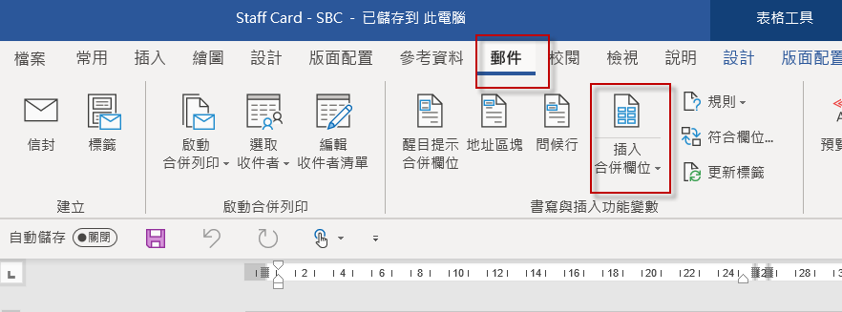

You may clear this page and create layout out

You may insert data field as below

