*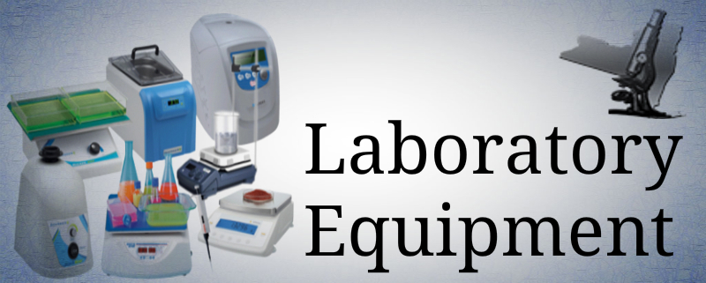Chapter Two Project*

Instructions

1. Download from Blackboard the *LabSupplies* file to your computer. Save the file as **Lastname_Firstname_LabSupplies** using your first and last name.
2. Create a one-to-many relationship between the Suppliers and Lab Supplies tables. Enforce referential integrity and select both cascade options. Create a Relationship Report using the name Lab Supplies Relationship Report.
3. Create a query using the Lab Supplies table that answers the question: What is the Item Name, Supplier ID, Category, Quantity in Stock, and Item Price for all items, sorted in ascending order by Category and descending order by Quantity in Stock. Display the fields in the order listed. Save the query as **1-Items by Category Query**
4. Create a query that will answer the question what are the Item ID, Item Name, Supplier Id, and Item Prices that are over fifty dollars, for Supplier ID SUPP-004? Have the results sorted in ascending order, by Item Name. Do not show the Supplier ID in the result. Name the query **2-Supplier 004 Items Query**
5. Create a query for the Suppliers table that shows the Supplier ID, Supplier Name, Phone, and Email Address for suppliers where the Phone is blank, sorted in ascending order by Supplier Name. Save the query as **3-Suppliers Missing Phone Number Query**
6. Create a query that answers the question what would the price per item be if there were a 20 percent price increase. Include the Supplier Name, Item Name, and Price Per Item fields in your table. Name the new field for the increased prices **2019 Prices**. Sort in ascending order by Supplier name and descending order by 2019 prices. Format the prices into currency with two decimal places. Save the query as **4-New Prices Query**
7. Create a query that answers the question What are the Average Prices Per Item, grouped by Category? Save this query as **5-Average Item Price per Category Query.**
8. Create a parameter query that allows users to type in a Supplier ID and a list of their item names and quantity in stock display. Name the query **6-Supplier ID Parameter Query**
9. Create a query that displays the Item Name, Location, and Price Per Item of all items that have the word Kit anywhere in the Item Name. Sort in ascending order, by the Item Name and Location. Save the query with the name **7-Kit Style Items by Location Query**
10. Close all objects, close the file, and exit Access. Submit your completed, closed file, to the appropriate assignment link, by the due date noted on the Assignments, Test Dates and Class Happenings.