CHAPTER -4
SYSTEM DESIGN
4.1.Introduction
This chapter presents the design of the Smart School Connect system. It translates the requirements identified in the previous chapter into a structured system architecture and detailed design components.
The system design focuses on defining how different modules interact, how data flows within the system, and how user interfaces and backend services are structured. It aims to ensure that the system is scalable, secure, maintainable, and efficient.
This chapter also discusses key design issues, architectural decisions, and design patterns applied in the development of the system to achieve reliability and flexibility.

4.2.Design issues
The design of the Smart School Connect system considers several critical issues to ensure effective system performance and usability.

4.2.1 Scalability
The system is designed to handle an increasing number of users, including students, teachers, and parents. A modular architecture and cloud-based deployment approach are adopted to support future growth without significant performance degradation.

4.2.2 Security
Security is a major concern due to the sensitive nature of student data. The system implements authentication and authorization mechanisms, encrypted data transmission, and role-based access control to ensure data confidentiality and integrity.

4.2.3 Performance
The system is optimized to support real-time communication and fast response times. Efficient database queries and asynchronous processing are used to minimize delays.

4.2.4 Usability
The user interface is designed to be simple and intuitive to accommodate users with varying levels of digital literacy, especially parents and students.

4.2.5 Reliability
The system ensures consistent operation with minimal downtime through proper error handling, backup mechanisms, and fault tolerance strategies.

4.2.6 Maintainability
The system is structured using modular components, making it easier to update, debug, and extend functionalities in the future.

4.2.7 Compatibility
The system is designed to operate across different devices and platforms, including mobile phones, tablets, and desktop computers.

4.3.Design patterns
The Smart School Connect system applies several software design patterns to improve system structure, reusability, and maintainability.

4.3.1 Model-View-Controller (MVC) Pattern
The system follows the MVC architectural pattern to separate concerns:
Model: Handles data and business logic (e.g., student records, assignments, attendance)
View: Represents the user interface (web and mobile screens)
Controller: Manages user input and system interactions
This separation improves maintainability and allows independent development of system components.

4.3.2 Observer Pattern
The Observer pattern is used in the notification system. When an event occurs (e.g., assignment upload or grade update), the system automatically notifies all relevant users such as students and parents.

4.3.3 Singleton Pattern
The Singleton pattern is used for managing shared system resources such as database connections, ensuring that only one instance is used throughout the application.

4.3.4 Factory Pattern
The Factory pattern is used for creating user objects (Administrator, Teacher, Student, Parent) dynamically based on role type, improving flexibility and scalability.

4.3.5 Layered Architecture Pattern
The system follows a layered architecture consisting of:
Presentation Layer (UI)
Application Layer (Business Logic)
Data Layer (Database)
This structure improves system organization and simplifies maintenance.

4.4.Class Diagram
The class diagram represents the static structure of the Smart School Connect system by illustrating the system’s classes, their attributes, methods, and the relationships among them. It provides a clear model of how data and behavior are organized within the system.
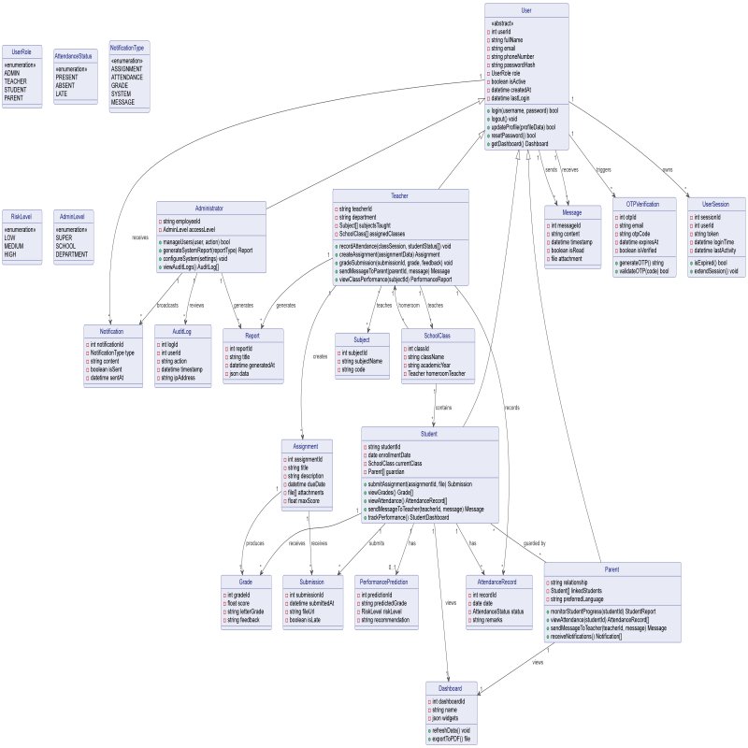

4.5.Collaboration Diagram
A collaboration diagram (also known as a communication diagram) illustrates how objects in the system interact with each other to perform a specific functionality. It focuses on the relationships between objects and the sequence of messages exchanged during an operation.
In the Smart School Connect system, collaboration diagrams are used to model interactions between system components for key functionalities such as messaging, attendance recording, and assignment management.
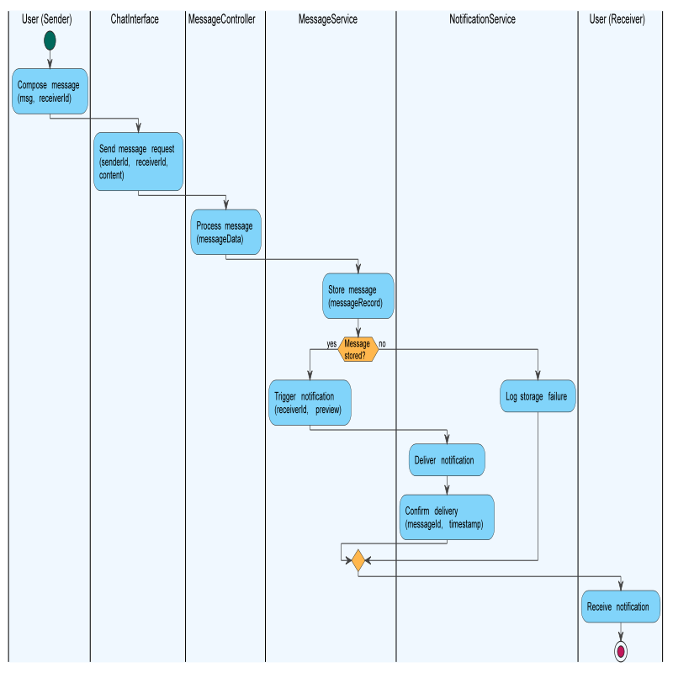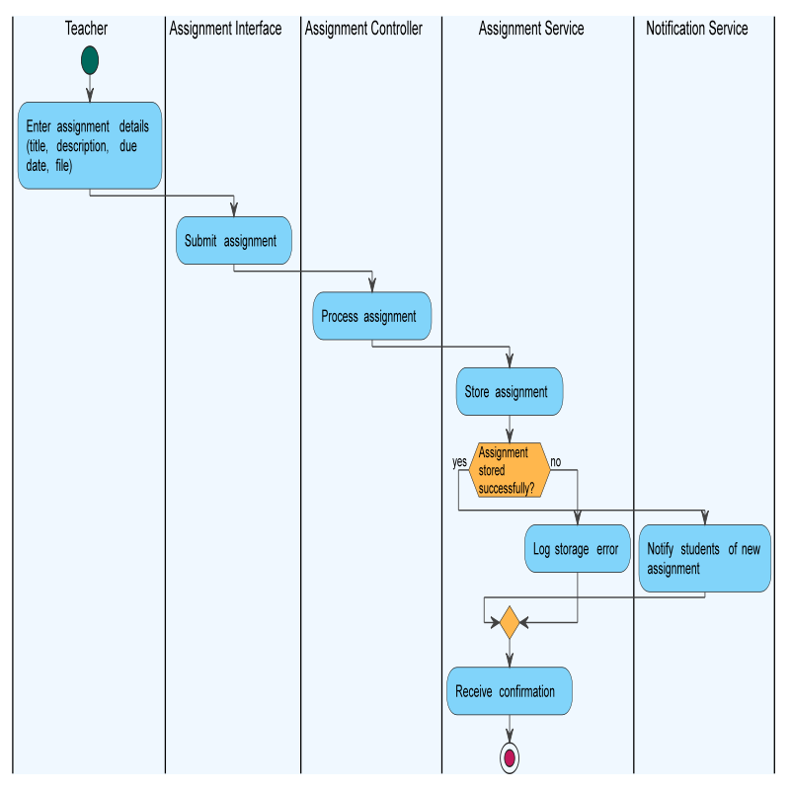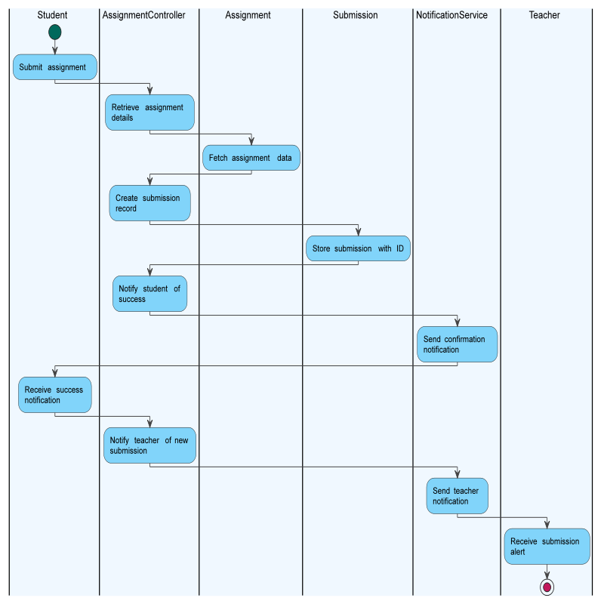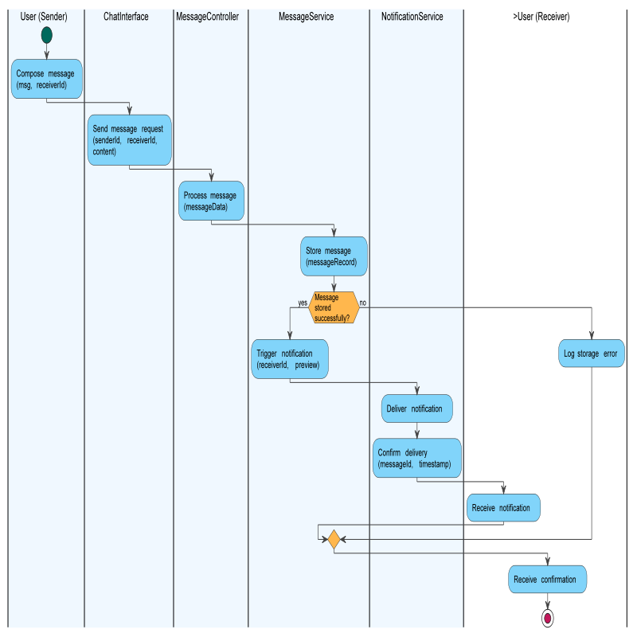

4.6.Database Model

4.6 Database Model
The database model of the Smart School Connect system defines how data is structured, stored, and managed to support system functionalities. The system uses a relational database model implemented using PostgreSQL, which ensures data consistency, integrity, and efficient querying.
The database is designed based on the system’s functional requirements and object-oriented models, and it follows normalization principles to minimize redundancy and maintain data accuracy.

4.6.1 Overview of the Database Design
The database consists of multiple related tables representing key system entities such as users, academic records, communication data, and administrative information.
Each table is defined with:
- Primary Keys (PK) to uniquely identify records
- Foreign Keys (FK) to establish relationships between tables
- Appropriate data types and constraints to ensure data integrity

4.6.2 Main Entities and Tables
Below are the core tables in the system:

1. User Table
Stores general information for all system users.
- user_id (PK)
- name
- email (unique)
- password
- role (Admin, Teacher, Student, Parent)

2. Student Table
Stores student-specific data.
- student_id (PK)
- user_id (FK → User)
- class_id (FK → Class)

3. Teacher Table
Stores teacher-specific data.
- teacher_id (PK)
- user_id (FK → User)

4. Parent Table
Stores parent/guardian data.
- parent_id (PK)
- user_id (FK → User)

5. Class Table
Represents school classes.
- class_id (PK)
- class_name
- grade_level

6. Attendance Table
Stores attendance records.
- attendance_id (PK)
- student_id (FK → Student)
- class_id (FK → Class)
- date
- status (Present/Absent)

7. Assignment Table
Stores assignment details.
- assignment_id (PK)
- teacher_id (FK → Teacher)
- class_id (FK → Class)
- title
- description
- deadline

8. Submission Table
Stores student assignment submissions.
- submission_id (PK)
- assignment_id (FK → Assignment)
- student_id (FK → Student)
- file_path
- grade
- feedback

9. Message Table
Stores communication between users.
- message_id (PK)
- sender_id (FK → User)
- receiver_id (FK → User)
- content
- timestamp

10. Notification Table
Stores system notifications.
- notification_id (PK)
- user_id (FK → User)
- message
- type
- created_at

11. Report Table
Stores generated reports.
- report_id (PK)
- student_id (FK → Student)
- generated_date

4.6.3 Entity Relationships
The database model defines relationships between entities:
- One User can be a Student, Teacher, or Parent
- One Teacher can manage multiple Assignments
- One Student can have multiple Submissions
- One Class contains multiple Students
- One Assignment belongs to one Class
- Messages are exchanged between Users
- Notifications are linked to Users

4.6.4 Database Constraints
To ensure data integrity, the following constraints are applied:
- Primary Key Constraint: Ensures uniqueness of records
- Foreign Key Constraint: Maintains referential integrity
- NOT NULL Constraint: Prevents missing critical data
- UNIQUE Constraint: Ensures unique fields like email
- CHECK Constraint: Validates values (e.g., attendance status)

4.6.5 Advantages of the Database Model
- Reduces data redundancy through normalization
- Ensures data consistency and integrity
- Supports efficient data retrieval
- Scalable for future system expansion
- Suitable for real-time applications

4.5.1 Entity Relationship Diagram (ERD)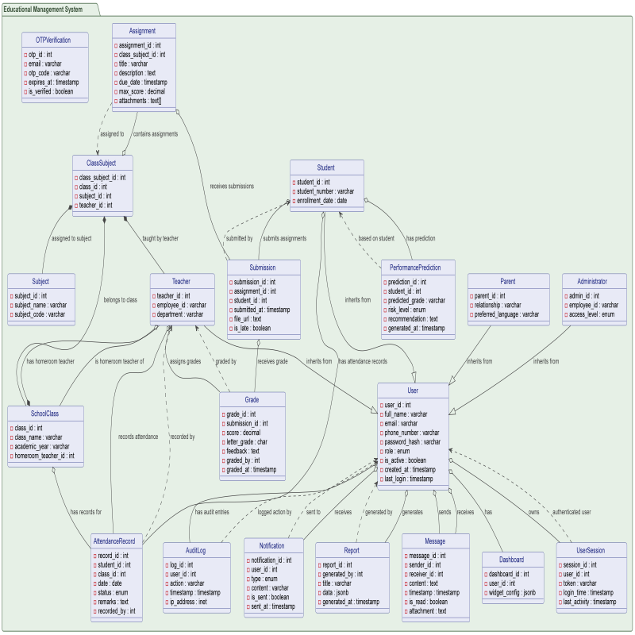
4.5.2 Persistence Modeling
Persistence modeling defines how system data is stored, maintained, and retrieved in a database. In the Smart School Connect system, persistence modeling ensures that all critical data—such as user information, attendance records, assignments, messages, and reports—is stored in a structured and consistent manner.
The system uses a relational database model (PostgreSQL) to manage persistent data. Each major entity in the system is represented as a table, and relationships between entities are defined using primary and foreign keys.

Key Persistent Entities
- User (user_id, name, email, password, role)
- Student (student_id, user_id, class_id)
- Teacher (teacher_id, user_id)
- Parent (parent_id, user_id)
- Attendance (attendance_id, student_id, class_id, date, status)
- Assignment (assignment_id, teacher_id, title, description, deadline)
- Submission (submission_id, assignment_id, student_id, file, grade)
- Message (message_id, sender_id, receiver_id, content, timestamp)
- Notification (notification_id, user_id, message, type)
- Report (report_id, student_id, generated_date)

Persistence Strategy
- Data is stored using structured tables with defined relationships
- CRUD operations (Create, Read, Update, Delete) are handled via backend services
- Indexing is used to improve query performance
- Transactions ensure data consistency and reliability
This model ensures efficient data storage, retrieval, and management across the system.

4.5.3 Mapping with Normalization
Mapping with normalization involves transforming system entities into relational database tables while reducing redundancy and ensuring data integrity.
The Smart School Connect database design follows standard normalization principles, mainly up to the Third Normal Form (3NF).

Normalization Process

First Normal Form (1NF)
- All attributes contain atomic (indivisible) values
- No repeating groups or multi-valued attributes
Example:
Student table stores one value per field (e.g., one phone number per record)

Second Normal Form (2NF)
- The table is in 1NF
- All non-key attributes are fully dependent on the primary key
Example:
In the Submission table, attributes such as grade depend entirely on submission_id, not partially on assignment_id or student_id.

Third Normal Form (3NF)
- The table is in 2NF
- No transitive dependencies exist
Example:
User details (name, email) are stored in the User table, not duplicated in Student or Teacher tables.

Benefits of Normalization
- Reduces data redundancy
- Improves data integrity
- Simplifies data maintenance
- Enhances database efficiency

4.7.Subsystem Decomposition
Subsystem decomposition divides the Smart School Connect system into smaller, manageable components (subsystems). Each subsystem handles a specific functionality, improving modularity, scalability, and maintainability.

Major Subsystems

1. User Management Subsystem
Responsible for:
- User registration and authentication
- Role management (Administrator, Teacher, Student, Parent)
- Profile management

2. Communication Subsystem
Handles:
- Real-time messaging between users
- Notifications and alerts
- Message storage and retrieval

3. Academic Management Subsystem
Manages:
- Attendance recording and reporting
- Assignment creation and submission
- Grading and performance tracking

4. Notification Subsystem
Responsible for:
- Sending alerts (attendance, grades, announcements)
- Real-time updates to users

5. Reporting and Analytics Subsystem
Handles:
- Report generation
- Dashboard visualization
- Performance analysis

6. AI-Based Subsystem (Optional/Advanced)
Provides:
- Student performance prediction
- Recommendation system
- Chatbot assistance

7. System Administration Subsystem
Manages:
- System monitoring
- User access control
- System configuration

Subsystem Interaction
- The User Management subsystem controls access to all other subsystems
- The Communication subsystem interacts with all user-related modules
- The Academic subsystem provides data to Reporting and AI subsystems
- The Notification subsystem supports all modules by delivering alerts

4.8.Component Diagram
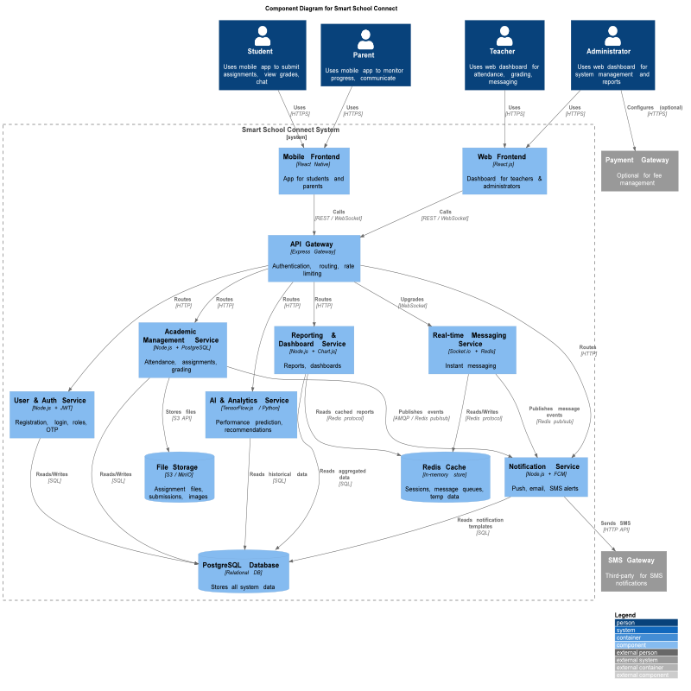
4.9.Deployment Diagram

4.10. System Architecture
System architecture defines the overall structure of the Smart School Connect system, including its components, their interactions, and how data flows between them. It provides a high-level view of how the system is organized to meet both functional and non-functional requirements.
The Smart School Connect system is designed using a multi-tier (layered) architecture combined with microservices and event-driven principles. This approach ensures scalability, flexibility, and efficient real-time communication.
The architecture separates the system into logical layers, allowing independent development, maintenance, and scalability of each component.

4.10.1 Overall System Architecture
The overall system architecture of Smart School Connect consists of the following major layers:

1. Presentation Layer (Frontend)
This layer represents the user interface through which users interact with the system.
Technologies Used:
- React.js (Web Application)
- React Native (Mobile Application)
- HTML5, CSS (Tailwind), JavaScript
Responsibilities:
- Display user interfaces (dashboards, chat, forms)
- Collect user input
- Communicate with backend via APIs
- Provide responsive and user-friendly design

2. Application Layer (Backend)
This layer handles business logic and processes user requests.
Technologies Used:
- Node.js
- Express.js
Responsibilities:
- Process user requests
- Handle authentication and authorization (JWT)
- Manage academic operations (attendance, assignments, grading)
- Control communication between components

3. Real-Time Communication Layer
This layer enables instant communication between users.
Technologies Used:
- WebSocket
- Socket.io
Responsibilities:
- Real-time messaging (chat system)
- Instant notifications
- Event-driven communication

4. Data Layer (Database & Storage)
This layer manages persistent data storage.
Technologies Used:
- PostgreSQL (Relational Database)
- Redis (Caching for performance improvement)
Responsibilities:
- Store user data, academic records, messages
- Maintain data integrity and relationships
- Support efficient data retrieval

5. Integration & External Services Layer
This layer connects the system to external services.
Examples:
- SMS/Notification APIs
- Payment systems (optional)
- Cloud services (AWS or similar)
Responsibilities:
- Enable third-party integrations
- Extend system capabilities

6. AI and Analytics Layer (Optional Advanced Layer)
This layer provides intelligent features.
Technologies Used:
- TensorFlow.js
Responsibilities:
- Student performance prediction
- Recommendation system
- Basic chatbot support

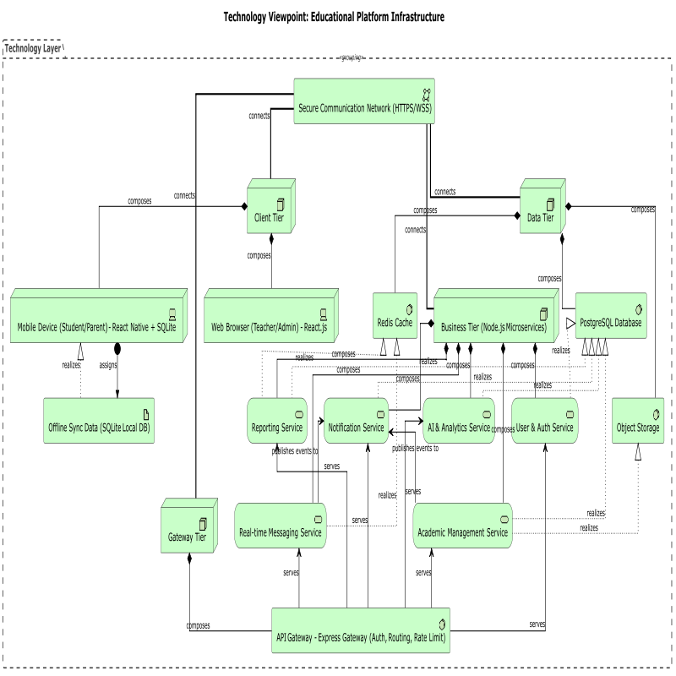
4.10.2 Detail of your architectural patterns and styles
The Smart School Connect system is designed using a combination of architectural patterns and styles to ensure scalability, maintainability, performance, and flexibility. The architecture integrates Layered Architecture, Microservices Architecture, and Event-Driven Architecture, each addressing specific system requirements.

1. Layered Architecture
The system follows a layered (multi-tier) architecture that separates functionality into distinct layers. Each layer has specific responsibilities and interacts only with adjacent layers.

Layers in the System:
- Presentation Layer: User interface (web and mobile applications)
- Application Layer: Business logic and request handling
- Data Layer: Database and data management

Benefits:
- Separation of concerns
- Easier maintenance and debugging
- Improved system organization
- Independent development of components

2. Microservices Architecture
The system adopts a microservices-based approach where functionalities are divided into independent services.

Major Services:
- User Management Service
- Communication (Chat) Service
- Academic Management Service (Attendance, Assignment, Grading)
- Notification Service
- Reporting and Analytics Service
Each service operates independently and communicates with others through APIs.

Benefits:
- High scalability
- Independent deployment of services
- Fault isolation (failure in one service does not affect others)
- Flexibility in technology usage

3. Event-Driven Architecture
The system uses an event-driven model, especially for real-time communication and notifications.

How It Works:
- Events such as message sent, assignment uploaded, or attendance recorded trigger actions
- These events are processed and notifications are sent instantly

Technologies Used:
- WebSocket
- Socket.io

Benefits:
- Real-time system responsiveness
- Efficient handling of asynchronous processes
- Improved user experience

4. Client-Server Architecture
The Smart School Connect system follows a client-server model where:
- The client (frontend) sends requests
- The server (backend) processes requests and returns responses

Benefits:
- Centralized data management
- Secure access control
- Simplified system updates

5. MVC (Model-View-Controller) Pattern
At the application level, the system uses the MVC design pattern.

Components:
- Model: Manages data and business logic
- View: Handles user interface
- Controller: Processes user input and connects Model and View

Benefits:
- Clear separation between logic and UI
- Easier testing and maintenance
- Better code organization

Integration of Architectural Styles
These architectural patterns are not used independently but are integrated:
- Layered architecture organizes the overall system
- Microservices divide the system into functional modules
- Event-driven architecture enables real-time communication
- MVC pattern structures the application logic
- Client-server model defines system interaction

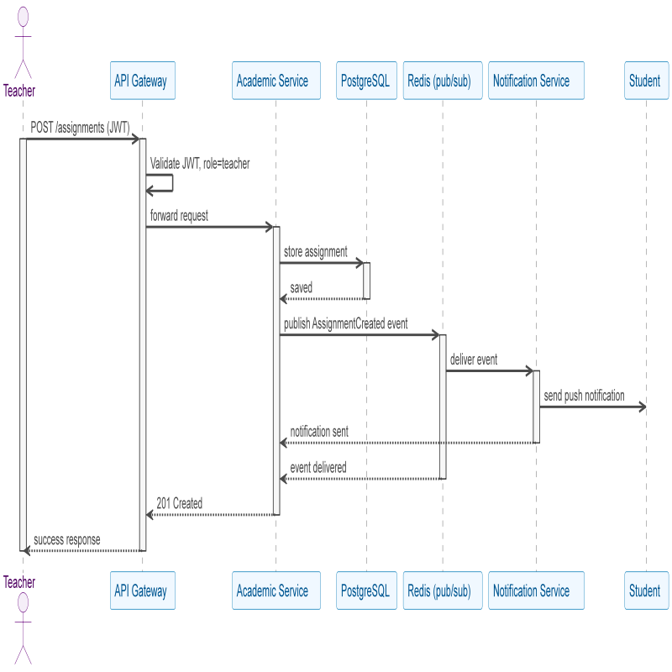
4.11. User-Interface (UI) Design
The User Interface (UI) design of the Smart School Connect system focuses on providing a simple, intuitive, and user-friendly interaction experience for all categories of users, including administrators, teachers, students, and parents. Since users have varying levels of digital literacy, especially parents, the interface is designed to be clear, consistent, and easy to navigate.
The UI design supports both web and mobile platforms, ensuring accessibility and usability across different devices.

4.11.1 Design Objectives
The UI design is guided by the following objectives:
- Simplicity: Interfaces are kept clean and easy to understand
- Consistency: Uniform design elements across all screens
- Accessibility: Suitable for users with basic digital skills
- Responsiveness: Works across desktops, tablets, and smartphones
- Efficiency: Enables users to complete tasks quickly

4.11.2 Design Principles
The following principles are applied in designing the user interface:
- Clarity: Clear labels, readable text, and simple navigation
- Feedback: System provides immediate responses (e.g., message sent confirmation)
- Consistency: Same layout and colors across similar pages
- Error Prevention: Input validation and helpful error messages
- User Control: Users can easily navigate and perform actions

4.11.3 User Interface Structure
The system interface is organized into key sections:

1. Login Page
- Fields for username/email and password
- Login button
- Error messages for invalid input

2. Dashboard
Each user has a personalized dashboard:
- Administrator Dashboard: User management, reports, system monitoring
- Teacher Dashboard: Attendance, assignments, communication tools
- Student Dashboard: Assignments, grades, notifications
- Parent Dashboard: Student performance, attendance, messaging

3. Navigation Menu
- Sidebar or top navigation bar
- Links to main features (Dashboard, Messages, Assignments, Reports)

4. Messaging Interface
- Chat window for real-time communication
- Contact list (students, teachers, parents)
- Message input box and send button
- Option to attach files

5. Attendance Interface
- Class selection
- Student list display
- Attendance marking options (Present/Absent)
- Save button

6. Assignment Interface
- Upload assignment (teacher)
- View and submit assignment (student)
- Display deadlines and instructions

7. Notification Panel
- Displays alerts and updates
- Shows recent activities (messages, assignments, attendance)

4.11.4 UI Technologies Used
The system uses modern frontend technologies:
- React.js for web interface
- React Native for mobile application
- HTML5, CSS (Tailwind CSS), JavaScript for layout and styling
These technologies ensure responsive, fast, and interactive user interfaces.

4.11.5 Usability Considerations
To ensure usability:
- Minimal text complexity for easy understanding
- Mobile-first design for accessibility
- Simple icons and visual cues
- Reduced number of steps for completing tasks
- Support for low-bandwidth environments

4.11.6 Sample Screen Descriptions
The system includes the following key screens:
- Login Screen
- User Dashboard
- Messaging Screen
- Assignment Management Screen
- Attendance Recording Screen
- Notification Screen
(Actual UI mockups or screenshots should be included here for better presentation.)

