
College of Engineering and Technology
DEPARTMENT OF SOFTWARE ENGINEERING

INTERNSHIP REPORT
On Industrial Practical Training at Fanaye Technologies
Submitted by:
Tinsae Abera…………………………wcu/R/14D2727
Tolera Fayisa………………………….wcu/R/14D2814
Tsion Tesfaye………………………..wcu/R/14D2861
Ashenafi Abebe…………………….wcu/R/1402864

Year: 4th Year
Duration of Internship:four months

COMPANY SUPERVISOR:minilik
ADVISOR: MR.fozia and sindu gebremareyam
OCTOBER 09//2024
HOSANNA, ETHIOPIA

Declaration
We, the undersigned, sincerely declare that this internship report entitled “Industrial Practical Training at Fanaye Technologies” is the outcome of our own dedicated effort and honest work carried out during the four-month internship program at Fanaye Technologies. The internship was successfully completed under the continuous guidance and supervision of our academic advisors from Wachemo University and our industrial supervisors at Fanaye Technologies.
This report clearly documents the activities, tasks, projects, and practical experiences we were involved in throughout the internship period. All information, analyses, illustrations, and discussions presented in this report are authentic and were developed by us based on our direct participation and learning. Any external materials or references used to support this work have been appropriately acknowledged and cited.
We further affirm that this report has not been submitted, either in whole or in part, to any other university, institution, or organization for the purpose of obtaining any degree, diploma, or certification. The contents of this report genuinely reflect our practical exposure, professional growth, and the application of theoretical knowledge gained during our software engineering studies at Wachemo University.
We would like to express our heartfelt appreciation to our academic mentors and industrial supervisors for their continuous support, guidance, and encouragement throughout the internship program, which greatly contributed to the successful completion of this report.
Certified by:
Academic Supervisor (Wachemo University): _______________________
Industrial Supervisor (Fanaye Technologies): _______________________

Acknowledgements
Above all, we give thanks to Almighty God for granting us life, good health, strength, wisdom, patience, and perseverance throughout our academic journey and the internship period. His constant guidance and protection enabled us to overcome challenges, remain focused during difficult times, and transform every obstacle into an opportunity for personal and professional growth.
We extend our sincere and heartfelt gratitude to Wachemo University, particularly the Department of Software Engineering, for organizing this industrial internship program. This initiative played a vital role in bridging the gap between theoretical knowledge gained in the classroom and practical, real-world industrial experience, thereby preparing us for future professional responsibilities.
We are deeply thankful to our academic supervisor, Mr. Alemayehu Shemebo, for his invaluable guidance, constructive feedback, encouragement, and continuous support throughout the internship period. His academic insight and dedication significantly contributed to the successful completion of our internship.
Our profound appreciation goes to Fanaye Technologies, especially our mentors, supervisors, and team members, for welcoming us into a professional working environment. Their technical guidance, mentorship, teamwork, and assignment of challenging and meaningful projects greatly enhanced our practical skills, professional confidence, and understanding of real-world software development practices.
Finally, we express our deepest gratitude to our families for their unwavering love, patience, moral support, prayers, and encouragement throughout the internship period. Their continuous support and belief in us provided the motivation and strength needed to successfully complete this internship and achieve our academic goals.

Executive Summary
This report presents a comprehensive overview of the four-month industrial internship undertaken by four final-year (4th-year) Software Engineering students from Wachemo University at Fanaye Technologies, Ethiopia, from September 15, 2025, to January 20, 2026. The internship program was designed to bridge the gap between academic learning and real-world industry practices by providing hands-on experience in professional software development environments.
The primary objective of the internship was to apply theoretical knowledge gained during academic studies to practical software development tasks, enhance technical and analytical problem-solving skills, and gain exposure to modern development tools and frameworks. Throughout the internship period, the interns actively worked with contemporary technologies including React, Next.js, Tailwind CSS, Node.js, Prisma, PostgreSQL, and GitHub, which are widely used in today’s software industry.
At the initial stage of the internship, each intern was assigned an individual project intended to assess their understanding of core software engineering concepts, coding skills, and problem-solving abilities. After successfully completing this evaluation phase, the interns were selected to participate in three major projects. These included the development of an E-commerce system tailored to specific client requirements, an Internal Project Management System designed to support project planning and task tracking, and Company Software Testing activities focused on improving software quality and reliability.
Overall, the internship experience significantly enhanced the interns’ technical competence while also strengthening essential professional skills such as teamwork, communication, time management, and adherence to workplace standards. The practical exposure gained during this period has played a vital role in preparing the interns for future professional careers in the field of software engineering.

ABBREVIATION
PMS: Project Management System
IT: Information Technology
ERP: Enterprise Resource Planning
UI/UX: User Interface / User Experience
SDLC: Software Development Lifecycle
API: Application Programming Interface
ORM: Object-Relational Mapping
IDE: Integrated Development Environment
CRUD: Create, Read, Update, Delete

Catalog
Declaration II
Acknowledgements III
Executive Summary IV
ABBREVIATION IV
List of table VI
Chapter 1: Introduction 1
1.1 Background of Software Engineering in Ethiopia 1
1.2 Importance of Industrial Internships 1
1.3 Objectives of the Internship 2
1.4 Personal Expectations and Learning Goals 3
1.5 Significance of the Internship in Professional Development 3
Chapter 2: Description of the Internship Hosting Organization and Position 4
2.1 Purpose of the Internship 4
2.2 Overview of Fanaye Technologies 5
Mission & Approach 5
Location & Presence 5
Company Size & Culture 5
History & Background 5
🚀 Values & Vision 5
2.3 Technologies and Tools Used we have used during intrenship 7
Chapter 3: Description of the Experience 9
3.1 Overview of Main Tasks 9
3.2 Detailed Project Analysis 10
Trendy Merches - Influencer Marketing Platform 12
20
3.3 Weekly Internship Log 20
3.4 Challenges Faced During Internship 21
3.5 Learning and Skills Gained 21
Chapter 4: Analysis of the Experience 22
4.1 Assessment of Assignment Performance 22
4.2 Skills and Knowledge Acquired 22
4.3 Applicability of Knowledge from University 23
4.4 Challenges and How They Were Overcome 23
4.5 Personal Reflections of Each Intern 24
4.6 Lessons Learned 25
4.7 Overall Assessment of the Internship 25
Chapter 5: Summary 26
5.1 Overall Internship Experience 26
5.2 Lessons Learned 26
5.3 Importance of Internship for Career Development 27
5.4 Group Recommendation for wachemo university 27
Attendance and Timesheet 27
References 28

List of table
Table 1 Frontend Technologies 7
Table 2 Backend Technologies 7
Table 3 Version Control and Collaboration Tools 7
Table 4 Daily Workflow Example 8
Table 5 Weekly Internship Log 20
Table 6 Technical Skills 23
Table 7 Applicability of Knowledge from University 23
List of figure
Figure 1 III
Figure 2 advntage of internship 4
Figure 3 Internship Workflow 2.4 Work Organization, Tools, and Methods 9
Figure 4 E-comeres Project Architecture Diagram 12
Figure 5 trendy merche (e-comerce) landing page 13
Figure 6 trendy merche sign up page 13
Figure 7 trendy merches add to cart page 14
Figure 8 trendy merche (e-comerce) influencer page in client side 14
Figure 9 landing page of pms 16
Figure 10 client dashboard 16
Figure 11 templates projects and task page 17
Figure 12 pms admin dashboard 17
Figure 13 Internal PMS Architecture Diagram 18
Figure 14 project work follow 18
Figure 15 GitHub commit history and branch management screenshots. 20
Figure 16 Skills Growth Diagram 26

Chapter 1: Introduction

1.1 Background of Software Engineering in Ethiopia
Software engineering is one of the fastest-growing fields in Ethiopia, driven by the increasing demand for digital transformation in businesses, government services, and startups. Over the past decade, the Ethiopian IT industry has evolved from basic computer services to more complex software solutions including web applications, mobile applications, and enterprise software systems.
Universities in Ethiopia, including Wachemo University, have recognized the importance of equipping students with not only theoretical knowledge but also practical skills. Courses in programming, database management, software design, and project management are complemented with industrial internship programs, which are crucial in bridging the gap between classroom knowledge and real-world applications.
The internship program allows students to work in professional environments, understand modern software development practices, and become familiar with industry-standard tools such as React, Next.js, Node.js, Prisma, PostgreSQL, and GitHub. In addition, students learn about team collaboration, problem-solving, and project lifecycle management, which are essential skills for any software engineer in Ethiopia or globally.
The Ethiopian software industry still faces challenges, including limited access to advanced technologies, lack of mentorship in some startups, and logistical difficulties. Therefore, internships at established companies like Fanaye Technologies offer students the opportunity to gain high-quality professional experience, overcoming these challenges in a structured and supportive environment.

1.2 Importance of Industrial Internships
Industrial internships are an integral part of the Software Engineering curriculum at Wachemo University. These internships provide students with opportunities to:
Apply Theoretical Knowledge:
During coursework, students learn programming languages, database management, and software design principles. Internships provide the chance to apply these concepts in real projects, allowing students to see the practical relevance of their studies.
Gain Hands-on Experience:
Interns are exposed to modern software development tools and frameworks that are commonly used in the industry. For instance, in our internship, we used React for frontend development, Node.js for backend services, Prisma for database management, and GitHub for version control. Working with these tools enhanced our understanding of how professional applications are developed.

Develop Problem-Solving Skills:
Real-world software development involves challenges such as integration issues, debugging complex errors, and meeting client-specific requirements. Internships provide a safe environment to practice critical thinking, troubleshooting, and iterative problem-solving.
Improve Teamwork and Communication:
Software development is rarely a solo activity. Interns learn how to collaborate with team members, mentors, and clients, improving their communication, reporting, and coordination skills.
Understand Professional Workflow and Industry Standards:
Internships expose students to Agile development methodologies, task tracking using notion, code reviews, and version control practices. These experiences are vital for understanding how projects are managed in a real professional setting.
Career Readiness:
Internships provide insights into workplace expectations, professional ethics, time management, and adaptability, preparing students for full-time employment after graduation.

1.3 Objectives of the Internship
The main objectives of our internship were:
To gain practical experience in software development using modern frontend and backend technologies.
To apply theoretical knowledge acquired in university courses to real-life projects.
To understand the complete software development lifecycle, from requirement analysis to deployment.
To develop teamwork and professional communication skills while working in a collaborative environment.
To improve problem-solving, debugging, and testing skills by facing real-world software development challenges.
To learn version control, task management, and Agile practices, which are essential for professional software development.
Expected Outcomes:
By the end of the internship, we expected to:
Successfully complete individual and client projects.
Understand how teams operate in professional software environments.
Develop confidence in using modern technologies and frameworks.
Improve communication, teamwork, and time management skills.

1.4 Personal Expectations and Learning Goals
Each intern had personal goals to achieve during the internship:
Frontend Development & Version Control
Gained a deeper understanding of frontend development concepts and best practices.
Improved proficiency in using Git and GitHub for version control, collaboration, and workflow management.
Backend Development & Database Integration
Enhanced backend development skills, including server-side logic and API development.
Learned how to integrate databases effectively with backend systems for data storage and retrieval.
Debugging, Testing & Problem Solving
Improved ability to debug applications and identify root causes of errors.
Developed skills in testing applications and applying systematic problem-solving techniques.
Project Architecture & Client-Oriented Development
Learned to work with complex project architectures and modular codebases.
Gained experience in understanding real client requirements and translating them into functional software solutions.

1.5 Significance of the Internship in Professional Development
The internship at Fanaye Technologies was not just a requirement for our degree but a critical stepping stone toward our professional growth. By working on real client projects, participating in team discussions, and following professional development practices, we gained experiences that cannot be taught in a classroom.
Internships provide a platform for continuous learning, where mistakes become learning opportunities, and guidance from mentors accelerates skill acquisition. This experience will enhance our employability, confidence, and readiness to join professional software engineering teams after graduation.
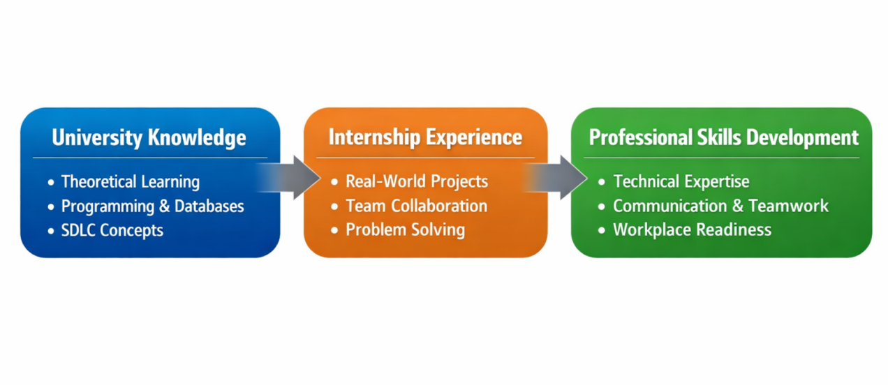
Figure 2 advntage of internship

Chapter 2: Description of the Internship Hosting Organization and Position

2.1 Purpose of the Internship
The primary purpose of the internship at Fanaye Technologies was to provide students with a professional environment to apply theoretical knowledge in practical projects, strengthen problem-solving abilities, and gain exposure to modern software development technologies.
Key objectives of this internship include:
Practical Application of Knowledge:
Implement frontend and backend solutions using React, Next.js, Node.js, Prisma, and PostgreSQL.
Understand the complete software development lifecycle (SDLC) from requirements gathering to deployment.

Skill Assessment and Improvement:
Interns were given an individual test project initially to evaluate their problem-solving and coding skills.
Completing the project successfully demonstrated readiness to participate in real client projects.
Professional Exposure:
Learn teamwork, project management, communication, and collaboration in a professional setting.
Develop adaptability by working on multiple projects, using version control systems, and handling client requirements.
Preparation for Future Careers:
Gain confidence in tackling professional software development tasks.
Acquire industry-relevant technical and soft skills to increase employability.

2.2 Overview of Fanaye Technologies
Fanaye Technologies is an innovative software development company based in Ethiopia, specializing in creating web and mobile solutions for diverse clients.

2.2.1 Company Profile

Mission & Approach
Fanaye Technologies aims to support digital transformation for organizations, particularly across Africa, by combining innovative technologies with strategic branding. They emphasize client success, quality work, and close collaboration with customers to bring ideas to life.

Location & Presence
Headquarters: Addis Ababa, Ethiopia
The company operates locally and works on projects serving a variety of clients needing digital and software solutions.

Company Size & Culture
Small but skilled team (approximately 10+ employees according to LinkedIn).
Personnel include developers, designers, marketers, and tech consultants focused on innovation and partnerships.

History & Background
The company was founded around 2019 and has been growing its portfolio since then, working on projects involving apps, websites, IT training, and branding strategies.

🚀 Values & Vision
Fanaye Technologies prioritizes:
Innovation – staying up-to-date with technology trends.
Quality – delivering solutions that go beyond client expectations.
Collaboration – working closely with clients throughout project lifecycles.
2.2.2 Services Offered
Fanaye Technologies specializes in a mix of tech and branding services, including:
Software development – building custom software solutions tailored to clients’ needs.
Mobile application development – creating apps for Android/iOS and other platforms.
IT training and capacity building – offering education, up-skilling, and technical training.
Consulting services – advising businesses on tech strategies and digital transformation.
Branding and digital strategy – helping companies build strong online identities and visibility.

2.2.3 Team and Organizational Capacity
Fanaye Technologies has a team structure designed to optimize project delivery and learning opportunities for interns:
CEO/Founder – Provides vision and oversees operations
Senior Developers (10+) – Mentors interns, guides project development, ensures quality standards
Social Media Manager (1) – Manages company’s online presence
Video and Graphics Editor (1) – Supports UI/UX and multimedia needs
Interns (8+ capacity) – Contribute to real projects while learning industry practices

2.2.4 Market Positioning
Fanaye Technologies is recognized in Ethiopia for delivering reliable, innovative, and client-focused software solutions. It maintains a competitive edge by:
Adopting modern technologies and frameworks
Providing structured mentorship for interns
Successfully delivering multiple client projects in various industries

2.3 Technologies and Tools Used we have used during intrenship

2.3.1 Frontend Technologies:
Technology | Purpose
Reat,vue,typescript | Build interactive and dynamic user interfaces
Next.js
Tailwind CSS | Responsive styling and UI design
Table 1 Frontend Technologies

2.3.2 Backend Technologies:
Technology | Purpose
Node.js(express) | Backend logic and server-side processing
Prisma | Object-Relational Mapping for database access
PostgreSQL | Relational database management and storage
Table 2 Backend Technologies

2.3.3 Version Control and Collaboration Tools:
Tool | Purpose
GitHub | Version control, branching, and code collaboration
notion | Task and project management
Zoom | Team communication and meetings(freelancer)
Table 3 Version Control and Collaboration Tools
2.4 Internship Role and Responsibilities
As Software Development Interns, our main responsibilities included:
Project Implementation:
Develop frontend and backend features for client projects
Integrate databases, APIs, and third-party services
Testing and Debugging:
Conduct functional and manual testing to ensure software reliability
Debug complex issues in coordination with senior developers
Version Control Management:
Manage project code using GitHub
Learn new Git commands, resolve merge conflicts, and maintain code quality
Collaboration and Team Communication:
Participate in team stand-ups, project reviews, and discussions
Communicate progress and challenges to mentors and team members
Documentation:
Maintain proper project documentation
Prepare reports for completed tasks and milestones
Daily Workflow Example:
Time | Activity
9–10 am | Stand-up meeting and task assignment
10–12 pm | Coding
12–1 pm | Lunch break
1–3 pm | Code review, mentor guidance, integration
3–5 pm | Testing, debugging, and deployment preparation
5–6 pm | Daily summary, documentation, plan next day
Table 4 Daily Workflow Example
2.5 Work Organization, Methods, and Learning Environment

2.5.1 Work Organization
Projects were organized using Agile methodology, divided into sprints for iterative development.
Mentors assigned tasks and monitored progress using task boards and daily stand-ups.
Interns worked collaboratively in teams, simulating professional software environments.

2.5.2 Learning Environment
Mentorship: Each intern received guidance from senior developers on best practices and project implementation.
Tools: Interns were trained in IDE usage, version control, and database management.
Feedback: Code reviews and evaluations helped interns identify and improve on weaknesses.

2.5.3 Challenges Faced by Interns
Version Control: Learning GitHub commands and resolving merge conflicts was challenging at first.
Team Communication: Coordinating with team members required clarity and active communication.
Transportation: Traveling from our villages to the company daily was sometimes difficult.
Project Complexity: Understanding client-specific requirements and designing software accordingly was challenging but improved our problem-solving skills.

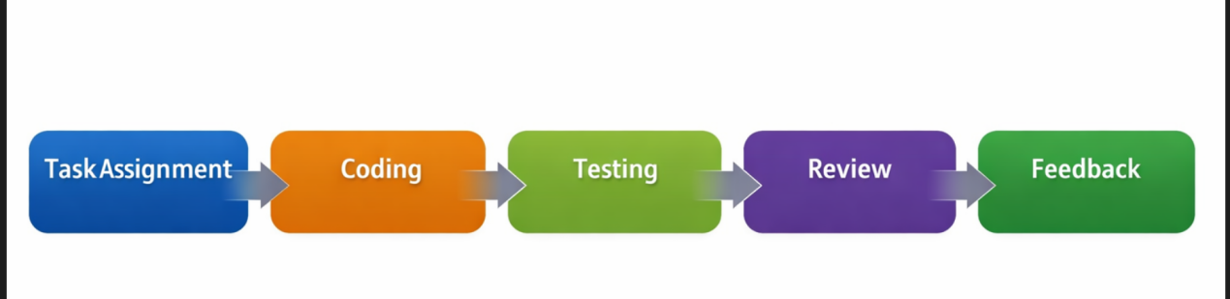
Figure 3 Internship Workflow
2.4 Work Organization, Tools, and Methods
Environment: Collaborative, professional, focused on learning.
Resources: Laptops, IDEs, PostgreSQL servers, GitHub, notion boards.
Methods: Agile development, daily stand-ups, iterative development, code reviews, mentorship guidance.

Chapter 3: Description of the Experience

3.1 Overview of Main Tasks
During the four-month internship at Fanaye Technologies, we were engaged in multiple activities that covered all aspects of software development. The primary tasks included:
Individual Test Project:
A project assigned at the beginning of the internship to test our understanding of software development principles.
Focused on coding, debugging, version control, and problem-solving.
Client Projects Development:
E-comperes Project: Web application for a client, including fronted, backed, and database integration.
Infernal Project Management System (PMS): Internal project tracking system for clients.
Company Test Software Development:
Testing and debugging preexisting company software.
Enhancing quality assurance skills.
Collaboration and Team Activities:
Daily stand-ups, task assignments, code reviews, and mentor guidance.
Use of GitHub for version control and notion for task management.
Documentation and Reporting:
Maintaining code documentation.
Preparing progress reports and submitting project updates for review.

3.2 Detailed Project Analysis

3.2.1 Individual Test Project
As part of the company’s recruitment and evaluation process, candidates were required to complete a project-based technical examination before joining the organization.
Each applicant was assigned a small, self-contained software project designed to assess their practical knowledge, problem-solving ability, and readiness for real-world development work.
The projects were selected based on industry relevance and role requirements, and included tasks such as:
Developing a simple note-taking application with sharing functionality
Building a basic e-commerce application
Creating a task management system
All projects were implemented using modern web technologies, primarily React for the frontend, Node.js for the backend, and PostgreSQL for database management.
This examination approach allowed the company to evaluate candidates’ technical skills, understanding of full-stack development, code structure, and ability to deliver functional solutions, ensuring that only qualified and prepared individuals were selected to join the organization.
Challenges Faced:
Learning new GitHub commands for version control.
Debugging complex errors in fronted and backed integration.
Understanding database schema and relationships using Prisma.
Solution and Outcome:
Mentor-ship guidance helped resolve Git issues.
Successfully implemented the CRUD functionalities.
The project was reviewed and approved, allowing us to move to real client projects.

3.2.2 e-comerse Project
Trendy Merches is a full-stack influencer marketing and e-commerce platform that connects brands, influencers, and customers in one system. The platform allows influencers to promote products and earn commissions from sales, while brands can manage products, promotions, orders, and payments. It is designed to be practical, secure, and ready for real-world use.
The system is built using a modern architecture with a separate frontend and backend. The frontend is developed with Next.js 14 and TypeScript, using Tailwind CSS for styling and Redux Toolkit for state management. Users log in securely using Google OAuth and JWT, and real-time features such as notifications are handled with Socket.io. The interface also includes forms with validation and simple charts for analytics.
The backend is developed with Node.js and Express using TypeScript. It uses PostgreSQL as the database with Prisma ORM for data management. The backend handles user authentication, product management, order processing, commission calculation, and payment workflows. Redis is used for session handling, Cloudinary for image storage, and Nodemailer for email notifications. Security is ensured through standard middleware such as CORS, Helmet, and rate limiting.
The platform supports three main user roles: Admin, Influencer, and Customer. Admins manage the system and approve requests, influencers promote products and track their commissions, and customers browse products and place orders. Influencer profiles are verified to maintain trust on the platform.
Product management features include a categorized product catalog, inventory tracking, exclusive products for influencers, and image uploads. The commission system tracks clicks, sales, and conversions to accurately calculate influencer earnings. Multiple payment methods are supported, including bank transfer, PayPal, Stripe, and Wise.
The checkout system supports both guest and logged-in users and includes Ethiopian address formats. Customers can upload payment proof, which is reviewed before order confirmation. The platform also tracks production progress for exclusive or custom products.
Simple analytics and reports are provided to show sales, commissions, and influencer performance. The database contains multiple connected tables for users, products, orders, payments, and commissions. The project includes development tools for testing, database setup, and production builds.
In summary, Trendy Merches is a simple yet powerful influencer e-commerce platform that combines online shopping with commission-based marketing, making it suitable for academic projects and real-world applications.

Challenges:
Integration of frontend with backend APIs.
Complex database queries for client-specific features.
Team communication to coordinate tasks among multiple developers.
Outcome:
Successfully delivered a fully functional application meeting client requirements.
Learned to manage client feedback and implement changes effectively.
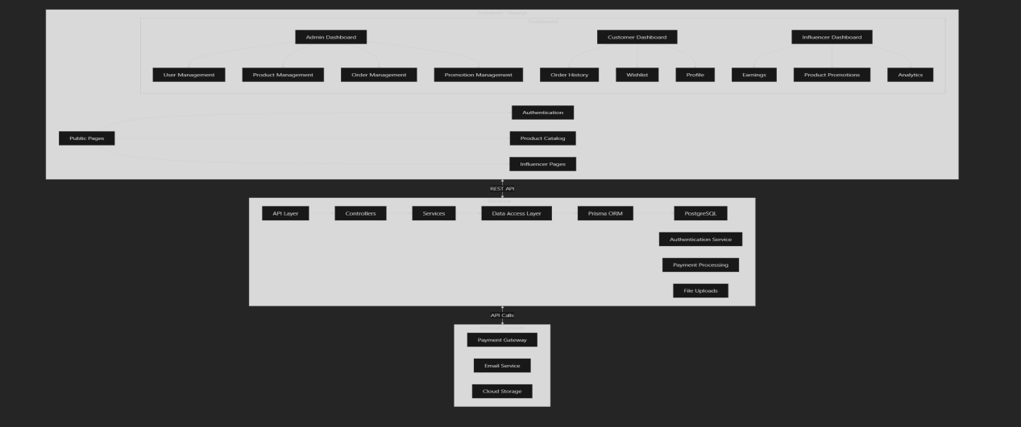
Figure 4 E-comeres Project Architecture Diagram

Trendy Merches - Influencer Marketing Platform
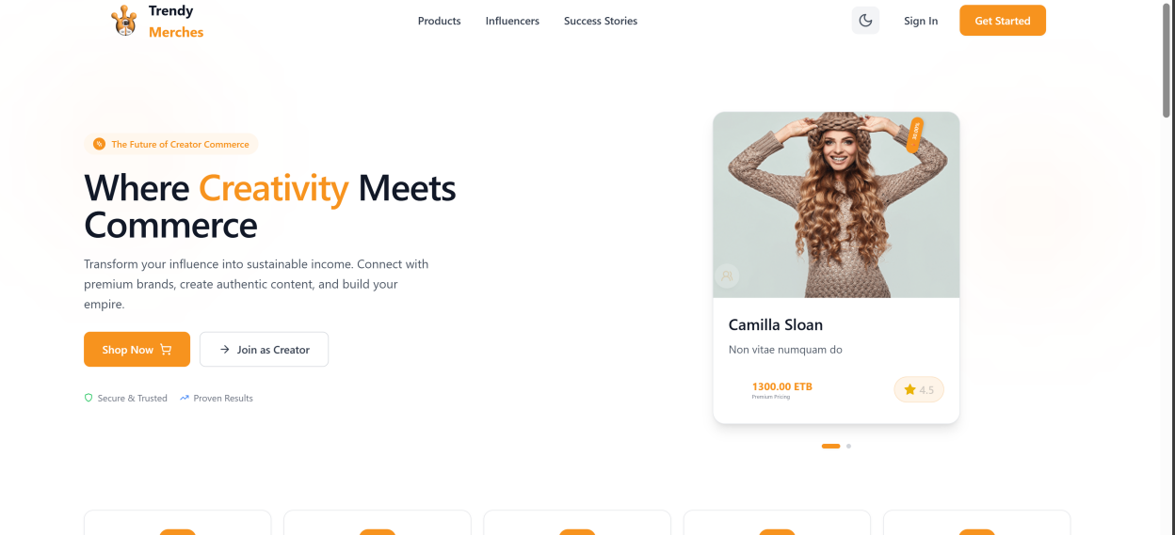
Figure 5 trendy merche (e-comerce) landing page

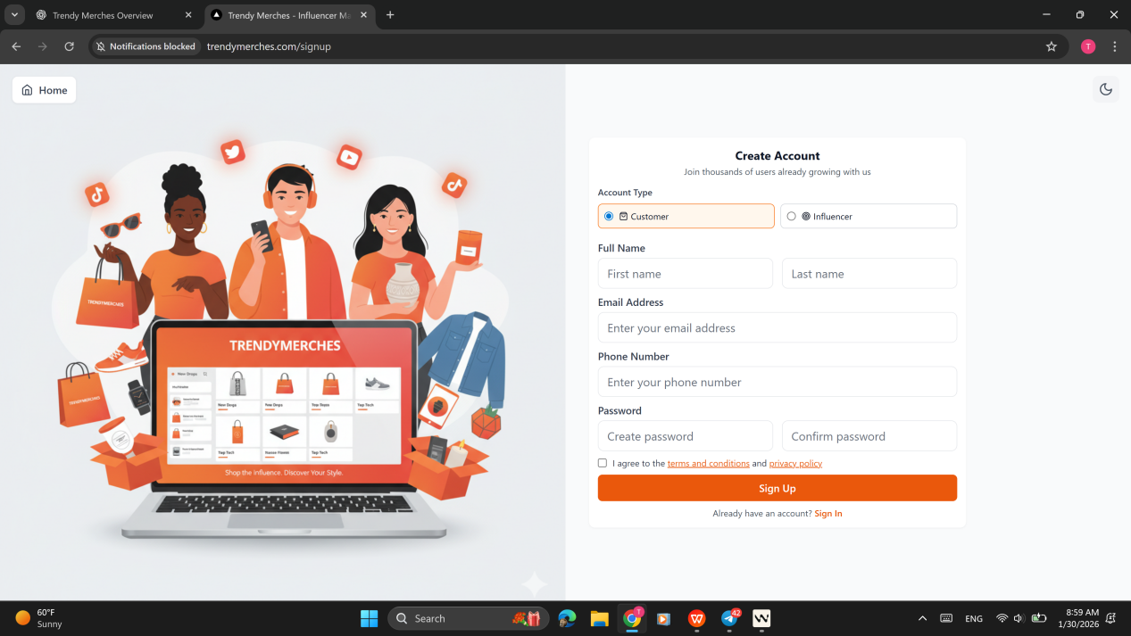

Figure 6 trendy merche sign up page

Figure 7 trendy merches add to cart page
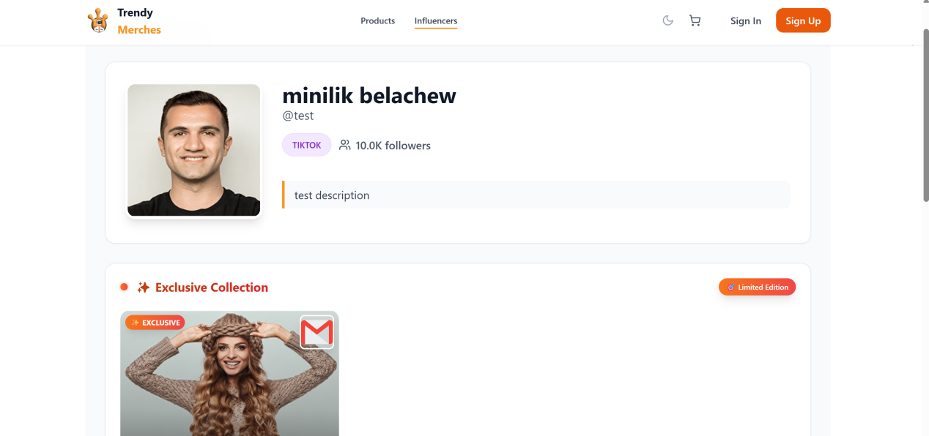
Figure 8 trendy merche (e-comerce) influencer page in client side
5.5 Internal PMS
This project is a modern project management platform developed to support teams in planning, organizing, tracking, and delivering work efficiently. The system focuses on clarity, structure, collaboration, and control, while avoiding unnecessary automation or complexity. Work within the platform follows a hierarchical model consisting of workspaces, projects, lists, tasks, and subtasks. The platform is designed as a multi-tenant system with role-based access control and detailed activity logging, making it suitable for both small teams and enterprise-level use.
The system defines two levels of user roles. At the system level, a System Administrator is responsible for managing the overall platform, including users, workspaces, security, backups, and analytics. This role operates independently from project-level activities. At the workspace and project level, the platform uses three simplified roles: Project Manager, Member, and Viewer. Project Managers control project structure, permissions, milestones, and team members, Members are responsible for executing tasks and collaborating with others, and Viewers have read-only access for monitoring purposes.
Users access the platform through a secure authentication process using email and password, with optional support for single sign-on. New users are guided to create a workspace, which represents an organization or team. The user who creates a workspace is automatically assigned the Project Manager role. A workspace serves as a container for projects, members, templates, and configuration settings, and users may belong to multiple workspaces with different roles in each.
Within a workspace, projects can be created either from scratch or by using predefined templates. Projects act as the main execution units where tasks are planned and completed. Templates function as reusable blueprints that include predefined lists, tasks, subtasks, dependencies, milestones, and workflows. When a template is used, the system creates a new project by copying the structure while generating new identifiers and activity logs, ensuring consistency without duplicating historical data.
Project work is organized using lists, tasks, and subtasks. Lists are used to group tasks into logical stages such as planning, development, testing, and completion. Each task contains essential attributes including title, description, status, priority, due dates, assigned users, tags, time tracking information, comments, and file attachments. Subtasks allow larger tasks to be broken down into smaller, manageable units. Tags are defined at the workspace level and are used to support filtering, searching, and reporting across projects.
Collaboration within the system is primarily task-based. Users can communicate through comments on tasks and projects, and mentions can be used to notify specific users. All significant actions performed within the system are recorded in activity logs, creating a transparent and auditable history of project activities. This ensures accountability and traceability throughout the project lifecycle.
The platform supports milestone management to represent key delivery points within a project. Milestones aggregate progress from related tasks and are displayed in timeline and calendar views. The system validates milestone deadlines to ensure they align with the project schedule and provides warnings when associated tasks are delayed.
To support different planning and tracking preferences, the platform provides multiple views of project data, including list view, board (Kanban) view, timeline (Gantt-style) view, and calendar view. These views allow users to visualize work in different ways without modifying the underlying project data.
File management is integrated directly into the platform. Files can be uploaded at the project, task, or comment level and support version control, ownership tracking, and access management. Each file maintains a complete history, ensuring traceability and supporting audit requirements.
The system includes both in-application and email-based notification mechanisms. Notifications are triggered by events such as task assignments, mentions, status changes, and approaching deadlines. Users can customize notification preferences, and email delivery is handled through an external email service.
The platform is designed with performance and scalability in mind, targeting support for a large number of users and concurrent operations. A dedicated administrative dashboard allows System Administrators to manage global users, workspaces, permissions, activity logs, security settings, and system reports without interfering with ongoing project work.
The platform is implemented using a modern technology stack, with a React-based frontend framework, a Node.js backend with RESTful APIs, and a relational database managed through an object–relational mapping tool. The user interface supports both light and dark themes and follows a clean, professional design optimized for extended usage.
In conclusion, this project management platform is designed around the principle that structured organization improves productivity and efficiency. By prioritizing clarity, transparency, and control, the system provides a reliable and scalable solution for managing projects in academic, professional, and enterprise environments.
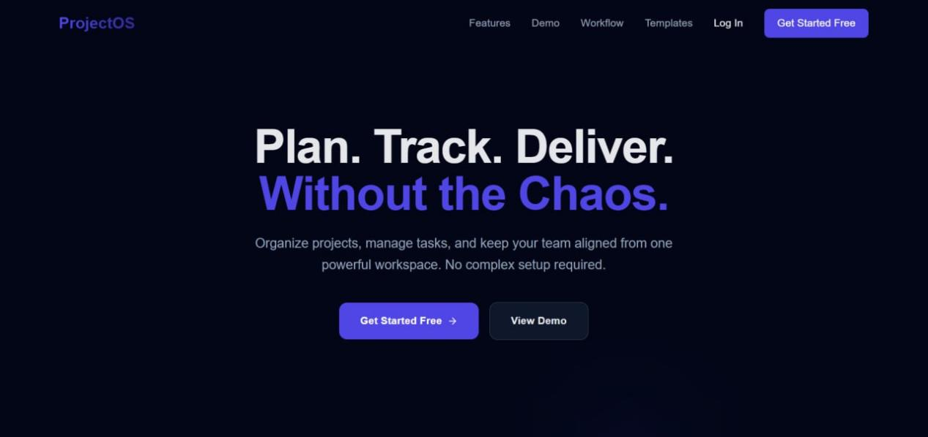
Figure 9 landing page of pms
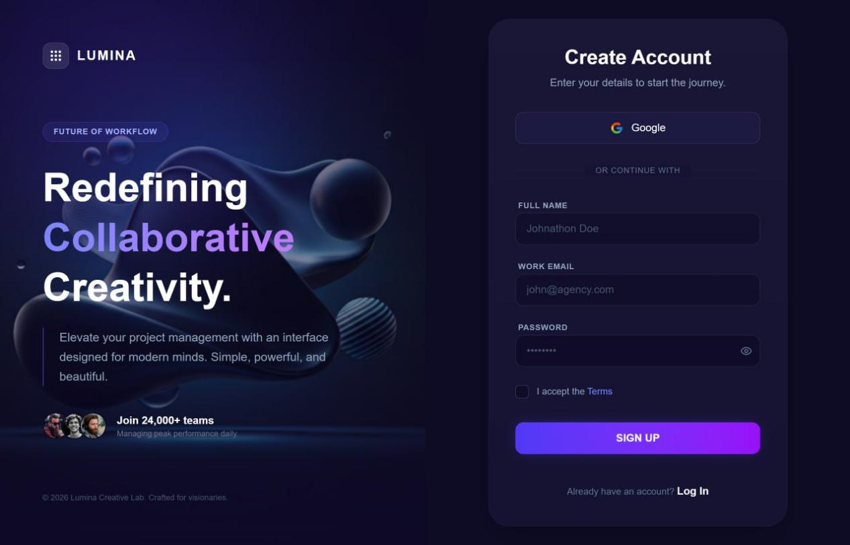
Figure 10client dashboard
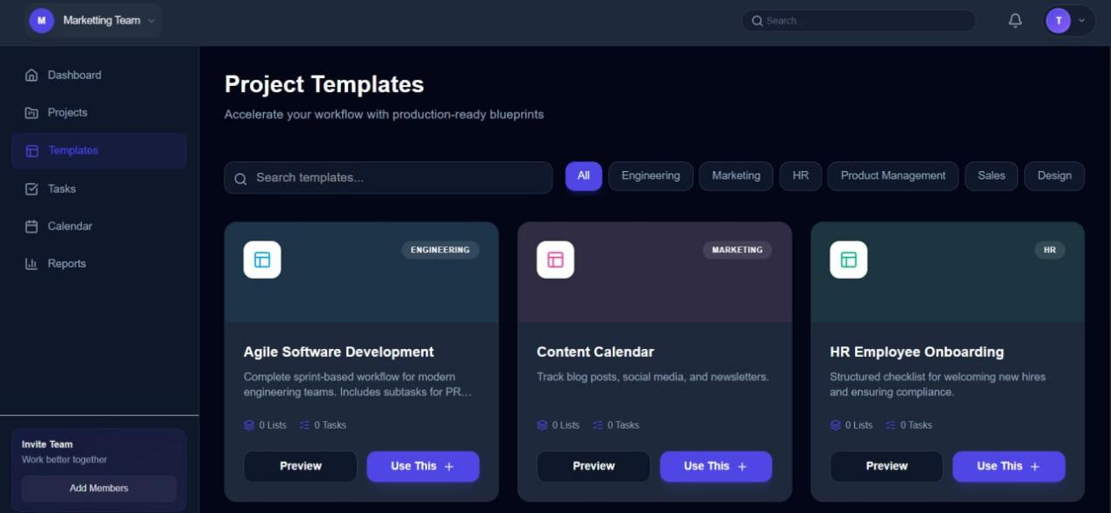
Figure 11 templates projects and task page
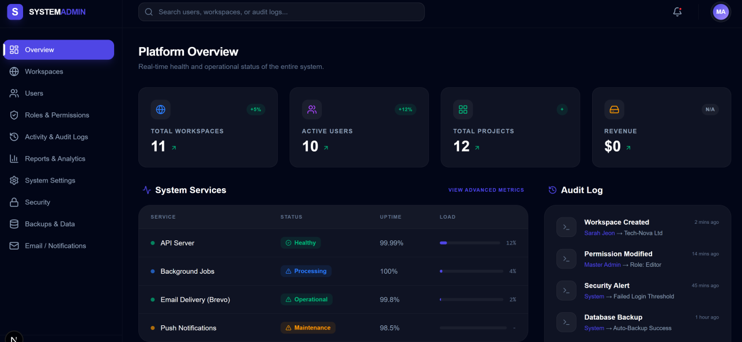
Figure 12 pms admin dashboard

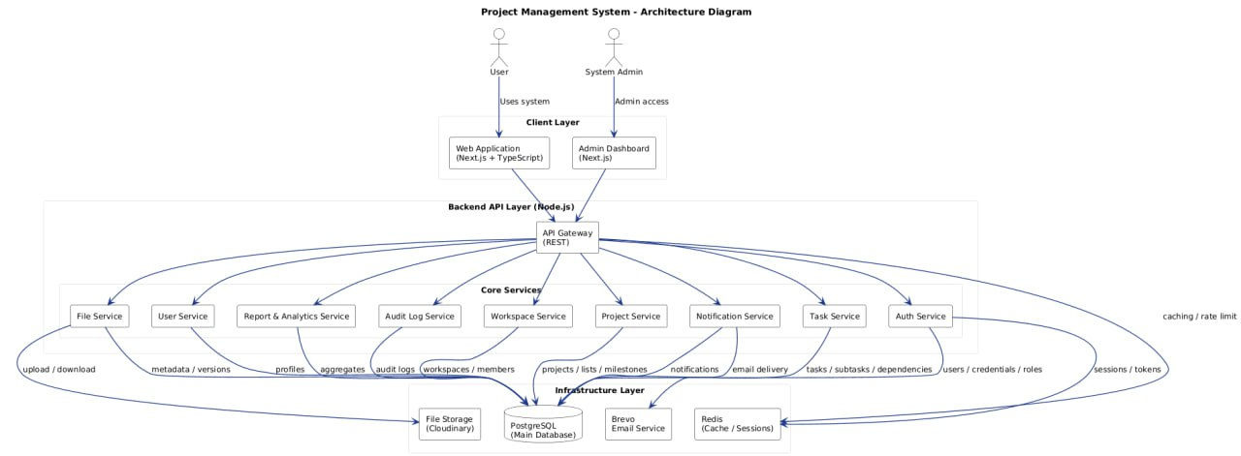
Figure 13 Internal PMS Architecture Diagram
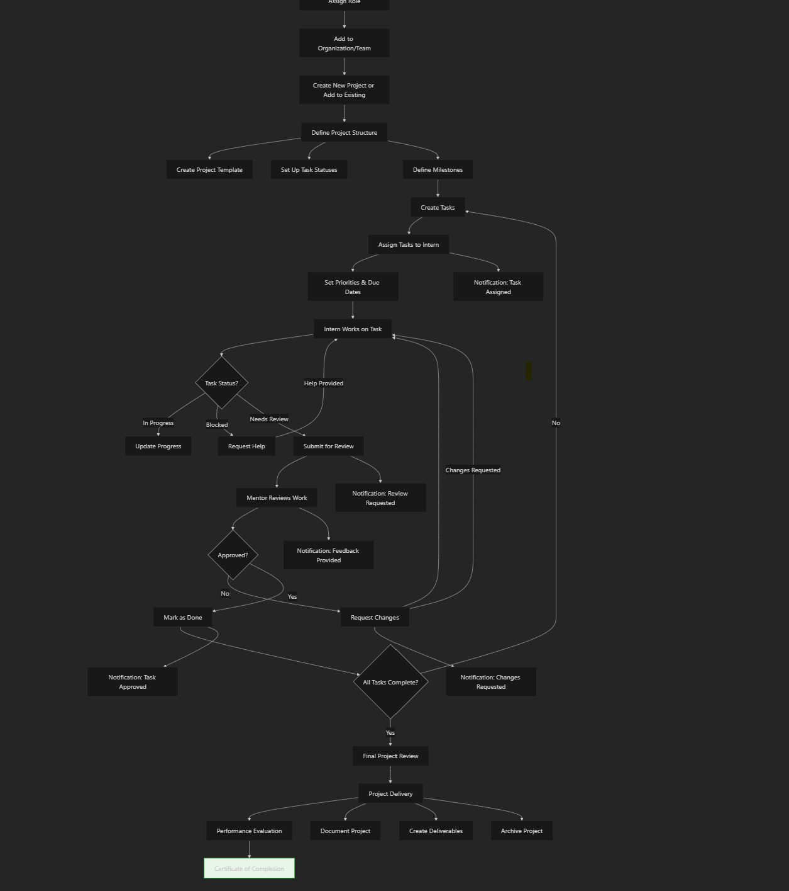
Figure 14 project work follow
Challenges:
Complex queries and relational data management in PostgreSQL.
Ensuring frontend UI was synchronized with real-time backend data.
Handling merge conflicts in GitHub during collaborative development.
Outcome:
Developed and deployed the system successfully.
Gained experience in team-based development, database design, and user interface integration.

3.2.4 Company Test Software
Objective:
Test and debug internal software products of Fanaye Technologies to ensure reliability.
Tasks:
Functional testing for features.
Identifying and reporting bugs to senior developers.
Suggesting possible improvements to enhance software usability.
Challenges:
Understanding pre-existing code written by other developers.
Tracking and documenting bugs effectively.
Outcome:
Enhanced debugging and problem-solving skills.
Improved understanding of software lifecycle in real-world applications.

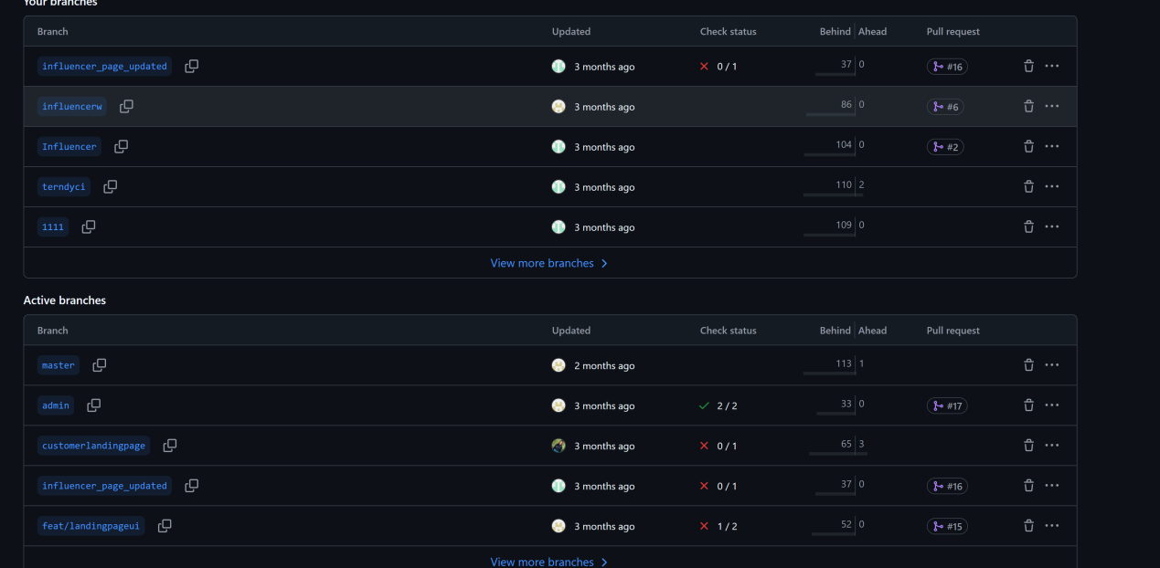
Figure 15 GitHub commit history and branch management screenshots.

3.3 Weekly Internship Log
To provide a detailed view of the experience, we maintained a weekly log of all tasks, challenges, solutions, and lessons learned. Below is a sample expanded version for the first few weeks.
Week | Dates | Tasks | Challenges | Solutions | Skills Gained
1 | Sep 15–21 | Orientation, environment setup | Familiarizing with tools, GitHub | Mentorship guidance | Basic workflow setup, tool familiarization
2 | Sep 22-29 | Start individual test project | Debugging errors in React/Node.js | Peer collaboration | Frontend/backend integration, database basics
3 | Sep 30-oc 6 | GitHub setup, CRUD operations | Merge conflicts | Mentorship and trial & error | Version control, commit management
4 | Oct 7-13 | Complete individual project, review | Implementing database relations | Mentor assistance | Database design, problem-solving
5 | Oct 14-21 | Start Ectomeres project frontend | Responsive design challenges | Tailwind CSS guidance | UI design skill
6 | Oct 22-28 | Backend API integration | API connection errors | Debugging and code review | API development, backend logic
7 | Oct 29-nov 6 | Database integration | Complex queries | Mentorship and documentation | PostgreSQL and Prisma ORM skills
… | … | … | … | … | …
 | Jan 14–20 | Final project review, feedback | Time management | Adjusted daily schedule | Professional discipline, project delivery
Table 5 Weekly Internship Log

3.4 Challenges Faced During Internship
Version Control Challenges:
Learning GitHub commands and resolving merge conflicts was initially difficult.
Overcame by practicing, reviewing tutorials, and mentor guidance.
Team Communication:
Coordinating tasks with senior developers and other interns required active communication and reporting.
Project Complexity:
Client projects had complex requirements, which required careful planning, debugging, and iterative testing.
Transportation Issues:
Traveling from our villages to the company was challenging, particularly during peak traffic hours.
Lesson Learned:
Adaptability, patience, teamwork, and problem-solving are essential skills for professional software development.

3.5 Learning and Skills Gained
Technical Skills:
Frontend: React, Next.js, Tailwind CSS
Backend: Node.js, REST APIs, Prisma ORM
Database: PostgreSQL design and optimization
Version control: GitHub branching, pull requests, merging
Soft Skills:
Teamwork and collaboration
Effective communication with mentors and peers
Professional discipline and time management
Problem-Solving Skills:
Debugging complex frontend and backend errors
Handling client-specific project requirements
Managing multiple tasks and deadlines

Chapter 4: Analysis of the Experience

4.1 Assessment of Assignment Performance
During the four-month internship at Fanaye Technologies, our performance was assessed through:
Completion of Individual Test Project:
Successfully implemented the project requirements using React, Node.js, and PostgreSQL.
Overcame challenges in version control (GitHub branching, merging, pull requests).
Client Projects Development (Ecomeres & Internal PMS):
Delivered projects according to client specifications.
Handled frontend, backend, database, and UI integration effectively.
Received constructive feedback from mentors and senior developers.
Company Test Software:
Conducted functional testing and bug identification.
Suggested improvements to enhance usability and efficiency.
Reflection on Performance:
Initially, project complexity and team coordination were challenging, but regular guidance, peer collaboration, and iterative learning enabled successful completion.
By the end of the internship, we were able to confidently develop, test, and deploy complete software solutions.

4.2 Skills and Knowledge Acquired

4.2.1 Technical Skills
Skill Area | Description | Example
Frontend Development | Building dynamic, responsive UIs | Next.js ,tailwind css
Backend Development | API creation, server logic, database integration | Node.js + Prisma backend for Infernal PMSPMS
Database Management | Designing schemas, writing queries, optimizing performance | PostgreSQL schema for multi-project management
Version Control | Using GitHub effectively for collaborative coding | Branching, pull requests, resolving conflicts
Testing & Debugging | Functional, manual, and unit testing | Testing company internal software and client projects
Table 6 Technical Skills

4.2.2 Soft Skills
Team Collaboration: Learned to communicate effectively, report progress, and coordinate tasks with team members and mentors.
Time Management: Balanced multiple projects and weekly deadlines efficiently.
Professional Discipline: Punctuality, adherence to company guidelines, and maintaining proper documentation.
Problem-Solving: Debugging complex issues, finding optimized solutions, and applying analytical thinking to development tasks.

4.3 Applicability of Knowledge from University
The internship allowed us to apply theoretical knowledge from Wachemo University into practical projects:
University Knowledge | Practical Application
Web Development (html, javascript,css) | Developed fully functional frontend UIs for projects
Database Design & SQL | Entity relationship diagram andQuery orented table design
Software Lifecycle (SDLC) | Participated in planning, coding, testing, deployment phases
Object-Oriented Programming(java) | Used for backend logic and modular code design
Agile Concepts (from class) | Applied sprint-based development and daily standups
Table 7 Applicability of Knowledge from University
Analysis:
University knowledge provided the foundation, but real projects demanded advanced problem-solving, collaborative work, and professional workflow understanding.
This shows the value of combining academic learning with industrial experience to produce competent software engineers.

4.4 Challenges and How They Were Overcome
Version Control Challenges:
Initially unfamiliar with GitHub commands like branching, merging, and pull requests.
Overcome through mentor ship guidance, practice, and online tutorials.
Team Coordination:
Collaborating on projects with multiple interns and senior developers required clear communication.
Solved by daily meetings, documentation, and active participation in stand-ups.
Project Complexity:
Client-specific requirements were sometimes ambiguous or challenging to implement.
Approach: Break down requirements, seek guidance, and iterative testing.
Transportation Issues:
Commuting from villages to the company daily was time-consuming.
Solution: Early departures and planning daily schedules efficiently.

4.5 Personal Reflections of Each Intern
Tinsae Abera
Developed strong full-stack development skills, with a focus on building responsive user interfaces using React and Tailwind CSS, and integrating them with backend services. Gained confidence in using GitHub for version control and team collaboration. Also learned the importance of clean code, proper documentation, and readable project structure in full-stack applications.
Tolera Feysa
Enhanced full-stack development experience by working on backend systems using Node.js and Prisma, while ensuring smooth integration with frontend components. Gained practical knowledge in database optimization, API development, and system performance. Strengthened problem-solving skills by independently handling complex full-stack tasks.
Tsion Tesfaye
Built solid full-stack development skills by working across both frontend and backend components. Improved debugging and testing abilities to ensure reliable and efficient applications. Learned to adapt quickly to changing project requirements and improved time management while handling multiple full-stack tasks simultaneously.
Ashenafi Abebe
Gained comprehensive full-stack development experience, including project architecture, frontend–backend integration, and deployment readiness. Worked closely with senior developers and other interns to deliver well-structured applications. Developed confidence in producing client-ready full-stack software solutions that meet professional standards.

4.6 Lessons Learned
Technical Growth:
Hands-on experience is crucial to mastering modern software technologies.
Exposure to frontend, backend, database, and version control enhances employability.
Soft Skills:
Teamwork, communication, and professional discipline are as important as technical skills.
Problem-Solving:
Real projects teach creative thinking, debugging, and optimized solutions.
Workplace Readiness:
Internships prepare students to handle client requirements, deadlines, and team collaboration in a professional environment.

4.7 Overall Assessment of the Internship
The internship at Fanaye Technologies was highly effective in:
Bridging theoretical knowledge and practical application.
Enhancing technical and professional skills through real-world projects.
Exposing interns to modern software development workflows, including Agile practices, version control, and collaborative development.
Building confidence and career readiness for all four interns.
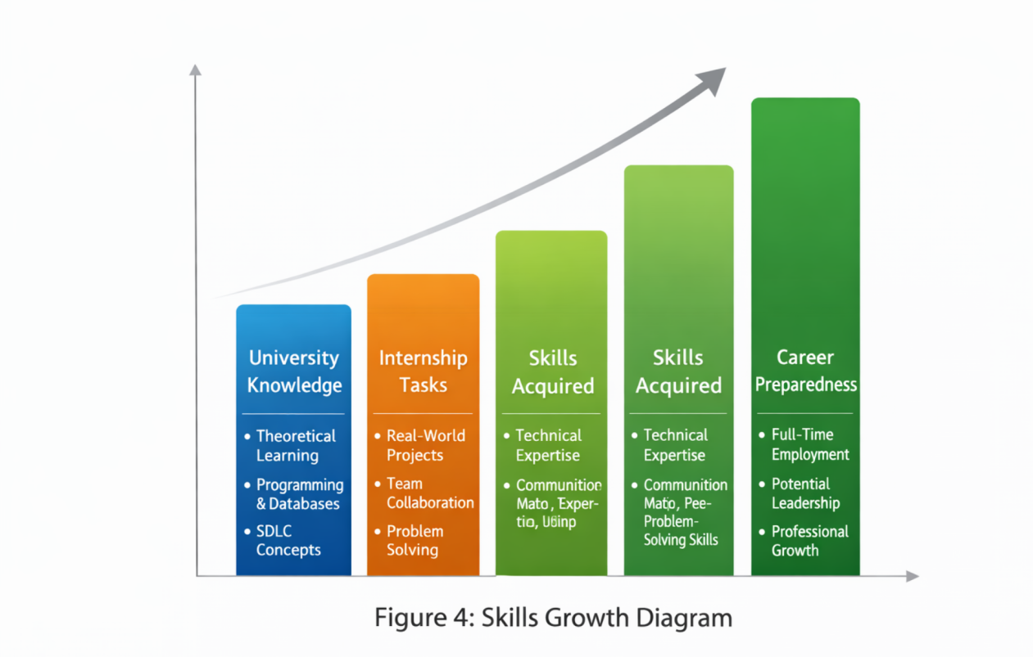
Figure 16 Skills Growth Diagram

Chapter 5: Summary

5.1 Overall Internship Experience
The internship at Fanaye Technologies was a comprehensive and transformative experience. Over the four months (September 15, 2025 – January 20, 2026), we transitioned from being university students with theoretical knowledge to practically skilled software engineers capable of handling real-world projects.
Key highlights:
Worked on three main projects: the individual test project, E-comer's, and the Infernal Project Management System, plus testing of company software.
Learned to develop full-stack applications using React, Next.js, Tailwind CSS, Node.js, Prisma, and PostgreSQL.
Gained professional experience in version control (GitHub), Agile workflows, and collaborative development.
Overcame challenges in project complexity, team communication, and transportation.

5.2 Lessons Learned
The internship provided both technical and soft skills growth:
Technical Lessons:
Advanced frontend and backend development skills.
Database design, query optimization, and API integration.
Version control management and GitHub collaboration.
Testing and debugging of complex software systems.
Professional Development Lessons:
Effective communication and collaboration in a professional team.
Time management and meeting project deadlines.
Adaptability in dynamic project environments.
Understanding professional software development workflows.
Personal Development Lessons:
Gained confidence in working independently and as a team.
Learned to accept constructive feedback and implement improvements.
Developed problem-solving, analytical thinking, and planning skills.

5.3 Importance of Internship for Career Development
The internship at Fanaye Technologies significantly enhanced our career readiness:
Prepared us for full-time employment in software engineering.
Strengthened our portfolio with real client projects.
Taught us the importance of continuous learning and staying updated with industry trends.
Provided insight into professional work ethics, team dynamics, and client interactions.

5.4 Group Recommendation for wachemo university

Attendance and Timesheet

References
Fanaye Technologies Official Website – https://fanayetechnologies.com
Wachemo University Internship Guidelines (2025)
Internship mentorship notes and task documentation from Fanaye Technologies
React, Next.js, Node.js, Tailwind CSS, Prisma, PostgreSQL official documentation
GitHub Guides: Version control, branching, merging, and pull requests

