浙江海洋大学
毕业论文（设计）外文翻译

学 院：船舶与机电学院
专 业：机械电子工程
班 级：A13机电
学 号：130408109
学生姓名：戴挺远
指导教师：陈胜

二○ 年 月

<外文翻译：原文>
Development of an innovative micro extrusion head based on screw for experimental additive manufacturing machines
Abstract: The purpose of this work is to present the design planning and development of a screw extrusion head with variable section screw. The conceptual validation was performed in a portable open-source additive manufacturing machine (Fab@CTI machine). It was made a pre-calculation of the main components of the head, which were: screw, barrel and transmission system. The materials considered for the theoretical calculations were Nylon® 12 and the biopolymer ε-PCL (ε-policaprolactone) in powder form. The screw extrusion head was manufactured and assembled demonstrating the functionality to carry the powder material through the sections of the screw extrusion and generated Nylon® 12 filaments with diameter of approximately 0.7 mm using a tip of diameter 0.4 mm. The morphological characteristics of the filaments were observed in Scanning Electron Microscopy (SEM) confirming the mixing of the powder, generating a continuous filament. SEM tests were made with ε-PCL using material generated from the feed zone and the compression zone of the screw extrusion head allowing the visualization of the adhesion of the grains in feed section and the complete mixing in the compression zone for the ε-PCL

1. INTRODUCTION
Recently there was an increasing development in additive manufacturing technologies as well as a real perspective to use it in the area of health, with highly complex geometries, specifically the ones of tissue engineering. Commercial AM machines generally need a high quantity of material to start
working and build parts; additionally there are limited operational settings and they are configured to use proprietary materials from the suppliers and manufacturers. These constraints hinder advances in research areas that include materials development and process. Therefore, it becomes interesting the development of technologies for open source 3D printers with reduced dimensions that permit the small quantities of feeding material and a freedom towards the software, hardware development and configuration parameters. Another motivation for this work is the increasing market related to desktop 3D printers with a crescent number of brands using different materials and techniques of deposition
The most common technologies used in desktop 3D printer included: the Fused Deposition Modeling (FDM) that is a commercial process consider the raw material as thermoplastic material fed in the form of a flexible filament rolled in a coil. The filament is guided into the head by a device controlled by integrated numerical command where pulleys are responsible for feeding wired material and pushes it into a heated channel, causing it to melt and to be extruded through a nozzle in the opposite end of the channel. Other technique uses the extrusion of cold materials by a syringe which occurs by the compression of the material within a deposition chamber and the subsequent extrusion of this material through a needle. Any of these processes, coupled to a (x,y,z) controlled displacement system enables prototyping 3D models. In the case study, the development of a screw extrusion head, the material enters in a powder form in the top of the device, being carried to the lower parts getting melted in the way by the use of a tubular resistance acquiring a continuous and viscous consistence enabling its extrusion through a nozzle tip in the end of the process. The success in this process relies in the capacity of producing continuous filaments which can be deposited in a 3-D printing platform permitting the construction of parts. In the case of using biomaterials it permits the fabrication of scaffolds can be defined as a “temporary porous structure used to promote cells growth where its function is to allow a structural support to the formation of new biological tissues” (Ikegami, 2007).
The purpose of this work is to present a systematic design development of an interchangeable screw extrusion head with variable section to be used in a desktop 3-D printer based on Filament Deposition Modeling. It was made a calculation methodology for the extrusion screw and transmission system. A validation of the conceptual design for industrial and biomaterials applications, respectively,
were carried out using polyamide (Nylon® 12) and ε-PCL producing continuous filaments and parts. The SEM analyses were made with these materials and the results presented morphological characteristics appropriated to polymer structure extrusion used in additive manufacture purposes

2.DEMAND IDENTIFICATION AND USER’S REQUIREMENTS

For a desktop 3-D printer alternative head design the main points observed were: a) raw material related to the use of different forms (pellets, powder, solids) and in reduced amount. In bioengineering applications the use of powder material to generate prototypes is highly indicated due to commercial availability. The use of powder raw material is common in the polymer industry, especially in injection and extrusion molding. In non-commercial AM machines, specifically desktop 3-D printers, the solutions found are: syringe injection (Bowyer and Sells 2004 and Malone and Lipson, 2007), thermoplastic filament extruder (Inforçatti Neto, et al., 2012) and transport extrusion system for previously melted biopolymer (PT 104247, 2008); all of them on open-source design. b) Operational performance, related to flexible platforms, reduced dimensions, again use of different raw materials and low cost. In commercial machines, technical solutions are protected by patents included control systems and combined mechanisms, making the purchase price of the machinery and raw material, as well as the cost of maintenance too high and even unfeasible to non-industrial users. In this way, a new
branch from Fab@Home, named Fab@CTI 3-D printer, showed in Fig. 1 (a), offers low cost, open platform to the assembly of an alternative screw extrusion head based on FDM
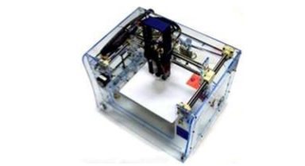
Fig.1 Fab@CTI with the syringe head extruder (Inforçatti Neto, et al 2013)

Fab@CTI characteristics:
A) Definition of the market “niche”: Tissue engineering (production of scaffolds) and small mechanical components.
B) Utilization environments: Research laboratories including research centers and universities.
C) Machine volume: 460mm x 410 mm x 470 mm.
D) Mass: 25-50kg Inforçatti Net
o (2013) presented a technical design feasibility of screw extrusion head of this study case. The user‘s requirements were raised at design phase and obtained from QFD (Quality Function Deployment) analysis. Figure 1 shows the user´s requirements list
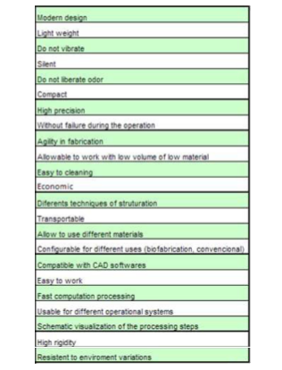
Fig. 2 – User’s requirements list (Inforçatti Neto, 2013).

The list of user’s requirements shown in Figure 2 was translated into technical characteristics which supports the constructive solutions choice to mechanical design of extrusion mini-head

3 CONSIDERATIONS ABOUT EXTRUSION PROCESS

The choice of the conformation method used in a specific polymer depends on some factors, as the choice of the polymer, geometry and size of the final part. In the case on a thermoplastic polymer, the rheological properties (flow curves, melting point), operational temperature, cooling time after the process should be considered, in the case of a thermofix, it’s considered the temperature and curing time. The temperature or melting point describes the phase transformation of a crystal solid for a liquid. According to Chung (2000) the melting point term is used only for crystalline polymers, because amorphous polymers without crystallization do not present the same melting point (it can occur up to Glass Transition Temperature (Tg), for amorphous thermoplastics polymers). Chung (2000) describes the melting process as a change in solid/liquid behavior in amorphous or semi-solid polymers. According Rauwendaal (2001), the polymer processing in extruders involves the use of any kind of solid material fed to the extrusion screw, which is melted and carried by the screw’s rotation until the end of course. The designs of a single or double extrusion screw are the most common configurations in industrial polymer processing. There are many mechanisms used to pump liquids with low and high viscosity. According to White and Potente (2003) for highly viscous liquids usually two different principles are used: (1) positive displacement pumps, where the fluid fills enclosed chambers and is moved forward by the mechanical movement of the parts of the machine (ram extruder in processing of thermoplastic); and (2) drag flow pumps, in this case the fluid fills a region between two surfaces, where one is in motion. The relative movement of the two surfaces drags the fluid along a channel, gradually pressurizing and forcing it through a die. The second mechanism has some technical solutions developed along the years, but the simplest machine is the drum flow pump or drum extruder invented by Gabrielli (1952) apud White and Potente (2003). In this machine, the material to be pumped is put on an annular space between the rotating drum and surrounding barrel. The rotation of the drum carries the liquid to a position where there is a wiper bar that diverts the liquid into the die. The die pressurizes the liquid and a pressure gradient develops along the length of the channel between the drum and the barrel. A complete study about behavior of extrusion processes involve an estimative on thermo-physical parameters, mainly related to screw, where its geometry, polymer rheology, and processing conditions must be considered. Béreaux, et al. (2009); Chung (2000); White and Potente (2003) describe the extrusion process to a standard single screw extruder into three zones related with screw design. The performance of an extrusion process can be improved substantially by optimization of the screw design. Summarizing, the screw performs three basic functions: (1) solid conveying function. (2) Melting function and (3) metering or pumping function. In most applications, these three functions occur simultaneously along screw length and they are strongly interdependent. The size of a screw is described by its diameter and length or “length-to-diameter (L/D) ratio”. Chung [10] used geometrical names to the three different sections: (1) feeding section at the hopper end with a constant, deep channel depth called “feeding depth”. In this region conveying of a solid bed from compacted pellets occurs. Pressure increases steeply along the screw but cannot reach high values in smooth barrel extruder without the phenomenon of melting of the superficial layer in contact with the barrel hence releasing any extra pressure, (2) metering section or pumping section at the die end with a constant, shallow channel depth called “metering depth”. Béreaux, et al. (2009) define this zone as “delay” where the molten film of polymer increases in thickness and possibly permeates the solid bed itself. This condition occurs at the end of the feed zone of the screw, and (3) a compression section (or transition section or melting section) between the feeding section and the metering section with a decreasing channel depth. In this region occurs the melting process, when the melt film has increased up to a point where it runs through the solid bed of ever decreasing width. Béreaux, et al. (2009) identify a forth section in the direction of the end of the compression zone and in the metering zone the solid bed is completely melted and there is melt conveying only. Throughput in the conveying zone is the combination of screw rotation that provides the drag flow and the pressure gradient in the screw channel. When the pressure gradient is positive it blocks the drag flow, while it promotes the flow when it is negative. Throughput is constant along the channel, while pressure development start from atmospheric pressure and ends at back pressure imposed on the screw in the case of injection molding, or at atmospheric pressure at the die exit in the case of extrusion. For the extrusion process, the level of back pressure is the result of the combination of die and screw.
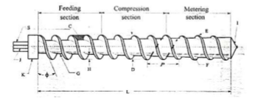
Fig.3 Geometric features of single-screw–double-flighted (From: Chung, 2000)

It’s important to realize that conventional extruders have large dimensions compared with the device developed in this study. With the intention of built a functional device with the same capabilities of a conventional extruders, but with reduced dimensions, developed concepts and methods for these industrial extruders where used and based on these, a calculation methodology was made. With this calculation methodology it was proposed the verification, dimensioning and choosing of the main components as screw extrusion, stepper motor, worm gear and barrel. The vertical configuration designed to the screw extrusion head allows better use of space design as well as the arrangement of the drive system.

4 CALCULATION PROCEDURES

With the aim to ensure strength and performance required, calculations to define the geometries of the extrusion screw and barrel were done. Calculation procedure was based on technical literature of standard industrial extrusion screw. A functional prototype was fabricated and assembled. From the theory described in item 4, were obtained the main design parameters of the barrel-screw and actuation system. Usually, the screws are not subjected to a high bending force because they run inside a strong rigid barrel and the clearance between screw and barrel is small, around 0.0005 to 0.002 (White and Potente, 2003). The small gap between screw and barrel prevents solidification by cooling of the melt. Leakage flow caused by the clearance between the inner barrel and screw flight reduces the melting efficiency also. Then, the manufacturing process of extrusion screw, in this case, must have high precision. The critical strength requirement is mechanical resistance to torque that is very dependent of polymeric’s material type. In this step a precalculation was made considering some geometric and fluid characteristics to the mini screw as well as the head extruder. In this step, calculations were made considering some geometric and fluid characteristics to the extrusion screw as well as the head extruder in general. The flowchart presented in Figure 8, shows a simplified sequence of calculations applied in a single screw extrusion head to a portable 3-D printer (Fab@CTI). The procedure of the calculation was based on Rauwendaal (2001) and Chung (2000).

a)
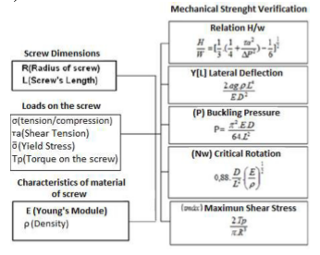

b)
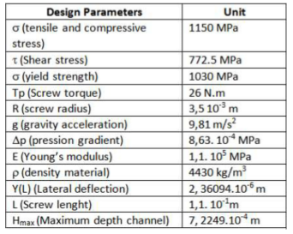
Fig.4 a) Calculation strategy b) Mechanical properties

The transmission system chosen was a gearbox (worm gear). This first choice has considered the high transmission ratio as well as the space restrictions. The viscosities were considered to selection of the stepper motor and those are directly related with power and torque characteristics. The materials chosen to the design and experimental validation were: Polyamide (Nylon® 12) and Polycaprolactone (PCL). Nylon® 12 was the first polymeric material used to obtain some important materials properties such as the relationship: shear rate and linear velocity. Its choice is due two reasons. First, the availability of the material in the laboratory (CTI), in its non-degraded and degraded form, result of previous prototyping processes by Selective Laser Sintering and second, its wide use in industrial parts. Polyamide (Nylon® 12) is a semi-crystalline polymer which is highly hygroscopic and because of this characteristic it should be taken to a greenhouse with air ventilation, before being processed. Its processing temperature is higher than 240°C, having a melting temperature in a narrow range and oxidizes easily when exposed to hot air and it presents low viscosity after being fused. With these properties this material needs a dosage zone with a constant shallow canal, to avoid fluctuations due to its low viscosity. The control of polyamide viscosity in different extrusion velocities, rheometry analysis of virgin and degraded materials were considered and the objective was the determination of rheological curves of these samples at 225°C. From the rheometry analysis it was possible to observe the shear strength of the non-degraded polyamide is significantly less than the degraded one, probably due to the thermal and mechanical solicitation, which are suffered in previous processing, this information are available in Inforcatti Neto (2013). This means when leaking, through the extrusion process the non-degraded polymer offers less resistance to shearing, and therefore needs less energy in the activation of the extrusion screw to flow along the extruder’s body. However, the rheometry analysis indicated a higher resistance in the case of ε-PCL shearing and thus, calculation of the gearbox was based on the torque moment of ε-PCL. The considered flowchart is represented in fig. 10.
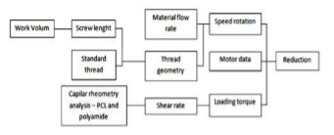
Fig.5 Flowchart related to calculation procedure and choice of the gearbox.

The ε-PCL was the biomaterial chosen for the device trials and this material is related to other previous studies (Rezende, et. al., 2012; Inforçatti, et. al., 2012) in the health area.

6 DETAIL DESIGN AND TRANSMISSION SYSTEM CHOICE
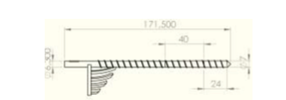
Fig.6 AISI Stainless Steel 304 machined extrusion screw for the 3D printer head.

The screw extrusion design presents three sections and it was developed considering mechanical strength to the torque caused by the turning into the viscous melted polymer material. The mixer in the feed section was proposed to avoid the caking of the powder material which would cause the locking of the screw and bubbles formation in the polymer material.
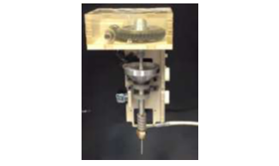
Fig.7 - First screw extruder mini head prototype.

7 PRELIMINAR EXPERIMENTAL TESTS – INTERCHANGEABLE SCREW EXTRUSION HEAD VALIDATION

From the detailed design, it was generated a mock-up to verify the assembly system and kinematics aspects. The following step was the manufacturing of a functional prototype. Machining processes and additive manufacturing were used in the fabrication of this prototype. Finally, experimental tests were conducted to investigate the capacity of extrusion head to generate continuous filaments from powder raw material. The preliminary tests showed the generation of continuous filaments with no large variations in diameter, where Nylon® 12 was successfully extruded with diameter filaments of 0.75 mm (mean width value) according to Figure 8.
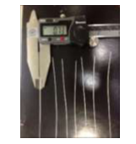
Fig.8 Filaments generated from Polyamide (Nylon® 12).

This initial test is important to demonstrate the capacity to transform the polymer powder in a melted polymer. The expected performance for the feed section is carrying the material to the downstream sections. The continuous filaments obtained reflect an adequate performance in the compression and metering section. In these sections, the rising pressure forces the melted polymer through the nozzle tip with the aim to produce continuous filaments demonstrating the conceptual design of create filaments from powder using polymers in a screw extruder of small proportions. This concept is based in an idea of using the known extrusion’s process in a small scale. In figure 10 it is shown the nozzle tip of the extrusion head performing the manufacturing a Polyamide Nylon® 12 15 layers block, without airgap, and 0.8 nozzle tip, showing the capacity of generating parts extruding layer by layer as it is required in rapid prototype purposes.
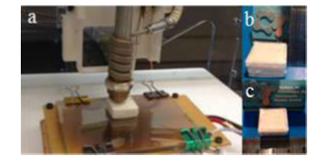
Fig. 9 – a) Functional screw extrusion head prototyping a 3D model with Nylon® 12 material. b) e c) Finished Nylon® 12 block in different angles.

The morphological characteristics were analyzed with SEM (Scanning Electron Microscopy). The photomicrographs were obtained in the Instrumental Chemical Analysis Center of the São Carlos Chemical Institute (CAQI/IQSC/USP) in ZEISS LEO 440 (Cambridge, England) with detector OXFORD (model 7060) equipment, operating with electron beam of 15kV. The samples were covered with 10 nm of gold in a sputter Coating System BAL-TEC MED 020 (BAL-TEC, Liechtenstein) and it was maintained in desiccators until the moment of the analysis.
- b)
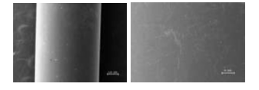
Fig. 10 - Nylon® 12 filaments photomicrographs.

It is possible to observe in Figure 10(a) that the filament of Nylon® 12 is cylindrical and continuous. In Figure 10b it can be seen that the material has a solid surface without any pore or surface‘s discontinuities.

For the ε-PCL SEM’s, the scheme in Figure 11 shows the sections where the ε-PCL was collected.
IFAC
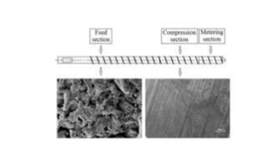
Fig. 11 – SEM for ε-PCL showing the material state and morphological aspects in feed and compression sections.

8 CONCLUSIONS

The preliminary tests of the head showed the capacity of extruding melted material producing continuous filaments demonstrating the performance of each section of the screw extrusion. Another important aspect to be considered is related of the success of the calculation method once the screw should support theoretical high torques, in order to 20 N.m for ε-PCL. The transmission system, including the stepper motor, presented a satisfactory performance, mainly related to driving control systems, once it was shown the screw extrusion head capability to fabricate a block composed by various layers characterizing the application in additive manufacturing. The mechanical solution and electric/electronic devices allowed the processing of two different kinds of materials, first an industrial one, Nylon® 12, and a biomaterial ε-PCL. The results present the potential of this interchangeable screw extrusion head to provide new opportunities for desktop 3D printers in several applications using powder as feedstock with the aim to generate 3D models. This experimental validation can be reinforced by results obtained by SEM photomicrographs which showed homogeneous and continuous filaments, a necessary condition for layer deposition purposes. In direction of new additive manufacturing correlated areas as health, tissue engineering, and biomaterial applications, this new device presents results using ε-PCL as powder material and has demonstrated its capacity to produce scaffolds. As future works, is proposed the optimization of the extrusion process using DOE (Design of Experiment) looking for the best mechanical and chemical properties for the presented materials. The use of new materials, in specific, thermoplastics is an interesting unexplored area towards the material sciences applications in additive manufacturing, more specifically in desktop machines. The blend or mixture of two kinds or more kinds of polymers in feed section and its respective study is another possibility of research.

REFERENCES

ASTM F2792-10: Standard terminology for additive manufacturing technologies, (2010) copyright ASTM International – 2010, Barr Harbor Drive, West Coshohocken, PA 19428.
Béreaux Y., Charmeau J., Moguedet M, A. (2009) Simple model of throughput and pressure development for single screw. Journal of materials processing technology Num. 209, pp.611-618.
Cheng, L. C; Melo Filho, L. D. R (2007) QFD - Planejamento da Qualidade. Editora Edgard Blücher. 568p.
Chung C.I (2000) Extrusion of polymers: theory and practice. 369p. Hanser: Cincinnati.
Gibson I., Rosen D.W, Stucker B. (2010) Additive Manufacturing Technologies: Rapid Prototyping to direct digital manufacturing. Springer. 479p.
P. Bártolo, et al.(2008) Processo e Equipamento de fabrico rápido por bioextrusão. Portuguese Patent No. 104247, 2008.
Inforçatti Neto, P.; Lixandrão Filho, A.L.; Pereira F.D.A.S. ; Silva, J.V.L. ; Silveira, Z.C.; Bártolo, P.(2012).: Thermoplastic filament extruder head for desktop additive manufacturing machines. In: Innovative Developments in Virtual and Physical Prototyping. London: Taylor and Francis, p. 635-628.
Ikegami R. A. (2007) Desenvolvimento de corpos cerâmicos compostos bioativos com estrutura de gradiente funcional. Tese de doutorado, Escola de Engenharia de São Carlos, Universidade de São Paulo. 110p
Malone, E. and Lipson, H. (2007) Fab@Home: the personal desktop fabricator kit. Rapid Prototyping Journal, Vol. 13 n. 4, p. 245-255. Emerald Group Publishing Limited
Rauwendaal C. (2001) Polymer Extrusion. 53p. Hanser. Munich
Rezende R.A, Pereira, F.D.A.S, Kemmoku, T., da Silva J.V.L. (2012) Enabling Technologies for robotic organ printing. Innovative Developments in Virtual and physical prototyping. pp. 121-138.Taylor & Francis Group, London, ISBN 978-0-415-68418-7.
White J. L. and Potente H, (2003) Screw Design. 444p. Hanser Verlag.
Silveira Z., Cavalca K. L. (2003) A Methodology Based on Robust Design and Optimization Statistics for Fitting of Parameters in Mechanical Systems. Proceedings of the 11th World Congress in Mechanism and Machine Sciences. IFToMM 2003. Tianjin, China.

备注：英文文献翻译原文必须注明出处

<外文翻译：译文>

1．著作：作者姓名．书名[M]．xx：出版社，xxxx，xx． 2．论文：作者姓名．论文题目[D]．杂志名称，xxxx（）：xx． 以英文大写字母方式标识各种参考文献,专著[M]、论文集[C]、报纸文章[N]、期刊文章[J]、学位论文[D]、报告[R]。

