**Measure energy consumption…**

* **Phase 5**
* **Documenting the design thinking process and preprocessing, visualization and innovative techniques…**

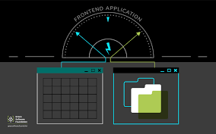

**Table of contents:**

1. **Abstract**
2. **Introduction**
3. **Design and thinking**
4. **Phases of development**
5. **Dataset and data preprocessing steps**
6. **Flowchart for preprocessed method**
7. **Program**
8. **Graph for the measure energy consumption(yearly increases)**
9. **Data on energy by world in data**
10. **Data sources**
11. **Change long**
12. **Data alteration**
13. **Visualization technique**
14. **Analyse and adjust**
15. **Tools used while consuming the energy in measurement**
16. **Advantages and disadvantages**
17. **Conclusion**

**Abstract:**

This study investigates the impact of energy efficiency measures installed through the Carbon Emission Reduction Target and the Community Energy Saving Programmed on domestic gas and total energy consumptions. The recently released National Energy Efficiency Data-Framework database is used to examine the changes in domestic gas and total energy consumptions for the dwellings in the sample relative to the changes in gas and total energy consumptions for a comparable control group in the year after installation. The results obtained from this difference-in-difference analysis confirm that observed energy consumption decreases significantly in dwellings following upgrades such as cavity wall insulation, loft insulation and a new efficient boiler. The single most effective energy efficiency measure when installed alone is found to be cavity wall insulation, reducing annual gas consumption by 10.5 % and annual total energy consumption by 8.0 % in the year following installation. Comparing bundles of different energy efficiency measures, we find that dwellings retrofitted with both cavity wall insulation and a new efficient boiler experience the largest reductions in annual gas and total energy consumptions of 13.3 and 13.5 %, respectively. This is followed by a mean annual reduction of 11.9 and 10.5 % in gas and total energy consumptions for dwellings with all three energy efficiency measures installed in the same year. Contrary to expectations, installing cavity wall insulation on its own is found to be more effective in reducing measured energy consumption than combining loft insulation and a new efficient boiler.

The abstract had been introduced about the topic of measure energy consumption.

Let us discuss with the types,

**Introduction:**

The rapidly growing world energy use has already raised concerns over supply difficulties, exhaustion of energy resources and heavy environmental impacts, such as ozone layer depletion, global warming, climate change, etc. The global contribution from buildings toward energy consumption, both residential and commercial, has steadily increased to between 20% and 40% in developed countries, and has exceeded the other major sectors: industrial and transportation [1]. Sources of electric energy in Japan include crude oil, coal, natural gas, nuclear power, hydropower and renewable energy that include wind, geothermal, and solar energy. Among them, nuclear power was an important energy source until the wake of the great earthquake in East Japan in 2011. The peoples’ interest in energy and electric consumption has increased after the great earthquake. On the other hand, annual electric consumption per person in Japan is more than 7800 kWh, which is 3 times the world average. One step toward making energy-saving plan and evaluating their success is monitoring how people use it. Focusing on energy consumption in buildings, the amount of electric consumption due to air-conditioning, electric power equipment, etc. is particularly large. The carbon dioxide emissions from energy consumption in the consumer sector accounts for one-third of the carbon dioxide emissions of Japan. Electricity is the largest portion of energy consumption by buildings in Japan.

Asia has experienced spectacular economic growth over the past two decades. However, this economic progress has come at a high cost. It has led to unprecedented environmental consequences. Today's building industry appears to be entering another era of change, with a view toward minimizing: the energy, carbon, and environmental footprint of commercial and resident and so on.

**Design and thinking:**

1. Empathize: Understand the problem by empathizing with the users or stakeholders. In this case, identify who or what consumes energy and why. Talk to individuals or groups affected by energy consumption, and gather their insights.

2. Define: Clearly define the problem. In this stage, you'd create a specific problem statement related to energy consumption. For example, "How might we reduce energy consumption in our office building during peak hours?"

3. Ideate: Generate creative ideas to address the problem. Invite cross-functional teams to brainstorm solutions. These ideas can range from optimizing lighting and HVAC systems to promoting energy-saving behaviors among employees.

4. Prototype: Develop prototypes or mock-ups of the potential solutions. This might involve creating a small-scale model of an energy-efficient system or designing an awareness campaign to encourage energy conservation.

5. Test: Test your prototypes with real users or in real environments. Collect data on how well each solution performs in reducing energy consumption. User feedback and data are crucial in this phase.

6. Iterate: Based on the test results, refine and improve your solutions. This might involve making adjustments to the prototypes or changing the approach based on what you've learned.

7. Implement: Once you have a well-tested and refined solution, it's time to implement it on a broader scale. This could mean rolling out energy-efficient systems across an entire building or launching an organization-wide energy conservation program.

8. Measure: Continuously monitor and measure the energy consumption after implementing your solution. Compare the results to the baseline data you collected initially.

9. Learn: Reflect on the outcomes and lessons learned from the implementation. Did your solution effectively reduce energy consumption? Are there further improvements needed?

10. Share and Scale: Share your successful approach and findings with others in your organization or industry. Scaling successful energy-saving initiatives can have a broader positive impact.

**Phases of development:**

**Research and Planning:**

Conduct market research and competitor analysis.

Define the scope, objectives, and success metrics of the recommendation system.

Create a development roadmap and allocate resources.

**Data Collection and Preparation:**

Gather historical user interaction data, including browsing behavior, purchases, and preferences.

Clean and preprocess the data to handle missing values, outliers, and ensure consistency.

**Model Selection and Development:**

Choose appropriate recommendation algorithms (e.g., collaborative filtering, content-based filtering, hybrid methods).

Develop and train the recommendation models using the preprocessed data.

**Integration and Testing:**

Integrate the recommendation system into the e-commerce platform.

Conduct extensive testing to ensure the system works smoothly and without any bugs.

User interface (UI) design:

Design an intuitive and user-friendly interface for displaying recommended products.

Ensure seamless integration with the existing platform design.

Deployment and Monitoring:

Deploy the recommendation system to the production environment.

Implement monitoring tools to track system performance and user interactions.

Dataset and Data Preprocessing Steps:

* Handle missing values by imputation or removal.
* Encode categorical variables

(e.g., user IDs, product categories)

* Using techniques like one-hot encoding or embeddings.
* Normalize numerical features if needed.
* Split the data into training and testing sets for model evaluation.

Visualization Techniques:

Heat maps: Visualize user-item interactions to identify popular products and user preferences.

Bar Charts and Histograms: Display distribution of user behaviors (e.g., views, purchases) and product popularity.

Line Charts: Track performance metrics over time to monitor system effectiveness.

Flowchart for preprocessed method:

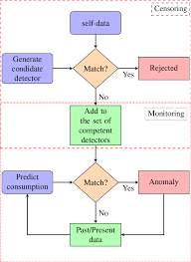

Program

import pandas as pd   
data = [['31_december_2021', 9825, 32334, 26707, 245, 1.2, 0.35, 5.73, 1.68, 0.42],   
['01_may_2022', 11015, 33324, 27555, 316, 1.2, 0.35, 5.73, 1.68, 0.42]]   
do = pd.DataFrame(data, columns = ['month', 'gas', 'electric_1', 'electric_2', 'water', 'gasp', 'elect_pr', 'water_pr', 'gas_pr_new', 'elect_pr_new'])  
def from PIL import Image,ImageTk   
import calendar  
import date time   
import tinder as to Window=tk.Tk ()  
window. Title (" Calculate the total cost of living")  
window. Geometry("750x750")   
new label = tk.Label(text = "Enter the current numbers on the meters", font=('Calibri', 16, 'bold'))  
newlabel.grid(column=3,row=1)   
gas = tk.Label(text = "Gas meter", font=('Calibri', 14))  
gas. Grid(column=2,row=2)   
elect_1 = tk.Label(text = "Electricity meter 1", font=('Calibri', 14))  
elect_1.grid(column=2,row=3)  
elect_2 = tk.Label(text = "Electricity meter 2", font=('Calibri', 14))  
elect_2.grid(column=2,row=4)  
water = tk.Label(text = "Water meter", font=('Calibri', 14))  
water. grid(column=2,row=5)   
number days = tk.Label(text = "Number of days", font=('Calibri', 14))  
number_days.grid(column=2,row=6)   
gas Entry = tk.Entry()  
gas Entry. grid(column=3,row=2)  
elect_1Entry = tk.Entry()  
elect_1Entry.grid(column=3,row=3)  
elect_2Entry = tk.Entry()  
elect_2Entry.grid(column=3,row=4)  
water Entry = tk.Entry()  
waterEntry.grid(column=3,row=5)   
number_daysEntry = tk.Entry()  
number_daysEntry.grid(column=3,row=6)  
window.mainloop()

Output

Enter the year: 2021

Enter the month: may

Enter the text: Calibri

Enter the size: 14

Enter the type of meter: gas, electricity

Enter the row: 3

Enter the column: 2

Enter the gas entry grid: electricity

Enter the water entry grid: 80

To run the output use idle python 64bit key f5 for the solution.

Graph for the measure energy consumption (yearly increases):

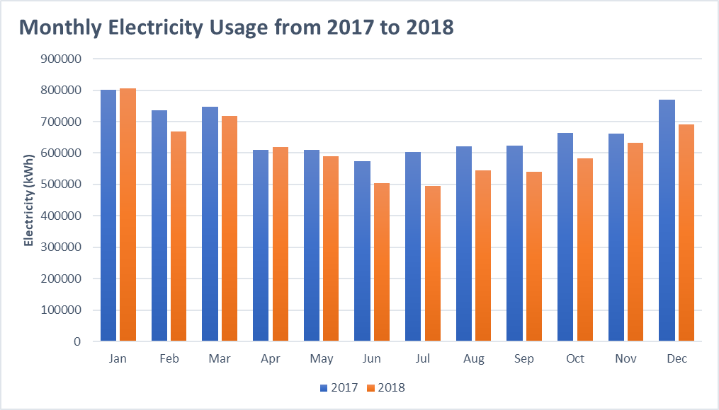

# Data on Energy by Our World in Data

This dataset is a collection of key metrics maintained by [Our World in Data](https://ourworldindata.org/energy). It is updated regularly and includes data on energy consumption (primary energy, per capita, and growth rates), energy mix, electricity mix and other relevant metrics.

**Data sources**

* **Energy consumption (primary energy, energy mix and energy intensity):**

This data is sourced from a combination of two sources—the [BP Statistical Review of World Energy](https://www.bp.com/en/global/corporate/energy-economics/statistical-review-of-world-energy.html) and [SHIFT Data Portal](https://www.theshiftdataportal.org/energy).

* **Electricity consumption (electricity consumption, and electricity mix):**

This data is sourced from a combination of two sources—the [BP Statistical Review of World Energy](https://www.bp.com/en/global/corporate/energy-economics/statistical-review-of-world-energy.html) and [EMBER – Global Electricity Dashboard](https://ember.shinyapps.io/GlobalElectricityDashboard/).

* **Other variables:**

This data is collected from a variety of sources (United Nations, World Bank, Gap minder, Madison Project Database, etc.). More information is available in [our codebook](https://github.com/owid/energy-data/blob/master/owid-energy-codebook.csv).

The CSV and XLSX files follow a format of 1 row per location and year. The JSON version is split by country, with an array of yearly records.

The variables represent all of our main data related to energy consumption, energy mix, electricity mix as well as other variables of potential interest.

**Change log**

* On March 31, 2021, we updated 2020 electricity mix data.
* On September 9, 2020, the first version of this dataset was made.

**Data alteration**

**Standardize names of countries and regions:**

 Since the names of countries and regions are different in different data sources, standardize all names to the [*Our World in Data* standard entity names](https://github.com/owid/energy-data/tree/master/scripts/input/shared).

**Recalculate primary energy in terawatt-hours:**

The primary data sources on energy—the BP Statistical Review of World Energy, for example—typically report consumption in terms of exajoules.

**Calculate per capita figures:**

 All of our per capita figures are calculated from our metric Population, which is included in the complete dataset. These population figures are sourced from [Gap minder](http://gapminder.org/) and the [UN World Population Prospects (UNWPP)](https://population.un.org/wpp/).

E = P*(t/100)

In this formula,

E refers to the measured Joules or kilowatt per hour (kWh).

P refers to power used per unit in watts.

t refers to the time over which the power

Visualization techniques:

All visualizations, data, and code produced by *Our World in Data* are completely open access under the [Creative Commons BY license](https://creativecommons.org/licenses/by/4.0/). You have the permission to use, distribute, and reproduce these in any medium, provided the source and authors are credited.

The data produced by third parties and made available by *Our World in Data* is subject to the license terms from the original third-party authors. We will always indicate the original source of the data in our database, and you should always check the license of any such third-party data before use.

Analyze and adjust:

The energy review requires that you collect energy use and consumption data and analyze it to:

• Determine significant energy uses.

• Identify energy opportunities.

• Develop End.

• Establish baselines.

• Set energy performance objectives and targets.

• Monitor energy performance.

Tools used while consuming the energy in measurement:

Voltmeter:

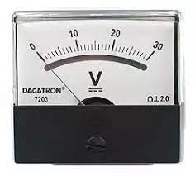

Ammeter:

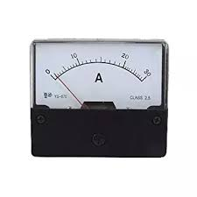

Wattmeter:

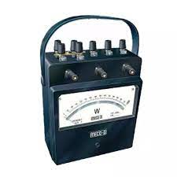

Advantages:

* Hardware –based measurement are considered to be most reliable.
* No additional hardware device or a pc is required.
* direct interaction with phone and additional applications are not required.

Disadvantages

* noise power loss during measurement; restriction to certain types of battery, additional hardware is required.
* Additional power consumption caused by energy logging application; restricted by functions provided by OS API and or proprietary applications; installation problems.
* Restricted by functions provided by OS API and or proprietary application: data communication problems.

Conclusion:

We have seen that the generation of electricity in American states is driven by the number of commercial and industrial customers. Concerning the electricity consumption, it is influenced by the energy production itself and the amount of commercial customers. Our prediction models are quite accurate and confirmed the results of our exploratory data analysis. About our models, we should not forget that lots of variables can explain the electricity consumption and production as we have seen during the exploratory data analysis, but we only used the most significant ones.

For the structure of the electricity production, we have seen that the energy mix varies tremendously from one region to another and from one state to another. We cannot determine whether a mix defines the price per KWh or not. However, power generation using coal and hydropower is correlated with low energy costs. we were able to model the average power per hour over a year.

We see that renewable energies are subject to seasonality. The power of renewable energies is highly volatile, which makes them difficult to predict and easy to display it.

Therefore the above given topics are explained briefly about measure energy consumption with its types and techniques.