VetScribe: An Open-Source Pipeline for Automated Veterinary Consultation Documentation
System Design, Cost–Latency Analysis, and a Projected-Savings Model
Nagarajan Shunmugam^{1,2,*} · Minh Long Hoang³
¹ Hirszfeld Institute of Immunology and Experimental Therapy, Polish Academy of Sciences, Wrocław, Poland
² Faculty of Veterinary Medicine, Wrocław University of Environmental and Life Sciences, Wrocław, Poland
³ Department of Engineering and Architecture, University of Parma, Parma, Italy
* Corresponding author: nagarajan.shunmugam@hirszfeld.pl · 123840@student.upwr.edu.pl · minhlong.hoang@unipr.it
Research prototype manuscript — working draft
Prepared for submission to a technology-and-clinical venue (e.g., Frontiers in Veterinary Science / JMIR)

Abstract
Clinical documentation is among the largest non-clinical demands on practitioner time and a recognised driver of burnout. In human ambulatory medicine, direct time-and-motion measurement attributes roughly half of the office day to electronic health record and desk work, against only about a quarter spent in direct patient contact [1]. Veterinary practice faces an analogous and growing burden, and administrative workload is repeatedly identified among the leading contributors to veterinary exhaustion and reduced wellbeing [2]. Ambient artificial-intelligence (AI) scribes have shown early promise for relieving this burden in human medicine [3], but most deployed systems are proprietary and closed, and reproducible, transparently-costed pipelines are scarce — particularly for veterinary consultations.
We present VetScribe, an open, reproducible pipeline that converts a recorded veterinary consultation into structured clinical documentation. The system chains automatic speech recognition, text-based speaker attribution, large-language-model (LLM) generation of a SOAP note and a plain-language owner discharge summary, clinical entity extraction, an automated “research-flag” gap analysis, and PDF export. We describe the architecture, the per-stage model-selection strategy, the software stack, and the implemented feature set. We report the measured application-programming-interface (API) cost of an average consultation (approximately US$0.10 for a ten-minute encounter, of which transcription is roughly 60%), and we analyse how per-stage model tiering trades cost against quality. Because no controlled clinical evaluation has yet been performed, time and cost savings are presented as an explicit, assumption-driven projection rather than a measured outcome: under a transparent model, a single clinician seeing twenty consultations per day could recover on the order of 290 hours per year against an annual API cost near US$500. We discuss the substantial limitations of present-day generative models for clinical documentation — including published SOAP-note error rates that preclude unsupervised use [4] — and we propose a pre-registered evaluation protocol to convert this projection into evidence. VetScribe is positioned as assistive, not autonomous, and is released as a research artifact for reproducibility.
Keywords: veterinary informatics; clinical documentation burden; ambient AI scribe; speech recognition; large language models; SOAP notes; reproducibility.

1. Introduction: the documentation burden problem
The administrative cost of modern clinical practice is now well quantified in human medicine. In a direct observational time-and-motion study across four specialties, Sinsky and colleagues found that physicians spent 49.2% of their office day on the electronic health record (EHR) and desk work and only 27.0% in direct clinical face time with patients; for every hour of patient contact, roughly two additional hours were absorbed by documentation and clerical tasks [1]. A scoping review of documentation-burden measurement confirms that this load is both substantial and consistently associated with clinician dissatisfaction and burnout [7]. The clinical record, once a brief contemporaneous note, has become a detailed medico-legal and billing instrument whose expectations have expanded faster than the time allotted to produce it.
Veterinary medicine inherits this problem without the staffing and revenue cushions of large hospital systems. The Merck Animal Health Veterinarian Wellbeing studies, conducted on nationally representative U.S. samples, document persistently elevated exhaustion among veterinarians relative to the general population and identify workload and administrative demands among the principal stressors [2]. Industry surveys commonly estimate that companion-animal practitioners spend on the order of a quarter to two-fifths of their working hours on records and non-clinical tasks; while these vendor-reported figures should be treated cautiously, the peer-reviewed wellbeing literature leaves little doubt that documentation is a meaningful and worsening contributor to veterinary strain. Figure 1 summarises the human-medicine time-and-motion anchor that frames the scale of the opportunity.
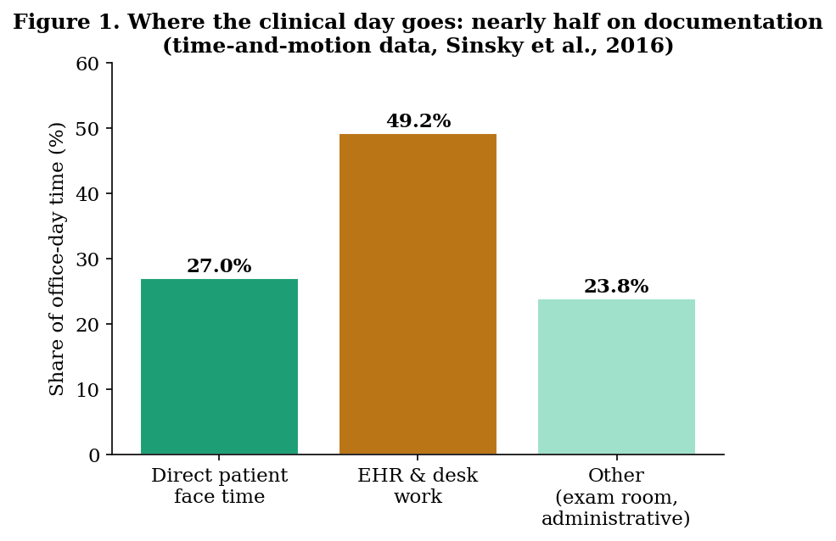
Figure 1. Allocation of clinician time in ambulatory practice; documentation and desk work dominate. Source: Sinsky et al., 2016 [1].
Ambient AI scribes — systems that listen to the clinical encounter and draft the note automatically — have emerged as the leading proposed remedy. A pilot of ambient AI documentation at Stanford Health Care reported statistically significant reductions in task load and burnout among participating physicians [3], and a subsequent randomized clinical trial of two commercial ambient scribes found reductions in time-in-note and modest improvements in burnout and work exhaustion [9]. These results are encouraging but partial: most systems are closed and commercial, their internal model choices and costs are opaque, and essentially none of this evidence base is veterinary. The contribution of VetScribe is therefore deliberately scoped. We do not claim a new clinical outcome; we contribute (i) a fully open, reproducible veterinary documentation pipeline; (ii) a transparent per-stage cost and model-selection analysis that practitioners and researchers can audit and reproduce; (iii) an automated human–AI gap-analysis feature; and (iv) an explicit savings model with a pre-registered evaluation protocol that the community can execute.

2. Adoption and early evidence of productivity gains in veterinary practice
Veterinary practice is in the early, steep part of the AI-adoption curve. In a 2024 survey of veterinary professionals published in the American Journal of Veterinary Research, 83.8% reported familiarity with AI tools and 39.2% had already trialled them in practice, with a further 38.7% intending to adopt AI in the near future [11]. Respondents most often expected AI to improve productivity and save time (60.6%) and to reduce administrative workload (56.1%), and identified the writing of patient records as one of the areas of greatest potential impact (38.6%) — precisely the task that VetScribe addresses (Table 1). Institutional adopters are also emerging; the UC Davis School of Veterinary Medicine has reported deploying an ambient AI-scribe platform in its teaching hospital (trade-press report) [12].
Table 1. Veterinary AI familiarity, adoption intent, and perceived benefits.
Indicator (2024 survey of veterinary professionals) [11] | Share
Familiar with AI tools | 83.8%
Have already trialled AI tools in practice | 39.2%
Intend to adopt AI in the near future | 38.7%
Expect AI to improve productivity / save time | 60.6%
Expect AI to reduce administrative workload | 56.1%
See patient-record writing as a top-impact area | 38.6%

This optimism is increasingly supported by measured evidence from the better-studied human-medicine setting. A pilot of ambient AI documentation reported significant reductions in clinician task load and burnout [3], and a randomized clinical trial of two commercial ambient scribes found reductions in time spent in the note together with modest improvements in burnout [9]. Two cautions are warranted. First, the strongest veterinary-specific figures — for example, vendor claims of one to two hours saved per clinician per day, or several minutes saved per note — originate in trade and commercial sources rather than peer-reviewed studies, and should be read as marketing-adjacent estimates rather than measured outcomes. Second, the peer-reviewed survey evidence measures familiarity, intent, and perceived benefit, not realised productivity. Closing the gap between perceived and realised benefit is precisely the purpose of controlled evaluation, including the protocol proposed in Section 9, and VetScribe is designed as a transparent, reproducible instrument for generating exactly that evidence.

3. What today’s AI can — and cannot — do for clinical documentation
A responsible system design begins from a clear-eyed account of current model capabilities. VetScribe is built on three families of model, each with well-characterised strengths and failure modes.

2.1 Automatic speech recognition
Large weakly-supervised speech models such as Whisper [5] and its successors (including the gpt-4o-transcribe family used here) have brought open-domain word-error rates (WER) into a range usable for documentation. In favourable conditions — a clinician dictating in a quiet room — reported WER can fall into the low single digits; one radiology dictation evaluation observed WER improving from 18.4% to 5.8% with domain adaptation. However, performance degrades sharply outside ideal conditions. Error rates rise substantially for non-native and accented speakers, in acoustically noisy environments, and on domain-specific vocabulary, and language coverage is uneven [10]. A veterinary consultation room — with a distressed animal, multiple speakers, background noise, and species- and breed-specific terminology — is precisely the kind of adverse setting in which baseline ASR is least reliable. Transcription is therefore treated in VetScribe as the un-recoverable foundation of the pipeline: an error introduced here cannot be repaired by any downstream model.

2.2 Large-language-model generation of clinical notes
General-purpose LLMs such as GPT-4 [6] can produce fluent, plausibly-structured SOAP notes from a transcript, but their reliability for unsupervised clinical documentation is not yet established. In the most directly relevant evaluation, Kernberg and colleagues used ChatGPT-4 to generate SOAP notes from simulated patient–provider encounters and found an average of 23.6 errors per clinical case, of which 86% were errors of omission; accuracy declined as transcript length and case complexity increased, and the authors concluded that the notes did not meet the standard required for clinical use and that the model should not be regarded as a safe substitute for human documentation [4]. This finding is the single most important design constraint on VetScribe: the system must be assistive, must surface rather than hide its uncertainty, and must require clinician verification before any note is signed.

2.3 Speaker attribution and entity extraction
Acoustic speaker diarization (for example, pyannote.audio [8]) can separate speakers from the audio signal but is computationally heavy and degrades in noisy, overlapping-speech conditions. Clinical entity recognition — identifying symptoms, differentials, drugs, and follow-up intervals — can be performed either by specialised named-entity models or by prompting a general LLM. Each approach trades coverage against reproducibility and cost. VetScribe’s design choices in these areas, described next, are made explicitly to remain reproducible and inexpensive while documenting their limitations.

4. System design

3.1 Pipeline architecture
VetScribe is organised as a five-stage pipeline: Record/Upload, Transcribe, Diarize, Generate, and Export (Figure 2). Audio is captured in-browser or uploaded; transcribed; segmented into Vet and Owner turns; passed to a set of LLM calls that produce the SOAP note, the owner summary, the clinical entities, and the research flags; and finally exported. Each stage emits a progress signal so the operator sees the pipeline advance, and every paid call is gated by per-session and global budget guards.
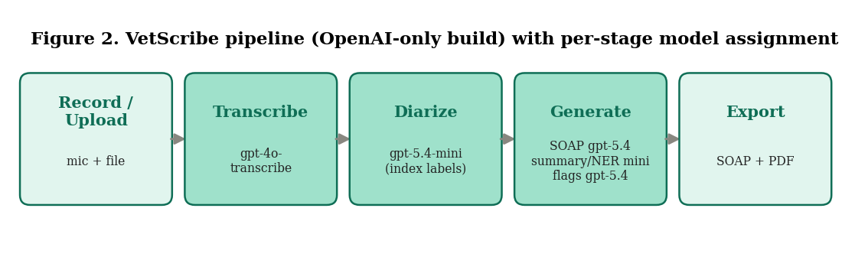
Figure 2. The VetScribe pipeline and the model assigned to each stage.

3.2 Model choices and the cost-tiering rationale
Rather than apply a single model to every task, VetScribe assigns a model to each stage according to that stage’s difficulty and its tolerance for error. Three principles govern the assignment. First, transcription is the un-recoverable foundation and is therefore not given the cheapest option; the gpt-4o-transcribe model is used for its lower word-error rate on medical speech. Second, the two reasoning-heavy, quality-critical stages — SOAP-note generation and the research-flag gap analysis — use the stronger gpt-5.4 model, because errors there propagate into the clinical record and the study’s central contribution. Third, the mechanical stages — speaker attribution, the plain-language owner summary, and entity extraction — use the cheaper gpt-5.4-mini, where a strong model yields little benefit. Any stage can be reassigned by configuration, allowing a deployment to escalate a single stage to a frontier model if expert review later shows it is warranted.
Table 2. Per-stage model assignment, rationale, and representative per-consult cost (ten-minute encounter).
Stage | Model | Rationale | Cost (USD)
Transcription | gpt-4o-transcribe | Un-recoverable foundation; lowest word-error rate | 0.060
Diarization | gpt-5.4-mini | Mechanical, index-based turn labelling | 0.003
SOAP note | gpt-5.4 | Quality-critical clinical reasoning | 0.015
Owner summary | gpt-5.4-mini | Plain-language rewrite | 0.003
Entity extraction | gpt-5.4-mini | Structured extraction | 0.004
Research flags | gpt-5.4 | Novel human-AI gap analysis | 0.014
Total (10-min consult) |  |  | ≈ 0.098

A second cost lever is architectural rather than model-based. An earlier diarization design asked the model to re-emit the entire transcript annotated with speaker labels, so its output token count scaled with the length of the transcript. VetScribe instead splits the transcript into numbered sentences locally and asks the model to return only an index-to-speaker mapping. This reduces diarization output tokens by roughly 60–70% and, more importantly, makes it structurally impossible for the model to alter a drug name or dose while “echoing” the text, because the verbatim transcript never leaves local control.

3.3 Software stack
The application is implemented in Python using the Gradio framework for the user interface, with the intention of public deployment on Hugging Face Spaces for reproducibility and live demonstration. All language and speech models are accessed through a single commercial API provider in the present build, selected for the availability of both a high-accuracy transcription model and a tiered family of generation models. PDF export is produced with the ReportLab library, which is dependency-light and cross-platform. Abuse and cost are controlled by a rate-limiting module that enforces a maximum audio length per clip, caps the number of transcriptions and generations per session, and applies a global daily spending kill-switch that refuses paid calls once a configurable budget is exceeded. For public deployment, VetScribe additionally supports a bring-your-own-key mode, in which each visitor supplies their own API key that is used only for their session and never stored on the server, so the operator's key is never exposed to demo users. A lightweight instrumentation module records per-stage timing for the planned evaluation, and a local case store persists the text outputs (never the audio) so prior consultations can be reviewed and re-exported.

3.4 Implemented feature set
The prototype implements: in-browser recording with pause, stop, re-record, and a dedicated playback control; automatic transcription and Vet/Owner turn attribution; SOAP-note generation with an explicit clinician-verification disclaimer and passive flagging of any drug or dose mention; a plain-language owner discharge summary; clinical entity extraction categorised as findings, differentials, procedures, drugs, and follow-up intervals; an automated research-flag panel that surfaces clinically significant items present in the transcript but under-represented in the generated note; a research/insights panel reporting consultation duration, vet/owner talk ratio, entity count, and a projected time-saved estimate; one-click PDF export of the current consultation and of any saved past case; a persisted case history; and a full-screen processing overlay that prevents interaction until the pipeline completes. A model-selection control allows the operator to switch the generation model and to run two models side by side for comparison.
Figures 6 and 7 show the two principal views of the interface. The capture view (Figure 6) presents patient and model configuration, the recording and playback control, the Process action, and a progress stepper that advances through the five pipeline stages. The review view (Figure 7) presents the generated outputs as tabs, with the SOAP note carrying a persistent clinician-verification disclaimer and the insights panel summarising consultation metrics, colour-coded clinical entities, and any automated research flags. Figure 8 shows a complete consultation report exported by the application for a synthetic case.
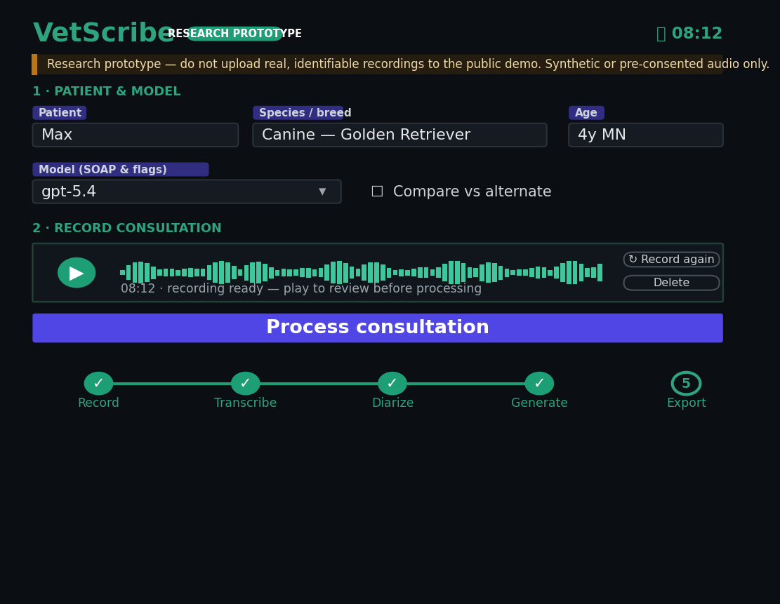
Figure 6. The VetScribe capture interface: patient and model configuration, recording and playback, the Process action, and the pipeline progress stepper (synthetic case).
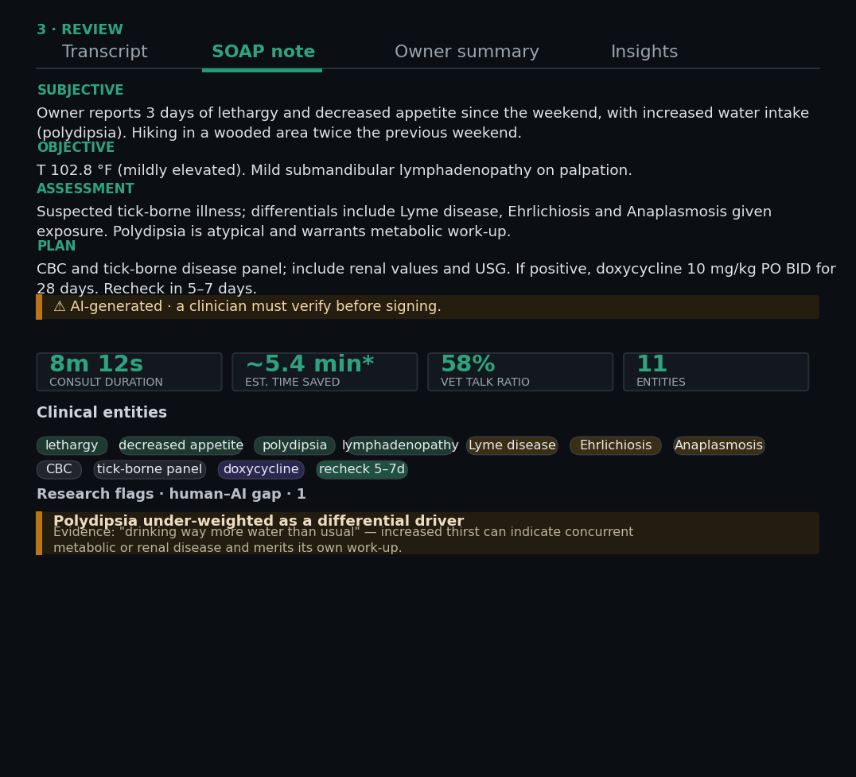
Figure 7. The review interface: the generated SOAP note with verification disclaimer, and the insights panel with metric cards, colour-coded entities, and an automated research flag (synthetic case).
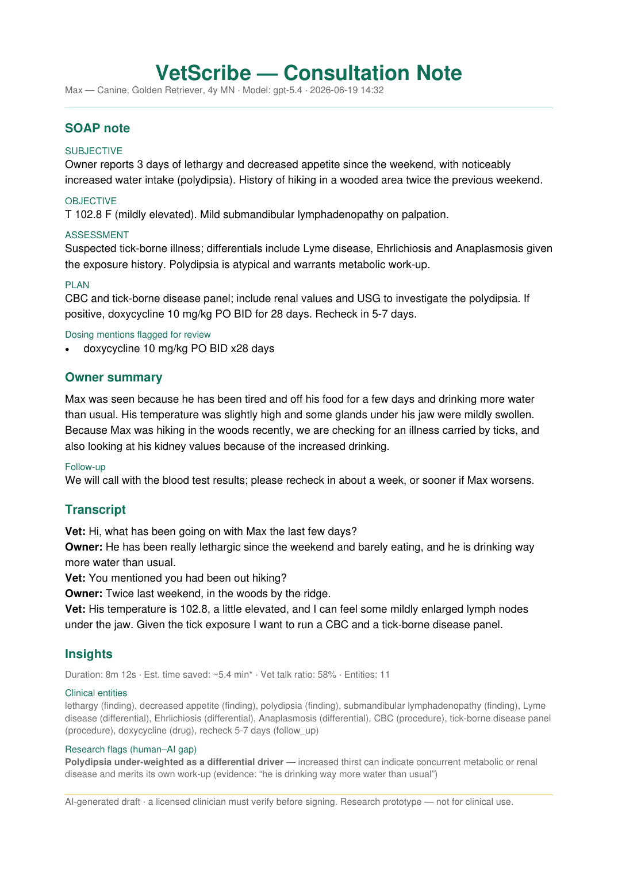
Figure 8. A complete consultation report exported by VetScribe (synthetic case), produced by the application's own PDF-export module.

5. Cost and latency analysis

4.1 Per-consultation cost
Cost is computed from the provider’s published per-token and per-minute rates and verified against the live pricing schedule. For a representative ten-minute consultation (approximately 1,500 spoken words), the total API cost under the recommended model tiering is approximately US$0.10. Figure 3 decomposes this by stage. Transcription, billed per minute of audio, is the single largest component at roughly 60% of total spend; the five LLM calls together account for the remainder, with the two gpt-5.4 stages (SOAP and flags) dominating the generation cost. The practical implication is that cost scales primarily with consultation length, not with the number of generation steps, and that the highest-leverage cost reductions come from the transcription choice rather than from trimming LLM calls.
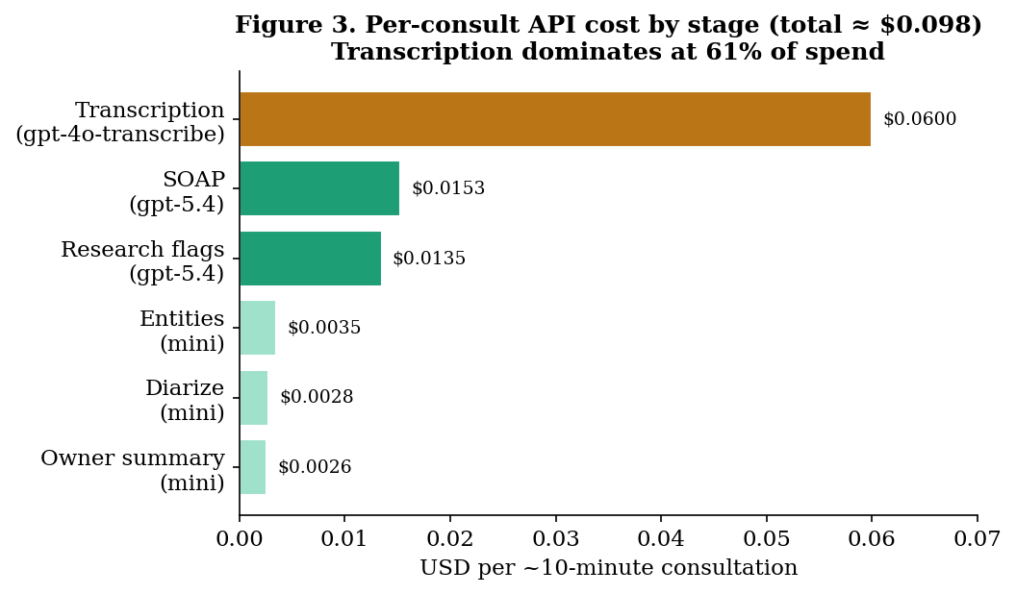
Figure 3. Per-consultation API cost by stage for a ten-minute encounter; transcription dominates.

4.2 The effect of model tiering
Figure 4 compares three model strategies holding the architecture constant. A legacy configuration using a single previous-generation model for every generation stage costs approximately US$0.108 per consultation. The recommended tiered configuration costs approximately US$0.098 while simultaneously upgrading the two quality-critical stages to the stronger gpt-5.4 model — a rare case in which the cheaper option is also the higher-quality one for the stages that matter. A budget configuration that substitutes the cheaper mini transcription model lowers cost to approximately US$0.068 but trades away word-error-rate performance on exactly the foundation stage where errors are unrecoverable; for clinical text we do not recommend it.
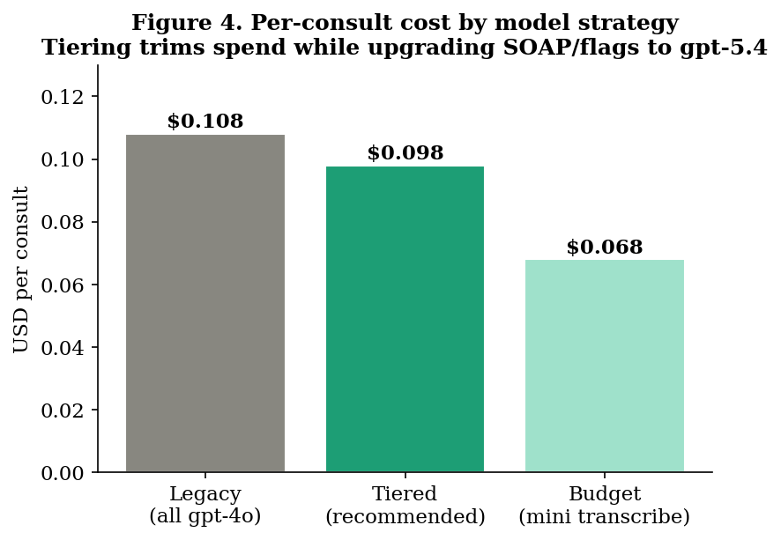
Figure 4. Per-consultation cost under three model strategies; tiering reduces cost while improving the quality-critical stages.

4.3 Latency
End-to-end latency is dominated by the two network round trips to the speech and language APIs; local processing (sentence splitting, rendering, file writing) is negligible by comparison. The application instruments wall-clock time at each stage, enabling latency to be reported as a measured quantity in the planned evaluation. For a short consultation, processing completes in the order of tens of seconds; latency grows with audio length (transcription) and transcript length (generation). Because the operator waits for the draft before reviewing it, this latency is a real component of the total documentation time and is included in the savings model below rather than ignored.

6. Projected time and cost savings (a model, not a measurement)
We state plainly that VetScribe has not yet been evaluated in a controlled study, and that the figures in this section are a transparent projection built on stated assumptions, not a measured outcome. They are intended to size the opportunity and to motivate the evaluation in Section 9, not to constitute evidence of effect.
The model has three inputs. First, a baseline documentation time per consultation: drawing on the documentation-burden literature [1,7] and conservative practice estimates, we assume a baseline of roughly six to ten minutes of clinician documentation per encounter. Second, a VetScribe documentation time: the pipeline latency (tens of seconds) plus clinician review and correction of the draft, which we assume at one to two minutes given the published need for verification [4]. Third, a per-encounter time saving equal to the difference, which under these assumptions is on the order of three to four minutes; we adopt 3.5 minutes as a central estimate. We then scale by consultation volume and a clinician time-value of US$100 per hour.
Figure 5 plots the resulting annual economics for a single clinician across a realistic range of consultation volumes. At twenty consultations per day over 250 working days, the model implies approximately 290 recovered clinician-hours per year, valued at roughly US$29,000, against an annual API cost of approximately US$500 — a roughly fifty-to-one ratio of clinician-time value to compute cost. The asymmetry is the central economic observation: the marginal cost of machine documentation (about US$0.10 per consult) is two orders of magnitude smaller than the marginal value of the clinician time it could return, which is why even a modest, conservatively-estimated per-consult saving produces a large annual figure.
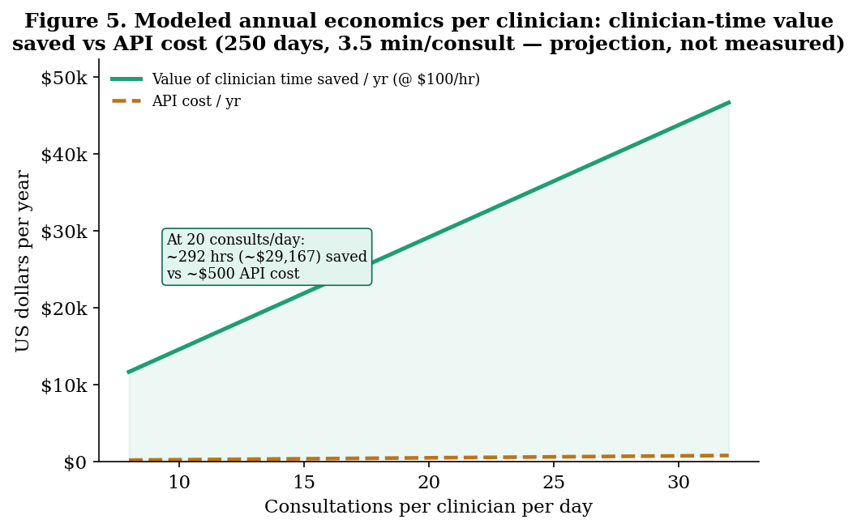
Figure 5. Modeled annual economics per clinician: clinician-time value saved versus API cost. Projection under stated assumptions, not a measured result.
These figures are sensitive to every assumption. Halving the baseline documentation time, or doubling the review time, roughly halves the projected saving; a lower clinician time-value scales the dollar figure proportionally. The model also omits second-order effects in both directions — reductions in after-hours “pajama-time” documentation and in burnout-related turnover on the benefit side [3,9], and the cost of error review, integration, and oversight on the other. The point of the model is not its precise output but its structure: it identifies the per-consult time delta as the single quantity that must be measured, which is exactly what the proposed evaluation targets.

7. The research-flag feature as a human–AI gap measure
A distinctive feature of VetScribe is its automated research-flag panel, which performs a second-pass analysis comparing the generated SOAP note against the transcript to surface clinically significant items that were raised in the consultation but are absent or under-weighted in the note. In informal testing we observed a systematic and useful pattern: stronger generation models produce fewer flags, because they incorporate more of the salient material into the note themselves, whereas weaker models leave more gaps for the flag pass to detect. This suggests that the flag-firing rate is not merely a user-facing safety feature but a measurable proxy for the human–AI documentation gap, and that it could be used as an inexpensive, automatable axis of model evaluation alongside expert rating. We note the corresponding risk — that a sufficiently strong model could produce few flags while still omitting material a clinician would consider essential — which is why the feature is positioned as a prompt for human attention rather than a guarantee of completeness.

8. Limitations
The limitations of this work are substantial and are stated directly. First and most importantly, the system has not been clinically validated; the savings model in Section 6 is a projection, not a measurement. Second, published evidence shows that current LLMs make frequent errors of omission in SOAP-note generation and are not yet safe for unsupervised clinical documentation [4]; VetScribe mitigates but does not eliminate this risk, and every note carries a clinician-verification requirement. Third, speaker attribution in the present build is a text-based heuristic rather than acoustic diarization, and will misattribute turns when linguistic cues are ambiguous. Fourth, transcription accuracy degrades in the noisy, accented, multi-speaker conditions typical of a real consultation room [10], and these errors are unrecoverable downstream. Fifth, the cost figures reflect one commercial provider’s pricing at a single point in time and will change. Sixth, the present evaluation evidence is limited to a single end-to-end functional test rather than a study with adequate sample size. Finally, the local case store and PDF export retain clinical text on disk; this is acceptable for a local research instrument but would require encryption, access control, and a per-session-only policy before any multi-user or public deployment, and consultations involving real, identifiable patients must not be processed on a public demonstration instance.

9. Proposed evaluation protocol
To convert the projection of Section 6 into evidence, we propose a pre-registered, two-arm evaluation. The primary endpoint is the time-to-document delta: in a within-subject design, participating clinicians document a common set of consultations both with and without VetScribe, with per-encounter documentation time captured by the application’s instrumentation and by independent observation, analysed by paired comparison. The secondary endpoint is documentation quality: a blinded panel of veterinary experts scores VetScribe-assisted notes against clinician-authored gold-standard notes on a structured rubric covering completeness, accuracy, and safety, with inter-rater reliability reported. A tertiary, automatable endpoint is the research-flag precision and recall against expert-identified omissions, testing the gap-measure hypothesis of Section 7. The study should report effect sizes with confidence intervals, pre-specify its analysis, and disclose all model versions and prompts to preserve reproducibility. Only on completion of such a study should any claim of clinical time or cost savings be made.

10. Conclusion
Documentation burden is a measured and worsening problem in clinical medicine and a documented contributor to veterinary burnout. VetScribe demonstrates that an open, reproducible pipeline can transform a recorded veterinary consultation into a structured SOAP note, a plain-language owner summary, clinical entities, an automated gap analysis, and an exportable record, at a measured API cost of approximately ten cents per consultation. We have been deliberate in separating what is measured — cost, latency, and system behaviour — from what is, for now, only modeled — the clinical time and cost saved. The economic structure is favourable: machine documentation costs roughly two orders of magnitude less than the clinician time it could plausibly return. Whether it does return that time is an empirical question that the proposed evaluation is designed to answer. Until then, VetScribe is offered as an assistive, clinician-supervised research instrument and as a reproducible foundation for that evaluation.

References
[1] Sinsky C, Colligan L, Li L, Prgomet M, Reynolds S, Goeders L, et al. Allocation of physician time in ambulatory practice: a time and motion study in 4 specialties. Annals of Internal Medicine. 2016;165(11):753–760. doi:10.7326/M16-0961.
[2] Volk JO, Schimmack U, Strand EB, Reinhard A, Vasconcelos J, Hahn J. Executive summary of the Merck Animal Health Veterinarian Wellbeing Study III and Veterinary Support Staff Study. Journal of the American Veterinary Medical Association. 2022;260(12):1–7. PMID:35943942.
[3] Tierney AA, Gayre G, Hoberman B, Mattern B, Ballesca M, Kipnis P, et al. Ambient artificial intelligence scribes to alleviate the burden of clinical documentation. NEJM Catalyst Innovations in Care Delivery. 2024;5(3). doi:10.1056/CAT.23.0404.
[4] Kernberg A, Gold JA, Mohan V. Using ChatGPT-4 to create structured medical notes from audio recordings of physician-patient encounters: comparative study. Journal of Medical Internet Research. 2024;26:e54419. doi:10.2196/54419.
[5] Radford A, Kim JW, Xu T, Brockman G, McLeavey C, Sutskever I. Robust speech recognition via large-scale weak supervision (Whisper). arXiv preprint arXiv:2212.04356. 2022.
[6] OpenAI. GPT-4 technical report. arXiv preprint arXiv:2303.08774. 2023.
[7] Moy AJ, Schwartz JM, Chen R, Sadri S, Lucas E, Cato KD, et al. Measurement of clinical documentation burden among physicians and nurses using electronic health records: a scoping review. Journal of the American Medical Informatics Association. 2021;28(5):998–1008. doi:10.1093/jamia/ocaa325.
[8] Bredin H, Yin R, Coria JM, Gelly G, Korshunov P, Lavechin M, et al. pyannote.audio: neural building blocks for speaker diarization. In: Proc. IEEE International Conference on Acoustics, Speech and Signal Processing (ICASSP). 2020. p. 7124–7128.
[9] A randomized clinical trial of two ambient artificial intelligence scribes: measuring documentation efficiency and physician burnout. 2025. PMID:40672471 (medRxiv 2025.07.10.25331333).
[10] Benchmarking speech-to-text robustness in noisy emergency medical dialogues: an evaluation of models under realistic acoustic conditions. JAMIA Open. 2025;8(6):ooaf147. doi:10.1093/jamiaopen/ooaf147.
[11] Familiarity with artificial intelligence drives optimism and adoption among veterinary professionals: 2024 survey. American Journal of Veterinary Research. 2025;86(S1):ajvr.24.10.0293. doi:10.2460/ajvr.24.10.0293.
[12] UC Davis veterinary school adopts use of AI scribe platform. dvm360. 2024. Available from: https://www.dvm360.com/view/uc-davis-veterinary-school-adopts-use-of-ai-scribe-platform (trade-press report).

