

TinyML Project — Milestone 2 Report
Hand Gesture Recognition Using IMU Data
(Track B: HGAG Dataset)
Team: Alaa Elkouni – Medhat Abouzeid – Khalid Ali
Date: April 16, 2026

R1. Dataset Description
We use the Hand Gesture Accelerometer and Gyroscope Dataset (HGAG-DATA), published on Mendeley Data (DOI: 10.17632/mkhn7kxjvy.3) by Abbas, Rashid, and Fortuna (2025), released under the CC BY 4.0 license. It contains 23,650 six-dimensional gesture samples from 43 healthy participants (26 male, 17 females; ages 18–69; 34 right-handed, 9 left-handed; 28 non-athletic, 15 athletic). Each participant performed 50 repetitions of 11 hand gestures, yielding 550 samples per subject.

Sensor and acquisition: Data was acquired using the tri-axial accelerometer and gyroscope of an MPU-92/65 sensor module worn as a wrist-mounted watch, connected to an ESP32 DEVKIT V1 transmitting via Wi-Fi to a second ESP32 receiver. Raw signals were sampled at 200 Hz and bandpass-filtered (4th-order Butterworth, 30–90 Hz) to isolate gesture-relevant signals.

Feature extraction: Raw time-series were transformed using the Discrete Wavelet Transform (DWT), producing 250 coefficients per sensor channel. With 6 channels (accel x/y/z, gyro x/y/z), each trial is a 1,500-dimensional feature vector.

Class definitions:

Gesture | Physical Definition
Clapping | Repeated bilateral hand contact; palms striking together 2–3 times.
Coin Flipping | Thumb flicks upward from a closed fist, simulating launching a coin.
Finger Snapping | Middle finger slides off thumb with a sharp snap; wrist stationary.
Fist Making | Open hand closes into a tight fist; wrist remains neutral.
Horiz. Wrist Ext. | Wrist extends horizontally outward from neutral, parallel to ground.
Index Finger Flick | Index finger flicks outward from a curled position; other fingers closed.
Index Thumb Tap | Index finger and thumb tap together repeatedly in a pinching motion.
Shooting | Index finger extends forward (pointing gesture) from a closed fist.
Thumb Up | Thumb extends upward from a closed fist; classic thumbs-up gesture.
Wrist Extension | Wrist bends backward (dorsiflexion) from a neutral position.
Wrist Flexion | Wrist bends forward (palmar flexion) from a neutral position.
Table 1: Class definitions for the 11 gesture categories.

Per-class sample distribution (per-subject split):

Class | Train | Val | Test | Total
Clapping | 1550 | 300 | 300 | 2150
Coin Flipping | 1550 | 300 | 300 | 2150
Finger Snapping | 1550 | 300 | 300 | 2150
Fist Making | 1550 | 298 | 300 | 2148
Horiz. Wrist Ext. | 1550 | 300 | 300 | 2150
Idx Finger Flick | 1550 | 300 | 300 | 2150
Index Thumb Tap | 1550 | 300 | 300 | 2150
Shooting | 1550 | 300 | 300 | 2150
Thumb Up | 1550 | 300 | 300 | 2150
Wrist Extension | 1550 | 300 | 300 | 2150
Wrist Flexion | 1550 | 300 | 300 | 2150
TOTAL | 17,050 | 3,298 | 3,300 | 23,648
Table 2: Per-class sample counts (per-subject split: 31 train / 6 val / 6 test subjects).

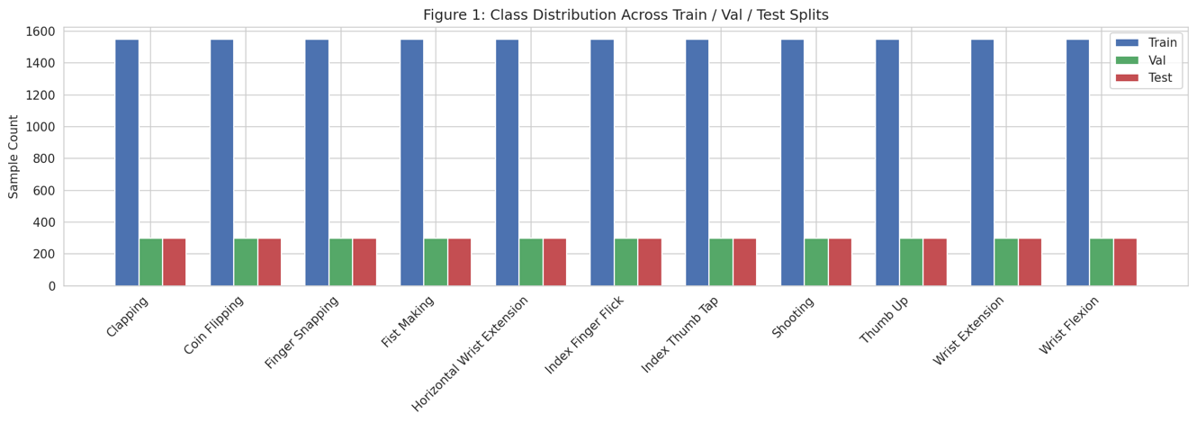
Figure 1 Class Distribution Across Train/Val/Test Splits
Why this dataset: HGAG-DATA uses the same sensor modalities as the Arduino Nano 33 BLE Sense (3-axis accelerometer + gyroscope), covers 11 diverse daily-life gestures with 50 repetitions per subject, and was collected from 43 participants spanning ages 18–69, providing natural inter-subject variability.
Domain gap acknowledgment: The HGAG dataset uses an MPU-92/65 at 200 Hz on an ESP32 platform, while the Arduino Nano 33 BLE Sense uses an LSM9DS1 IMU at up to 119 Hz. Key differences:
- different sensor hardware with different noise floors
- different sampling rates (200 vs. 119 Hz) requiring resampling
- different mounting (wristwatch vs. handheld board)
- the original 30–90 Hz bandpass filter may not be replicable on-device.

R2. Data Card

Field | Value
Task type | Classification (11-class hand gesture recognition)
Number of classes | 11
Sensor(s) and sampling rate | MPU-92/65: 3-axis accel + 3-axis gyro at 200 Hz
Preprocessing | 4th-order Butterworth bandpass (30–90 Hz), then DWT
Features extracted | DWT coefficients: 250 per channel x 6 channels = 1,500
Total samples | 23,648 (Fist Making has 2 missing trials across 2 subjects)
Train / Val / Test split | 17,050 / 3,298 / 3,300 (72% / 14% / 14%)
Split method | Per-subject (31 / 6 / 6 subjects; zero overlap)
Number of subjects | 43 (26M / 17F, ages 18–69, 34 RH / 9 LH)
Known limitations | Single environment; wrist-mounted sensor; DWT params not fully published
Dataset name / URL | HGAG-DATA v3 — DOI: 10.17632/mkhn7kxjvy.3 (Mendeley Data)
License | CC BY 4.0
Original equipment | MPU-92/65 + ESP32 DEVKIT V1 (wrist-worn, Wi-Fi TX)
Domain gap vs. Arduino | Different IMU (LSM9DS1), lower rate (119 Hz), handheld vs. wrist
Arduino collection plan | See Section R7
Table 3: Data Card for HGAG-DATA.

R3. Preprocessing Pipeline
- Segmentation: Each trial is a single complete gesture execution, pre-segmented by the dataset authors. No windowing or overlap is applied.
- Feature extraction: The dataset provides pre-computed DWT coefficients (250 per channel). We concatenate 6 channel CSVs (accel x/y/z, gyro x/y/z) into a 1,500-dim vector per trial. The original raw data was bandpass-filtered (4th-order Butterworth, 30–90 Hz) prior to DWT.
- Normalization: sklearn StandardScaler fitted on training set only. Post-scaling: train mean=0.000, std=1.000; test mean=-0.000, std=0.841. No information leaks from test data into normalization.
- Data augmentation: None at this stage. Planned for Milestone 3: noise injection, time-shifting.

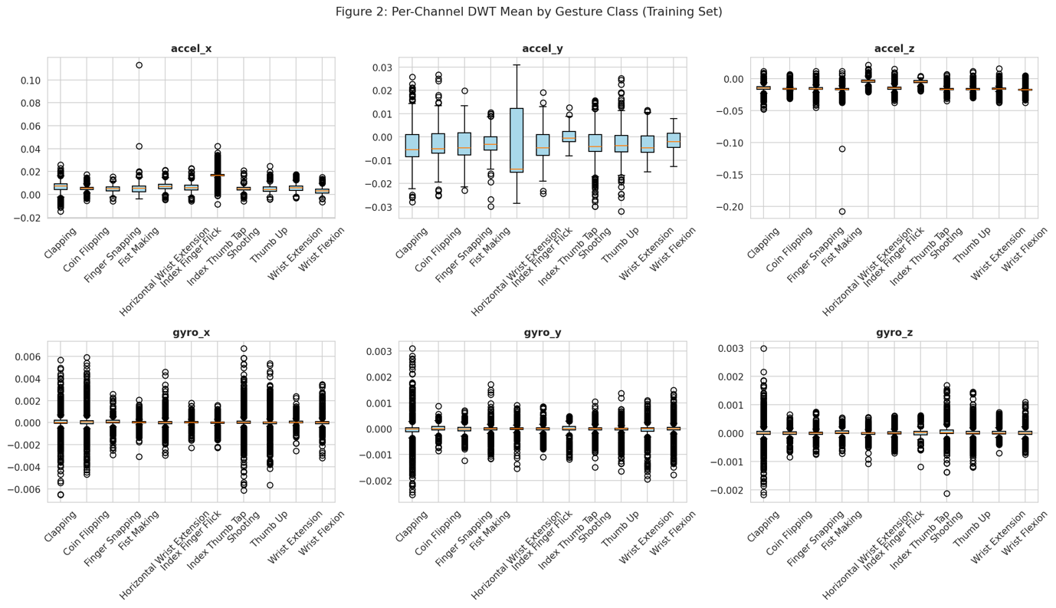
Figure 2 Per-Channel DWT Mean by Gesture Class

R4. Baseline Model
We trained four baseline classifiers on the 1,500-dim DWT feature vectors. The table below summarizes all results; SVM (RBF)
achieved the highest macro F1 and is our primary baseline.

Model | Accuracy | Macro F1 | Weighted F1
Random Forest | 0.6173 | 0.6205 | 0.6205
SVM (RBF, C=10) | 0.7058 | 0.7063 | 0.7063
k-NN (k=5) | 0.3927 | 0.4091 | 0.4091
Dense NN (3-layer) | 0.6836 | 0.6807 | 0.6807
Table 4: Model comparison — all evaluated on the held-out test set (3,300 samples, 6 unseen subjects). Chance level: 9.1%.

Parameter | Value
Architecture | Support Vector Machine (sklearn.svm.SVC)
Kernel | RBF (Radial Basis Function)
C (regularization) | 10
Gamma | scale (1 / (n_features * var))
class_weight | balanced
Input shape | [1500] (flattened DWT feature vector)
Output | 11 classes
Table 5: SVM baseline hyperparameters.
Why this baseline: SVM with RBF kernel is well-suited for high-dimensional feature spaces, handles non-linear class boundaries, and achieved the best macro F1 (0.7063) among all four models tested. It establishes a strong performance floor that an improved or deployable model in M3 must match.

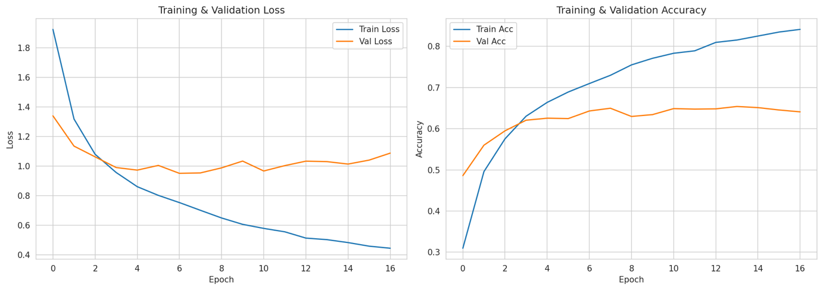
Figure 3 Training Curves

R5. Baseline Results (Held-Out Test Set)
All results are on the held-out test set: 3,300 samples from 6 unseen subjects (Subjects 15, 19, 21, 29, 39, 8). No test subject appears in training or validation.

Metric | Value
Overall accuracy | 0.7058
Macro F1-score | 0.7063
Weighted F1-score | 0.7063
Test set size | 3,300 (6 subjects x 11 gestures x 50 reps)
Table 6: Overall test-set metrics (SVM baseline)

Table 7: Per-class precision, recall, and F1-score on the test set (SVM baseline).
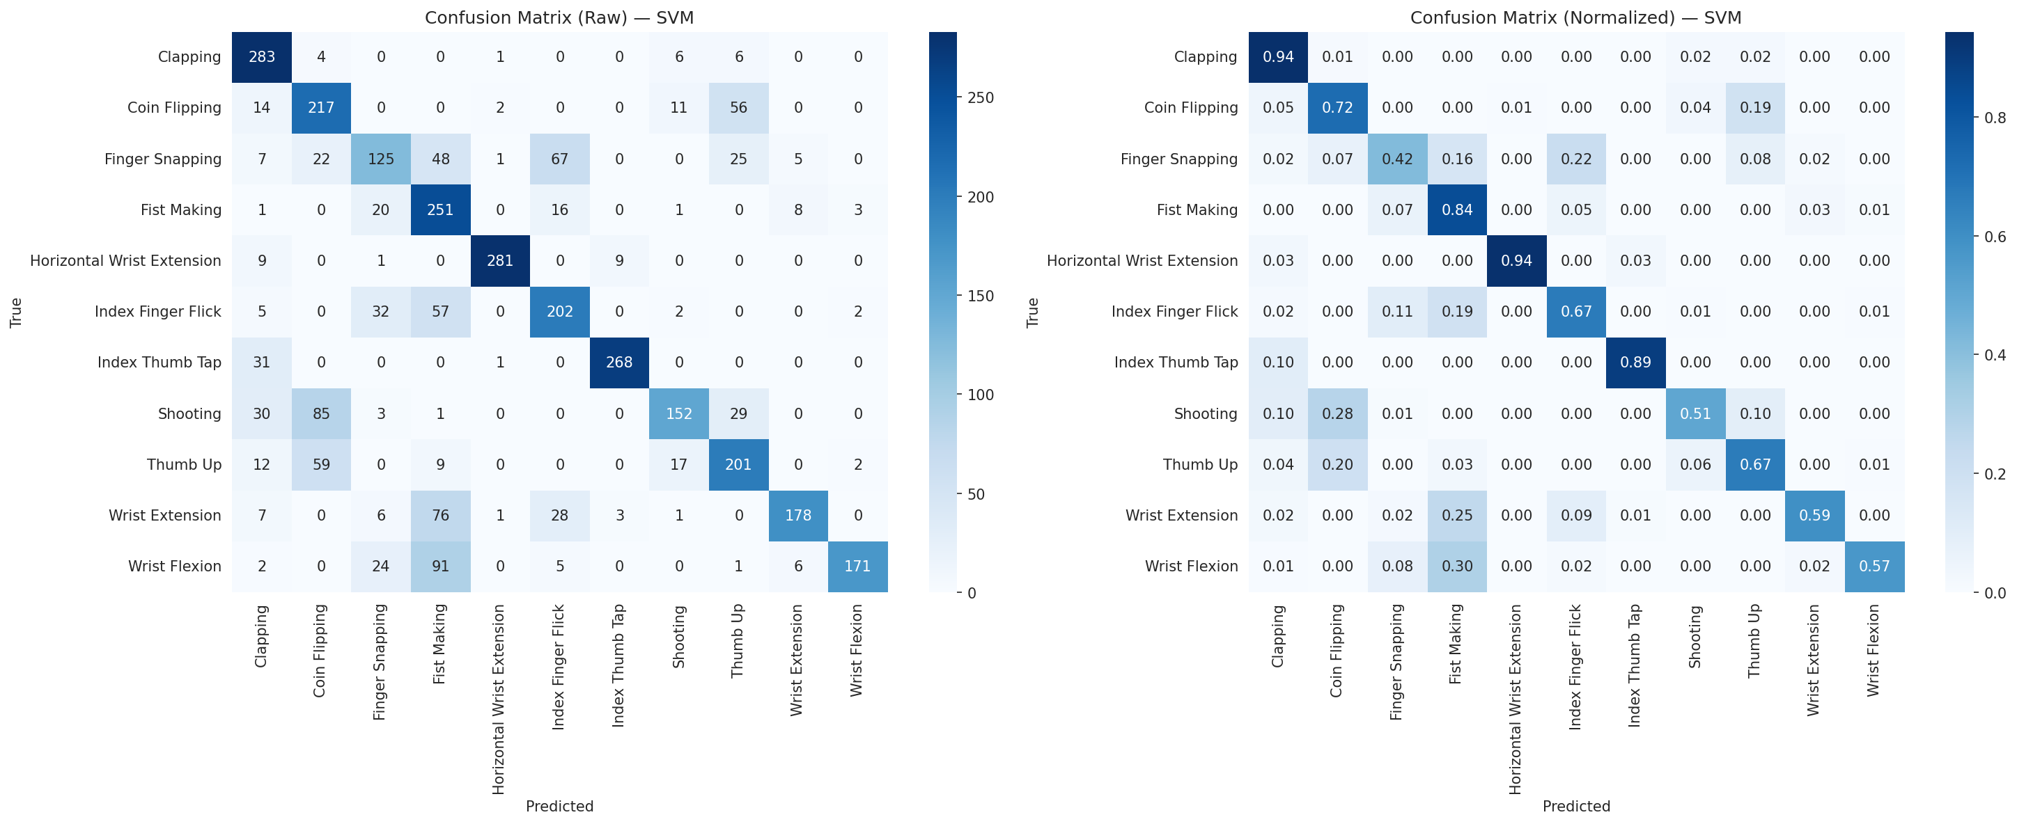

Figure 4 Confusion matrix (raw counts + normalized) for SVM

Class | Prec. | Recall | F1 | Support
Clapping | 0.706 | 0.943 | 0.807 | 300
Coin Flipping | 0.561 | 0.723 | 0.632 | 300
Finger Snapping | 0.592 | 0.417 | 0.489 | 300
Fist Making | 0.471 | 0.837 | 0.603 | 300
Horiz. Wrist Ext. | 0.979 | 0.937 | 0.957 | 300
Idx Finger Flick | 0.635 | 0.673 | 0.654 | 300
Index Thumb Tap | 0.957 | 0.893 | 0.924 | 300
Shooting | 0.800 | 0.507 | 0.620 | 300
Thumb Up | 0.632 | 0.670 | 0.651 | 300
Wrist Extension | 0.904 | 0.593 | 0.716 | 300
Wrist Flexion | 0.961 | 0.570 | 0.716 | 300
Macro avg | 0.745 | 0.706 | 0.706 | 3,300
Table 7: Per-class precision, recall, and F1-score on the test set (SVM baseline).

R6. Error Analysis

True Class | Predicted As | Errors | Error Rate
Wrist Flexion | Fist Making | 91 | 30.3%
Shooting | Coin Flipping | 85 | 28.3%
Wrist Extension | Fist Making | 76 | 25.3%
Finger Snapping | Idx Finger Flick | 67 | 22.3%
Thumb Up | Coin Flipping | 59 | 19.7%
Idx Finger Flick | Fist Making | 57 | 19.0%
Coin Flipping | Thumb Up | 56 | 18.7%
Table 8: Top confusion pairs from the SVM test-set evaluation.

Hypothesized causes and planned fixes:
Cluster 1 — Fist Making absorbs Wrist Flexion (30.3%) and Wrist Extension (25.3%): Fist Making has very high recall (83.7%) but low precision (47.1%), meaning the SVM over-predicts it. Closing the hand into a fist involves involuntary wrist motion; the IMU cannot distinguish finger-closing from deliberate wrist movement. Both Wrist Flexion and Wrist Extension leak heavily into Fist Making. Fix: Weight gyroscope channels more heavily (they may capture rotational vs. translational differences); try a two-stage classifier separating wrist-dominant from finger-dominant gestures first.
Cluster 2 — Shooting leaks into Coin Flipping (28.3%): Both involve a quick forward finger extension. The SVM conflates the trigger-pull motion in Shooting with the thumb-flick in Coin Flipping because the dominant accelerometer signal is a similar forward burst. Fix: Add time-domain features (jerk, peak count) to distinguish dynamics; try a 1D-CNN to capture temporal patterns within DWT coefficients.
Cluster 3 — Finger Snapping vs. Index Finger Flick (22.3%): Both are rapid single-finger release gestures. The snap adds a thumb-contact phase, but the dominant signal is the sharp deceleration spike common to both. Fix: Explore higher-resolution DWT decomposition to capture the pre-release contact phase.
Well-separated classes: Horizontal Wrist Extension (93.7% recall, 97.9% precision) and Index Thumb Tap (89.3% recall, 95.7% precision) are near-perfect — these involve unique, large-amplitude, multi-axis motions with no physical overlap. Clapping also performs well (94.3% recall) due to its distinctive bilateral impact signature.
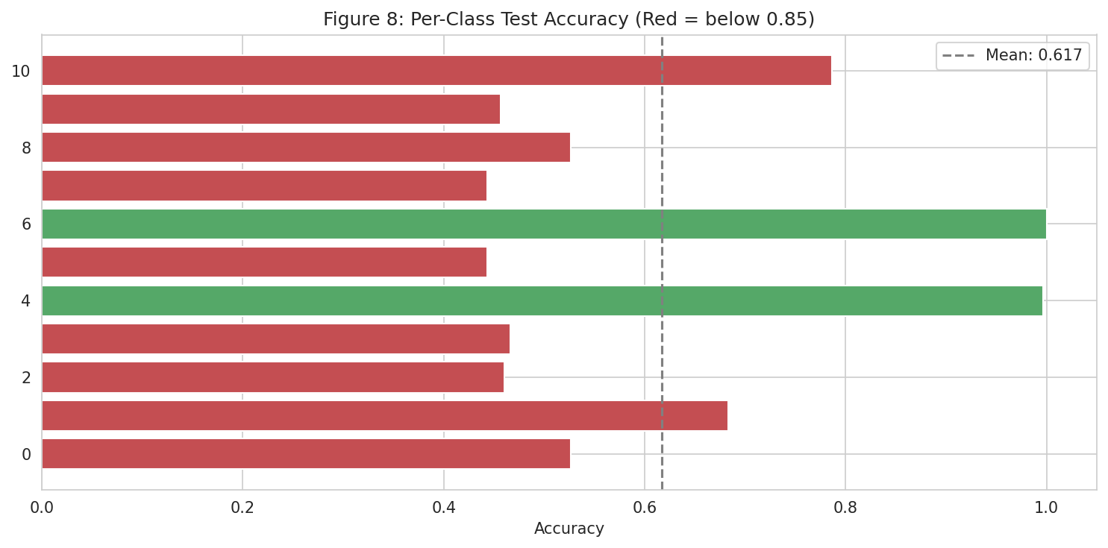
Figure 5 Per-class accuracy bar chart

Feature importance (Random Forest): Accelerometer channels dominate (accel_x: 20.9%, accel_z: 20.3%, accel_y: 19.4%) vs. gyroscope (gyro_x: 14.9%, gyro_y: 12.6%, gyro_z: 11.9%). The gyro channels are underutilized despite potentially capturing the rotational differences that separate confused gesture pairs.
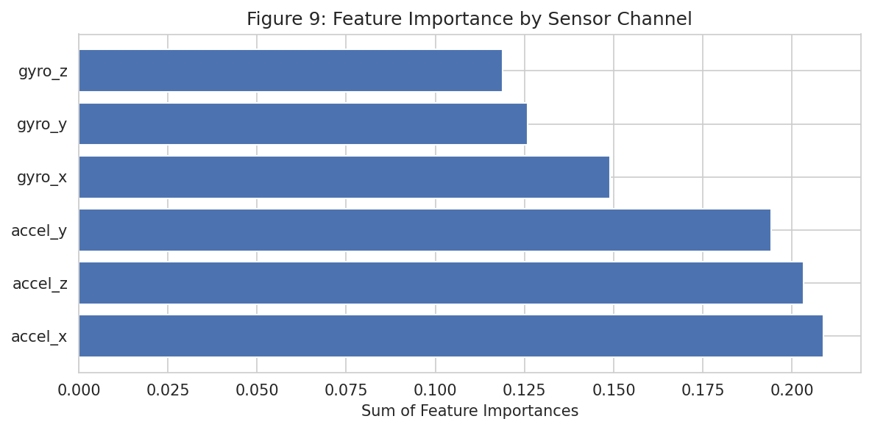
Figure 6 Feature importance by sensor channel

Domain gap analysis (Track B): The per-subject accuracy of 70.6% already reflects cross-user generalization difficulty. On Arduino hardware, we expect further degradation because:
- the LSM9DS1 has a different noise floor than the MPU-92/65
- 119 Hz vs. 200 Hz sampling means the bandpass filter and DWT must be recalibrated
- wrist-dominant gestures (Horiz. Wrist Extension, Wrist Flexion)
should transfer better than finger-level ones (Finger Snapping, Index Finger Flick).

Note on split methodology: We use a per-subject split (31/6/6 subjects, zero overlap). An earlier trial-level random split yielded ~74.6% accuracy with the same RF model, confirming that within-subject leakage inflated metrics by ~13 pp. We report per-subject results as primary.

R7. Updated Plan for Milestone 3

Model improvements:
- Try a lightweight 1D-CNN on the DWT sequences to capture temporal patterns.
- Hybrid features: DWT + time-domain statistics (mean, std, jerk, zero-crossing rate).
- Data augmentation: Gaussian noise, time-shifting, scaling.
- PCA dimensionality reduction (~50 components for 90%+ variance) for smaller deployable models.

Deployment: Convert best model to TensorFlow Lite Micro for Arduino Nano 33 BLE Sense. Target: under 100 KB model size, under 200 ms inference latency. Post-training int8 quantization.

Arduino data collection plan (Track B):

Item | Detail
When | Weeks 1–2 of M3 period (before submission)
Sensor config | Arduino Nano 33 BLE Sense — LSM9DS1 IMU at 119 Hz, 6-axis
Gestures | All 11 (prioritize the 5 most confused for domain gap testing)
Samples per class | 30 reps per gesture per user
Users | Minimum 2 (team members)
Environments | At least 2 (seated desk, standing)
Total target | ~660 samples (11 x 30 x 2)
Table 9: Arduino data collection plan.

Domain adaptation: Phase 1: Evaluate HGAG-trained model on Arduino data. Phase 2: Fine-tune if accuracy drops below 40%. Phase 3: Retrain from scratch on combined data with Arduino-matched preprocessing if needed.
Fallback: If domain gap is too large for all 11 gestures, reduce to the 5 best-separated classes (Horiz. Wrist Ext., Index Thumb Tap, Wrist Flexion, Clapping, Thumb Up).
Robustness testing: New users not in training, different environments, synthetic noise injection.

Ethics and Limitations
Informed consent and participant welfare: The HGAG dataset was collected from 43 adult volunteers (ages 18–69) who completed a demographic questionnaire prior to data collection. Two individuals who exhibited neurological tremor symptoms were excluded by the original researchers to ensure consistent gesture execution. While this exclusion was justified for data quality, it means the dataset, and any model trained on it, does not represent users with motor impairments, which is a relevant population for gesture-based assistive technology. Future work should consider inclusive data collection.
Demographic representation: The participant pool consists of 26 males and 17 females, with 34 right-handed and 9 left-handed individuals, all recruited from the University of Basrah in Iraq. This introduces geographic, cultural, and institutional bias: gesture execution patterns may vary across populations due to differences in hand size, grip habits, and physical conditioning (28 non-athletic vs. 15 athletic participants are represented, but the balance may not reflect the general population). Our model has not been tested on populations outside this demographic.
Privacy: The dataset contains only anonymized IMU sensor signals (accelerometer and gyroscope readings) with no personally identifiable information, biometric data, or video recordings. Subject identifiers are limited to numeric labels (Subject_1 through Subject_43). The risk of re-identification from 6-axis motion data alone is negligible.
Licensing and attribution: The dataset is released under CC BY 4.0 on Mendeley Data (DOI: 10.17632/mkhn7kxjvy.3), permitting use, modification, and redistribution with appropriate credit. We cite the original authors (Abbas, Rashid, and Fortuna, 2025) throughout this report and in our repository.
Limitations of the current study:
- The dataset was collected in a single controlled environment; real-world deployment would encounter variable lighting, movement, and background vibration that may degrade performance.
- The sensor was wrist-mounted as a watch-style device, whereas our target deployment uses a handheld Arduino board with different mounting positions produce different signal characteristics for the same gesture.
- The DWT preprocessing was applied by the dataset authors with parameters not fully documented, limiting our ability to replicate the exact pipeline on new hardware.
- Our per-subject evaluation (70.6% accuracy) already shows significant cross-user variation; deploying to entirely new populations may further reduce accuracy.
- The exclusion of individuals with motor impairments means the system should not be assumed to work for users with tremor, limited mobility, or other motor conditions without dedicated evaluation.

