Chapter 7 Wireless and Mobile Networks

In the telephony world, the past 25 years have been the golden years of cellular telephony. The number of worldwide mobile cellular subscribers increased from 34 million in 1993 to 8.3 billion subscribers in 2019. There are now a larger number of mobile phone subscriptions than there are people on our planet. The many advantages of cell phones are evident to all—anywhere, anytime, untethered access to the global telephone network via a highly portable lightweight device. More recently, smartphones, tables, and laptops have become wirelessly connected to the Internet via a cellular or WIFI network. And increasingly, devices such as gaming consoles, thermostats, home security systems, home appliances, watches, eye glasses, cars, traffic control systems and more are being wirelessly connected to the Internet.

From a networking standpoint, the challenges posed by networking these wireless and mobile devices, particularly at the link layer and the network layer, are so different from traditional wired computer networks that an individual chapter devoted to the study of wireless and mobile networks is appropriate.

We will begin this chapter with a discussion of mobile users, wireless links, and networks and their relationship to the larger(typically wired) networks to which they connect. We will draw a distinction between the challenges posed by the wireless nature of the communication links in such networks, and by the mobility that these wireless links enable. Making this important distinction--between wireless and mobility--will allow us to better isolate, identify, and master the key concepts in each area.

We will begin with an overview of wireless access infrastructure and associated terminology. We’ll then consider the characteristics of the wireless link in Section7.2. We include a brief introduction to code division multiple access(CDMA), a shared-medium access protocol that is often used in wireless networks, in Section7.2. In Section 7.3, we’ll examine the link-level aspects of the IEEE 802.11(WIFI) wireless LAN standard in some depth; We’ll also say a few words about Bluetooth wireless personal area networks. In Section 7.4, we’ll provide an overview of cellular Internet access, including 4G and emerging 5G cellular technologies that provide both voice and high-speed Internet access. In Section 7.5, we’ll turn our attention to mobility, focusing on the problems of location a mobile user, routing to the mobile user, and “handing over” the mobile user who dynamically moves from one point of attachment to the network to another. We’ll examine how these mobility services are implemented in the 4G/5G cellular networks, and the in the Mobile IP standard in Section 7.6. Finally, we’ll consider the impact of wireless links and mobility on transport-layer protocols and networked applications in Section 7.7.

7.1 Introduction

Figure 7.1 shows the setting in which we’ll consider the topics of wireless data communication and mobility. We’ll begin by keeping our discussion general enough to cover a wide range of networks, including both wireless LANs such as WiFi and 4G and 5G cellular networks; we’ll drill down into a more detailed discussion of specific wireless architectures in later sections. We can identify the following elements in a wireless network:

Wireless hosts: hosts are the end-system devices.

Wireless links: A host connects to a base station or to another wireless host through a wireless communication link. Different wireless link technologies have different transmission rates and can transmit over different distances. Figure 7.2 shows two key characteristics, link transmission rates and coverage ranges, of the more popular wireless network standards.

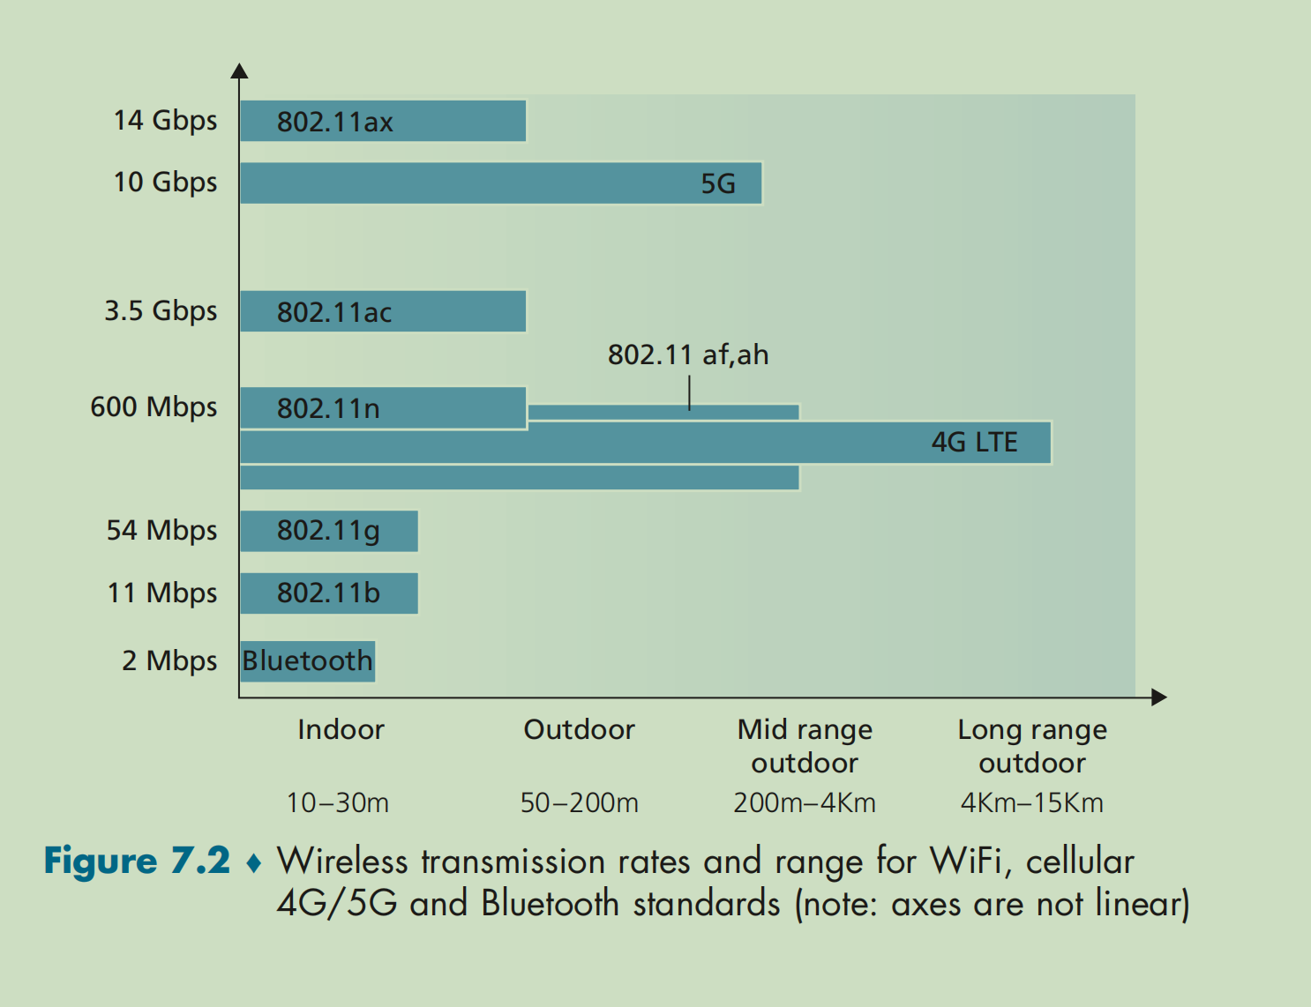

In Figure 7.1, wireless links connect wireless hosts located at the edge of the network into the large network infrastructure. We hasten to add that wireless links are also sometimes used within a network to connect routers, switches, and other network equipment. However, our focus in this chapter will be on the use of wireless communication at the network edge, as it is here that many of the most exciting technical challenges, and most of the growth, are occurring.

Base station. The base station is a key part of the wireless network infrastructure. Unlike the wireless host and wireless link, a base station has no obvious counter part in a wired network. A base station is responsible for sending and receiving data to and from a wireless host that is associated with that base station. A base station will often be responsible for coordination the transmission of multiple wireless hosts with which it is associated. When we say a wireless host is “associated” with a base station, we mean that (1) the host is within the wireless communication distance of the base station, and (2) the host uses that base station to relay data between it and the larger networks. Cell towers in cellular networks and access points in 802.11 wireless LANs are examples of base stations.

In Figure 7.1, the base station is connected to the larger network(e.g., the Internet, corporate or home network), thus functioning **as a link-layer relay between the wireless host and the rest of the world** with which the host communicates.

Hosts associated with a base station are often referred to as operation in infrastructure mode, since all traditional network services(e.g., address assignment and routing) are provides by the network services are provided by the network to which a host is connected via the base station. In ad hoc networks, wireless hosts have no such infrastructure with which to connect. In the absence of such infrastructure, the hosts themselves much provide for services such as routing, address assignment, DNS-like name translation, and more.

When a mobile host moves beyond the range of one base station and into the range of another, it will change its point of attachment into the larger network(i.e., change the base station with which it is associated)--a process referred to as handoff or handover. Such mobility raises many challenging questions. If a host can move, how does one find the mobile host’s current location in the network so that data can be forwarded to that mobile host? How is addressing performed, given that a host can be in one of many possible location? If the host moves during a TCP connection or phone call, how is data routed so that the connection