ER. LEE CHOON KUAN

Periodic Façade Inspection Report

Notice Reference No: PFI2024/12/7049

THE SOVEREIGN
99 Meyer Rd, Singapore 437920

Section 1 - Facade System of the Building
1.1 General Information of the Building
Development/building address and name | THE SOVEREIGN  99 Meyer Rd, Singapore 437920
Number of building blocks in the development | 1 Block
Age of each building block within the development | 34 years
Height of each building block within the development | 95 m
Number of storey in each building block within the development | 30 storey
Description of main usage of the  buildings (e.g. commercial, residential,  industrial, hospitality, mix-use  development consist of commercial  and residential, industrial, etc.) | Commercial use
Details of as-built records/ drawings of façade systems, (if available, please attach in Annex C) | See drawings attached in Annex C
Maintenance history of the façade (i.e. list records of Repair and Redecoration work) | N/A
Known defects from past PFI report provided by the owner, (list if any) | N/A
Resurfacing of past defects, (list if any) | N/A

Section 2 - 100% Visual inspection
2.1 Diary and Scope of Visual Inspection
Time and dates of inspection | 5 April 2025  9am to 1pm
Duration of inspection | 4 hour
Location of inspection | 99 Meyer Rd, Singapore 437920
Methodology of carrying out  the 100% visual inspection.  If drone is not used, explained  why and provide vantage  locations in Annex A. | Drone
Names, addresses, contact  details of others, drone service  provider/specialist/consultants  involved in the inspection (list if  any) | MaxzRange Pte Ltd
Particulars of Façade Inspector  engaged to assist the  Competent Person in the  inspection (if any) | Pang Jin Yong  Registration no: FI-0249  Expiry date: 31 December 2025
Description of any areas not  covered by the visual  inspection, and the reasons for  the non-coverage) | N/A
Highlight any discrepancies  and deviations from the  approved plans by showing  façade elevations (in drawings  or photographs) | N/A
The visual inspection has covered all façade system within the buildings.

Section 2 - Minimum 10% Close-range Inspection
3.1 Diary and Scope of Close-range Inspection
Basis of selection of locations/ areas to carry  out the Close-range inspection | North, South, West, East
Drawings/plan of selected areas as record  (calculations showing the 10% area) | See Annex B
Time and dates of Close-range inspection | 10 -11 January 2025  9am to 5pm
Duration of inspection | 2 days
Methodology of carrying out the Close-  range inspection, including the type of  inspection tools & equipment used.  Inspection of concealed fixings. Include CP’s  instructions given to Façade Inspector | MaxzRange Pte Ltd
Particulars of Façade Inspector engaged to  assist the Competent Person in the  inspection (if any). To provide separate  input if FI differs from visual inspection and  more than one FIs.) | Pang Jin Yong  Registration no: FI-0249  Expiry date: 31 December 2025
The close-range inspection has covered at least 10% of the surface area of each elevation.

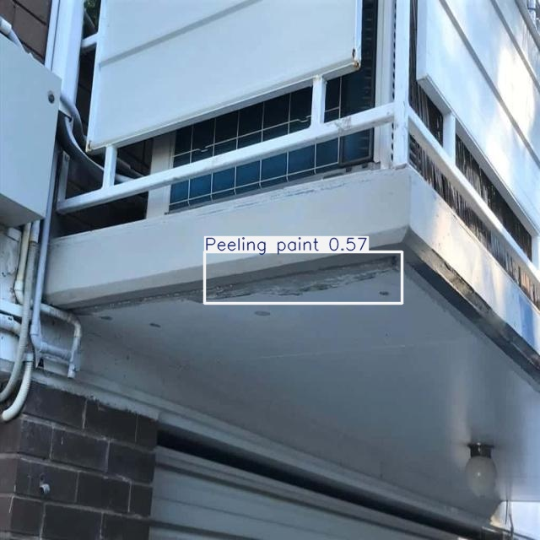
Photograph 1 | General view of rooftop ledge wall
Observation | Cracks
Nature of defect: | Structural
Recommended Actions | Reference to Summary List from 3.10

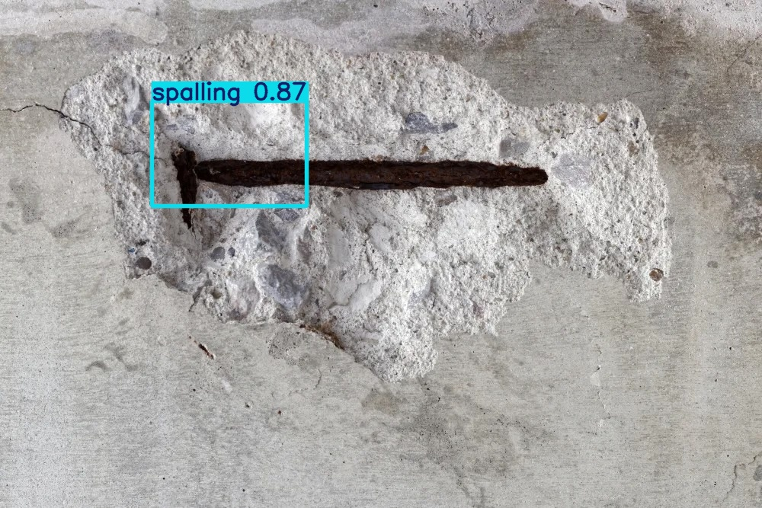
Photograph 2 | Close-up of column base
Observation | Spalling concrete
Nature of defect: | Structural
Recommended Actions | Reference to Summary List from 3.10


Photograph 3 | Beam soffit at carpark
Observation | Water leakage
Nature of defect: | Non-structural
Recommended Actions | Reference to Summary List from 3.10


Photograph 4 | Expansion joint at facade
Observation | Joint displacement
Nature of defect: | Structural
Recommended Actions | Reference to Summary List from 3.10


Photograph 5 | Exterior wall of Block A
Observation | Algae growth
Nature of defect: | Non-structural
Recommended Actions | Reference to Summary List from 3.10


Photograph 6 | Ceiling near lift lobby
Observation | Water seepage
Nature of defect: | Non-structural
Recommended Actions | Reference to Summary List from 3.10


Photograph 7 | Staircase handrail
Observation | Corrosion
Nature of defect: | Structural
Recommended Actions | Reference to Summary List from 3.10


Photograph 8 | Roof slab junction
Observation | Efflorescence
Nature of defect: | Non-structural
Recommended Actions | Reference to Summary List from 3.10


Photograph 9 | Carpark floor slab
Observation | Delamination
Nature of defect: | Structural
Recommended Actions | Reference to Summary List from 3.10


Photograph 10 | Basement wall
Observation | Hairline cracks
Nature of defect: | Structural
Recommended Actions | Reference to Summary List from 3.10

