ER. LEE CHOON KUAN

Periodic Façade Inspection Report

Notice Reference No: 17049

Ang Mo Kio 1
Ang Mo Kio Rd, Singapore 437920

Section 1 - Facade System of the Building
1.1 General Information of the Building
Development/building address and name | Ang Mo Kio  Ang Mo Rd, Singapore 437920
Number of building blocks in the development | 1 Block
Age of each building block within the development | 34 years
Height of each building block within the development | 95 m
Number of storey in each building block within the development | 30 storey
Description of main usage of the  buildings (e.g. commercial, residential,  industrial, hospitality, mix-use  development consist of commercial  and residential, industrial, etc.) | Commercial use
Details of as-built records/ drawings of façade systems, (if available, please attach in Annex C) | See drawings attached in Annex C
Maintenance history of the façade (i.e. list records of Repair and Redecoration work) | N/A
Known defects from past PFI report provided by the owner, (list if any) | N/A
Resurfacing of past defects, (list if any) | N/A

Section 2 - 100% Visual inspection
2.1 Diary and Scope of Visual Inspection
Time and dates of inspection | 5 April 2025  9am to 1pm
Duration of inspection | 4 hour
Location of inspection | Ang Mo Kio Rd, Singapore 437920
Methodology of carrying out  the 100% visual inspection.  If drone is not used, explained  why and provide vantage  locations in Annex A. | Drone
Names, addresses, contact  details of others, drone service  provider/specialist/consultants  involved in the inspection (list if  any) | MaxzRange Pte Ltd
Particulars of Façade Inspector  engaged to assist the  Competent Person in the  inspection (if any) | Pang Jin Yong  Registration no: FI-0249  Expiry date: 31 December 2025
Description of any areas not  covered by the visual  inspection, and the reasons for  the non-coverage) | N/A
Highlight any discrepancies  and deviations from the  approved plans by showing  façade elevations (in drawings  or photographs) | N/A
The visual inspection has covered all façade system within the buildings.

Section 3 - Minimum 10% Close-range Inspection
3.1 Diary and Scope of Close-range Inspection
Basis of selection of locations/ areas to carry  out the Close-range inspection | North, South, West, East
Drawings/plan of selected areas as record  (calculations showing the 10% area) | See Annex B
Time and dates of Close-range inspection | 10 -11 January 2025  9am to 5pm
Duration of inspection | 2 days
Methodology of carrying out the Close-  range inspection, including the type of  inspection tools & equipment used.  Inspection of concealed fixings. Include CP’s  instructions given to Façade Inspector | MaxzRange Pte Ltd
Particulars of Façade Inspector engaged to  assist the Competent Person in the  inspection (if any). To provide separate  input if FI differs from visual inspection and  more than one FIs.) | Pang Jin Yong  Registration no: FI-0249  Expiry date: 31 December 2025
The close-range inspection has covered at least 10% of the surface area of each elevation.

Section 4 – Assessment of the defects

The inspection revealed minimal observable defects, with some requiring repairs due to wear and tear. Close-range inspections were limited to specific areas, prompting the use of the
tapping method to identify hollow plaster in other sections during detailed assessments.
Defects identified as requiring repairs will be closely monitored, and timely repairs should be
scheduled to prevent potential safety issues. Proper barricades and protection measures
must be implemented during repairs to ensure the safety, the public, and property. No further
investigation is deemed necessary at this stage.

Section 5 - Recommendations, Remedial and Follow-Up Actions
No unsafe defects were observed during inspection.

5.1 Repair Methodology

Cracks
a) Scrap away any loose or flaking material around the crack. Then cut a piece of mesh joint tape slightly longer than the crack. Press the tape firmly onto the crack, ensuring that it covers the entire length of the crack.

b) Apply a thin layer of joint compound over the mesh tape, pressing it firmly into the crack to fill any gaps.

c) Smooth the joint compound around the edges then, allow the joint compound to dry completely then smoothen the repaired area with sandpaper.

d) Apply a coat of primer to the repaired area to ensure proper adhesion of the paint and allow the primer to dry completely before proceeding.

e) Apply paint that matches the existing ceiling colour over the repaired area. Apply multiple thin coats, allowing each coat to Dry.

Rust
a) Determine the extent of the rust damage. Light surface rust can often be remove easily, while deeper rust may require more intensive treatment or even replacement of the affected part.

b) Start by cleaning the rusted area with a wire brush, sandpaper, or steel wool to remove loose rust flakes and debris. For more significant rust, use a power tool like an angle grinder or drill with a wire brush attachment.

c) Apply a rust remover or rust converter to the affected area. These products are available in liquid or gel form and contain chemicals (like phosphoric acid or tannic acid) that convert rust into a more stable compound. Follow the manufacturer’s instructions for application and dwell time.

d) After the rust remover has worked, scrub the area again with a wire brush or sandpaper to remove any remaining rust and the chemical residue.

Hollowness
a) Detect hollow areas using tapping techniques, mark affected spots, and remove compromised tiles while avoiding damage to surrounding areas.

b) Inject specialized fillers or adhesives into voids, reattach tiles firmly, and use vibration-free methods to ensure complete bonding.

c) Allow sufficient curing, test adhesion strength, and conduct periodic inspections to prevent detachment or further structural compromise over time.

Blistering Paint
a) Scrape off blistered paint using a putty knife, ensuring to remove all loose and affected layers completely.
b) Sand the area thoroughly to smoothen the surface and feather edges, ensuring proper adhesion for new paint.

c) Apply primer suitable for the surface, then repaint using high-quality paint under proper environmental conditions to prevent recurrence.

Paint Peel
a) Scrape off all peeling paint completely, reaching stable underlying layers to ensure a sound surface for repainting.

b) Sand the surface evenly to remove any remaining flakes and create a smooth base for new coating adhesion.

c) Prime the area with appropriate primer, then repaint using weather-resistant paint suited to the surface and climate conditions.

Paint Cracks
a) Identify and clean cracked areas thoroughly, removing dirt and loose particles to reveal the extent of damage.

b) Fill cracks using flexible acrylic filler or caulk, ensuring full penetration into gaps for long-lasting repair.

c) Sand the area smooth, prime it, and repaint with quality paint that has good elasticity and crack resistance.

Chip off
a) Identify and mark the sections of the plaster that need to be removed.

b) Carefully chip off the plaster using a hammer and chisel, starting from the edges and working inward to prevent damage to the underlying surface.

c) Scrape off any remaining loose plaster or debris to ensure a clean and stable surface.

d) Check the exposed surface for any underlying issues such as cracks, spalling, or damage that need repair.

e) Thoroughly clean the surface by removing dust and debris,
preparing it for any further treatment or re-plastering.

Defects that require repair
Photo Number | Location | Observation | Posible Couse | Recomendation | Timefram (months) | Remedial Work requiring CP
1 | Elevation1 | Crack | Wear crack | Refer to Repair Metodology 5.1 | 2 | Yes
2 | Elevation 2 | Crack | Woldern | Refer to Repair Metodology 5.1 | 2 | Yes
3 | Elevation 3 | Crack | Rust | Refer to Repair Metodology 5.1 | 2 | Yes

Section 6 – Conclusion
The inspection revealed that minimal defects could be observed from the inspection, However some defects require repairs due to wear and tear. Defects categorized as needing repair will be closely monitored, and scheduled repairs should be conducted to prevent them from becoming unsafe.
It is recommended that the building owner shall continue to properly maintain the façade of the building and conduct their own regular checks and repairs before the next cycle of inspection which will be conducted again in 7-years.

ANNEX A – Visual inspection report
ELEVATION 1
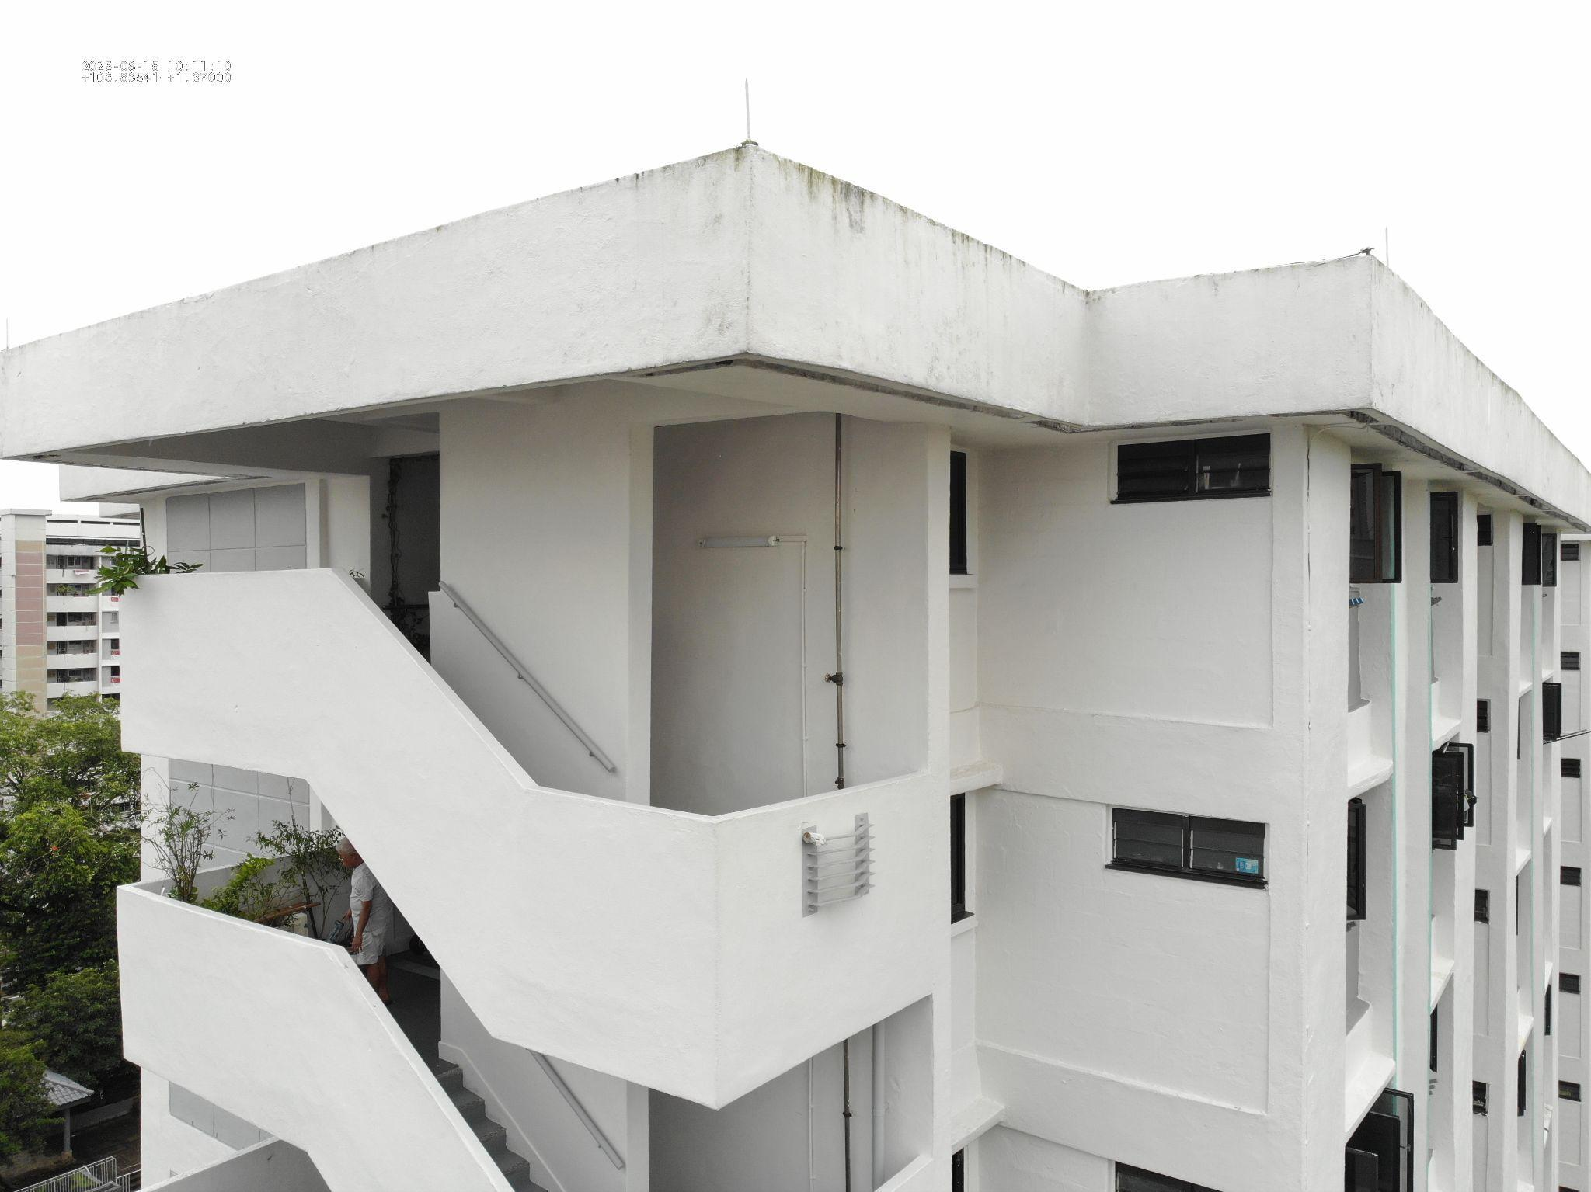

Photograph 1 | General view of rooftop ledge wall
Observation | Cracks
Nature of defect: | Structural
Recommended Actions | Reference to Summary List from 3.10

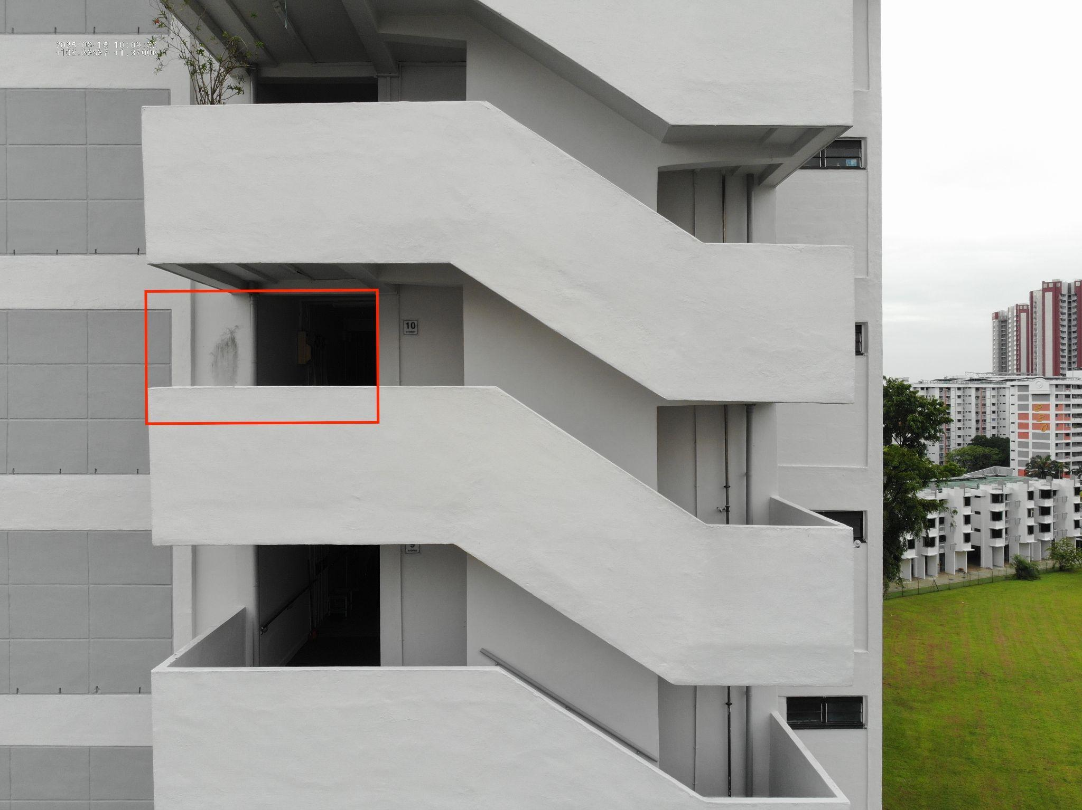

Photograph 2 | Close-up of column base
Observation | Spalling concrete
Nature of defect: | Structural
Recommended Actions | Reference to Summary List from 3.10

ELEVATION 2

Photograph 2 | General view of building exterior Elevation 1
Observation | Water leakage
Nature of defect: | Non-structural

Photograph 3 | Close-up of column base
Observation | Spalling concrete
Nature of defect: | Structural
Recommended Actions | Reference to Summary List from 3.10

ELEVATION 3
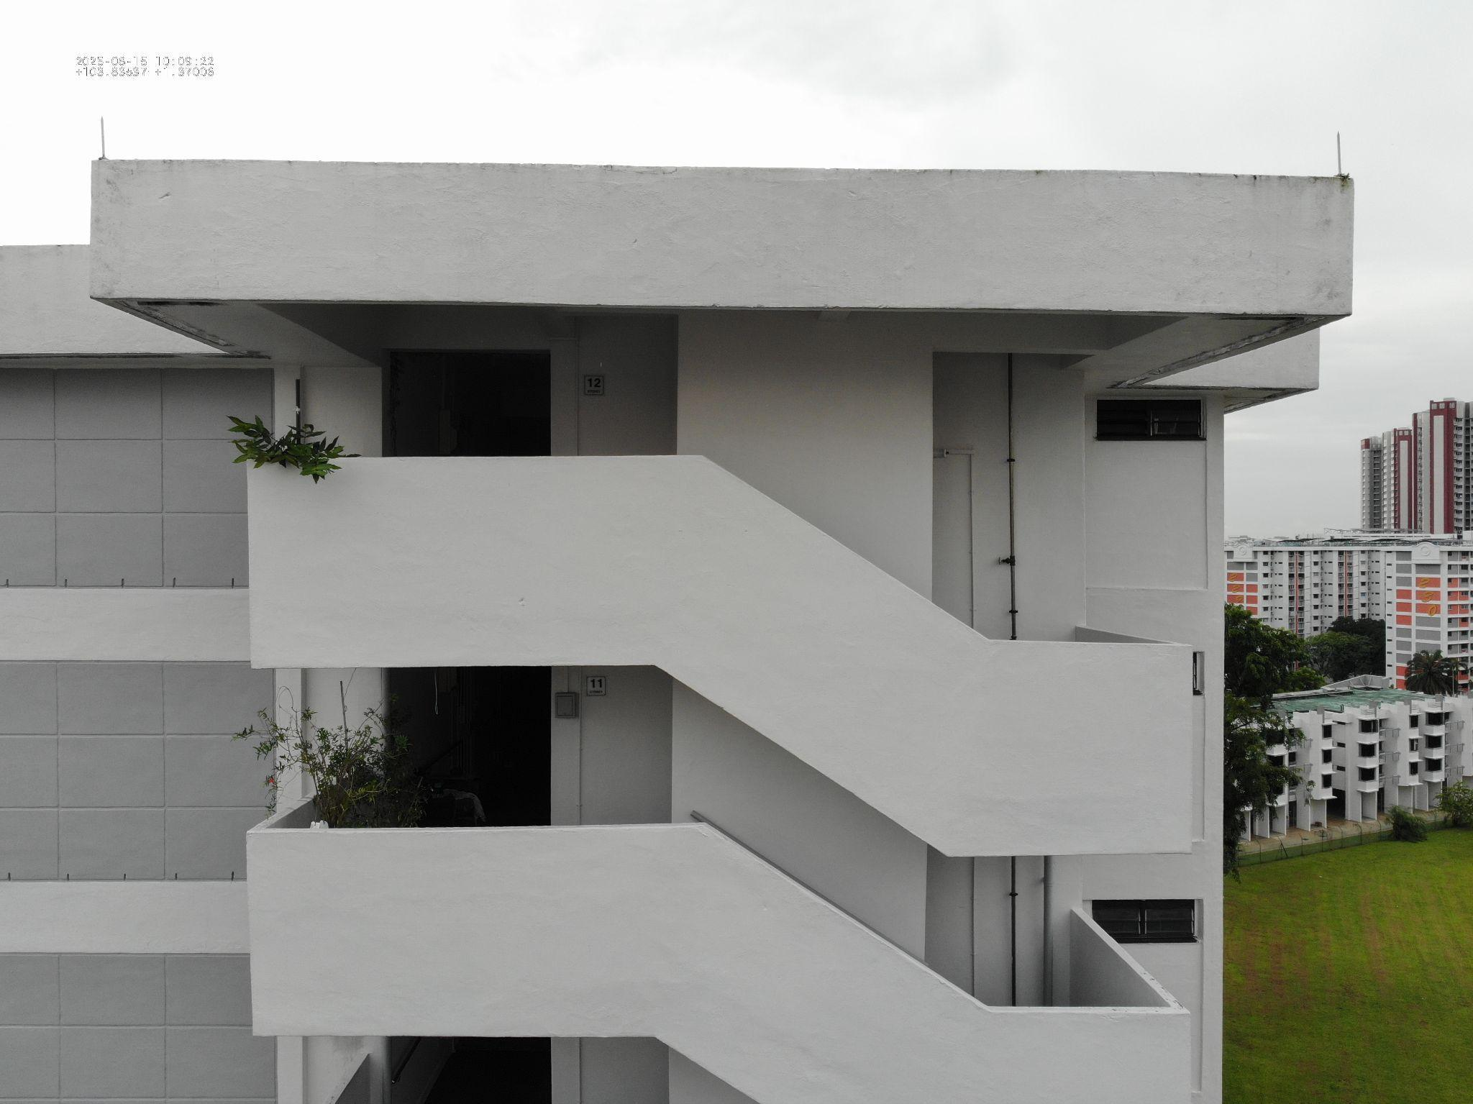
Photograph 4 | Expansion joint at facade
Observation | Joint displacement
Nature of defect: | Structural

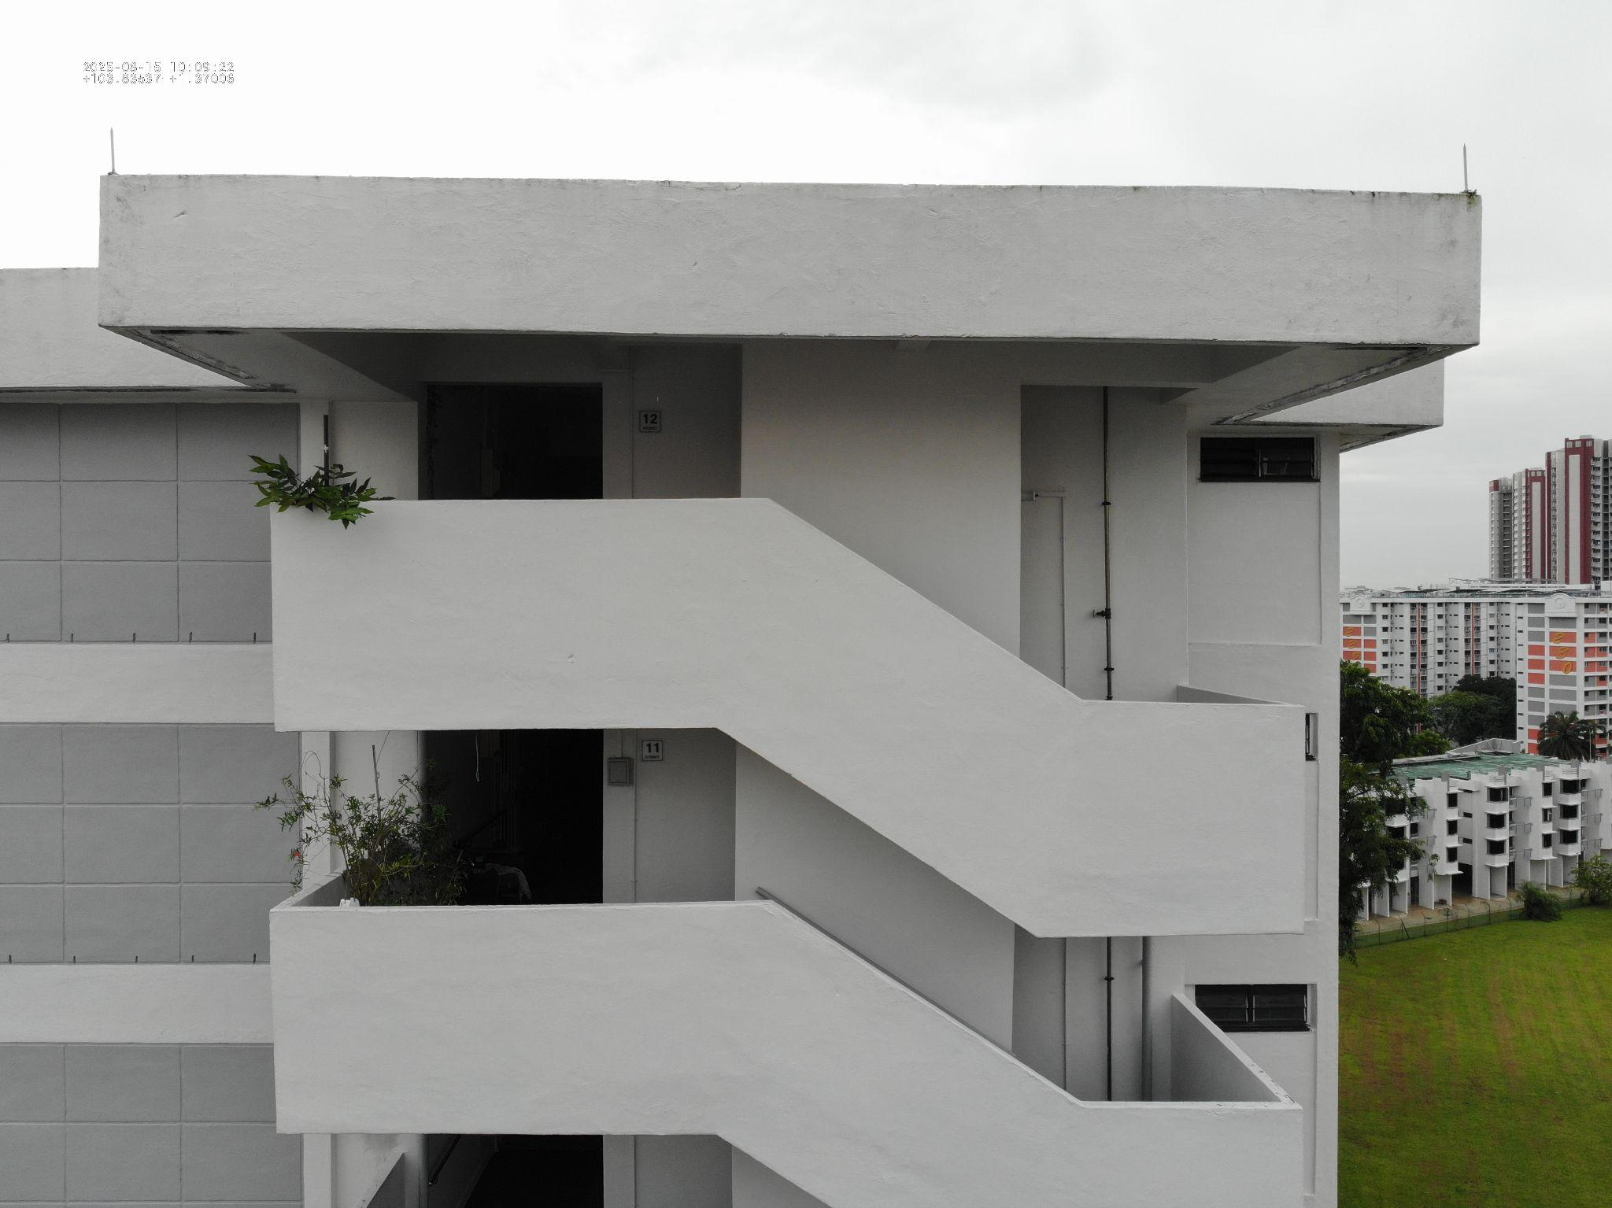

Photograph 2 | Close-up of column base
Observation | Spalling concrete
Nature of defect: | Structural
Recommended Actions | Reference to Summary List from 3.10

ANNEX D – Standard Declaration by Competent Person

Standard Certification by Competent Person for
Periodic Façade Inspection of Buildings

In accordance with Section 28(6) of the Building Control Act (the “Act”) and
Regulations 15,16 and 17 of (Periodic Inspection of Buildings and Building Facades)
Regulations 2021 (the “Regulations”), I, LEE CHOON KUAN , the Competent Person
appointed by the building owner under Section 28(3) of the Act have conducted an
inspection on the condition and integrity of the building façade and hereby submit the
report of the results of the inspection. I certify that the inspection was carried out and
the report was prepared by me in accordance with the provisions of the Act and the
Regulations.

__________________________ _________________ Fri, May 16, 2025
Competent Person Date _________________
For Periodic Façade Inspection of Buildings

(Signature and Stamp)
__________________________ Façade Inspector Date Fri, May 16, 2025
For Periodic Façade Inspection of Buildings
(Signature)

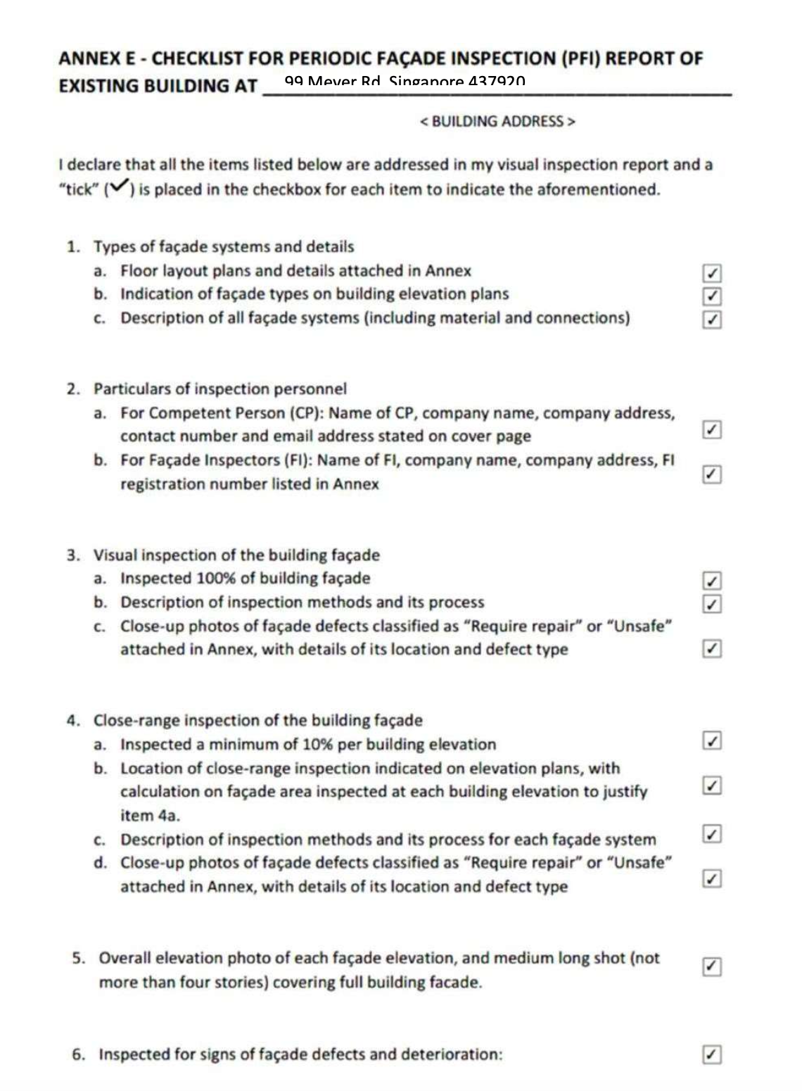
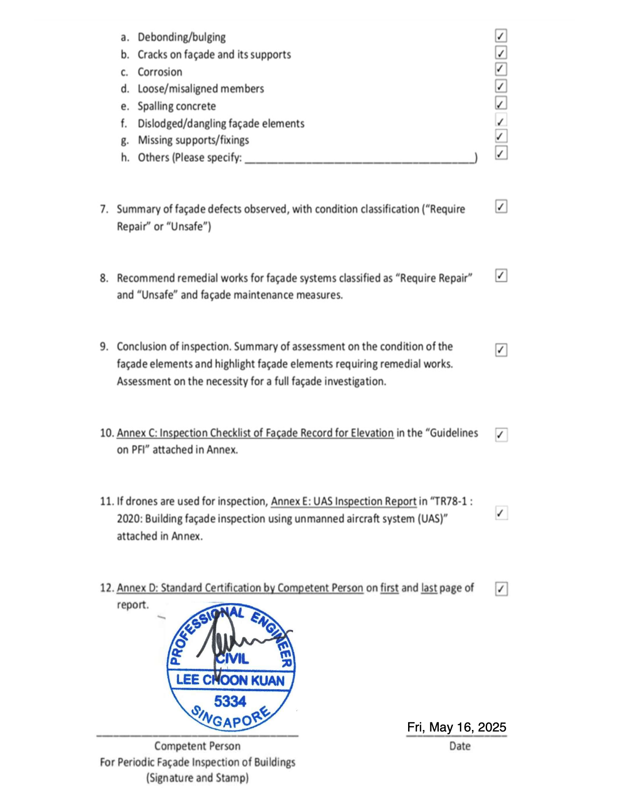

APPENDIX F - APPOINTMENT OF COMPETENT PERSON
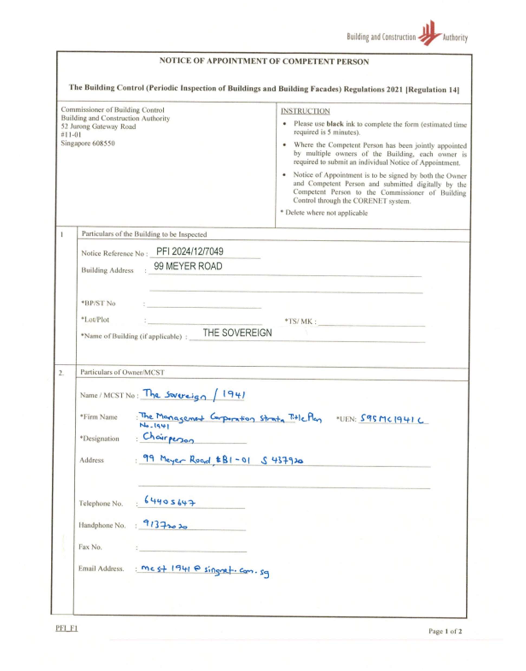
APPENDIX G - CERTIFICATE OF COMPETENT PERSON


APPENDIX H - CERTIFICATE OF FAÇADE INSPECTOR
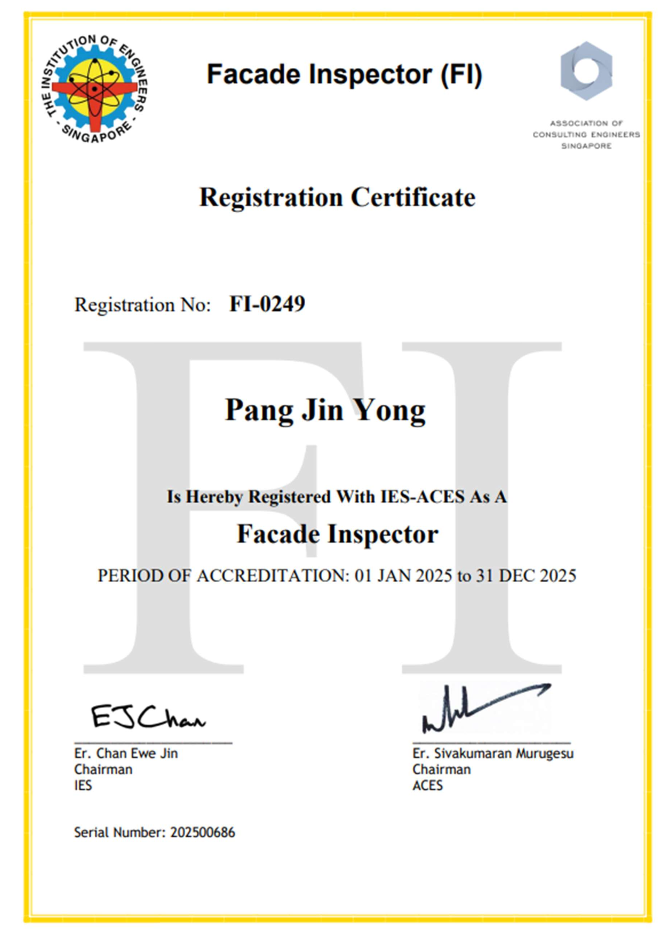

APPENDIX H - CERTIFICATE OF DRONE OPERATOR




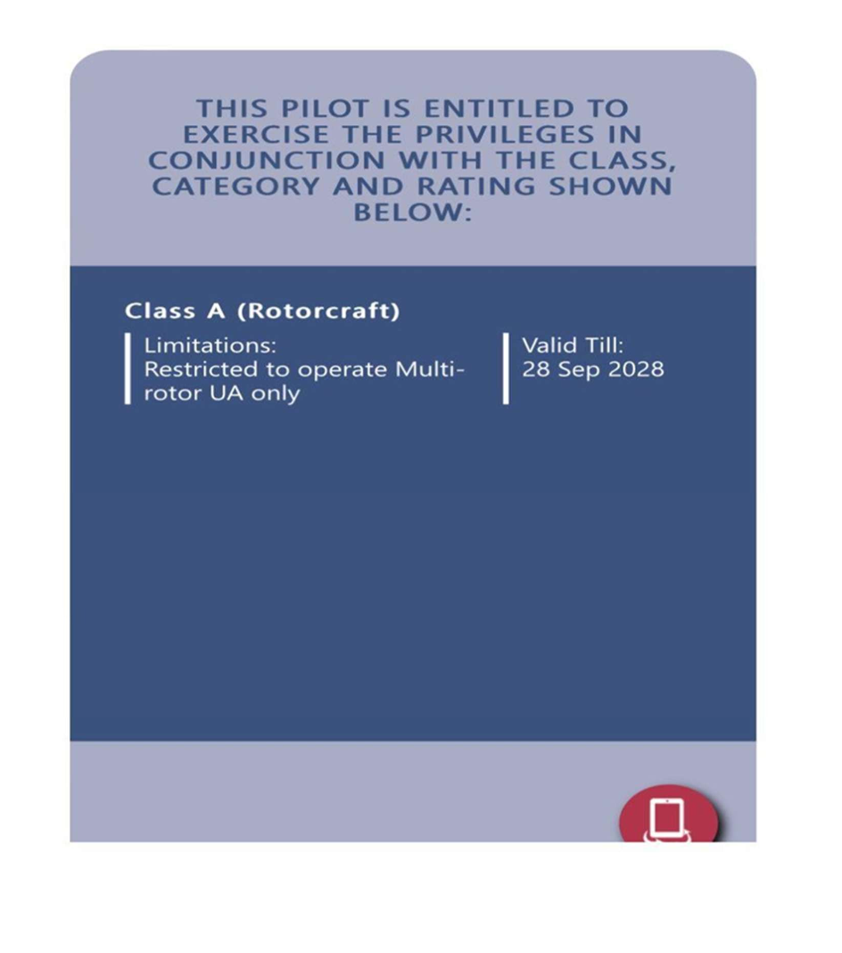

APPENDIX I- ACTIVITY PERMIT FROM CAAS
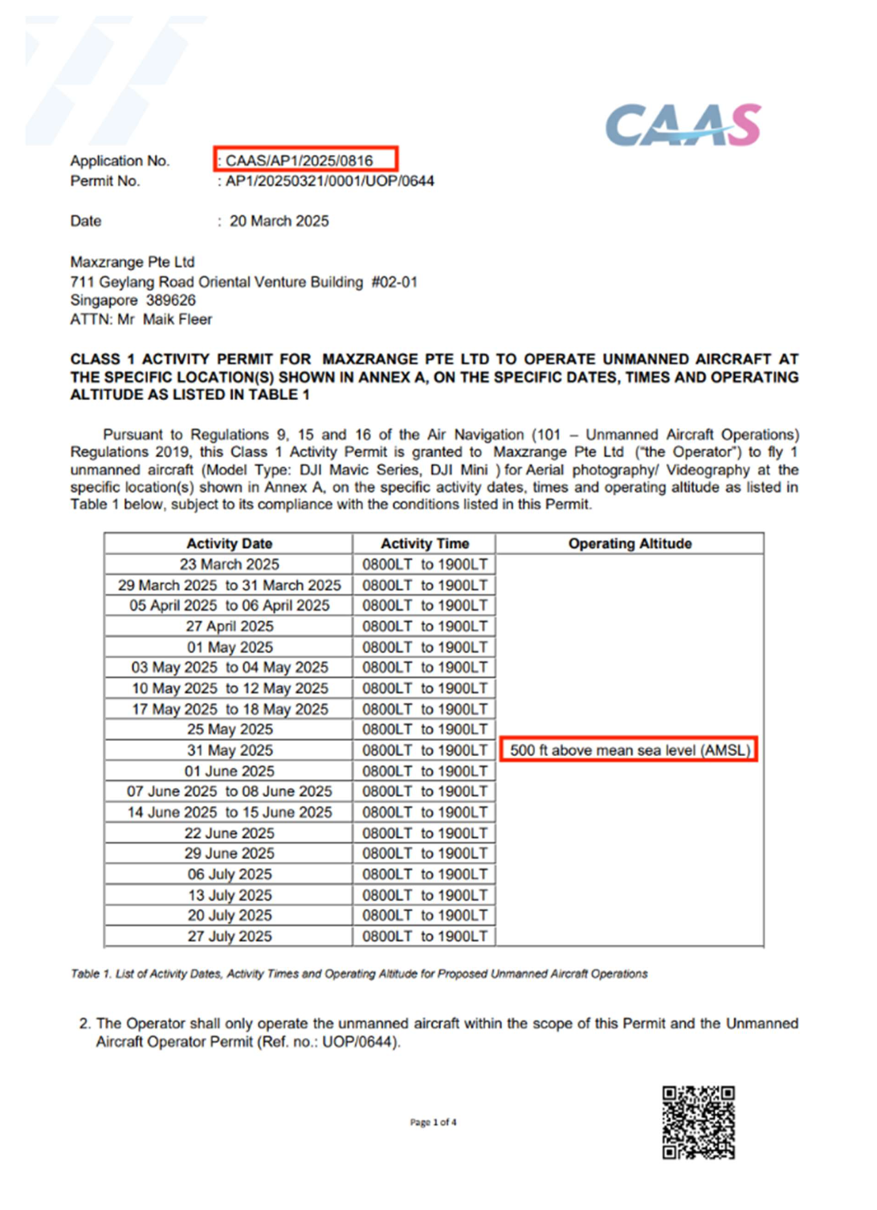

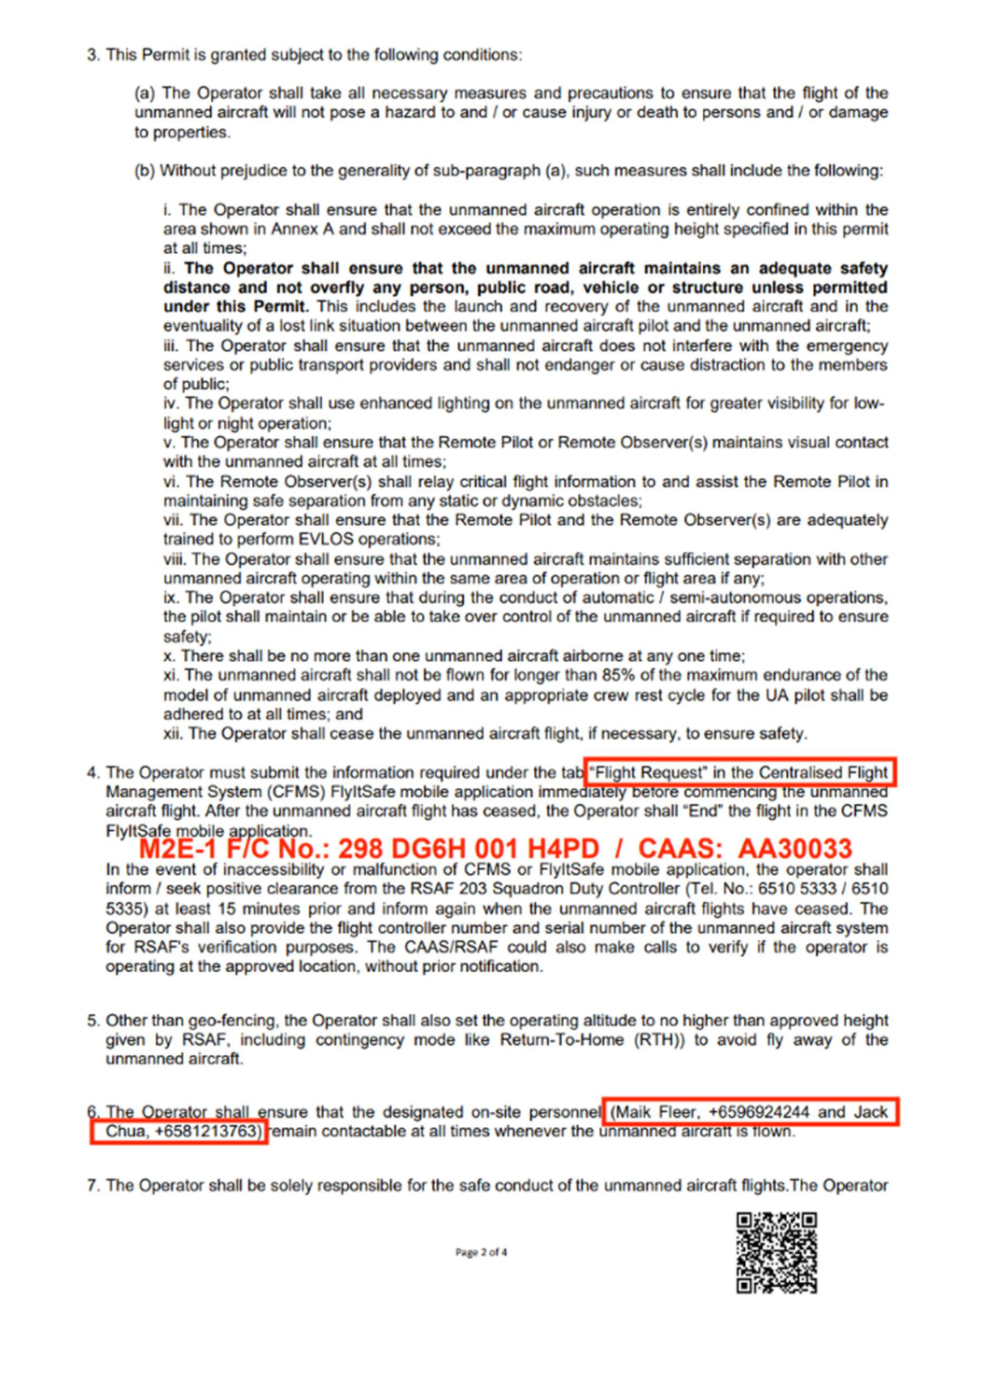
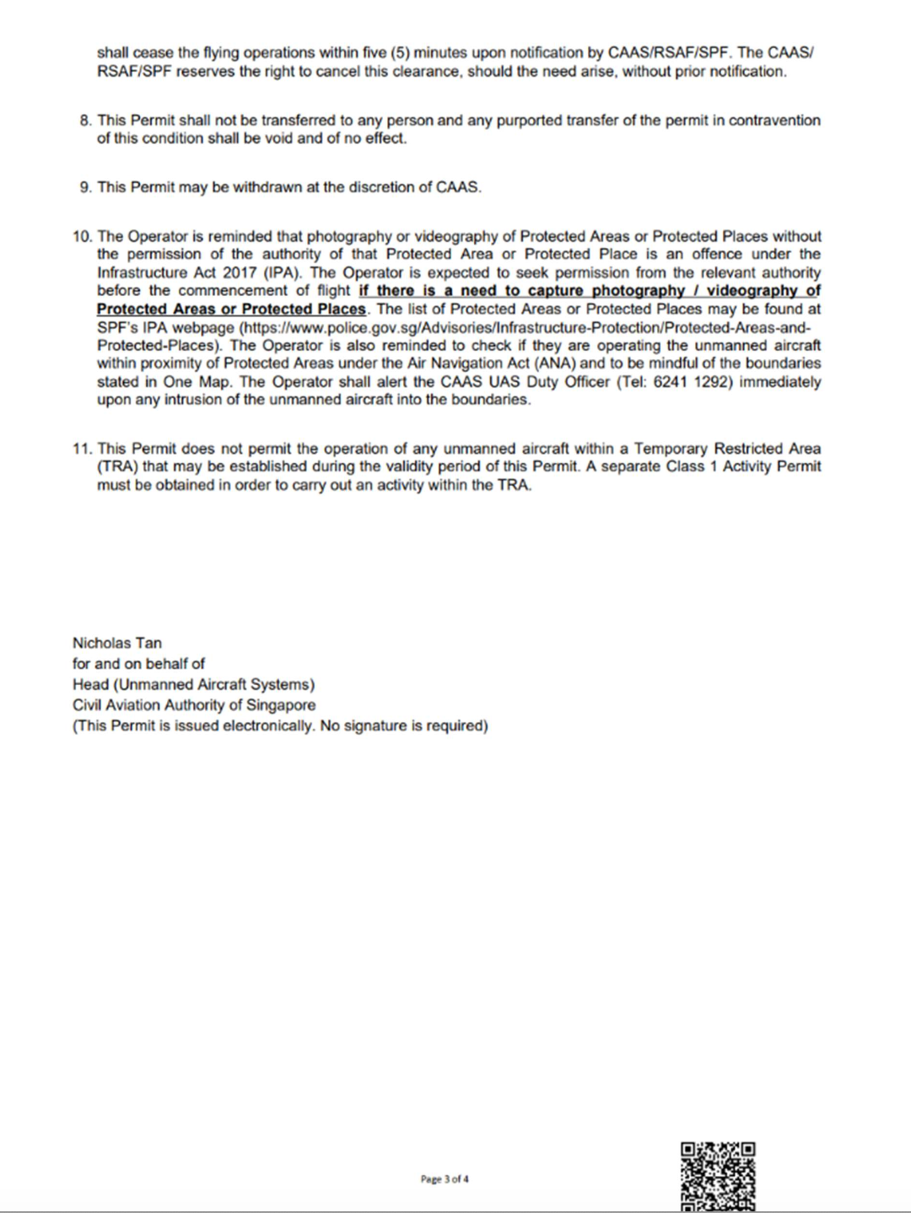
APPENDIX J - UAS INSPECTION REPORT

Flight Location | Ang Mo Kio, Singapore 437920
Flight Date & Time | 10 Oct 2025  10am-11am
Purpose | Building Façade Inspection
CAAS Activity Permit
Reference number

Areas of Operation
Media & file format
UA(s) model
Tethered UA (if  applicable) | No
Building Information
B.1 – Client Information
MCST 1941

8.2 - Address
Ang Mo Kio, Singapore 437920

