Unit #3

In Unit #3 the focus will be on activities throughout the Van de Walle Reading. In Unit #2 we focused on planning our lessons based on the 5 Practices around that unit. In Unit #3 we will be looking at the following topics:
- Addition and Subtraction
- Multiplication
- Division

Week 9, Day 1:

K-2 Number Sense Standards

What main ideas are part of the number sense strand in the Indiana academic standards?
K: Count to 100, recognize/write numerals 0-20, one-to-one correspondence, compare groups. 1st: Place value (tens/ones), number line, compare two-digit numbers using >, <, =, count to 120. 2nd: Place value to 1000, skip count by 5s/10s/100s, read/write numbers to 1000, compare three-digit numbers.

What standards did we not fully understand the meaning of?
Discuss in class. Commonly confusing: 2.DA.1 (data analysis with scaled graphs) requires place value reasoning for scales of 2s, 5s, 10s. 1.NS.5 (count to 120 starting at any number) — why 120? Because it crosses the hundreds boundary, requiring place value understanding.

What is gone from 1st grade and 2nd grade standards that was there in a previous grade (i.e., assumed to have been learned in the previous grade)?

1st grade: Counting and cardinality (K focus) is assumed. Basic number recognition to 20 assumed. 2nd grade: Counting to 120 assumed. Basic place value for tens/ones assumed. Single-digit addition/subtraction within 10 assumed.

What is new in 1st and 2nd grade that was not there in the previous grade? (Pay attention to number range, not just standards)

1st: Place value (tens and ones), number line introduction, comparison with >/</=, number range extends to 120, two-digit number concepts. 2nd: Place value to 1000, skip counting by 5s/10s/100s, even/odd numbers, estimation and rounding readiness.

K-2 Computation and Algebraic Thinking Standards

What main ideas are part of the number sense strand in the Indiana academic standards?

K: Addition/subtraction concepts within 10, composing/decomposing numbers to 10. 1st: Add/subtract within 20, fluency within 10, word problems with unknowns in all positions (result, change, start). 2nd: Fluent add/subtract within 20, add/subtract within 100, two-step word problems, repeated addition as multiplication precursor.

What standards did we not fully understand the meaning of?

Discuss in class. Common confusion: 2.CA.1 (fluency within 20 using mental strategies) — fluency means efficient strategies, not memorized facts. 1.CA.6 (add/subtract within 20 demonstrating fluency) — “demonstrating” means showing reasoning, not just giving answers.

What is gone from 1st grade and 2nd grade standards that was there in a previous grade (i.e., assumed to be learned)?

1st grade: Counting-all strategies (e.g., count both sets from 1) give way to counting-on. K-level work within 5 is assumed. 2nd grade: Basic facts within 10 assumed. Single-step word problems as primary focus replaced by two-step problems.

What is new in 1st and 2nd grade that was not there in the previous grade? (Pay attention to number range, not just standards)

1st: Word problems with unknowns in all positions (not just result unknown). Properties of addition (commutative). Relationship between addition and subtraction. 2nd: Two-step word problems, mental strategies for fluency within 20, add/subtract within 100 with regrouping, repeated addition (2.CA.4).

Week 9, Day 1
Process Standards K-2: What do they look like?
Carousel Recording Sheet

 | Process Standard | What would this look like in a classroom?
PS1
PS2
PS3
PS4
PS5
PS6
PS7
PS8

Week 9, Day 2: Addition and Subtraction Problem Structures
Reading à Van De Walle et al., Chapter 8 pp.159-171

Class Discussion à Additive Problem Structures

Part A: For each problem, (a) use manipulatives to represent the problem and (b) classify as Join, Separate, Part-Part-Whole, or Compare. Draw a picture of your manipulatives.
- Tamika has 7 grapes. Her sister has 5 grapes. How many more grapes does Tamika have than her sister?

- Diego had 12 stickers. He lost 4 of them. How many does he have now?

- Max has 3 jellybeans. His brother gave him 8 more jellybeans. How many jellybeans does he have now?

- Keisha has 3 red jellybeans and 8 blue jellybeans. How many total jellybeans does she have?

Part B: For each of the following Join problems, (a) use manipulatives to represent the problem, (b) state what is unknown (the start, the change, or the result), and (c) write an equation that uses addition for each problem. Draw a picture of your manipulatives.
- Jordan had 5 pencils. He bought 7 more pencils. How many does he have now?

- Rylie has some grapes. Her mom gives her 9 more. Now she has 17 grapes. How many grapes did Rylie have to begin with?

- Anna has 8 pennies. Her mom gives her some more for her allowance. Now she has 13 pennies. How many pennies did her mom give her for her allowance?

STRUCTURE & UNKNOWN | STORY PROBLEM
Change: Join
Start unknown  (use numbers) | Story Problem | Equation
Change unknown (use numbers) | Story Problem | Equation
Result unknown  (use numbers) | Story Problem | Equation
Change: Separate
Start unknown  (use numbers) | Story Problem | Equation
Change unknown (use numbers) | Story Problem | Equation
Result unknown  (use numbers) | Story Problem | Equation

Compare
Difference unknown (use numbers) | Story Problem (Write BOTH a “more than” and a “fewer than” version of this question.) | Equation
Larger quantity unknown  (use numbers) | Story Problem | Equation
Smaller quantity unknown  (use numbers) | Story Problem | Equation
Part-Part Whole
Whole unknown  (use numbers) | Story Problem | Equation
One part unknown (use numbers) | Story Problem | Equation
Both parts unknown (use numbers) | Story Problem | Equation
Part D: Choose one of your problems from within each type (e.g., one from Join, one from Separate, …). Make an appropriate representation (i.e., number line, drawn picture of objects, ten frames, etc.) to model the whole problem. Once you have a representation, consider what features of the representation you would provide for students (e.g., open number line) and what features you would have them create (e.g., the jumps on the open number line).
Join

Separate

Part-Part-Whole

Comparison

Week 10, Day 1:
Class Discussion à Building Basic Fact Knowledge/Addition and Subtraction Strategies

Become an Expert. In your group each person will become an expert on one set of the following strategies:
- One and Two More Than (p. 194)
- Doubles & Near Doubles (p. 196, 198)
- Combinations of 10 & Making 10 (pp. 197, 199)
- Pretend-a-10 (or Use 10) (p. 200).

Share your expertise on these strategies in your small group.

Watch the Video linked here and Record Any Strategies You See Students Using
a. Doubles: 6+6=12, then +2=14 (Kim)
d. Used prior problem: 7+6=13 from before, +1=14 (Greta)

b. Decompose: 1+3=4, 5+5=10, so 4+10=14 (Lane)
e. Make doubles: moved 1 dot to create 7+7=14 (Ethan)

c. Make 10: rearranged to get 10+4=14 (Cameron)
f. Make 10: 8+2=10, then +4=14 (Jeffrey)

The teacher in the video you just watched is supporting fact fluency. Watch the video again to list at least three teaching moves that you notice her engaged in during the video that you think are supporting fact fluency.

Teacher move 1
Asked students to explain HOW they got their answer, not just what the answer was (“How do you know that’s 14?”)

Teacher move 2
Connected student strategies to prior learning (“So those doubles we spent all that time learning last week are really important”)

Teacher move 3
Had students locate numbers in the visual representation, grounding abstract strategies in the concrete dot image (“Where’s the four Lane’s talking about?”)

PART 2: NUMBER TALK WITH SUBTRACTION STRATEGIES

Instructions: Your job is to run a number talk using tens-frames with your tablemates. One person will act as the teacher and the other two or three tablemates will be students. The person who is the teacher should set up the number talk with students and support the students to show their solutions on the tens frame. Time permitting you can change roles so that someone else is the teacher with a new problem.

Problem 1: 17 – 9

Problem 2: 15 – 8

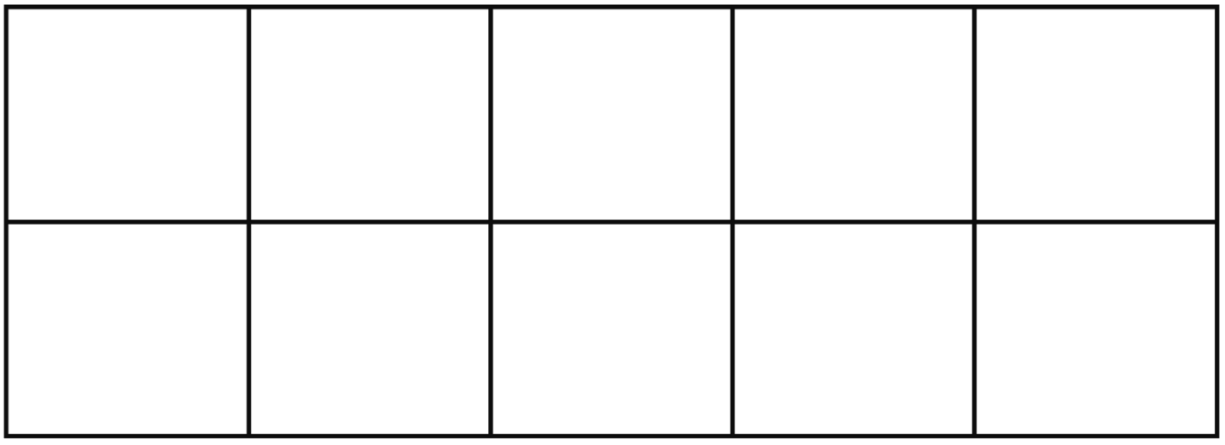

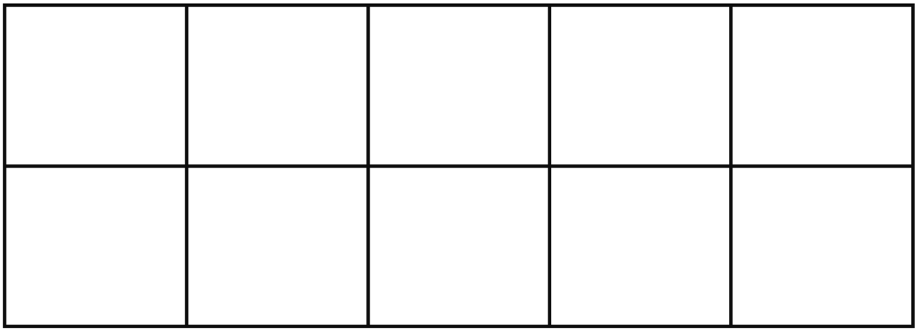

The subtraction strategies that VdW discusses are listed below. Did students in your number talk use all of these strategies? Did they use other strategies as well (e.g., rounding)? Did anyone use a counting back or counting down to strategy?

Think-Addition: Students use known addition facts to produce the unknown quantity or part of the subtraction. For 13 – 8, a student thinks, “What plus 8 equals 13?” Students taught this strategy do significantly better than their peers on subtraction.

Down Under 10: This strategy is the reverse of Making 10, and there are two ways to think about it—separate and comparison. Consider 14 – 8. For separate, you are taking away 8, so jump down 4 to get to 10, then jump down 4, and the answer is 6. For comparison, you are finding the difference or distance. How far apart are 14 and 8? Jump down 4 to get to 10, and then 2 more to get to 8—they are 6 apart.

Take From 10: Takes advantage of students’ knowledge of the combinations that make 10, taking the initial value apart into 10 + ____. For 15 – 8 , for example: Think (10 + 5) – 8, then take from the 10: 10 – 8 = 2, and last add 5: 2 + 5 = 7.

Week 10, Day 2
Class Discussion à 2nd-3rd Grade Number Sense Standards

What main ideas are part of the number sense strand in the Indiana academic standards?
Place value extends to four digits (thousands) in 2nd grade, five+ digits in 3rd. Fractions appear in 3rd grade (unit fractions, fractions on a number line). Number comparison using >, <, = grows in range. Money, time, and measurement contexts deepen.

What standards did we not fully understand the meaning of?
Discuss in class. Common confusions: 3.NS.9 (rounding) often taught as a procedure without place value reasoning. 2.NS.6 (mental addition/subtraction up to 20) assumes fluency strategies, not memorized facts.

What is gone from 2nd grade and 3rd grade standards that was there in a previous grade (i.e., assumed to have been learned in the previous grade)?
Counting and cardinality standards disappear after K-1. Basic place value for tens and ones is assumed. Number recognition and writing to 120 is assumed in 2nd grade. By 3rd grade, fluency with addition/subtraction within 100 is assumed.

What is new in 2nd and 3rd grade that was not there in the previous grade? (Pay attention to number range, not just standard, in responding to this question)

2nd grade: Place value to 1000, skip counting by 5s/10s/100s, even and odd numbers. 3rd grade: Fractions (unit fractions, number line, comparing fractions with same numerator/denominator), rounding to nearest 10 or 100, place value to 10,000+.

2nd-3rd Grade Computation and Algebraic Thinking Standards

What main ideas are part of the number sense strand in the Indiana academic standards?
Addition and subtraction fluency within 100 (2nd grade) and within 1000 (3rd grade). Multiplication and division are introduced in 3rd grade through equal groups, arrays, and area. Two-step word problems appear. Properties of operations (commutative, associative, distributive) become explicit.

What standards did we not fully understand the meaning of?
Discuss in class. 3.AT.2 (solve two-step word problems) is commonly underestimated—students need experience with all four operations, not just addition. 3.AT.5 (determine unknown whole number in multiplication/division equation) connects to algebraic thinking, not just fact recall.

What is gone from 2nd grade and 3rd grade standards that was there in a previous grade (i.e., assumed to be learned)?
Single-digit addition/subtraction as a primary instructional focus. Counting-based strategies (counting on, counting back) are replaced by reasoning strategies. One-step problems are assumed; two-step problems become the new focus.

What is new in 2nd and 3rd grade that was not there in the previous grade? (Pay attention to number range, not just standard, in responding to this question)
2nd grade: Fluent addition/subtraction within 20, two-step addition/subtraction word problems, even/odd numbers, repeated addition as precursor to multiplication. 3rd grade: Multiplication and division within 100, properties of operations, area as multiplication, representing problems with equations using a letter for the unknown.

Week 10, Day 2
Class Discussion à Multiplication and Division Operation Sense

Part A, Problem types: The five problem types that VdW talks about are in the colored boxes at the top. Identify which problem type goes with which contextualized problem listed below.

Part B, Unknown Parts and Equations: For each task, classify the problem according to problem type, what is known and unknown, and write an equation for each. Make sure to be specific about whether a problem is multiplication, sharing (partition) division, or measurement (quotative) division (pp. 172-173).

Tasks | Problem Type, Unknown, Equation
- Holly has 30 marbles. She placed 5 marbles in a row. How many rows could she make?  - Holly has 42 marbles. She puts them into 6 rows. How many marbles are in each row? | Array, measurement division. Total (30) and group size (5) known; number of groups unknown. __ x 5 = 30
- John has 28 cookies total. He has 4 packages. How many cookies are in each package?  - Nancy had 48 books from the library. She returned 6 books each days until all her books were returned. How many days did it take? | Array, sharing division. Total (42) and number of groups (6) known; group size unknown. 6 x __ = 42  Equal groups, sharing division. Total (28) and number of groups (4) known; group size unknown. 4 x __ = 28  Equal groups, measurement division. Total (48) and group size (6) known; number of groups unknown. __ x 6 = 48
- John earns 3 times as much as money as Jack in a week. John earns 12 dollars a week. How much money does Jack earn in a week?  - John earns 36 dollars in a week. Jack earns 12 dollars in a week. In a week, how many times the amount of money does John earn than Jack? | Comparison, sharing division. Product (12) and multiplier (3) known; reference set unknown. 3 x __ = 12  Comparison, measurement division. Product (36) and reference set (12) known; multiplier unknown. __ x 12 = 36
- My rectangular garden is 20 square feet. One of its sides is 4 feet long. How long is the other side? | Area/product of measures. Total area (20) and one dimension (4) known; other dimension unknown. __ x 4 = 20 (or 4 x __ = 20; area problems have symmetry between the two dimensions)

Part C, Modeling Problems: Now put yourself in the role of a teacher. Consider a model that you would use to represent four of the problems on the previous page. Make a representation (pp. 173, 174, 177, 179) that makes sense for the problem structure. Write a multiplication or division statement for each problem that follows Van de Walle et al.’s convention for symbolizing problems (p. 175, bottom, “The U.S. convention is that…”)

Problem 1 | Problem 2
Problem 3 | Problem 4

Week 11, Day 1
Class Discussion à Multiplication Fact Teaching

Observe, Reflect, Advise
Video we will watch together. Answer the first question WHILE you’re watching the video!

Record the order the teacher presented the problems in.
Problems in order: 2×7, 4×7, 3×7, 7×7. The teacher started with 2×7=14 as a known fact, then presented 4×7 so students could double the 2×7. Then 3×7 so they could use 2×7+7. Finally 7×7 requires combining 4×7+3×7 (28+21=49). Each problem builds on previous ones — the sequencing supports derived fact strategies.

Discuss and then comment: What order did the teacher present the problems in?
How does the order that the teacher presents the problems support student strategy usage?

Discuss and then comment: What representations did the teacher use? Are all of them equally useful?
Circles with dots (equal groups model). Teacher erased after each problem. Reasons for erasing: (1) forces students to hold derived facts in memory rather than looking back, (2) keeps focus on current problem, (3) each new problem should be solved using RECALLED results from earlier, not re-reading them. Trade-off: loses ability to compare/contrast strategies visually. Advice: consider keeping at least the equations visible so students can reference the number relationships even if pictures are erased.

Discuss and then comment: When teaching math, we typically keep all student thinking visible as much/long as possible. Meaning we don’t erase student thinking after each explanation so that students can compare and contrast. This teacher erased student thinking after each problem. This was an intentional move. What reasons (both pedagogical and practical) do you think she had for doing that? What are your thoughts about her decision?
What advice would you give this teacher about selecting and sequencing student solutions?

Create an Instructional Plan for Learning Basic Multiplication Facts
Using the Van de Walle et al. reading and our discussion of the video, your job is to make an instructional plan for how you would organize learning basic multiplication facts.

1. Big Picture Planning

Give a “big picture” view of the order in which you would have students work on their multiplication facts. Use Van de Walle et al. to state why certain numbers would precede others (pp. 204-207).

2. Consistency
State how you will interpret the symbols 4 x 8: is it 4 groups of 8 OR 8 groups of 4? Write down how you would interpret each symbolic statement below making sure you are CONSISTENT across all.

4 x 8
8 x 4
9 x 6
5 x 7

3. Anticipating Student Reasoning: Addition or Multiplication?
Sometimes students aren’t sure when to use addition and when to use multiplication. You anticipate that students might add instead of multiply when they are given “naked number” problems, such as 8 x 7. Provide two SPECIFIC examples (or activities) for how you would help a student understand that 8 x 7 is multiplication rather than addition.

Example 1
Example 2

4. Specific Strategy Support
Suppose you are working with students on “6 facts” (that is, one group of 6, two groups of 6, three groups of 6, and so on). You want to support strategy usage (see pp. 208-209).
- State five “6 facts” and the order in which you would present them.
- Based on the order you present the facts state what strategy you are hoping a student might use.

6 Facts in Order of Presentation | Strategy/Strategies Students Might Use

5. Assessment Plan
Van de Walle et al. recommend that students monitor their own progress. State how you will keep track of student progress in a way that takes into account that students should be helping to monitor their own progress.

6. Enjoyment
Van de Walle et al. recommend making facts practice enjoyable. Make a plan for doing this.

Describe, in detail, one game that is presented in the chapter.
Would you want the game to be competitive or collaborative? Why?
How would you differentiate for different students in the context of the game?

Week 11, Day 2
Class Discussion à Multiplication Strategies and Standard Algorithm for Multiplication

Use a Complete Number Strategy for 7 x 53
7 × 53: Think 7 × 50 = 350, then 7 × 3 = 21. 350 + 21 = 371. (Keep one factor whole, decompose the other.)

Use a partitioning strategy to solve 6 x 28
6 × 28: Partition 28 into 20 + 8. 6 × 20 = 120, 6 × 8 = 48. 120 + 48 = 168. (Distributive property: split one factor by place value.)

Use a compensation strategy to solve 7 x 37
7 × 37: Round 37 up to 40. 7 × 40 = 280. Compensate: 7 × 3 = 21. 280 − 21 = 259. (Adjust to a friendly number, then correct.)

Write a set of Cluster Problems for 32 x 29
Cluster: 30 × 30 = 900; 30 × 29 = 870; 2 × 29 = 58. Answer: 870 + 58 = 928. (Build from known facts toward the target product.)

Instructor Led:

The multiplication algorithm is based on the distributive property. Students usually first apply it for two-digit times one digit numbers. The goal is to continue to emphasize place value and meaning when working on the algorithm.

13
x 7

We can use base ten blocks arranged as arrays to model multiplication.

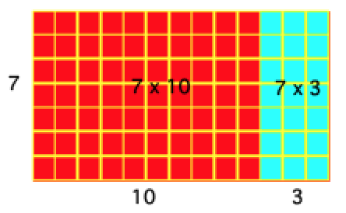

OVER TIME we can work to compress notation to help students understand but it is good to start with less compressed notation rather than more compressed notation.

Step 1: Write notation that shows place value explicitly

13 à (10 + 3)
x 7 à x 7
21
+70
91

Written in algebra as: 7 x (10 + 3) = 70 + 21 = 91

Step 2: Show each partial product in notation

1 3
x 7
2 1
+7 0
9 1

Notation I DO NOT recommend: It is unhelpful to use fully compressed notation because students tend to focus on digits rather than place value, there is no connection to future mathematics, and students do not usually understand the size of the product.

²1 3
x 7
9 1

Partner Work

Use base ten blocks to make an array model for the following problem, describing to your partner what you are doing.

14
x 8

Use base ten blocks to make an array. Then draw a picture of your base ten blocks below.

Write down the explanation you gave to your partner of your base ten array model.

Write notation for 14 x 8 shown in step 1 and step 2 above.

Step 1 | Step 2

Write down what you would say as a teacher as you are writing the step 2 notation.

Instructor Led:

The standard algorithm for a two-digit number times a two-digit number involves taking four partial products. The picture below shows the four partial products as well as how you could make an array with base ten blocks.

Watch the video and record the four partial products that Nikolas takes for the problem and record the strategy that Nikolas uses for each partial product.

47
x36

Product 1:  6 × 7 = 42  Known fact (ones × ones). | Strategy 1:
Product 2:  6 × 40 = 240  Counted by 40s three times to 120, then doubled to 240 (halving/doubling). | Strategy 2:
Product 3:  30 × 7 = 210  Counted by 30s — 30×3=90, doubled to 180, plus 30 more = 210. | Strategy 3:
Product 4:  30 × 40 = 1200  Broke into 10×10=100, then ×4=400, then ×3=1200. | Strategy 4:

Step 1: Make place value explicit

47 à (40 + 7)
x36 à x (30 + 6)
42
240
210
+1200
1692

Written in algebra as: (40 + 7) x (30 + 6) = 1200 + 240 + 210 + 42 = 1692

Step 2: Show all partial products

4 7
x 3 6
4 2
2 4 0
2 1 0
+1 2 0 0
1 6 9 2

Partner Work: With a partner make an array using base ten blocks for the following problem.

24
x 23

Draw an array using base ten block below, make sure to label your array.

Write down what you said to your partner as you made the model.

Write notation for 24 x 23 shown in step 1 and step 2 above.

Step 1 | Step 2

Write down what you would say as a teacher as you are writing the step 1 notation. Share with your partner.

Week 12, Day 1 and 2
Class Discussion à Teaching Division: Two Different Ways to Record Division Problems

Teaching structure: A common structure for teaching is to have students model problems first with manipulatives AND THEN create a written record. We are going to compare what Van De Walle talks about as sharing (partition) division and measurement division, looking across grade levels to see how these ideas develop. Both measurement and sharing division are explicitly referenced in standards and the recording of them and thinking for them is different.

4th Grade Sharing & Measurement Division Problems
Sharing | Measurement
Use the base ten blocks to show sharing 684 among 6 people. | A school buys 384 pencils. They plan to give 6 pencils to each student. How many students are there?

4th Grade Sharing & Measurement Division Problems
Sharing | Measurement
A fabric company orders 359 yards of fabric. The owner distributes the fabric among 7 stores. How many yards of fabric does each store get? | A baker baked 889 cookies for the holidays. She puts them into bags of 7 cookies each. How many bags can she make?
Compare how measurement and sharing division are different:

5th Grade Sharing & Measurement Division Problems
Sharing | Measurement
A bank has $1456 that to give evenly to 13 people. How much money does each person get? | To park for the football game each car has to pay $13. A parking attendant collects a total of $1586. How many cars parked in the lot?

6th Grade: Modeling the Division Algorithm Using Sharing Division
Sharing | Measurement
A bank has $1456 that to give evenly to 13 people. How much money does each person get? | To park for the football game each car has to pay $13. A parking attendant collects a total of $1586. How many cars parked in the lot?
6th Grade: You record using the method shown on the previous page
Sharing | Measurement
Try Problem 1 if you are less confident, problem 2 if you are somewhat confident, and problem 3 if you are very confident. If you finish your problem, then complete the others and compare them to determine how they are different.  Problem 1: 6 students are doing a science experiment. They need to share 876 milliliters of water. How many milliliters does each student get for the experiment?  Problem 2: 1452 M&Ms are distributed to 11 bags (the same number goes in each bag). How many M&Ms are in each bag?  Problem 3: 2655 M&Ms are distributed to 27 bags (the same number goes in each bag). How many M&Ms are in each bag? | Try Problem 1 if you are less confident, problem 2 if you are somewhat confident, and problem 3 if you are very confident. If you finish your problem, then complete the others and compare them to determine how they are different.  Problem 1: 276 students attend Summit elementary. The school is making teams of 6 students for a school wide event. How many teams will they have?  Problem 2: A bakery bakes 657 cookies. A baker packs them up into packages of 9 cookies. How many packages can they make?  Problem 3: A farmer collects 1584 chicken eggs in a week. She packs the eggs into packages of 12. How many packages does she make?

