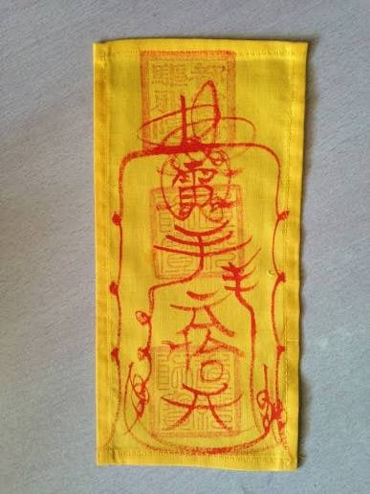
now i have done my talisman minigame part, but it looks very simple, what can i do if i want to make the visual more like the real talisman like this picture
Great job on getting the mechanic working! You have the logic down, now we need to upgrade the visuals from "programmer art" to "horror game asset."
We are going to transform your white square into a weathered, ancient, cloth talisman, using the photo you provided (image_0.png) as a reference.
Here is the step-by-step process.
🎨 Asset Creation Phase (Getting the Reference into the Game)
The first step is to get the visual elements from the photo ready for Unity. Since this is a Game Jam, we'll focus on the most important parts.
- Extract the Talisman Design:
  - Using an image editor (like Photoshop or the free editor GIMP), isolate the main yellow talisman from image_0.png.
  - The Yellow Base: You need the yellow cloth texture. Try to get a clean section of just the fabric texture and color. Save this as a texture (e.g., TalismanBase.png).
  - The Red Markings: You need the red calligraphic character and the faded stamps. The best way to make this look "magic" is to separate them.
    - Extract just the bright red calligraphy (the large complex character) and the faded square stamps.
    - Save this image (with a transparent background!) as TalismanMarkings.png.
If extracting them from the photo is too difficult, you can find simple, stylized "Taoist Talisman" graphics online (ensure they are free for use).
🛠️ Unity Implementation Phase (Applying the Visuals)
Now we will apply these textures and colors to your existing UI setup (image_1.png).
Step 1: Update the Background Canvas (The Talisman Body)
- Select your Canvas: The white panel that covers the screen in image_1.png.
- Assign the Image Component:
  - Change the Image Source Image from null (or whatever it is now) to your TalismanBase.png (the yellow cloth).
  - Crucial: Check Preserve Aspect on the Image component. This stops the talisman from stretching.
  - Set the Color to pure white (255, 255, 255, 255) so the yellow texture shows correctly.
- Add the Markings:
  - Create a new, second Image object as a child of the main yellow Canvas.
  - Assign your TalismanMarkings.png (the red calligraphy) to this new Image.
  - Use the RectTransform to scale and position it so it looks correct (like in image_0.png).
Step 2: Stylize the "Moving Target" (The Magic Spark)
Right now, your target is a simple yellow box. Let's make it look like a magical spark tracing a path.
- Create a Spark Image: Create or find a small, white, glowing "orb" or "spark" texture with a transparent background.
- Assign the Texture: Select your moving target GameObject. In the Image component, replace the default square Sprite with your new spark texture.
- Add the Magic Color: Change the Image Color component to a bright, saturated magic color. Based on your design, a Golden-Orange or Deep Blue will look excellent against the yellow paper and red markings.
- Optional Polish (Glow): If you can, add an "Outer Glow" to the spark image in your image editor or use a free "VFX Glow" package from the asset store to make it pop.
🎮 Final Comparison: Before and After
By following these steps, you will move from this prototype to the polished version:
Element | Prototype (image_1.png) | Polished (Inspired by image_0.png) | Result
Background | Plain, opaque White Square | Yellow, textured cloth fabric, featuring faded red square stamps and centered calligraphy. | Atmospheric and Authentic
Moving Target | Plain, opaque Yellow Square | A small, brilliant, glowing point of light (gold or blue), perhaps with a slight particle trail. | Clearly "Magic" and urgent.
This aesthetic upgrade will change the feel of the mini-game from a simple puzzle to a desperate ritual, fitting your Clockwork Exorcism concept perfectly. The player will now feel like they are interacting with the sacred object from image_0.png.

