* **Given the provided data, what are three conclusions that we can draw about crowdfunding campaigns?**

1st- In whole world, artistic crowdfunding as Film & Video, music and Theater has a better percentage to success than other categories.

2nd- A crowdfunding percentage of success is the better if it starts in the middle of the year, the best month is July.

3rd- If Crowdfunding Goal is around 1000 to 4999 the percentage of success is high.

* **What are some limitations of this dataset?**
  + There still data that is missing talking about what were the issues the crowdfunding could have along the process until the outcome came out.
  + Generalize sensible data could end in wrong results of what you are looking for.
* **What are some other possible tables and/or graphs that we could create, and what additional value would they provide?**
  + A merge table that compares Date created and Date Ended Vs category filtered by year, with this one we could estimated how many time does a crowdfunding needs to be successful per category by time. Which leave us with a margin that tell if it is already in time to success or if it needs to be canceled.
  + Percentage of success Vs Category.
* **Use your data to determine whether the mean or the median better summarizes the data.**
  + In the data extract below, we can see that in the success outcome, the variance is large due to the amount of data in the sample which increases the standard deviation and as a result the mean is distorted.

Also, we can denotated that the median works better with that big variance.

It all depends in the quantity of the sample.

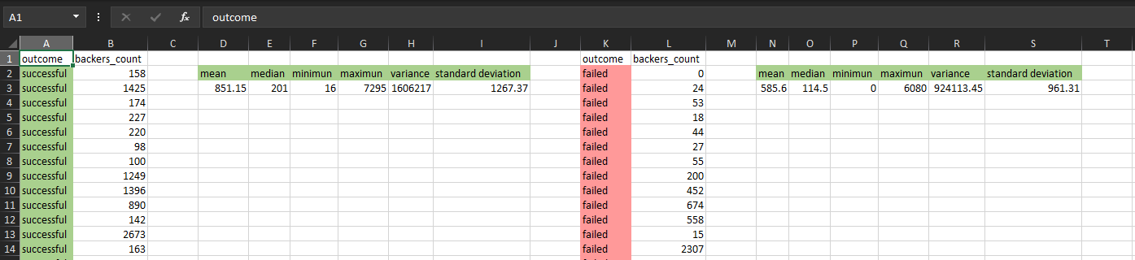

* **Use your data to determine if there is more variability with successful or unsuccessful campaigns. Does this make sense? Why or why not?**
* **- There is more variance in successful due to the amount of data of the sample, it all depends of the quantity of the data sample.**