Student Name_______________________________ID_________________________

Please fill in the correct answer. (5 questions, 5 points)



Given:

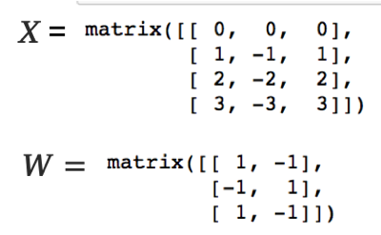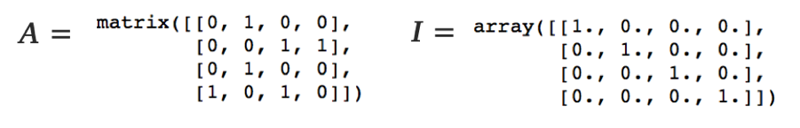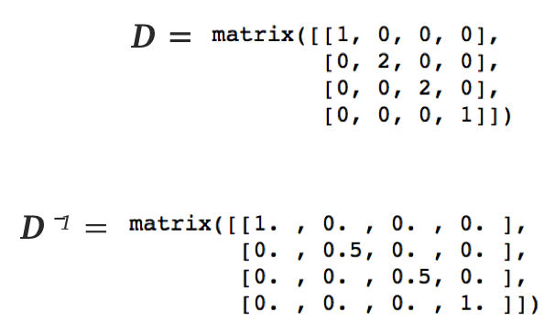

1. What is the value of

Ans:

2. What is the value of ***D****⁻¹*

Ans:

3. What is the value of ***D****⁻¹****X***

Ans:

4. What is the value of ***D****⁻¹****XW***

Ans:

5. What is the value of *Relu(****D****⁻¹ $\hat{A}$****XW****) $?$*

Ans: