CAMPUSKART
COMPREHENSIVE QA TEST REPORT
Buyer and Seller Mobile Web Experience

Product | campuskart.site
Execution date | 17 September 2026
Test platform | Mobile phone • portrait and landscape
Result | 55 passed • 12 failed • 0 blocked
Release recommendation: DO NOT SHIP in the current state

1. Executive Summary
A mobile-focused functional and exploratory test cycle was completed across CampusKart’s buyer and seller experiences. All 67 planned test cases were executed. Fifty-five passed and twelve failed; no test was blocked. Thirty-eight cases exercised negative or edge conditions. The application remained broadly navigable and stable during normal use, but defects in authentication feedback, post-logout routing, seller identity display, search behaviour, wishlist discoverability and state persistence create avoidable user risk.

Release decision
The current build should not be released unchanged.
Fix the invalid-login feedback and post-logout routing defects first, then correct seller attribution in the cart. These issues affect trust, recovery and transaction confidence. Retest the affected journeys and run a focused regression before reconsidering release.

Headline results
Executed | Passed | Failed | Blocked | Negative / edge
67 | 55 | 12 | 0 | 38

Most serious observed defect
BUG-008 — Browser Back after logout opens a persistent 404 page. After a valid logout, using browser history led to a broken route that remained after refresh. Although private content was not exposed, the defect damages confidence in session handling and traps the user on an invalid page. It is Medium severity and High priority because it affects a security-sensitive journey and should be corrected before release.

2. Scope, Approach and Environment

In scope
- Homepage and primary navigation; theme controls and refresh behaviour.
- Search, categories, product discovery and product-detail navigation.
- Wishlist, cart contents, quantity/totals and badge behaviour.
- Buyer profile, orders, login and logout.
- Seller dashboard, orders, wallet, messages, profile completion and role switching.
- Help/FAQ, Terms & Privacy, portrait and landscape responsiveness.

Out of scope
- Live payments, wallet withdrawals and financial settlement: no safe funded transaction path was available.
- Completed-order lifecycle and seller ratings: no completed transaction data existed.
- Seller product publishing, moderation and approval: completion required identity verification and administrative approval.
- Broad desktop, tablet, Android and cross-browser coverage: this cycle used the available mobile test device.

Environment matrix
Dimension | Coverage
Site | campuskart.site
Device | Mobile phone
Browser | Mobile web browser (Safari interface shown in evidence)
Operating system | Mobile operating system; exact version not recorded
Orientations | Portrait and landscape
Accounts | Authorized buyer and seller accounts
Test date | 17 September 2026

Method
Testing combined scripted functional checks with exploratory, negative and boundary checks. Actual results and statuses were recorded for every case. Screenshots were captured for reproducible failures and relevant state transitions. Refresh, browser Back, role switching and orientation changes were included where applicable.

3. Execution and Coverage Summary
- Homepage & Navigation
- Theme / Persistence
- Search & Categories
- Product Details
- Cart & Wishlist
- Buyer Authentication
- Buyer Profile & Orders
- Seller Dashboard & Products
- Seller Orders / Wallet / Messages
- Seller Profile & Validation
- Help / FAQ
- Terms & Privacy
- Role Switching
- Responsive Layout

What worked well
- Buyer and seller pages opened without freezes during the exercised journeys.
- Primary navigation highlighting and browser Back behaviour were generally correct outside the logout defect.
- Page state generally remained intact after refresh.
- Seller navigation, buyer storefront switching and return to the seller interface worked, with the seller session retained.
- Buyer and seller interfaces functioned in landscape orientation.
- FAQ accordion interactions, Terms/Privacy switching, input length limits and required-input highlighting worked in the exercised scenarios.

Defect distribution
Severity | Count | Priority focus | Disposition
Medium | 7 | BUG-004, BUG-007, BUG-008 | Fix before release
Low | 5 | BUG-001, BUG-009–012 | Schedule and verify

4. Defect Register
ID | Module | Title | Severity | Priority | Status
BUG-001 | Technical / Homepage | Web manifest request returns HTTP 404 | Low | Low | Open
BUG-002 | Search | Clearing search does not restore the full catalogue | Medium | Medium | Open
BUG-003 | Search / Product Details | Search result opens a category instead of the selected product | Medium | Medium | Open
BUG-004 | Cart | Cart shows “Unknown Seller” for products with known sellers | Medium | High | Open
BUG-005 | Cart / Homepage | Homepage cart badge does not update immediately | Medium | Medium | Open
BUG-006 | Wishlist / Product Details | Wishlist exists in the profile but products have no visible save control | Medium | Medium | Open
BUG-007 | Authentication | Invalid buyer login provides no error message | Medium | High | Open
BUG-008 | Authentication / Routing | Browser Back after logout opens a persistent 404 page | Medium | High | Open
BUG-009 | Seller Profile | Seller username accepts unsupported characters without feedback | Low | Medium | Open
BUG-010 | Help / FAQ | FAQ search has no no-results message | Low | Low | Open
BUG-011 | Terms & Privacy | Refreshing Privacy resets the selected tab to Terms | Low | Medium | Open
BUG-012 | Seller Authentication | Seller logout completes without confirmation | Low | Low | Open
All defects below include the linked test, reproduction steps, expected and actual results, classification, status and available evidence.

BUG-001 — Web manifest request returns HTTP 404
Linked test: TC-006 | Module: Technical / Homepage | Status: Open
Severity  Low | Priority  Low | Environment  Mobile web • 17 Sep 2026

Steps to reproduce
1. Open campuskart.site on the mobile browser.
2. Load or refresh the homepage.
3. Observe the request for manifest.json.
Expected result: The web manifest loads successfully, or the page does not request a missing manifest.
Actual result: The manifest.json request returned HTTP 404. Core browsing continued to work.

Evidence
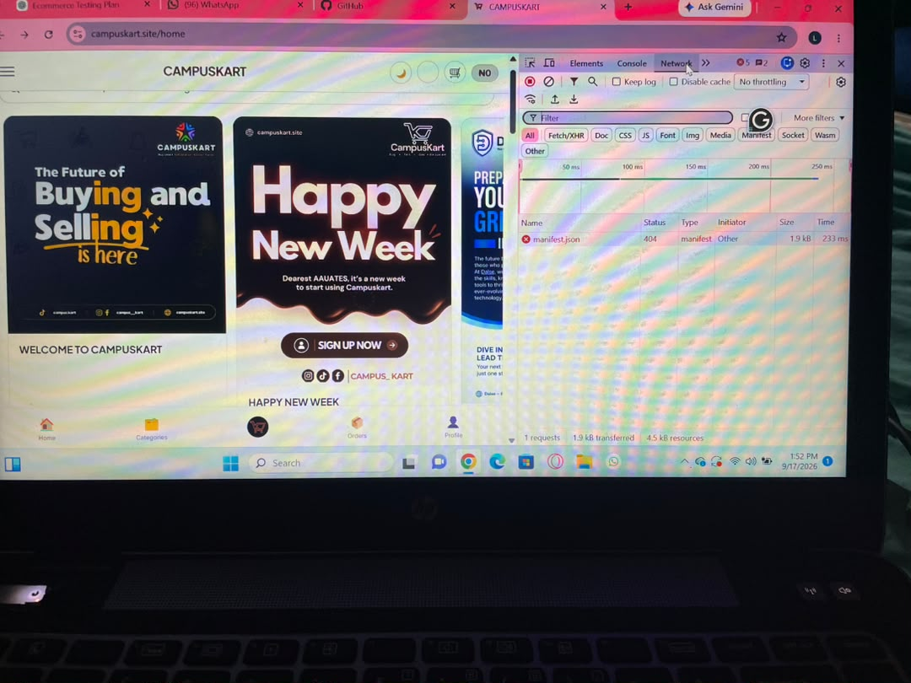
homepage2.jfif — Homepage/network observation associated with the missing manifest request.

BUG-002 — Clearing search does not restore the full catalogue
Linked test: TC-014 | Module: Search | Status: Open
Severity  Medium | Priority  Medium | Environment  Mobile web • 17 Sep 2026

Steps to reproduce
1. Open the buyer storefront.
2. Search for “Jollof rice”.
3. Delete all text from the search field.
4. Inspect the product list.
Expected result: Clearing the query immediately restores the default product catalogue.
Actual result: The previous Jollof search result remained after the field was cleared.

Evidence
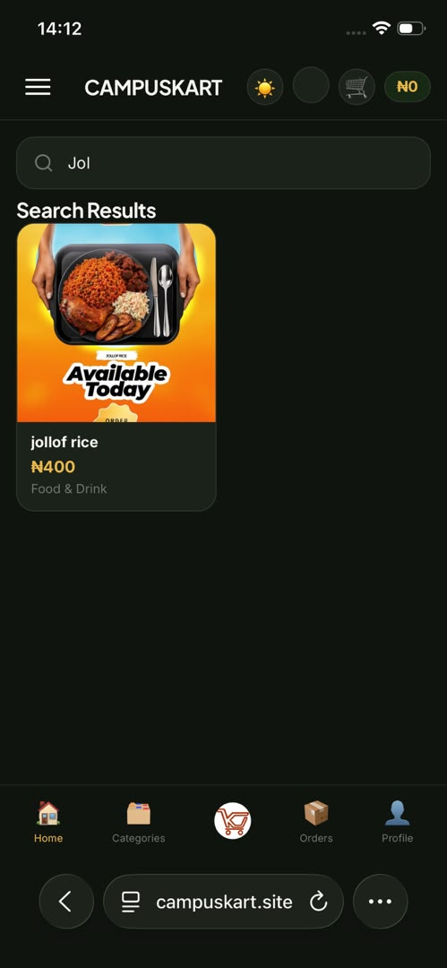
jollof3.jfif — Catalogue remained filtered after the search field was cleared.

BUG-003 — Search result opens a category instead of the selected product
Linked test: TC-016 | Module: Search / Product Details | Status: Open
Severity  Medium | Priority  Medium | Environment  Mobile web • 17 Sep 2026

Steps to reproduce
1. Search for a product from the buyer storefront.
2. Tap the displayed product result.
3. Observe the destination page.
Expected result: The selected product detail page opens.
Actual result: The Food & Drink category page opened instead of the selected product detail page.

Evidence
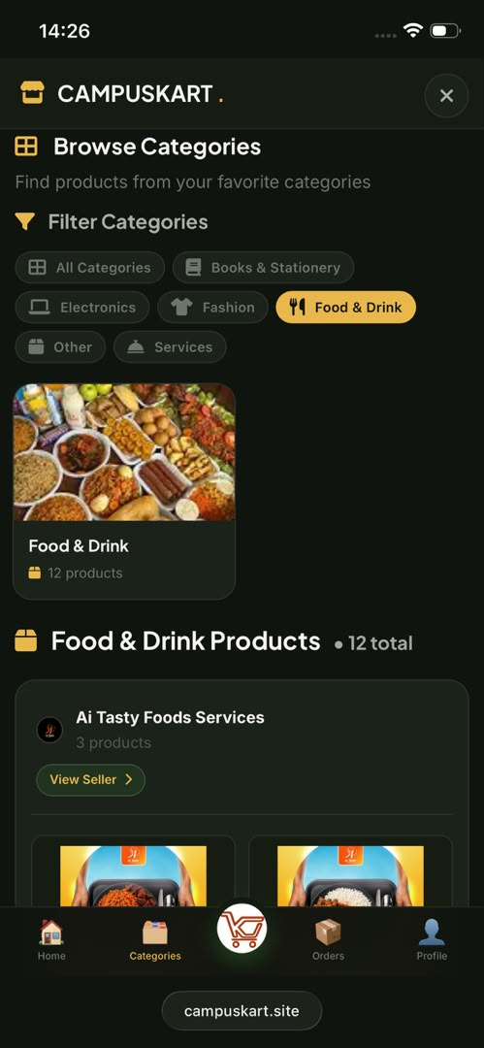
search(1).jfif — Unexpected category destination after selecting a search result.

BUG-004 — Cart shows “Unknown Seller” for products with known sellers
Linked test: TC-025 | Module: Cart | Status: Open
Severity  Medium | Priority  High | Environment  Mobile web • 17 Sep 2026

Steps to reproduce
1. Open Jollof rice and Airtel 5G ODU.
2. Add both products to the cart.
3. Open the cart.
4. Inspect the seller label for each line item.
Expected result: Each cart line displays the seller associated with that product.
Actual result: Both products displayed “Unknown Seller”, reducing transaction traceability.

Evidence
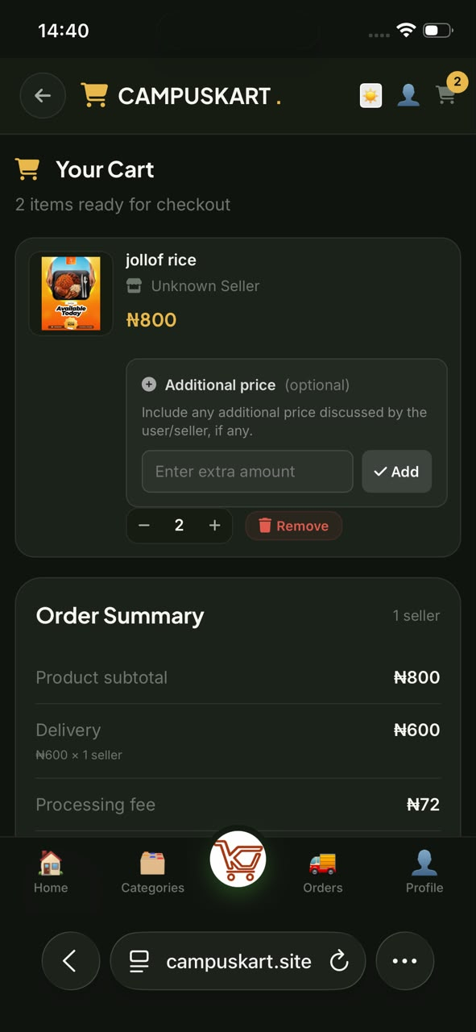  cart1.jfif — Cart line item with an unresolved seller name. | 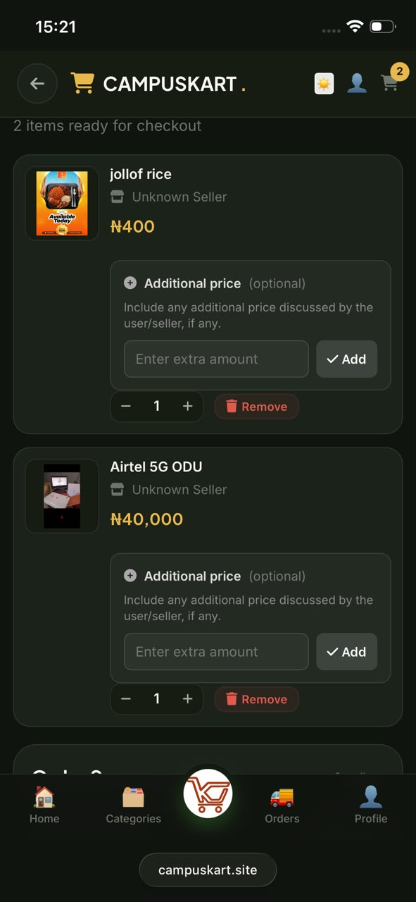  cart 4.jfif — Multiple products displayed “Unknown Seller”.

BUG-005 — Homepage cart badge does not update immediately
Linked test: TC-028 | Module: Cart / Homepage | Status: Open
Severity  Medium | Priority  Medium | Environment  Mobile web • 17 Sep 2026

Steps to reproduce
1. Add two products to the cart.
2. Return to the homepage without first reopening the cart.
3. Inspect the cart badge.
Expected result: The homepage badge immediately shows the current cart quantity.
Actual result: The badge did not show the new count until the cart was opened.

Evidence
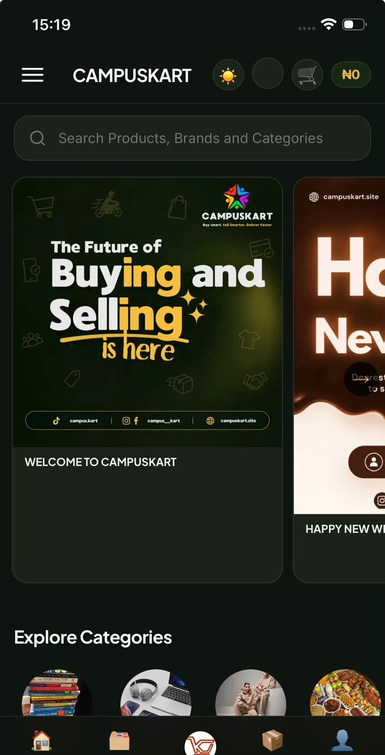
cart error.jfif — Homepage state did not immediately reflect the products already added.

BUG-006 — Wishlist exists in the profile but products have no visible save control
Linked test: TC-033 | Module: Wishlist / Product Details | Status: Open
Severity  Medium | Priority  Medium | Environment  Mobile web • 17 Sep 2026

Steps to reproduce
1. Open product cards and a product detail page.
2. Look for a heart, save, or wishlist action.
3. Open Profile and select Wishlist.
Expected result: A visible product-level control lets the buyer add or remove an item from Wishlist.
Actual result: The profile contains a Wishlist tab, but no save control was present on the inspected product surfaces.

Evidence
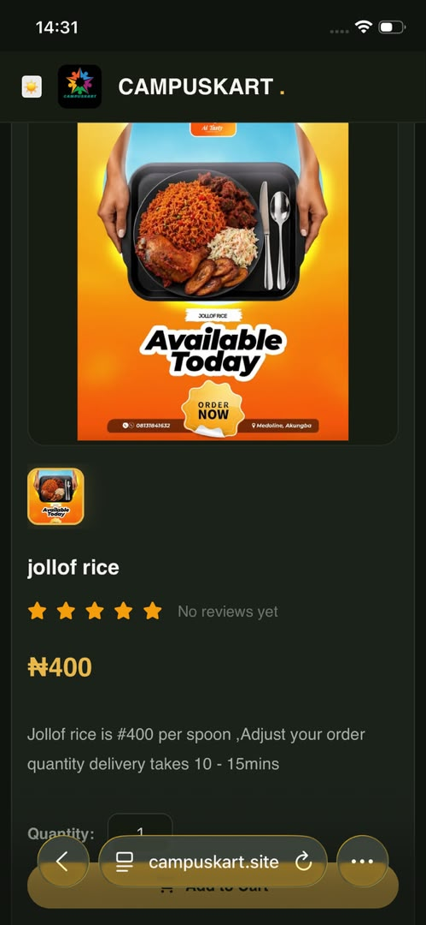  product.jfif — Product surface without a visible wishlist/save action. | 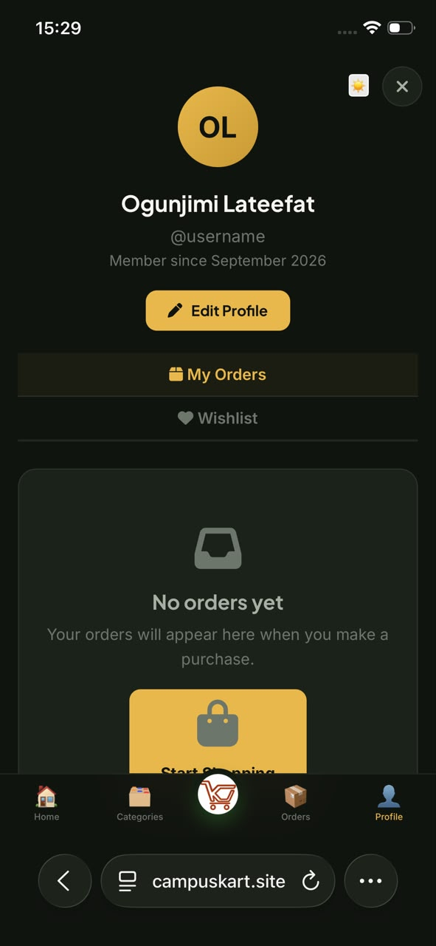  profile(1).jfif — Profile contains a Wishlist destination, demonstrating an incomplete user journey.

BUG-007 — Invalid buyer login provides no error message
Linked test: TC-039 | Module: Authentication | Status: Open
Severity  Medium | Priority  High | Environment  Mobile web • 17 Sep 2026

Steps to reproduce
1. Open the buyer login page.
2. Enter an incorrect email and password.
3. Tap Log In.
4. Observe the form response.
Expected result: A clear, generic authentication error is shown while preserving security.
Actual result: The user was returned to a blank login form with no explanation that authentication failed.

Evidence
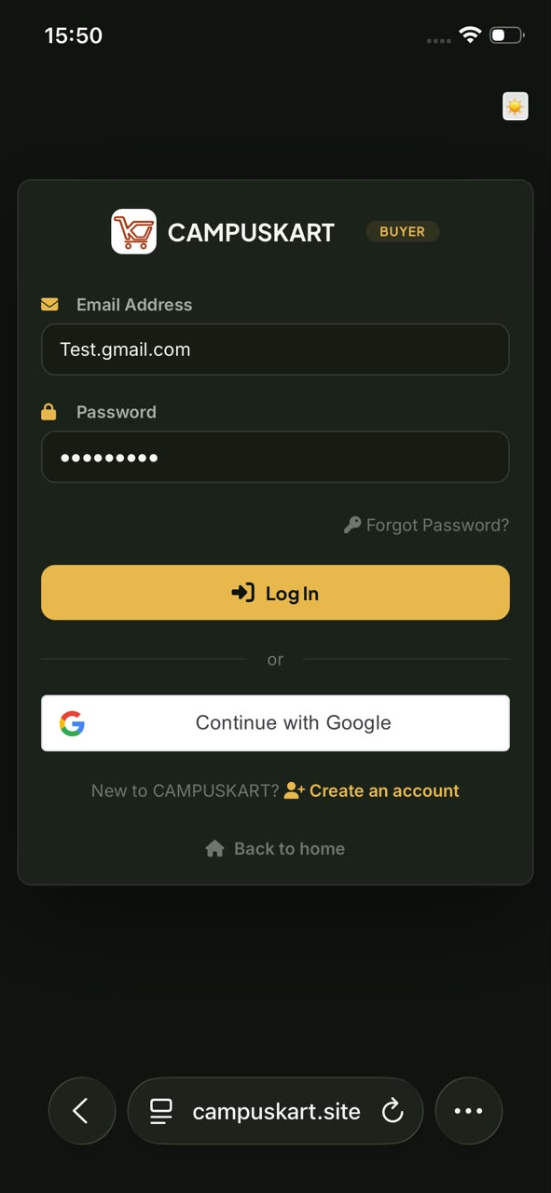  login(1).jfif — Incorrect credentials entered on the buyer login form. | 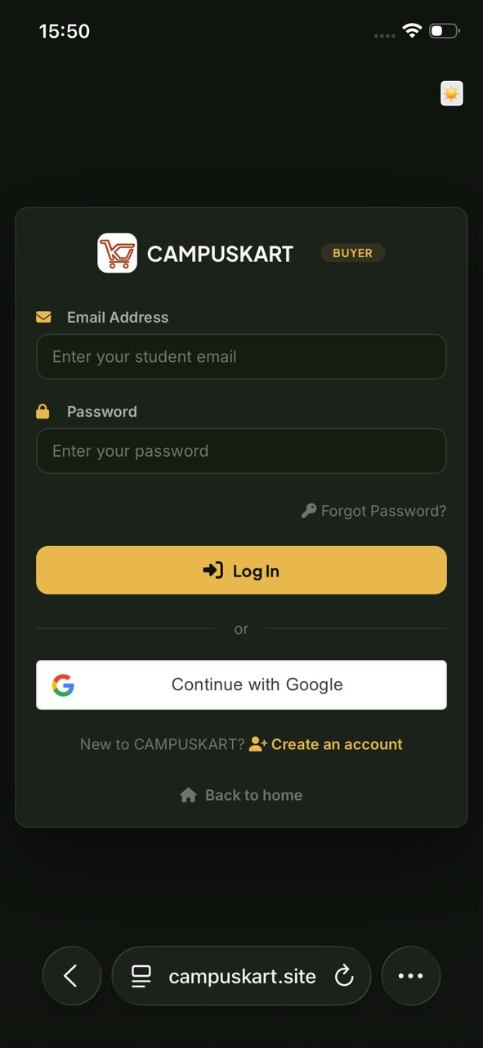  login1.jfif — Form returned without a visible authentication error.

BUG-008 — Browser Back after logout opens a persistent 404 page
Linked test: TC-043 | Module: Authentication / Routing | Status: Open
Severity  Medium | Priority  High | Environment  Mobile web • 17 Sep 2026

Steps to reproduce
1. Sign in as a buyer.
2. Sign out.
3. Tap the browser Back button.
4. Refresh the resulting page.
Expected result: The user remains logged out and is routed to the login page or a valid public page.
Actual result: A “This Page Does Not Exist” 404 page appeared and remained after refresh. No private data was exposed.

Evidence
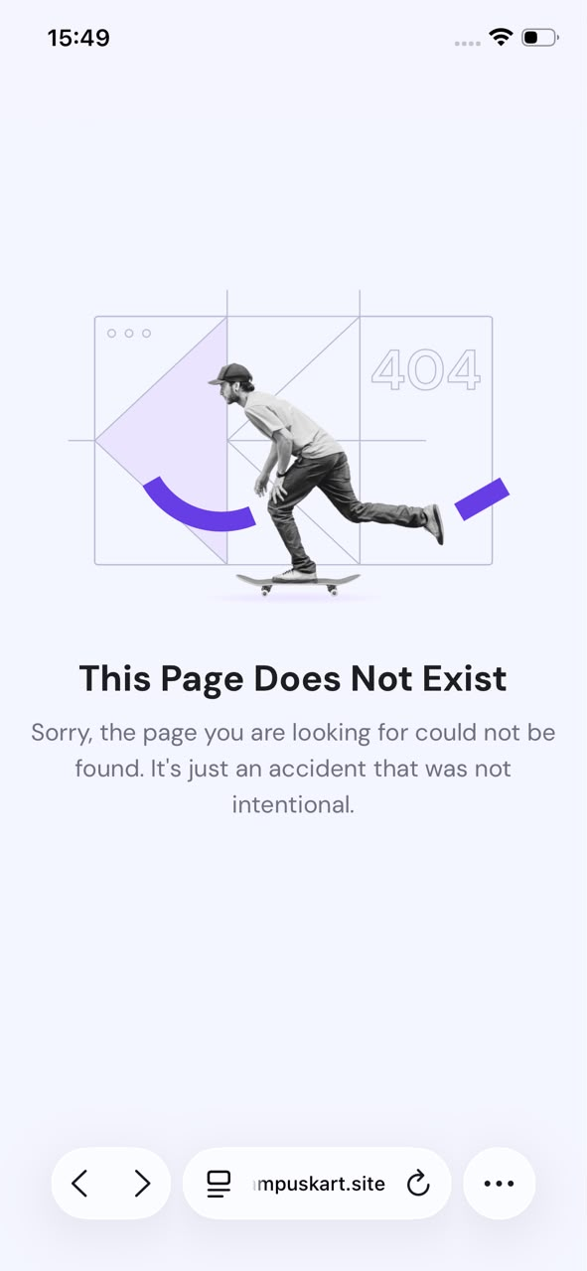
back page.jfif — Persistent 404 displayed after using browser Back following logout.

BUG-009 — Seller username accepts unsupported characters without feedback
Linked test: TC-052 | Module: Seller Profile | Status: Open
Severity  Low | Priority  Medium | Environment  Mobile web • 17 Sep 2026

Steps to reproduce
1. Open the seller profile completion form.
2. Enter spaces and unsupported symbols in Username.
3. Move focus to another field.
Expected result: Unsupported characters are blocked or a validation message explains the allowed format.
Actual result: Unsupported characters remained in the field and no validation feedback appeared.

Evidence
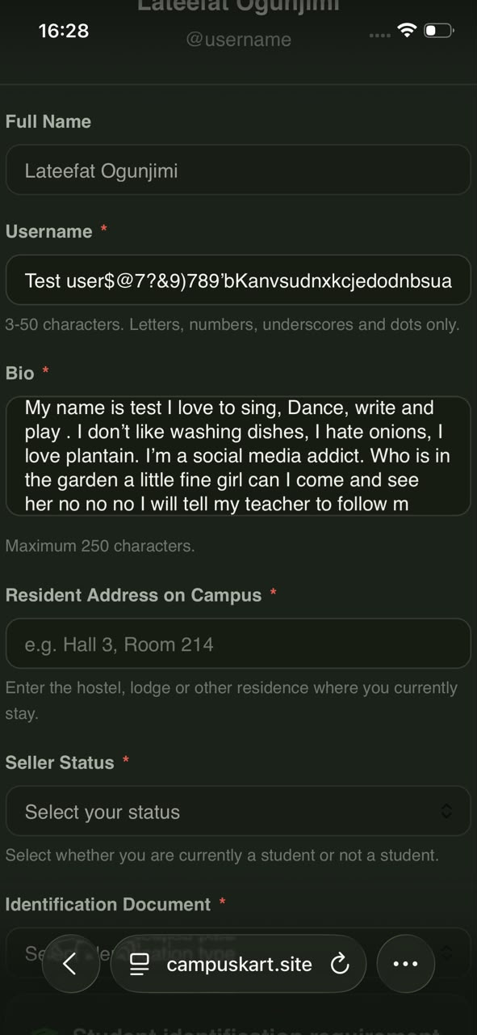
bio2.jfif — Username contains characters outside the stated letters, numbers, underscores and dots rule.

BUG-010 — FAQ search has no no-results message
Linked test: TC-058 | Module: Help / FAQ | Status: Open
Severity  Low | Priority  Low | Environment  Mobile web • 17 Sep 2026

Steps to reproduce
1. Open Help & Support.
2. Enter “Xyz987654” in Search questions.
3. Inspect the results area.
Expected result: A clear no-results message is displayed with guidance to modify or clear the search.
Actual result: The FAQ questions disappeared, but no no-results message was shown.

Evidence
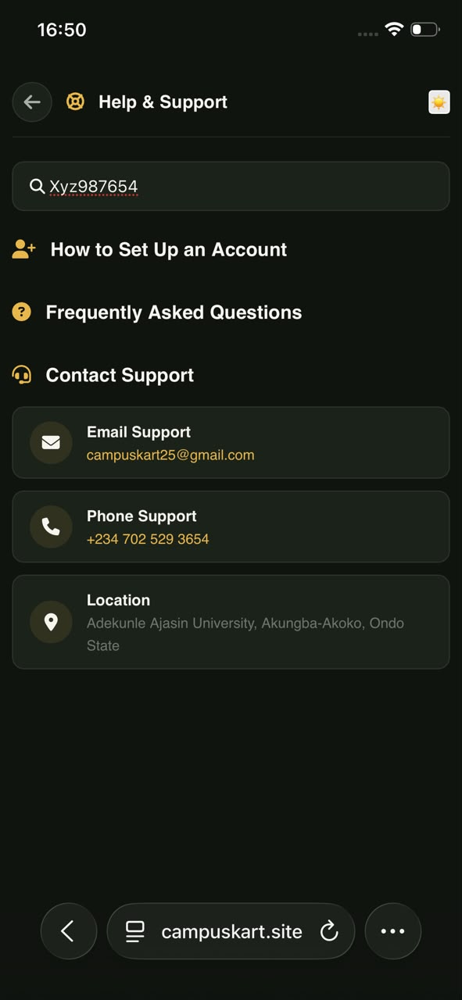
faq2.jfif — Invalid FAQ query leaves an unexplained empty results area.

BUG-011 — Refreshing Privacy resets the selected tab to Terms
Linked test: TC-061 | Module: Terms & Privacy | Status: Open
Severity  Low | Priority  Medium | Environment  Mobile web • 17 Sep 2026

Steps to reproduce
1. Open Terms & Privacy.
2. Select Privacy.
3. Refresh the browser.
4. Observe the selected tab and content.
Expected result: Privacy remains selected after refresh, or its URL/state is restored.
Actual result: The page reset to Terms after refresh.

Evidence
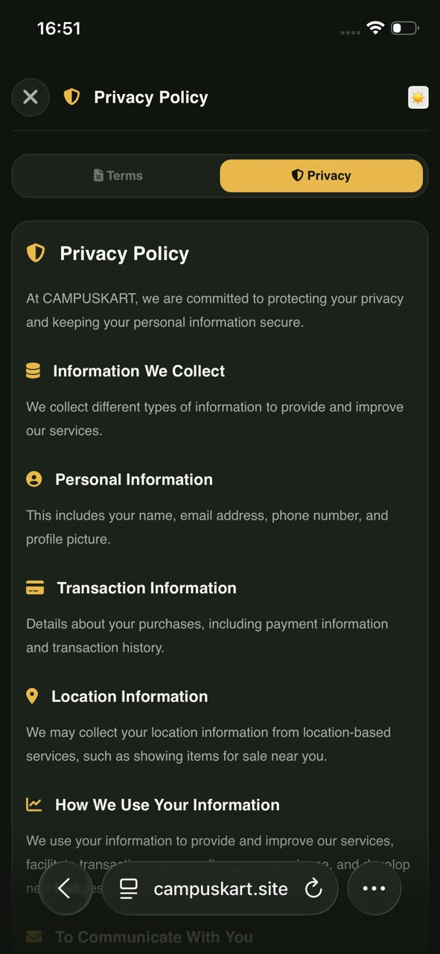  terms2.jfif — Privacy selected before refresh. | 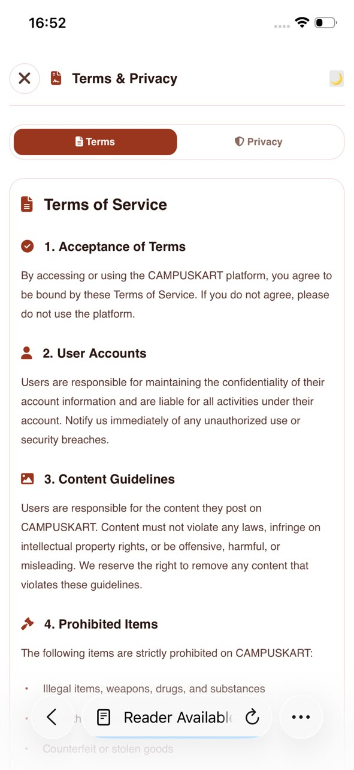  terms3.jfif — Terms selected after refreshing the Privacy view.

BUG-012 — Seller logout completes without confirmation
Linked test: TC-066 | Module: Seller Authentication | Status: Open
Severity  Low | Priority  Low | Environment  Mobile web • 17 Sep 2026

Steps to reproduce
1. Sign in to the seller interface.
2. Open the seller navigation menu.
3. Tap Sign Out.
Expected result: A confirmation prompt appears before ending the seller session.
Actual result: The seller session ended immediately with no confirmation message.

Evidence
No screenshot captured. The observed behaviour is documented in the executed test result.

5. Risk Assessment and Recommendation

Riskiest area: authentication and session routing
Authentication and session routing present the highest release risk. BUG-007 provides no useful feedback after invalid credentials, while BUG-008 sends a signed-out user to a persistent 404 when browser history is used. These failures occur at trust-sensitive boundaries and make it harder for users to understand whether an action succeeded or recover safely.

Release verdict
Do not ship CampusKart as it stands. Resolve BUG-007 and BUG-008 first, then BUG-004, and complete targeted regression across login, logout, session expiry, Back/Forward navigation, refresh and role switching before release.

Recommended fix order
- 1. Authentication feedback and post-logout routing (BUG-007, BUG-008).
- 2. Seller identity in the cart (BUG-004).
- 3. Search navigation and reset behaviour (BUG-002, BUG-003).
- 4. Cart badge and Wishlist journey (BUG-005, BUG-006).
- 5. Validation, FAQ empty state, legal-tab persistence, manifest and seller logout confirmation (remaining defects).

Next test cycle
With another week, expand to Android and desktop browsers, add multiple screen sizes, exercise interrupted-network and session-expiry scenarios, and complete end-to-end product publishing, moderation, checkout, payment, order fulfilment, wallet withdrawal and seller-rating flows using controlled test accounts. These areas were deferred because the current cycle lacked safe funded transactions, completed orders, identity verification and administrative approval access.

Evidence note
The embedded screenshots are contemporaneous evidence from the mobile test session. Where a defect could not be represented clearly by one still image—such as the absence of seller logout confirmation—the executed observation is documented explicitly. The original evidence files should be retained with the test-case spreadsheet and defect log for traceability.

