Fifteen minutes is a "Deep Dive" in interview terms. Most candidates speak for 2 minutes and run out of things to say. To fill 15 minutes impressively, you cannot just list features. You must tell an engineering story.
You need to break your explanation into four distinct "chapters." This structure allows the interviewer to interrupt with questions (which is good!) while keeping you on track.
Here is your script. Do not memorize it word-for-word. Learn the "flow" of the story.

Chapter 1: The "Why" & High-Level Architecture (2-3 Minutes)
Goal: Hook them immediately. Prove you didn't just copy a YouTube tutorial.
The Script: "I built TradePro, which is a financial portfolio simulation engine.
A lot of junior developers build stock apps that just fetch an API and display a number. I wanted to go deeper. I wanted to understand the ledger engineering that happens behind the buy button—how to handle double-entry accounting, precise profit/loss calculations, and database integrity when dealing with money.
The Tech Stack: I built the frontend in React with Tailwind for a responsive dashboard. But the real complexity is in the backend. I used Node.js and PostgreSQL. I specifically chose PostgreSQL over MongoDB because financial transactions require strict ACID compliance and relational integrity. I couldn't risk data inconsistency where money is deducted but the stock isn't credited."

Chapter 2: The Database "Whiteboard" Moment (5 Minutes)
Goal: Show off your database design. This is your strongest asset. (If you are in a live interview, ask: "Can I quickly sketch the schema for you?" and draw the relationships between Users, AssetLots, and Transactions.)
The Script: "The core of the system is a normalized database with 8 tables. The most critical decision I made was not to store a user's holdings as a simple number (e.g., 'User has 10 Apple stocks').
Instead, I implemented an Asset Lot Tracking System. I have a table called AssetLots and a table called TransactionsLedger.
- The Problem: If I buy 1 share of Apple at $100 and another at $150, my average is $125. But if I sell one share, which one did I sell? The $100 one or the $150 one? This changes my tax realization.
- My Solution: My database tracks every purchase as a distinct 'Lot' with its own price basis.
- I also used Postgres Enums for transaction types (BUY/SELL) and states (OPEN/CLOSED) to enforce data integrity at the database level, ensuring a transaction can never be in an invalid state."

Chapter 3: The "Hardest Challenge" – FIFO Logic (4-5 Minutes)
Goal: Walk through the logic. This proves you are a problem solver.
The Script: "The hardest engineering challenge was the Sell Logic. When a user sells a stock, I don't just decrease a counter. I implemented a FIFO (First-In-First-Out) algorithm.
Let's say a user wants to sell 5 shares of Google.
- My backend first queries the AssetLots table for 'Open' lots, ordered by the oldest purchase_date.
- It iterates through these lots. Maybe Lot A has 3 shares, and Lot B has 10 shares.
- It 'closes' Lot A (takes 3 shares) and partially depletes Lot B (takes 2 shares).
- It then calculates the Realized P/L based on the difference between the sell price and the specific cost basis of those exact lots.
- Finally, it writes these details into a SellLotJournal table so I have a full audit trail of exactly which shares were sold.
This double-entry approach ensures that the Portfolio Value shown on the dashboard is mathematically accurate to the cent."

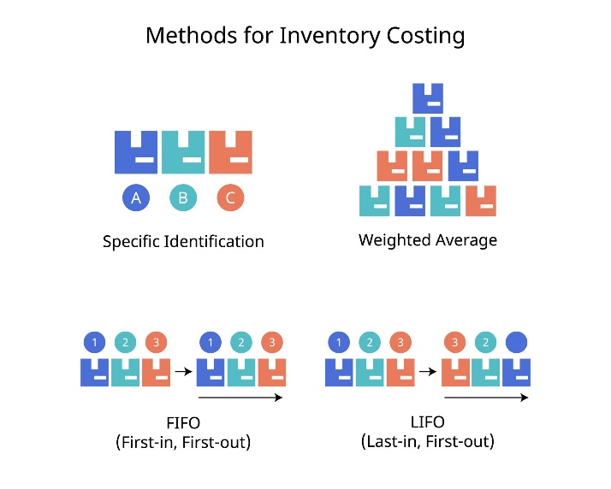

Chapter 4: The Transaction Lifecycle & Admin Control (3 Minutes)
Goal: Explain the "Simulation" aspect and wrap up.
The Script: "To manage the ecosystem, I built an Admin Panel with Role-Based Access Control. Currently, the system acts as a market simulator. As an Admin, I can inject specific market prices to test how the P/L logic handles volatility—like simulating a market crash to see if the user's 'Unrealized Loss' updates correctly in the UI.
In the Transaction Lifecycle, I use SQL Transactions (BEGIN/COMMIT). When a user deposits funds:
- The system creates a record in WalletTransactions.
- It updates the Users table balance. If either step fails, the entire transaction rolls back. This guarantees that the ledger and the wallet balance never drift apart."

Handling the "Static Data" Question
If they ask: "Where does the price data come from?"
The Answer: "Right now, the system operates as a closed-loop simulator where the Admin 'sets the market' to test the accounting logic. However, the system is architected to accept external data. My next step is replacing the Admin simulation input with a real-time feed from the Finnhub API, which would just act as the new 'price setter' for the existing ledger logic."

Summary of the "15-Minute Flow"
- Intro: Not a stock app; a ledger simulation.
- DB: 8 Tables, not 1. Postgres for ACID.
- Logic: FIFO (First-In-First-Out) is the star.
- Flow: Transactions are atomic (Begin/Commit).

UPDATED
The Setup (0:00 - 2:00)
Goal: Hook them immediately. Don't say "It's a stock app." Say "It's a trading engine."
You: "I built TradePro. On the surface, it looks like a standard portfolio tracker where users buy and sell stocks. But under the hood, I engineered it to solve three specific problems that happen in real fintech systems:
- Concurrency: How to prevent users from spending money they don't have during race conditions.
- Latency vs. Limits: How to show real-time prices without getting blocked by API rate limits.
- Accounting Accuracy: How to calculate true profit using FIFO (First-In-First-Out) rather than just simple averages.
I’d love to walk you through the architecture, specifically how I moved the logic from Node.js into the Database to handle these challenges. Does that sound good?"

Module 1: The "Money" Problem (Database Layer)
Time: ~5-8 Minutes The Story: "Why I stopped trusting JavaScript with money."
You: "When I started, I wrote the 'Buy' logic in Node.js. I would fetch the user's balance, check if balance > cost, and then update it.
But I realized this had a massive flaw: Race Conditions. If a user double-clicked the 'Buy' button, or if two requests came in at the exact same millisecond, my Node server might authorize both transactions before the database updated, putting the user in negative balance.
My Solution: I moved the entire transaction logic into PostgreSQL Stored Procedures. Instead of three network calls (Get Balance -> Calculate -> Update), I send one instruction: execute_trade(user, stock, quantity).
The database locks the row, performs the check, deducts the money, and adds the stock in a single ACID-compliant transaction. If anything fails, the whole thing rolls back. This guarantees the ledger is never out of sync."
[Action: Pause] Ask: "Have you guys faced similar concurrency issues with your transaction ledgers here?" (This forces them to engage and treat you like a peer.)

Module 2: The "Data" Problem (API & Caching)
Time: ~5-8 Minutes The Story: "How I fought the API Limit and won."
You: "The next bottleneck was data. I’m using the Finnhub API for real-time prices. The problem is they strictly limit you to 60 calls per minute.
At first, my 'Market Dashboard' tried to fetch live prices for 50 stocks at once. It crashed immediately.
My Solution: I implemented a 'Stale-While-Revalidate' caching strategy in the backend.
Here is how it works:
- When a user requests a stock price, my backend checks the local database first.
- If the price timestamp is less than 60 seconds old, I return the cached price instantly (0ms latency).
- If it’s 'stale' (older than 60s), I fetch the live price from Finnhub, update the cache, and then serve it.
This ensures that no matter how many users hit the site, or how many times they refresh, I never exceed 1 API call per minute per stock. It decouples user traffic from API load."

Module 3: The "Math" Problem (FIFO Architecture)
Time: ~5-8 Minutes The Story: "Why 'Average Price' wasn't good enough."
You: "The hardest logical challenge was calculating Realized Profit. Most tutorials just track 'Total Quantity'.
- Example: I buy 1 Apple stock at $100, then another at $150. Average cost is $125.
But in real trading (and for tax purposes), the order matters. So, I designed a normalized schema using an AssetLots table.
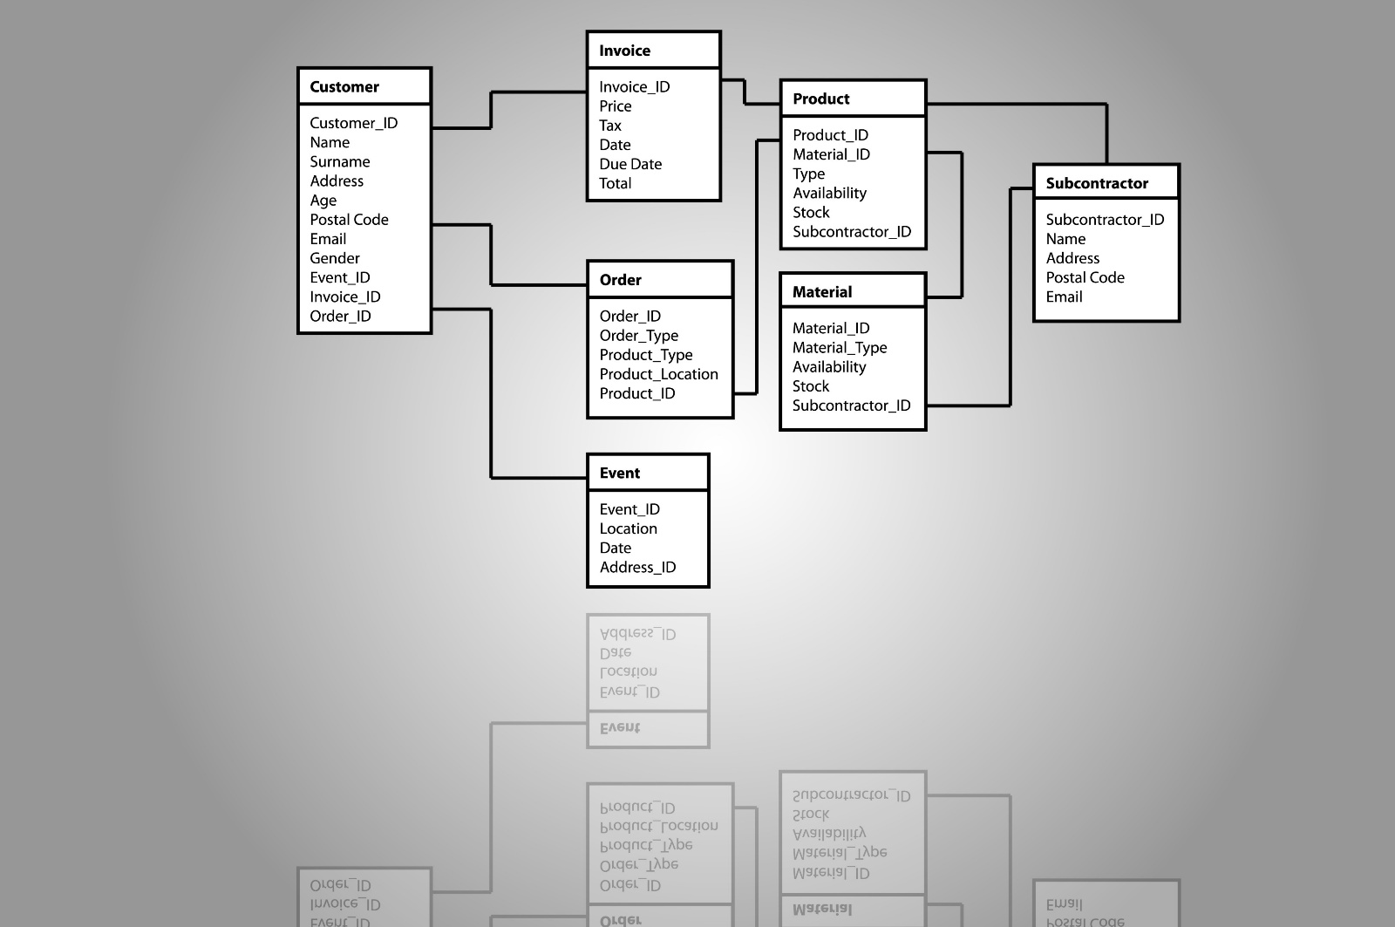Opens in a new window
Shutterstock
Explore
Every time a user buys, I create a new 'Lot' record with that specific price and date. When they sell, my SQL function uses a FIFO (First-In-First-Out) algorithm. It finds the oldest open lot, deducts shares from there first, calculates the profit on that specific lot, and then moves to the next one.
This allows me to show the user exactly which trade made money, rather than just a generic average."

Module 4: The Conclusion (Reflection)
Time: ~2-3 Minutes
You: "So effectively, I moved away from a 'Monolithic Frontend' approach and built a Hybrid System:
- Postgres acts as the Source of Truth for Money and Inventory.
- Node.js acts as the Traffic Controller and Cache Manager.
- React purely reflects the state.
If I were to take this to production, my next step would be to add a Message Queue (like RabbitMQ) for the price updates, so the background worker is even more robust.
But for now, it handles the core financial integrity requirements I set out to build."

Visual Aid (Whiteboard Plan)
If they ask you to draw it (which they often will in a 30-min session), draw this simple flow:
- Left: User/React
- Middle: Node.js (Draw a box inside called "Cache Logic").
- Right:
  - Top: Finnhub API (Cloud)
  - Bottom: PostgreSQL (Draw a box inside called "Stored Procedure").
Arrows:
- React -> Node: "Get Price"
- Node -> Finnhub: "Fetch if Stale"
- Node -> Postgres: "Execute Trade (ACID)"
Why this script works
- It respects the time: You aren't rambling about CSS or login buttons.
- It highlights "Senior" traits: Concurrency, Caching, and Data Normalization are mid-to-senior level concepts.
- It invites questions: By pausing after each module, you turn the interview into a conversation, which makes the 30 minutes fly by.

NEW ONE

A 20-30 minute explanation is massive. In a standard interview, you usually get 2-3 minutes for an "Elevator Pitch," and then the remaining 20 minutes are spent on a "Deep Dive" where the interviewer asks specific questions.
If you try to talk for 20 minutes straight, you will lose them.
Instead, I have designed this as a Modular Script.
- Module 1: The High-Level Pitch (3 Minutes) — Always say this.
- Module 2: The Architecture & System Design (5-7 Minutes) — Use this if they ask "How is it built?"
- Module 3: The Engineering Challenges (10-15 Minutes) — This is the core. You pick 2-3 "War Stories" to discuss in detail.

Module 1: The "Elevator Pitch" (Start Here)
Time: 2-3 Minutes
Goal: Hook them and prove you are a serious engineer.
"TradePro is a high-frequency trading engine simulation I built to solve the core engineering problems found in fintech: Concurrency, Data Integrity, and API Latency.
On the surface, it’s a React and Node.js app that lets users buy and sell stocks using real-time market data. But the real engineering complexity lies in the backend.
Most student apps handle money like a simple Javascript variable. I treated it like a bank.
- Concurrency: I migrated critical logic to PostgreSQL Stored Procedures with FOR UPDATE row locking to ensure that even if two requests hit the server at the exact same millisecond, a user can never double-spend their balance.
- Accuracy: I implemented a Double-Entry Ledger system using Database Triggers. Every cent moving in or out is logged immutably, ensuring the 'Cash Balance' always matches the 'Transaction History.'
- Optimization: To handle the strict rate limits of the Finnhub API, I built a 'Stale-While-Revalidate' caching layer that serves data instantly while updating in the background, reducing external calls by over 90%.
Essentially, I wanted to move beyond just building a 'CRUD app' and focus on building a system that is ACID-compliant and race-condition proof."
(Pause here. Let them ask: "Tell me more about the Concurrency part...")

Module 2: The Architecture (Whiteboard Mode)
Time: 5-7 Minutes
Goal: Show you understand System Design.
"If I were to visualize the architecture..." (Motion with hands or draw)
"I have a Client-Server architecture:
- Frontend: A React dashboard focusing on data visualization. I used Recharts for the portfolio allocation and efficient state management to handle live price updates without re-rendering the whole page.
- Backend: A Node.js/Express REST API. However, I kept the Node layer 'thin.' It mostly handles validation and routing.
- Database (The Core): This is where the heavy lifting happens. I used PostgreSQL not just for storage, but for logic.
  - I used Views (V_UserPortfolio) to calculate real-time Portfolio Value and Unrealized P/L on the fly, so I don't store redundant data.
  - I used Stored Functions to handle the atomic transactions of buying/selling.
Data Flow:
When a user buys a stock, the request hits Node.js. Node.js calls the execute_trade function in Postgres. Postgres locks the user's row, verifies funds, deducts cash, adds shares, logs the ledger entry, and only then commits the transaction. This ensures Atomicity—either everything happens, or nothing happens."

Module 3: The "War Stories" (The Deep Dive)
Time: 10-15 Minutes (Pick and choose based on their interest)
Goal: Prove you solved hard problems.
Story A: The Concurrency Problem (The "Double Spend")
"One of the biggest challenges I faced was the Race Condition.
Initially, I did the check in Node.js: if (balance > cost) { buy() }.
But I realized that if a user sends two requests simultaneously (e.g., accidental double-click), both requests could pass the if check before the balance was updated.
The Fix: I moved the logic to the database layer. I used the SQL command SELECT ... FOR UPDATE.
This acts as a 'Pessimistic Lock.' When Request A reads the balance, it literally freezes that row. Request B has to wait in a queue until Request A finishes. This guarantees Serializability for financial transactions."
Story B: The "Infinite Loop" Bug (The Trigger Fix)
"I also ran into a serious logic bug with my Audit Logs.
I had a Trigger: 'Whenever Balance changes, log it in the Ledger.'
But my Trading Function also logged the trade.
So, a $100 Stock Purchase was being logged twice: once as a 'Trade' and once as a generic 'Withdrawal.' The accounting didn't match.
The Fix: I learned about Session Variables in Postgres.
I updated my Trading Function to set a flag: set_config('app.is_trading', 'true').
Then, I taught the Trigger to check this flag: 'If app.is_trading is true, ignore this update.'
This prevented the double-counting while keeping the trigger active for other manual deposits. It was a great lesson in managing Side Effects in database logic."
Story C: The API Bottleneck (Caching)
"Finally, the external API (Finnhub) had a limit of 30 calls per second. My dashboard needed to show prices for 10 stocks. If 5 users refreshed at once, I would crash the app.
The Fix: I implemented a Cache-Aside pattern.
When a price is requested:
- Check the cache (Node.js memory).
- If data exists and is less than 60 seconds old -> Return it instantly.
- If older -> Return the old data immediately (so the UI is fast), but trigger a background fetch to update the cache for the next user.
This 'Stale-While-Revalidate' strategy made the app feel instant even though the API is slow."

Module 4: The Closing (Future Scope)
Time: 2 Minutes
Goal: Show you are still thinking.
"So, TradePro is currently a robust, single-server simulation.
If I were to take this to production, my next step would be implementing WebSockets for true real-time streaming instead of polling, and perhaps moving the caching layer to Redis so it persists across server restarts.
But overall, I’m proud that I built a system that prioritizes Data Safety over just features."

How to Practice This
- Don't Memorize: If you recite this like a poem, you will fail.
- Use "Signposts": Memorize the bold headers ("Concurrency," "ACID," "Locking").
- Pause for Impact: After you say "Race Condition," stop for a second. Let them nod.

