* 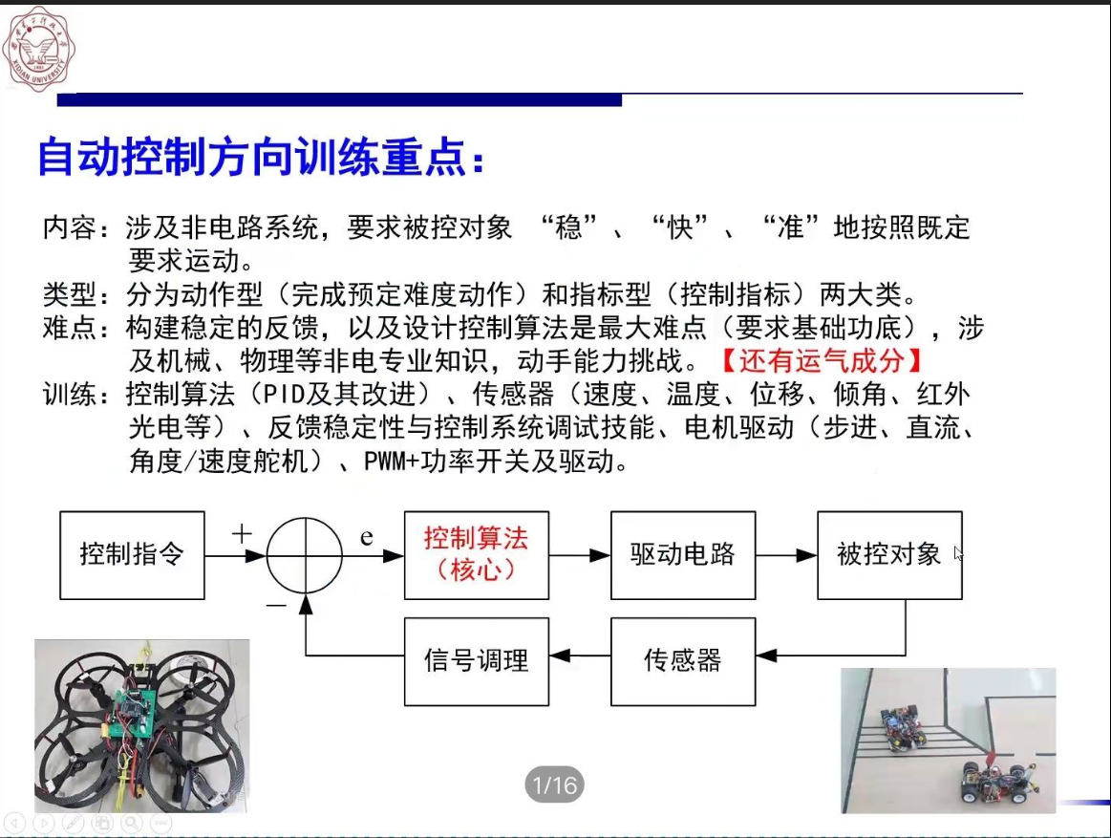
* 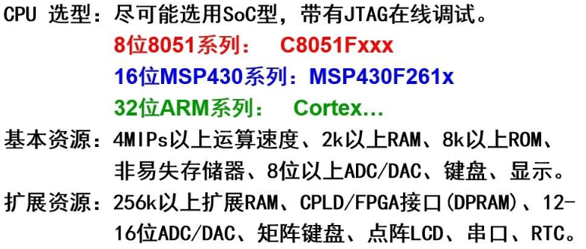
* TI官网: <https://www.ti.com.cn/>
* 立创开源硬件平台：<https://oshwhub.com/explore/collection>