**Introduction**

Fitness center membership registration and exercise for customers.

Our project involves workout plans such as, boxing, Zumba, yoga and weightlifting which will require gloves, mat, sneakers and dumbbells etc. to do such exercises. For enrolment, customer have to register his\her to the fitness center and for that it will require him or her to give few details such as his\her full name as well as start date for the fitness center registration and duration of plan as the duration of the plan is only for 24 months, after that it needs to be renewed as per the new terms and conditions and customer can choose the duration of months between 1-24 months. Also, the class will be available for 7 days a week and customer have to give information about the number of classes he\she wants per week and by clicking on check button, it will display the recently added trainee’s information, type of trainee, full name and total price.

However, the customer will check the price first and then he/she will take the plan according to their choice and services would be given to them based on training they have chosen and by clicking on service button, it will show duration, classes per week, start and end date of trainee with equipment, fitness advisor and the locker room to keep things.

Moreover, after registration, customer will be eligible to fitness center’s all services and by clicking on register button, the information gets saved in xml file.

In addition, after pressing the display button, it will display all the registered members information. We can also filter the information trainee type or by name. After filtering, full name, start date, duration, classes per week and expiry date of registered members would be displayed, if the information is displayed in red color then the trainee program is expired and the if the information is displayed in yellow color then the program gets expired in less than 20 days.

**Steps of Application:**

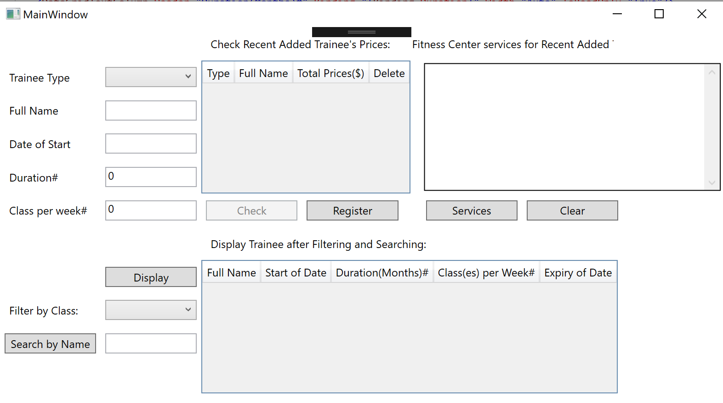

1. Run the application.
2. Please select any type of training from the drop-down combo box

* Zuma
* Boxing
* Yoga
* Weightlifting

1. Enter the full name in the Text box.

* Full name can be entered with alphabet and whit space only and the last input can not be white space
* Example: John or Jay Chou
* Error Message for Validation: Not Alphabet; Empty Input; No white space on last input

1. Then enter date in mm-dd-yyyy format
   * Error Message for Validation: Please enter correct Date Time! [Ex: MM-DD-YYYY]
2. Duration can be entered from 1-24 months (only digits)
   * Error Message for Validation: Not Integer!

Out of Range!

Enter an Integer between [1-24]

1. User can enter digits 1 to 7 for classes per week
   * Error Message for Validation: Not Integer!

Out of Range!

Enter an Integer between [1-7]

1. **Note:** When customer enter blank or wrong format of information in the text box, then the text box gets highlighted in red color after clicking somewhere.
2. Click on Check button to check prices. It will display Trainee Type, full Name and Total price at Data Grid Check Recent Added Trainees’ Prices. Check button can check more than one trainee.
   * Note: Check button is enabled only when every input is correct.
3. Click Full Name in Data Grid for check prices, we can edit the Full Name with correct format. If Full Name is wrong format, when click somewhere, the border of the text box of full name in data grid will become red; And when you edited name is wrong and the red border of text box, at this time click the Register button, the window will show
   * "Full Name is editing or wrong! Please Enter information again!"
4. Click on services button which displays duration, classes per week, start date and end date of training with the equipment, fitness advisor and locker at text block Fitness Center services for recent added Trainees.

* Note: Services button is disabled until the trainees’ information is added into data Grid for checking prices

1. Clear button is to clear the information displayed for services
2. The recently checked information is displayed with Total price which is calculated as per the entered information
3. Click on Register button to register in Xml file and message box pops up to get register

The information which gets register in Xml file is Trainee Type, Full Name, Date of Start, Duration and Classes per week

* Note: When no trainee is checked and clicked on register button, message box is displayed stating no trainee.

1. To delete the registration, click on Delete button in the Data Grid Check Recent Added Trainees’ information.
2. Display button is displaying all trainees’ information we stored into Trainee.xml file and the displayed trainees will be sorted by Duration time
   * Note: When no xml file and clicked on display button, message box is displayed stating xml file is empty.
3. To filter the information, select any type of training from the drop-down combo box

* Zuma
* Boxing
* Yoga
* Weightlifting

1. To search by name (case sensitive), enter the name in the textbox and click Search by name button. Date Grid will display the searched name’s trainee

* Note: If the search name is one part of full name, it will show trainees who contains this part of name.

1. The *Display Trainees after filtering and searching* is displayed with date of expiry. If the information is displayed in red color, then the training program is expired and if the information is displayed in yellow color, then the program gets expired in less than 20 days.

**Two Class Diagrams**

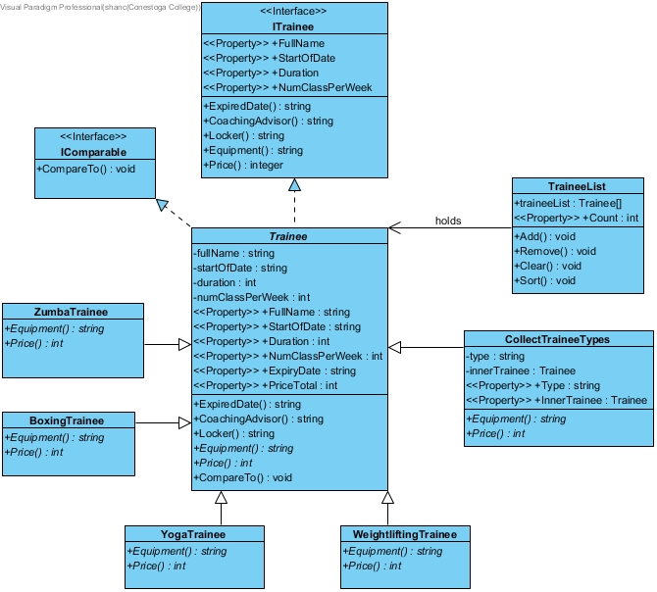

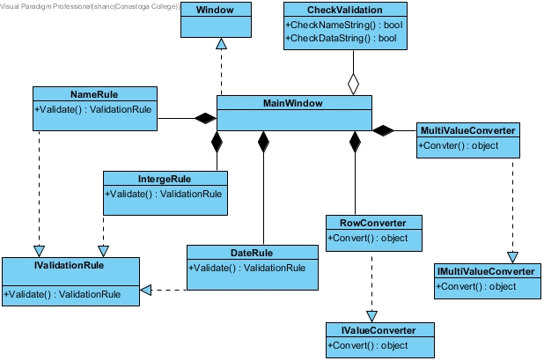

**Sequence Diagrams**

## Customer check exercise class price and services and delete their registration

* *Scenario Name: Delete the registration*
* *Scenario Description: A customer enters date of choosing class, full name, start of date, duration and per week courses; then check the prices according to their information and check the services of the classes; but customer finally press delete button for deleting this registration.*
* *Sequence Diagram:*

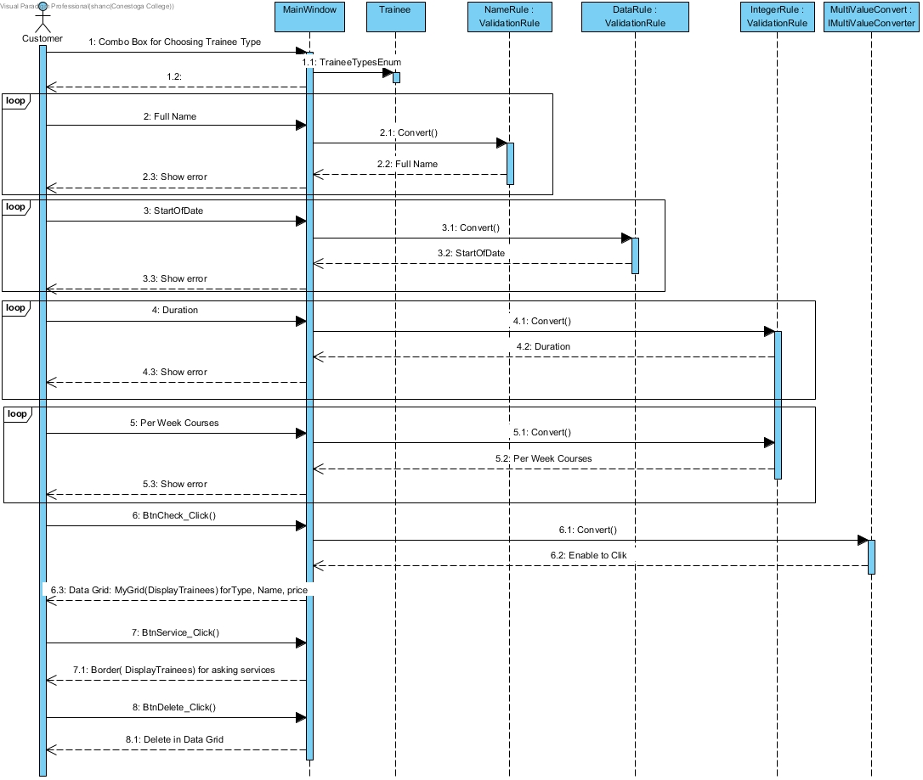

## Customer check price and then registered scenarios

* *Scenario Name: Register a class for customer*
* *Scenario Description: A customer select the type exercise class and input their information to check price, then register.*
* *Sequence Diagram:*

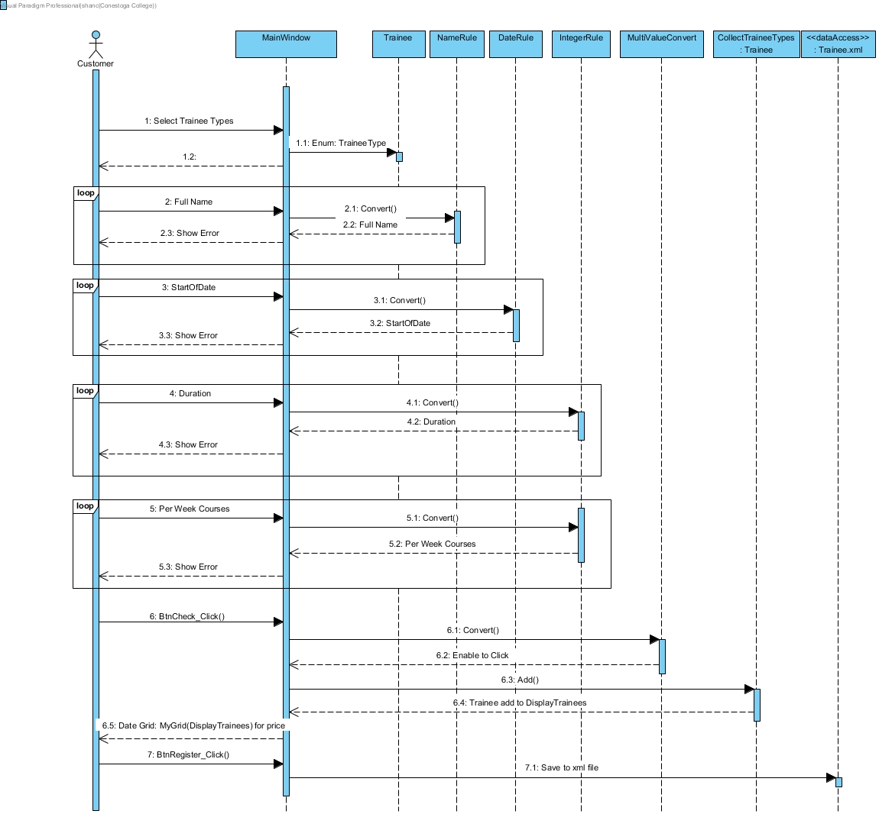

## Manager Check the expiry date for specific customer Scenarios

* *Scenario Name: Search Customer and check his/her expiry date*
* *Scenario Description: A Manager use display button to display all customers information, then filtered by customer’s type, then search the customer’s name. Finally Manager can get his/her expiry date.*
* *Sequence Diagram:*

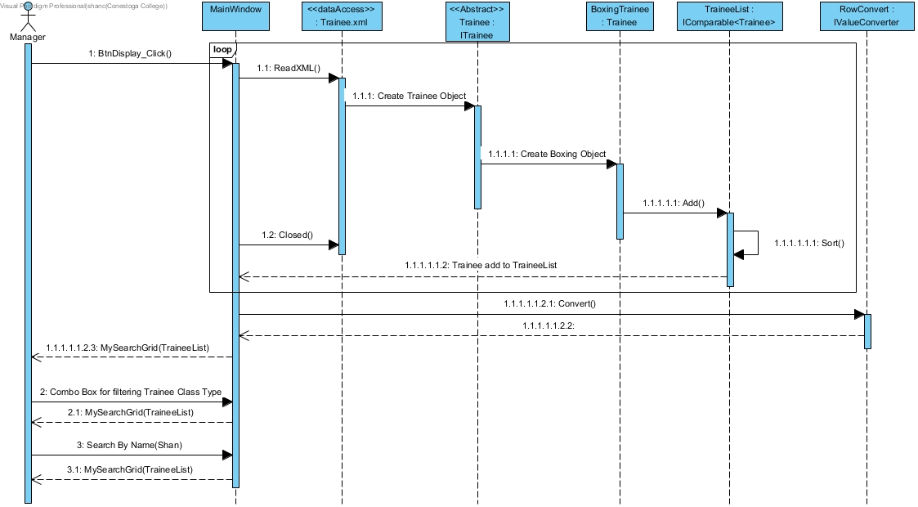

*Ps: In the file, should have four kind of trainee types. When we read, we should provide four kinds classes in sequences diagram; But I only show one BoxingTrainee Class.*

**Rubric Checking:**

**GUI-Screen Design:**

1. Define Grid and use Grid.RowDefinitions and Grid.ColumnDefinitions
2. Use Grid.Resources and Styles to set border,label, button, comboBox, textbox and border for different properties

**GUI-Binding:**

1. Binding input validation for textboxes using NameRule, IntegerRule, DateRule
2. Binding add button for enable using MultiValueConventer
3. Binding two Data Grid and their columns using DisplayTrainees and TraineeList
4. Binding expiry of Date for changing background colors in the bottom of data Gird using RowConventer

**GUI-Lists:**

1. TraineeList which is a list of Trainee object banded with the bottom of Data Grid
2. DisplayTrainees which is ObservableCollection banded with the top of Data Grid

**GUI-Grids:**

1. Use two DataGrids:
   1. The top of DataGrid binding by ObservableCollection *DisplayTrainees* which is a list ofCollectTraineeTypesand use DataGrid.Columns to set each of column;
   2. The bottom of DataGrid binding by *TraineeList* which is a list of Trainee and DataGrid.Columns to set each of column.

**GUI-Errors and Converters:**

1. Error
   1. CheckValidation Class contains CheckNameString (string nameStr), CheckDateString(string dateStr), CheckIntegerDuration(string numStr) and CheckIntegerPerWeek(string numStr) for checking validation
   2. NameRule Class which is handling name input textbox
   3. DateRule Class which is handling data input textbox
   4. IntegerRule Class which is handling duration and per week input textboxes
2. Converters:
   1. RowConverter for controlling the expiry day of trainees
   2. MultiValueConverter for controlling the add button

**Code-Proper Distribution:**

1. Check Trainee.xml file in Dubug
2. Check when use display button, search button and comboBox for filtering trainee type

**Code-Use of Collections:**

1. ObservableCollection
2. A list object which contains trainees call TraineeList

**Code-Class Design:**

See Class Diagrams

**Files-Saving and Retrieving:**

1. When Trainee’s information acquires from textbox and comboBox, it will display on the top of Data Grid after click add button
2. Using [XmlIgnore], [XmlXmlRoot], [XmlInclude], [XmlArray], [XmlArrayItem]
3. When the top of the Data Grid shows Trainees’ information, click save button, all the trainees’ information will be serialized into Trainee.xml file one by one.
4. Click Display button, all information from the Trainee.xml will be deserialized to TraineeList then it will display on the bottom of Data Grid.

**LINQ-Queries:**

1. Use comboBox to switch trainee type and use LINQ to filter each type of trainees after click Display button
2. Use textBox to acquire Trainee’s name and use LINQ to Search this Name when trainees displayed on bottom of Data Grid.

**Documentation:**

1. Introduction of project
2. How to use our program
3. Diagrams
4. Rubric cover

**General Errors:**

1. No complied and running error