***Prototype_Relationel_Model***

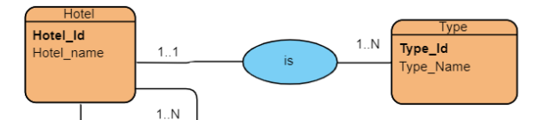

***Hotel(Hotel_id,Hotel_Name,#Type_id),***

***Type(Type_id,Type_Name);***

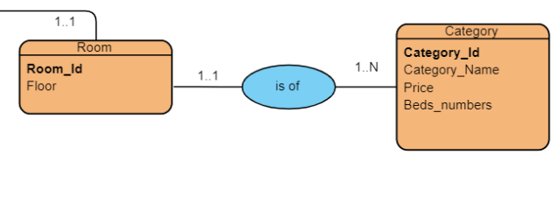

***Room’(Room_id,Floor,#Category_id),***

***Category(Category_id,Category_Name,Price,Beds_Numbers);***

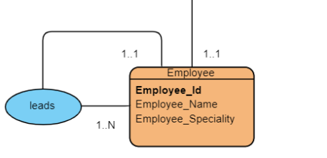

***Employee(Employee_id, Employee_Name,Employee_Specialty,#leader_id);***

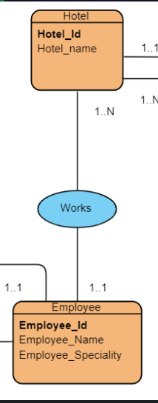

***Hotel(Hotel_id,Hotel_Name),***

***Employee(Employee_id,Employee_Name,Employee_Speciality,#Hotel_id);***

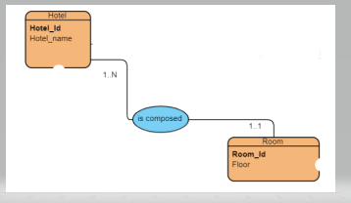

***Hotel(Hotel_id,Hotel_Name),***

***Room(Room_id,Floor,#Hotel_id);***