ADMIT-LIPA:
A WEB-BASED ADMISSIONS CUSTOMER RELATIONSHIP
MANAGEMENT SYSTEM FOR THE ADMISSIONS OFFICE
OF STI COLLEGE LIPA
STI College Lipa
C. M. Recto Avenue, Barangay 6, Lipa City, Batangas
School of Information and Communications Technology
Prototype Progress Report
Presented in Partial Fulfillment of the Requirements in
Application Development and Emerging Technologies
Submitted by the Proponents:
Atienza, Kurt Judd P.
Garonia, Ian Humprey M.
Apura, Alexis H.
Tenedo, Francis Gerald G.

Submitted to:
Ms. Gabrielle Hernandez
Course Facilitator
First Semester, School Year 2026-2027
Report date: October 28, 2026

1. Summary of Progress
The proponents moved ADMIT-Lipa from the approved System Concept Proposal to a working web application. All fourteen use cases in the use-case diagram (Figure 1 of the proposal) now run end to end in the development build, and the automated acceptance suite passed 52 of 52 checks on October 28, 2026. Every functional requirement FR-01 to FR-14 is exercised by at least one check that follows the verification method written in the proposal.
Item | Status as of October 28, 2026
Use cases implemented | 14 of 14 (UC1 to UC14)
Functional requirements verified by automated test | 14 of 14 (FR-01 to FR-14)
Non-functional requirements verified by automated test | NFR-02, NFR-03 (in part); NFR-05 by screenshot at 390 px
Screens designed and captured | 13 screens, desktop (1920 x 1080) and mobile (390 x 844), light and dark
Source code | https://github.com/Tiredicey/APPDEV
Deployment | Runs in the development environment; public hosting on Cloudflare Pages is the next step

2. Technology Used
Layer | Choice | Reason
Server | Hono web framework on Cloudflare Workers / Pages | Runs at the network edge; no server for the campus to maintain
Database | Cloudflare D1 (SQLite) | Relational tables for tickets, requirements, payments and the audit log; Cloudflare states D1 encrypts data at rest and in transit (Cloudflare, 2026)
Field encryption | AES-256-GCM via the Web Crypto API | Date of birth, mobile number, address and financial-aid answers are encrypted before they reach the database (NFR-03)
Passwords | PBKDF2-SHA-256, 100,000 iterations, per-user salt | No plain-text passwords stored
Front end | Plain JavaScript single-page app, IBM Plex type, no framework | Small download for mobile users on slow connections
Development assistant | Genspark AI coding agent | Generated code, tests and the background video under the proponents' direction; the team reviewed the screens and tested the prototype

3. Requirement Traceability: What Was Built and How It Was Verified
Req. | Use case | Implemented behavior | Result
FR-01 | UC1 | Inquiry form returns a ticket number such as ADM-2026-00001 in the same session and stores it | PASS
FR-02 | UC2 | Second profile with the same surname, first name and date of birth is blocked with a message (keyed HMAC index, so the duplicate check works on encrypted data) | PASS
FR-03 | UC3 | Each required document shows received, pending or rejected; a rejection requires a reason | PASS
FR-04 | UC4 | TES, TES-3A, TDP and SHS Voucher flagged from the encoded profile; boundary tested at P400,000 and P400,001 | PASS
FR-05 | UC5 | Applicant sees own stage only; opening another record returns "forbidden" | PASS
FR-06 | UC6 | Elapsed working days computed against the 3 / 7 / 20-day tiers, excluding weekends and holidays entered by the administrator | PASS
FR-07 | UC7 | Volume, stage conversion and case aging for any date range; totals reconcile with the raw case list; CSV export | PASS
FR-08 | UC8 | Consent statement text, timestamp and purpose stored for every inquiry and application; no consent, no record | PASS
FR-09 | UC9 | Reservation fee validated only with an official receipt number; a receipt number cannot be reused | PASS
FR-10 | UC10 | Deficiency notice lists each document still pending after its deadline; repeat runs do not duplicate notices | PASS
FR-11 | UC11 | Endorsed case reaches the financial aid coordinator queue with the program document list | PASS
FR-12 | UC12 | Opening a record requires a stated purpose; user, record, time and purpose are logged; applicants can download their own access log | PASS
FR-13 | UC13 | Ticket owned by one named officer; cannot be resolved without a closing remark | PASS
FR-14 | UC14 | Overdue ticket raised to the School Administrator queue; on-time tickets are not | PASS

4. Screens
The screens below were captured from the running build with an automated browser. The landing page uses the 1921 x 1080 "Landing Page" frame and its #FFF5C3 fill from the team Figma file as its base.
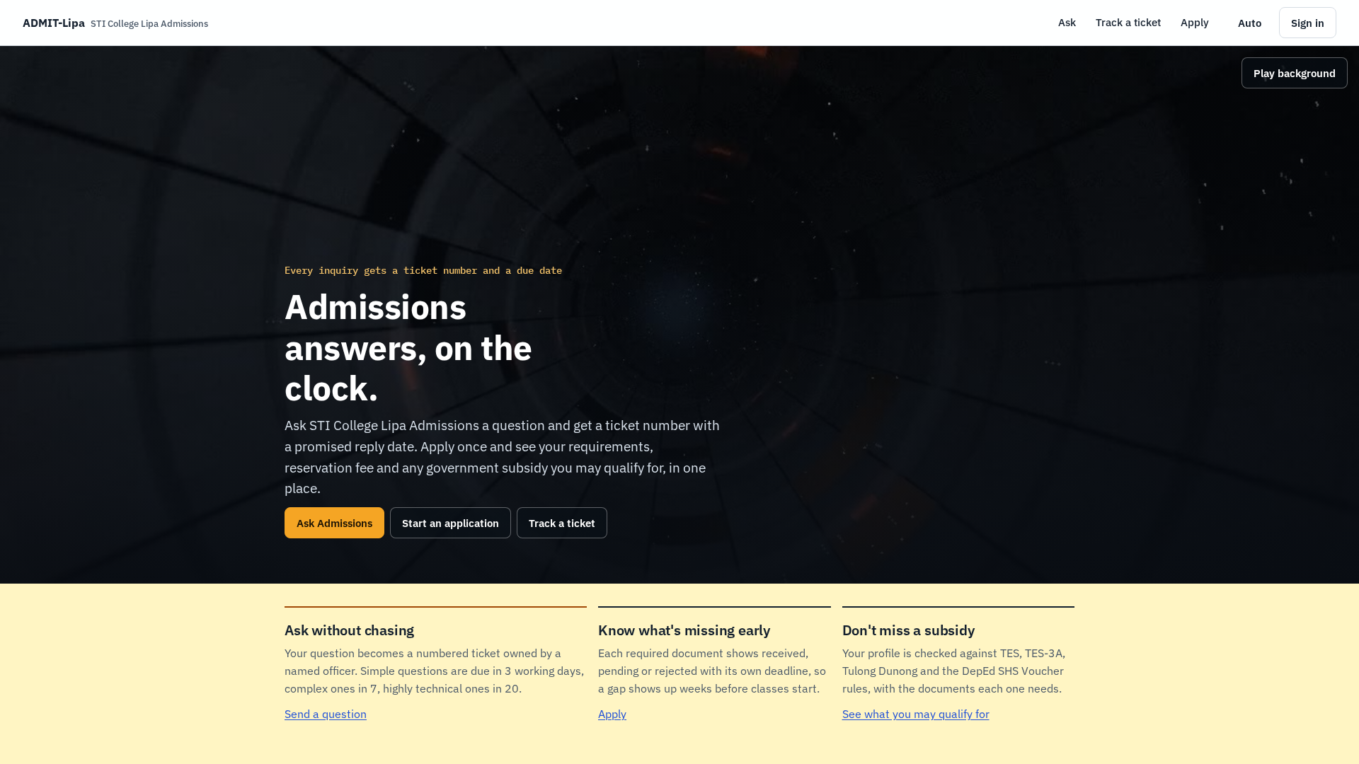
Figure 2. Landing page with the looping background video (desktop).
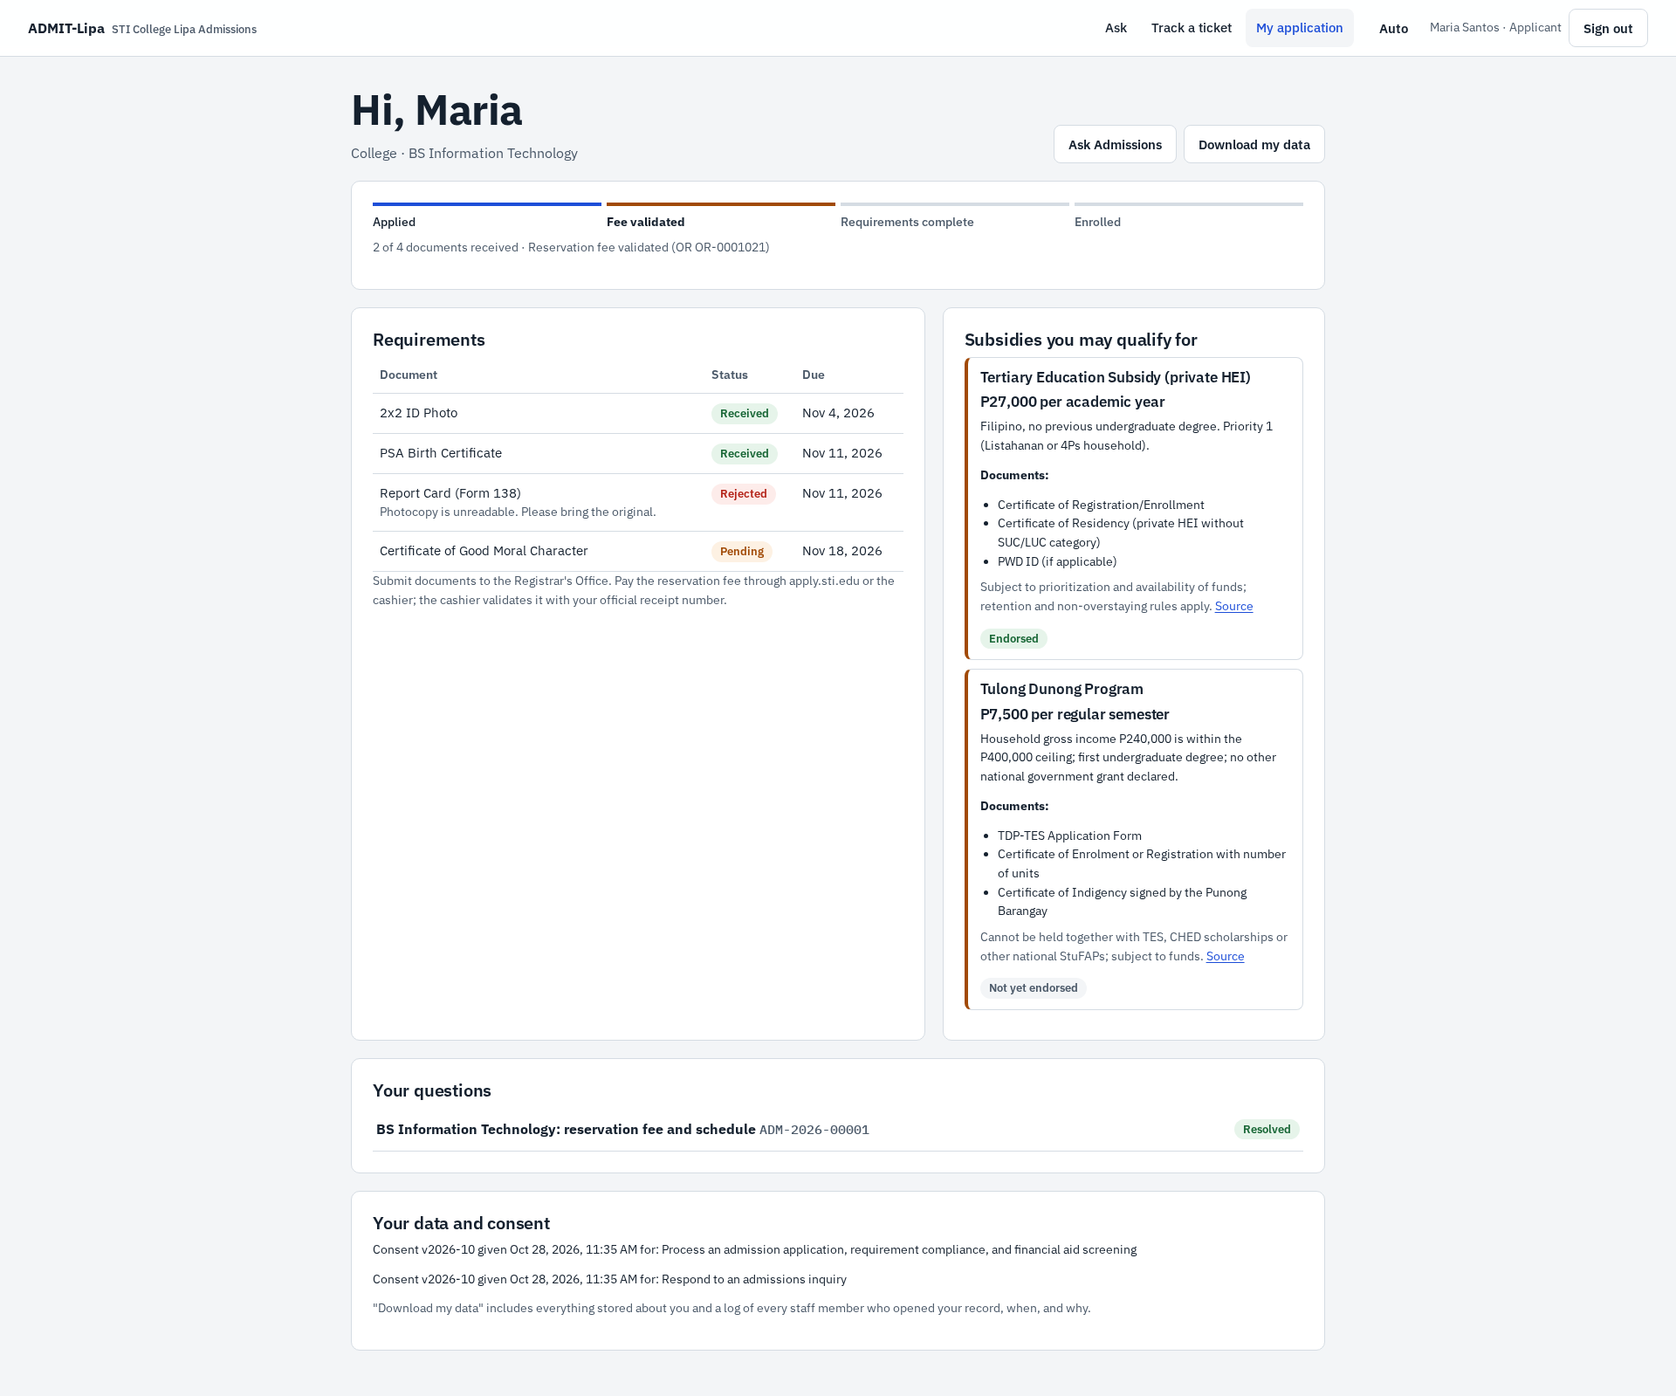
Figure 3. Applicant dashboard: stage, requirements, subsidy matches, questions, consent (UC3, UC4, UC5, UC8).
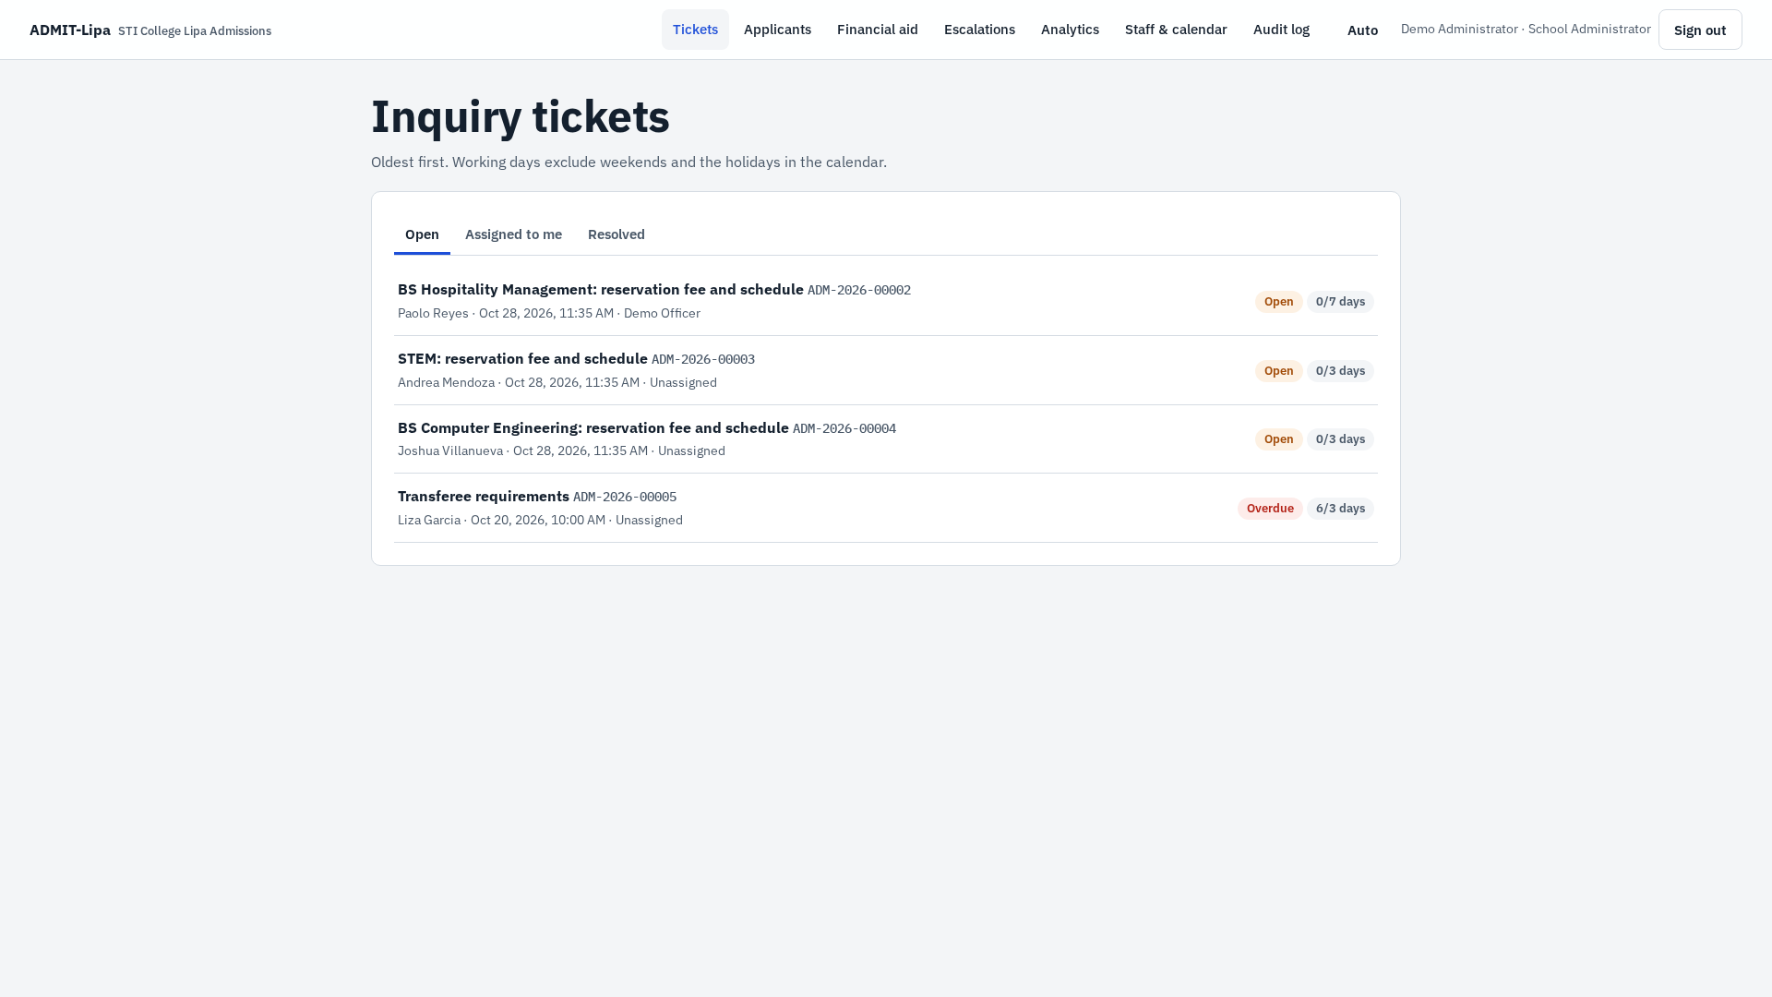
Figure 4. Officer ticket queue with service-level clock (UC6, UC13).
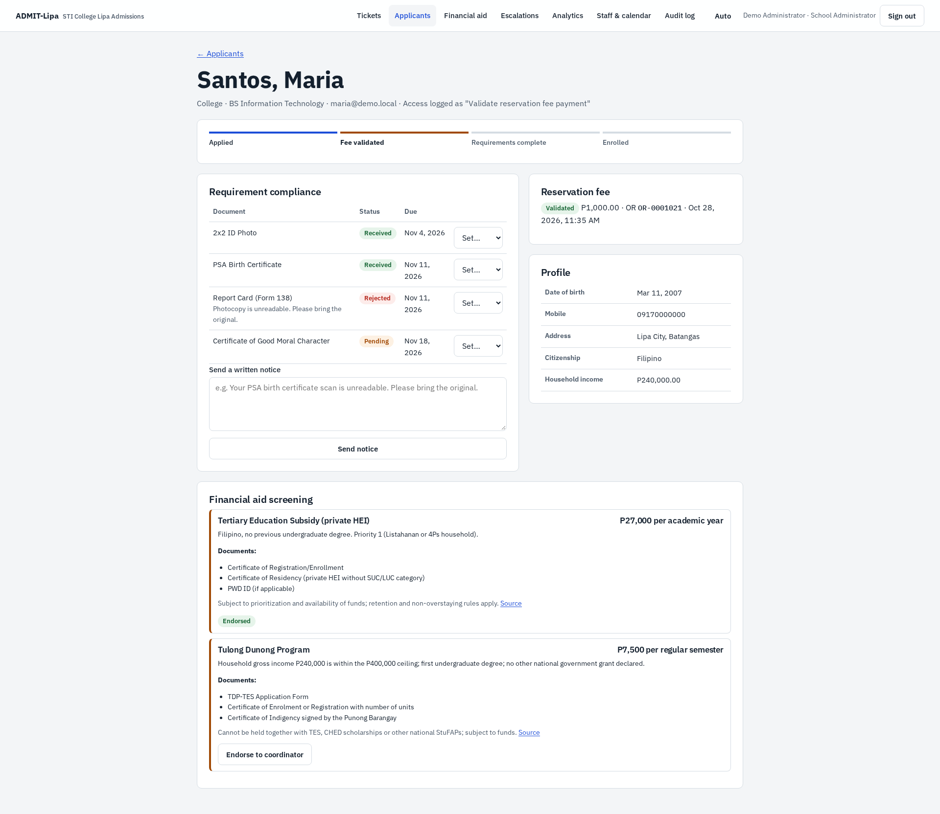
Figure 5. Staff view of an applicant record: compliance, payment, aid endorsement (UC3, UC9, UC10, UC11).
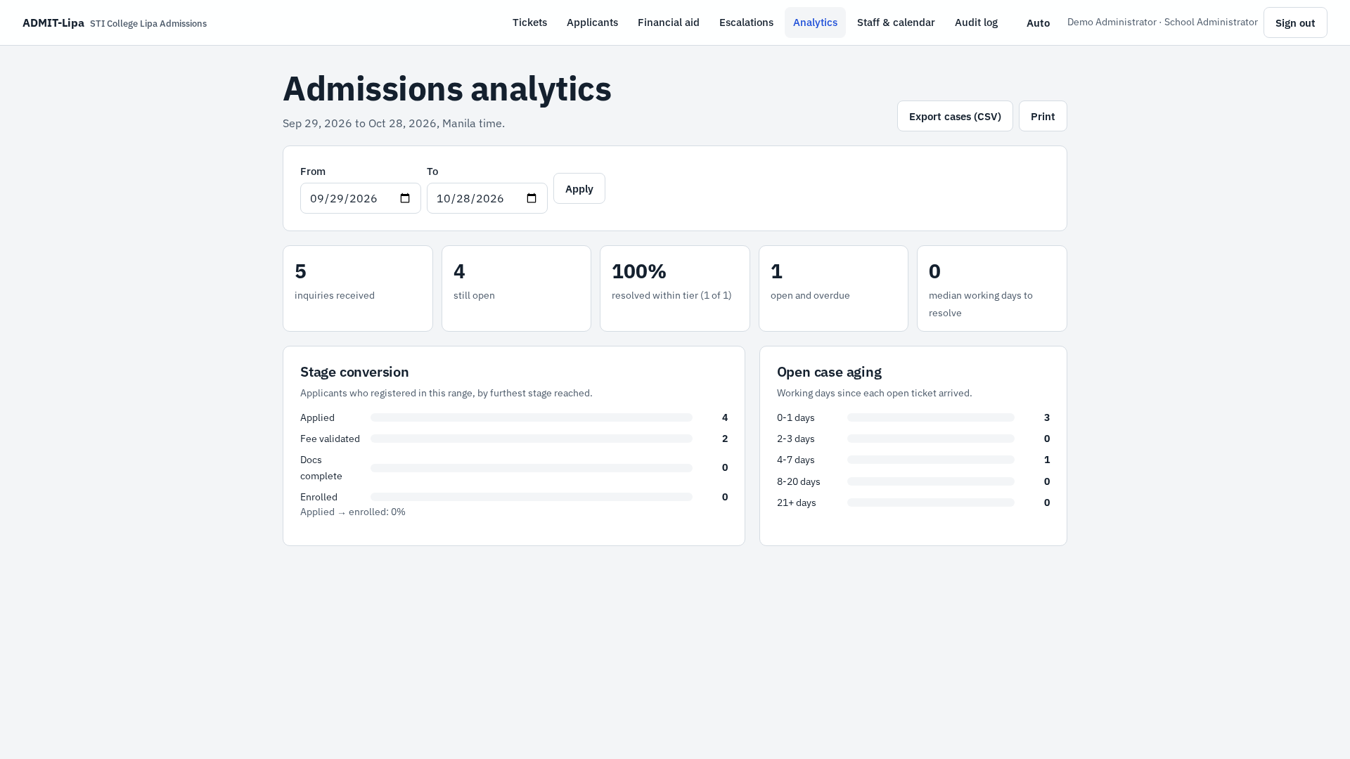
Figure 6. Admissions analytics for the School Administrator (UC7).
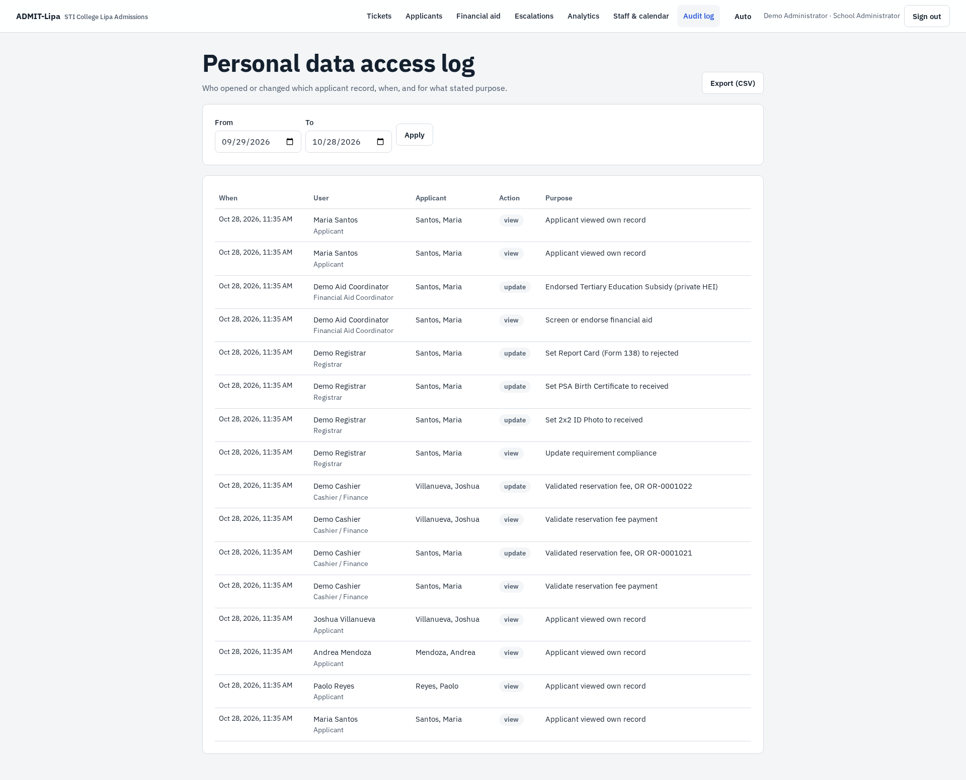
Figure 7. Personal data access log for the Data Protection Officer (UC12).

5. Background Video
The landing page plays a 12-second seamless loop at 30 frames per second, 1280 x 720, 6.3 MB, H.264. It shows a slow fall down the core of an abandoned orbital station. Camera speed and the amber warning lamps pulse at 140 beats per minute. The largest frame-to-frame brightness change is {video["max_delta"]:.2f} of 255 levels, far below the WCAG 2.3.1 flash threshold. The video is muted, carries no information, and has a Pause control. It does not autoplay for visitors who set "reduce motion" on their device.

6. Member Contributions
Each member signs his own row to confirm the contribution listed.
Member | Role | Contribution | Signature
Atienza, Kurt Judd P. | Project Lead | Designed the landing frame in Figma; directed the AI-assisted build of the back end, database and test suite; integrated and tested the prototype
Garonia, Ian Humprey M. | UX/UI Designer and Tester | Designed screens in Figma; tested the prototype
Apura, Alexis H. | UX/UI Designer and Tester | Designed screens in Figma; tested the prototype
Tenedo, Francis Gerald G. | UX/UI Designer and Tester | Designed screens in Figma; tested the prototype

References
Cloudflare. (2026, April 21). Data security. Cloudflare D1 docs. https://developers.cloudflare.com/d1/reference/data-security/
Department of Education. (n.d.). Senior high school voucher program guidelines. https://depedroxi.ph/voucher-program/
STI Education Services Group. (n.d.). Admissions. https://www.sti.edu/admissions.asp
Unified Student Financial Assistance System for Tertiary Education. (n.d.). Tertiary education subsidy and Tulong Dunong program. https://unifast.gov.ph/tes.html
World Wide Web Consortium. (2023). Web Content Accessibility Guidelines (WCAG) 2.2. https://www.w3.org/TR/WCAG22/

