IT2406 Performance Task 1: PS and FI, Development of Ultralight Bike
System M53, client 236, host m53p.ucc.cloud. SAP user LEARN-653, project P/2653. Session date 2026-09-29.

Status per task (verified by live read-back)
Task | Status | Evidence
1 Project, WBS, responsible cost centres | Done and saved | CJ03 opens P/2653; grid read-back 6 WBS, PE+Acct ticked, CA EU00, EURD1000/EURD1000/EURD1000/EUQM1000/EUPR1000/EUQM1000
2a Activities 0010-0140 + WBS assignment | Done and saved | Save message "Project P/2653 is being changed"; reopened tree lists network 4000100 activities 0010-0140
2b External 0045 service lines, 2c primary cost 0135 | Not done | Not started this session
3 to 14 | Not done | Not started this session; depend on task 2 completion

Screenshots
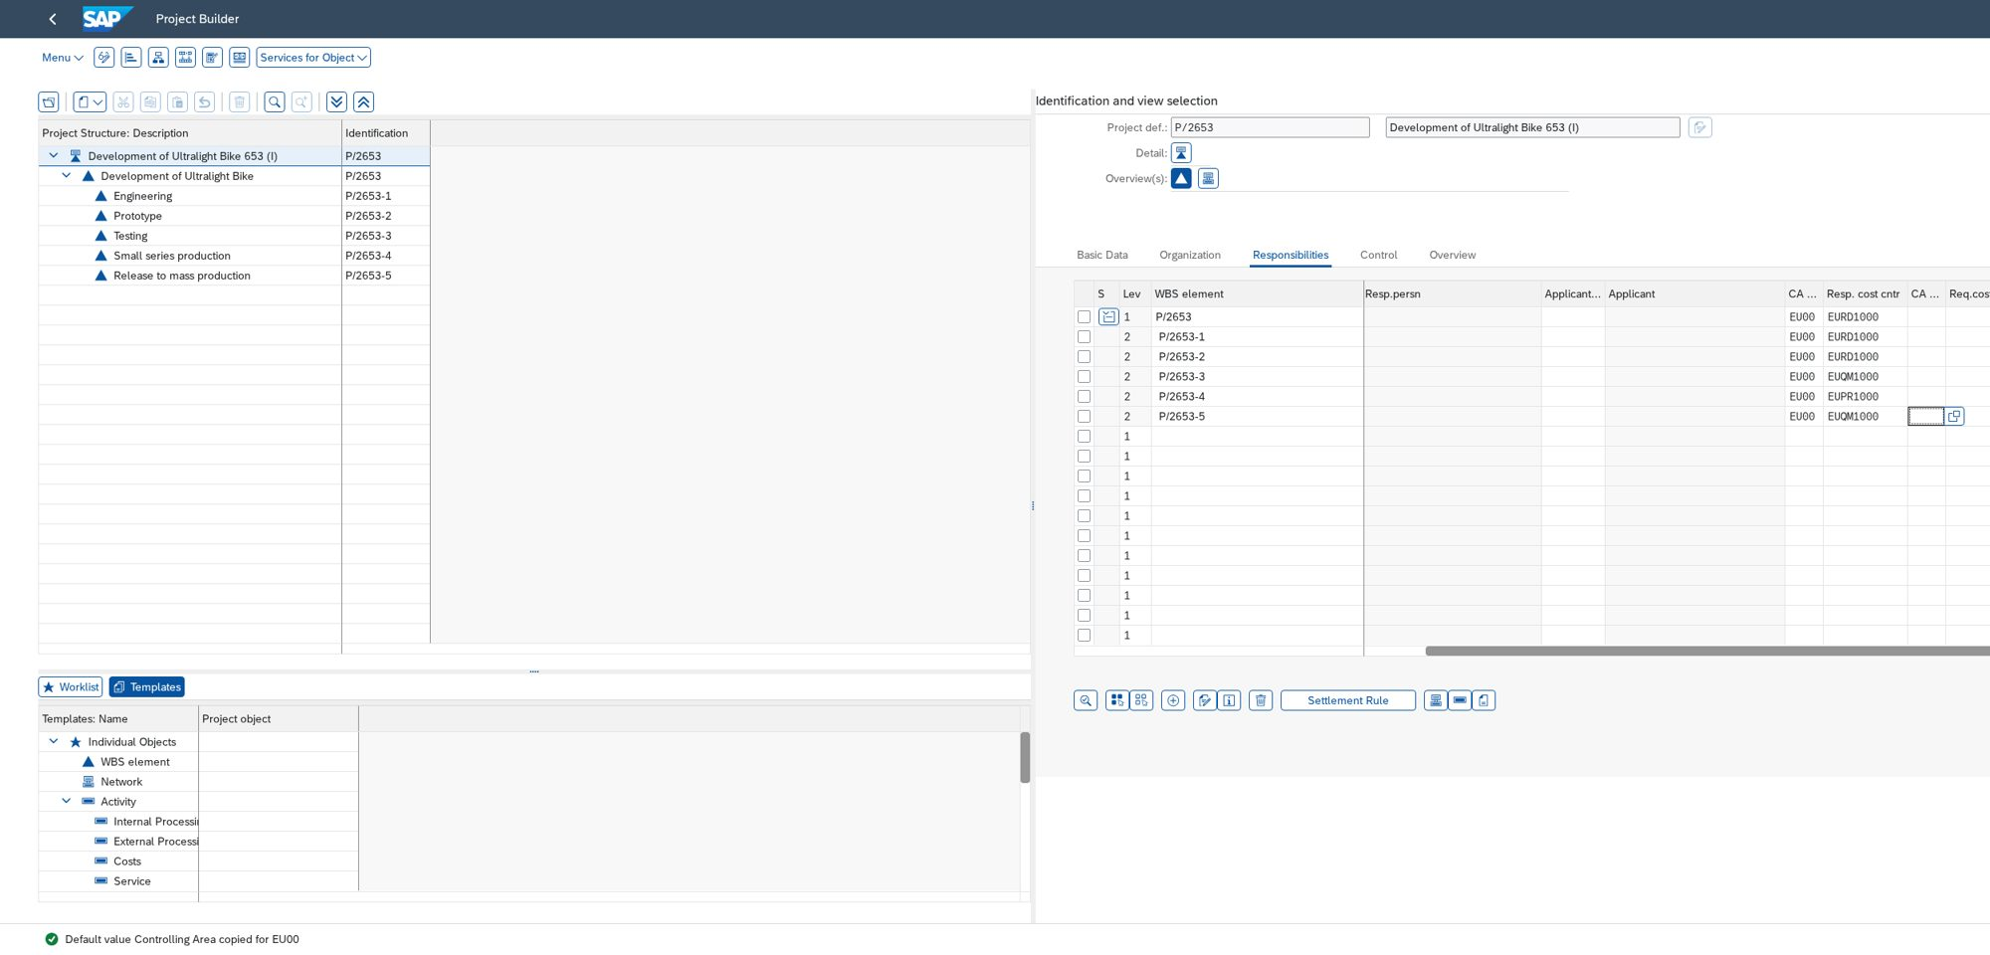
Figure 1. Task 1, CJ20N Responsibilities tab: WBS P/2653 to P/2653-5, controlling area EU00, responsible cost centres. Required screenshot 1 of 7.
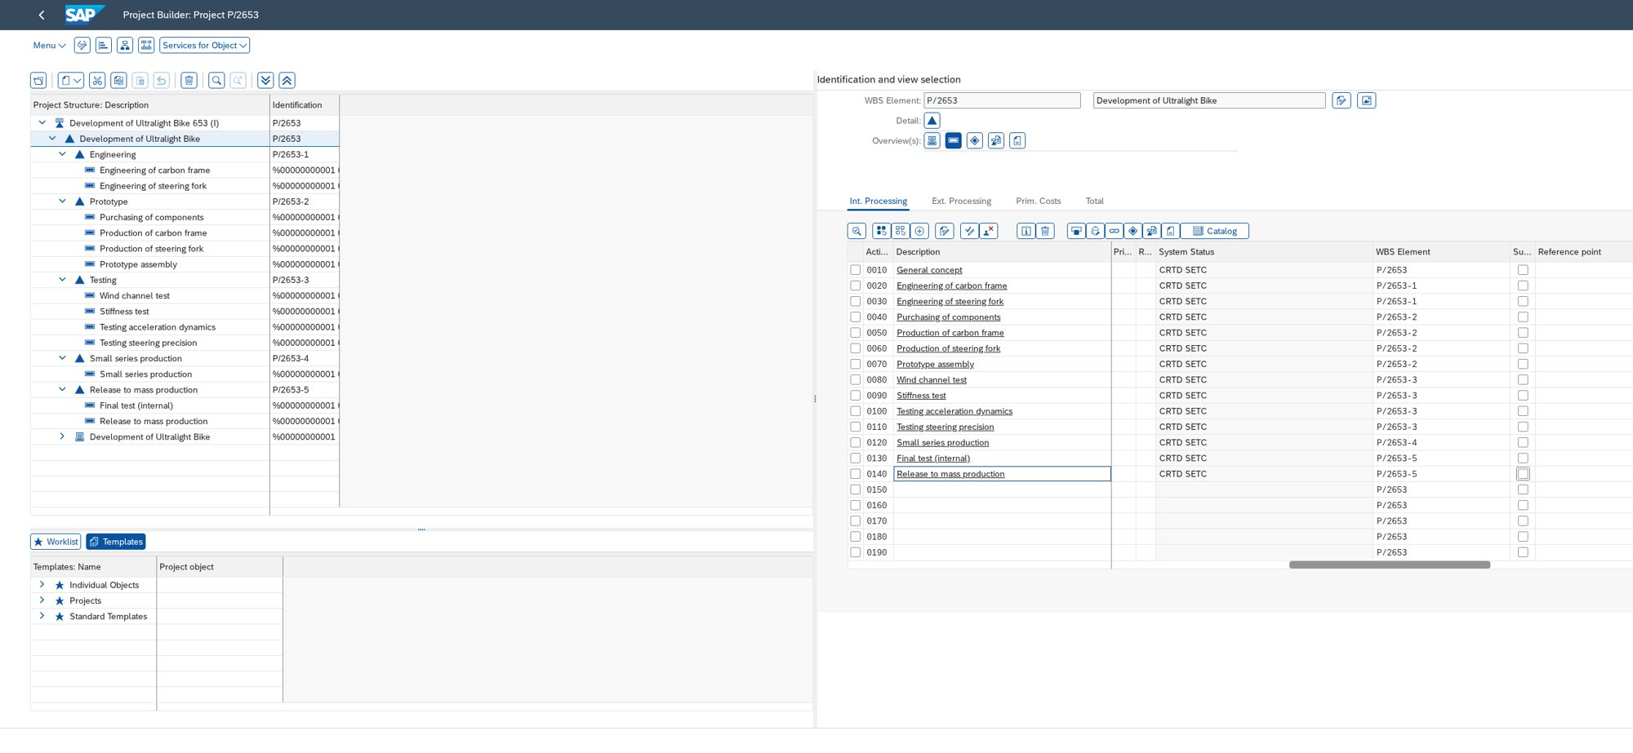
Figure 2. Task 2, CJ20N Activity Overview before save: 14 activities with duration, work, work centre. Partial: 0045 and 0135 not yet entered, so this is not the final required screenshot 2.
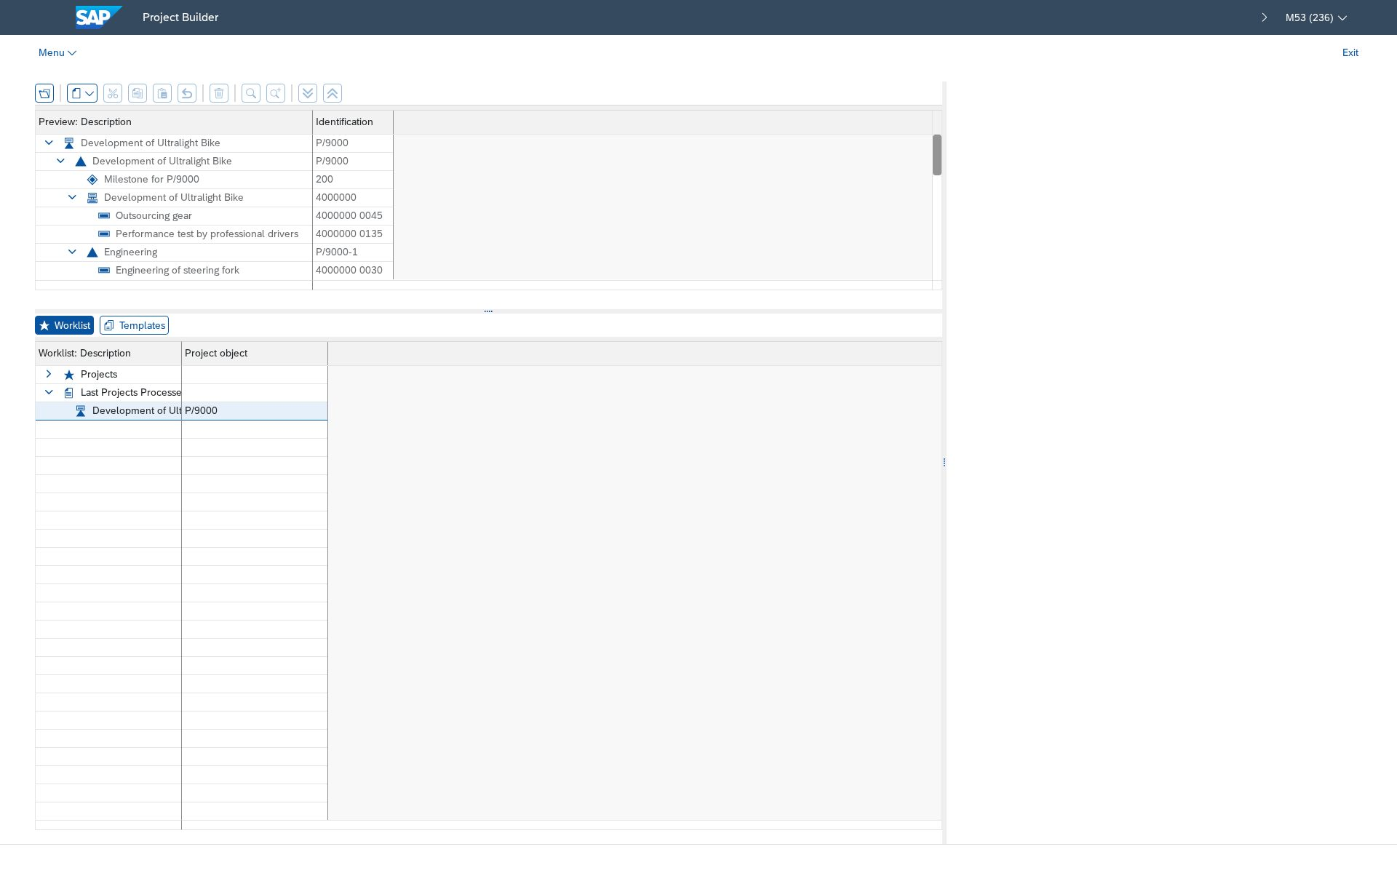
Appendix A1. Before this session: LEARN-653 worklist held only P/9000. CJ03 returned "Project P/2653 does not exist".
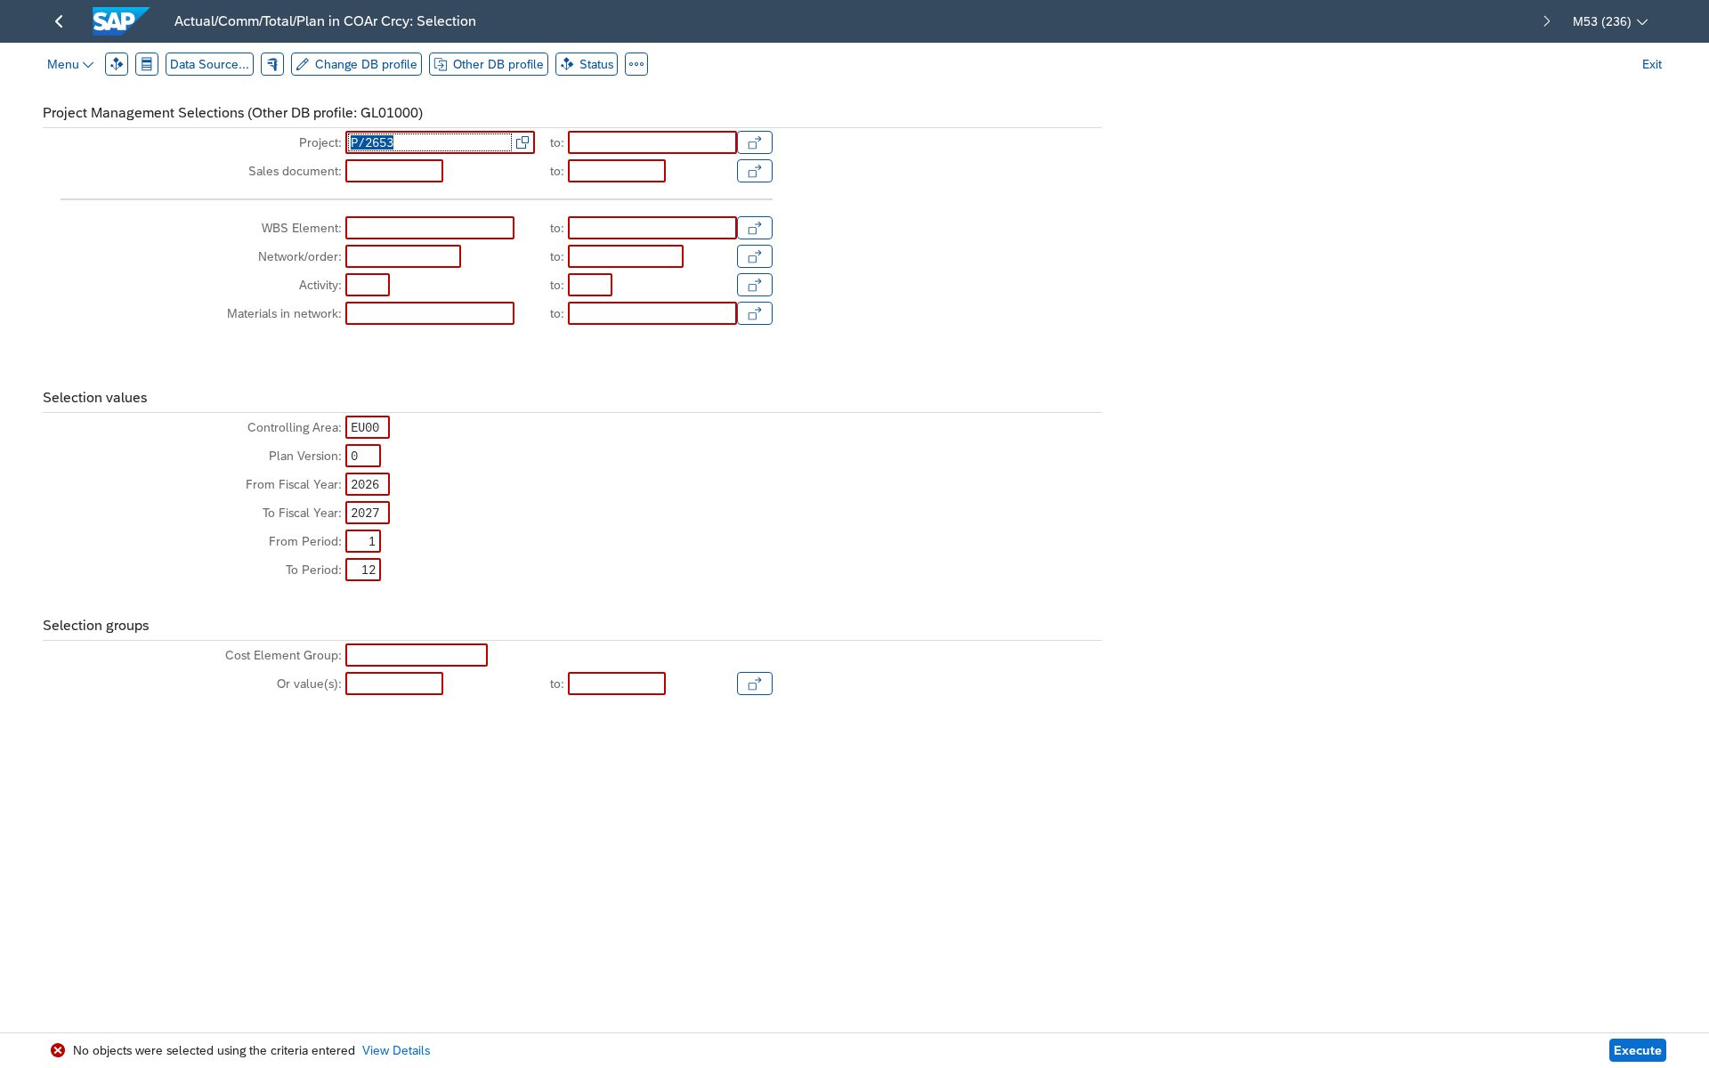
Appendix A2. Validate run #6 on the live site: S_ALR_87013542 for P/2653 returned "No objects were selected" (project did not exist yet).
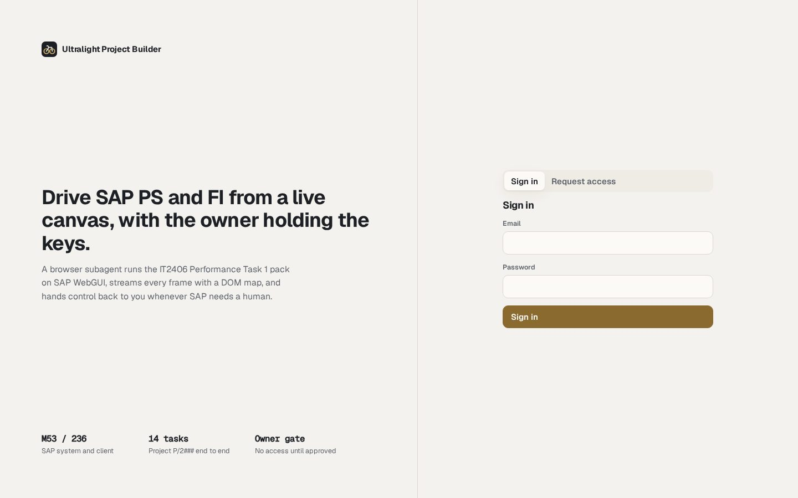
Appendix A3. Control site ultralight-project-builder.pages.dev, sign-in screen.

Conclusion
The conclusion compares the planned cost reports (tasks 8, 12) with the final actual report (task 14). Those reports cannot be written yet: tasks 8 to 14 are not done for P/2653. The expected figures from the task sheet are actual 1,750.00 EUR after the 35 h confirmation and 11,450.00 EUR after the 9,700.00 EUR invoice. They are targets, not results.

Not confirmed
- The grading monitor for LEARN-653. Only the user can open it.
- Whether the Oracle runner password for LEARN-626 was changed on purpose. SAP rejected it in validate run #5.
- Tasks 3 and 5 (network graph). Not opened this session.

