**Supplemental Text 3**. Latent clusters and cardiovascular medication (N=8,182).

We utilized chi-squared tests to investigate whether latent cluster membership (high-risk vs. low-risk cluster) is independent from taking drugs for cardiovascular problems (yes vs. no). We undertook this analysis at all five timepoints (Phases 3, 5, 7, 9 & 11).

**Phase 3**

|  |  |  |
| --- | --- | --- |
| *Cluster membership* | *Drug* | *Percentage* |
| *Low-risk* | *No* | *96%* |
| *Yes* | *4%* |
| *High-risk* | *No* | *80%* |
| *Yes* | *10%* |

*Pchi-squared*= 2.7×10-24

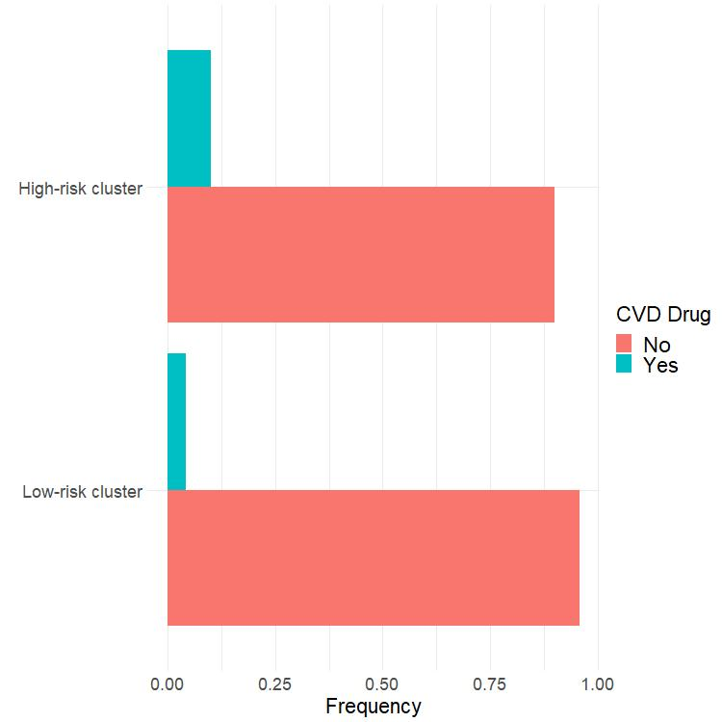

**Phase 5**

|  |  |  |
| --- | --- | --- |
| *Cluster membership* | *Drug* | *Percentage* |
| *Low-risk* | *No* | *91%* |
| *Yes* | *9%* |
| *High-risk* | *No* | *80%* |
| *Yes* | *20%* |

*Pchi-squared*= 1.9×10-47

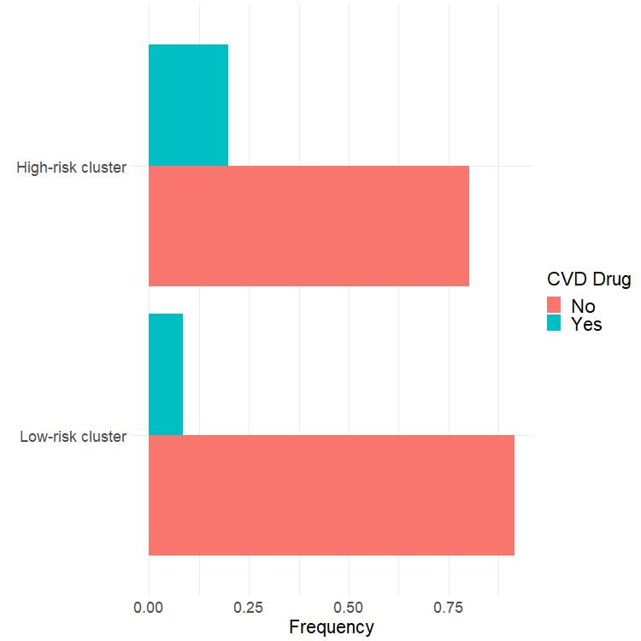

**Phase 7**

|  |  |  |
| --- | --- | --- |
| *Cluster membership* | *Drug* | *Percentage* |
| *Low-risk* | *No* | *83%* |
| *Yes* | *17%* |
| *High-risk* | *No* | *63%* |
| *Yes* | *37%* |

*Pchi-squared*= 1.1×10-87

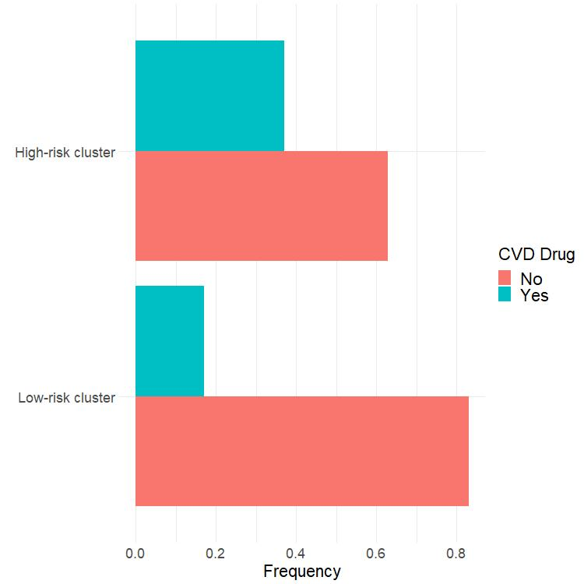

**Phase 9**

|  |  |  |
| --- | --- | --- |
| *Cluster membership* | *Drug* | *Percentage* |
| *Low-risk* | *No* | *55%* |
| *Yes* | *45%* |
| *High-risk* | *No* | *32%* |
| *Yes* | *68%* |

*Pchi-squared*= 2.6×10-80

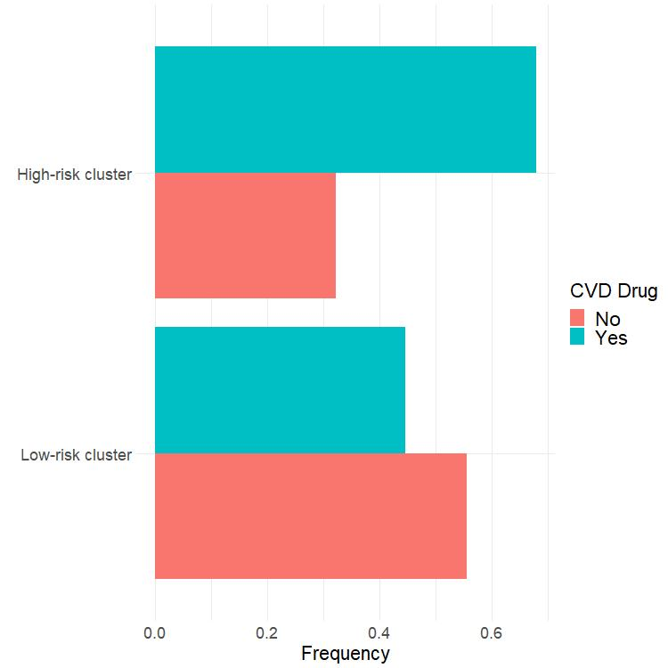

**Phase 11**

|  |  |  |
| --- | --- | --- |
| *Cluster membership* | *Drug* | *Percentage* |
| *Low-risk* | *No* | *47%* |
| *Yes* | *53%* |
| *High-risk* | *No* | *23%* |
| *Yes* | *77%* |

*Pchi-squared*= 3.1×10-90

