*UNFAIL – Transforming Failure into Knowledge*

*Author: Tibor V. Varga*

All parts of this project assignment are uploaded and made public at:

<https://github.com/Tirgit/unfail>

**Background**

For most academics, work life is paved with painful mistakes and failures. Failures come in many shapes and sizes – missing an important deadline, giving a bad presentation, embarrassing yourself or others in public, failing to understand key concepts, being rejected or just being late from a meeting can inflict negative emotions that can be harboured for a long time to come. Failures are painful for two major reasons; First, simply, they feel bad. Experiencing failure often also means missing out on the feeling of success and self-appreciation. Second, failure often correlates with a sense of fault and carries with a presumption that one has done something wrong [1]. On the other hand, facing failures and learning from them is considered an important path towards learning. This is underscored by the inspirational quote from the world-famous basketball player, Michael Jordan: “*I've missed more than 9000 shots in my career. I've lost almost 300 games. 26 times, I've been trusted to take the game winning shot and missed. I've failed over and over and over again in my life. And that is why I succeed.*” – in fact, the authors of the book *10 Mindframes for Visible Teaching – Teaching for Success* used this very quote as their main conclusion for their overall work, which represents the vital importance of failures in education [2]. While it is not immediately clear whether the emphasis in this quote is on perseverance/grit [3] or an active learning from failures (moving on *despite* the failure vs. moving on *by processing* the failure), the authors encourage educators to make the classroom a safe place to make mistakes where “*errors are opportunities for learning*” [2]. According to the authors, the means of reaching this state is to create an atmosphere of confidence and trust where mistakes are not frowned upon but rather considered as learning opportunities. As the level of anxiety is negatively correlated with the learning process, general strategies to reduce anxiety and transform failures into learning are warranted [2]. In 2018, Google has made public its internal process of documenting and learning from failures (called “*postmortems*”) in the company [4]. While such frameworks are implemented at Google and elsewhere in large companies [5], no such system exists at Lund University for students.

The overall goal of this project work is to develop an educational framework that has the potential to help individuals processing failure by describing, logging and categorizing them. My hypothesis is that failures can be extremely useful in driving learning if they are properly analysed, processed, understood, documented and remembered.

I termed to project *UNFAIL* – first, the word could be interpreted as an acronym of UNderstanding FAILure; second, the immediate notion the word gives is the feeling of recovering or coming back from failure, which this project is indeed ought to help with.

**Methodology**

The planned outcome of this inquiry, UNFAIL, is an educational framework that will help students process, remember, understand and overcome failure in an effective and productive manner. I chose an **app wireframe** as the output medium of this assignment. A wireframe is basically a draft that is used to demonstrate the main functionalities of an app or a software. The focus here is on functionality and not aesthetics, although I aimed to put together a visually appealing draft.

The tool is inspired by and constructed based on three major resources:

1. Analysis of responses to a short questionnaire I put together about prior experiences on failure (filled in by 6 PhD students) (see *Appendix 1 - Questionnaire* for the questions and *Appendix 2 – Key concepts* for the analysis of the responses)
2. Google’s internal failure management system [4]
3. Amy Edmondson’s published article in the Harvard Business Review [1]

The questionnaire (see *Appendix 1 – Questionnaire*) first asked the participants to recall a past failure in their academic life and spend few minutes on recalling the surrounding details. Subsequently, 5 questions asked them about their immediate feelings and emotions, circumstances of the event, what made the failure memorable, what could have helped processing the failure and what are the key learning points from the failure.

**Results & Presentation of the Wireframe**

The responses to the questionnaire were analysed using qualitative methods. First, codes were extracted from all the responses. Here, codes represent key concepts and messages delivered by the responses – this can be a single word or sequence of words that deliver a key message. The goal here was to be as detailed as possible; each piece of information was considered valuable. Subsequently, the codes were copied to another document and were organized around emerging groups of key concepts (see *Appendix 2 – Key concepts*). These categories were:

1. **FEELINGS** – feelings and emotions that are associated with the failure
2. **ACCEPTING FAILURE** – “wisdoms” about failure being part of life
3. **LEARNING POINTS** – other, more specific learning outcomes from failures
4. **SURPRISE** – elements of surprise associated with failure
5. **PROCESSING** – details about the internal processing of failure
6. **CONTRIBUTING FACTORS – BY OTHERS** – contributors to the experience by others
7. **CONTRIBUTING FACTORS – BY SELF** - contributors to the experience by self
8. **COULD BE HELPFUL** – real or proposed circumstances that were/could be helpful in processing failure

What is very apparent from these results is the cluster of negative emotions associated with failure: feelings of anger, betrayal, disappointment, fear, frustration, regret and sadness occurred more than once in the testimonials. Overarching themes amongst the contributing factors are related to high expectations from others and self, fear of not being enough, lack of understanding from others, high pressure situations and lack of control. A couple of key long-lasting take-home messages emerged: in brief, in multiple testimonials failure was accepted as part of life and was considered important for learning. This underscores the main aim of the planned app: that reflection on past failures contributes to acceptance of one’s own situations and puts failure in perspective. In addition, a safe environment to make mistakes, support from others, the proper understanding of the nature of the failure and just the ability to safely talk about the failure and a chance to explain the failure were considered to be helpful.

The planned app will offer a short “ritual” that students will be able to use on their own, after experiencing failure. The “ritual” is comprised of logging failures and mistakes with i) Title; ii) Description (the whole story); and iii) Learning Points and subsequently tagging them with feelings, contributing factors or other terms (options and suggestions here are inspired from findings from the questionnaire). The app would create a memory symbolized as a gem of a certain shape and colour and the app would assemble a timeline/collection of gems which are always there to browse and look back on. As there is evidence that documenting and revisiting mistakes and failures contribute to learning [1,4,5], such “repository” of past mistakes will likely be extremely helpful for students, especially if the framework is presented in a visually appealing way that takes out blame and fault from their way of thinking about failures and instead, encourages them to process, learn and observe patterns of past mistakes. Through the app, when adding a story, users will be forced to add a very brief (160 characters) brief “wisdom” for their future self. These short messages will randomly appear when opening the app and when browsing ones’ own collection.

In addition, the app will provide an option for users to publish their stories, strictly anonymously, to the cloud, where it would be browsable by all users, by selecting tag categories. As mentioned, this will be an optional functionality, but will be encouraged by receiving different kind of gems for making a story public.

I selected a gem as the symbol for the app, as these stories should represent something precious, worthy and something you should hold dear – by browsing your collection of gems you can revisit your past failures and remind yourself of the associated learning points. Through certain analytic assessments the users will also be able to see patterns emerging (e.g. most of your stories are associated with the lack of self-worth or have similar learning outcomes).

The wireframe is presented below:

1. **Opening screen and main menu:**

1. **Adding a story:**

1. **The joy of receiving a gem!**

1. **Browsing one’s own collection of gems:**

1. **Browsing anonymous online collection of gems:**

1. **Pattern analysis of gems:**

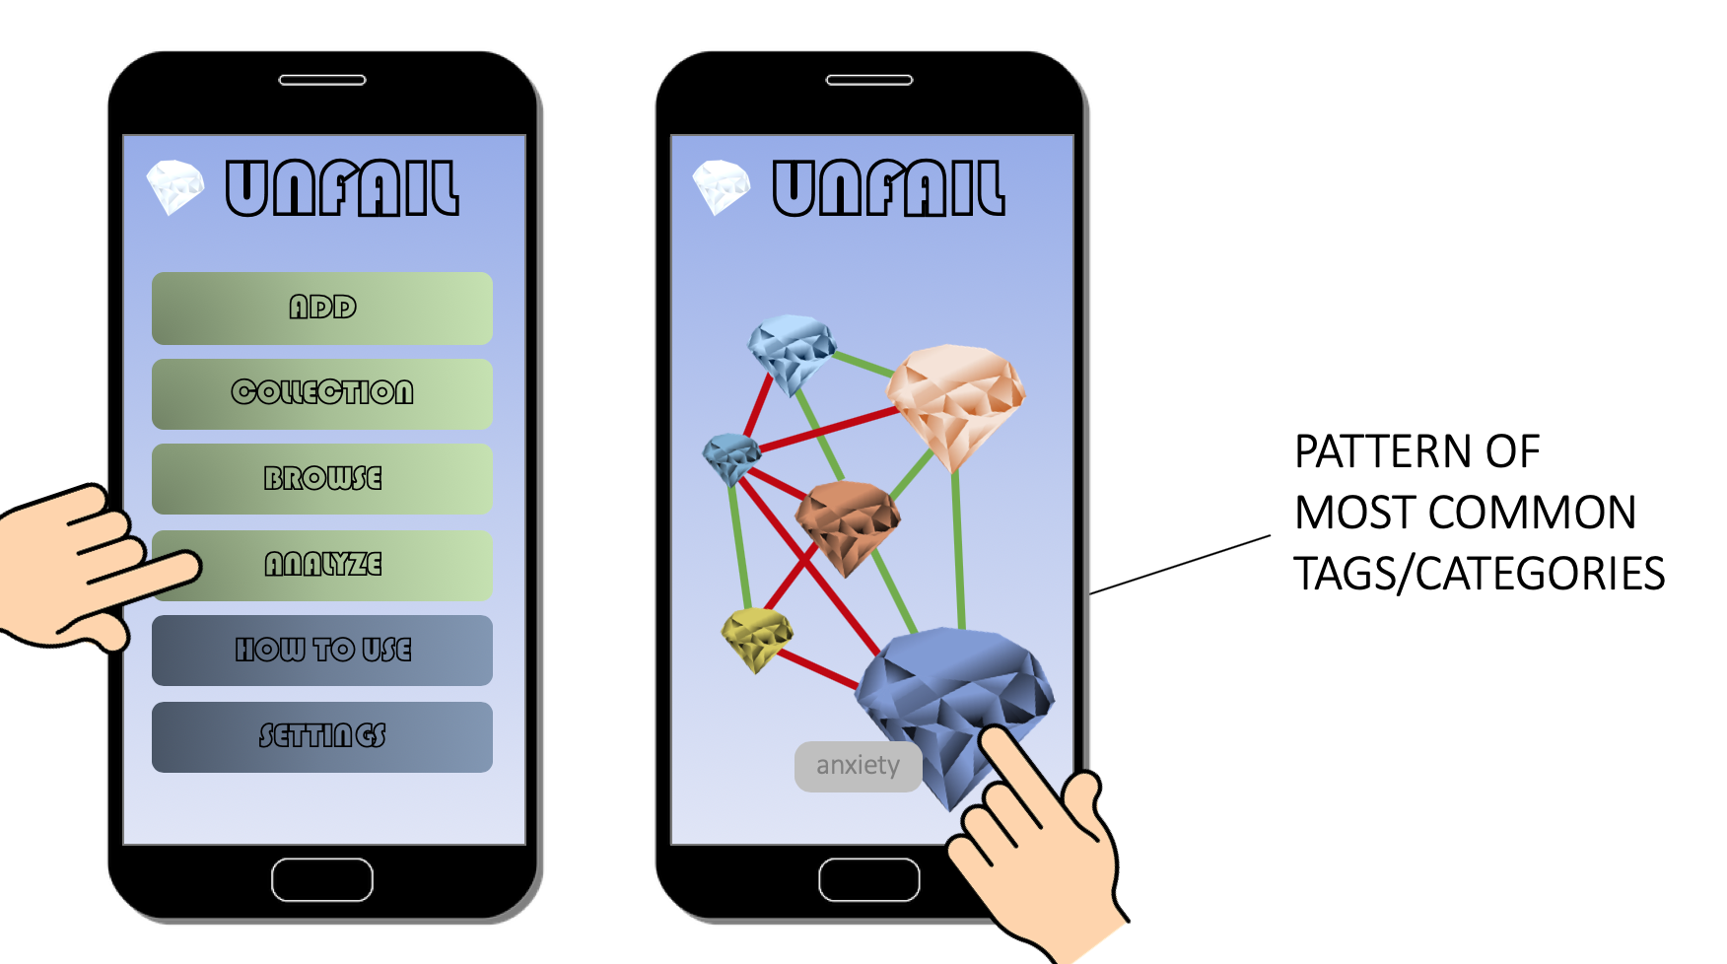

**References**

1. Edmondson, A.C., Strategies of learning from failure. Harv Bus Rev, 2011. 89(4): p. 48-55, 137. - Amazing paper that redefines failure and its relationship with blame and fault. This article had a big impact on my thinking of failures. Most important message: failure is not personal and not final.

2. Hattie, J. and K. Zierer, 10 mindframes for visible learning : teaching for success. 2018, London ; New York, NY: Routledge. xxv, 180 pages. - I read three chapters that seemed to be relevant to mistakes, failures and anxiety in general: Chapter 6 (cultivation of culture of making mistakes), Chapter 9 (building trust, anxiety, safe place to make mistakes), Chapter 11 (Michael Jordan, overall conclusion)

3. Ted Talks Education. Angela Lee Duckworth - Grit: The Power of Passion and Perseverance. <http://t.ted.com/f5s2aeV> (Accessed: 22 March 2019). 2013. - In this TED Talk, the lecturer talks about her experience in teaching and how the strongest predictor of success and positive learning outcomes is perseverance/grit

4. Lunney, O., et al. re:Work - Postmortem culture: how you can learn from failure. <https://rework.withgoogle.com/blog/postmortem-culture-how-you-can-learn-from-failure/> (Accessed: 22 March 2019). 2018. - Internal failure management of Google. Very interesting to see how big companies have internal procedures to do this! It is also worth noting that they have an intensive documentation!

5. Toyota. Toyota Production System. <https://www.toyota-global.com/company/vision_philosophy/toyota_production_system/> (Accessed: 22 March 2019). - website describing the mistake management of the assembly line at Toyota