Software Requirements Specification

for

**Version 1.0 approved**

**Prepared by Tirian Judy, Alexander Way,**

**Rishita Garg, Debrah Kwaku**

**Department of Computer Science, Mississippi State University**

**10 September 2023**

# Introduction

## Purpose

This Software Specifications and Requirements (SRS) document provides the requirements specification for all implemented systems featured in the release of Y Version 1.0, a novel social media platform built on principles of minimalism and simplicity. The purpose of this document is to define all software features, functions, and nonfunctional requirements associated with Version 1.0, developed in accordance with the stakeholders’ preliminary high-level requirements as defined in Reference [2]. The document pertains only to systems and subsystems for Version 1.0, any subsequent releases will include updated SRS documents.

## Document Conventions

This document uses a tiered section format, with primary section titles written in bold, size eighteen font with a numerical format that follows the scheme ‘**X. Title**’, where X represents the section number, and Title represents the title of the section. Subsections are conveyed using the ‘**X.Y Title**’ scheme, where X represents the section number, Y represents the subsection index, and Title represents the subsection title. Unless otherwise stated, all detailed requirements inherit the priority of the encompassing high-level requirements. All acronyms are defined in Appendix A: Glossary.

## Intended Audience and Reading

The SRS is intended to serve as a guide for developers, project stakeholders, users, testers, and documentation writers. While each subgroup of the intended audience may find unique value in the information contained herein, it is suggested that all readers begin by becoming familiar with ‘Section 2: Overall Description’, which provides a high-level overview of the software release and its functions, classes, and constraints. Users, documentation writers, and project stakeholders will also find the information contained in ‘Section 3: System Features’ to be helpful for understanding the capabilities and features available in Y, Version 1.0. Developers should consult Sections 3, 4, and 5 as a guide to workflow formation, as these sections provide insight into the specified system features and requirements. Those tasked with testing the software should read Sections 3, 4, and 5 to develop test strategies that ensure all requirements are satisfied for each feature.

## Product Scope

Y is a novel social media platform rooted in the principles of minimalism and simplicity. Designed to stand in stark contrast to the rise of mega-platforms set on inundating the user with advertisements, sponsored content, and endless widgets, Y will draw from critical features from the popular platform Facebook, in order to provide a lightweight platform focused on building relationships and facilitating genuine content sharing. Unlike other platforms, which thrive on gimmicks and malintentions designed to maximize the amount of time a user spends on the platform, Y aims to provide a crisp and refreshing user experience without fostering detrimental behaviors. In this way, Y provides a sense of classical innovation to the development of a social media platform that is antithetical to the current status quo, in which social media giants continually choose commercialism over well-being and enjoyment of their users.

## References

1. *Kanduri, A., Introduction to Software Fall 2023 Lab Guidelines, 8 Aug. 2023,* [*https://canvas.msstate.edu/courses/104978/files/8867768?module_item_id=2361735*](https://canvas.msstate.edu/courses/104978/files/8867768?module_item_id=2361735)
2. *Kanduri, A., Project Topic: A Facebook Like Social Media Platform, 8 Aug. 2023,* [*https://canvas.msstate.edu/courses/104978/files/8867769?module_item_id=2361734*](https://canvas.msstate.edu/courses/104978/files/8867769?module_item_id=2361734)

# Overall Description

## Product Perspective

Y is a new standalone , self-contained product which provides users the ability and functionality to get in touch and share life updates with their friends through a social media (common to both) platform. It is a replica of the already known and vastly popular meta product Facebook. Y is a work product designed for the partial fulfillment of credits for the Introduction to Software Engineering course at Mississippi State University.

The usage of the product is limited to the bounds of the concerned department in the said University. The purpose of the product is to replicate Facebook as a part of project work.









Web Server RDS

## Product Functions

-A user will be able to login into his/her account to be able to connect with his/her friends and access their timeline.

- A user will be able to compose, edit and post status on his/her timeline.

- A user will be able to send and accept friend requests from others which will allow them to be friends with others and enable them to interact with them.

- A user will be able to like, comment and share the status/timeline post of their friends.

*(These are the requirements as listed in the project topic document.)*

## User Classes and Characteristics

User classes for Y are as follows:-

1. Users - Users must have an ID and Password to use Y. If they don't, then Y requires them to create a new account.
2. Returning - Can use all the features mentioned in section 3 and interact with other users of Y.
3. New - Will need to create a new account with unique ID and Password to use the features supported by Y.
4. Admin - Has access to user IDs and Passwords. Admin is able to view all kinds of activities on Y.

All of these user classes are important for this product to satisfy.

## Operating Environment

Y will be served by an AWS EC2 instance based in N. Virginia. It will be running off of an Amazon Linux OS and will interface with a mySQL RDS instance from the server location as the EC2 instance.

## Design and Implementation Constraints

The development team will be hosting the ‘live’ version of the application on AWS free tier services. These services have a limited number of free uptime hours that will not be exceeded under expected load, but procedures to reduce compute resources during low use time will be implemented to ensure that compute resources are available at times of higher demand.  
All transactions performed between the web client and the RDS will be performed asynchronously and as such will have to be validated by returns confirming the data that was submitted to the RDS with success.

# System Features

## 3.1 User Registration and Authentication

This feature allows new users to create accounts and existing users to securely log in.

Use Case: User Registration

User Class: New Users

New users can create accounts using their email or phone number. The system should validate and securely store user credentials.

Use Case: User Login

User Class: Registered Users

Registered users can log in securely using their registered credentials. The system should perform authentication, including password checks and two-factor authentication, if enabled.

**Functional Requirements**

* The system shall provide a user registration form with fields for username, email, password, and optional personal information.
* The system shall validate the email format (e.g., user@example.com) and ensure it is unique. If the email format is invalid or already in use, display an error message.
* The system shall enforce password strength requirements (e.g., minimum length, complexity). If the password does not meet these requirements, display an error message.
* Upon successful registration, the system shall securely store the user's credentials (username/email and password) and create a new user account.
* The system shall provide a login page with fields for username/email and password.
* The system shall validate the user's credentials during login, checking against the stored user data. If the credentials are incorrect, display an error message.
* The system shall provide an option for users to reset their password in case of forgotten credentials.
* The system shall support password hashing and salting for secure storage of user passwords.
* The system shall provide a "Forgot Password" link on the login page.
* Upon clicking the "Forgot Password" link, the system shall display a password recovery form where users can enter their registered email address.
* The system shall send a unique password reset link to the provided email address.
* The password reset link shall expire after a specified time period to ensure security.
* The system shall validate the reset password form and securely update the user's password if the input is valid.

After registration for an account the User will be directed to their Home page.

## 3.2 Profile Management

Users can customize their profiles with profile pictures, cover photos, personal information, and status updates.

Use Case: Profile Creation and Customization

User Class: Registered Users

Users can create and customize their profiles, including uploading profile pictures and cover photos, adding personal information, status updates, and bios.

**Functional Requirements**

* Users should have the ability to edit their profile information, including name, profile picture, cover photo, bio, contact information, and other personal details.
* Users should be able to configure privacy settings to control who can view their profile and posts. This may include options for public, friends only, or custom privacy settings.
* Users should be able to upload and change their profile pictures.
* Users should be able to send and accept friend requests, as well as manage their list of friends. They should also have the ability to unfriend or block other users.
* Users should have a timeline or wall where their posts and updates are displayed in reverse chronological order.
* Users should be able to tag themselves in photos and posts, as well as tag others with their permission.
* Users should have the option to deactivate or delete their profiles if they wish to leave the platform.
* Users should receive notifications about friend requests, comments, likes, and other interactions related to their profile.
* The app should implement security measures to protect user profiles from unauthorized access and hacking.
* Users should be able to search for other users' profiles based on criteria such as name, username, or interests.
* Reporting and Blocking: Users should have the ability to report inappropriate content or users and block unwanted contacts.

After managing their profile users will be returned to their Profile management page to review their recent changes

## 3.3 Social Networking

Users can send and accept friend requests, follow other users, and view personalized news feeds.

Use Case: Friend/Follow System

User Class: Registered Users

Functional Requirement: Users can send and accept friend requests or follow other users. The system should provide mutual friend suggestions.

Use Case: News Feed

User Class: Registered Users

Functional Requirement: Users can view a personalized news feed displaying updates from friends or followed users. The system should use date time for feed sorting.

## 3.4 Content Posting and Sharing

Users can create and share various types of content and set privacy settings.

Use Case: Post Creation and Sharing

User Class: Registered Users

Functional Requirement: Users can create and share text, photos, videos, and links. They can set privacy settings to control who can see their posts.

## 3.5 Interaction and Engagement

Users can comment on and react to posts.

Use Case: Commenting and Liking

User Class: Registered Users

Functional Requirement: Users can comment on posts and like or react to posts. The system should send notifications for post interactions.

## 3.6 Messaging and Chat

Use Case: Private Messaging

User Class: Registered Users

Functional Requirement: Users can engage in private one-on-one messaging.

## 3.7 Notifications Alert

Users receive in site notifications for various events.

Use Case: Notification Center

User Class: Registered Users

Functional Requirement: Users receive push notifications for friend requests, messages, likes, and comments.

# Other Nonfunctional Requirements

## Performance Requirements

Y is dependent on AWS web server and RDS for its functionality. Y s response time and scalability is limited to AWS response time and scalability. AWS is a world renowned and adopted cloud services. The response time of AWS depends on the severity of each user case.

## Safety Requirements

Y is designed with an aim of having limited users therefore there aren't many security and safety issues. IDs and Passwords are hidden from other users and no other user can access someone else's account without authorization. All the IDs and passwords are stored in a secure database, the access to the database is limited to admin only. Y uses AWS which performs security best checks to secure all the data on the cloud. Y safety issues are subjected but not limited to AWS security and safety issues.

## Security Requirements

Y will be secured against SQL injection to reasonable levels that do not require a slowdown in processing requests made by signed in and tokened users.

Users will be required to log into the system to access or post information on Y, but they will not be repeatedly challenged so long as they are signed in from the same device that their current session token is valid for and valid during.

## Software Quality Attributes

Y will have continuous uptime and thus be readily available for up to 100 concurrent users without delay. It will be usable from any web browser that supports modern HTML elements and is able to support JWT.   
Y will have an easy to use and easy to understand interface that promotes use of the application without being overly complex to learn or use.

# Other Requirements

All database actions will be done asynchronously and as such timelines will only be updated when either the page is refreshed or an action is performed by the client that would prompt an update to the timeline.

**Appendix A: Glossary**

**JWT** - Java Web Tokens - Tokens used to store information about user sessions that are frequently used to prove that a user has access to the resources they are requesting

**AWS -** Amazon Web Services

**SRS** - System Requirements and Specifications - Document that defines all system features, functions, nonfunctional requirements, and classes in order to convey the objectives of the software and the manner in which the software will satisfy those objectives.

**Appendix B: Analysis Models**

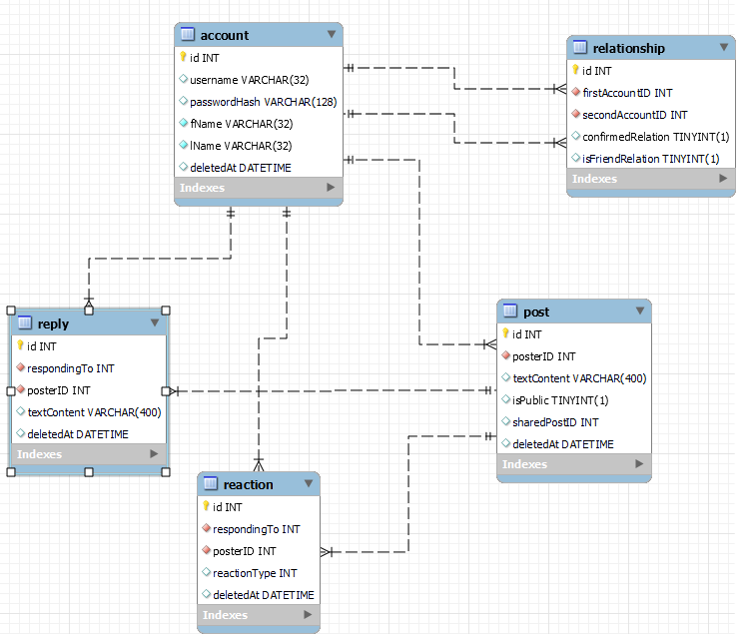

*A basic EER diagram of the minimal classes. Subject to robust change as system evolves.*

**Appendix C: To Be Determined List**

*<Collect a numbered list of the TBD (to be determined) references that remain in the SRS so they can be tracked to closure.>*