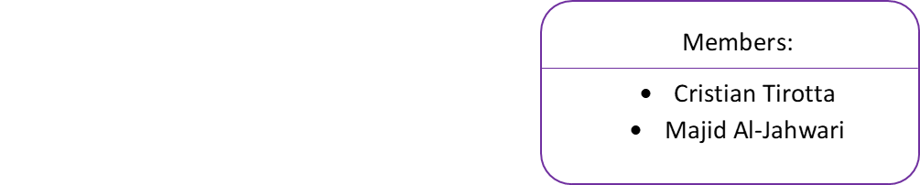**Paris Whatever**

EDO Assignment Week 8

Group: PC01-3

**Design topic description**

Last time we were game developers. Now we are web developers who are creating a website for our beloved clients who would like to visit Paris for whatever reason.

**Target Audience**

* We target mainly “Paris lovers”. i.e. people who have either been to Paris at least once and absolutely adore the city or people who do not know much about the city but they would love to give it a visit
* Our website has 2 main responsibilities:
  + Helping users find the most convenient hotel for their stay
  + Providing helpful facts about the city to the user in case he/she is not that familiar with them

Storyboard

Sketching

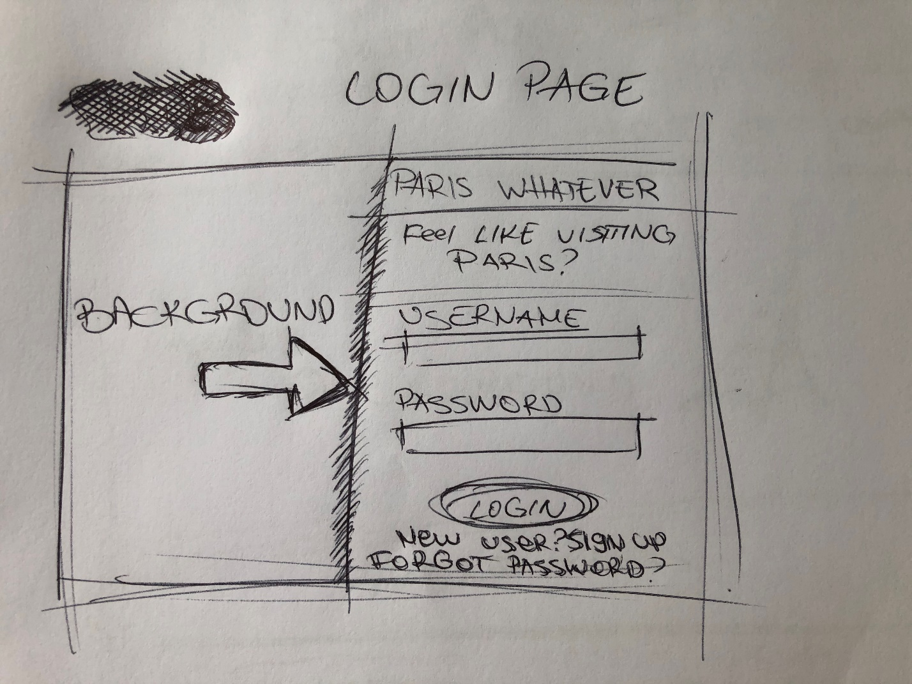

1. Login page sketch

Represents the login page of the web app:

* A Fullscreen background which is half shown because of the login form. The arrow indicates that the background continues on the right just behind the login form
* Login form. Consisting of the website logo, a moto, username and password input fields, login button and some extra buttons for help and sign up

1. 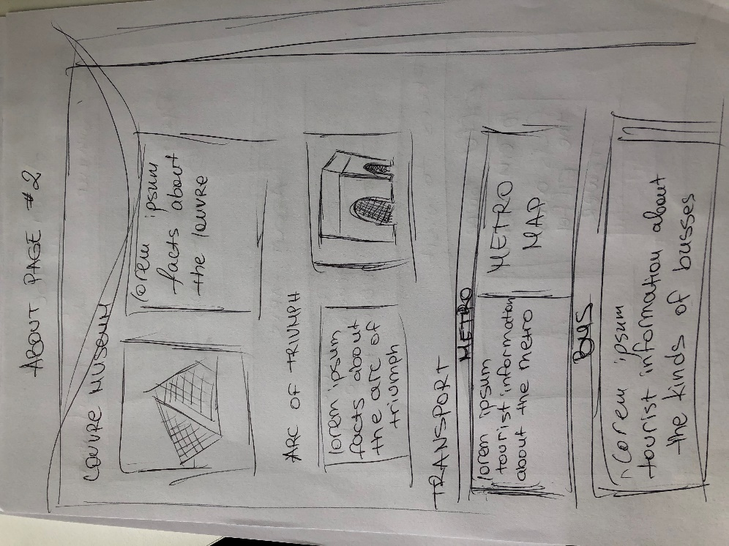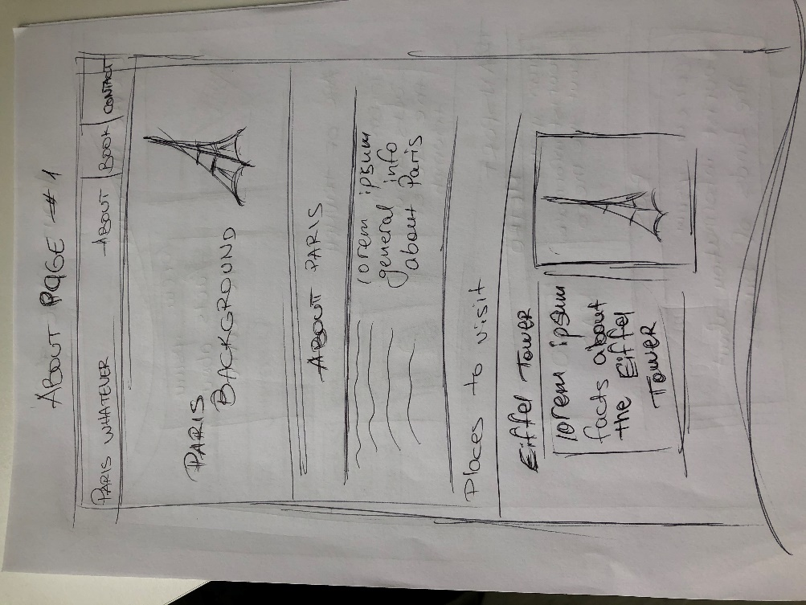About page sketches 1 & 2 – Representing the about page

* The navbar (top-most element), consisting of all the links in the website and a clickable logo (link to the home page)
* A Fullscreen Paris background featuring the Eiffel Tower
* General information about the city in a couple of lines
* Section with most famous places in Paris with facts about them and a picture
* Transport Section: General tourist information about the transport in Paris
  + Includes a Paris Metro map

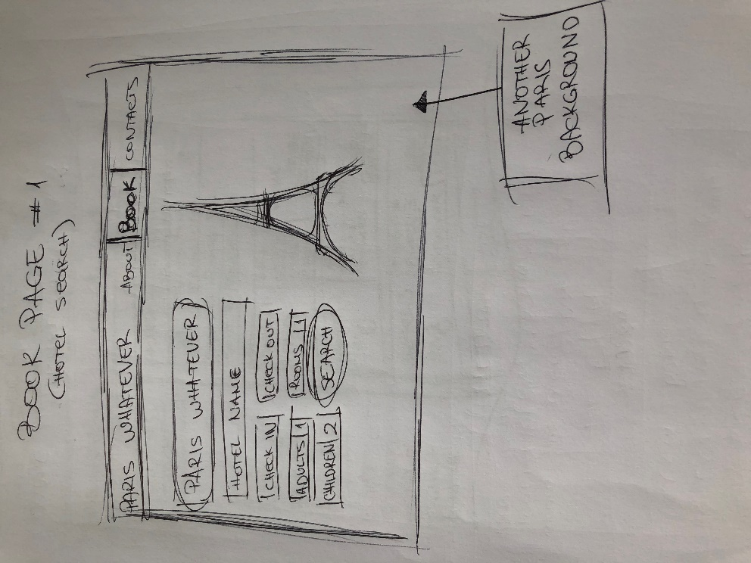

1. Book Page #1: Represents the first stage of the book page

* Navbar on top of the page as always
* Another Paris background
* Hotel Searching form

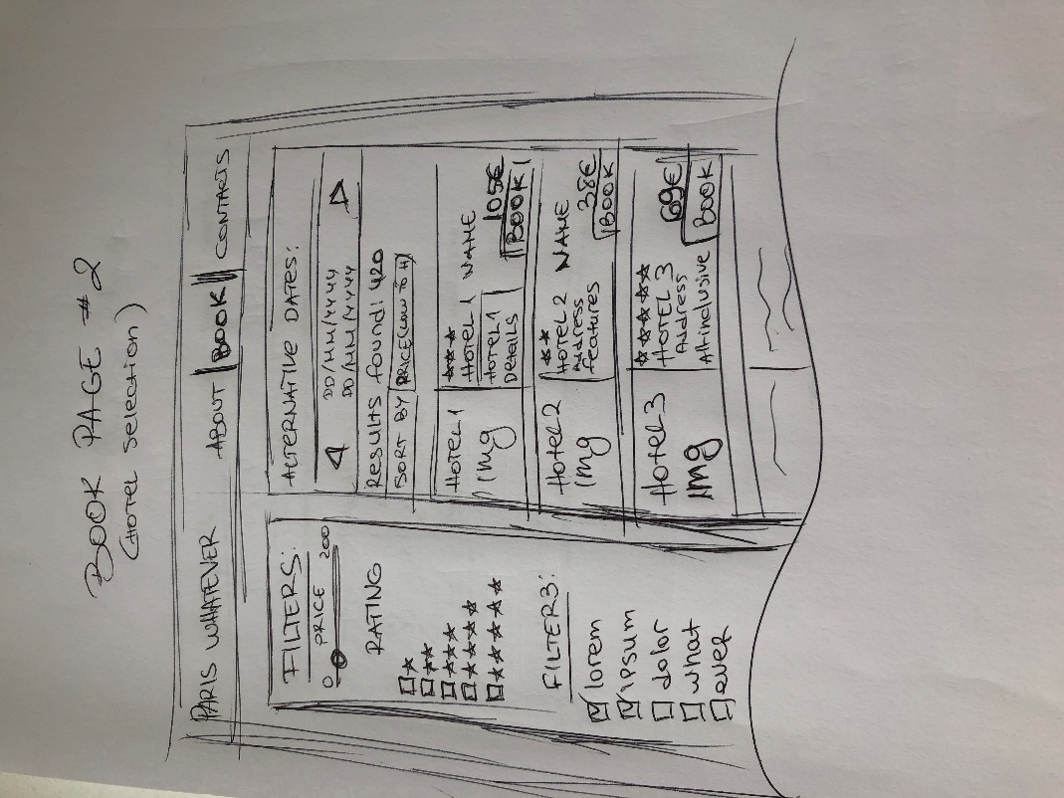

1. Book Page #2: Represents the booking page after the user has filled out the form
   * Navbar on the top
   * Sidebar with applicable filters to the user’s search
   * Main container, consisting of:
     + Alternative dates for the reservation
     + Label showing the number of results found
     + Sort dropdown menu
     + A small container for each hotel found, containing a picture of the hotel room, Hotel name & Rating, details and additional features about it, price per night and a Book button

Task Reflection:

* **Done** **by**: Cristian
* **Experience**: pretty fun, would do it again
* **What could have been better**: at least 2-3 weeks of practicing Sketching techniques before actually implementing them on a project
* **Proud of**: the result, even though some people mind find it ugly

Wireframes

Digital/Paper prototype