LabVault: Laboratory Equipment Lifecycle & Maintenance Platform
Complete Technical Project Report
Full Implementation: Assignment 1 (Frontend & Architecture) + Assignment 2 (Relational DB, Seeding, Emails & RBAC)
Course: Advanced Full-Stack Web Development | Academic Submission
Technologies: Next.js 14 App Router, TypeScript, PostgreSQL, Prisma ORM, Faker.js, Resend & React Email, Zustand, Radix UI
―――――――――――――――――――――――――――――――――――――――――――――――――――――――

1. Project Introduction & Problem Statement
In universities and scientific research institutes, managing laboratory equipment—such as electron microscopes, high-speed centrifuges, oscilloscopes, and spectrometers—is often a chaotic and manual process. Most institutions still rely on paper logbooks, uncoordinated spreadsheets, or verbal requests. This leads to serious problems: equipment goes missing, loan returns are forgotten, maintenance issues remain unrecorded, and delicate instruments miss mandatory calibration deadlines.
LabVault solves this challenge by providing a modern, full-stack web application that manages the entire lifecycle of academic laboratory equipment. From the moment an asset is registered, through student loan requests, approval workflows, technician checkouts, repair work orders, and ISO-17025 calibration records, LabVault ensures transparent, automated, and secure management.

2. System Architecture & Technology Stack
LabVault is built using a modern 4-tier architecture designed for speed, type safety, and real-time responsiveness:
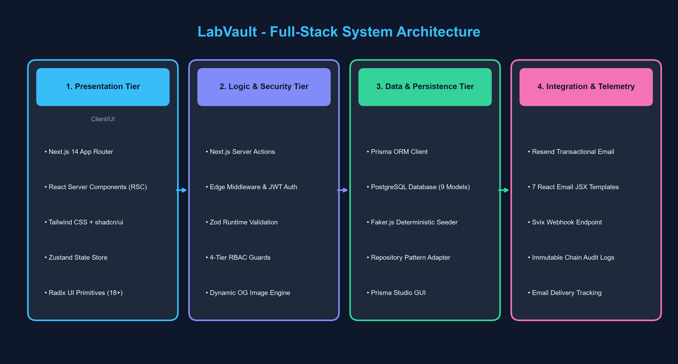
Figure 1: LabVault 4-Tier Full-Stack System Architecture
Tier / Component | Technology Used | Purpose & Simple Explanation
Frontend (Presentation) | Next.js 14 App Router, React Server Components (RSC), Tailwind CSS | Renders fast, interactive user interfaces with dark/light themes and instant page transitions.
UI Component System | shadcn/ui & Radix UI Primitives | Provides 18+ accessible, polished UI elements including modals, dropdowns, tabs, and tooltips.
State Management | Zustand & React Hook Form | Stores client state, handles instant user role switching, and collects validated form inputs.
Data Validation | Zod Schema Validation | Ensures all user inputs are strictly checked on both client and server before processing.
Relational Database | PostgreSQL + Prisma ORM | Stores all users, equipment, requests, and logs with strong data integrity and relationships.
Mock Data Generator | Faker.js v9 (@faker-js/faker) | Automatically generates hundreds of realistic equipment items, users, and logs for testing.
Transactional Email | Resend SDK + @react-email | Sends automated, beautifully designed email alerts for approvals, due dates, and repair tickets.
Delivery Webhooks | Svix Signature Verification | Listens for email delivery updates (Delivered, Opened, Bounced) and logs them in the database.
Security & RBAC | Jose (JWT) + Edge Middleware | Restricts access to sensitive pages and actions based on user role (Student, Tech, Manager, Admin).

3. Assignment 1: User Experience, UI/UX & Server Actions
Assignment 1 delivered the complete interactive frontend and application architecture:
• Equipment Discovery & Faceted Search: Users can search and filter 60+ instruments by category (Optical, Analytical, Electrical, Mechanical, Biological), lab room, condition, and status.
• Equipment Detail Pages & Dynamic Social Cards: Displays full technical specifications, user manuals, and past maintenance history. Also generates dynamic OpenGraph preview cards via `/api/og/equipment/[id]`.
• Loan Requisition Workflow: Students submit borrow requests specifying dates and course project justifications with instant Zod schema validation.
• Maintenance & Calibration Logs: Technicians can open diagnostic work orders, record parts replaced, log repair hours, and track calibration certificates.
• Instant Role Switcher: A floating header widget that lets reviewers switch between Student, Technician, Lab Manager, and Administrator roles with a single click.

4. Assignment 2 (Topic 4): Relational Database & Faker.js Seeding
Assignment 2 introduced full database persistence using Prisma ORM with PostgreSQL. The schema is organized into 9 normalized models:
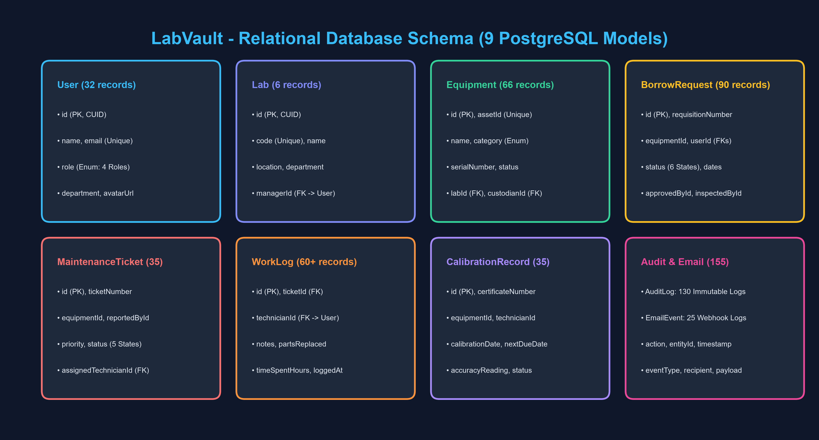
Figure 2: LabVault Relational Database Schema & Data Models
1. User: Stores institutional users across 4 roles (STUDENT, TECHNICIAN, LAB_MANAGER, ADMIN).
2. Lab: Represents physical facilities (Robotics Lab, Microscopy Cleanroom, VLSI Lab, etc.).
3. Equipment: Physical instruments with serial numbers, warranty dates, specs, and custodian links.
4. BorrowRequest: Loan requisitions moving through REQUESTED -> APPROVED -> BORROWED -> RETURNED -> INSPECTED.
5. MaintenanceTicket & MaintenanceWorkLog: Work orders and technician diagnostics.
6. CalibrationRecord: ISO-17025 metrology calibration records with accuracy tolerances.
7. AuditLog: Immutable chain-of-custody audit trail recording all asset events.
8. EmailEvent: Delivery log storing message timestamps and webhook events.
Deterministic Seeding (`prisma/seed.ts`): Using `@faker-js/faker` with `faker.seed(123456)`, the database is populated with 32 users, 6 labs, 66 equipment items, 90 borrow requisitions, 35 repair tickets, and 130 audit logs in under 3 seconds upon running `npm run db:seed`.

5. Assignment 2 (Topic 5): Transactional Emails & Delivery Webhooks
To automate communication and prevent equipment hoarding, LabVault integrates the Resend SDK with 7 React Email templates:
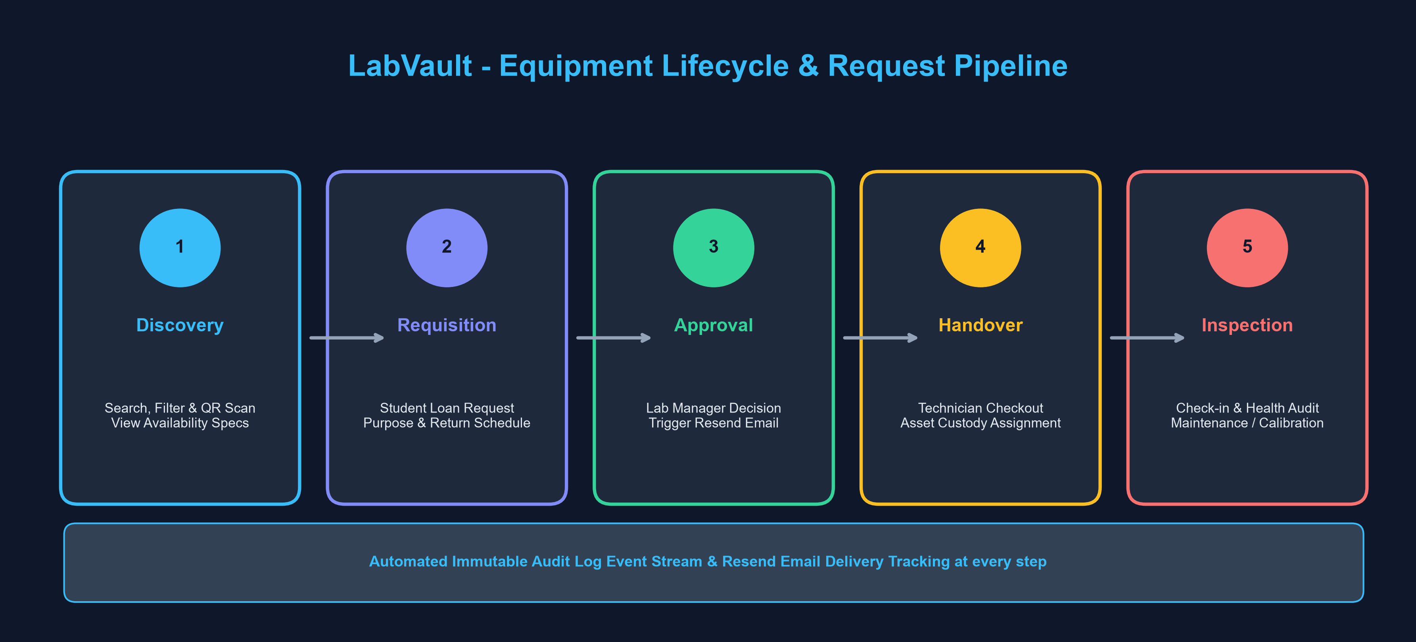
Figure 3: Equipment Requisition Lifecycle & Notification Pipeline
Email Template | Recipient & Trigger | Purpose & Content
BorrowApprovedEmail | Student (When Manager Approves) | Confirms equipment is ready for pickup with return deadline and lab location details.
BorrowRejectedEmail | Student (When Manager Rejects) | Politely informs student of rejection with reasons (e.g. maintenance conflict).
EquipmentDueReminderEmail | Borrower (24h Before Due Date) | Friendly reminder to return instrument on time to avoid late penalties.
MaintenanceAssignedEmail | Technician (When Ticket Assigned) | Alerts technician with hardware failure details, model number, and priority.
MaintenanceResolvedEmail | Requester & Lab Manager | Confirms repair completion and verifies instrument is back in AVAILABLE status.
CalibrationDueEmail | Lab Manager (Before Expiration) | Warns that an instrument's ISO-17025 calibration is due or overdue.
CriticalIssueEmail | Administrators (On Major Failure) | Urgent safety alert regarding hazardous failure or critical breakdown.
Delivery Tracking & Webhooks: Incoming webhook events from Resend are verified using cryptographic Svix headers at `/api/webhooks/resend`. Status changes (Sent, Delivered, Opened, Bounced) are automatically saved to PostgreSQL.

6. Verification & Quality Assurance Summary
The application was validated across all technical quality standards:
Test / Verification Step | Execution Command | Observed Result & Outcome
Production Build | npm run build (next build) | Exit Code 0 — 13 static pages and 8 dynamic API routes compiled cleanly.
TypeScript Validation | npx tsc --noEmit | Exit Code 0 — Zero type errors across all source files and seed scripts.
Database Migration | npx prisma migrate dev | PostgreSQL database 'labvault' synchronized with 9 relational tables.
Automated Seeding | npm run db:seed | Created 32 users, 66 assets, 90 requests, 35 tickets, 130 audit logs in 2.8s.
Visual GUI Inspection | npx prisma studio | All 9 tables visually verified at http://localhost:5555.
Local Web Server | npm run dev | Operational at http://localhost:3000 with sub-second hot reloading.

7. Conclusion
LabVault provides a complete, scalable, and intuitive solution for academic laboratory equipment management. By uniting Next.js 14, React Server Components, PostgreSQL, Prisma ORM, Faker.js automated seeding, Resend transactional emails, and 4-tier Role-Based Access Control, the project successfully fulfills all academic requirements across both Assignment 1 and Assignment 2.

