UNIFLEX
SMART CAMPUS MANAGEMENT SYSTEM

PROJECT LOGBOOK & COMPARATIVE INNOVATION REPORT
Improving the existing university mobile experience through a unified, student-first campus platform.
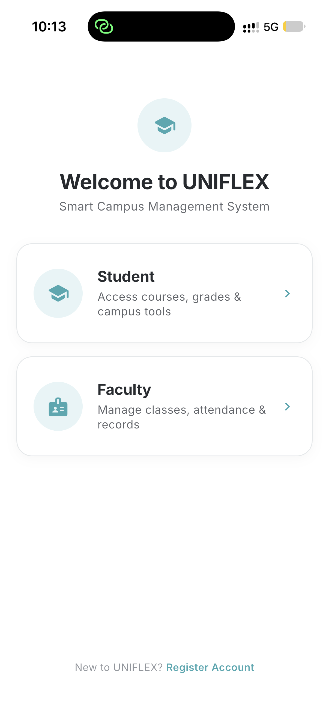
Prepared as a visual development log showing the existing university app, the UNIFLEX redesign, and new campus innovations.

01 • PROJECT CONTEXT

Why We Built UNIFLEX
The current university app handles core academic functions, but the student experience is fragmented and leaves many day-to-day campus needs outside the app.
• UNIFLEX was designed as an improvement concept: keep essential academic services, present them more clearly, and add campus-life tools in one place.
• The goal is not only a visual redesign. It is a broader digital campus layer covering academics, opportunities, collaboration, support, marketplace, lost & found and free-space discovery.
• The screenshots in this logbook document both the existing university application and our UNIFLEX prototype.

Core design principle
One app → one student identity → academics + campus life + opportunities + support.

Project Objectives
• Reduce navigation friction and surface important information immediately.
• Make attendance, timetable, assignments and results easier to understand.
• Introduce features missing from the current app that solve real campus problems.
• Create a consistent mobile UI suitable for both students and faculty.

02 • EXISTING VS PROPOSED

At-a-Glance Comparison
Area | Existing University App | UNIFLEX Improvement
Home | Menu-oriented dashboard | Daily classes, overall attendance, deadlines and quick access on one screen
Attendance | Attendance records and percentage | Overall attendance + subject-wise progress and missed/attended counts
Timetable | Functional timetable list | Clean day/week navigation with subject cards and room/faculty context
Assignments | Basic assignment area | Rich assignment detail, attachments, deadline, grading and submission files
Results | Core result access | Semester-wise academic record and subject-level grade presentation
Campus life | Limited | Lost & Found, Marketplace, Study Groups, Skill Exchange, Free Spaces
Career | Not central | Internships/opportunities with filters and application tracking
Support | Request forms | Helpdesk tickets, FAQ and visible ticket status

03 • CORE EXPERIENCE

Dashboard Redesign
The first screen should answer: What do I have today? How is my attendance? What is due next?
Existing University App  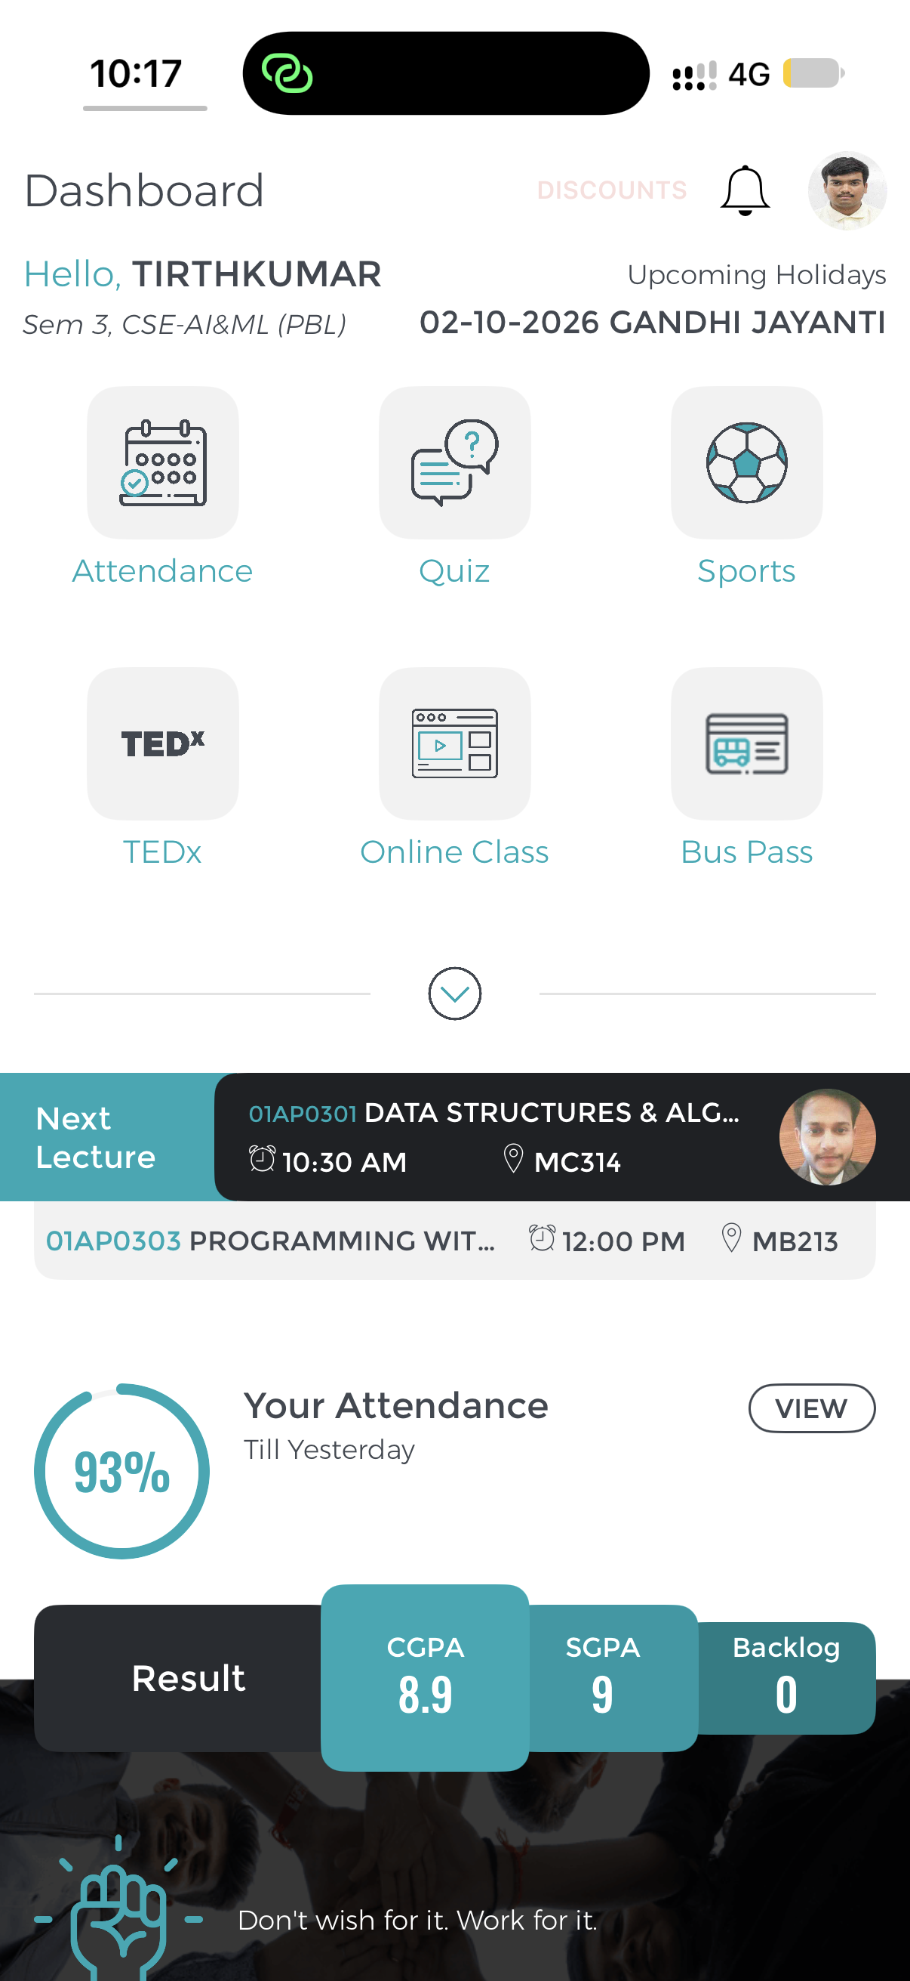  Current dashboard | UNIFLEX  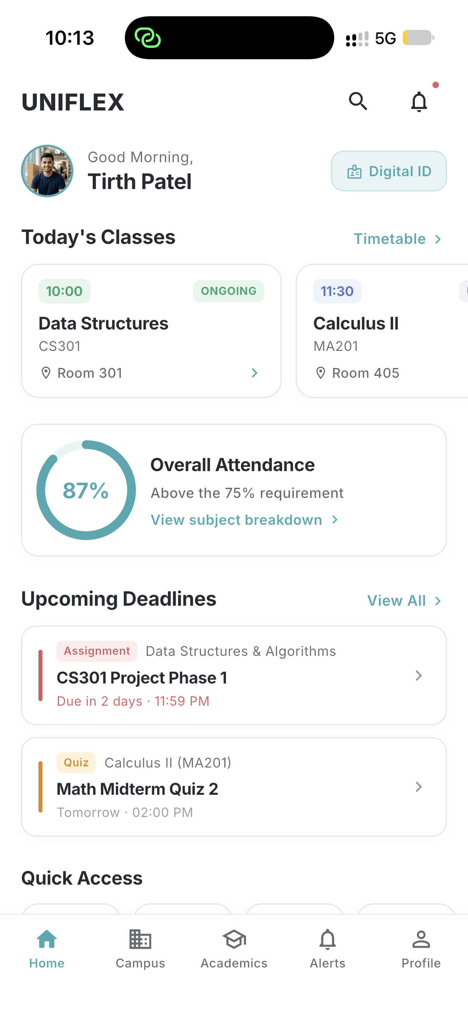  Proposed student home
• UNIFLEX prioritizes today's classes instead of making the student open separate modules.
• Overall attendance is visible as a prominent progress indicator.
• Upcoming deadlines are brought to the home screen to reduce missed submissions.
• Bottom navigation keeps major areas reachable with fewer taps.

04 • ACADEMIC IMPROVEMENT

Attendance: From Records to Insight
Existing University App  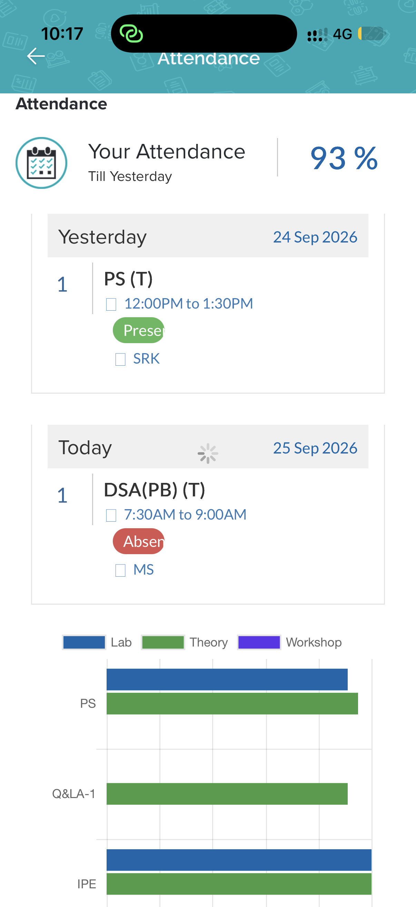 | UNIFLEX  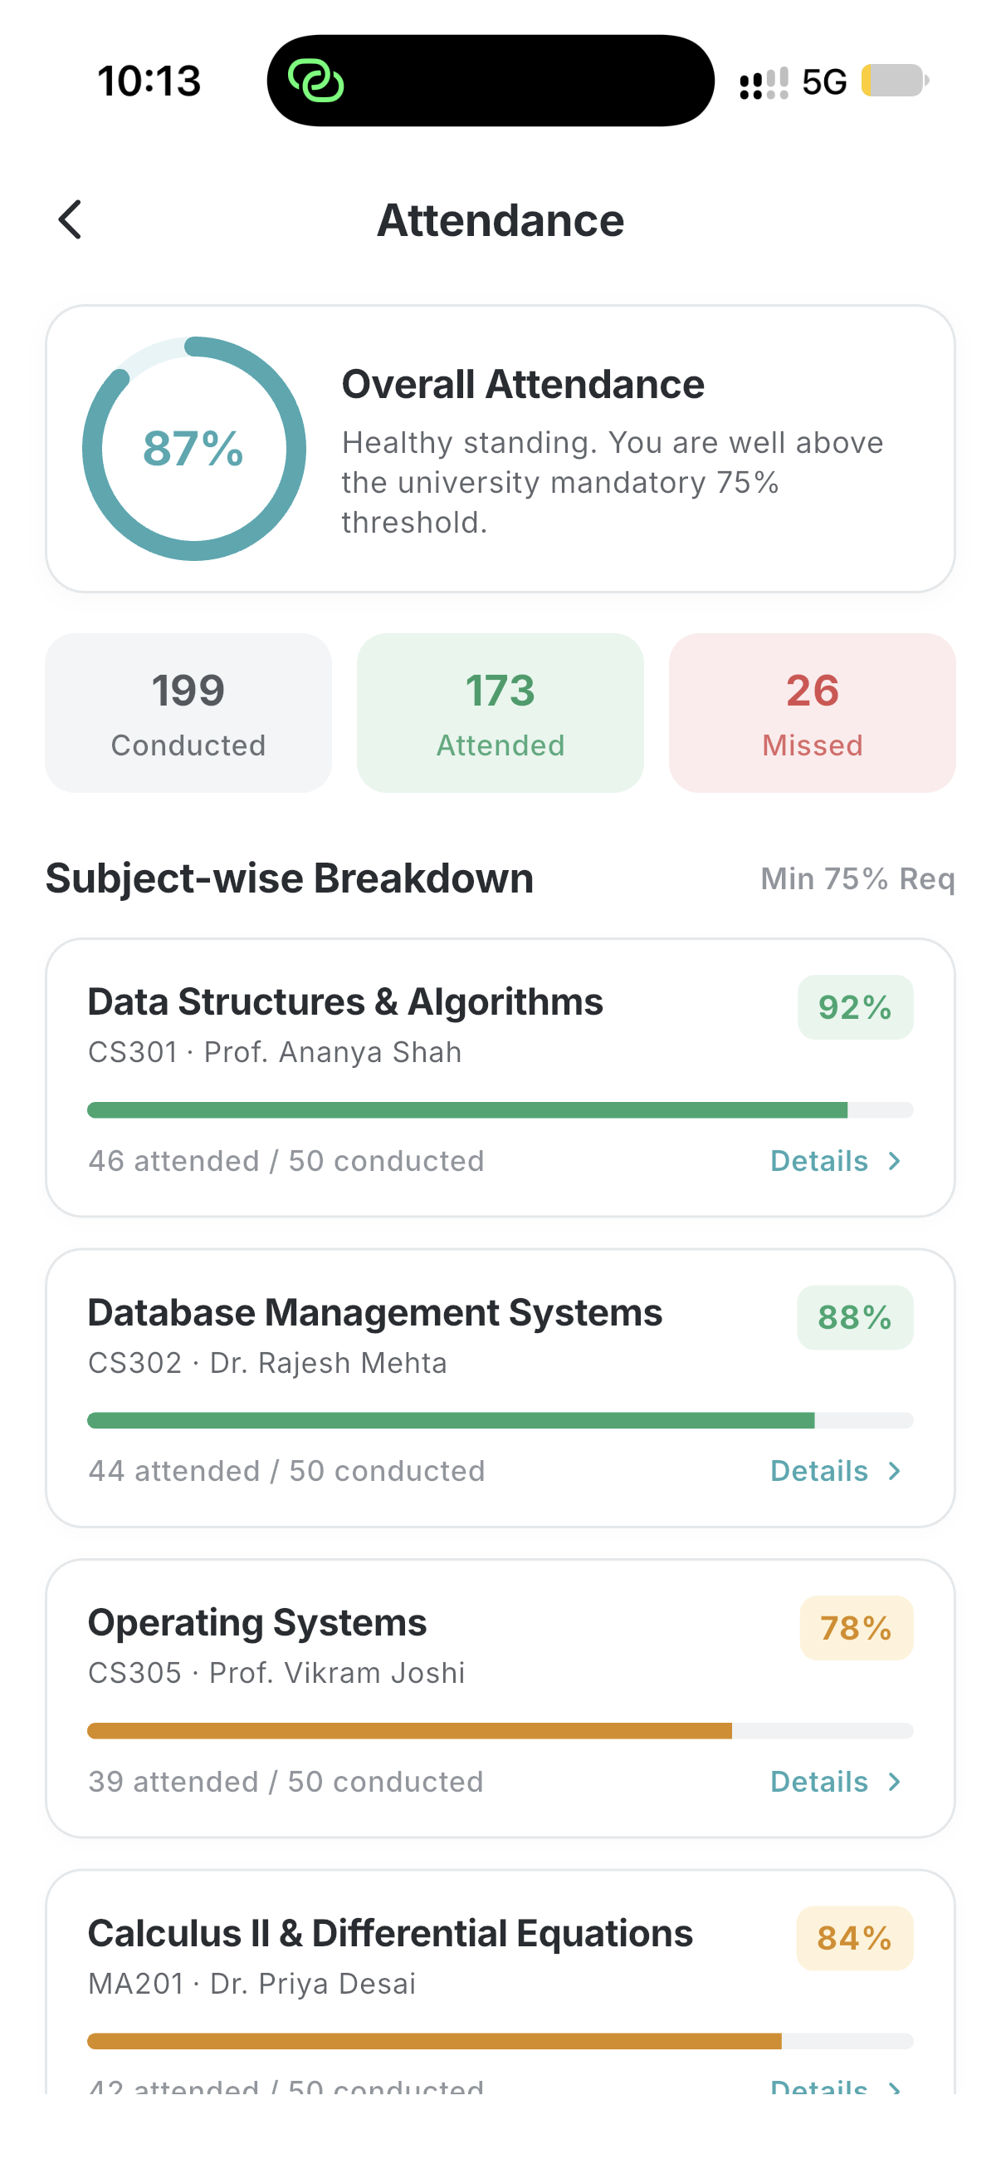
• The existing app provides attendance data; UNIFLEX reorganizes it into an immediate overall status plus subject-wise breakdown.
• Each subject shows a percentage and progress bar, making low-attendance subjects easy to identify.
• Summary counts for attended, missed and total classes make the metric more understandable.

05 • ACADEMIC IMPROVEMENT

Timetable: Faster Daily Planning
Existing University App  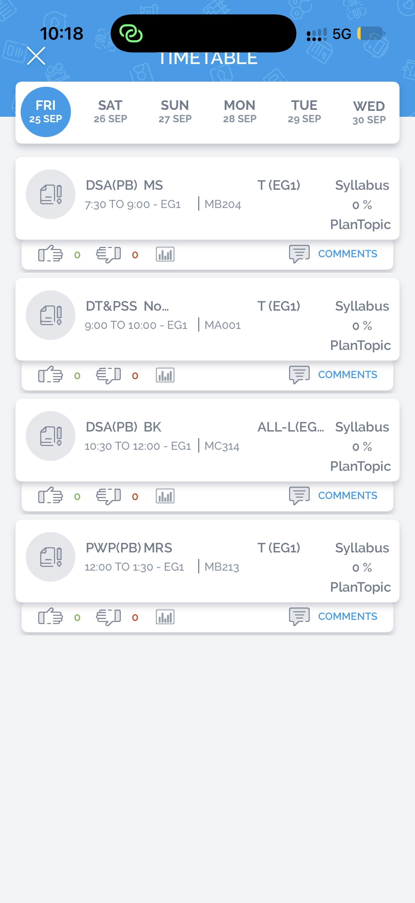 | UNIFLEX  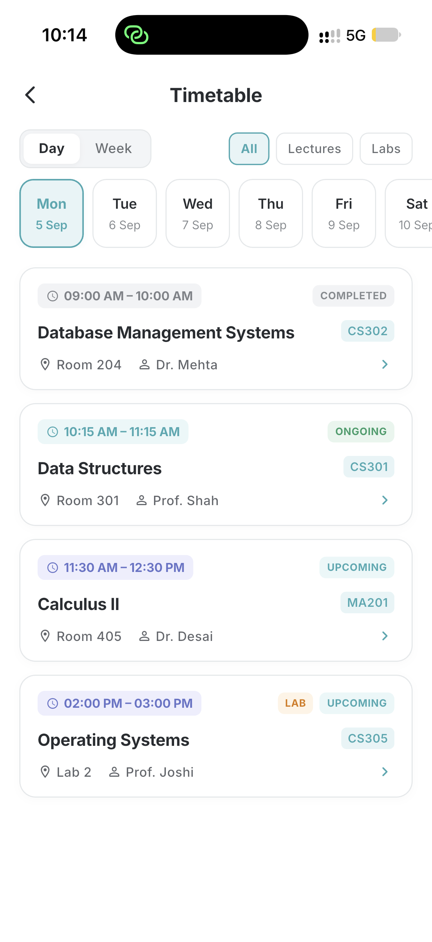
• UNIFLEX uses a day selector and clean subject cards for quick scanning.
• Course code, faculty, room and time are grouped together rather than visually scattered.
• The design supports both Day and Week views for different planning needs.

06 • ACADEMIC IMPROVEMENT

Assignments: More Context, Better Submission Flow
Existing University App  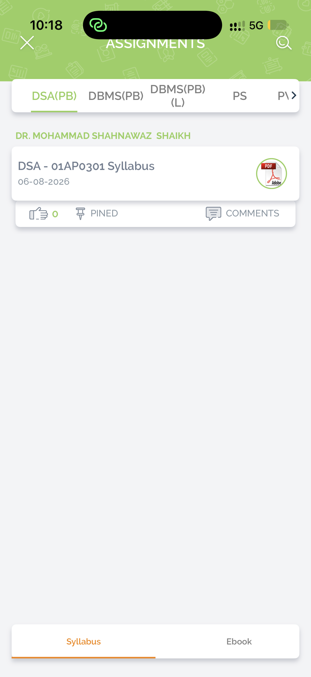 | UNIFLEX  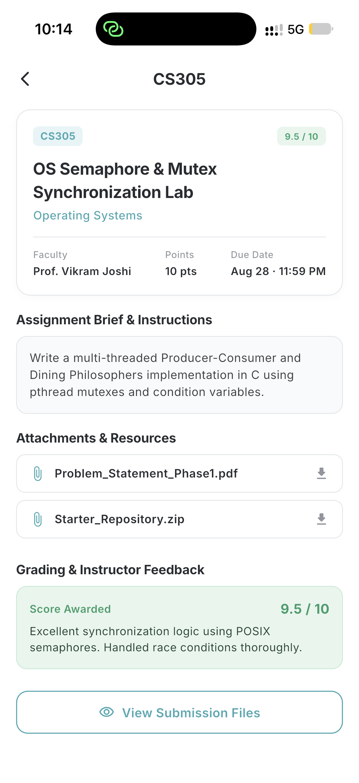
• UNIFLEX assignment detail combines instructions, deadline, attachment, submission status and grading feedback.
• Students can understand the full task without switching between multiple screens.
• A visible 'View Submission Files' action supports a clearer submission lifecycle.

07 • ACADEMIC IMPROVEMENT

Results & Learning Resources
UNIFLEX extends the academic area beyond basic access into a clearer academic record and resource experience.
Semester Results  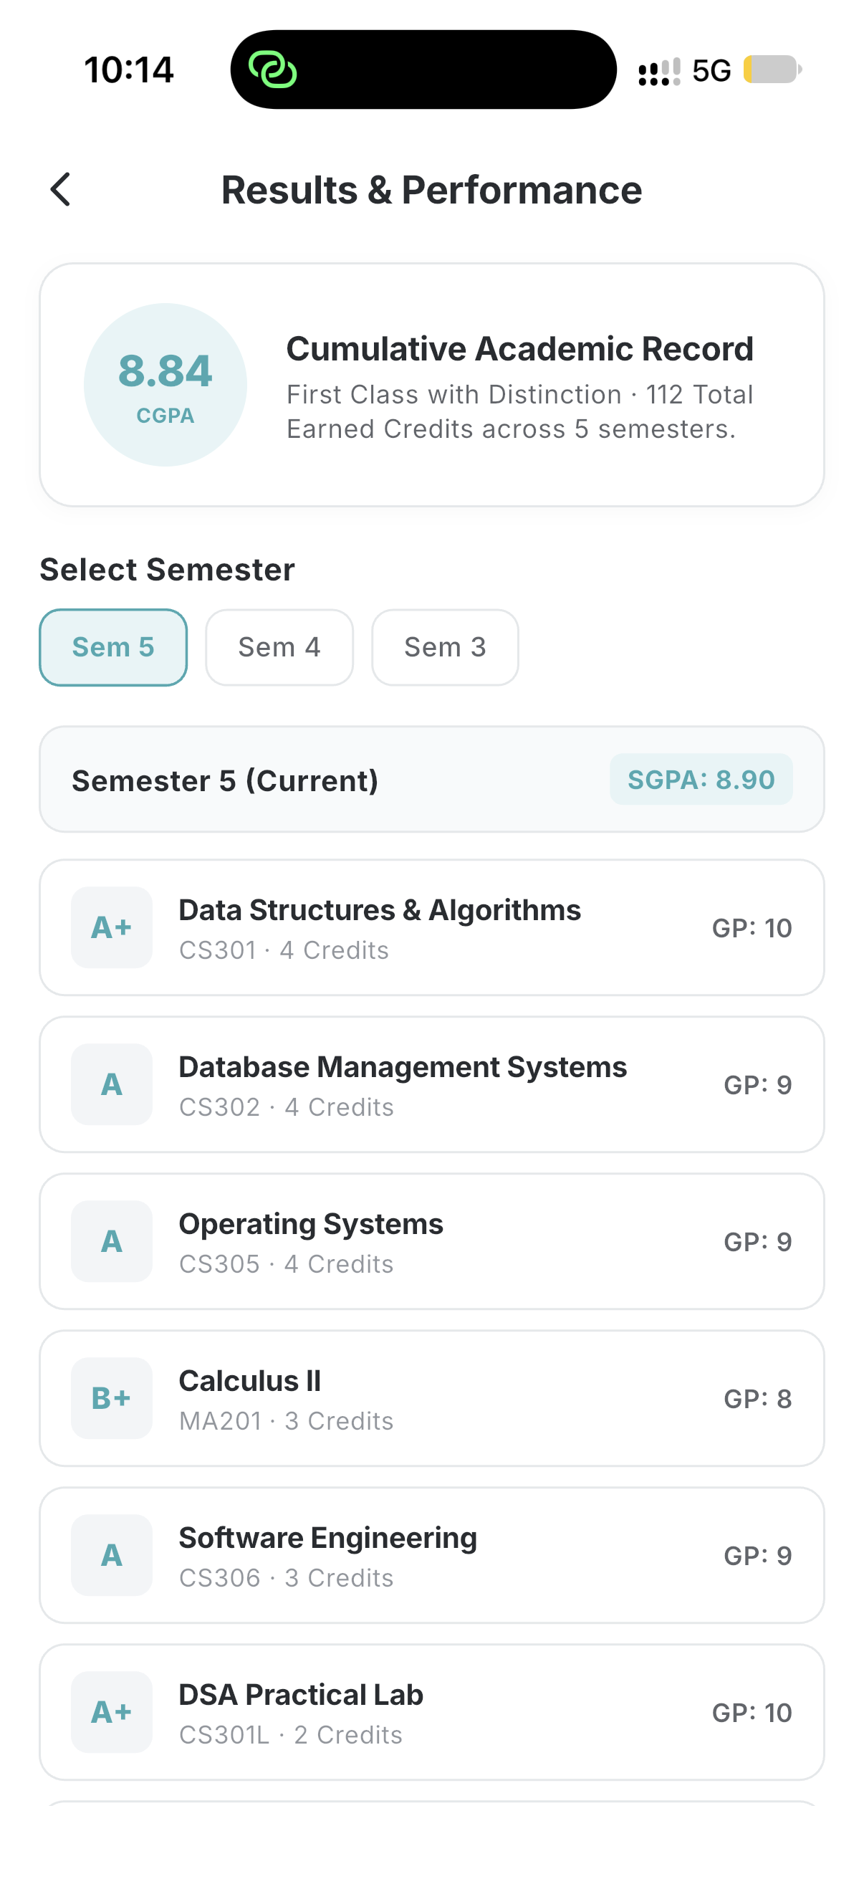  Semester-wise performance | Course Resource / PDF  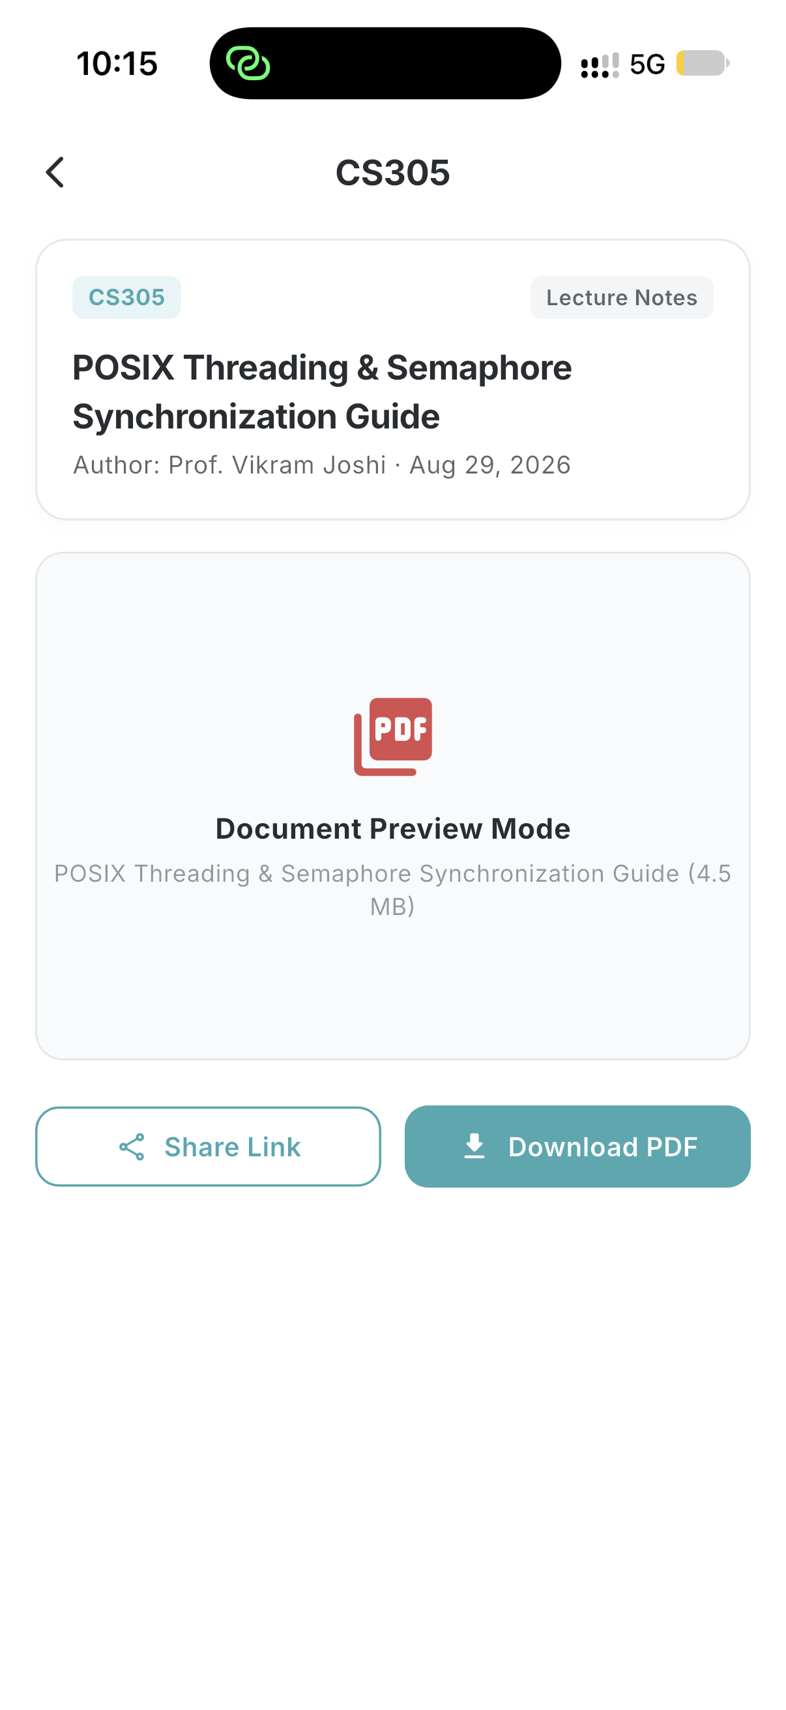  In-app document preview
• Semester results are organized as a cumulative academic record with subject-level grades.
• Course resources can be previewed inside the app and downloaded when required.
• This keeps learning material connected to the course context.

08 • UNIFLEX INNOVATION

Campus Exchange Layer
These modules are designed as new student-to-student services rather than simple redesigns of existing screens.
Lost & Found  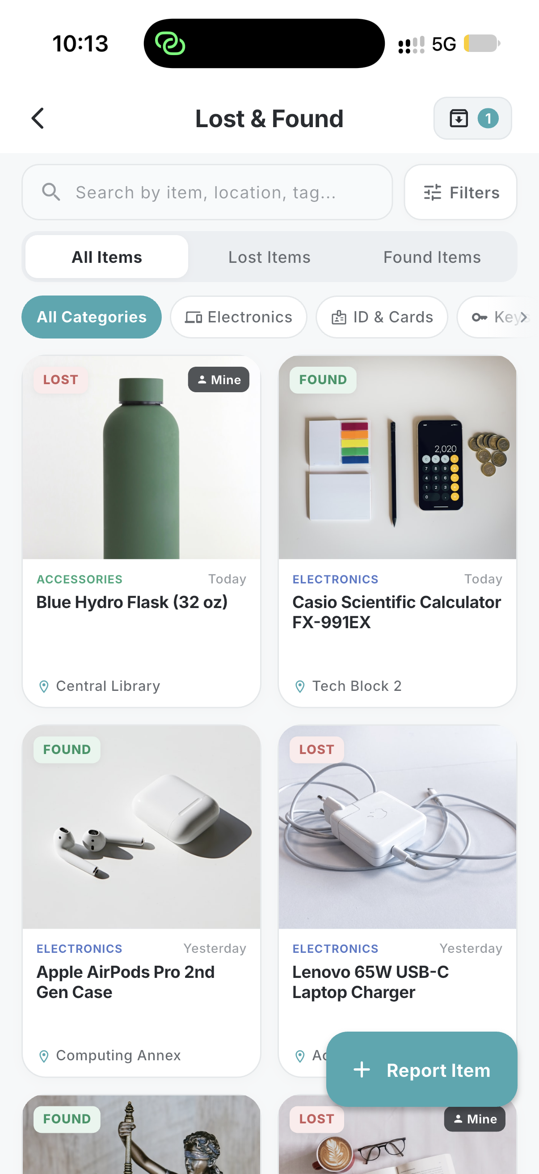 | Campus Marketplace  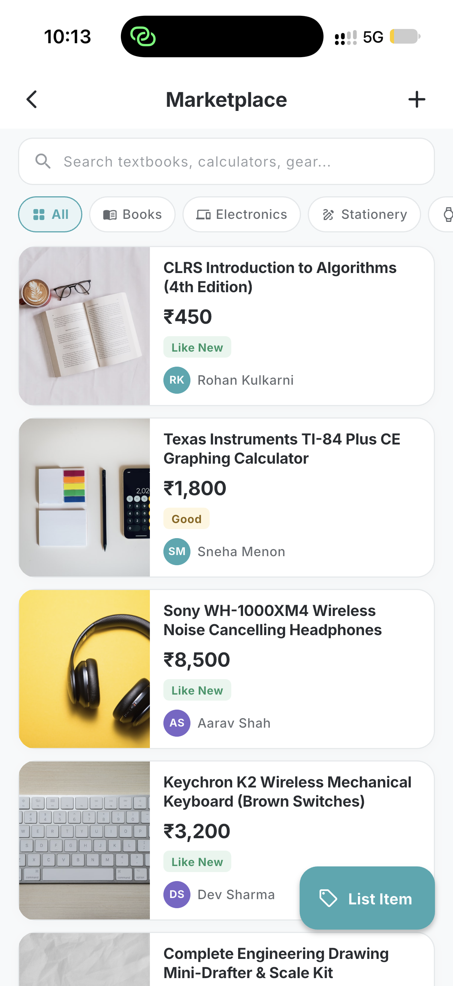
• Lost & Found lets students post and filter lost/found items, reducing dependence on scattered group messages.
• Marketplace enables a campus-only exchange for books, calculators, electronics and other student items.
• Both modules use searchable cards, categories and clear actions to make discovery practical.

09 • UNIFLEX INNOVATION

Collaboration & Skill Sharing
Study Groups  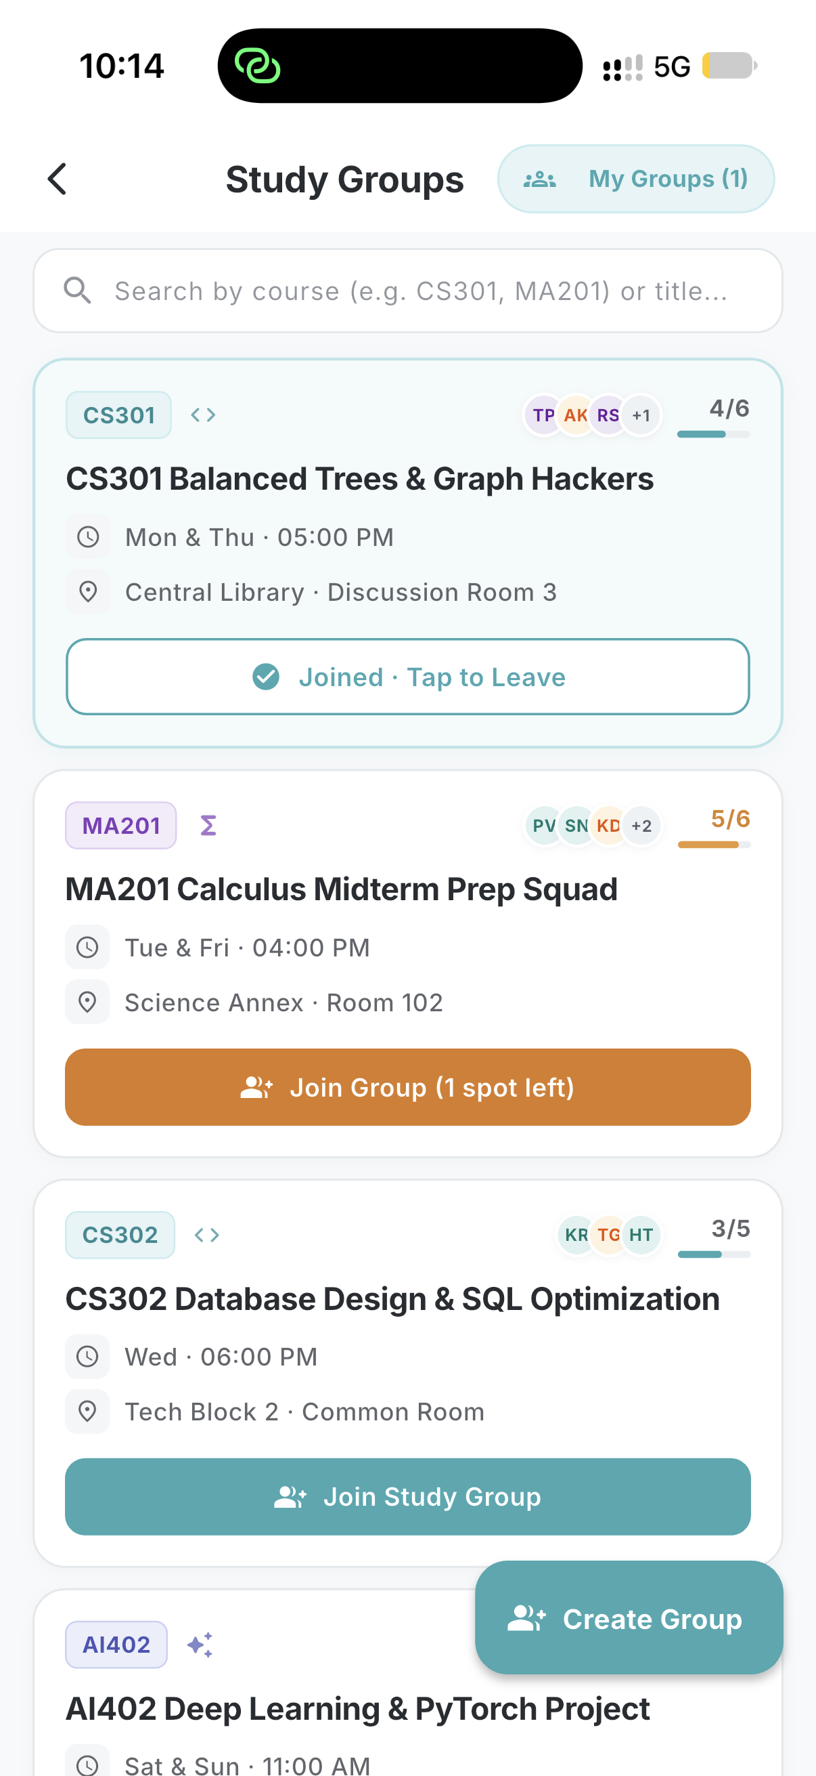 | Skill Exchange  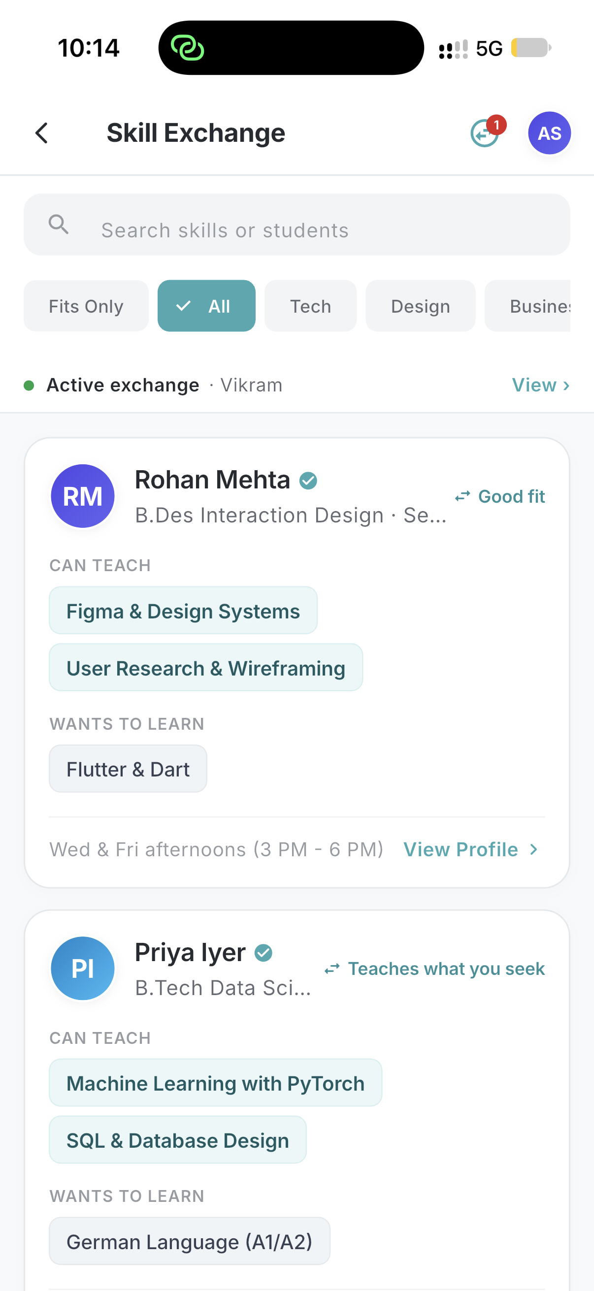
• Study Groups helps students discover or create groups around a course, topic or project.
• Skill Exchange lets students teach and learn from one another — for example coding, design, research or languages.
• Together, these features turn the university app from an administrative utility into a peer-learning platform.

10 • UNIFLEX INNOVATION

Free Spaces & Opportunities
Free Classroom / Space Finder  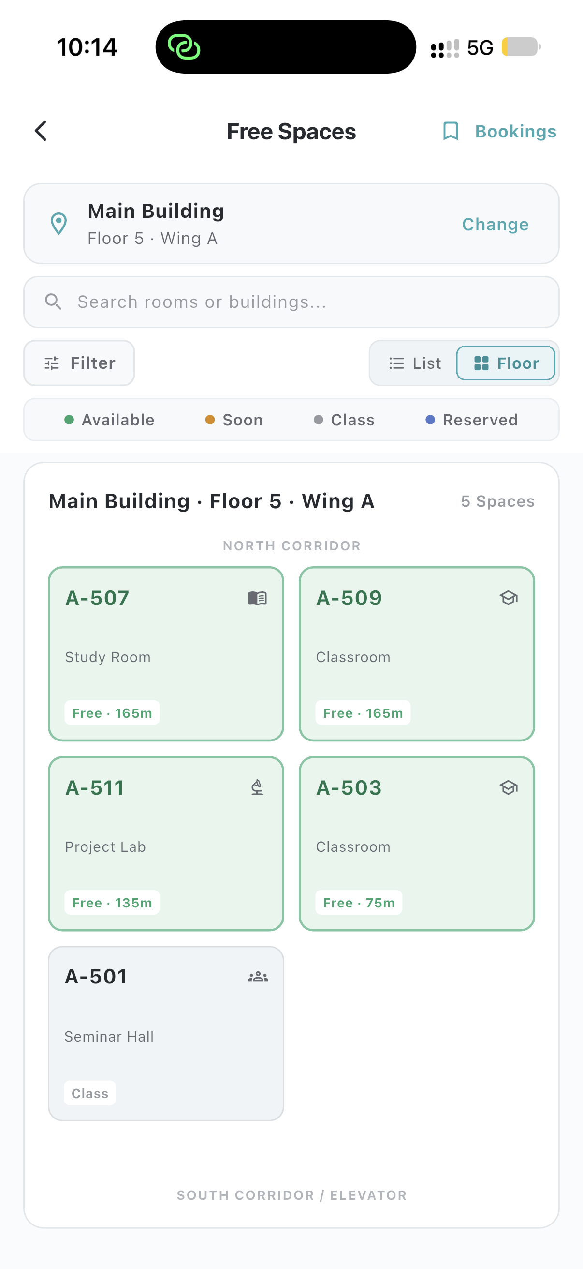 | Internships & Opportunities  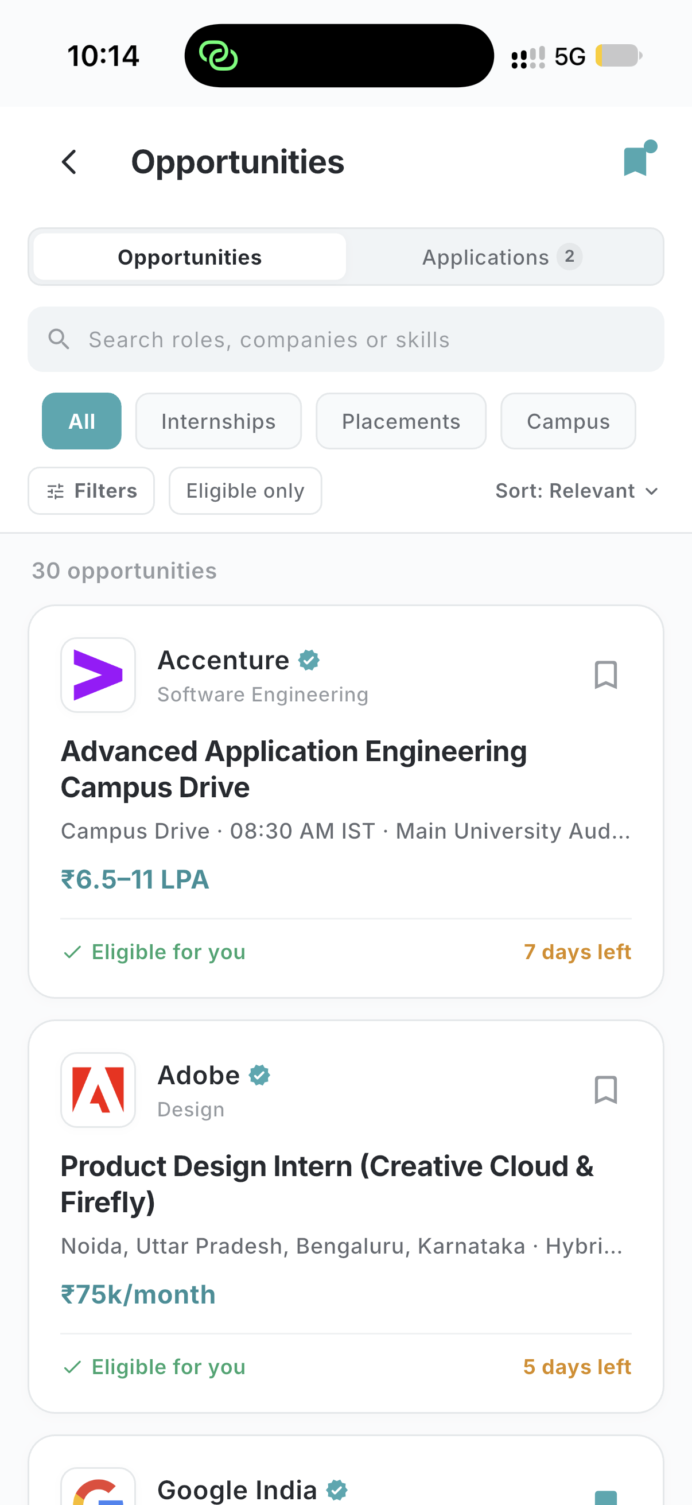
• Free Spaces shows available classrooms/areas so students can quickly find a place to study or collaborate.
• Opportunities centralizes internships, placements and campus opportunities with filters and application status.
• These solve two frequent student problems: finding space and discovering timely opportunities.

11 • STUDENT EXPERIENCE

Notifications, Faculty Access & Student Profile
Notification Center  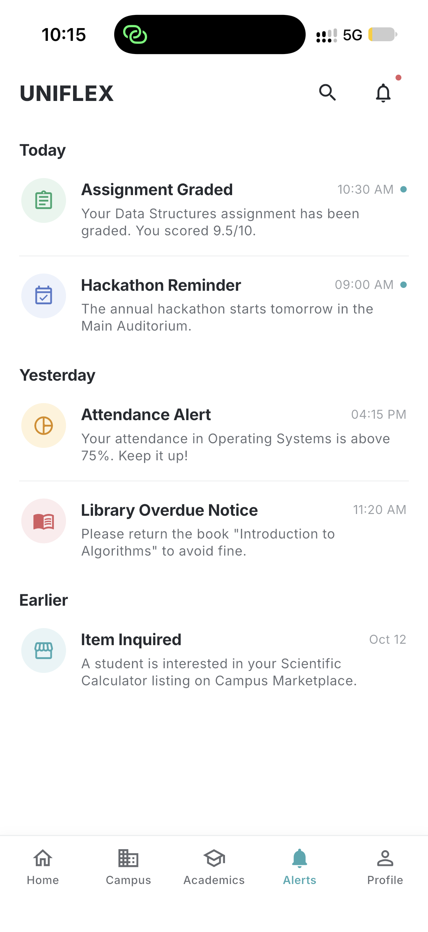 | Faculty Profile  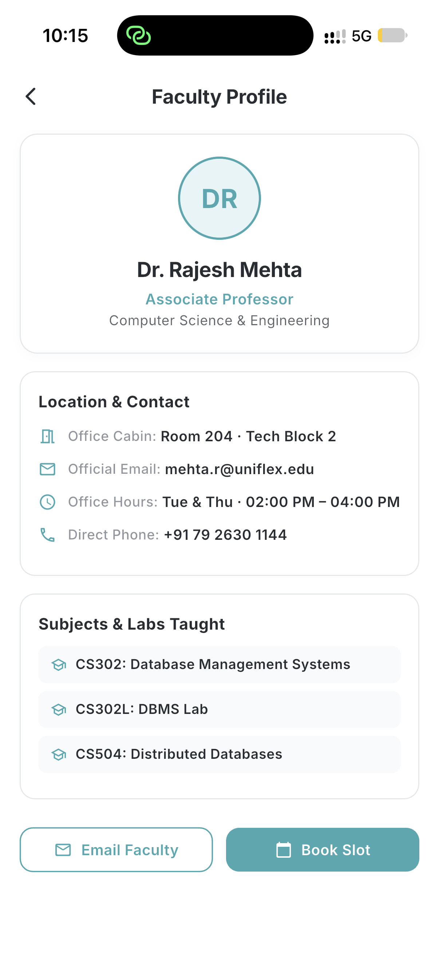 | Student Profile  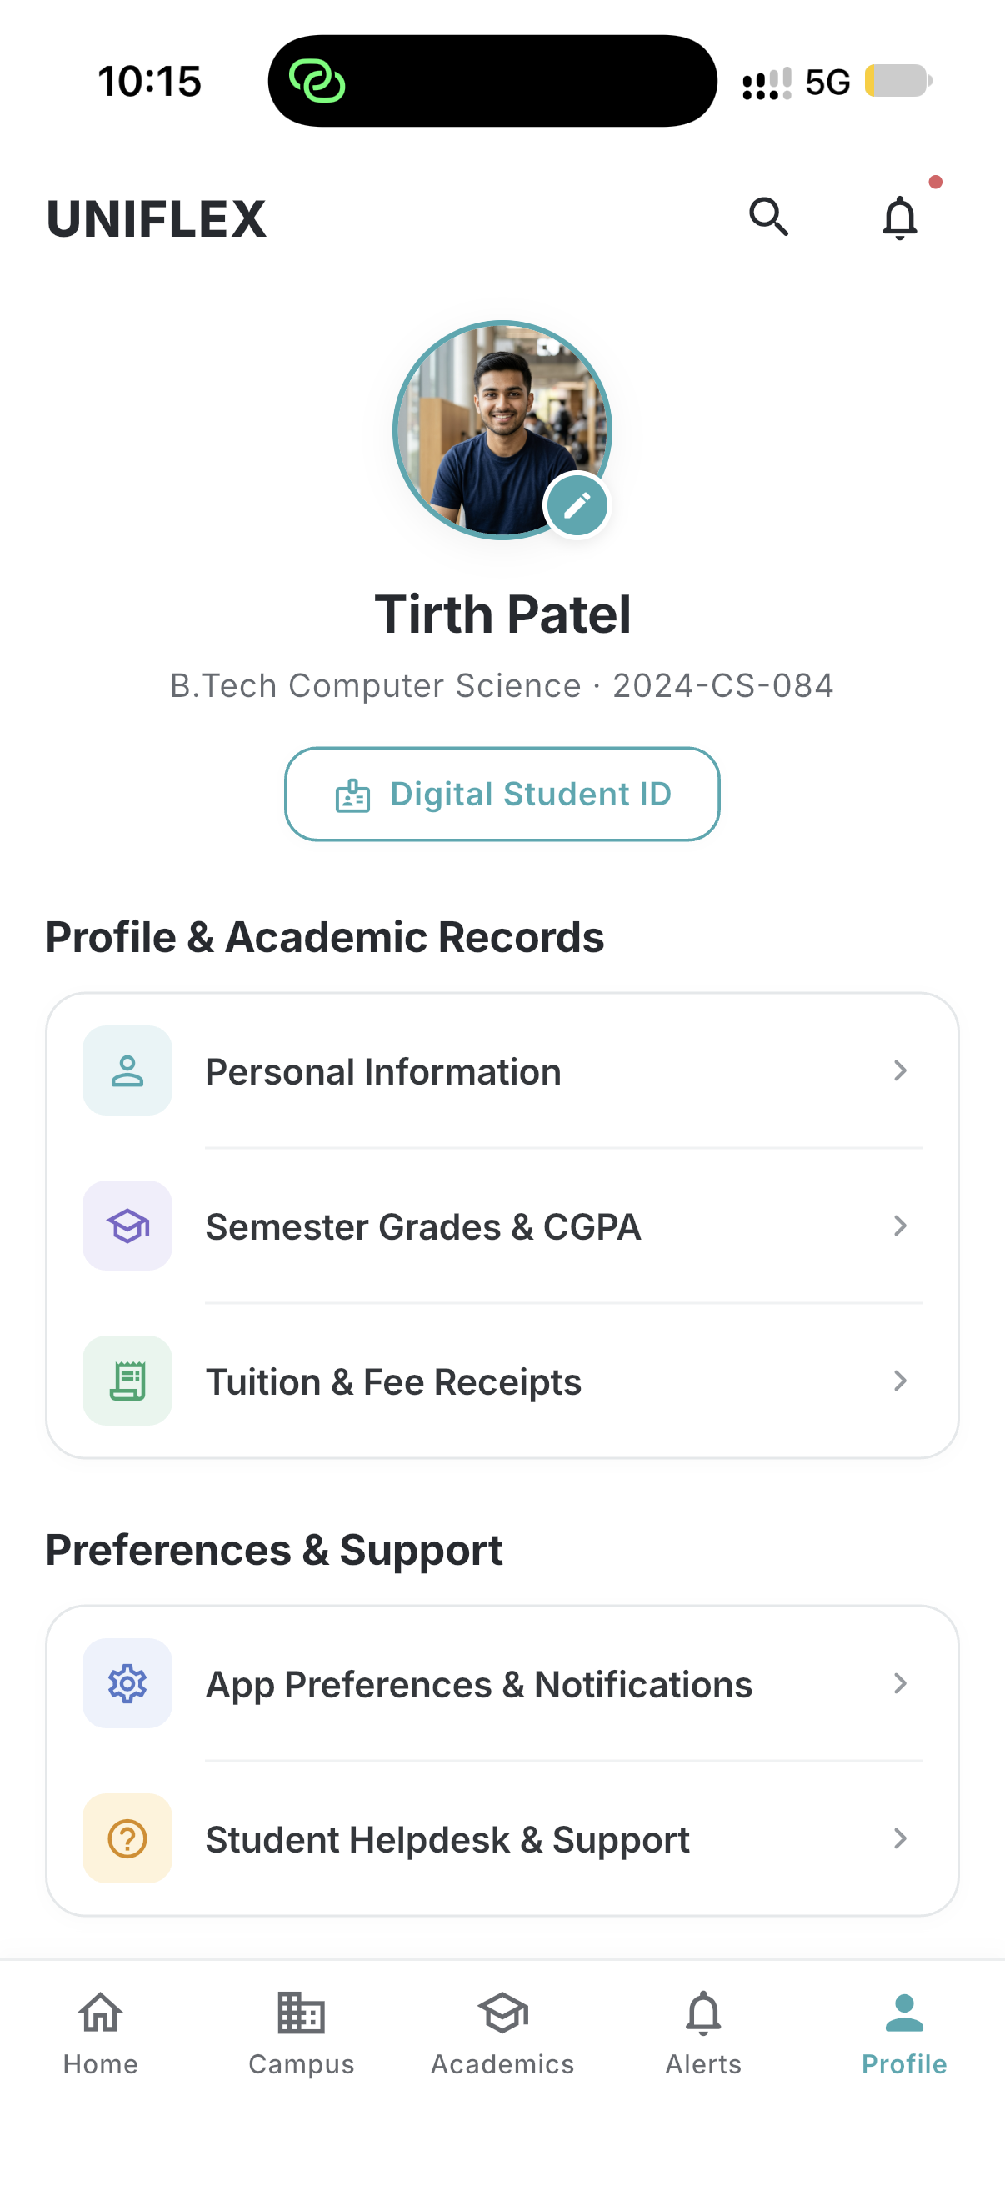
• Notifications are categorized so academic, attendance, library and enrollment alerts are easier to scan.
• Faculty profiles expose useful academic/contact information and subjects taught.
• Student profile consolidates academic records, receipts, preferences and support access.

12 • SERVICE IMPROVEMENT

From Request Forms to a Support Experience
Existing Request Form  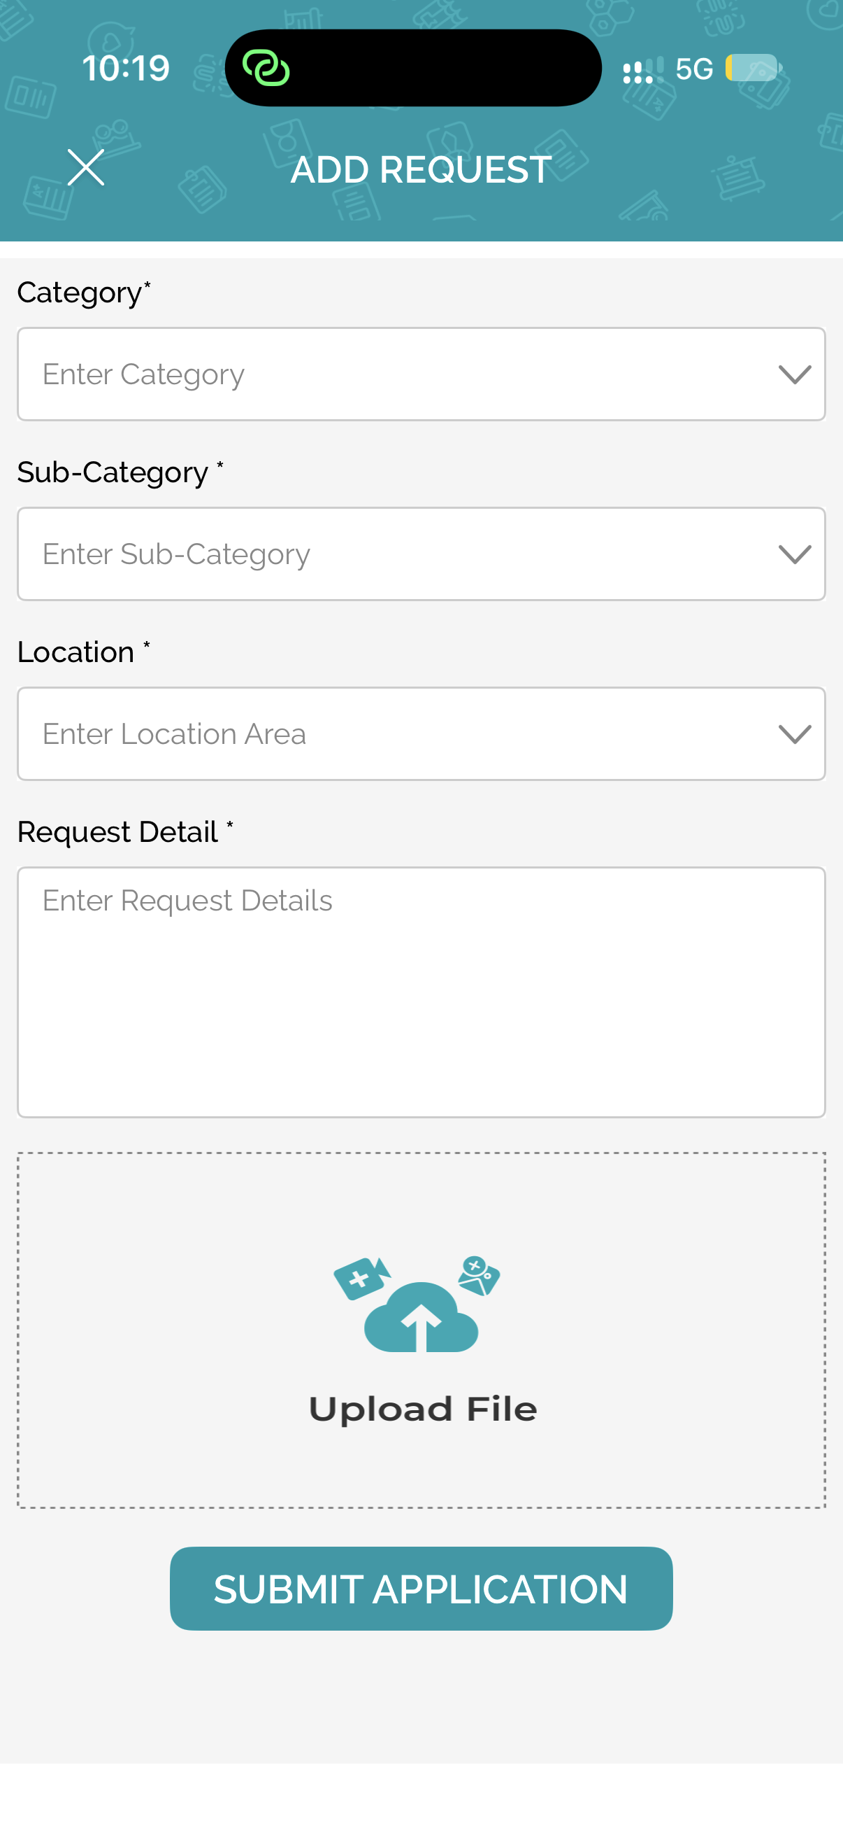 | UNIFLEX Helpdesk & Support  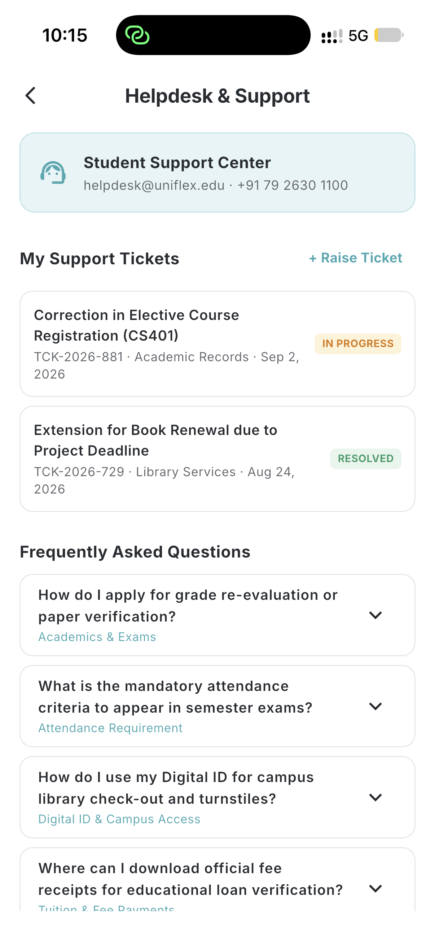
• The existing flow focuses on submitting a request. UNIFLEX adds a support center with ticket status and FAQs.
• Students can see whether an issue is open, in progress or resolved instead of treating submission as the end of the process.
• Common questions are surfaced directly to reduce repeated support requests.

13 • DEVELOPMENT LOG

Project Logbook
A concise record of the design and prototype work represented by this submission.
01 | Problem identification | Reviewed the current university app and identified usability gaps plus missing campus-life services.
02 | Feature planning | Separated requirements into Academics, Campus, Opportunities, Notifications and Profile.
03 | Information architecture | Designed a five-tab student shell and grouped related functions under consistent navigation.
04 | Home dashboard | Built a student-first home with classes, attendance, deadlines and quick access.
05 | Academic modules | Designed attendance, timetable, assignments, results and learning-resource experiences.
06 | Campus innovation | Added Lost & Found, Marketplace, Study Groups, Skill Exchange and Free Spaces.
07 | Career layer | Added internships/opportunities discovery and application-oriented UI.
08 | Communication | Added categorized notifications and faculty profile access.
09 | Student services | Added profile records, fee receipt access and Helpdesk/Support.
10 | Comparison & validation | Compared prototype screens with existing app screens to demonstrate improvement and innovation.

14 • INNOVATION SUMMARY

What Makes UNIFLEX Different
UNIFLEX does not simply reproduce the university app with a new color palette. The prototype expands the scope of the campus application.
Academic clarity — Daily-first dashboard, subject-wise attendance, clearer timetable, richer assignment detail and structured results.
Campus utility — Lost & Found, student marketplace and free-space discovery.
Peer ecosystem — Study groups and skill exchange inside the same trusted campus environment.
Career visibility — A dedicated opportunities area for internships, placements and campus openings.
Service transparency — Helpdesk tickets, status tracking and FAQs instead of only request submission.
Unified experience — Consistent navigation, cards, typography, status indicators and mobile interaction patterns across modules.

Outcome
A concept for a single digital campus companion: academically useful every day, socially useful across campus, and designed around the real student journey.

