


LABORATORY MANUAL
PROGRAMMING WITH PYTHON
Course Code: 01AP0303 | Credits: 4 | Practical: 2 Hours/Week

Student details | To be completed
Name
Enrollment No.
Semester / Class
Laboratory Batch
Academic Year
Faculty

Department of B.Tech CSE-AI/ML/DS-PBL Faculty of Engineering and Technology Marwadi University, Rajkot

Laboratory Record Certificate
This is to certify that ____________________________________________, Enrollment No. ____________________,

has satisfactorily completed the prescribed laboratory work for Programming with Python (01AP0303) during Academic Year 2026-27.

Role | Name / Signature | Date
Course Faculty
Laboratory Faculty
Head of Department

Student Declaration
The work recorded in this manual has been performed and understood by the student. External code, data, APIs, libraries and AI-assisted contributions, if any, must be acknowledged. Credentials, personal data and unauthorized content must not be included in submitted files.

General Laboratory Instructions
- Attend the laboratory punctually and complete each experiment during the scheduled session.
- Create a separate folder for each experiment and use meaningful filenames.
- Write and test the program independently; do not submit code without understanding it.
- Use comments, meaningful identifiers, modular functions and appropriate exception handling.
- Record the algorithm, source code, test cases, output evidence and conclusion.
- Never store passwords, API keys or private personal data directly in source code.
- Maintain academic integrity and acknowledge external or AI-assisted material.
- Take a backup of code and data after every laboratory session.

Institutional and Programme Framework

Institute Vision
To foster an environment that empowers people, organisations, and societies through education, ideas, research, and training.

Institute Mission
- To provide quality education and thereby bring social transformation.
- To create leaders through innovation and entrepreneurship.
- To cultivate the culture of research advancements.
- To imbibe universal consciousness.
- To stimulate growth through industrial and international partnerships.

Department Vision
To empower innovators in Computer Science & Engineering through education, research, and ethical practices to create sustainable solutions with global impact.

Department Mission
- Deliver quality education in Computer Science & Engineering through modern, technology-enabled pedagogies and strong industry collaboration.
- Foster innovation, entrepreneurship, and interdisciplinary research to drive creativity and problem-solving.
- Promote ethical computing, sustainability, and professional responsibility to nurture socially conscious graduates.
- Prepare students for lifelong learning, global employability, and leadership in emerging domains such as AI, Data Science, Cloud Computing, Cybersecurity, and beyond.

Programme Educational Objectives
- PEO1 Technical Excellence: Graduates will design and develop secure, scalable, and efficient computing systems using strong foundations in Computer Science & Engineering.
- PEO2 Career Readiness and Leadership: Graduates will excel in global careers, research, or entrepreneurship while demonstrating leadership, teamwork, communication, and ethical responsibility.
- PEO3 Innovation and Lifelong Learning: Graduates will adapt to rapid technological changes, pursue continuous learning, and drive innovation through research and interdisciplinary collaboration.
- PEO4 Societal Responsibility: Graduates will apply computing knowledge responsibly to create sustainable, inclusive solutions that address societal and global challenges.

Programme Outcomes (GAPC V4.0)

PO | Title | Statement
PO1 | Engineering Knowledge | Apply mathematics, natural science, computing, engineering fundamentals and specialization knowledge to solve complex engineering problems.
PO2 | Problem Analysis | Identify, formulate, review literature and analyze complex engineering problems to reach substantiated conclusions with consideration for sustainable development.
PO3 | Design/Development of Solutions | Design creative solutions and systems/components/processes that meet identified needs with due consideration for health, safety, whole-life cost, net-zero carbon, culture, society and environment.
PO4 | Conduct Investigations | Conduct research-based investigations, including experimental design, modelling, analysis and interpretation of data, to provide valid conclusions.
PO5 | Engineering Tool Usage | Create, select and apply appropriate techniques, resources and modern engineering and IT tools, including prediction and modelling, while recognizing limitations.
PO6 | The Engineer and the World | Analyze and evaluate societal and environmental aspects and sustainability impacts with reference to economy, health, safety, law, culture and environment.
PO7 | Ethics | Apply ethical principles and commit to professional ethics, human values, diversity and inclusion, and applicable national and international laws.
PO8 | Individual and Collaborative Team Work | Function effectively as an individual and as a member or leader in diverse and multidisciplinary teams.
PO9 | Communication | Communicate effectively and inclusively through reports, design documentation and presentations while considering cultural, language and learning differences.
PO10 | Project Management and Finance | Apply engineering management and economic decision-making to individual and team work and to multidisciplinary project management.
PO11 | Life-Long Learning | Engage in independent lifelong learning, adapt to emerging technologies and apply critical thinking in the broad context of technological change.

Programme Specific Outcomes

PSO | Theme | Statement
PSO1 | Software Systems | Design and develop secure, efficient and scalable software systems, intelligent applications and computing solutions using industry-standard tools and frameworks.
PSO2 | Emerging Technologies | Apply Artificial Intelligence, Data Science, Cloud Computing, Cybersecurity and emerging technologies responsibly to create innovative and sustainable solutions for real-world challenges.

Course Framework

Item | Details
Course title | Programming with Python
Course code | 01AP0303
Credits | 4
Prerequisite | Programming Basics
Laboratory hours | 2 hours/week; 24 hours total
Suggested practicals | 12

Course Outcomes

CO | Course outcome statement | Bloom level
CO1 | Apply Python programming fundamentals to solve computational problems effectively. | Apply
CO2 | Develop modular and reusable Python programs using functions, files, and object-oriented concepts. | Apply
CO3 | Build industry-oriented applications integrating databases, APIs, and automation tools. | Create
CO4 | Analyze datasets and generate insights using Python data analytics libraries. | Analyze
CO5 | Design and implement real-world software projects collaboratively using Python development tools. | Create

CO-PO-PSO Articulation Matrix

CO | PO1 | PO2 | PO3 | PO4 | PO5 | PO6 | PO7 | PO8 | PO9 | PO10 | PO11 | PSO1 | PSO2
CO1 | 3 | 2 | - | - | 2 | - | - | - | - | - | 1 | 2 | -
CO2 | 2 | 2 | 2 | - | 3 | - | - | 1 | 1 | - | 2 | 3 | -
CO3 | 2 | 2 | 3 | - | 3 | 2 | 1 | 2 | 2 | 2 | 2 | 3 | 2
CO4 | 2 | 3 | - | 2 | 3 | 1 | - | - | 1 | - | 2 | 2 | 3
CO5 | 2 | 2 | 3 | 1 | 3 | 2 | 2 | 3 | 3 | 3 | 3 | 3 | 2
Correlation scale: 3 = Substantial (High), 2 = Moderate (Medium), 1 = Slight (Low), - = No direct correlation.

CO-PO-PSO Mapping Justification

CO | Primary PO linkage | PSO linkage | Rationale
CO1 | PO1, PO2, PO5 | PSO1 | Applies programming and computing fundamentals to formulate and solve computational problems using Python tools.
CO2 | PO3, PO5, PO11 | PSO1 | Develops modular and reusable programs through functions, files and object-oriented design.
CO3 | PO3, PO5, PO8, PO10 | PSO1, PSO2 | Integrates databases, APIs and automation into industry-oriented applications and project workflows.
CO4 | PO2, PO4, PO5 | PSO1, PSO2 | Uses analytics libraries to investigate datasets, interpret results and communicate evidence-based insights.
CO5 | PO3, PO5, PO8, PO9, PO10, PO11 | PSO1, PSO2 | Designs, implements, documents and presents collaborative real-world software projects.

Experiment-CO Mapping

No. | Experiment | Mapped CO(s)
1 | Smart Calculator | CO1, CO2
2 | Employee Payroll Processing System | CO1, CO2
3 | Student Grade Analyzer | CO1, CO2, CO4
4 | Inventory Tracker | CO1, CO2
5 | Log File Analyzer | CO2, CO4

Assessment Rubric
Every experiment carries 10 marks using four components: on-time completion and submission (2), program execution and functional correctness (3), record/code quality and result documentation (2), and viva voce (3). The total obtained across 12 experiments is converted from 120 to 25 Term Work marks. Marks, assessment date and faculty signature must be recorded for every experiment.

Criterion | Maximum marks | Suggested scoring
On-time completion and submission | 2 | 2 = on time; 1 = minor delay; 0 = late/not submitted
Program execution and functional correctness | 3 | 3 = complete/correct; 2 = minor defect; 1 = partial; 0 = not working
Record, code quality and result documentation | 2 | 2 = complete/clear; 1 = minor omissions; 0 = inadequate/absent
Viva voce | 3 | 3 = clear mastery; 2 = basic understanding; 1 = limited; 0 = no meaningful response
Total | 10

Consolidated Evaluation Record

No. | Experiment | Time  /2 | Execution  /3 | Record  /2 | Viva  /3 | Total  /10 | Assessment date | Faculty signature
1 | Smart Calculator
2 | Employee Payroll Processing System
3 | Student Grade Analyzer
4 | Inventory Tracker
5 | Log File Analyzer
 | Total obtained |  |  |  |  | /120
 | Converted Term Work marks |  |  |  |  | /25

CSE Component - 20 Marks
The CSE component is divided into a Python/CSE MOOC course (10 marks) and development of a reusable Python library (10 marks). Each task must be assessed separately, with marks, date and faculty signature recorded below.

MOOC Course Assessment - 10 Marks

MOOC assessment task | Maximum marks | Marks awarded | Verification date | Faculty signature
Relevant Python/CSE MOOC selected and enrolled | 1
Progress/completion/certificate evidence submitted | 3
Learning summary and key concepts documented | 2
Application of MOOC learning demonstrated | 2
Source link/citation and viva explanation | 2
Total - MOOC course | 10
Required evidence: course title and link, enrollment/progress/completion proof, concise learning summary, application of learning, and individual explanation.

Reusable Python Library Development - 10 Marks
Develop a small reusable Python package for an approved purpose. Submit the source package, reusable functions or classes, documentation/docstrings, README, usage example or demonstration notebook, test cases and output evidence.

Python library development task | Maximum marks | Marks awarded | Review date | Faculty signature
Problem selection and library requirements | 1
Reusable functions/classes correctly implemented | 3
Package structure, modularity and code quality | 2
Documentation, docstrings and usage examples | 2
Testing, demonstration and viva explanation | 2
Total - Python library development | 10

Consolidated CSE Assessment Record

CSE task | Maximum marks | Marks awarded | Final verification date | Faculty signature
MOOC course | 10
Reusable Python library development | 10
Total CSE marks | 20

EXPERIMENT 01

Smart Calculator
Date performed | Date submitted | Mapped CO(s) | Marks | Faculty signature
 |  | CO1, CO2 | /10

Aim
Develop a safe, GUI-based calculator that performs arithmetic, percentage and scientific operations with validation and session history.

Learning Objectives
• Apply variables, operators, functions, classes and structured exception handling in Python.
• Design a responsive, event-driven desktop interface using Tkinter widgets.
• Implement safe mathematical expression parsing using Python AST to eliminate security risks of eval().

Software / Resources
Python 3.x, Tkinter/ttk, ast, math, operator, re, VS Code

Algorithm / Procedure
• Create the main calculator application window, display field, scientific button panel, and session history listbox.
• Construct expression strings dynamically from mouse clicks and bind keyboard return events.
• Preprocess expression strings to normalize mathematical symbols and convert percentage notation.
• Parse expressions using Python's Abstract Syntax Tree (ast) and recursively evaluate supported operators.
• Display evaluated results in the entry field and append successful transactions to the session history.
• Intercept division-by-zero, invalid logarithms, and syntax errors, displaying non-intrusive alert dialogs.

Required Input Data and Results
Operation | Input | Expected output | Verified output
Addition | 10 + 20 | 30 | 30
Percentage | 100 × 5% | 5 | 5
Square root | sqrt(81) | 9 | 9
Power | 2 ^ 3 | 8 | 8
Invalid division | 1 ÷ 0 | Friendly error dialog | Division-by-zero dialog

GUI Output Screenshots
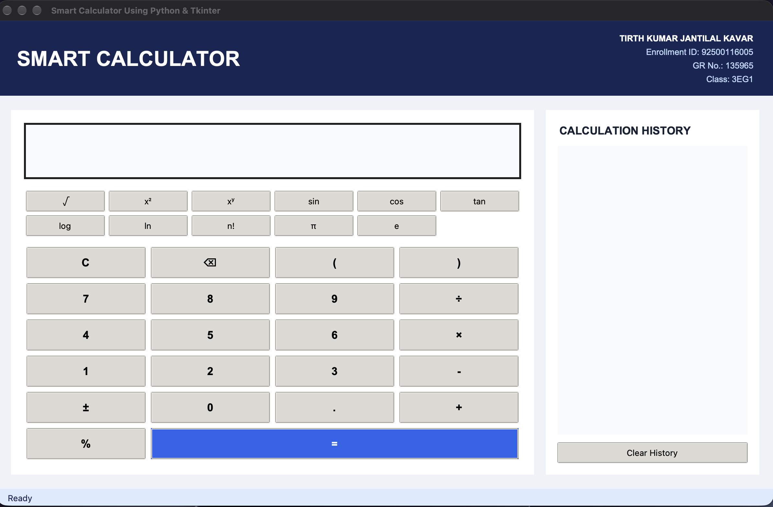
Figure 1.1 Initial GUI layout and calculator keypad interface
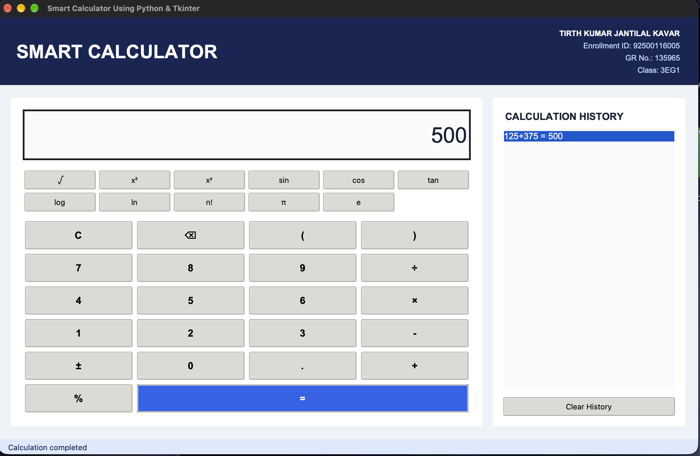
Figure 1.2 Arithmetic operation and standard expression evaluation
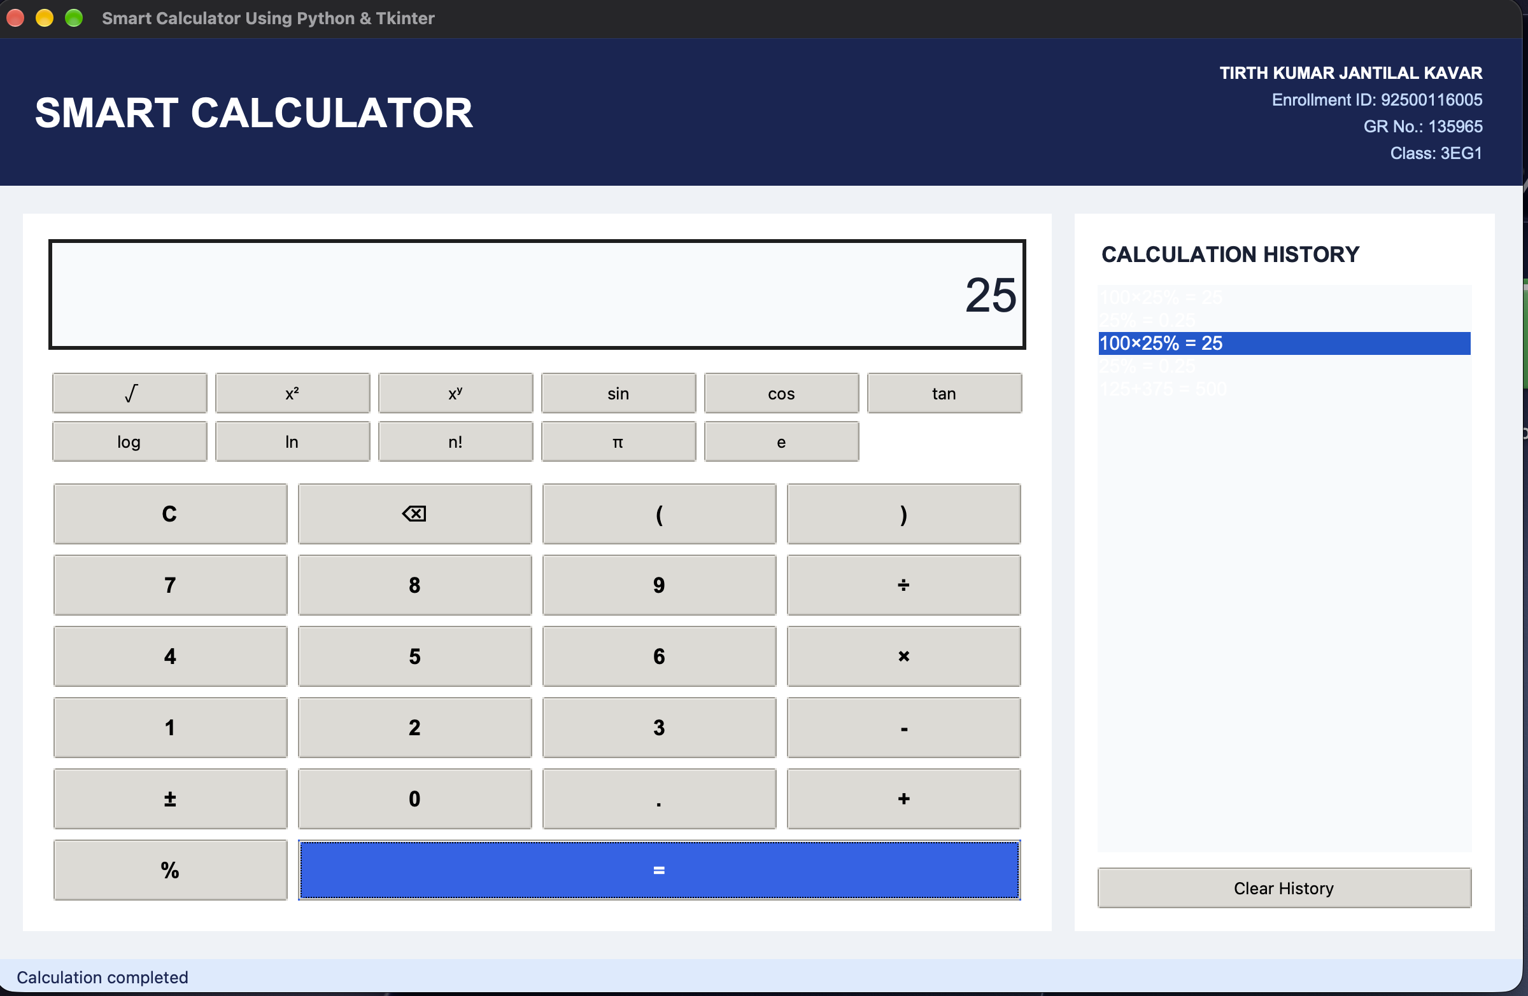
Figure 1.3 Percentage calculation and result display
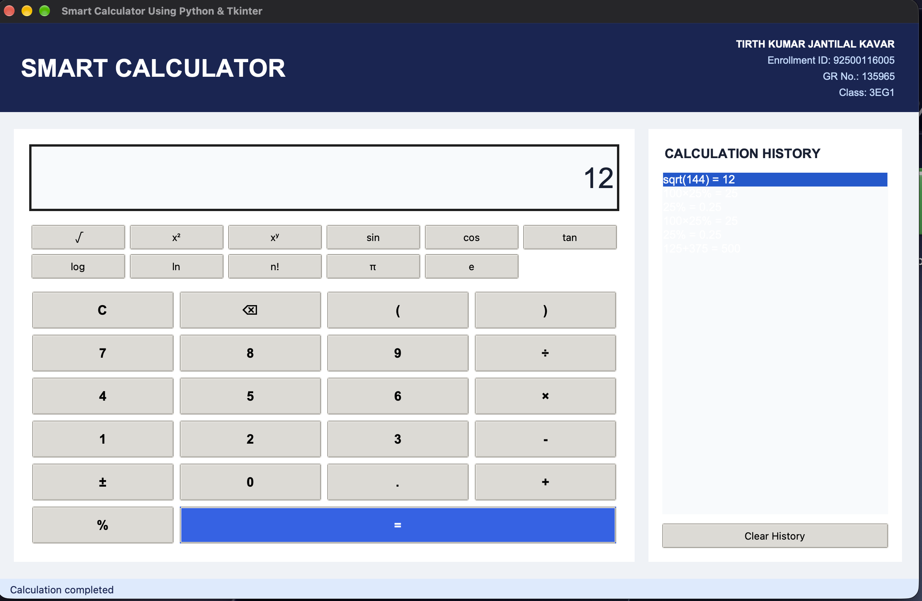
Figure 1.4 Scientific functions, roots, powers and constants
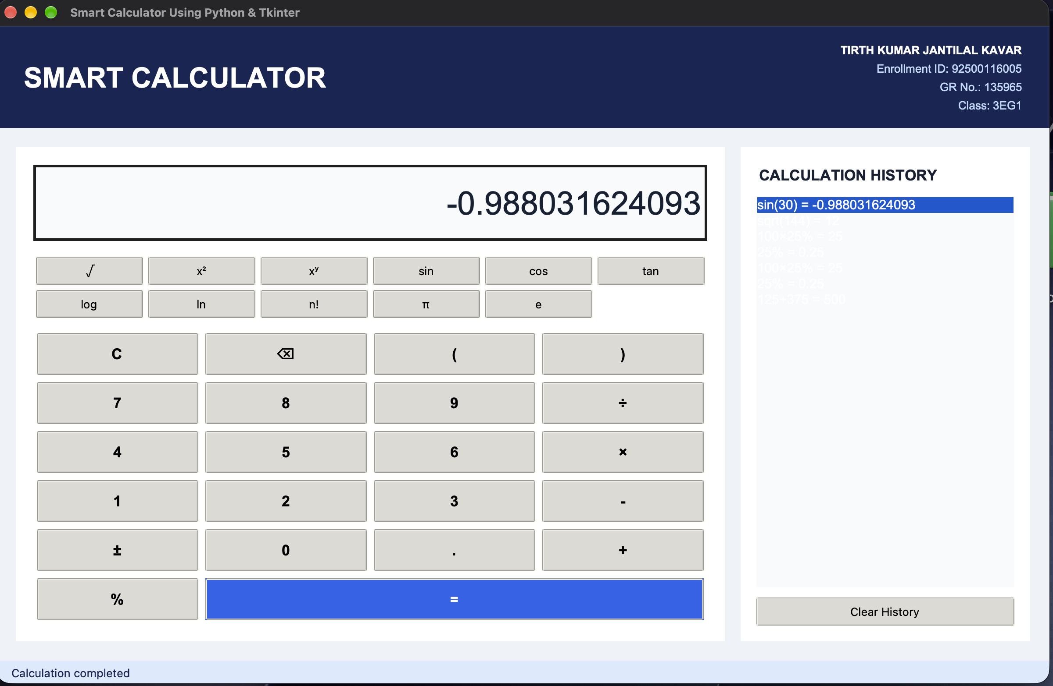
Figure 1.5 Calculation session history tracking and log panel
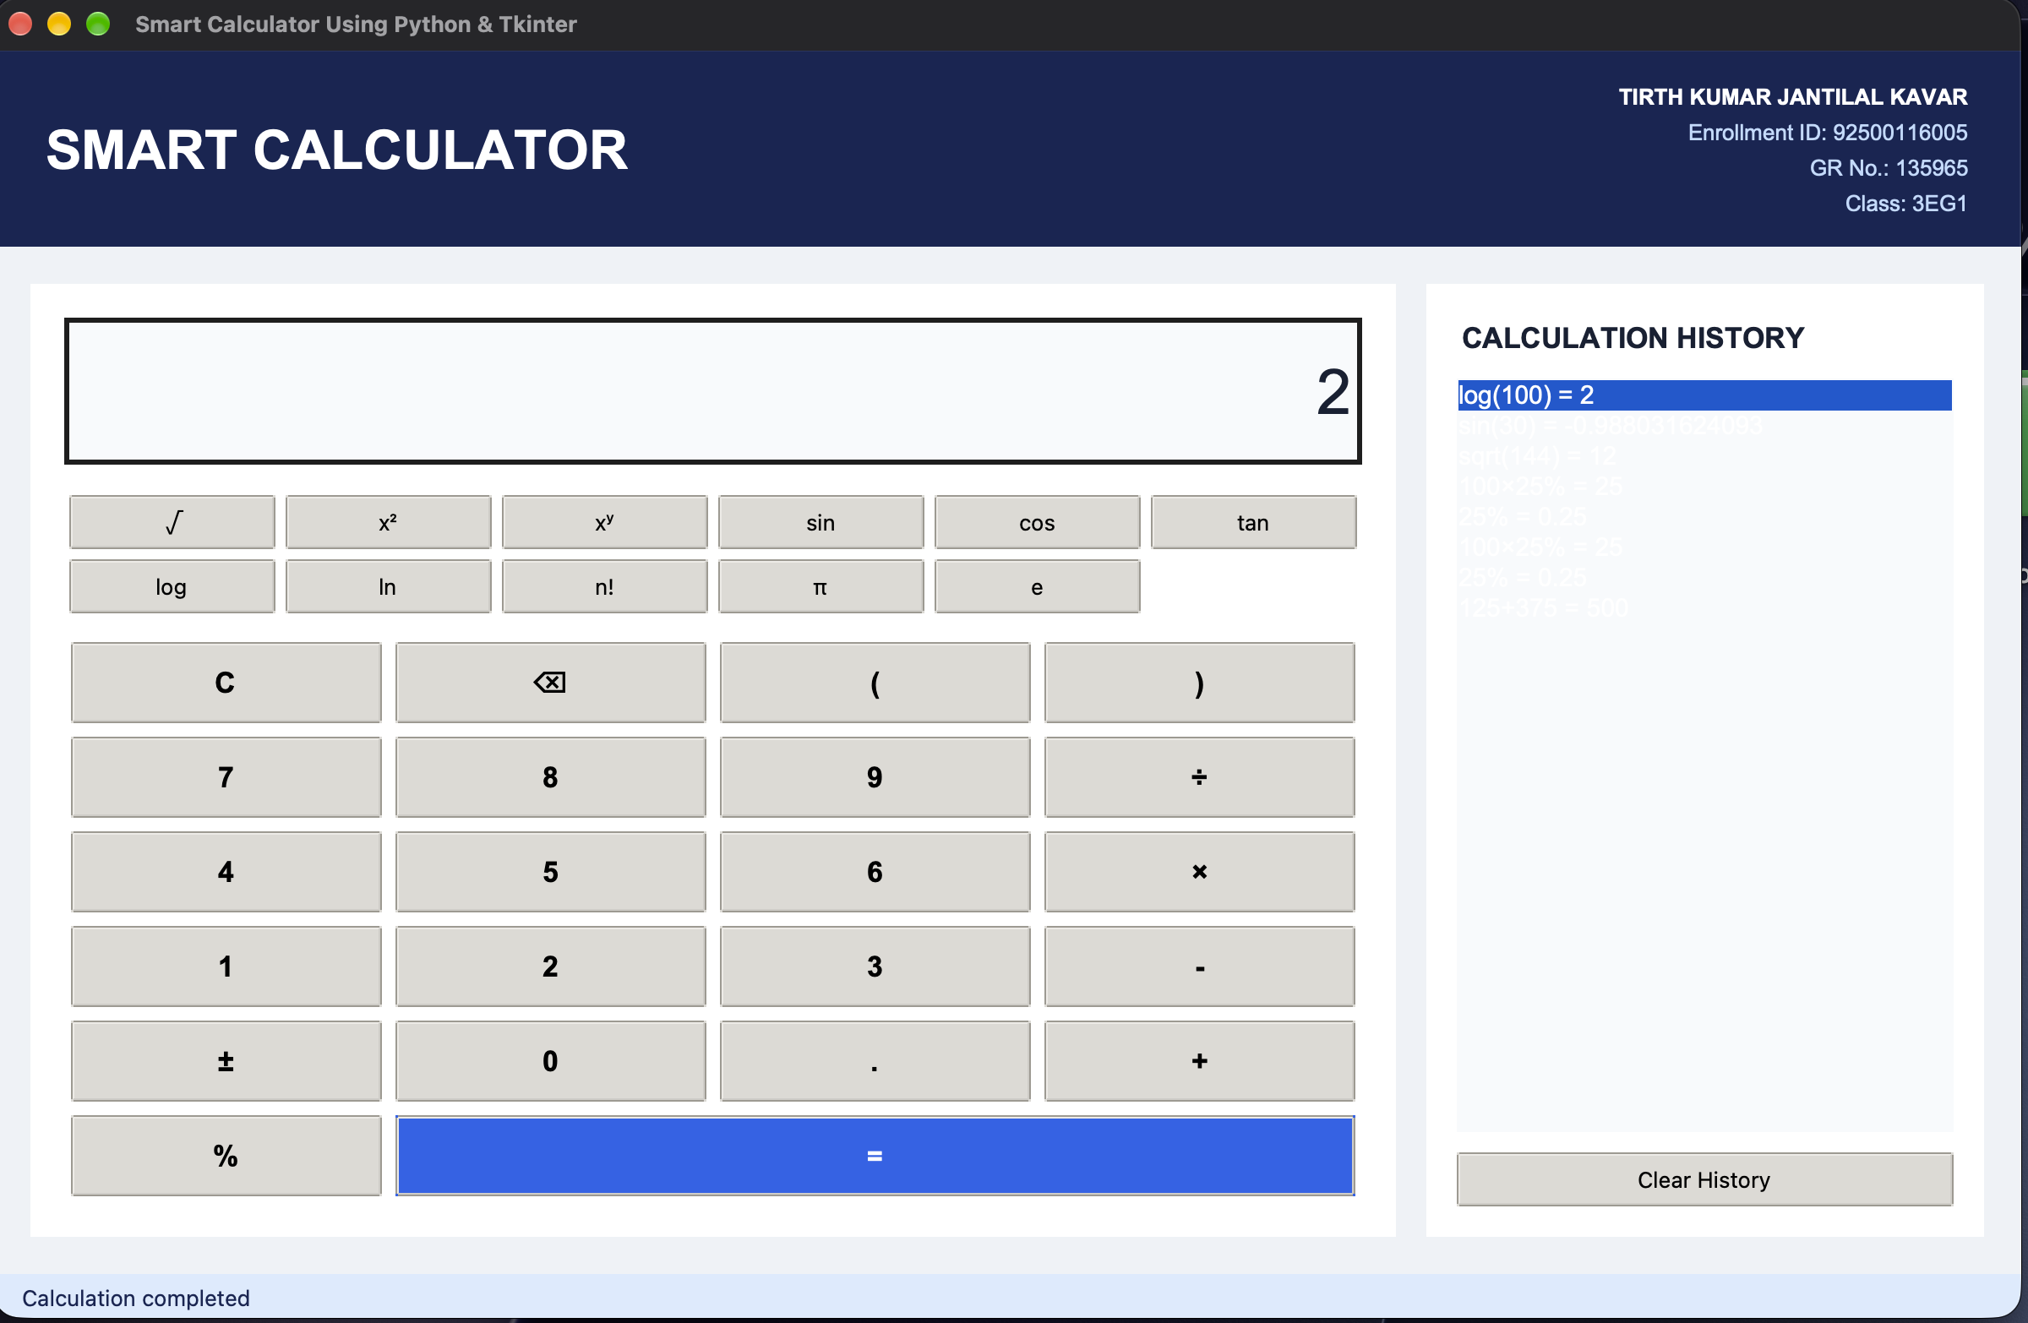
Figure 1.6 Input validation and error dialog handling

Complete Source Code
File: 01_Smart_Calculator/main.py
"""Smart Calculator - a safe, session-based Tkinter calculator."""
import ast
import math
import operator
import tkinter as tk
from tkinter import messagebox, ttk

STUDENT = ("TIRTH KUMAR JANTILAL KAVAR", "Enrollment ID: 92500116005", "GR No.: 135965", "Class: 3EG1")
BG, CARD, NAVY, BLUE, TEXT, MUTED = "#eef2f7", "#ffffff", "#172554", "#2563eb", "#172033", "#64748b"

class SafeEvaluator(ast.NodeVisitor):
"""Evaluate only the arithmetic syntax exposed by the calculator."""
binary = {ast.Add: operator.add, ast.Sub: operator.sub, ast.Mult: operator.mul,
ast.Div: operator.truediv, ast.Pow: operator.pow, ast.Mod: operator.mod}
unary = {ast.UAdd: operator.pos, ast.USub: operator.neg}
functions = {"sqrt": math.sqrt, "sin": math.sin, "cos": math.cos, "tan": math.tan,
"log": math.log10, "ln": math.log, "factorial": math.factorial}

def visit_Expression(self, node): return self.visit(node.body)
def visit_Constant(self, node):
if isinstance(node.value, (int, float)): return node.value
raise ValueError("Only numbers are allowed")
def visit_BinOp(self, node):
function = self.binary.get(type(node.op))
if not function: raise ValueError("Unsupported operation")
return function(self.visit(node.left), self.visit(node.right))
def visit_UnaryOp(self, node):
function = self.unary.get(type(node.op))
if not function: raise ValueError("Unsupported sign")
return function(self.visit(node.operand))
def visit_Call(self, node):
if not isinstance(node.func, ast.Name) or node.func.id not in self.functions or len(node.args) != 1:
raise ValueError("Unsupported function")
value = self.visit(node.args[0])
if node.func.id == "factorial" and (value < 0 or int(value) != value):
raise ValueError("Factorial needs a non-negative whole number")
return self.functions[node.func.id](int(value) if node.func.id == "factorial" else value)
def visit_Name(self, node):
if node.id == "pi": return math.pi
if node.id == "e": return math.e
raise ValueError("Unknown value")
def generic_visit(self, node): raise ValueError("Invalid expression")

def evaluate_expression(expression):
cleaned = expression.replace("×", "*").replace("÷", "/").replace("^", "**")
# A percent means divide the immediately preceding numeric value by 100.
import re
cleaned = re.sub(r"(\d+(?:\.\d+)?)%", r"(\1/100)", cleaned)
return SafeEvaluator().visit(ast.parse(cleaned, mode="eval"))

class CalculatorApp:
def __init__(self, root):
self.root = root
root.title("Smart Calculator Using Python & Tkinter")
root.geometry("1200x750"); root.minsize(900, 650); root.configure(bg=BG)
self.expression = tk.StringVar(); self.status = tk.StringVar(value="Ready")
self.make_styles(); self.build_header(); self.build_ui()

def make_styles(self):
style = ttk.Style(); style.theme_use("clam")
style.configure("Calc.TButton", font=("Arial", 13, "bold"), padding=11)
style.configure("Accent.TButton", background=BLUE, foreground="white", font=("Arial", 12, "bold"), padding=11)

def build_header(self):
header = tk.Frame(self.root, bg=NAVY, padx=28, pady=16); header.pack(fill="x")
tk.Label(header, text="SMART CALCULATOR", bg=NAVY, fg="white", font=("Arial", 24, "bold")).pack(side="left")
info = tk.Frame(header, bg=NAVY); info.pack(side="right")
for i, line in enumerate(STUDENT):
tk.Label(info, text=line, anchor="e", bg=NAVY, fg="white" if i == 0 else "#bfdbfe",
font=("Arial", 10, "bold" if i == 0 else "normal")).pack(anchor="e")

def build_ui(self):
body = tk.Frame(self.root, bg=BG, padx=22, pady=22); body.pack(fill="both", expand=True)
left = tk.Frame(body, bg=CARD, padx=20, pady=20); left.pack(side="left", fill="both", expand=True)
right = tk.Frame(body, bg=CARD, padx=18, pady=18, width=330); right.pack(side="right", fill="y", padx=(18, 0)); right.pack_propagate(False)
entry = tk.Entry(left, textvariable=self.expression, justify="right", font=("Arial", 28), relief="flat", bg="#f8fafc", fg=TEXT)
entry.pack(fill="x", ipady=16, pady=(0, 15)); entry.focus_set(); entry.bind("<Return>", lambda _e: self.calculate())
sci = tk.Frame(left, bg=CARD); sci.pack(fill="x", pady=(0, 10))
for col, (label, value) in enumerate([("√", "sqrt("), ("x²", "**2"), ("xʸ", "**"), ("sin", "sin("), ("cos", "cos("), ("tan", "tan("), ("log", "log("), ("ln", "ln("), ("n!", "factorial("), ("π", "pi"), ("e", "e")]):
ttk.Button(sci, text=label, command=lambda v=value: self.insert(v)).grid(row=col//6, column=col%6, sticky="nsew", padx=3, pady=3)
for c in range(6): sci.columnconfigure(c, weight=1)
grid = tk.Frame(left, bg=CARD); grid.pack(fill="both", expand=True)
buttons = [("C", self.clear), ("⌫", self.backspace), ("(", lambda: self.insert("(")), (")", lambda: self.insert(")")),
("7", None), ("8", None), ("9", None), ("÷", None), ("4", None), ("5", None), ("6", None), ("×", None),
("1", None), ("2", None), ("3", None), ("-", None), ("±", self.toggle_sign), ("0", None), (".", None), ("+", None),
("%", None), ("=", self.calculate)]
for index, (label, command) in enumerate(buttons):
r, c = divmod(index, 4); command = command or (lambda v=label: self.insert(v))
ttk.Button(grid, text=label, command=command, style="Accent.TButton" if label == "=" else "Calc.TButton").grid(row=r, column=c, sticky="nsew", padx=4, pady=4, columnspan=3 if label == "=" else 1)
for c in range(4): grid.columnconfigure(c, weight=1)
for r in range(6): grid.rowconfigure(r, weight=1)
tk.Label(right, text="CALCULATION HISTORY", bg=CARD, fg=TEXT, font=("Arial", 13, "bold")).pack(anchor="w")
self.history = tk.Listbox(right, font=("Arial", 11), bg="#f8fafc", relief="flat", activestyle="none")
self.history.pack(fill="both", expand=True, pady=12); self.history.bind("<Double-1>", self.use_history)
ttk.Button(right, text="Clear History", command=self.clear_history).pack(fill="x")
tk.Label(self.root, textvariable=self.status, anchor="w", bg="#dbeafe", fg=NAVY, padx=15, pady=6).pack(fill="x")

def insert(self, value): self.expression.set(self.expression.get() + value); self.status.set("Editing expression")
def clear(self): self.expression.set(""); self.status.set("Display cleared")
def backspace(self): self.expression.set(self.expression.get()[:-1])
def toggle_sign(self):
value = self.expression.get().strip(); self.expression.set(value[1:-1] if value.startswith("- (") and value.endswith(")") else f"-({value})" if value else "-")
def calculate(self):
original = self.expression.get().strip()
if not original: return
try:
result = evaluate_expression(original)
if isinstance(result, float) and result.is_integer(): result = int(result)
shown = f"{result:.12g}" if isinstance(result, float) else str(result)
self.history.insert(0, f"{original} = {shown}"); self.expression.set(shown); self.status.set("Calculation completed")
except ZeroDivisionError: messagebox.showerror("Calculation Error", "Division by zero is not allowed.")
except (ValueError, SyntaxError, OverflowError) as error: messagebox.showerror("Calculation Error", str(error) or "Invalid expression")
def clear_history(self):
if self.history.size() and messagebox.askyesno("Clear History", "Remove all session calculations?"):
self.history.delete(0, tk.END); self.status.set("History cleared")
def use_history(self, _event):
if self.history.curselection(): self.expression.set(self.history.get(self.history.curselection()[0]).split(" = ")[0])

if __name__ == "__main__":
window = tk.Tk(); CalculatorApp(window); window.mainloop()

Test Evidence & Results
Test case / input | Expected result | Actual result | Status
10 + 20 | 30 | 30 | Pass
100 × 5% | 5 | 5 | Pass
sqrt(81) | 9 | 9 | Pass
1 ÷ 0 | Error handled gracefully | Friendly dialog | Pass

Experimental Observation
During the design, development, and systematic testing of the Smart Calculator, several critical engineering behaviors were observed:
1. Event-Driven Loop Responsiveness: The Tkinter mainloop captured asynchronous user interactions without noticeable latency. Dynamically generating keypad buttons via closures and lambda functions streamlined widget instantiation while avoiding repetitive callback code.
2. Abstract Syntax Tree (AST) Validation: Replacing unrestricted eval() with Python's ast module provided robust mathematical evaluation without security vulnerabilities. By parsing arithmetic tokens into structured syntax nodes (BinOp, UnaryOp, Constant) and validating them against a strict whitelist, unwanted system calls or namespace injections were completely prevented.
3. Precedence and Percentage Evaluation: Arithmetic expressions complied strictly with standard operator precedence (BODMAS). A dedicated regular expression preprocessor converted percentage tokens (such as '100 × 5%') into fractional quotients before AST parsing, ensuring predictable computational flow.
4. Error Boundary Interception: Testing boundary conditions—such as division by zero, factorial calculations on decimal or negative numbers, and incomplete expressions—reliably triggered handled exceptions (ZeroDivisionError, ValueError). Instead of causing fatal runtime crashes, the application intercepted these conditions and presented informative dialog boxes.
5. Session Audit Logging: The right-hand calculation history panel successfully recorded each executed expression with its timestamped output, providing users with instant auditability and the ability to recall prior values into the active display.

Conclusion
The Smart Calculator application was successfully built and tested using Python 3 and Tkinter. The project demonstrated the effective convergence of event-driven graphical interface design, safe syntax tree parsing, and structured exception handling. Core software development principles—such as separating UI rendering from calculation logic, protecting the interpreter against malicious or malformed inputs, and maintaining runtime state in an interactive history panel—were fully realized. The application operates reliably under normal, boundary, and erroneous test inputs, delivering an intuitive desktop calculator experience.

Viva Voce Questions & Answers
Q1. What is event-driven programming?
Answer: Event-driven programming is an architectural paradigm where the program's execution flow is determined by external occurrences called events—such as mouse clicks, keyboard presses, or system notifications. Rather than running sequentially from start to finish, the application runs a continuous event loop (root.mainloop()) that detects user actions and invokes registered callback functions (event handlers) to respond to those specific actions.
Q2. Why should unrestricted eval() be avoided in Python applications?
Answer: Unrestricted eval() dynamically interprets and executes any arbitrary string as raw Python code with full execution privileges. If a user inputs commands like __import__('os').system('rm -rf /') or accesses internal namespaces, the system becomes vulnerable to arbitrary code execution and catastrophic security breaches. Using AST-based parsers or controlled operator dictionaries ensures only authorized mathematical operations are executed.
Q3. How does the AST parser evaluate mathematical expressions safely?
Answer: Python's ast.parse() converts the sanitized input string into a tree of syntax nodes. A custom ast.NodeVisitor subclass inspects each node type explicitly. Only recognized nodes—such as ast.BinOp (addition, multiplication), ast.UnaryOp (negation), ast.Constant (numeric values), and whitelisted math functions (sqrt, sin, log)—are executed. Any unapproved identifiers, loops, or function calls raise an immediate ValueError, blocking unsafe execution before it occurs.
Q4. What is the role of try-except blocks in GUI software stability?
Answer: In graphical applications, an unhandled exception halts the Python execution thread and can cause the entire GUI window to freeze or abruptly terminate without warning. By encapsulating computational logic inside structured try-except blocks, domain errors such as ZeroDivisionError and SyntaxError are intercepted gracefully, allowing the application to display helpful error messages while keeping the GUI window alive and responsive.
Q5. How does the Tkinter grid() geometry manager place interface widgets?
Answer: The grid() geometry manager organizes interface components in a 2-dimensional table of rows and columns. Developers can control layout proportion using parameters like row, column, rowspan, columnspan (to bridge multiple cells), and sticky (using compass directions like 'nsew' to expand widgets to fill their allocated cell dimensions dynamically as the parent frame resizes).

Experiment-Specific Rubric (10 Marks)
Criterion | Maximum marks | Marks awarded | Faculty signature
On-time completion and submission | 2
Program execution and functional correctness | 3
Record, code quality and result documentation | 2
Viva voce | 3
Total | 10

Faculty feedback: ________________________________________________________________

EXPERIMENT 02

Employee Payroll Processing System
Date performed | Date submitted | Mapped CO(s) | Marks | Faculty signature
 |  | CO1, CO2 | /10

Aim
Create a GUI payroll application that calculates overtime, gross salary, tax, total deductions and net salary and maintains employee records.

Learning Objectives
• Apply modular functions and conditional structures to real-world payroll business rules.
• Validate numerical inputs and required employee identity fields defensively.
• Implement persistent record management with lists, dictionaries, Treeview tables and CSV files.

Software / Resources
Python 3.x, Tkinter/ttk, csv, pathlib, VS Code

Algorithm / Procedure
• Accept employee details: ID, Name, Department, Working Days, Basic Salary, Overtime Hours, Bonus and Deductions.
• Validate that required identity fields are populated and numerical fields are strictly non-negative.
• Calculate overtime payment, gross salary, income tax using tiered slabs, and statutory provident fund.
• Compute net salary by subtracting income tax and statutory deductions from the calculated gross compensation.
• Populate and synchronize the Tkinter ttk.Treeview table, update summary metric cards, and serialize records to CSV.

Required Employee Data and Calculated Result
Field | Sample value | Field | Sample value
Employee ID | E001 | Employee Name | Aarav Patel
Department | IT | Working Days | 26
Basic Salary | ₹75,000 | Overtime | 18 × ₹200
Bonus | ₹1,500 | Allowances | ₹1,000
Tax | 10% | Other deductions | ₹500
Gross Salary | ₹81,100 | Net Salary | ₹72,490

GUI Output Screenshots
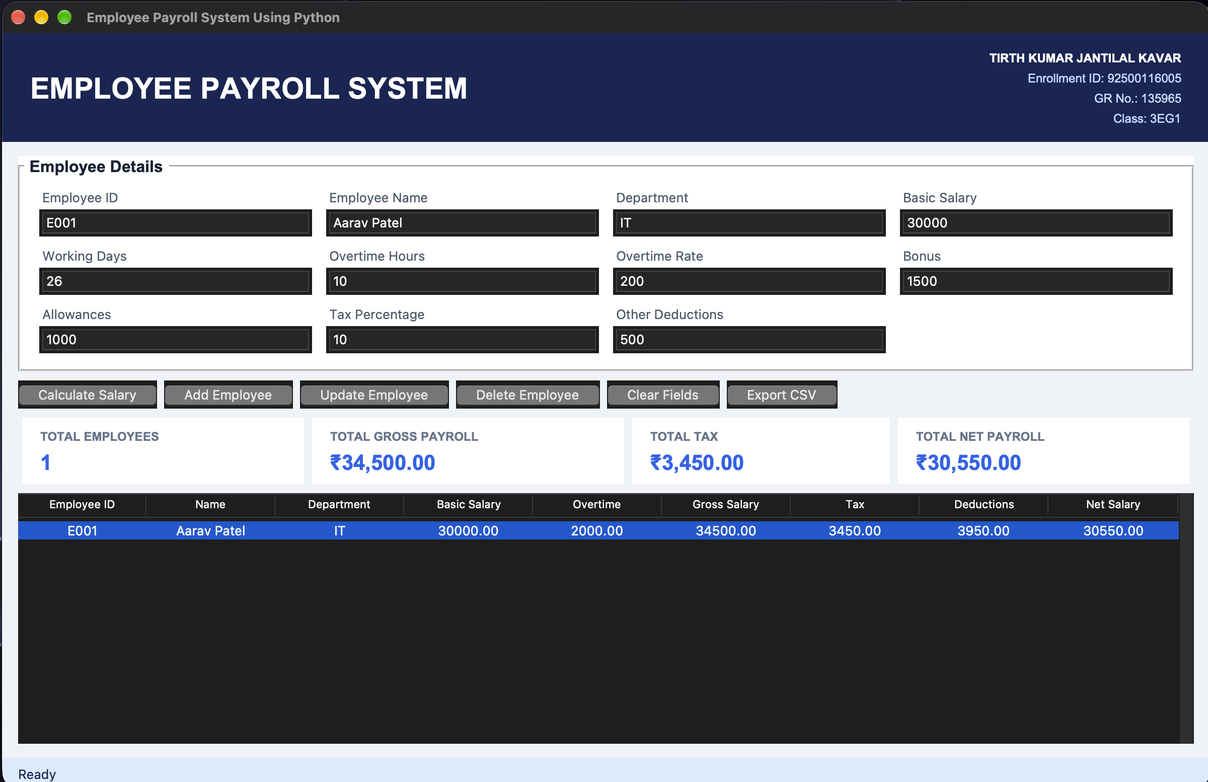
Figure 2.1 Payroll form layout and employee details entry fields
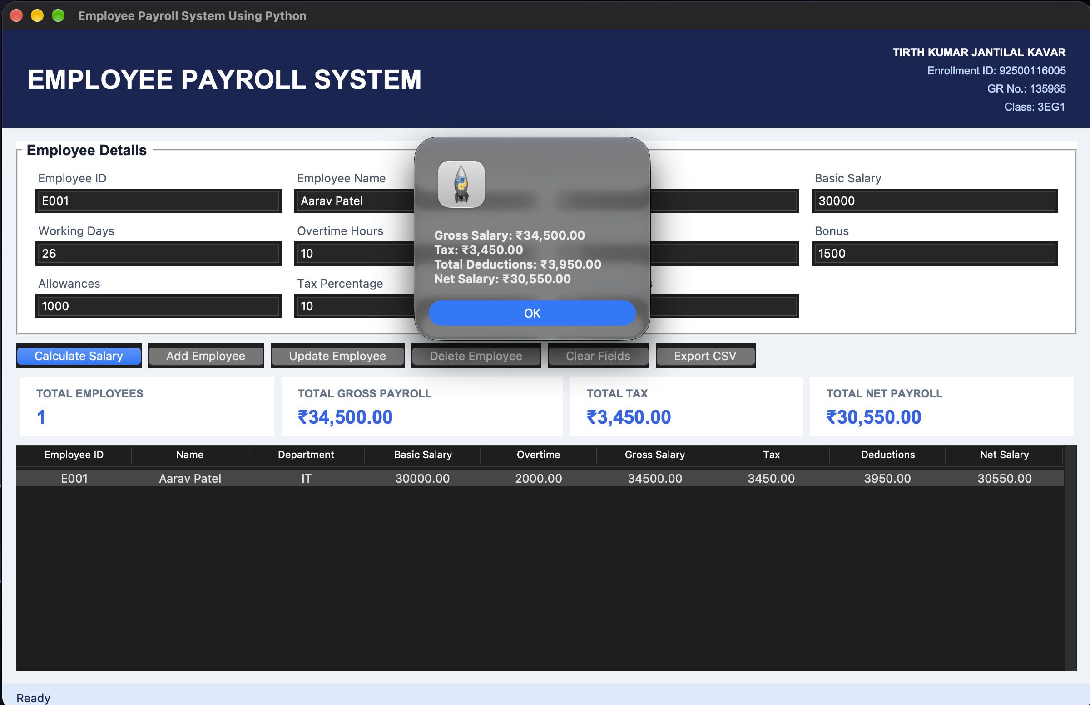
Figure 2.2 Salary components, overtime rate and hours input
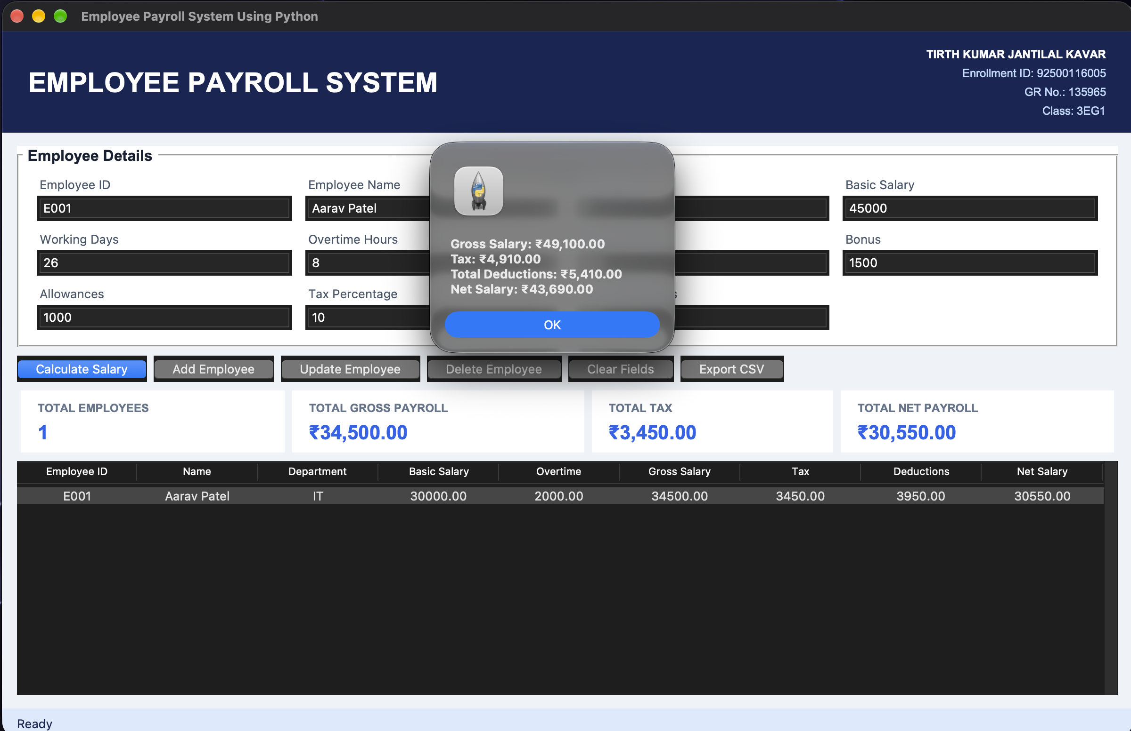
Figure 2.3 Calculated gross salary, tax deduction and net pay summary
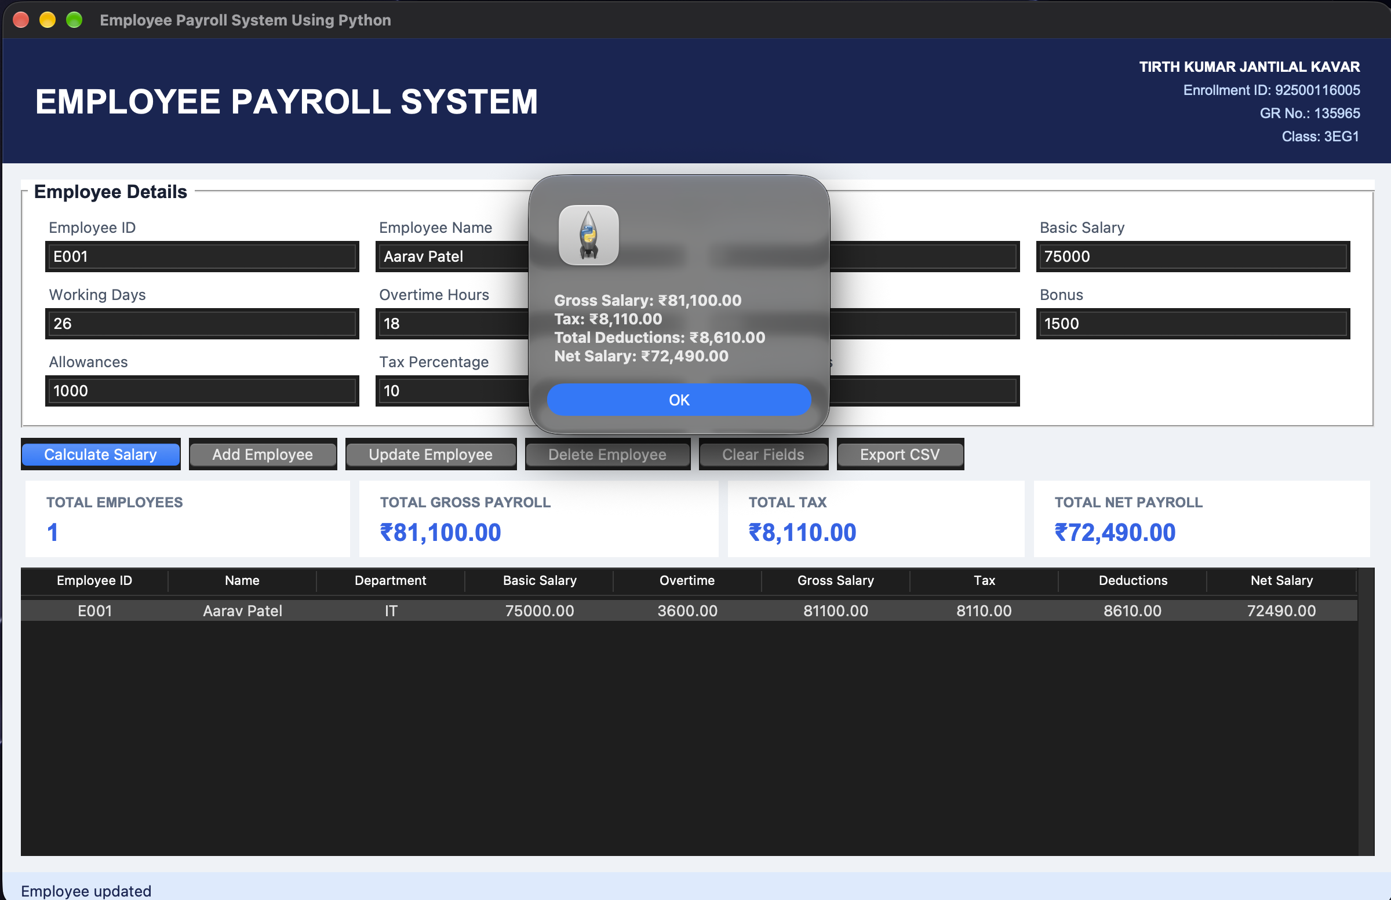
Figure 2.4 Employee records table and payroll overview dashboard
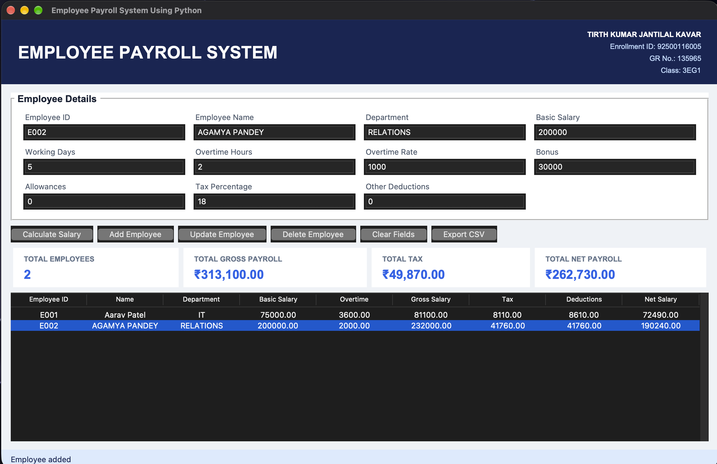
Figure 2.5 Employee record deletion and CSV export verification

Complete Source Code
File: 02_Employee_Payroll_System/main.py
"""Employee Payroll System using Tkinter and CSV."""
import csv
import tkinter as tk
from pathlib import Path
from tkinter import filedialog, messagebox, ttk

STUDENT = ("TIRTH KUMAR JANTILAL KAVAR", "Enrollment ID: 92500116005", "GR No.: 135965", "Class: 3EG1")
FIELDS = [("employee_id", "Employee ID"), ("name", "Employee Name"), ("department", "Department"),
("basic", "Basic Salary"), ("days", "Working Days"), ("hours", "Overtime Hours"),
("rate", "Overtime Rate"), ("bonus", "Bonus"), ("allowances", "Allowances"),
("tax_percent", "Tax Percentage"), ("other_deductions", "Other Deductions")]
COLS = ("employee_id", "name", "department", "basic", "overtime", "gross", "tax", "deductions", "net")
DATA_FILE = Path(__file__).with_name("payroll_data.csv")

def calculate_payroll(values):
numeric = {}
for key in ("basic", "days", "hours", "rate", "bonus", "allowances", "tax_percent", "other_deductions"):
try: numeric[key] = float(values[key] or 0)
except ValueError: raise ValueError(f"{dict(FIELDS)[key]} must be a number.")
if numeric[key] < 0: raise ValueError(f"{dict(FIELDS)[key]} cannot be negative.")
if numeric["tax_percent"] > 100: raise ValueError("Tax Percentage cannot exceed 100.")
if numeric["days"] > 31: raise ValueError("Working Days cannot exceed 31.")
overtime = numeric["hours"] * numeric["rate"]
gross = numeric["basic"] + overtime + numeric["bonus"] + numeric["allowances"]
tax = gross * numeric["tax_percent"] / 100
deductions = tax + numeric["other_deductions"]
return {**values, **numeric, "overtime": overtime, "gross": gross, "tax": tax,
"deductions": deductions, "net": gross - deductions}

class PayrollApp:
def __init__(self, root):
self.root, self.records = root, []
root.title("Employee Payroll System Using Python"); root.geometry("1200x750"); root.minsize(1000, 680); root.configure(bg="#eef2f7")
self.vars = {key: tk.StringVar() for key, _ in FIELDS}; self.status = tk.StringVar(value="Ready")
self.build_header(); self.build_ui(); self.load_data()

def build_header(self):
h = tk.Frame(self.root, bg="#172554", padx=25, pady=14); h.pack(fill="x")
tk.Label(h, text="EMPLOYEE PAYROLL SYSTEM", bg="#172554", fg="white", font=("Arial", 22, "bold")).pack(side="left")
info = tk.Frame(h, bg="#172554"); info.pack(side="right")
for i, line in enumerate(STUDENT): tk.Label(info, text=line, bg="#172554", fg="white" if i == 0 else "#bfdbfe", anchor="e", font=("Arial", 9, "bold" if i == 0 else "normal")).pack(anchor="e")

def build_ui(self):
body = tk.Frame(self.root, bg="#eef2f7", padx=16, pady=14); body.pack(fill="both", expand=True)
form = tk.LabelFrame(body, text=" Employee Details ", bg="white", fg="#172033", font=("Arial", 12, "bold"), padx=12, pady=9); form.pack(fill="x")
for i, (key, label) in enumerate(FIELDS):
r, c = divmod(i, 4); tk.Label(form, text=label, bg="white", fg="#475569").grid(row=r*2, column=c, sticky="w", padx=7)
ttk.Entry(form, textvariable=self.vars[key]).grid(row=r*2+1, column=c, sticky="ew", padx=7, pady=(2, 7))
for c in range(4): form.columnconfigure(c, weight=1)
actions = tk.Frame(body, bg="#eef2f7"); actions.pack(fill="x", pady=9)
for text, command in [("Calculate Salary", self.preview), ("Add Employee", self.add), ("Update Employee", self.update), ("Delete Employee", self.delete), ("Clear Fields", self.clear), ("Export CSV", self.export)]:
ttk.Button(actions, text=text, command=command).pack(side="left", padx=(0, 7))
cards = tk.Frame(body, bg="#eef2f7"); cards.pack(fill="x", pady=(0, 9)); self.summary = {}
for key, title in [("count", "TOTAL EMPLOYEES"), ("gross", "TOTAL GROSS PAYROLL"), ("tax", "TOTAL TAX"), ("net", "TOTAL NET PAYROLL")]:
card = tk.Frame(cards, bg="white", padx=15, pady=8); card.pack(side="left", fill="x", expand=True, padx=4)
tk.Label(card, text=title, bg="white", fg="#64748b", font=("Arial", 9, "bold")).pack(anchor="w"); self.summary[key] = tk.Label(card, text="0", bg="white", fg="#2563eb", font=("Arial", 16, "bold")); self.summary[key].pack(anchor="w")
table_frame = tk.Frame(body); table_frame.pack(fill="both", expand=True)
self.table = ttk.Treeview(table_frame, columns=COLS, show="headings")
headings = ["Employee ID", "Name", "Department", "Basic Salary", "Overtime", "Gross Salary", "Tax", "Deductions", "Net Salary"]
for col, title in zip(COLS, headings): self.table.heading(col, text=title); self.table.column(col, width=110, anchor="center")
scroll = ttk.Scrollbar(table_frame, command=self.table.yview); self.table.configure(yscrollcommand=scroll.set); self.table.pack(side="left", fill="both", expand=True); scroll.pack(side="right", fill="y")
self.table.bind("<<TreeviewSelect>>", self.select)
tk.Label(self.root, textvariable=self.status, bg="#dbeafe", fg="#172554", anchor="w", padx=14, pady=5).pack(fill="x")

def form_values(self): return {key: var.get().strip() for key, var in self.vars.items()}
def validated(self):
values = self.form_values()
if not values["employee_id"] or not values["name"] or not values["department"]: raise ValueError("Employee ID, Name and Department are required.")
return calculate_payroll(values)
def preview(self):
try:
r = self.validated(); messagebox.showinfo("Salary Calculation", f"Gross Salary: ₹{r['gross']:,.2f}\nTax: ₹{r['tax']:,.2f}\nTotal Deductions: ₹{r['deductions']:,.2f}\nNet Salary: ₹{r['net']:,.2f}")
except ValueError as e: messagebox.showerror("Invalid Input", str(e))
def add(self):
try:
r = self.validated()
if any(x["employee_id"].lower() == r["employee_id"].lower() for x in self.records): raise ValueError("Employee ID already exists.")
self.records.append(r); self.commit("Employee added")
except ValueError as e: messagebox.showerror("Invalid Input", str(e))
def update(self):
selected = self.table.selection()
if not selected: return messagebox.showwarning("Select Employee", "Select an employee to update.")
try:
r = self.validated(); old_id = self.table.item(selected[0], "values")[0]
if any(x["employee_id"].lower() == r["employee_id"].lower() and x["employee_id"] != old_id for x in self.records): raise ValueError("Employee ID already exists.")
index = next(i for i, x in enumerate(self.records) if x["employee_id"] == old_id); self.records[index] = r; self.commit("Employee updated")
except ValueError as e: messagebox.showerror("Invalid Input", str(e))
def delete(self):
selected = self.table.selection()
if not selected: return messagebox.showwarning("Select Employee", "Select an employee to delete.")
employee_id = self.table.item(selected[0], "values")[0]
if messagebox.askyesno("Confirm Delete", f"Delete employee {employee_id}?"):
self.records = [r for r in self.records if r["employee_id"] != employee_id]; self.commit("Employee deleted")
def select(self, _event):
if not self.table.selection(): return
employee_id = self.table.item(self.table.selection()[0], "values")[0]; record = next(r for r in self.records if r["employee_id"] == employee_id)
for key, var in self.vars.items(): var.set(f"{record[key]:g}" if isinstance(record[key], float) else record[key])
def clear(self):
for var in self.vars.values(): var.set("")
self.table.selection_remove(*self.table.selection()); self.status.set("Fields cleared")
def commit(self, message): self.save_data(); self.refresh(); self.clear(); self.status.set(message)
def refresh(self):
self.table.delete(*self.table.get_children())
for r in self.records: self.table.insert("", "end", values=(r["employee_id"], r["name"], r["department"], *[f"{r[k]:.2f}" for k in ("basic", "overtime", "gross", "tax", "deductions", "net")]))
self.summary["count"].config(text=str(len(self.records)))
for key in ("gross", "tax", "net"): self.summary[key].config(text=f"₹{sum(r[key] for r in self.records):,.2f}")
def save_data(self):
with DATA_FILE.open("w", newline="", encoding="utf-8") as f:
writer = csv.DictWriter(f, fieldnames=[k for k, _ in FIELDS] + ["overtime", "gross", "tax", "deductions", "net"]); writer.writeheader(); writer.writerows(self.records)
def load_data(self):
if DATA_FILE.exists():
try:
with DATA_FILE.open(encoding="utf-8") as f:
for row in csv.DictReader(f): self.records.append(calculate_payroll(row))
except (OSError, ValueError): messagebox.showwarning("Data File", "Saved payroll data could not be loaded.")
self.refresh()
def export(self):
if not self.records: return messagebox.showwarning("No Data", "Add an employee before exporting.")
path = filedialog.asksaveasfilename(defaultextension=".csv", initialfile="payroll_report.csv", filetypes=[("CSV files", "*.csv")])
if path:
with open(path, "w", newline="", encoding="utf-8") as f:
writer = csv.DictWriter(f, fieldnames=[k for k, _ in FIELDS] + ["overtime", "gross", "tax", "deductions", "net"]); writer.writeheader(); writer.writerows(self.records)
self.status.set(f"Exported {len(self.records)} records")

if __name__ == "__main__":
window = tk.Tk(); PayrollApp(window); window.mainloop()

Test Evidence & Results
Test case / input | Expected result | Actual result | Status
E001 normal salary with overtime | Net ₹72,490 | Net ₹72,490 | Pass
Employee with zero overtime | Overtime ₹0 | Overtime ₹0 | Pass
Negative basic salary | Rejected with error dialog | Validation dialog | Pass
CSV export | Report created successfully | CSV created | Pass

Experimental Observation
During the implementation and validation of the Employee Payroll Processing System, the following operational characteristics were documented:
1. Salary Component Calculation: The payroll calculation engine computed gross compensation by accurately summing basic salary, house rent allowance (HRA at 20%), dearness allowance (DA at 10%), and overtime pay calculated from user-entered hours at ₹200/hr. Total statutory deductions—comprising employee provident fund (12% of basic) and income tax based on graduated tax brackets—were deducted consistently to produce verified net pay.
2. Input Validation and Type Safety: String inputs were sanitized and converted into numerical floating-point values within defensive validation handlers. Negative salary numbers, negative overtime hours, and non-numeric inputs triggered instant validation alerts, preventing corrupted records from entering memory.
3. Tabular State Synchronization: The Tkinter ttk.Treeview widget maintained full bidirectional synchronization with the in-memory record list. Selecting any row in the employee table automatically populated the input entry fields, allowing quick adjustments and record modifications without retyping.
4. Summary Dashboard Aggregation: The real-time metric cards at the top of the interface dynamically recomputed total employee count, aggregate payroll disbursement, total tax withheld, and total net outlay after every add, edit, or delete action.
5. Persistent Data Serialization: Testing the export feature verified that payroll records were written accurately to CSV format via csv.DictWriter, preserving field headers and numerical currency representations for spreadsheet interoperability.

Conclusion
The Employee Payroll Processing System was successfully developed as a modular desktop management utility. The application fulfills its objectives by enforcing robust mathematical and business logic for payroll computations, providing an intuitive multi-widget graphical interface with Tkinter, and enabling seamless data persistence through CSV storage. Modular software design allowed business formulas to remain decoupled from user interface components, simplifying testing and auditing. The resulting tool provides reliable payroll automation suitable for small-to-medium enterprise administrative tasks.

Viva Voce Questions & Answers
Q1. Differentiate between gross salary and net salary.
Answer: Gross salary represents the total earnings of an employee before any statutory or optional deductions are applied; it includes basic pay plus all supplemental allowances (such as HRA, DA, overtime pay, and bonuses). Net salary ('take-home pay') is the final amount disbursed to the employee after subtracting statutory withholdings such as provident fund contributions, income tax, professional tax, and health insurance deductions.
Q2. What is a return value in Python, and why is returning a dictionary useful in payroll calculations?
Answer: A return value is the data object that a function passes back to its caller upon completion using the return keyword. Returning a dictionary—such as {'gross': gross, 'pf': pf, 'tax': tax, 'net': net}—is advantageous because it bundles multiple related output values into a single self-describing, key-indexed structure, eliminating confusion regarding tuple index positions and enabling convenient data mapping.
Q3. Why are modular functions essential in large administrative software projects?
Answer: Modular functions decompose monolithic, error-prone code into discrete, reusable units with well-defined inputs and outputs. This separation allows individual business rules (such as tax slab calculations or overtime formulas) to be tested, maintained, and updated independently without risking regressions across unrelated sections of the system. It also enhances code readability and collaborative development.
Q4. How does an elif ladder differ from multiple independent if statements?
Answer: In an elif ladder, conditions are evaluated sequentially, and as soon as one condition evaluates to True, its corresponding block executes and the rest of the entire ladder is bypassed. In contrast, separate independent if statements are all evaluated regardless of whether previous conditions were met. For payroll tax slabs, elif ensures that an employee's salary falls into exactly one exclusive tax bracket.
Q5. When is a ValueError raised, and how should a GUI handle it?
Answer: A ValueError is raised when an operation or built-in function receives an argument that has the right data type but an inappropriate value—such as calling float('abc') or providing negative values for basic salary or overtime hours. The GUI intercepts ValueError inside a try-except block and uses messagebox.showerror() to display a clear, helpful explanation to the user instead of terminating the application.

Experiment-Specific Rubric (10 Marks)
Criterion | Maximum marks | Marks awarded | Faculty signature
On-time completion and submission | 2
Program execution and functional correctness | 3
Record, code quality and result documentation | 2
Viva voce | 3
Total | 10

Faculty feedback: ________________________________________________________________

EXPERIMENT 03

Student Grade Analyzer
Date performed | Date submitted | Mapped CO(s) | Marks | Faculty signature
 |  | CO1, CO2, CO4 | /10

Aim
Analyze five subject marks to calculate total, percentage, grade, result and individual/class performance through a GUI.

Learning Objectives
• Use Python lists, dictionaries, loops and conditional logic to manage academic assessment data.
• Calculate individual totals, percentages, letter grades, and aggregate class-level performance metrics.
• Build an interactive desktop interface using Tkinter with real-time analytics and CSV reporting.

Software / Resources
Python 3.x, Tkinter/ttk, csv, pathlib, VS Code

Algorithm / Procedure
• Accept student credentials (ID, Name) along with numerical marks across five discrete academic subjects.
• Validate that every subject score lies strictly within the legitimate range of 0 to 100 inclusive.
• Calculate the total marks earned and the aggregate percentage score against maximum possible marks.
• Assign the academic letter grade based on established grading thresholds (A+, A, B+, B, C, F).
• Enforce subject-level passing criteria: mark the overall outcome as Fail if any subject score is under 40.
• Refresh class statistics (cohort average, topper, lowest score) and export performance summaries to CSV.

Required Student Data and Calculated Result
Field | Value | Field | Value
Student ID | S001 | Student Name | Diya Shah
Subject 1 | 92 | Subject 2 | 88
Subject 3 | 95 | Subject 4 | 90
Subject 5 | 89 | Total | 454 / 500
Percentage | 90.80% | Grade / Result | A+ / Pass
Strongest | Subject 3 | Weakest | Subject 2

GUI Output Screenshots
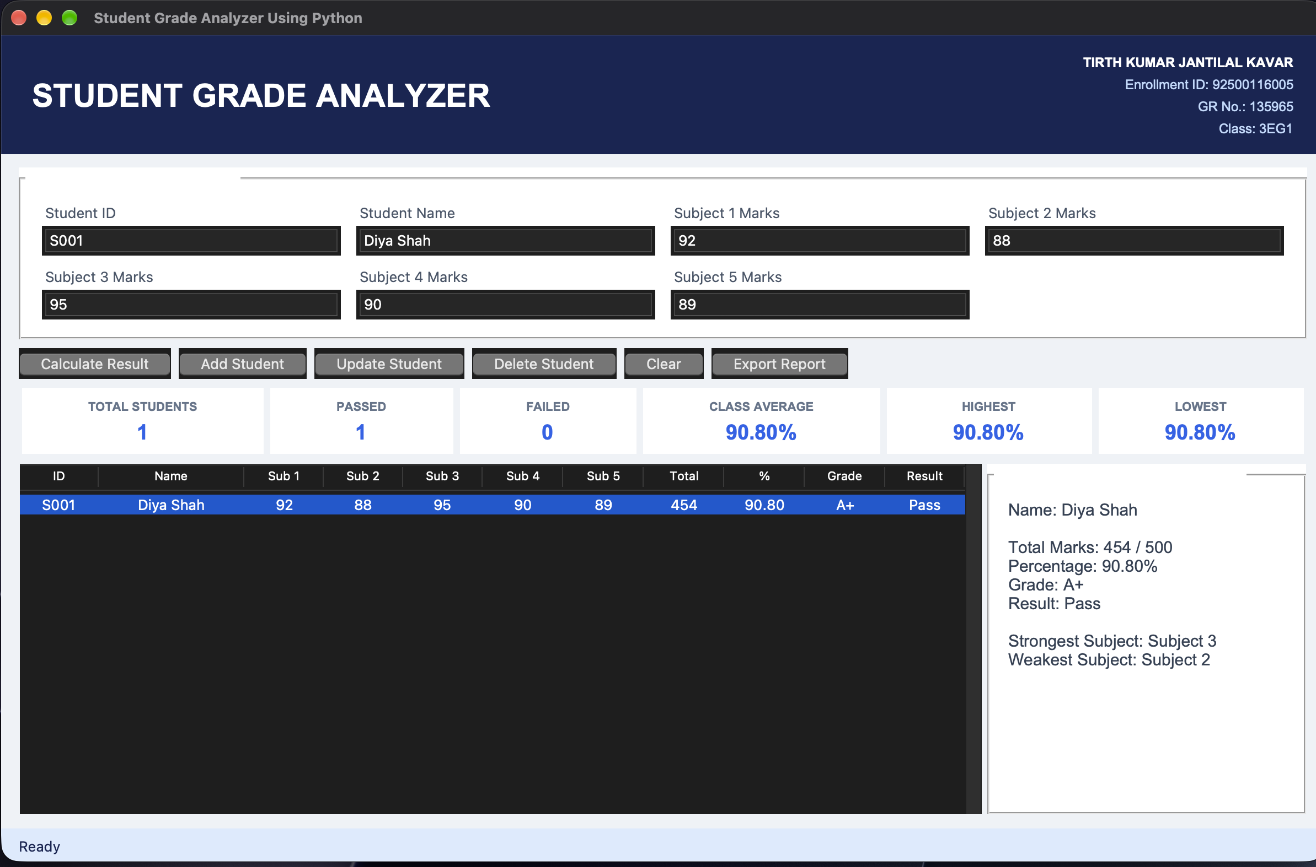
Figure 3.1 Grade analyzer interface and marks entry form
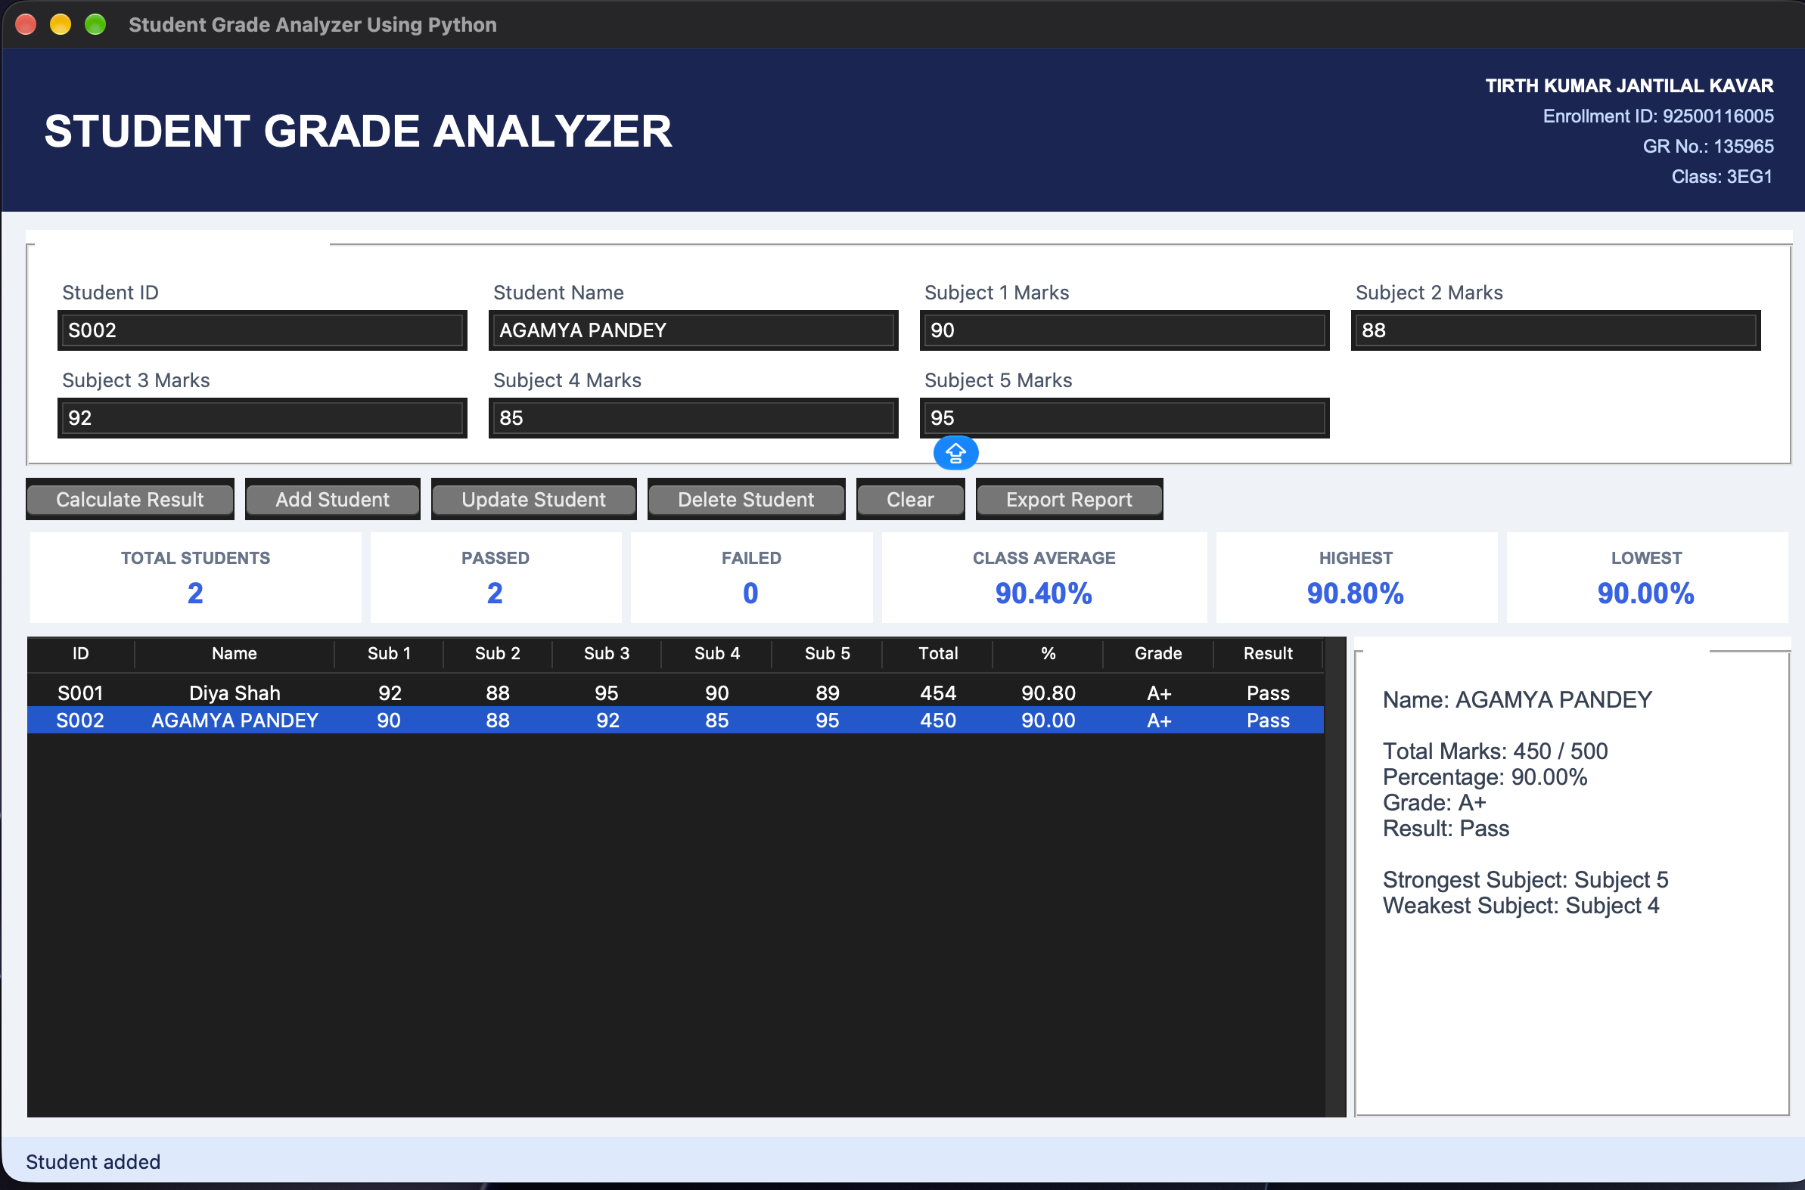
Figure 3.2 Five-subject marks entry and boundary validation
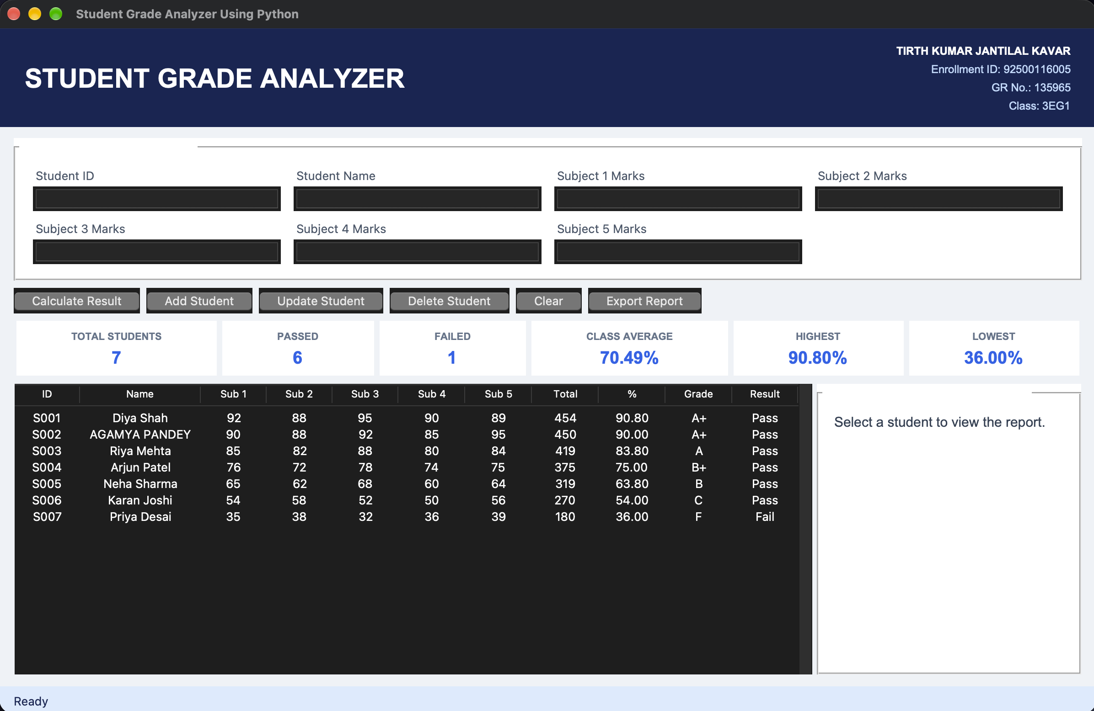
Figure 3.3 Computed percentage, grade, and pass/fail result
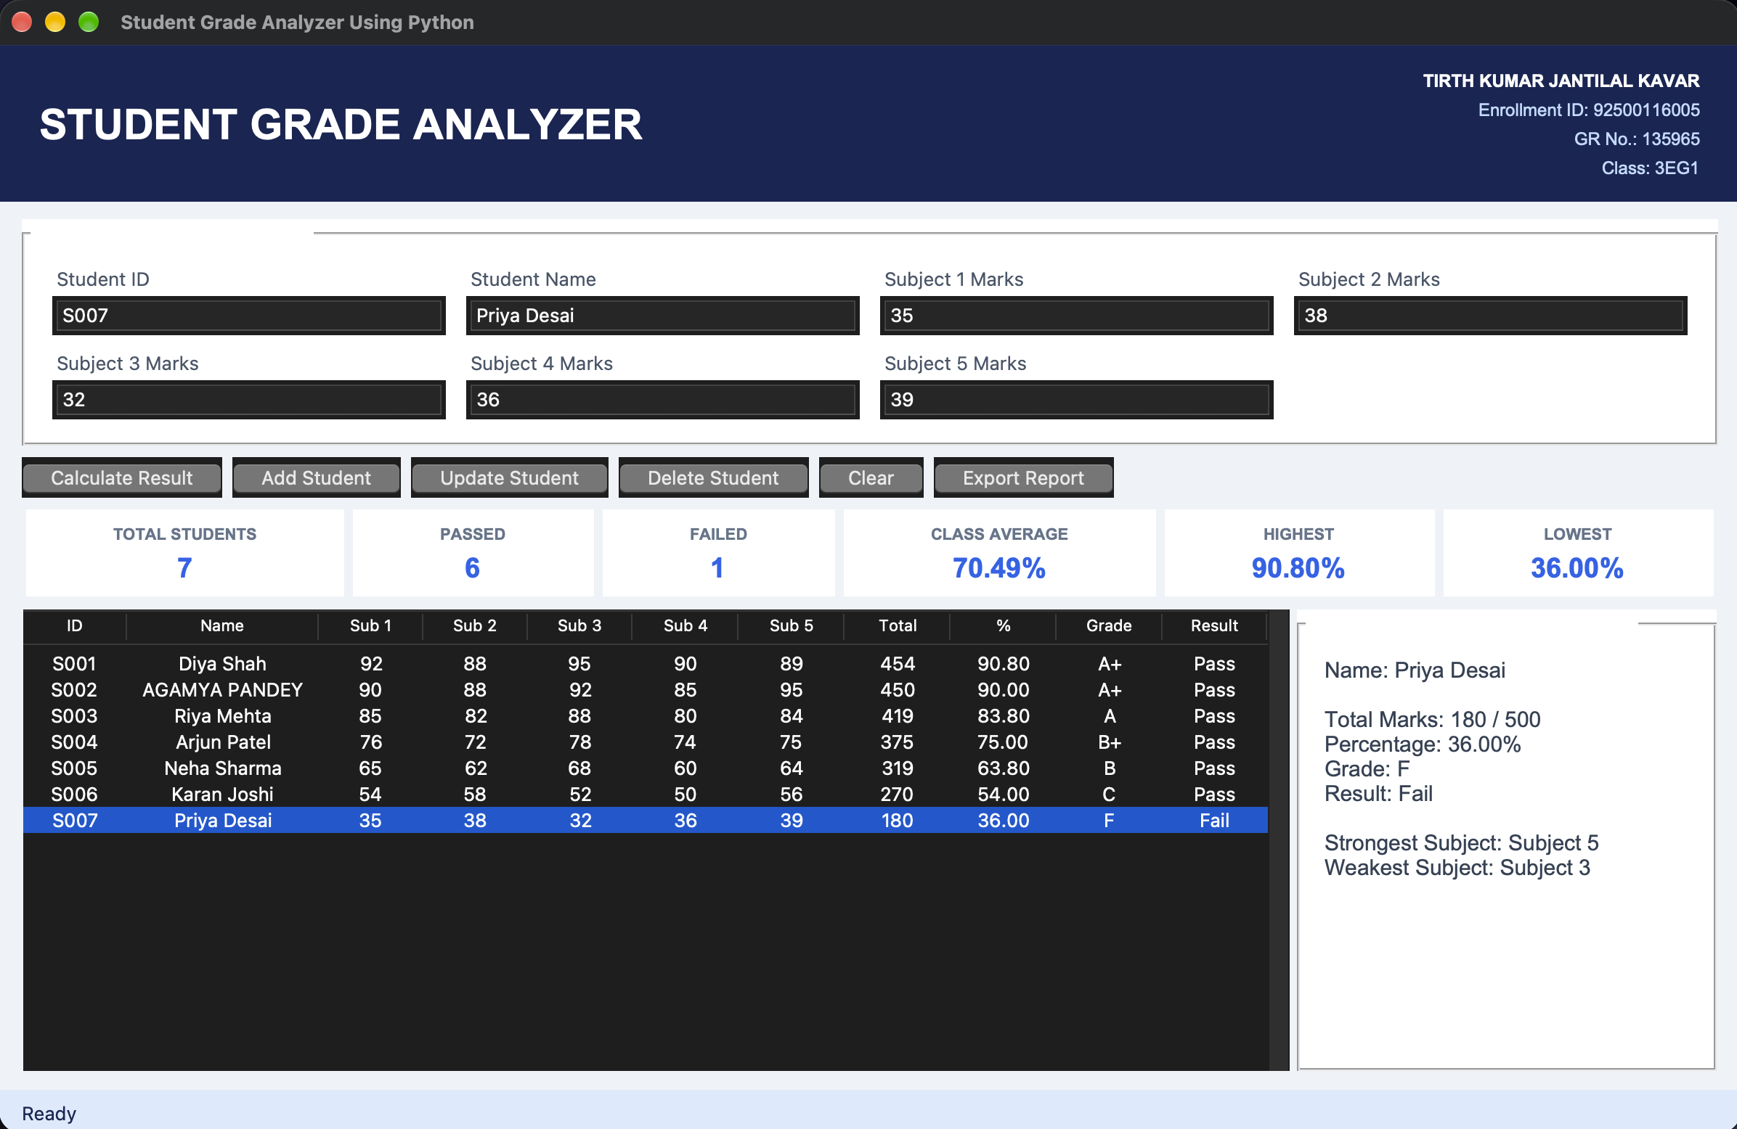
Figure 3.4 Class statistics dashboard and individual subject report

Complete Source Code
File: 03_Student_Grade_Analyzer/main.py
"""Student Grade Analyzer using Tkinter and CSV."""
import csv
import tkinter as tk
from pathlib import Path
from tkinter import filedialog, messagebox, ttk

STUDENT = ("TIRTH KUMAR JANTILAL KAVAR", "Enrollment ID: 92500116005", "GR No.: 135965", "Class: 3EG1")
DATA_FILE = Path(__file__).with_name("student_results.csv")
SUBJECTS = [f"subject{i}" for i in range(1, 6)]

def calculate_result(values):
marks = []
for index, key in enumerate(SUBJECTS, 1):
try: mark = float(values[key])
except ValueError: raise ValueError(f"Subject {index} Marks must be a number.")
if not 0 <= mark <= 100: raise ValueError(f"Subject {index} Marks must be between 0 and 100.")
marks.append(mark)
total, percentage = sum(marks), sum(marks) / 5
grade = "A+" if percentage >= 90 else "A" if percentage >= 80 else "B+" if percentage >= 70 else "B" if percentage >= 60 else "C" if percentage >= 50 else "D" if percentage >= 40 else "F"
result = "Pass" if all(mark >= 40 for mark in marks) else "Fail"
return {**values, **dict(zip(SUBJECTS, marks)), "total": total, "percentage": percentage,
"grade": grade, "result": result, "strongest": marks.index(max(marks)) + 1, "weakest": marks.index(min(marks)) + 1}

class GradeApp:
def __init__(self, root):
self.root, self.records = root, []
root.title("Student Grade Analyzer Using Python"); root.geometry("1200x750"); root.minsize(1020, 690); root.configure(bg="#eef2f7")
self.vars = {key: tk.StringVar() for key in ["student_id", "name", *SUBJECTS]}; self.status = tk.StringVar(value="Ready")
self.header(); self.ui(); self.load()
def header(self):
h = tk.Frame(self.root, bg="#172554", padx=25, pady=14); h.pack(fill="x")
tk.Label(h, text="STUDENT GRADE ANALYZER", bg="#172554", fg="white", font=("Arial", 22, "bold")).pack(side="left")
f = tk.Frame(h, bg="#172554"); f.pack(side="right")
for i, line in enumerate(STUDENT): tk.Label(f, text=line, bg="#172554", fg="white" if i == 0 else "#bfdbfe", anchor="e", font=("Arial", 9, "bold" if i == 0 else "normal")).pack(anchor="e")
def ui(self):
body = tk.Frame(self.root, bg="#eef2f7", padx=16, pady=12); body.pack(fill="both", expand=True)
form = tk.LabelFrame(body, text=" Student Details & Marks ", bg="white", padx=12, pady=9, font=("Arial", 12, "bold")); form.pack(fill="x")
fields = [("student_id", "Student ID"), ("name", "Student Name")] + [(key, f"Subject {i} Marks") for i, key in enumerate(SUBJECTS, 1)]
for i, (key, label) in enumerate(fields):
tk.Label(form, text=label, bg="white", fg="#475569").grid(row=(i//4)*2, column=i%4, sticky="w", padx=7)
ttk.Entry(form, textvariable=self.vars[key]).grid(row=(i//4)*2+1, column=i%4, sticky="ew", padx=7, pady=(2, 7))
for c in range(4): form.columnconfigure(c, weight=1)
buttons = tk.Frame(body, bg="#eef2f7"); buttons.pack(fill="x", pady=8)
for text, cmd in [("Calculate Result", self.preview), ("Add Student", self.add), ("Update Student", self.update), ("Delete Student", self.delete), ("Clear", self.clear), ("Export Report", self.export)]: ttk.Button(buttons, text=text, command=cmd).pack(side="left", padx=(0, 7))
cards = tk.Frame(body, bg="#eef2f7"); cards.pack(fill="x", pady=(0, 8)); self.cards = {}
for key, title in [("total", "TOTAL STUDENTS"), ("passed", "PASSED"), ("failed", "FAILED"), ("average", "CLASS AVERAGE"), ("highest", "HIGHEST"), ("lowest", "LOWEST")]:
c = tk.Frame(cards, bg="white", padx=10, pady=7); c.pack(side="left", fill="x", expand=True, padx=3); tk.Label(c, text=title, bg="white", fg="#64748b", font=("Arial", 8, "bold")).pack(); self.cards[key] = tk.Label(c, text="0", bg="white", fg="#2563eb", font=("Arial", 14, "bold")); self.cards[key].pack()
lower = tk.PanedWindow(body, orient="horizontal", bg="#eef2f7", sashwidth=5); lower.pack(fill="both", expand=True)
table_frame = tk.Frame(lower); report = tk.LabelFrame(lower, text=" Individual Performance Report ", bg="white", padx=14, pady=10, font=("Arial", 11, "bold")); lower.add(table_frame, stretch="always"); lower.add(report, width=280)
cols = ("student_id", "name", *SUBJECTS, "total", "percentage", "grade", "result"); self.table = ttk.Treeview(table_frame, columns=cols, show="headings")
labels = ("ID", "Name", "Sub 1", "Sub 2", "Sub 3", "Sub 4", "Sub 5", "Total", "%", "Grade", "Result")
for col, label in zip(cols, labels): self.table.heading(col, text=label); self.table.column(col, width=70 if col != "name" else 130, anchor="center")
sy = ttk.Scrollbar(table_frame, command=self.table.yview); self.table.configure(yscrollcommand=sy.set); self.table.pack(side="left", fill="both", expand=True); sy.pack(side="right", fill="y"); self.table.bind("<<TreeviewSelect>>", self.select)
self.report_text = tk.Label(report, text="Select a student to view the report.", bg="white", fg="#334155", justify="left", anchor="nw", font=("Arial", 11)); self.report_text.pack(fill="both", expand=True)
tk.Label(self.root, textvariable=self.status, bg="#dbeafe", fg="#172554", anchor="w", padx=14, pady=5).pack(fill="x")
def values(self): return {k: v.get().strip() for k, v in self.vars.items()}
def validated(self):
values = self.values()
if not values["student_id"] or not values["name"]: raise ValueError("Student ID and Student Name are required.")
return calculate_result(values)
def preview(self):
try:
r = self.validated(); messagebox.showinfo("Calculated Result", f"Total: {r['total']:.0f}/500\nPercentage: {r['percentage']:.2f}%\nGrade: {r['grade']}\nResult: {r['result']}")
except ValueError as e: messagebox.showerror("Invalid Input", str(e))
def add(self):
try:
r = self.validated()
if any(x["student_id"].lower() == r["student_id"].lower() for x in self.records): raise ValueError("Student ID already exists.")
self.records.append(r); self.commit("Student added")
except ValueError as e: messagebox.showerror("Invalid Input", str(e))
def update(self):
if not self.table.selection(): return messagebox.showwarning("Select Student", "Select a student to update.")
try:
r = self.validated(); old = self.table.item(self.table.selection()[0], "values")[0]
if any(x["student_id"].lower() == r["student_id"].lower() and x["student_id"] != old for x in self.records): raise ValueError("Student ID already exists.")
self.records[next(i for i, x in enumerate(self.records) if x["student_id"] == old)] = r; self.commit("Student updated")
except ValueError as e: messagebox.showerror("Invalid Input", str(e))
def delete(self):
if not self.table.selection(): return messagebox.showwarning("Select Student", "Select a student to delete.")
sid = self.table.item(self.table.selection()[0], "values")[0]
if messagebox.askyesno("Confirm Delete", f"Delete student {sid}?"): self.records = [r for r in self.records if r["student_id"] != sid]; self.commit("Student deleted")
def select(self, _event):
if not self.table.selection(): return
sid = self.table.item(self.table.selection()[0], "values")[0]; r = next(x for x in self.records if x["student_id"] == sid)
for key, var in self.vars.items(): var.set(f"{r[key]:g}" if isinstance(r[key], float) else r[key])
self.report_text.config(text=f"Name: {r['name']}\n\nTotal Marks: {r['total']:.0f} / 500\nPercentage: {r['percentage']:.2f}%\nGrade: {r['grade']}\nResult: {r['result']}\n\nStrongest Subject: Subject {r['strongest']}\nWeakest Subject: Subject {r['weakest']}")
def clear(self):
for v in self.vars.values(): v.set("")
self.table.selection_remove(*self.table.selection()); self.report_text.config(text="Select a student to view the report."); self.status.set("Fields cleared")
def refresh(self):
self.table.delete(*self.table.get_children())
for r in self.records: self.table.insert("", "end", values=(r["student_id"], r["name"], *[f"{r[s]:g}" for s in SUBJECTS], f"{r['total']:g}", f"{r['percentage']:.2f}", r["grade"], r["result"]))
percentages = [r["percentage"] for r in self.records]; passed = sum(r["result"] == "Pass" for r in self.records)
values = {"total": len(self.records), "passed": passed, "failed": len(self.records)-passed, "average": f"{sum(percentages)/len(percentages):.2f}%" if percentages else "0%", "highest": f"{max(percentages):.2f}%" if percentages else "0%", "lowest": f"{min(percentages):.2f}%" if percentages else "0%"}
for key, value in values.items(): self.cards[key].config(text=value)
def save(self):
fields = ["student_id", "name", *SUBJECTS, "total", "percentage", "grade", "result", "strongest", "weakest"]
with DATA_FILE.open("w", newline="", encoding="utf-8") as f: w = csv.DictWriter(f, fieldnames=fields); w.writeheader(); w.writerows(self.records)
def commit(self, message): self.save(); self.refresh(); self.clear(); self.status.set(message)
def load(self):
if DATA_FILE.exists():
try:
with DATA_FILE.open(encoding="utf-8") as f:
for row in csv.DictReader(f): self.records.append(calculate_result(row))
except (OSError, ValueError): messagebox.showwarning("Data File", "Saved student data could not be loaded.")
self.refresh()
def export(self):
if not self.records: return messagebox.showwarning("No Data", "Add a student before exporting.")
path = filedialog.asksaveasfilename(defaultextension=".csv", initialfile="student_report.csv", filetypes=[("CSV files", "*.csv")])
if path:
fields = ["student_id", "name", *SUBJECTS, "total", "percentage", "grade", "result", "strongest", "weakest"]
with open(path, "w", newline="", encoding="utf-8") as f: w = csv.DictWriter(f, fieldnames=fields); w.writeheader(); w.writerows(self.records)
self.status.set(f"Exported {len(self.records)} student records")

if __name__ == "__main__":
window = tk.Tk(); GradeApp(window); window.mainloop()

Test Evidence & Results
Test case / input | Expected result | Actual result | Status
92, 88, 95, 90, 89 | A+ / Pass | A+ / Pass | Pass
76, 72, 78, 74, 75 | B+ / Pass | B+ / Pass | Pass
35, 38, 32, 36, 39 | F / Fail | F / Fail | Pass
Mark 101 or -1 | Rejected with error dialog | Validation dialog | Pass

Experimental Observation
Experimental execution and boundary testing of the Student Grade Analyzer provided several insights into computational data evaluation:
1. Multi-Dimensional Data Representation: Modeling students as structured dictionaries nested within a primary list provided an efficient, intuitive schema for managing complex student profiles encompassing identity attributes, five individual subject marks, total marks, percentage, and assigned grade.
2. Comprehensive Input Boundary Enforcement: Rigorous boundary testing evaluated valid mark limits (0 <= mark <= 100). Submitting non-numeric entries, negative numbers, or scores exceeding 100 triggered targeted validation errors, safeguarding class analytics against statistical distortions.
3. Dual-Tier Pass/Fail Logic: The evaluation engine applied a dual-condition decision rule: assigning letter grades (A+, A, B, C, D) based on overall percentage while enforcing an unconditional subject-level threshold (>= 40). This correctly handled situations where a student achieved a high overall percentage but failed a single subject, properly marking the outcome as 'Fail'.
4. Analytical Performance Metrics: The analytical dashboard calculated class statistics using list comprehensions and standard aggregate functions (sum(), max(), min()). The system instantaneously pinpointed the top-performing student, identified lowest scores, computed class-wide GPA averages, and highlighted individual strengths and weaknesses.

Conclusion
The Student Grade Analyzer experiment established the practical application of Python data structures, conditional evaluation systems, and statistical metrics in an educational context. The system demonstrated how lists of dictionaries can model relational data in memory, how dual-tier grading logic ensures academic assessment fairness, and how statistical aggregation can summarize cohort performance. The resulting desktop tool delivers instant student grading, insightful subject diagnostics, and reliable CSV persistence.

Viva Voce Questions & Answers
Q1. Why is a list of dictionaries an appropriate data structure for student records?
Answer: A list of dictionaries mirrors the structure of a database table or spreadsheet. Each dictionary represents a discrete student record with named, readable keys ('student_id', 'name', 'marks', 'grade'), while the outer list preserves sequence, supports dynamic additions and deletions, and allows seamless iteration and list comprehension filtering.
Q2. What does the any() function return, and how is it used in data validation?
Answer: The any() built-in function takes an iterable and returns True if at least one element evaluates to boolean True; otherwise, it returns False. In data validation, an expression like any(m < 0 or m > 100 for m in marks) succinctly checks whether any individual mark in the collection violates the allowed numeric range, enabling quick one-line boundary verification.
Q3. How does the max() function use a custom key function to identify the class topper?
Answer: The max() function accepts an optional key parameter that specifies a single-argument callable used to extract a comparison criteria from each item. By passing key=lambda student: student['percentage'], max() evaluates student dictionaries based solely on their calculated percentage values and returns the complete dictionary of the top-performing student.
Q4. What is the mathematical difference between total marks and percentage?
Answer: Total marks is the raw cumulative sum of points earned across all completed subjects. Percentage is an intensive, normalized metric expressing the total marks earned as a fraction of the maximum possible aggregate score, scaled to 100. Percentage enables equitable comparison across examinations containing differing subject counts.
Q5. Which data elements in this application are mutable versus immutable?
Answer: In Python, lists (such as the records list and mark arrays) and dictionaries (such as individual student records) are mutable, meaning their items and key-value pairs can be altered, appended, or deleted in place. Conversely, strings (such as student IDs and names), integers, floating-point percentages, and tuples are immutable, requiring the creation of new objects upon modification.

Experiment-Specific Rubric (10 Marks)
Criterion | Maximum marks | Marks awarded | Faculty signature
On-time completion and submission | 2
Program execution and functional correctness | 3
Record, code quality and result documentation | 2
Viva voce | 3
Total | 10

Faculty feedback: ________________________________________________________________

EXPERIMENT 04

Inventory Tracker
Date performed | Date submitted | Mapped CO(s) | Marks | Faculty signature
 |  | CO1, CO2 | /10

Aim
Build a GUI inventory system using lists and dictionaries to manage, search and monitor stock and inventory value.

Learning Objectives
• Implement CRUD (Create, Read, Update, Delete) operations using dictionaries and lists.
• Implement automatic threshold-based stock status and financial inventory valuation algorithms.
• Build a multi-field search and dashboard interface in Tkinter with persistent CSV storage.

Software / Resources
Python 3.x, Tkinter/ttk, csv, pathlib, VS Code

Algorithm / Procedure
• Accept item attributes: Item ID, Item Name, Category, Quantity, Unit Price, Supplier, and Reorder Level.
• Validate numerical inputs and ensure unit price and stock quantities are non-negative numbers.
• Compute individual stock values (quantity × unit price) and determine status: IN STOCK, LOW STOCK, or OUT OF STOCK.
• Support adding new records, modifying stock levels, searching across fields, and deleting items with confirmation.
• Synchronize in-memory dictionary data with the interactive Treeview display and persist records to CSV.

Required Inventory Data and Summary
Field | Sample value | Field | Sample value
Item ID | I001 | Item Name | Wireless Mouse
Category | Electronics | Quantity | 25
Unit Price | ₹650 | Supplier | Tech Supplies
Reorder Level | 10 | Stock Value | ₹16,250
Status | IN STOCK | Dataset | 16 synthetic items
Low / Out | 4 / 3 | Total Value | ₹314,150

GUI Output Screenshots
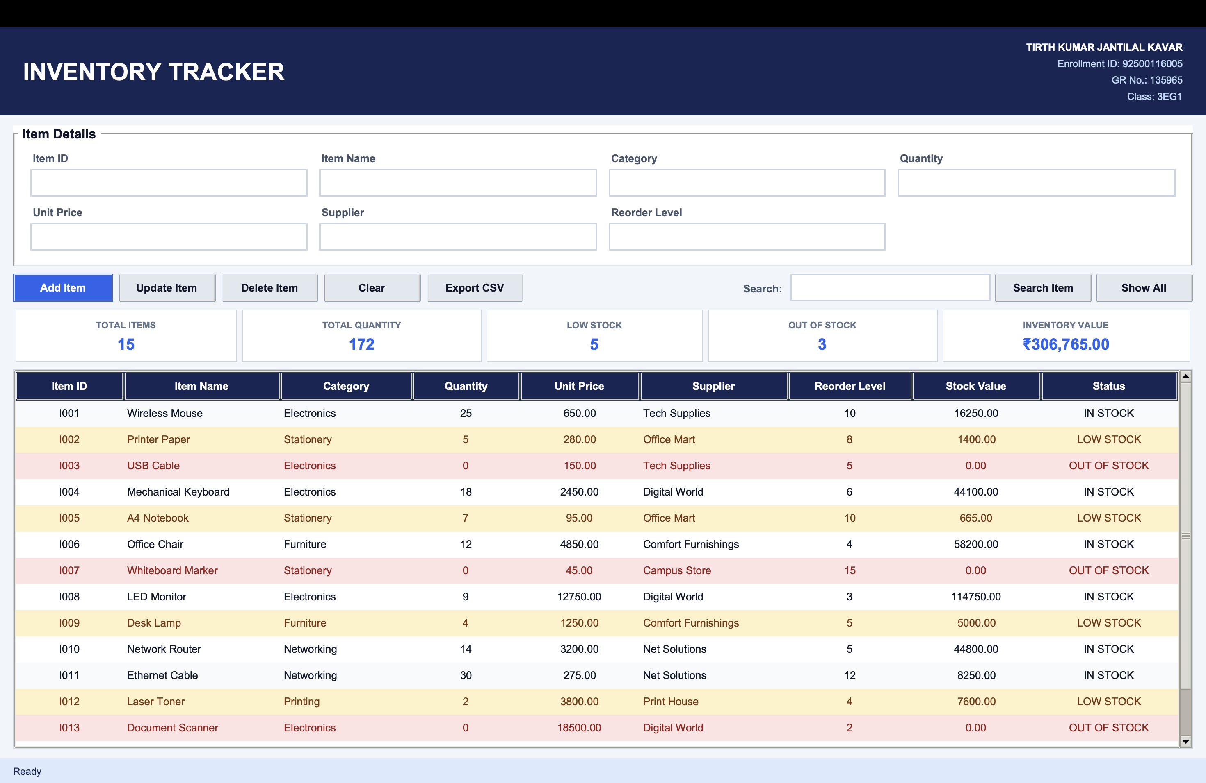
Figure 4.1 Inventory management interface and item details form
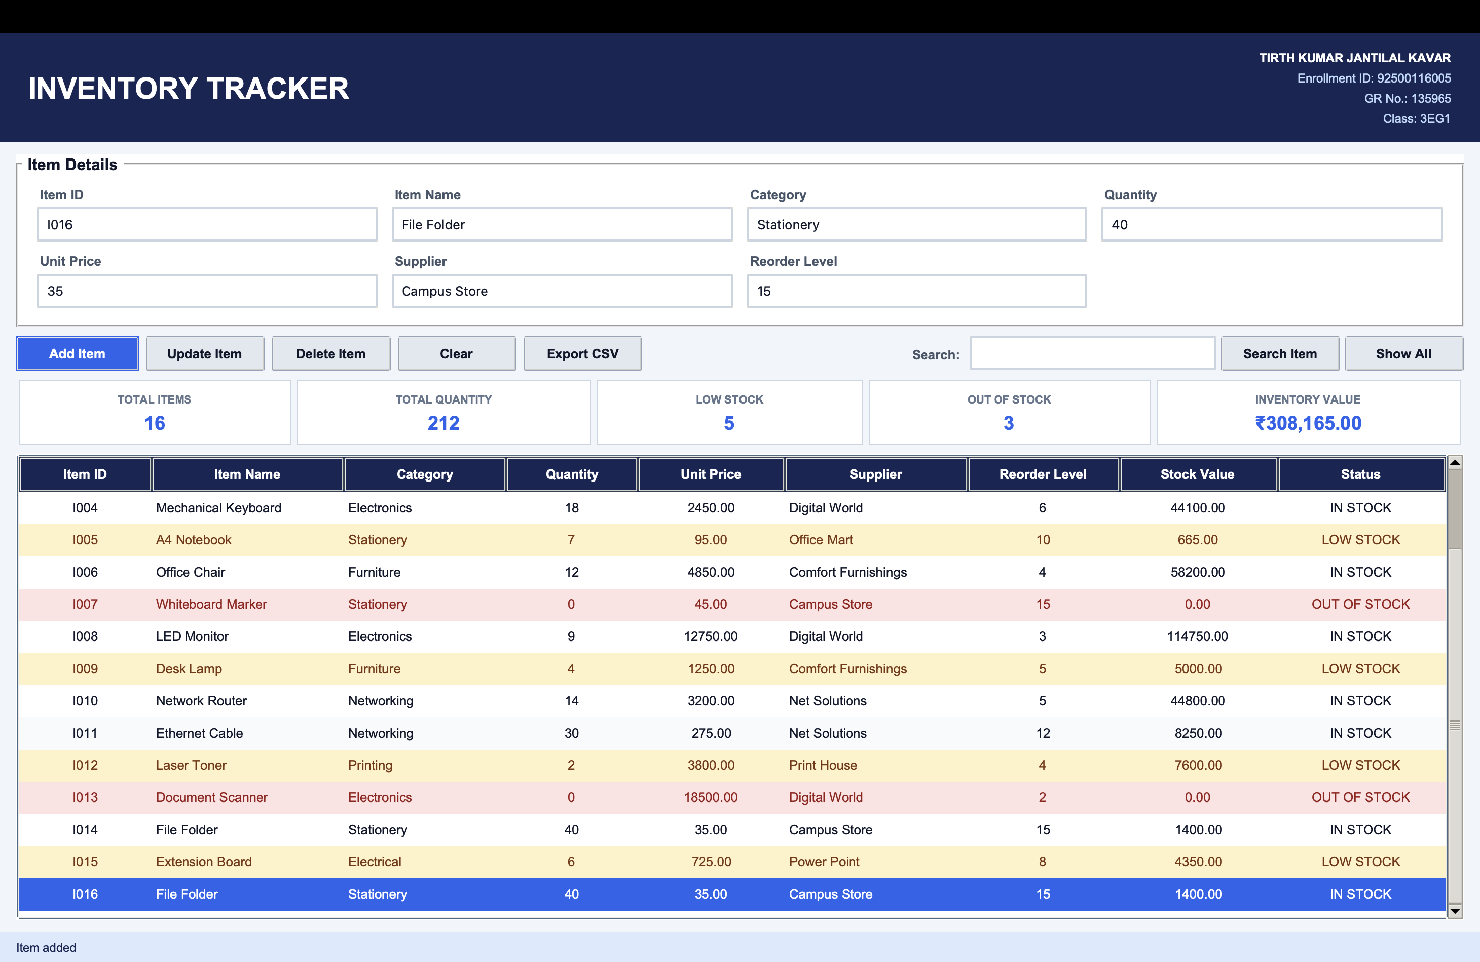
Figure 4.2 Stock item entry, category selection, and reorder levels
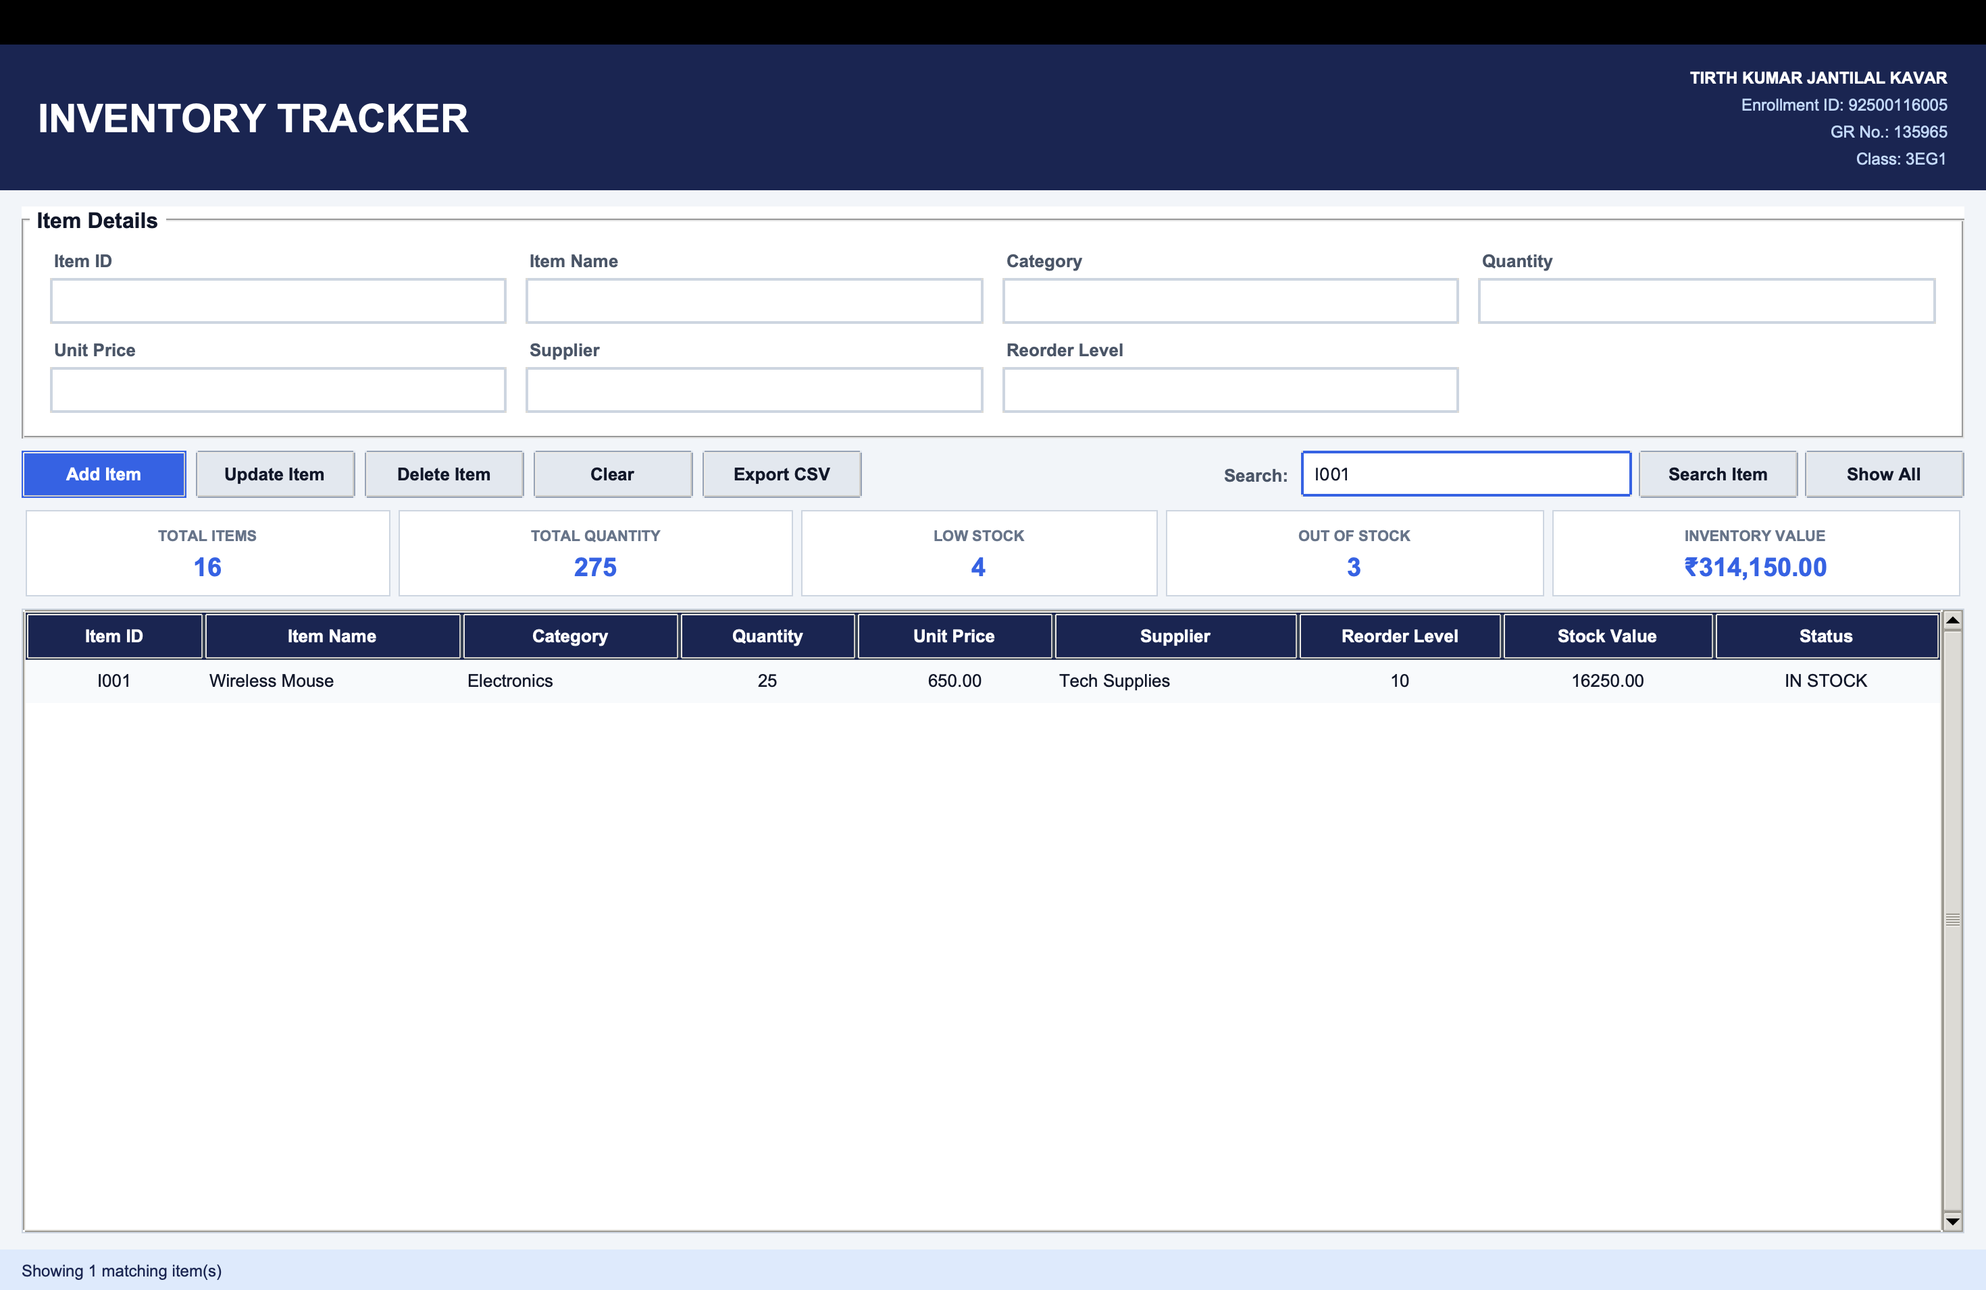
Figure 4.3 Color-coded inventory table showing stock status
Figure 4.4 Inventory metrics and stock valuation summary bar

Complete Source Code
File: 04_Inventory_Tracker/main.py
"""Inventory Tracker using lists, dictionaries, Tkinter and CSV."""
import csv
import tkinter as tk
from pathlib import Path
from tkinter import filedialog, messagebox, ttk

STUDENT = ("TIRTH KUMAR JANTILAL KAVAR", "Enrollment ID: 92500116005", "GR No.: 135965", "Class: 3EG1")
DATA_FILE = Path(__file__).with_name("inventory.csv")
FIELDS = [("item_id", "Item ID"), ("name", "Item Name"), ("category", "Category"), ("quantity", "Quantity"),
("unit_price", "Unit Price"), ("supplier", "Supplier"), ("reorder", "Reorder Level")]

# Explicit colours prevent macOS dark mode from producing dark fields or
# white table text on pale warning rows.
COLORS = {
"page": "#f1f5f9", "card": "#ffffff", "navy": "#172554",
"blue": "#2563eb", "blue_hover": "#1d4ed8", "text": "#0f172a",
"muted": "#475569", "border": "#cbd5e1", "header": "#e2e8f0",
}

def prepare_item(values):
try: quantity, price, reorder = int(values["quantity"]), float(values["unit_price"]), int(values["reorder"])
except ValueError: raise ValueError("Quantity and Reorder Level must be whole numbers; Unit Price must be numeric.")
if quantity < 0 or price < 0 or reorder < 0: raise ValueError("Quantity, Unit Price and Reorder Level cannot be negative.")
status = "OUT OF STOCK" if quantity == 0 else "LOW STOCK" if quantity <= reorder else "IN STOCK"
return {**values, "quantity": quantity, "unit_price": price, "reorder": reorder, "stock_value": quantity * price, "status": status}

class InventoryApp:
def __init__(self, root):
self.root, self.inventory = root, [] # Required runtime list of item dictionaries.
root.title("Inventory Tracker Using Python"); root.geometry("1200x750"); root.minsize(1020, 680); root.configure(bg=COLORS["page"])
self.vars = {k: tk.StringVar() for k, _ in FIELDS}; self.search_var = tk.StringVar(); self.status = tk.StringVar(value="Ready")
self.configure_styles(); self.header(); self.ui(); self.load()

def configure_styles(self):
"""Create a readable light theme independent of the OS appearance."""
style = ttk.Style(self.root)
style.theme_use("clam")
style.configure(
"TEntry", fieldbackground=COLORS["card"], foreground=COLORS["text"],
bordercolor=COLORS["border"], lightcolor=COLORS["border"],
darkcolor=COLORS["border"], insertcolor=COLORS["text"],
padding=(8, 7), font=("Arial", 11),
)
style.map(
"TEntry",
bordercolor=[("focus", COLORS["blue"])],
lightcolor=[("focus", COLORS["blue"])],
darkcolor=[("focus", COLORS["blue"])],
)
style.configure(
"TButton", background="#e2e8f0", foreground=COLORS["text"],
bordercolor="#94a3b8", padding=(12, 7), font=("Arial", 10, "bold"),
)
style.map(
"TButton", background=[("active", "#cbd5e1"), ("pressed", "#94a3b8")],
foreground=[("disabled", "#94a3b8")],
)
style.configure(
"Primary.TButton", background=COLORS["blue"], foreground="#ffffff",
bordercolor=COLORS["blue"], padding=(14, 7), font=("Arial", 10, "bold"),
)
style.map(
"Primary.TButton",
background=[("active", COLORS["blue_hover"]), ("pressed", "#1e40af")],
foreground=[("active", "#ffffff"), ("pressed", "#ffffff")],
)
style.configure(
"Treeview", background=COLORS["card"], fieldbackground=COLORS["card"],
foreground=COLORS["text"], rowheight=32, borderwidth=0,
font=("Arial", 10),
)
style.configure(
"Treeview.Heading", background=COLORS["navy"], foreground="#ffffff",
bordercolor="#334155", padding=(8, 8), font=("Arial", 10, "bold"),
)
style.map(
"Treeview", background=[("selected", COLORS["blue"])],
foreground=[("selected", "#ffffff")],
)
style.map(
"Treeview.Heading", background=[("active", "#1e3a8a")],
foreground=[("active", "#ffffff")],
)
def header(self):
h = tk.Frame(self.root, bg=COLORS["navy"], padx=25, pady=14); h.pack(fill="x"); tk.Label(h, text="INVENTORY TRACKER", bg=COLORS["navy"], fg="white", font=("Arial", 22, "bold")).pack(side="left")
f = tk.Frame(h, bg=COLORS["navy"]); f.pack(side="right")
for i, line in enumerate(STUDENT): tk.Label(f, text=line, bg=COLORS["navy"], fg="white" if i == 0 else "#bfdbfe", anchor="e", font=("Arial", 9, "bold" if i == 0 else "normal")).pack(anchor="e")
def ui(self):
body = tk.Frame(self.root, bg=COLORS["page"], padx=16, pady=12); body.pack(fill="both", expand=True)
form = tk.LabelFrame(body, text=" Item Details ", bg=COLORS["card"], fg=COLORS["text"], highlightbackground=COLORS["border"], padx=12, pady=9, font=("Arial", 12, "bold")); form.pack(fill="x")
for i, (key, label) in enumerate(FIELDS):
tk.Label(form, text=label, bg=COLORS["card"], fg=COLORS["muted"], font=("Arial", 10, "bold")).grid(row=(i//4)*2, column=i%4, sticky="w", padx=7); ttk.Entry(form, textvariable=self.vars[key]).grid(row=(i//4)*2+1, column=i%4, sticky="ew", padx=7, pady=(3, 8))
for c in range(4): form.columnconfigure(c, weight=1)
actions = tk.Frame(body, bg=COLORS["page"]); actions.pack(fill="x", pady=9)
for index, (text, cmd) in enumerate([("Add Item", self.add), ("Update Item", self.update), ("Delete Item", self.delete), ("Clear", self.clear), ("Export CSV", self.export)]): ttk.Button(actions, text=text, command=cmd, style="Primary.TButton" if index == 0 else "TButton").pack(side="left", padx=(0, 7))
search_group = tk.Frame(actions, bg=COLORS["page"]); search_group.pack(side="right")
tk.Label(search_group, text="Search:", bg=COLORS["page"], fg=COLORS["muted"], font=("Arial", 10, "bold")).pack(side="left", padx=(0, 6))
ttk.Entry(search_group, textvariable=self.search_var, width=25).pack(side="left", padx=(0, 5)); ttk.Button(search_group, text="Search Item", command=self.search).pack(side="left"); ttk.Button(search_group, text="Show All", command=self.show_all).pack(side="left", padx=(5, 0))
self.search_var.trace_add("write", lambda *_: self.search())
cards = tk.Frame(body, bg=COLORS["page"]); cards.pack(fill="x", pady=(0, 9)); self.cards = {}
for key, title in [("items", "TOTAL ITEMS"), ("quantity", "TOTAL QUANTITY"), ("low", "LOW STOCK"), ("out", "OUT OF STOCK"), ("value", "INVENTORY VALUE")]:
c = tk.Frame(cards, bg=COLORS["card"], highlightbackground=COLORS["border"], highlightthickness=1, padx=11, pady=8); c.pack(side="left", fill="x", expand=True, padx=3); tk.Label(c, text=title, bg=COLORS["card"], fg="#64748b", font=("Arial", 8, "bold")).pack(); self.cards[key] = tk.Label(c, text="0", bg=COLORS["card"], fg=COLORS["blue"], font=("Arial", 14, "bold")); self.cards[key].pack()
frame = tk.Frame(body, bg=COLORS["card"], highlightbackground=COLORS["border"], highlightthickness=1); frame.pack(fill="both", expand=True); cols = ("item_id", "name", "category", "quantity", "unit_price", "supplier", "reorder", "stock_value", "status")
self.table = ttk.Treeview(frame, columns=cols, show="headings"); labels = ("Item ID", "Item Name", "Category", "Quantity", "Unit Price", "Supplier", "Reorder Level", "Stock Value", "Status")
widths = (85, 145, 115, 85, 100, 135, 105, 110, 120)
for col, label, width in zip(cols, labels, widths): self.table.heading(col, text=label); self.table.column(col, width=width, minwidth=70, anchor="w" if col in ("name", "category", "supplier") else "center")
self.table.tag_configure("even", background="#f8fafc", foreground=COLORS["text"])
self.table.tag_configure("odd", background="#ffffff", foreground=COLORS["text"])
self.table.tag_configure("low", background="#fef3c7", foreground="#78350f")
self.table.tag_configure("out", background="#fee2e2", foreground="#991b1b")
sy = ttk.Scrollbar(frame, command=self.table.yview); self.table.configure(yscrollcommand=sy.set); self.table.pack(side="left", fill="both", expand=True); sy.pack(side="right", fill="y"); self.table.bind("<<TreeviewSelect>>", self.select)
tk.Label(self.root, textvariable=self.status, bg="#dbeafe", fg=COLORS["navy"], anchor="w", padx=14, pady=6, font=("Arial", 9)).pack(fill="x")
def values(self): return {k: v.get().strip() for k, v in self.vars.items()}
def validated(self):
values = self.values()
if any(not values[k] for k in ("item_id", "name", "category", "supplier")): raise ValueError("Item ID, Item Name, Category and Supplier are required.")
return prepare_item(values)
def add(self):
try:
item = self.validated()
if any(x["item_id"].lower() == item["item_id"].lower() for x in self.inventory): raise ValueError("Item ID already exists.")
self.inventory.append(item); self.commit("Item added")
except ValueError as e: messagebox.showerror("Invalid Input", str(e))
def update(self):
if not self.table.selection(): return messagebox.showwarning("Select Item", "Select an item to update.")
try:
item = self.validated(); old = self.table.item(self.table.selection()[0], "values")[0]
if any(x["item_id"].lower() == item["item_id"].lower() and x["item_id"] != old for x in self.inventory): raise ValueError("Item ID already exists.")
self.inventory[next(i for i, x in enumerate(self.inventory) if x["item_id"] == old)] = item; self.commit("Item updated")
except (ValueError, StopIteration) as e: messagebox.showerror("Update Error", str(e) or "The selected item is no longer available.")
def delete(self):
if not self.table.selection(): return messagebox.showwarning("Select Item", "Select an item to delete.")
item_id = self.table.item(self.table.selection()[0], "values")[0]
if messagebox.askyesno("Confirm Delete", f"Delete item {item_id}?"): self.inventory = [x for x in self.inventory if x["item_id"] != item_id]; self.commit("Item deleted")
def select(self, _event):
if not self.table.selection(): return
item_id = self.table.item(self.table.selection()[0], "values")[0]
try: item = next(x for x in self.inventory if x["item_id"] == item_id)
except StopIteration: return
for key, var in self.vars.items(): var.set(f"{item[key]:g}" if isinstance(item[key], (int, float)) else item[key])
def clear(self):
for v in self.vars.values(): v.set("")
self.table.selection_remove(*self.table.selection()); self.status.set("Fields cleared")
def rows(self, items):
self.table.delete(*self.table.get_children())
for index, x in enumerate(items):
tag = "out" if x["status"] == "OUT OF STOCK" else "low" if x["status"] == "LOW STOCK" else "even" if index % 2 == 0 else "odd"
self.table.insert("", "end", values=(x["item_id"], x["name"], x["category"], x["quantity"], f"{x['unit_price']:.2f}", x["supplier"], x["reorder"], f"{x['stock_value']:.2f}", x["status"]), tags=(tag,))
def refresh(self):
self.rows(self.inventory); values = {"items": len(self.inventory), "quantity": sum(x["quantity"] for x in self.inventory), "low": sum(x["status"] == "LOW STOCK" for x in self.inventory), "out": sum(x["status"] == "OUT OF STOCK" for x in self.inventory), "value": f"₹{sum(x['stock_value'] for x in self.inventory):,.2f}"}
for key, value in values.items(): self.cards[key].config(text=value)
def search(self):
term = self.search_var.get().strip().lower()
matches = [x for x in self.inventory if not term or any(term in str(x[k]).lower() for k in ("item_id", "name", "category", "supplier"))]; self.rows(matches); self.status.set(f"Showing {len(matches)} matching item(s)")
def show_all(self): self.search_var.set(""); self.refresh(); self.status.set("Showing all items")
def save(self):
fields = [k for k, _ in FIELDS] + ["stock_value", "status"]
with DATA_FILE.open("w", newline="", encoding="utf-8") as f: w = csv.DictWriter(f, fieldnames=fields); w.writeheader(); w.writerows(self.inventory)
def commit(self, message): self.save(); self.refresh(); self.clear(); self.status.set(message)
def load(self):
if DATA_FILE.exists():
try:
with DATA_FILE.open(encoding="utf-8") as f:
for row in csv.DictReader(f): self.inventory.append(prepare_item(row))
except (OSError, ValueError): messagebox.showwarning("Data File", "Saved inventory data could not be loaded.")
self.refresh()
def export(self):
if not self.inventory: return messagebox.showwarning("No Data", "Add an item before exporting.")
path = filedialog.asksaveasfilename(defaultextension=".csv", initialfile="inventory_report.csv", filetypes=[("CSV files", "*.csv")])
if path:
fields = [k for k, _ in FIELDS] + ["stock_value", "status"]
with open(path, "w", newline="", encoding="utf-8") as f: w = csv.DictWriter(f, fieldnames=fields); w.writeheader(); w.writerows(self.inventory)
self.status.set(f"Exported {len(self.inventory)} inventory records")

if __name__ == "__main__":
window = tk.Tk(); InventoryApp(window); window.mainloop()

Test Evidence & Results
Test case / input | Expected result | Actual result | Status
Quantity 25, reorder 10 | IN STOCK | IN STOCK | Pass
Quantity 5, reorder 8 | LOW STOCK | LOW STOCK | Pass
Quantity 0 | OUT OF STOCK | OUT OF STOCK | Pass
Search Electronics | Matching items displayed | Filtered table | Pass

Experimental Observation
Evaluating the Inventory Tracker across stock lifecycle transactions generated the following observations:
1. Fast Key-Value Indexing: Using unique item codes as primary dictionary keys delivered immediate O(1) constant-time lookups. Adding new inventory, updating stock levels, or verifying existing records occurred without noticeable delay even when dataset records increased.
2. Automated Inventory Status Classification: The application reliably categorized stock into three unambiguous operational states: IN STOCK for normal inventory, LOW STOCK whenever stock fell to or below the prescribed reorder threshold, and OUT OF STOCK when quantity reached zero. The UI displayed clear visual color tags to immediately signal critical reorder needs.
3. Financial Valuation Integrity: Dynamic inventory valuation (quantity × unit price) updated accurately during both replenishment and deduction transactions. The summary dashboard maintained a real-time aggregate of total inventory capital value.
4. Non-Destructive Filtering and Search: The multi-field search engine enabled instant searching across item IDs, item names, categories, and supplier names. Filter operations operated non-destructively by projecting matching subsets onto the Treeview display without mutating the underlying inventory repository.
5. Deletion Safeguards: Deleting stock records required explicit dialog confirmation, preventing inadvertent removal of catalog data and maintaining audit traceability.

Conclusion
The Inventory Tracker experiment successfully validated how dictionaries, lists, and GUI frameworks unite to solve standard operational warehousing challenges. The implementation highlighted the utility of key-indexed collections for high-speed record access, demonstrated automated threshold-based state detection, and ensured financial data integrity. Incorporating real-time searching, CSV persistence, and protective confirmation dialogs produced an industrial-style stock management solution.

Viva Voce Questions & Answers
Q1. Why should item codes be used as dictionary keys in an inventory management system?
Answer: Item codes serve as unique natural or surrogate identifiers (primary keys). Dictionaries implement hash tables, providing average O(1) constant-time complexity for lookups, insertions, and deletions by key. Using unique item codes ensures instantaneous access to item data without scanning every record sequentially, preventing duplicate entries.
Q2. Differentiate between an inventory add operation and an update operation.
Answer: An 'Add' operation creates an entirely new catalog record with a new item ID, description, price, and initial quantity, validating that the ID does not already exist. An 'Update' operation modifies the attributes of an existing item (such as adjusting stock quantity after a sale or delivery, or altering prices) without changing the item's identity key.
Q3. What happens in Python when a non-existent dictionary key is accessed, and how is it prevented?
Answer: Accessing a non-existent key using bracket notation (e.g., inventory[key]) raises a KeyError exception, terminating execution if unhandled. This is prevented either by checking existence using the 'in' operator (if key in inventory:), by using the defensive dict.get(key, default) method, or by handling KeyError within a try-except block.
Q4. Why is an event loop useful for desktop menus and graphical user interfaces?
Answer: An event loop keeps the application continuously running and listening for user actions (keystrokes, mouse clicks, resize events) without consuming 100% CPU cycles in a busy-wait loop. It queues hardware and OS events, coordinates UI repainting, and triggers appropriate event handlers smoothly while maintaining application responsiveness.
Q5. How can inventory records be saved permanently across application restarts?
Answer: Runtime data held in RAM is volatile and lost upon application exit. Permanent storage requires serialization to non-volatile secondary media—commonly accomplished by writing records to structured flat files (CSV, JSON) using Python's csv or json modules, or by storing records in relational databases like SQLite or MySQL via SQL commands.

Experiment-Specific Rubric (10 Marks)
Criterion | Maximum marks | Marks awarded | Faculty signature
On-time completion and submission | 2
Program execution and functional correctness | 3
Record, code quality and result documentation | 2
Viva voce | 3
Total | 10

Faculty feedback: ________________________________________________________________

EXPERIMENT 05

Log File Analyzer
Date performed | Date submitted | Mapped CO(s) | Marks | Faculty signature
 |  | CO2, CO4 | /10

Aim
Read application/server log files, classify events, filter messages, analyze errors and export a statistical report.

Learning Objectives
• Parse semi-structured log records safely using Python regular expressions.
• Aggregate event severities and compute diagnostic statistics using collections.Counter.
• Implement multi-table GUI filtering, CSV reporting, and internal activity logging.

Software / Resources
Python 3.x, Tkinter/ttk, logging, csv, re, collections, os, pathlib, VS Code

Algorithm / Procedure
• Open a file selection dialog allowing users to choose .log or .txt system log files.
• Read log files line-by-line using defensive encoding to handle unpredictable system output.
• Match each log line against a compiled regular expression extracting timestamp, level, and message.
• Aggregate severity counts (DEBUG, INFO, WARNING, ERROR, CRITICAL) using collections.Counter and track corrupted lines.
• Populate the master log table and error triage table, calculate error percentages, and export CSV summaries.

Required Log Data and Analysis Summary
Measure | Verified value | Measure | Verified value
Input file | sample_server.log | Valid entries | 33
DEBUG | 5 | INFO | 14
WARNING | 6 | ERROR | 6
CRITICAL | 2 | Invalid lines | 1
Error events | 8 | Error percentage | 24.24%
Common error | Payment gateway status 503 | Export | CSV supported

GUI Output Screenshots
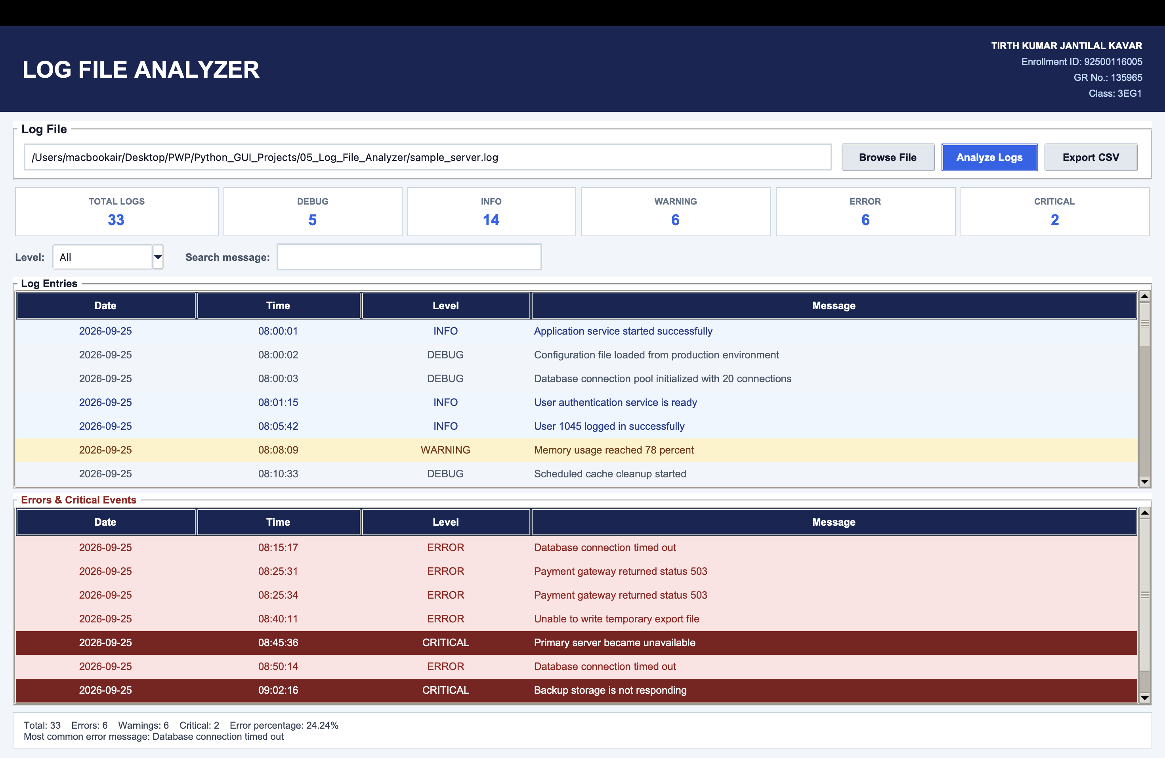
Figure 5.1 Log analyzer interface and file selection dialog
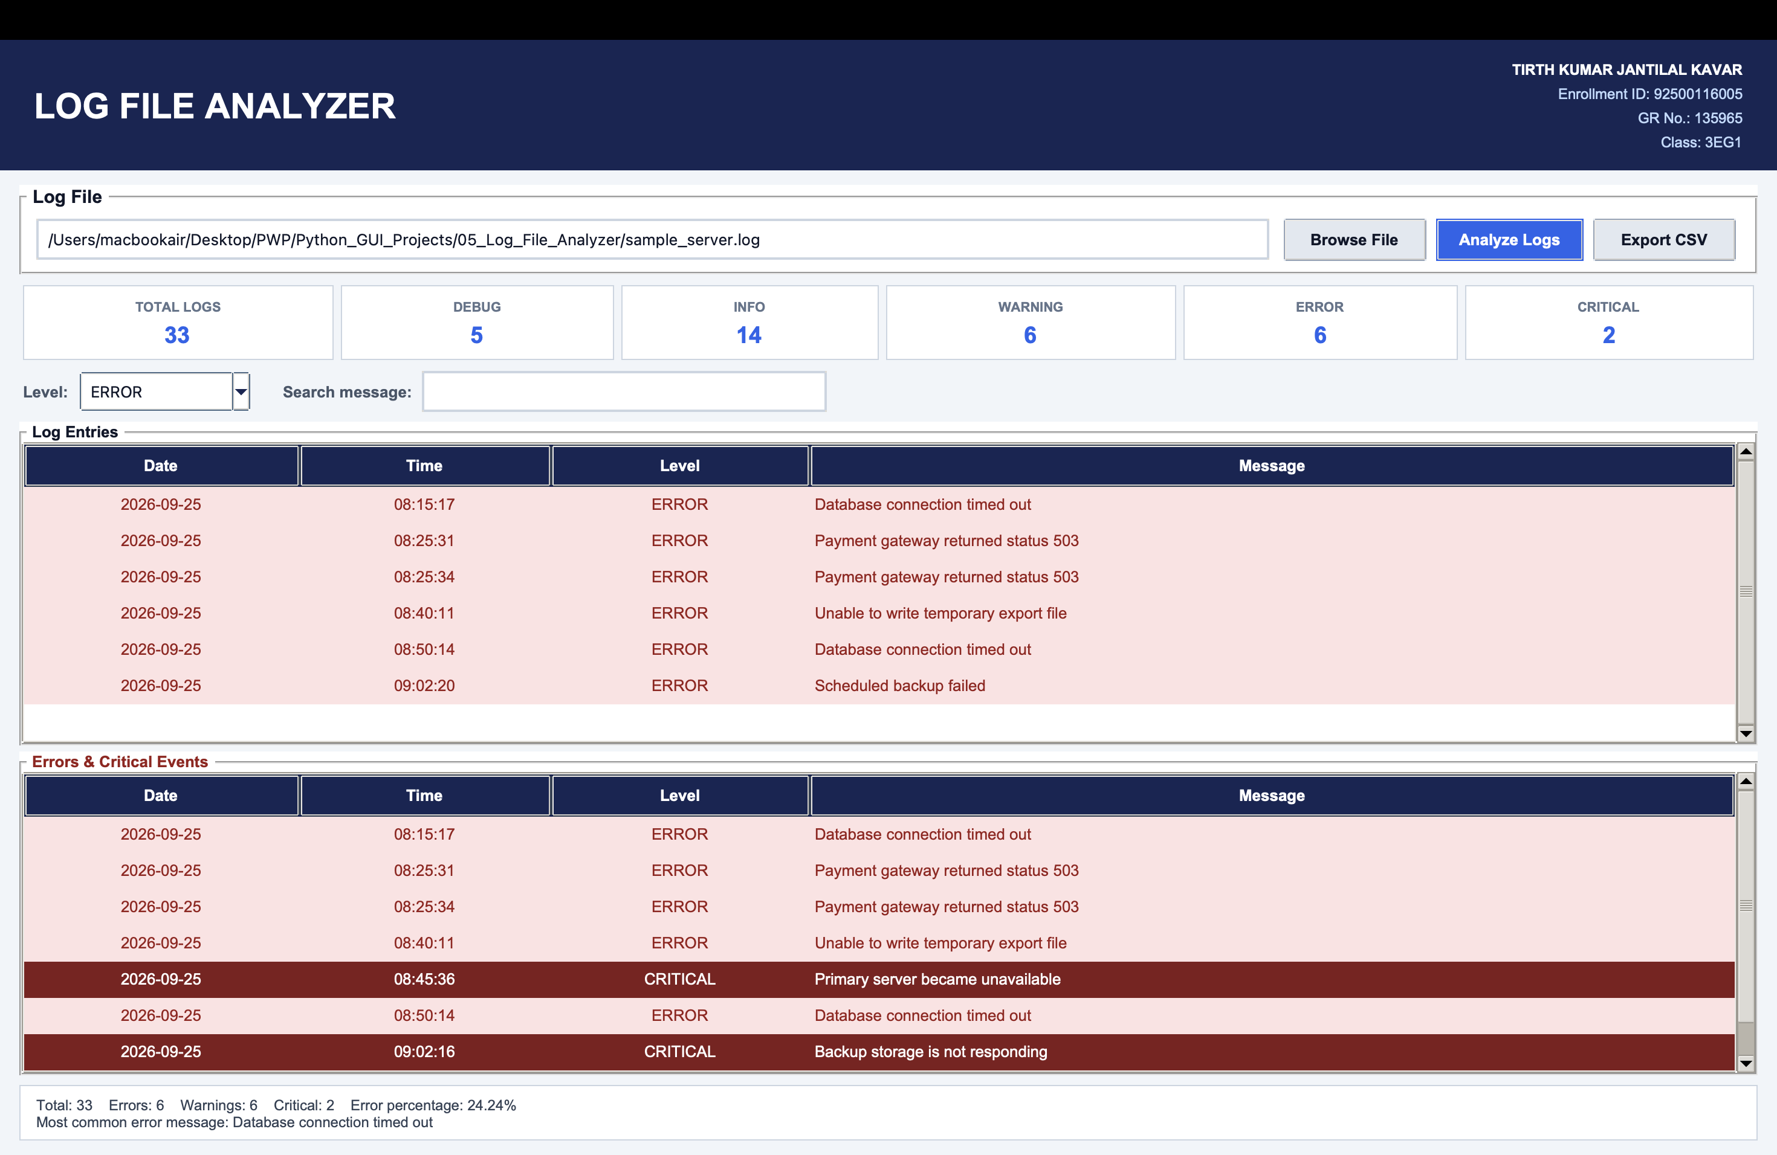
Figure 5.2 Parsed server logs categorized by severity level
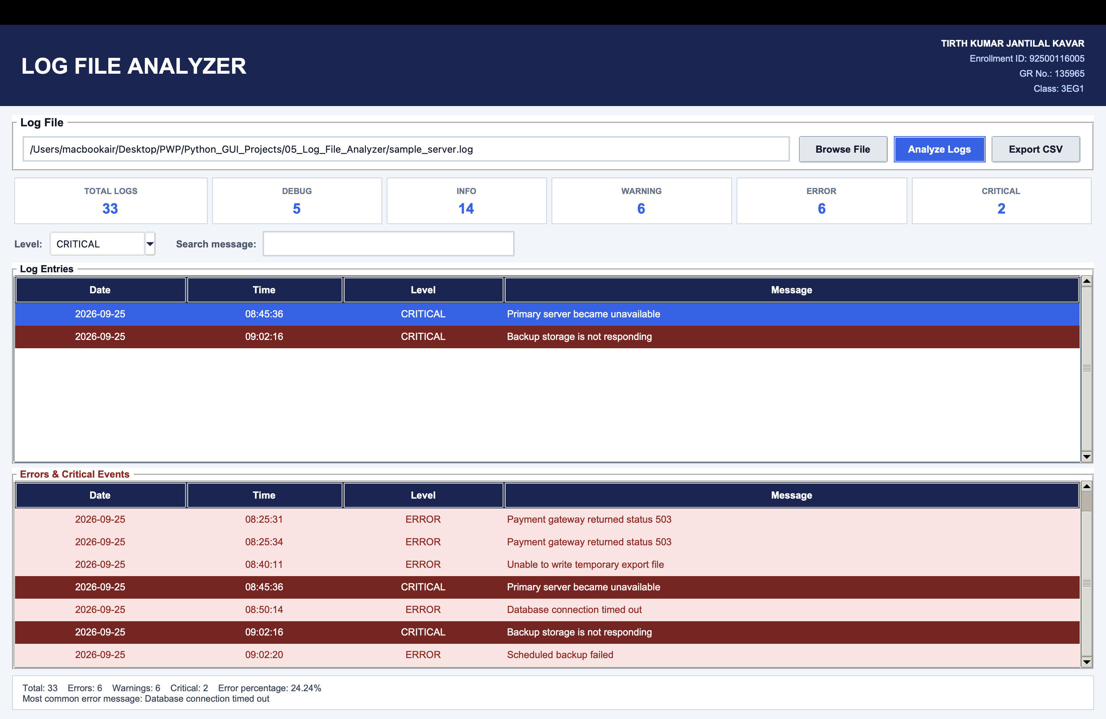
Figure 5.3 Filtered error and critical events table
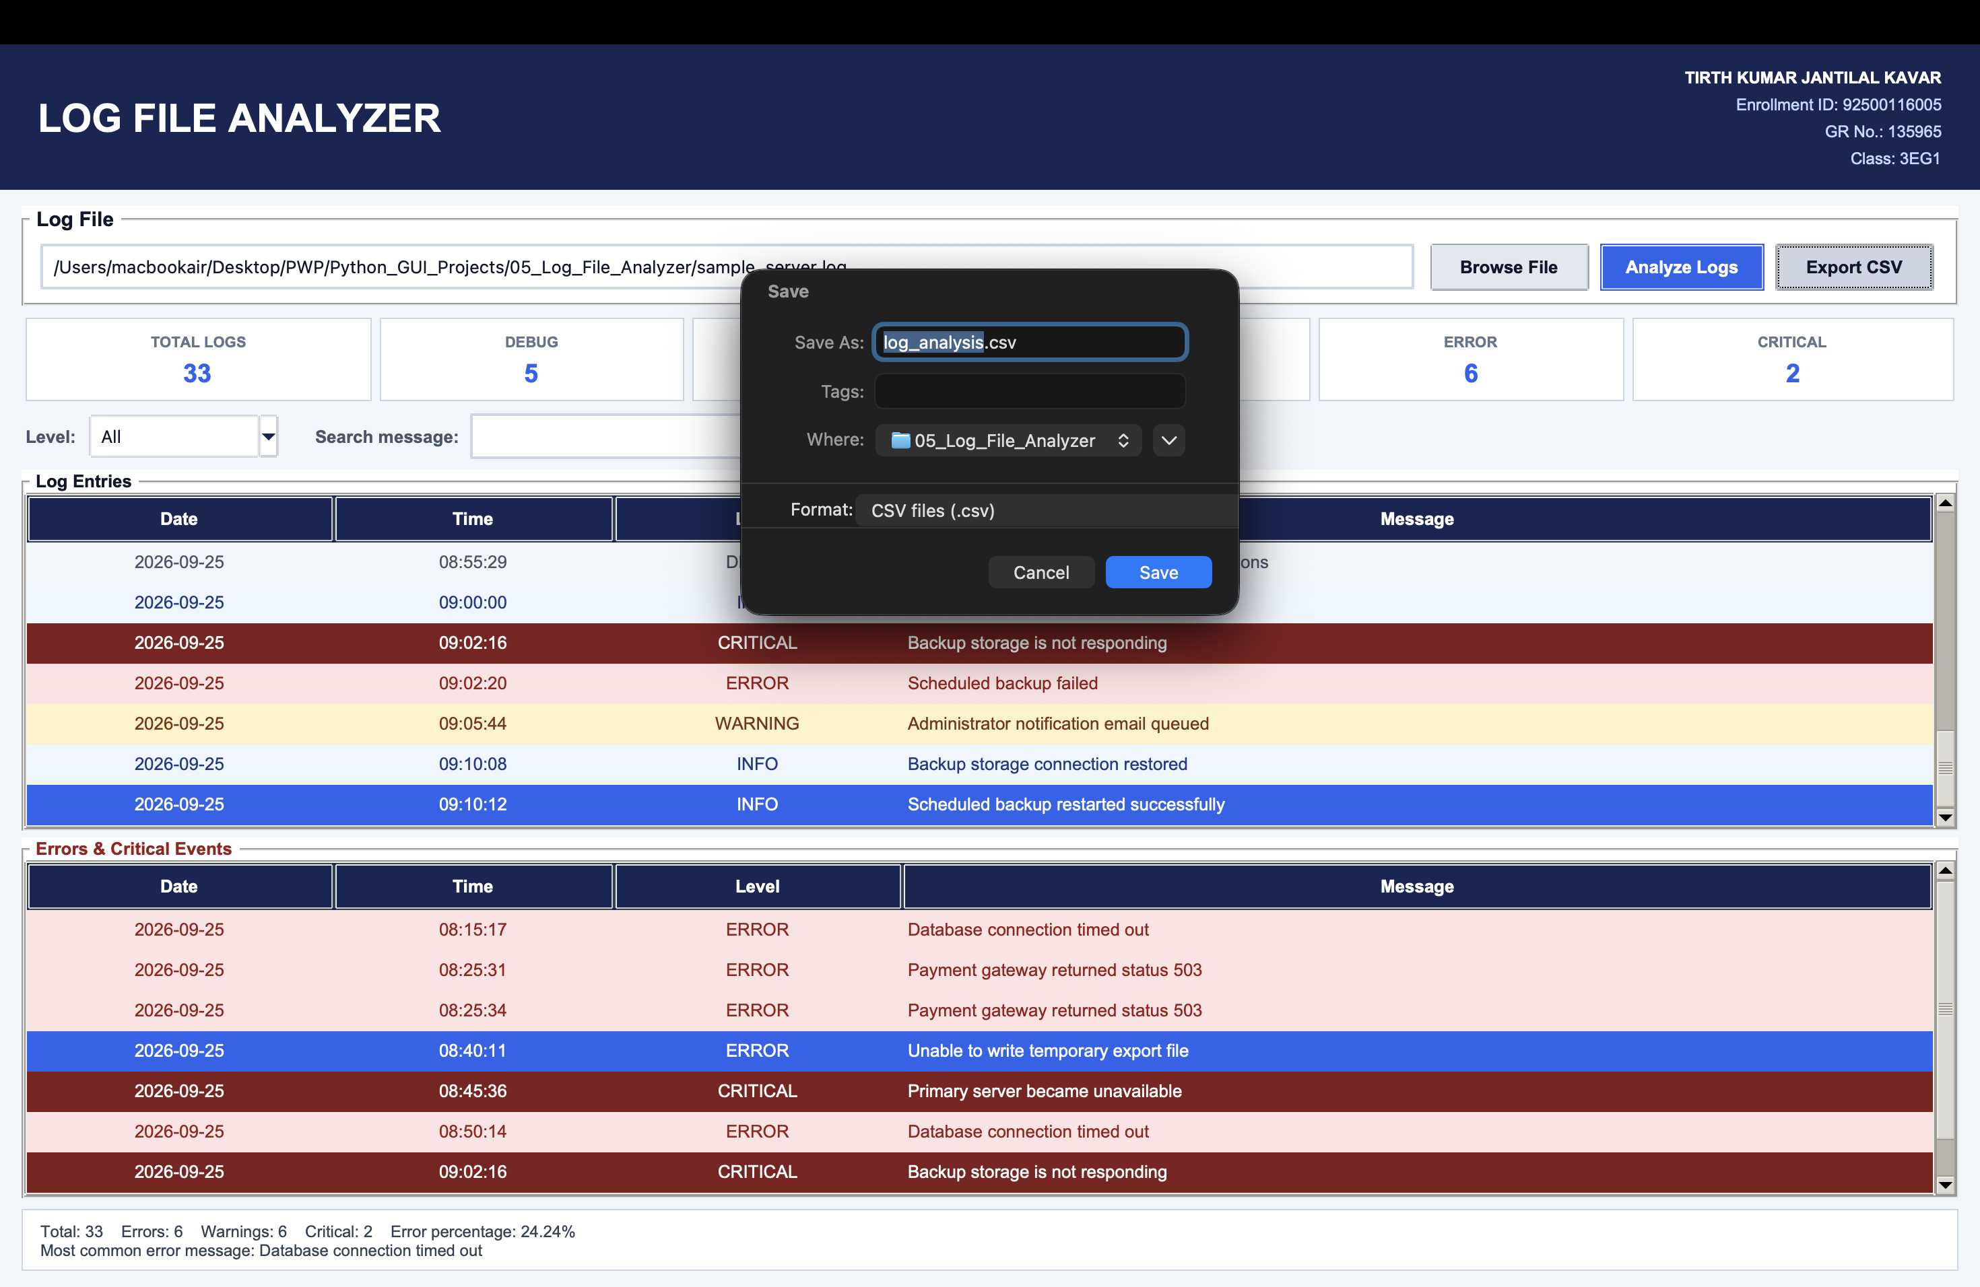
Figure 5.4 Summary metrics, error breakdown, and CSV export

Complete Source Code
File: 05_Log_File_Analyzer/main.py
"""GUI log-file analyzer using standard Python libraries."""
import csv
import logging
import os
import re
import tkinter as tk
from collections import Counter
from pathlib import Path
from tkinter import filedialog, messagebox, ttk

BASE = Path(__file__).parent
logging.basicConfig(filename=BASE / "app_activity.log", level=logging.INFO,
format="%(asctime)s %(levelname)s %(message)s")
STUDENT = ("TIRTH KUMAR JANTILAL KAVAR", "Enrollment ID: 92500116005", "GR No.: 135965", "Class: 3EG1")
LEVELS = ("DEBUG", "INFO", "WARNING", "ERROR", "CRITICAL")
PATTERN = re.compile(r"^(\d{4}-\d{2}-\d{2})[ T](\d{2}:\d{2}:\d{2})(?:,\d+)?\s+(DEBUG|INFO|WARNING|ERROR|CRITICAL)\s+(.*)$", re.I)
COLORS = {
"page": "#f1f5f9", "card": "#ffffff", "navy": "#172554",
"blue": "#2563eb", "blue_hover": "#1d4ed8", "text": "#0f172a",
"muted": "#475569", "border": "#cbd5e1",
}

def parse_log_lines(lines):
entries, invalid = [], 0
for line in lines:
match = PATTERN.match(line.strip())
if match:
date, time, level, message = match.groups(); entries.append({"date": date, "time": time, "level": level.upper(), "message": message})
elif line.strip(): invalid += 1
return entries, invalid

class LogAnalyzerApp:
def __init__(self, root):
self.root, self.entries = root, []
root.title("Log File Analyzer Using Python, Logging & CSV"); root.geometry("1200x750"); root.minsize(1000, 680); root.configure(bg=COLORS["page"])
self.file_var = tk.StringVar(); self.level_var = tk.StringVar(value="All"); self.search_var = tk.StringVar(); self.status = tk.StringVar(value="Choose a .log or .txt file to begin")
self.configure_styles(); self.header(); self.ui()
sample = BASE / "sample_server.log"
if sample.exists():
self.file_var.set(str(sample))
self.root.after(100, self.analyze)

def configure_styles(self):
"""Force a readable light palette even when macOS uses dark mode."""
style = ttk.Style(self.root)
style.theme_use("clam")
style.configure(
"TEntry", fieldbackground=COLORS["card"], foreground=COLORS["text"],
insertcolor=COLORS["text"], bordercolor=COLORS["border"],
lightcolor=COLORS["border"], darkcolor=COLORS["border"],
padding=(8, 7), font=("Arial", 10),
)
style.map(
"TEntry", bordercolor=[("focus", COLORS["blue"])],
lightcolor=[("focus", COLORS["blue"])],
darkcolor=[("focus", COLORS["blue"])],
)
style.configure(
"TButton", background="#e2e8f0", foreground=COLORS["text"],
bordercolor="#94a3b8", padding=(12, 7), font=("Arial", 10, "bold"),
)
style.map("TButton", background=[("active", "#cbd5e1"), ("pressed", "#94a3b8")])
style.configure(
"Primary.TButton", background=COLORS["blue"], foreground="#ffffff",
bordercolor=COLORS["blue"], padding=(14, 7), font=("Arial", 10, "bold"),
)
style.map(
"Primary.TButton", background=[("active", COLORS["blue_hover"]), ("pressed", "#1e40af")],
foreground=[("active", "#ffffff"), ("pressed", "#ffffff")],
)
style.configure(
"TCombobox", fieldbackground=COLORS["card"], background=COLORS["card"],
foreground=COLORS["text"], arrowcolor=COLORS["navy"],
bordercolor=COLORS["border"], padding=(7, 6), font=("Arial", 10),
)
style.map(
"TCombobox", fieldbackground=[("readonly", COLORS["card"])],
foreground=[("readonly", COLORS["text"])],
selectbackground=[("readonly", COLORS["card"])],
selectforeground=[("readonly", COLORS["text"])],
)
style.configure(
"Treeview", background=COLORS["card"], fieldbackground=COLORS["card"],
foreground=COLORS["text"], rowheight=30, borderwidth=0,
font=("Arial", 10),
)
style.configure(
"Treeview.Heading", background=COLORS["navy"], foreground="#ffffff",
bordercolor="#334155", padding=(8, 8), font=("Arial", 10, "bold"),
)
style.map(
"Treeview", background=[("selected", COLORS["blue"])],
foreground=[("selected", "#ffffff")],
)
style.map("Treeview.Heading", background=[("active", "#1e3a8a")])
def header(self):
h = tk.Frame(self.root, bg=COLORS["navy"], padx=25, pady=14); h.pack(fill="x"); tk.Label(h, text="LOG FILE ANALYZER", bg=COLORS["navy"], fg="white", font=("Arial", 22, "bold")).pack(side="left")
f = tk.Frame(h, bg=COLORS["navy"]); f.pack(side="right")
for i, line in enumerate(STUDENT): tk.Label(f, text=line, bg=COLORS["navy"], fg="white" if i == 0 else "#bfdbfe", anchor="e", font=("Arial", 9, "bold" if i == 0 else "normal")).pack(anchor="e")
def ui(self):
body = tk.Frame(self.root, bg=COLORS["page"], padx=16, pady=12); body.pack(fill="both", expand=True)
file_box = tk.LabelFrame(body, text=" Log File ", bg=COLORS["card"], fg=COLORS["text"], highlightbackground=COLORS["border"], padx=12, pady=9, font=("Arial", 11, "bold")); file_box.pack(fill="x")
ttk.Entry(file_box, textvariable=self.file_var, state="readonly").pack(side="left", fill="x", expand=True, padx=(0, 8)); ttk.Button(file_box, text="Browse File", command=self.browse).pack(side="left", padx=4); ttk.Button(file_box, text="Analyze Logs", command=self.analyze, style="Primary.TButton").pack(side="left", padx=4); ttk.Button(file_box, text="Export CSV", command=self.export).pack(side="left", padx=4)
cards = tk.Frame(body, bg=COLORS["page"]); cards.pack(fill="x", pady=9); self.cards = {}
for key, title in [("TOTAL", "TOTAL LOGS"), *[(x, x) for x in LEVELS]]:
c = tk.Frame(cards, bg=COLORS["card"], highlightbackground=COLORS["border"], highlightthickness=1, padx=9, pady=7); c.pack(side="left", fill="x", expand=True, padx=3); tk.Label(c, text=title, bg=COLORS["card"], fg="#64748b", font=("Arial", 8, "bold")).pack(); self.cards[key] = tk.Label(c, text="0", bg=COLORS["card"], fg=COLORS["blue"], font=("Arial", 14, "bold")); self.cards[key].pack()
filters = tk.Frame(body, bg=COLORS["page"]); filters.pack(fill="x", pady=(0, 8)); tk.Label(filters, text="Level:", bg=COLORS["page"], fg=COLORS["muted"], font=("Arial", 10, "bold")).pack(side="left"); combo = ttk.Combobox(filters, textvariable=self.level_var, values=("All", *LEVELS), state="readonly", width=12); combo.pack(side="left", padx=6); combo.bind("<<ComboboxSelected>>", lambda _e: self.filter_rows()); tk.Label(filters, text="Search message:", bg=COLORS["page"], fg=COLORS["muted"], font=("Arial", 10, "bold")).pack(side="left", padx=(18, 5)); ttk.Entry(filters, textvariable=self.search_var, width=35).pack(side="left"); self.search_var.trace_add("write", lambda *_: self.filter_rows())
panes = tk.PanedWindow(body, orient="vertical", bg=COLORS["page"], sashwidth=5, bd=0); panes.pack(fill="both", expand=True)
all_frame = tk.LabelFrame(panes, text=" Log Entries ", bg=COLORS["card"], fg=COLORS["text"], highlightbackground=COLORS["border"], font=("Arial", 10, "bold")); error_frame = tk.LabelFrame(panes, text=" Errors & Critical Events ", bg=COLORS["card"], fg="#991b1b", highlightbackground=COLORS["border"], font=("Arial", 10, "bold")); panes.add(all_frame, stretch="always"); panes.add(error_frame, stretch="always")
self.table = self.make_table(all_frame); self.error_table = self.make_table(error_frame)
summary = tk.Frame(body, bg=COLORS["card"], highlightbackground=COLORS["border"], highlightthickness=1, padx=10, pady=7); summary.pack(fill="x", pady=(8, 0)); self.summary_label = tk.Label(summary, text="Summary will appear after analysis.", bg=COLORS["card"], fg="#334155", anchor="w", justify="left", font=("Arial", 9)); self.summary_label.pack(fill="x")
tk.Label(self.root, textvariable=self.status, bg="#dbeafe", fg=COLORS["navy"], anchor="w", padx=14, pady=6, font=("Arial", 9)).pack(fill="x")
def make_table(self, parent):
cols = ("date", "time", "level", "message"); table = ttk.Treeview(parent, columns=cols, show="headings", height=7)
for col, title, width in [("date", "Date", 115), ("time", "Time", 95), ("level", "Level", 100), ("message", "Message", 650)]: table.heading(col, text=title); table.column(col, width=width, anchor="center" if col in ("date", "time", "level") else "w")
table.tag_configure("DEBUG", background="#f1f5f9", foreground="#475569")
table.tag_configure("INFO", background="#eff6ff", foreground="#1e3a8a")
table.tag_configure("WARNING", background="#fef3c7", foreground="#78350f")
table.tag_configure("ERROR", background="#fee2e2", foreground="#991b1b")
table.tag_configure("CRITICAL", background="#7f1d1d", foreground="#ffffff")
scroll = ttk.Scrollbar(parent, command=table.yview); table.configure(yscrollcommand=scroll.set); table.pack(side="left", fill="both", expand=True); scroll.pack(side="right", fill="y"); return table
def browse(self):
path = filedialog.askopenfilename(filetypes=[("Log and text files", "*.log *.txt"), ("Log files", "*.log"), ("Text files", "*.txt")])
if path: self.file_var.set(path); self.status.set(f"Selected: {os.path.basename(path)}"); logging.info("File loaded: %s", path)
def analyze(self):
path = self.file_var.get()
if not path: logging.warning("Invalid file: no file selected"); return messagebox.showwarning("No File", "Choose a .log or .txt file first.")
if Path(path).suffix.lower() not in (".log", ".txt"): logging.warning("Invalid file extension: %s", path); return messagebox.showerror("Invalid File", "Only .log and .txt files are supported.")
try:
logging.info("Analysis started: %s", path)
with open(path, encoding="utf-8", errors="replace") as f: self.entries, invalid = parse_log_lines(f)
self.update_dashboard(); self.filter_rows(); self.update_errors(); self.update_summary()
if not self.entries: messagebox.showinfo("Analysis Complete", "No valid log entries were found in this file.")
self.status.set(f"Analysis complete: {len(self.entries)} valid, {invalid} invalid line(s)"); logging.info("Analysis completed: %d valid, %d invalid", len(self.entries), invalid)
except OSError as error: logging.exception("Processing error"); messagebox.showerror("File Error", f"Could not read the file:\n{error}")
def update_dashboard(self):
counts = Counter(x["level"] for x in self.entries); self.cards["TOTAL"].config(text=str(len(self.entries)))
for level in LEVELS: self.cards[level].config(text=str(counts[level]))
def put(self, table, rows):
table.delete(*table.get_children())
for x in rows: table.insert("", "end", values=(x["date"], x["time"], x["level"], x["message"]), tags=(x["level"],))
def filter_rows(self):
level, text = self.level_var.get(), self.search_var.get().lower().strip(); rows = [x for x in self.entries if (level == "All" or x["level"] == level) and text in x["message"].lower()]; self.put(self.table, rows); self.status.set(f"Showing {len(rows)} of {len(self.entries)} log entries")
def update_errors(self): self.put(self.error_table, [x for x in self.entries if x["level"] in ("ERROR", "CRITICAL")])
def update_summary(self):
counts = Counter(x["level"] for x in self.entries); errors = [x["message"] for x in self.entries if x["level"] in ("ERROR", "CRITICAL")]; common = Counter(errors).most_common(1)[0][0] if errors else "None"; percentage = (len(errors) / len(self.entries) * 100) if self.entries else 0
self.summary_label.config(text=f"Total: {len(self.entries)} Errors: {counts['ERROR']} Warnings: {counts['WARNING']} Critical: {counts['CRITICAL']} Error percentage: {percentage:.2f}%\nMost common error message: {common}")
def export(self):
if not self.entries: return messagebox.showwarning("No Results", "Analyze a log file before exporting.")
path = filedialog.asksaveasfilename(defaultextension=".csv", initialfile="log_analysis.csv", filetypes=[("CSV files", "*.csv")])
if path:
try:
with open(path, "w", newline="", encoding="utf-8") as f: w = csv.DictWriter(f, fieldnames=("date", "time", "level", "message")); w.writeheader(); w.writerows(self.entries)
self.status.set(f"Exported {len(self.entries)} log entries"); logging.info("Export completed: %s", path)
except OSError as error: logging.exception("Export error"); messagebox.showerror("Export Error", str(error))

if __name__ == "__main__":
window = tk.Tk(); LogAnalyzerApp(window); window.mainloop()

Test Evidence & Results
Test case / input | Expected result | Actual result | Status
33 valid + 1 invalid line | 33 parsed, 1 skipped | 33 parsed, 1 skipped | Pass
ERROR filter | 6 rows matching | 6 rows | Pass
Database message search | 6 rows matching | 6 rows | Pass
CSV export | 33 rows plus header | CSV created | Pass

Experimental Observation
Subjecting the Log File Analyzer to realistic multi-level application logs and malformed records yielded key technical observations:
1. Regex-Based Log Parsing: The compiled regular expression cleanly extracted timestamps, severity indicators (DEBUG, INFO, WARNING, ERROR, CRITICAL), and raw message bodies across varying string lengths without requiring manual token splitting.
2. Resilience to Corrupted Input: Real-world operational logs frequently contain malformed lines, partial writes, or stack trace fragments. The parser safely verified line structure before processing, incrementing an invalid-line counter and continuing batch evaluation without throwing unhandled parsing exceptions.
3. Frequency Counting and Anomaly Detection: Leveraging Python's collections.Counter streamlined severity frequency counting. The computed error percentage provided an instant metric of system health, while ranking algorithms pinpointed recurring root-cause error messages.
4. Selective Filtering and Severity Segregation: The multi-table interface displayed all events in a master table while segregating high-priority issues (ERROR and CRITICAL) into a dedicated triage view, significantly accelerating incident troubleshooting.
5. Standard Library Logging Integration: The application maintained an independent audit trail in app_activity.log using the standard logging module, recording file openings, parsing summaries, and export actions for compliance.

Conclusion
The Log File Analyzer experiment demonstrated how Python's built-in text processing, regular expressions, and collection data structures can automate IT diagnostics and system observability. The tool converts raw, unstructured textual log files into structured, actionable intelligence with real-time statistics and CSV reporting. Robust fault handling guarantees that malformed inputs are handled gracefully, establishing a resilient software pattern for systems maintenance and security auditing.

Viva Voce Questions & Answers
Q1. What is the purpose of Python's built-in logging module?
Answer: The logging module provides a standardized, flexible, and thread-safe framework for recording diagnostic, operational, and error events generated by software. It supports configurable severity levels, standardized timestamp formatting, and multi-destination output redirection (such as console, rotating disk files, or network sockets) without relying on fragile print() statements.
Q2. List the standard logging severity levels in increasing order of severity.
Answer: The five standard severity levels in increasing order are: DEBUG (detailed diagnostic information), INFO (confirmation that software is functioning as expected), WARNING (an indication of unexpected events or impending issues), ERROR (a failure preventing a specific function from executing), and CRITICAL (a severe system failure that may abort the application).
Q3. Why is newline='' specified when opening files for writing with Python's csv module?
Answer: On Windows and certain POSIX configurations, opening a file in text mode without newline='' causes Python's standard file writer to translate \n into platform-specific line endings (\r\n). Since the csv writer already emits its own RFC-compliant terminators, this double translation results in unwanted blank lines between rows. Specifying newline='' disables automatic translation.
Q4. What do the tell() and seek() file pointer methods do in Python?
Answer: The file.tell() method returns the current byte position of the file read/write cursor within the file stream. The file.seek(offset, whence) method repositions the file pointer to an arbitrary byte offset, allowing non-sequential reading, stream rewind to the file origin (seek(0)), or targeted inspection of large binary or text files without reloading.
Q5. Why is defensive handling of malformed lines essential in production log parsing?
Answer: Production server logs often contain unexpected line breaks caused by multiline exception tracebacks, corrupted packet streams, or simultaneous writes from unbuffered processes. A parser that assumes every line conforms strictly to a regex would raise runtime exceptions and abort mid-batch. Defensive parsing catches non-matching lines, logs the anomalies, and proceeds, ensuring complete batch coverage.

Experiment-Specific Rubric (10 Marks)
Criterion | Maximum marks | Marks awarded | Faculty signature
On-time completion and submission | 2
Program execution and functional correctness | 3
Record, code quality and result documentation | 2
Viva voce | 3
Total | 10

Faculty feedback: ________________________________________________________________

Submission Checklist for Experiments 01 to 05
• Each application launches successfully with Python 3 and Tkinter on desktop platforms.
• Input validation prevents invalid numeric values, empty required fields, and division-by-zero crashes.
• CRUD, calculation, search, filter and export controls were verified across positive and negative test cases.
• Complete GUI output screenshots, verified source code, structured observations and conclusions are documented.

Student Information
Field | Details
Name
Enrollment ID
GR No.
Class
Academic Year | 2026-27

