Aromatawai tuatoru | Assessment 3 – Outline
Title | Hardware, Troubleshooting, Cloud and Virtualisation Labs | Total  Possible Mark | 30
Type | Lab work | Weighting | 30%
Learning  Outcome(s) | - Explain computer operating systems, configuration, security and software  - Explain computer hardware, virtualisation, cloud computing and troubleshooting

Task / Aim
Complete a portfolio of lab work to demonstrate an understanding of computer operating systems, configuration, security, software, hardware, virtualisation, cloud computing and troubleshooting.

Conditions
- Most of this work will be done in class time. You can work with your classmates to solve issues and provide guidance, but all submissions must be your own work (i.e. written sections should not detect similarity when analysed by Turnitin and have appropriate APA references where applicable.)
- There are two different submissions for this assessment: a copy of your lab book and the cloud/virtualisation lab portfolio.
  - Submit the lab book to the ‘Assessment Three - Lab Book Upload’ link on the assessments tab of Moodle.
  - Submit the Cloud and Virtualisation Lab portfolio work to the ‘Assessment Three - Lab Portfolio Evidence’ link on the assessments tab of Moodle.

Task Details / Instructions / steps
  - Refer to the timetable tab of Moodle to see when we are covering each topic. There will be a theory presentation on each topic followed by practical work. There should be enough class time to complete the lab work as per the schedule. Any work not completed in class can be done in your self-directed study time after class.
  - Keep a copy of the lab book in your OneDrive or other cloud storage so you have a backup if your laptop/PC has issues.
  - Work through the labs in class as per the schedule.
    - The first part of the lab work is in the lab book, you will be marked for completion of all the written sections throughout the book, there are no marks for completing the practical work as this is assessed in the OS and Hardware practical test, the lab book is a great way to practice your skills for the test. (15% of final grade)
    - The second part of the lab work is at the end of this document; we will not start those labs until after the mid-semester break. (15% of final grade)
Lab Book
(Completion and submission of the Lab Book are pre-requisites to taking Assessment 3)
The lab book is in the assessments tab under Assessment 3. The student must complete the lab book by working through the lab activities in class and completing the question/answer sections. Once completed, the lab book must be upload to the link on Moodle. Completion and submission of the Lab Book are pre-requisites to taking Assessment 3.

Lab Work Part One: Virtualisation (10%)
Objective: Install VirtualBox and set up an Ubuntu server VM and a Windows desktop VM. Some general instructions are below; you may need to do some extra research to complete each task.

Step 1: Installing VirtualBox
- Download VirtualBox from the official website.
- Follow the installation wizard, accepting default options.
- Launch VirtualBox upon completion.

Step 2: Setting up Ubuntu Server VM
- Download the Ubuntu Server ISO.
- In VirtualBox, click "New" and name your VM "Ubuntu Server".
- Assign memory (e.g., 2GB) and create a virtual hard disk.
- Start the VM and select the Ubuntu Server ISO when prompted.
- Follow the Ubuntu installation process.

Step 3: Making Ubuntu a Web Server
- Open the terminal in your Ubuntu VM.
- Update packages with: sudo apt update && sudo apt upgrade
- Install Apache: sudo apt install apache2
- Open a browser and type localhost to see the Apache default page.
Use this as a rough guide: https://www.digitalocean.com/community/tutorials/how-to-install-the-apache-web-server-on-ubuntu-20-04
- Challenge: Can you get some sample website code and put it on the webserver?

Step 4: Setting up Windows Desktop VM
- Download a Windows ISO (e.g., Windows 10 or Windows 11).
- In VirtualBox, click "New" and name your VM "Windows Desktop".
- Assign memory (e.g., 4GB) and create a virtual hard disk.
- Start the VM and select the Windows ISO when prompted.
- Follow the Windows installation process.

Step 5: Reflection & Questions
- Explain virtualisation and its role in computing.
Virtualization is a technology which is used to abstract underlying physical hardware IT resources such as servers, storage and networks so that one physical machine can support many instances which are isolated and independent. This is done by use of a hypervisor that controls and distributes access of the physical resources to each virtual machine (VM) in order to ensure that the numerous virtual machines are independent. Its main use in computer is that it is focused on the utilization of the available resources at hand in such a way that by utilizing a large number of physical machines it can save a lot of money by reducing the number of physical machines and using less energy. Moreover, virtualization offers a superior IT agility by facilitating fast-provision and scale, advances disaster recovery and offers isolated environments that are essential in permitting safe development and testing, which makes virtualization the key element in contemporary cloud computing and data-centers.

- What is a virtual machine, and why/where would you use them?

A virtual machine (VM) is the simulation of a full computer system, it uses only a virtualized hardware, operating system, and application environment, all independent of the physical (host) machine. They are also very popular when it comes to the preservation of hardware as they allow a large number of server loads to be run on a lower amount of physical machines thus saving money and energy. VMs can also be used to create sandboxed environments in which to develop and test robust software, support fault tolerant disaster recovery planning, are the building blocks of the compute elements of cloud computing and can run legacy applications, and may be used as secure testing grounds to examine possibly malicious code.

- Explain the concept of a virtual machine and discuss the advantages or use cases for using virtual machines in a computing environment.
A virtual machine (VM) is a computer-based software that runs independently with its virtual computing hardware, operating system and applications, yet shares physical resources of only one host computer via a hypervisor.

Benefits and application of Virtual Machines:

VMs provide the impressive advantages in a variety of computing situations:

Resource Optimization: they enable many workloads to be executed on fewer physical machines which makes high use of hardware and lowers the expenses made in purchasing hardware, electrical energy, and cooling.
Agile Development & testing: VMs can build much more quickly and reliably isolated and reproduced environments to develop and test software without affecting the rest of the systems so that a software program can be iterated much more speedily and bugs can be fixed quickly.
Strong Disaster Recovery: VMs can be back up, replicated and recovered on other hardware easily and it can allow faster recovery in case of an outage and also improve the business continuity.
Cloud Computing foundation: These are the basis of the cloud and enable the providers to readily and on an as-you-need-it basis provide users with scalable computing resources (such as virtual servers).
Legacy Application Support: VMs offer the possibility to support older applications which may be out of compatibility with either contemporaneous operating systems or with contemporary hardware.
Increased Security: VMs are perfect candidates to be used in a sanboxed environment to test already identified suspect programs or study malware free of the host machine.
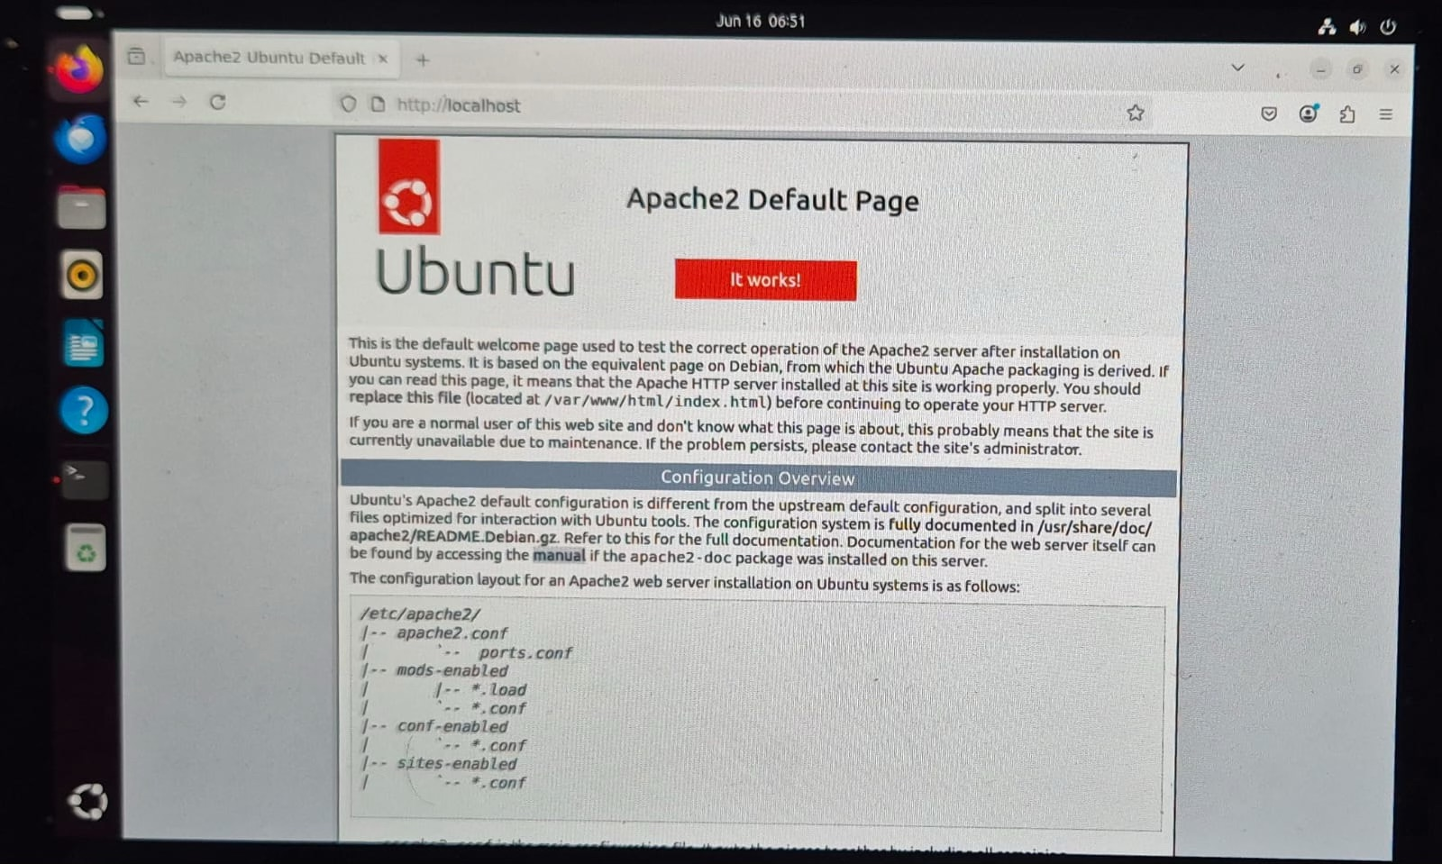
- Paste a screenshot of your Ubuntu web server.

- Paste a screenshot of your Windows Desktop VM.

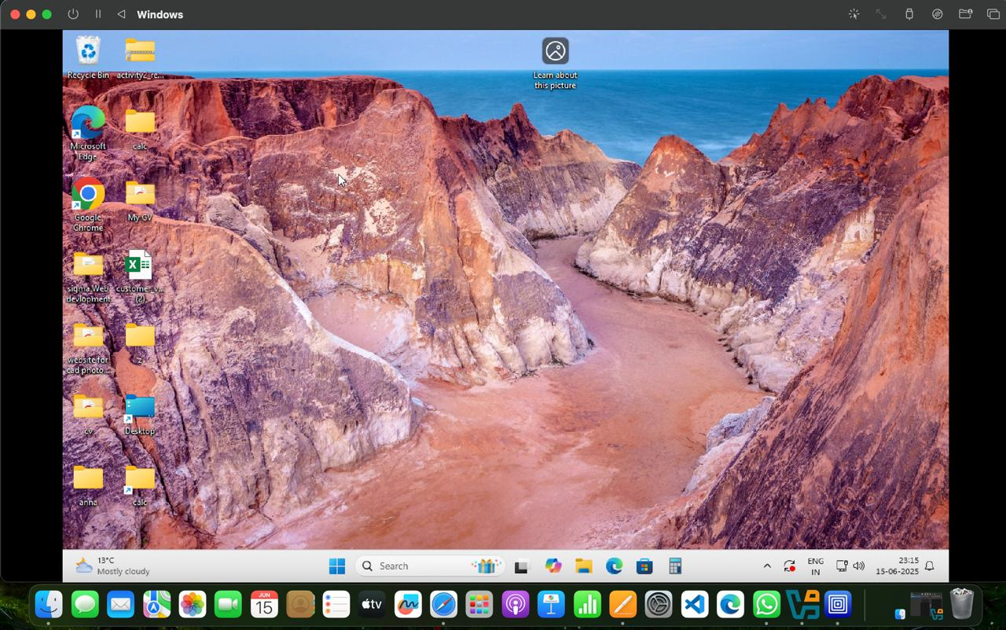
Lab Work Part Two: Cloud Infrastructure (10%)

Definitions
Define each of the following terms in your own words.
Cloud computing | Cloud computing can be described as the practice of using the internet in an effort of accessing computing resources, such as storage, servers, databases, micro-soft and networking, without necessarily owning any of the physical equipment. Consumers do not need to store files on their machine or run their application locally, as they can turn to third-party providers, like Amazon Web Services (AWS), Microsoft Azure, or Google Cloud, and use remote servers to store their data. It is not rigid, is capable of scaling, and is much cheaper to use since a user can only pay a huge proportion of the resources he/she uses.  .
Cloud storage | Cloud storage is the storage like we can store something on other storage and we can pay for it like a rent and now a days Most famous cloud storage is used by google photos and apple iCloud is fully run on cloud storage and the biggest advantages of Cloud storage is that we can be backup of something very easy just we need internet for it.
Amazon Web Services (AWS) | AWS is one type of cloud computing and it iOS one of the largest in the world and it was launch in 2006, offering over 200 fully function serviced that include storage, database network, machine learning and some many other feature and we can run game and our website on AWS just paying some amount of money like a rent and we will get required storage like 100GB or 1000GB its upto you and your requirement.
Server | A server is one type of computer software or system that provides resources, services or data to other computer or devices knowns as client with the help of network. Severe wait for a request like somethings we are requesting from the webserver and server will be responds back. Server is run on most powerful computer 24/7.There are many different types, such as web servers (who serve HTTP content), file servers, database servers, mail servers, DNS servers, and others, each optimized of course for their particular task

Benefits
List the six main benefits of cloud computing for businesses and write a short description of each.
1. Cost‑Efficiency- we need to pay for storage only there is no required to buy higher processing device it may run on normal ready
2. Scalability & Elasticity- With cloud resources and services, compute power, storage, databases can be increased or decreased based on fast demand which may vary quickly. This sort of scale-out avoids the over-provisioning and scales well with highly variable or seasonal workloads
3. Legacy Software & OS Compatibility- it allows to use older version of windows, MAC/os, linux or any other type of old or New person of the operating system.
4. Disaster Recovery & Backups- VM snapshots or images can be saved as entire systems. In case of VM crash or server failure, VM can be easily restored or even migrated, often in a live state, reducing downtime .
5. Business Continuity & Disaster Recovery- Cloud solutions have redundancies, automated backups and geographical distribution of data stored. Businesses are able to recover within a short time in the event of a disaster either in the form of hardware failure or a natural disaster.
6. Agility & Innovation- Cloud platforms: Cloud platforms enable the rapid deployment of services and infrastructure accelerating development cycle and time to market. They also provide an easy access to advanced technologies like AI, big data, analytics and IoT that are causing innovation without necessitating huge up-front investments.

AWS services
In the following table, briefly describe each AWS service that is listed and then describe what the service is used for.
AWS Service | What It Is | What It Is Used For
Amazon Elastic Compute Cloud (Amazon EC2) | A virtual server (also known as an instance) which offers resizable compute resources in the AWS cloud | Running applications, web servers, batch processing, machine learning training, or whatever compute intensive work needs to be done, you launch as many instances as you need, configure OS, storage, networking.
Amazon Relational Database Service (Amazon RDS) | fully sourced relational database service engines like MySQL, PostgreSQL, Oracle, SQL Server, Aurora | Simpler to configure, scale, back up, patch web backends, e-commerce, analytics; transactional and analytic workloads;
Amazon CloudFront | However, across the globe or Content Delivery Network (CDN) that caches (stores) static and dynamic content at edges; | Fastens the delivery of web site assets, APIs, video/audio streaming; decreases latency, origin load, and enhances the experience of users worldwide
Amazon Simple Storage Service (Amazon S3) | Infinite scalability, high durability, and storage classes Object storage service. | Accelerates the delivery of web site assets, APIs, streaming of video / audio; Reduces latency, origin load, and improves the experience of users, anywhere in the world

AWS labs
Paste a screenshot of your completed AWS Academy Lab 2 (VPC and Web Server)

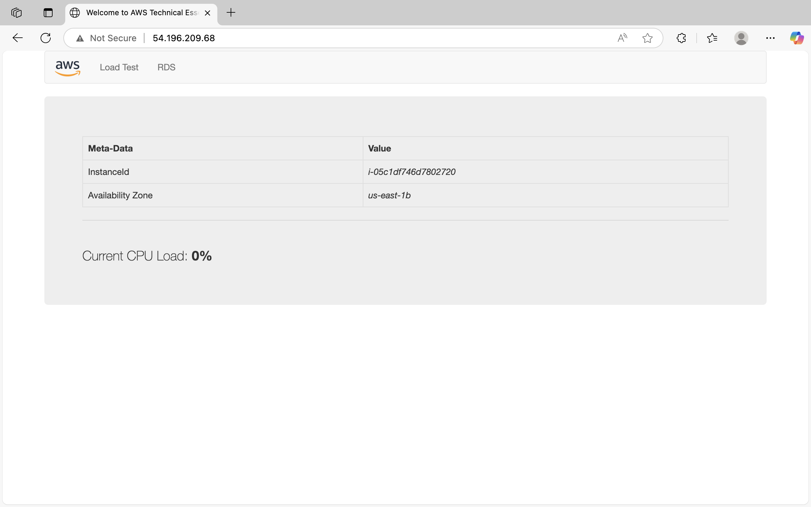
Lab Work Part Three: Firebase (10%)

Lab Instructions: Hosting a Website on Firebase using VS Code
Prerequisites:
- Node.js & npm: Required for the Firebase CLI.
  - Download and install from Node.js official site.
- Visual Studio Code (VS Code):
  - Download and install from VS Code official site.
- Firebase Account: For hosting your website.
  - Use your Google account to sign up or log in at the Firebase console.
- GitHub Account (Challenge Activity)

Steps:
1. Downloading the Website:
a. Visit Free-CSS Templates:
- Go to Free-CSS Templates.
b. Choose a Template:
- Browse and select a template that you like.
- Click on the template and then download it to your local machine.
2. Setting Up Firebase:
a. Login to Firebase:
- Visit Firebase.
- Click "Sign in" and log in using your Gmail account.
b. Create a Firebase Project: - Navigate to the Firebase console once logged in.
- Click on "Add Project".
- Provide a name for your project and follow the on-screen instructions.
3. Setting Up Your Website in VS Code:
a. Open the Downloaded Template in VS Code:
- Extract the downloaded template zip file.
- Open VS Code, go to File > Open Folder, and select the extracted template folder.

4. Hosting Website from VS Code:
a. Install Firebase CLI:
Open your terminal and run the following command:
npm install -g firebase-tools
b. Link Local Website to Firebase Project:
In the terminal, execute the following commands in sequence:
firebase login
firebase projects:list
c. Initialize Firebase in Project:
Run the following command in the terminal:
firebase init
During initialisation:
- Choose 'Hosting' from the prompted options.
- Select 'Use an existing project' and choose your previously created Firebase project.
- When asked for setup preferences, provide the following answers:
  - Public directory: This is the folder's name containing the HTML files. Typically, it's the root directory or sometimes a dist folder.
  - Configure as a single-page app: Answer with No.
d. Deploy the Website:
Finally, deploy your website with the following command in the terminal:
firebase deploy

After completing these steps, your website should be live on Firebase Hosting. Firebase will provide a URL to your hosted website, which you can share or view in any browser.

Part Three Questions:
- What is the benefit of using a cloud service like Firebase for hosting a website?

Firebase Hosting provides an easy but effective way to host your site: using a single command (`firebase deploy`) your static content is published to a CDN covering the whole world with SSD .It also has the automatic, zero-config SSL so your site will be served over HTTPS with no configuration. Another feature you receive is one‑click rollbacks, which allows you to switch to the previous version in no time . In addition, Hosting can be smoothly combined with Cloud Functions or Cloud Runso that you can augment your backend with serverless backend logic or dynamic content without having to operate servers .

Overall, Firebase Hosting is a good fit when you need a blazing fast, secure, and hassle free** publishing experience of websites that can scale automatically, and you never have to think about infrastructure management.

- Imagine you're a developer in the early 2000s. How would your process of developing and deploying a web application using Firebase and VS Code differ from methods used in the past?

Suppose I am a developer in the early 2000s, to publish a web application, Firebase, and VS Code would be a totally different experience of the old-school code-in-Notepad-or-Dreamweaver-upload-to-shared-hosting-provider approach, there will be no version control, no HTTPS, and no CI/CD. Today I would write your code with auto completion, linting, live debugging etc., locally in VS Code and then only would I execute locally (firebase serve) and only then can I deploy (single firebase deploy). Behind the scenes, Firebase has planet-scale CDN distribution, SSL certificates, caching, and automatic roll-back (no Downtime) - and it is so much more performant and secure than the directory swaps and manual file upload of the past. And, of course, come such things as Git-based versioning, preview environments, and CI/CD pipelines with automated testing and multi-environment releases, which simply did not exist in the early 2000s .

- How does deploying an app on Firebase compare to traditional deployment methods regarding speed and efficiency?

A typical deployment of an app on Firebase is several orders of magnitude faster and more efficient than the traditional cases: you run `firebase deploy` and within seconds only the changed files are transferred, CDN caches are invalidated, SSL is configured, and your content is deployed worldwide with gzip/HTTP2 optimization enabled by default . This is a far cry compared to manual FTP/SCP uploads, which are slow, prone to error and inefficient, not to mention time consuming and complex self configuration of servers, SSL certificates, caching and load balancing. And with versioned deployments and rollbacks in seconds and native integration with CI/CD via Git hooks, Firebase offers an automation, reliability, and worldwide performance that cannot be compared to traditional deployment.

- Paste a screenshot of your live website
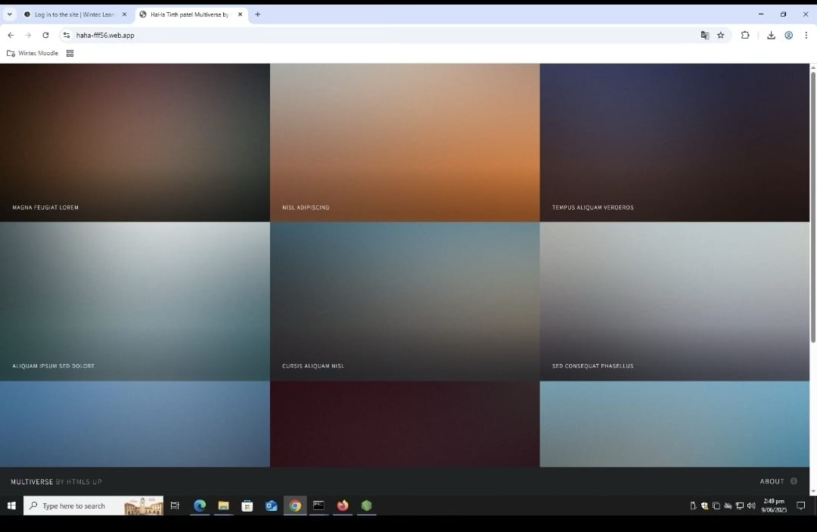

Aromatawai tuatoru | Assessment 3 - Marking Schedule

Criteria | Marks
Lab Book | Compulsory  submission
Lab Portfolio Part One: Virtualisation | 10
Lab Portfolio Part Two: Cloud Infrastructure | 10
Lab Portfolio Part Three: Firebase | 10
Total | 30

