
COMP501 2024 S2
Information Technology Operations

Netacad IT Essentials Chapters 1 - 14
Hardware: A+ 220-1001 Core 1 exam topics
Software: A+ 220-1002 Core 2 exam topics

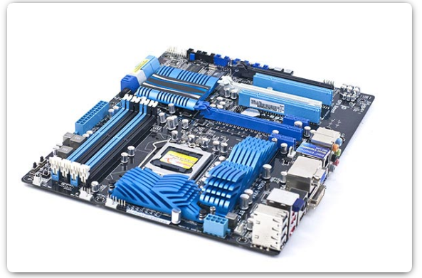

Name: Tirth kaileshkumar Patel

Lab work at home 5
Lab 1 – Intro to PC hardware 6
Knowledge check questions 6
Dissasemble a PC 9
Lab 2 – PC Assembly 13
Assemble the computer 13
lab 3 – Advanced Computer Hardware 18
Knowledge Check Questions 18
Boot the computer 23
Computer configuration 35
lab 4 – Preventative Maintenance and Troubleshooting 41
Check Your Knowledge 41
Troubleshooting process 45
lab 5 – Networking Concepts 48
Check Your Knowledge 48
Network cables 53
lab 6 – Applied Networking 55
Check Your Knowledge 55
Device to Network Connection 57
lab 7 – Laptops and other Mobile devices 69
Check Your Knowledge 69
Mobile characteristics 71
Laptop hardware 71
lab 8 – Printers 75
Check Your Knowledge 75
Installing and configuring printers 76
Lab 10.3.3.4 - Boot Methods 78
Lab 10.3.1.1 – Windows Installation 83
Lab 10.3.1.4 – Finalize Windows Installation 86
Lab 10.2.1.8 - Create a Partition in Windows 89
Lab 11.1.3.4 - Work with Task Manager 96
Lab 11.1.4.11 - Working with File Explorer 98
Lab 11.2.1.5 – Explore Control Panel Categories - Optional 102
Lab 11.2.2.3 - User Accounts 105
Lab 11.2.2.4 - Permissions 107
Lab 11.2.6.2 – Use Device Manager 110
Lab 11.2.7.4 - Region and Language Options 112
Lab 11.3.1.11 - Monitor and Manage System Resources - Optional 116
Lab 11.3.2.7 - System Utilities - Optional 120
Lab 11.4.1.5 - Work in the Windows Commands Shell 125
Lab 11.4.2.7 – File System Commands (optional) 128
Lab 11.4.3.2 – Disk CLI Commands - Optional 134
Lab 11.4.4.2 – Task and System CLI Commands - Optional 141
Lab 11.5.2.4 - Share Resources 147
Lab 11.5.6.2 – Windows Remote Desktop and Assistance - Optional 150
Lab 11.6.1.2 – Manage the Startup Folder 153
Lab 11.6.2.4 - System Restore 156
Lab 13.1.2.6 - Operating System Security 160
Lab 13.2.3.7 - Bitlocker and Bitlocker To Go 162
Lab 13.3.1.6 – Operating System Login - Optional 165
Lab 13.3.3.6 – Configure Users and Groups in Windows 168
Lab 13.3.4.6 – Configure Windows Firewall 175

Lab work at home

Using your Windows PC or Laptop
You can do most of the software labs safely on your Windows device. Make sure you understand what you are doing so that you can remove or put back the settings after doing the labs.
Setting up your device with a second copy of Windows
You can install a second copy of windows to do the labs, so you don’t interfere with your main copy. In the first class, you can get help setting up your virtual second copy of Windows on your laptop. If you miss the first class, you can also get help from a peer tutor in the study group session.
- Check your device can run a second virtual copy of Windows.
- You need at least 65 GB of free space, 8GB RAM or more and a fast multi-core CPU
- Enable virtualisation in the BIOS if it isn’t already turned on. You will need to Google your laptop or PC model to find instructions for how to do this on your device.
- Getting the software
- Download and install the free VMWare workstation player or VirtualBox from the internet. Use the www.vmware.com or https://www.virtualbox.org/wiki/Downloads official site. Just use all the default settings.
- Get a copy of a Windows 10 and 11 ISO file from your tutor or peer tutor or download it from here using your Wintec student logon (this one gives you a product key)
  - https://azureforeducation.microsoft.com/devtools
  - Windows 10 Education, version 21H2 - DVD (don’t get the N version)
  - Windows 11 Education (updated Nov 2021) - DVD

- Create a virtual copy of Windows in VMWare
Follow the screen – what you see might be different in places from these instructions.
Create a virtual machine
- Start VMWare and select “Create New Virtual Machine.”
- Select Installer disk image file (iso)
- Select “Browse”, and go to where you have copied the Windows ISO file (download folder)
- Click on the file and select “Next”.
- Don’t worry about a product key; leave Windows 10 Education selected
- Under “Personalise Windows”, type your own name as the full name, leave the password blank. Click “Next” and then “Yes”.
- For the virtual machine name, enter your own name and select Next.
- Leave the disk size at 60GB and split the virtual disk into multiple files. Click next.
- Click Finish
- Wait for it to finish installing. It could take about 15 minutes.
- Do you want to allow your PC to be discoverable….? select Yes
You now have a virtual Windows machine that you can use for the labs without affecting your main device.

Lab 1 – Intro to PC hardware

Knowledge check questions
Check your knowledge by answering the following questions.

Personal Computers
Question | Your Answer
What might happen if you borrow someone else’s AC adaptor to charge your laptop? | It will damage your Laptop or slowly slowly your battery life will be reduce, so be careful wile using someone’s adaptor and make sure that adaptor is certified
What are 4 recommendations to prevent ESD damage to electrical components? | 1.Wear ESD-safe clothing.  2.Make all surfaces ESD-safe.  3.Make use of anti-static wrist straps.  4.Use antistatic packaging

PC Components
Question | Your Answer
Identify each of the power supply connectors. | 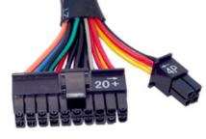 | 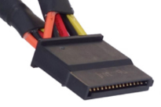 |  | 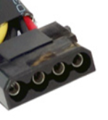
Identify each of the power supply connectors. | 24ATX(Advanced Technology extended) or PSU power supply unit | 4/8- pin EPS connector |  | IDE to SATA power cable
Identify each of the power supply connectors. | 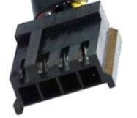 | 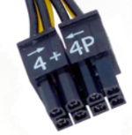 |  | 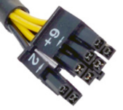
Identify each of the power supply connectors. | Molex connector | 4 + 4 pin Auxiliary |  | 6 + 2 pin power for GPU or CPU
Identify each of the adaptors | 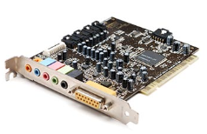 |  | 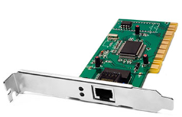
Identify each of the adaptors | Internal sound cards or audio card |  | Network Interface Card (NIC)
Identify each of the adaptors | 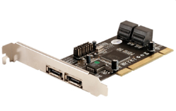 |  | 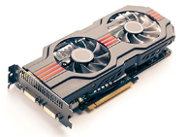
Identify each of the adaptors | eSata card |  | Video adapter
Identify each of the cables | 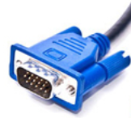 |  | 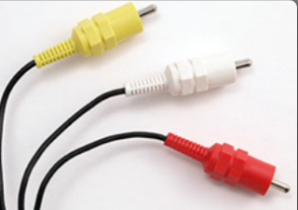
Identify each of the cables | VGA (video graphics array) |  | 3 pin RCA connector cable
Identify each of the cables | 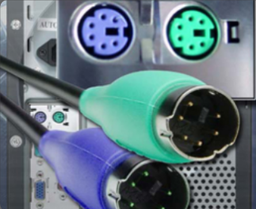 |  | 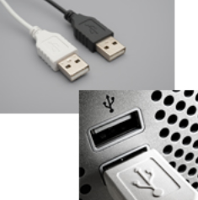
Identify each of the cables | PS/2 |  | USB TO USB
Identify each of the adaptors and converters | 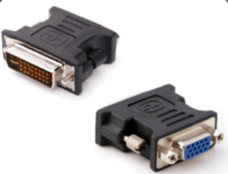 |  | 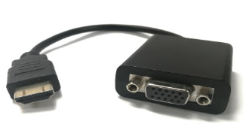
Identify each of the adaptors and converters | DVI to VGA adapter |  | HDMI to VGA converter
Identify each of the adaptors and converters | 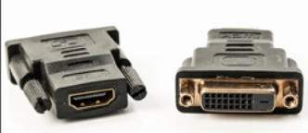 |  | 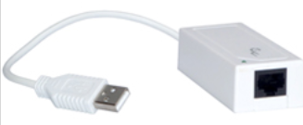
Identify each of the adaptors and converters | DVI to HDMI adpater |  | USB to Ethernet converter

Dissasemble a PC
In this lab, you will disassemble a computer using safe lab procedures and the proper tools. Use extreme care and follow all safety procedures. The first time that you do this task it could take you as long as an hour. When you practice and repeat this it will take as little as 10 minutes.

Computer Disassembly
If you cannot locate or remove a component, ask your instructor for help.
DO NOT
- remove the CPU or heat sink from the motherboard
- pile components on top of each other on the bench
DO
- place RAM module, graphics card and M.2 SSD in individual antistatic bags
- lay your components out individually on the antistatic matting

Tools
A pull-apart computer  Antistatic wrist strap  1 Antistatic bag | Phillips head screwdriver  A container for screws  Phone camera to photograph where cables go

Check the computer works before you start.
- Collect a “pull-apart PC, plug it in and check that it works – boots to Windows.
- If it doesn’t start up start by troubleshooting to find the problem
- Call the tutor to help you if you can’t troubleshoot and make it boot
- Turn off the computer and disconnect the power cable.

Open the Computer Case.
- Remove the side panel
- Take pictures of the inside to be used as a reference when reassembling the computer.
- As you disassemble the computer – lay each component tidily and flat on the antistatic bench – not touching other components.

Antistatic Wrist Strap.
- Put on an antistatic wrist strap and connect the other end to the clips under the bench. If there are none then clip the other end of the conductor to an unpainted, metal part of the case.
- The lab workbench tops are antistatic but components should not be allowed to touch anything else on the bench, nor touch each other. RAM must always be placed in an anti-static bag.

Remove the Power Supply.
- Disconnect all power supply cables from where they are connected to the motherboard and devices. Take photos so you know where to plug them back in!
- Unscrew the power supply from the case – never remove screws from the power supply itself.

Remove other cables and plugs.
- Remove the SATA cables
- Unplug the switch plugs, serial port plug, audio cable etc
Make sure you have a photo of where these cables go.
When removing SATA cables carefully press the tab in before pulling on it.  If you don’t do this, you can destroy the cable or damage the motherboard. | 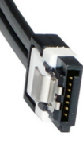

Remove graphics Card
- Remove any screws attaching the graphics card to the case
- Carefully lift the graphics card from the slot. There is often a locking tab on the slot that must be released before the card can be removed.
- Hold the graphics card by the mounting bracket or by the edges.
NEVER TOUCH THE GOLD PINS – Grease from your hands may prevent it from working

Remove the storage Devices (SSD, M.2)
- Remove the screws or fittings that hold the device in place. Put the screws or fittings in one place in your container.
- The M.2 has a plastic clip holding the end of the drive down. Pull the plastic clip up to release it, then gently slide the drive out of the fitting.
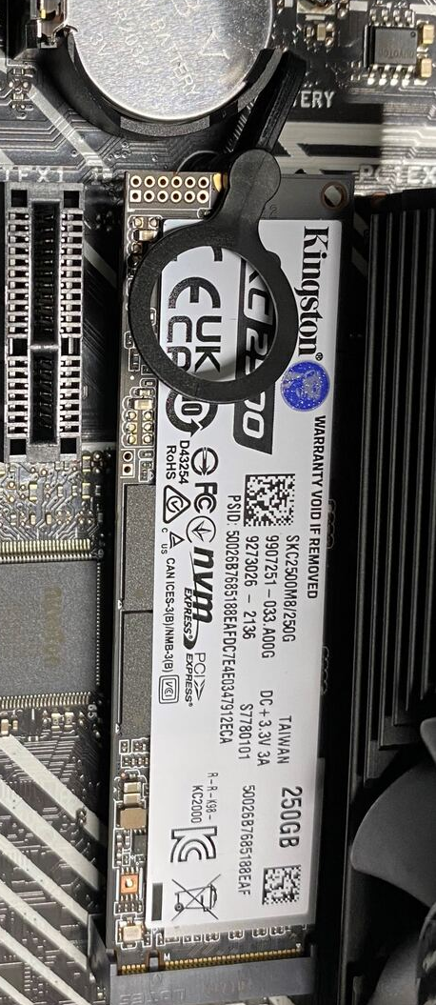

Remove optical drive
- Once unscrewed they should slide out the front of the case (not inwards)
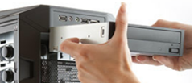

Remove Memory Modules (RAM).
- Release the locking tabs that secure the memory module.
- Hold the memory module by the edges and gently lift out of the slot.
DO NOT touch any of the gold connection area with your hands
Put the memory modules in an antistatic bag.

How long did disassembly take? _________30 min________________________

 | Get your tutor to check you have fully disassembled the PC before continuing.

 | Develop work-readiness skills  - Appraising own skills and the job tasks realistically  - Employing field-specific reasoning to solve problems  - Showing decisiveness in action  - Dealing with problems  - Problem solving in context

Classroom motherboard - label this diagram so you can remember what each part is

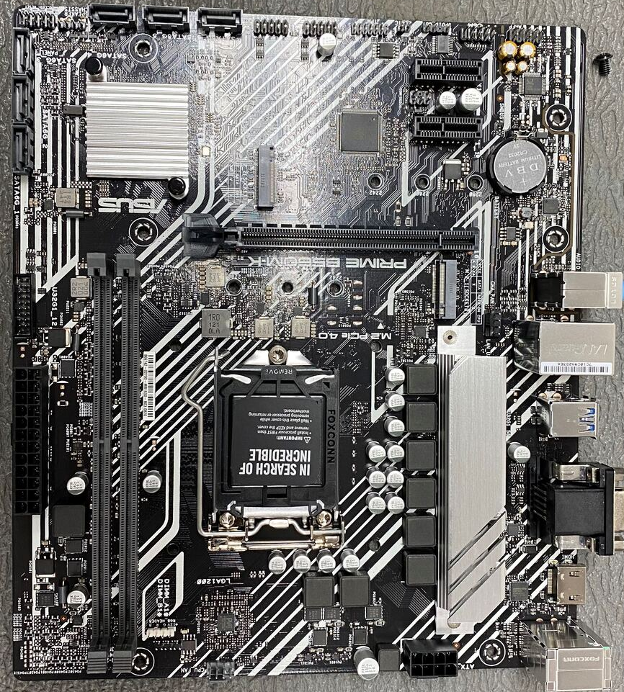

Lab 2 – PC Assembly

Assemble the computer

Computer assembly
Using your photos, memory and any notes that you wrote re-assemble and test the PC.
Detailed instructions are on the following pages but following is a checklist.
CHECKLIST
Check | Item | Watch for
 | RAM | Fully seated, correct slot, right way around, tab closed to lock in
 | SSD Drive | Connected to power and SATA
 | M.2 Drive | Locked in place
 | Optical Drive | Connected to power and SATA
 | Graphics Card | Fully seated and screwed to case
 | Power Supply | Power cables to:  - SSD  - Optical Drive  - Motherboard x 2
 | SATA Cables | Data cables  - From SSD to motherboard  - From Optical drive to motherboard
 | Case fan | Plugged into motherboard
 | CPU fan | Plugged into motherboard
 | Front panel connectors | USB  Power switch  Reset switch  LED x 2

Notes

Install the RAM.
- Align the notch on the bottom edge of the RAM module to the notches in the slot. It is stiff and you have to push in firmly.
- Press down until the locking tabs click into place
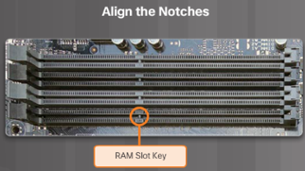 | 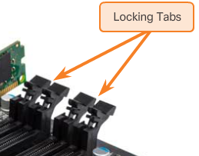
 | Ram comes in pairs and should be inserted into the same coloured slots when there are 4 slots.

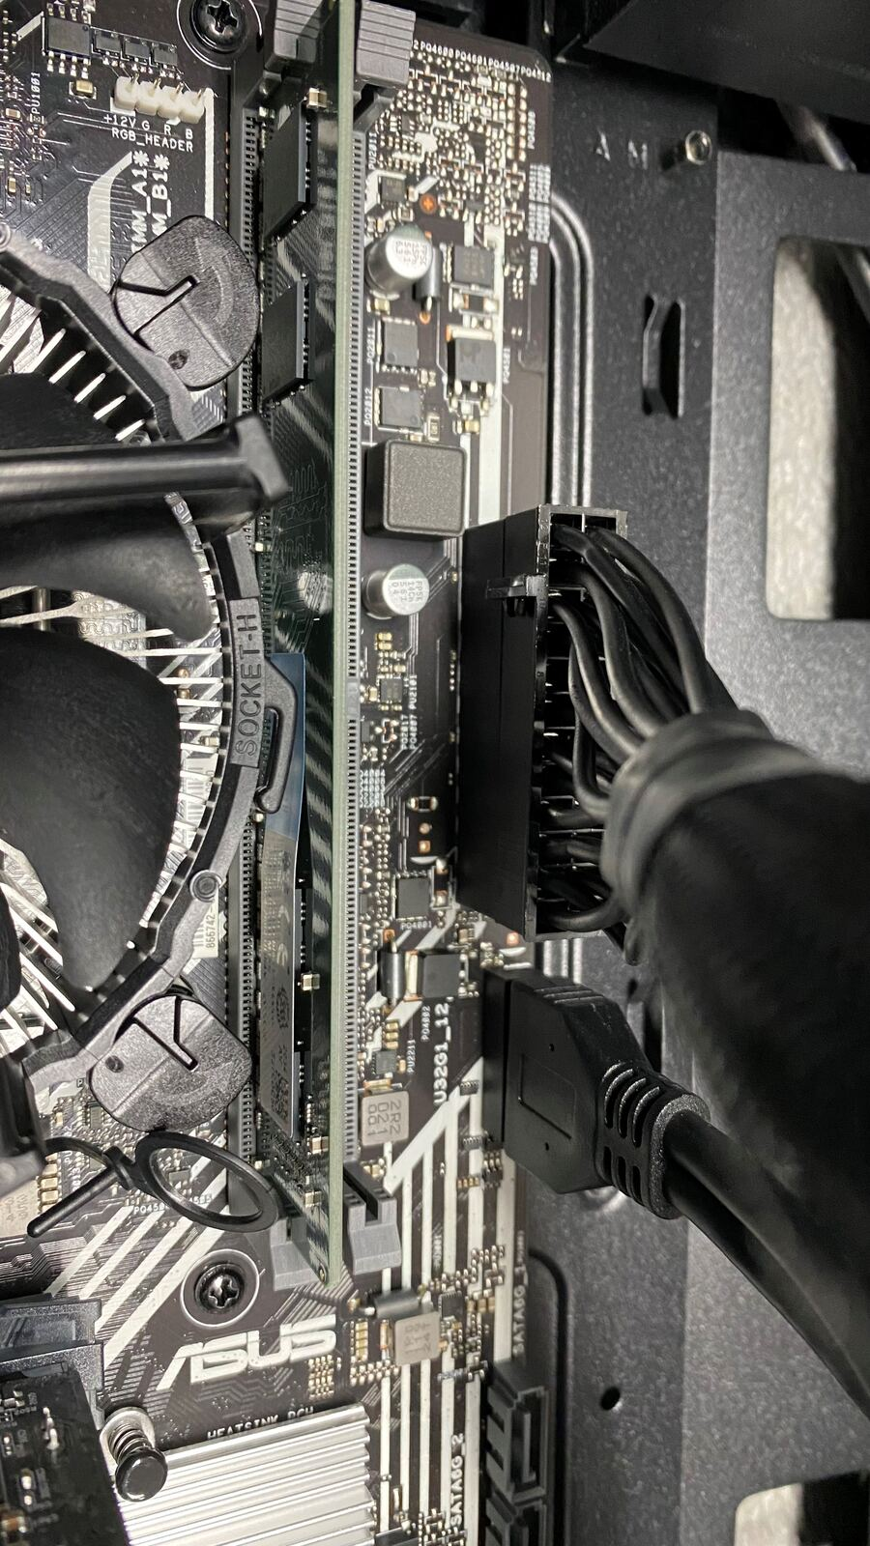

Install the Drives.
- Insert the SSD drive in the 2.5-inch drive bay.
- Install the M.2 drive and lock into place with the plastic tag

Install the optical drive
- Align the drive with the 5.25-inch drive bay and slide into place.
- Secure the drive to the case using the proper screws.

Install THE Graphics card.
- Press down gently on the card until the card is fully seated.
- Secure the card by attaching the PC mounting bracket to the case with a screw.

Install the power supply.
- Install the power supply
This is a modern modular power supply. The drives cables are for the SSD and the CD ROM drive.
The others go to the motherboard (MB).
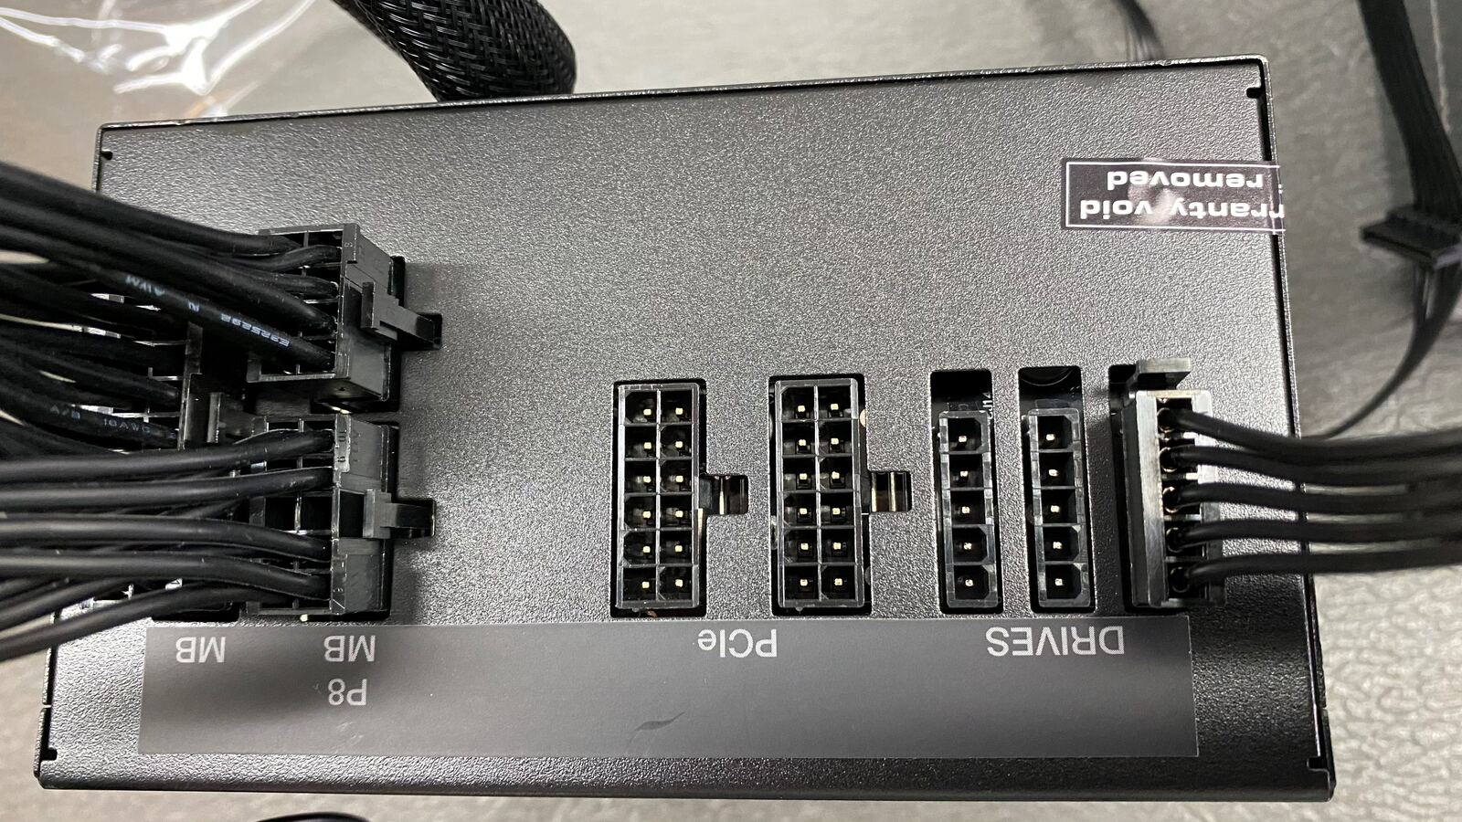
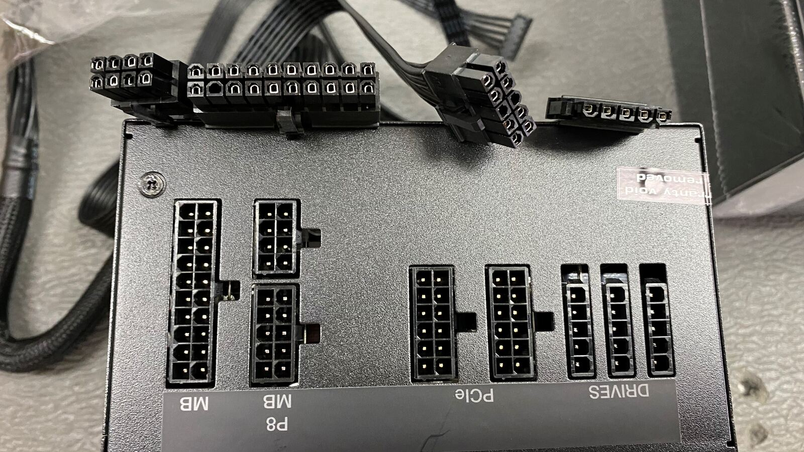

Connect the power supply cables
- Motherboard power supply
- Motherboard auxiliary power
- SSD disk drive
- Optical drive

Connect the remaining connectors.
- Plug the front panel connectors into the motherboard
- Plug the audio cable in
- Plug the case fan and cpu fan into the motherboard

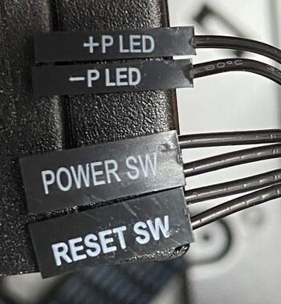 | 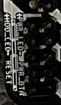
Power SW = PWR-BTN (power button)
Reset SW = Reset (reset button)
+P LED = +PWR_LED- (left)
-P LED = +PWR_LED- (right)
Refer to your photo or the writing on the motherboard. The images above will help you.
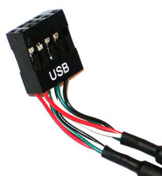
Plug the front panel USB connector into the motherboard

Connect the SATA cables.
Note: SATA cables are keyed to ensure correct orientation with the connector.
- Connect the SSD drive to the motherboard connector.
- Connect the optical drive to the motherboard

Attach the monitor, keyboard, mouse and power cables
- Leave the case cover off, but plug in the power and peripherals.

Before you turn your computer on get your tutor to check your work.
Incorrect assembly can cause permanent damage.

- Boot the computer and see that it still boots up into Windows
- If it does not boot up, turn it off and check all your work for errors.

As the computer boots the BIOS does a check of all internal components (known as the POST – Power On Self Test).
The firmware (BIOS or UEFI) uses a pattern of beep codes to indicate any errors encountered by the POST.
If the computer beeps three times it mean the RAM is not correctly installed

How long did reassembly take? ______40 mins___________________________

Removing and reinstalling the CPU and heatsink assembly
Students can take turns removing and replacing the CPU and heatsink assembly on a non- working motherboard.
This is not to be done on the working classroom pull-apart machines.
Normally on a working machine you would:
- Take antistatic precautions – the CPU is sensitive to ESD.
- Clean the surfaces
- Apply thermal paste.

      - Remove the heat sink and fan assembly and CPU from the motherboard
      - Reassemble the CPU, heat sink and fan assembly making sure it is fully secured (not wobbly).
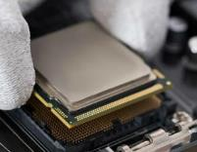
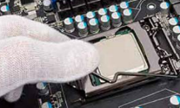
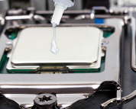
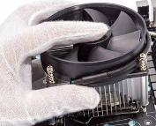

Get your tutor to check your work.

lab 3 – Advanced Computer Hardware

Knowledge Check Questions
Check your knowledge by answering the following questions.

Advanced computer functionality
Question | Your Answer
RAID Concepts  Describe what each of the terms means | Striping: Data is split across multiple disks to improve speed  Mirroring: Data is duplicated across two disks for redundancy  Parity: Adds erros- hacking info to data for recovery  Double Parity: stores two sets of parity data across multiple drives
Briefly explain the terms that enhance CPU operation. | Intel Hyperthreading: Allows each core handle multiple threads  AMD HyperTransport: High-speed data link for CPUs.  Overclocking: Increases CPU speed beyond default  CPU Virtualisation:- Enables running virtual machine
List 5 components that keep a computer cool and briefly describe how they provide cooling. | 1. Heat sink  2. Cooling fans  3.liquid cooling fan  4.Thermal paste  5.case ventilation/fans
Ports, Connectors and Cables  Identify each of the following ports | 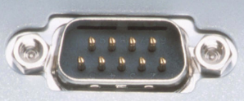 | 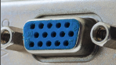
 | DB9 serial port or RS-232 PORT | VGA
 | 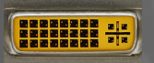 | 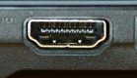
 | DVI | HDMI
Identify each of the following cables | 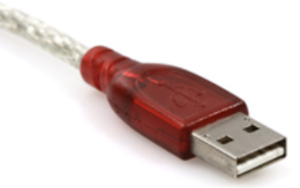 | 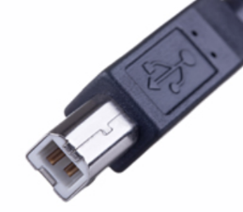
Identify each of the following cables | USB-a | Display port
Identify each of the following cables | 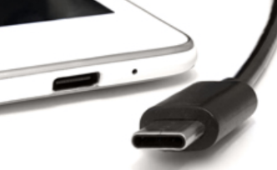 | 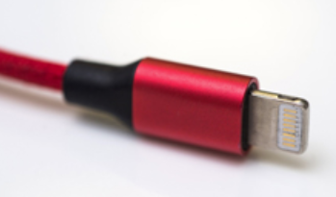
Identify each of the following cables | Type-C | Lightning
Identify each of the following cables | 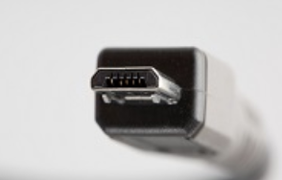 | 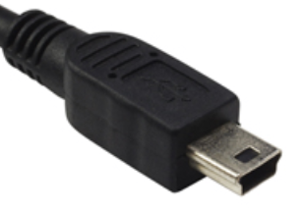
Identify each of the following cables | MIRCO USB | USB-B MINI CONNECTOR
Identify the following cables | 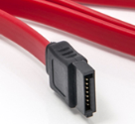 | 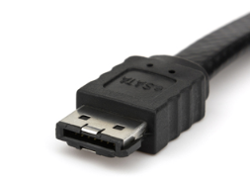
Identify the following cables | SATA | eSATA
Identify the following connectors | 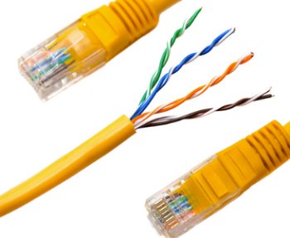 | 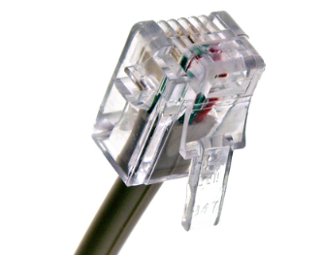
Identify the following connectors | CAT5 ETHERNET CABLE | CAT6
Identify the following connectors | 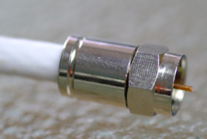 | 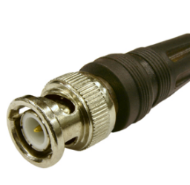
Identify the following connectors | RG-6 COAXIAL CABLE | BNC CABLE

computer configuration
Question | Your Answer
List the main differences between a thick client and a thin client. | Thick Client | Thin Client
 | -Full computer that does its own processing  - It has own CPU, RAM,ROM  - EG. Home PCs, gaming pc, office pc. | Relies on a server to do most of the processing.  Very basic hardware  Eg. computers in libraries of call centres.
NAS  Explain what NAS is and what it is used for. List the specialised components that is has. | NAS is a one type of device which helps to connect withs Networks that stores and share file or data for multiple users.  - Multiple hard drivers (RAID)  - Network interface(ethernet)  - Specilalized NAS operating system (like sinology DSM)  - Cooling systems for drives.

Boot the computer

Investigate BIOS or UEFI settings

In this lab, you will explore the BIOS or UEFI firmware setup utility program.  The BIOS is in a ROM chip which contains a small program that controls the communication between the operating system and the hardware.  Some settings in the BIOS can be configured by the user and are stored in the CMOS memory chip. | 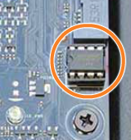

Power on the computer.
    - Ensure your computer is plugged into the power, keyboard, and monitor
    - Note – the menu in your BIOS might not contain of the items in the following steps

Enter the firmware setup program.
During POST, press the firmware setup key (F2). The firmware setup utility program screen will appear.
 | Some PCs may have the password innervision

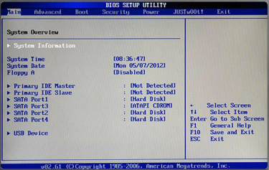 | 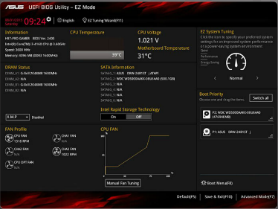
BIOS – found on older computers | UEFI – found on newer computers

You will need the following information for a future lab. Make sure you answer these accurately
Who manufactures the BIOS for your computer? | Motherboard manufacture then customised this BIOS to suit it its own hardware
What is the BIOS version? | The BIOS version is a timestamp indicating the software version of the basic input/output system on a computer.
What is the BIOS date? | The BIOS date is represents when the computer is last updated

List the main menu options (the ones across the top of the screen).
List the main menu headings and briefly explain what type of settings are under each menu
Menu name | Contents
Main | System summary (cpu, RAM)
Advanced | Device settings like USB, CPU, feature
Security | Passwords, TPM, secure BOOT.
Boot | Boot order settings.
Exit | Save or discard changes

Find the security settings.
Navigate through each screen to find the security settings. What security settings and features are available?
Name | What it does
Set super password | Protect BIOS settings.
TPM Device | Needed for Bitlocker encryption
Secure Boot | Prevents booting unauthorised OS.

Find other settings
Navigate through each screen to find the following:
What is the CPU speed? | 3.5 GHz
What other information is listed for the CPU? | Number of cores and threads, Cpu, manufacture (eg. Intel or AMD). Cache size, cpu temp. And virtualisation support (like Intel VT-x or AMD-V)
What is the RAM speed? | 2666 MHz and its depends on installed RAM
What other information is listed for the RAM? | Totally capacity (eg, 8GB or 16 GB), numbers of installed modules (eg, 2*8 gb) Ram manufacturer, and which slots are populated.
What information is listed for the hard drive? | On computer Hard drive we can see the Letter like C,Z,B,A…..Etc. and we can also see drive name like local drive or disk and one more important informations is Size of the hard drive like 500 gb or 1TB is can be any size and free and left size inside hard drive .
What is the first device in the boot order sequence? | The initial boot order device is most probably the internal storage drive on the system e.g.  HDD (Hard Disk Drive)  SSD (solid state drive)  It has the operating system in it, hence the computer will first look into this drive in order to boot (or kickstart itself) normally.
List the other devices can be assigned in the boot order sequence | 1- Hard drive (HDD or SSD) normally stores the operating system.  2- CD/DVD Drive Required: To start from install or recovery cd; USB Drive Required: To install OS or to repair  3- Network (PXE Boot): It is applicable in businesses and learning institutions and boots off a server through a network.  4- External Hard Drive: There is the ability to use an external hard disk (external SSD or HDD).
What power management settings are available? | 1- One most common is keep your device on sleep mode  2- You can cut down or low down your brightness  3- Nowadays many computer come with power saving mode in power saving mode your CPU power will lowdown to 20 per-cent and it will low down your brightness  4- remove unwanted background running app.

Troubleshooting Scenarios

If the computer does not PXE boot, where would you go to configure this? | 1- I will reboot my PC  2- I will use DEL or F2 OR ESC key in turning on the pc  3- click on the bios and advance tab  4- Enhance PXE boot (or Network boot)  5- please ensure that your network (PXE) boot appears first or early in the boot order.  6- save changes and quit.  In case PXE is not mentioned, then it is also possible that you have to:  Allocate Legacy Boot or UEFI Network Stack  Insert an Ethernet cable, since PXE is used on a wired connection
When using Virtual Box you get an error about intel VT-X, What BIOS setting do you need to change to resolve this issue? | In case VT-x error appears when using VirtualBox, then your system does not enable virtualization at the moment, as it is disabled in BIOS or UEFI. This can be fixed by starting your computer and then entering BIOS by pressing F2, Del or Esc and then enabling Intel Virtualization Technology or VT-x. In many CPUs, Security Settings can be located in Advanced, CPU Configuration or Security. Once you enable it and store the settings, the VirtualBox will support virtual machines which require hardware virtualization.
What do you do if the ‘press F2 or del key to enter BIOS’ prompt does not appear during the boot process? | In case you fail to get the message Press F2 or Del to enter BIOS during boot up, you can follow some steps to enter into BIOS menu. When you are starting up your computer, you need to ensure that you hit the right key depending on your computer. F2, Del, Esc or F10 are some of the common function keys in many keyboards. In case your system appears to boot up really fast, press your key immediately you switch on the computer. Alternatively, you can open your BIOS by opening Settings, choosing System, pressing Recovery and clicking Restart now under Advanced startup. Once the computer restarts, choose Troubleshoot > Advanced options > UEFI Firmware Settings and then click the Restart button to enter BIOS. In case the initial attempts are unsuccessful, it is recommended to pull the CMOS battery off the motherboard momentarily to ensure that all is set right or that no hardware changes are incorrectly set. Also, in case your keyboard is faulty or loose, the problem may prevent the boots when you press the buttons.

BIOS/UEFI Security Configurations

BIOS passwords – Supervisor and user level passwords to restrict access to the BIOS
Drive Encryption – encrypts the hard drive and requires a password to boot and access the drive, even if the drive is installed in another machine
LoJack – allows the devices to be remotely located, locked or all files to be deleted
Trusted Platform Module (TPM) – a chip to store passwords and allow full disk encryption
Secure Boot – used by UEFI to prevent unauthorised OS’s from loading during start-up
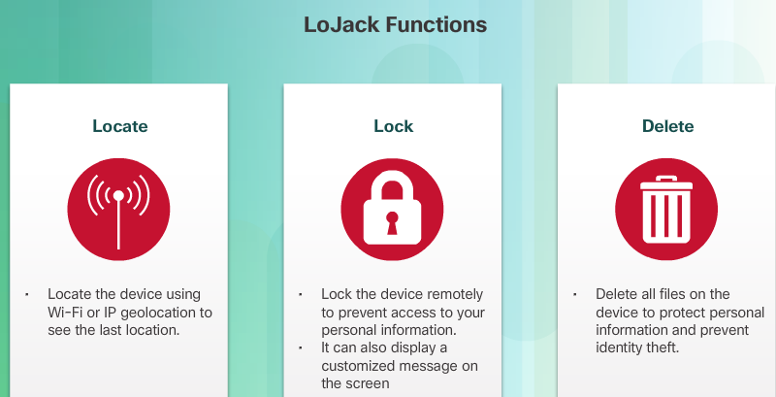
BIOS/UEFI Hardware diagnostics
If a PC is overheating check both the CPU clock speed and the CPU fan speed
Reducing the clock speed of the CPU will reduce the CPU temperature – running slower means it will be cooler. Increasing the speed (overclocking) is not recommended as the CPU can overheat.
Increasing the fan speed can help cool the CPU

In future labs you may have to change the boot order settings. You need to remember how to do this.
Exit without saving. The computer should restart automatically.

Install Windows
In this lab, you will create a Windows 10/11 installation on a USB. If you do not have a suitable USB you can skip to the next lab and return to it at another time. Having a bootable USB that you can install a fresh copy of Windows from is useful to have. (Lab 10.3.1.1 has extra instructions for installing Windows 10 and instructions for installing

Compare Windows 10 and Windows 11

Use the internet to find the minimum and recommended hardware specs for Windows 10 and 11

Windows 10
Minimum Requirements:
- Processor: 1 GHz or faster
- RAM: 1 GB (32-bit) or 2 GB (64-bit)
- Storage: 16 GB (32-bit) or 32 GB (64-bit)
- Graphics: DirectX 9 or later
- Display: 800x600 resolution
Recommended Requirements:
- Processor: Intel i5/i7 or AMD Ryzen 3000 series or newer
- RAM: 8 GB or more
- Storage: 256 GB SSD
- Display: 1920x1080 resolution or better
Windows 11
Minimum Requirements:
- Processor: 1 GHz, 2 cores, 64-bit compatible
- RAM: 4 GB
- Storage: 64 GB
- Graphics: DirectX 12 or later
- TPM: TPM 2.0 (security feature)
- Display: 720p resolution or higher
Recommended Requirements:
- Processor: Intel i5/i7 or AMD Ryzen 3000 series or newer
- RAM: 8 GB or more
- Storage: 256 GB SSD
- Display: 1920x1080 resolution or better

List the main difference in features between Windows 10 and 11

1. Start Menu & Wood RS

Windows 10: Live tiles Start Menu.

Windows 11: Start Menu has been placed in the center and simplified icons without live tiles and a stronger streamline design.

2. User Interface (UI)

Windows 10: Retro user interface and the square corners, as well as a combination of traditional features.

Windows 11: Rounded corners and new icons, a fresher and minimal design in style called ModernUI.

3. Virtual Desktops

Windows 10: This one has Virtual Desktops and is not customizable.

Windows 11: even more customizable Virtual Desktops with unique wallpaper on each and better multitasking.

4. Snap Layouts

Windows 10: Simple window snapping.

Windows 11: Improved Snap Layouts to improve multi-windowing, even including pre-set gridlines to place windows in the desired position.

5. Performance Efficiency

Windows 10: Unrelated performance.

Windows 11: Newly enhanced performance and improvements in efficiency, such as memory management and optimization of new hardware.

Create a bootable USB drive
Use the classroom PC (not the lab pull-apart). Log in as Student/Router. Use the Blue USB port on the back of the PC (USB3).
Rufus is free software that formats and creates a bootable USB to install Windows. It requires about 3-4MB of space on the USB.
NOTE: You can choose to install Windows 10 or 11 for this activity. It is recommended to use Windows 11 so you become familiar with the differences during the install process compared with Windows 10. Depending on the version of OS you pick you may have some different steps to follow. The following instructions are a general guide based on Windows 10. If you get stuck there are many online guides to work from.
You need an 8GB USB (ideally USB3) with nothing of importance on it (all files will be deleted)
      - Using a classroom PC insert the USB – ideally into a USB3 port.
      - From the internet find and download the Rufus executable
      - Run Rufus (no installation necessary)
      - Make sure the Device selected is your USB
      - Click on SELECT
      - Navigate to \\itsw1\Public and click on Operating System ISOs
      - Select Windows desktop, Windows 10 or 11.
      - Click on the Windows ISO image. Wait for it to download.
      - Keep the default settings in Rufus – do not change any. The partition scheme must be MBR.
      - Click Start.
      - When it has finished, remove the USB.
      - Use the USB to install Windows onto the lab pull-apart PC (Next lab)

Install WIndows from the USB

If you did not have a USB then you will need to install Windows from the network using PXE boot using previous instructions. You can do this lab next week instead.

Start the Installation Media
      - Check the BIOS settings and make sure boot from USB is enabled. Also set the boot priority to CD/DVD drive first.
      - Plug the bootable USB flash drive into a USB port on the lab pull-apart PC.
      - When the computer starts up, watch for the message Press any key to boot from CD or DVD. The computer starts loading files from the USB flash drive.

Configuring Initial settings
      - The Windows Setup window opens. Click Next to continue unless you need to change the default settings.
      - Click Install now to continue the installation.

Collecting Information
      - Skip the step to activate Windows window, continue without a product key.
      - In the License terms window, read and confirm that you accept the license by selecting the box I accept the license terms. Click Next.
      - In the Which type of installation do you want? Window, click Custom: Install Windows only (advanced).
      - In the Where do you want to install Windows? Window, select the hard drive or partition on which Windows will be installed.
      - If the hard drive already has partitions, you should delete all of the partitions until you only have one.
      - Click to select Disk 0 Unallocated Space. Click Next to continue.

Installing Windows
      - The Installing Windows window opens. Windows will take some time to copy the files and install the OS on your computer. During the setup, the computer will restart several times.
      - When the Windows needs to restart to continue window opens, your computer will automatically restart or you can click Restart now.
      - If you get the message Press any key to boot from CD or DVD…, do not press any key and Windows will boot from the hard disk to continue the installation.

Basics Setup
In this step, you will select your region and your keyboard layer.
Note: The personalization sub steps maybe different depending on your Windows version.
      - Verify the region and select yes. If not, choose your region and select yes.
      - Verify the keyboard layout and select yes.
      - Click Skip if you are not adding a second keyboard layout.

Network Setup
In this step, the installation may continue without your input. If prompted, provide the installation with the necessary information.

Account Setup
In this step, you will set up a local account to access the computer. You will not be creating a Microsoft account for this exercise.
      - Click Offline account to create a local account.
      - Click No to continue using a local account, instead of Microsoft account.
      - Enter a username and click Next to continue.
      - Create a password and confirm the password when prompted. Click Next to continue.
      - Answer all the security questions and click Next to continue.

Services Setup
In this step, you can give permission to use Cortana and select your privacy settings.
      - You can choose to use Cortana as your personal assistant. Click Yes or No to continue.
      - Read the privacy settings and click Learn More to find out more details. Then decide which features to use and click Accept to continue.

Finishing the Installation
      - When you are finished with the installation, Windows continues to finalize your settings.
      - After the installation is completed, the Desktop displays and you are logged into Windows for the first time.

Connect your PC to the classroom network
      - Plug your Ethernet cable in and give it time to start the network on your PC
      - Test that you have internet access.

Optional: Restoring a USB to how it was (if you need the USB for something else)
      - Run Rufus
      - Select the Boot selection drop down
      - Select Non bootable
      - Select whatever you want for the file system (e.g. NTFS)
      - Select START

Install Third Party Software
A common task that the family/friends of an IT person ask is to fix their laptop/desktop. Often the solution is to perform a clean install of Windows. When performing a clean installation of Windows on a PC or laptop it is beneficial to pre-install some software for the user (especially for non-tech savvy people).
In this task, you will download some common software and create accounts for a user.

- Download and install the Google Chrome web browser
- Create a new Google account and sign into the browser, enable bookmarks and create a bookmark for Moodle, Netacad and Outlook
What are web browser bookmarks?
Book mark is nothing but it is one of the short cuts that is easy to access anything without typing a single word in the search engine like in case of YouTube where in if i use it everyday every time but when i bookmark YouTube i can see YouTube when i open any browser it is in the middle (or first) page I can open without typing any thing.

How would signing into a web browser help a typical user?
Signing into a web browser, like Chrome or Firefox, can help a typical user in several ways:
Sync Across devices: You can sync your bookmarks, history, passwords and open tabs across all the devices (such as phone, laptop and tablet) so that you can have access to them on any device.
Convenient data access: There is no need to transfer the settings or bookmarks to other devices manually when you are signed in. It eases the process of your browsing.
Individualized Experience: The browser will be able to provide personalized suggestions, e.g. give recommendations on which site to visit which is recommended depending on your history or interests.
Security: It allows you to manage and secure your passwords easier when you are signed in via in-built password managers, and you should use two-factor authentication.

- Add an ad blocker extension to the browser
What is a web browser extension? What are some examples of extensions you use on your own PC? Compare your answers with the people sitting next to you.
A web browser extension is a small add-on program which you can add to your web browser to add new functionality, customize your web experience, or make it work in new ways. Extensions are able to do such things as block advertisements, store passwords, increase productivity, or assist with web development.

What are two benefits of having an ad block extension?
1- it gives a clear experience to user in any task like game, watching movies, study, and it remove unwanted videos
2- One biggest benefits is it can protect you from dangerous or fake ads that might contain viruses or malware like adware and fishing attack is one of the famous malware.

- Download and install Google Drive for desktop.
Why would you install Google Drive for a user? What could happen if the user did not have software like Google Drive or OneDrive?
Google drive comes in handy to such a user who needed cloud backup instead of USB and other form of physical or offline backing up and the greatest strength of google drive is that anytime where ever a user wants to have an access to it needs to have the internet and that is it.
WHY ? If I lose any important documents or they stolen my device but I backup in Drive will it be very easy to me to access them in form of photos and documents everywhere and anytime.

- Edit the Windows start menu and task bar to remove any unnecessary applications for the user. Pin the apps you would suggest a typical home PC user needs.

Computer configuration

Research a hardware upgrade
In this workplace scenario the computer you are working on belongs to a customer.
It most likely has about 4-8 GB of RAM, a 250/500 GB SATA hard disk drive/SSD, and a PCIe video adapter card with 2GB of RAM.
Your customer wants to be able to play the latest computer games and wants to know what a hardware upgrade would cost to make this possible.
Use the Internet to gather information about hardware components (pbtech.co.nz or pcpartpicker).

Research memory options.
Shop around and in the table below list the brand, model number, features, and cost for two different RAM modules. Select the cheapest and most expensive.
Brand and Model Number | Features | Cost
WD BLUE SN570 | M.2 NVME 1TB, 3500 MB/S | $80
Samsung 980 Pro | NVME 1 TB/ 7000 MB/S | $120

Research hard disk drive options.
What is the difference between NVMe, M.2 and SATA (SSD and HDD) drives?
NVMe SSD – Fastest (~7000 MB/s), uses PCIe, best for gaming & editing.
M.2 SSD – Compact, can be NVMe (fast) or SATA (slower).
SATA SSD – Slower (~500 MB/s), uses cables, budget-friendly.
HDD – Very slow (~100-200 MB/s), best for bulk storage.

In the table below list the brand, model number, features, and cost for a range of drives NVMe, M.2, SSD and HDD
Brand and Model Number | Features | Cost
WD BLUE SN570 | M.2 NVME 1TB, 3500 MB/S | $80
Samsung 980 Pro | NVME 1 TB/ 7000 MB/S | $120
Western Digital WDS500G2B0A | SATA 3 6 GB/s 2.5″ / 7mm  Also need a mounting bracket: 2.5″ to 3.5 | $144
Seagate ST2000DM006 | 2 TB 7200 RPM 64 MB Cache SATA 3 3.5” | $44

Research video adapter card options.
Select any recently released PC game and select two different PCIe video adapter cards that can run the game. One that meets the minimum specifications and one that meets the recommended specifications (find the cheapest/best vaule available).

Game | Minimum Specifications | Recommended Specifications
Alan Wake 2 | NVIDIA GeForce GTX 1660 / AMD RX 590 (6GB VRAM) | NVIDIA RTX 3070 / AMD RX 6700 XT (8GB VRAM+)

Brand and Model Number | Features | Cost
MSI GeForce GTX 1660 Ventus XS 6G OC | 6GB GDDR5, Dual Fan, PCIe 3.0, DirectX 12, 1408 CUDA cores | $318 NZ
XFX Speedster SWFT309 Radeon RX 6700 XT | 12GB GDDR6, PCIe 4.0, 2560 Stream Processors, DirectX 12 Ultimate, RDNA 2 | $587 NZ

Identify, Compare and Recommend Computers
Scenario: You are working in a technology retailer. Your job is to recommend suitable products to customers that fit their requirements and budget.
Provide a link and detail the hardware specifications and price for a suitable device for the three customers below. Your recommendation should be good value performance/price system for the customer.

Customer one: Personal home computer. The customer uses MS Office and web browsers
- Intel Core i5-12400
- 12GB DDR4 RAM
- 512GB SSD
- Windows 11 Home
- Wi-Fi 6 and Bluetooth 5.2
Price: ~$449 USD (NZD ~$750)
Reason: Fast for home use, affordable, smooth multitasking for Office/web apps.

Customer two: Business user: The customer uses MS Office, Zoom, Xero and other corporate software.
Use Case: MS Office, Zoom, Xero, and corporate software
Recommended PC: HP ProDesk 400 G9 Small Form Factor
Specifications:
- Intel Core i5-13500
- 16GB RAM
- 512GB NVMe SSD
- Windows 11 Pro
- Integrated TPM 2.0 and security features
Price: ~$679 USD (NZD ~$1,130)
Reason: Reliable, secure, and fast for corporate tasks with room to expand.

Customer three: Gaming user: The customer wants a PC that can play the latest PC games.
Use Case: Playing the latest PC games
Recommended PC: Skytech Blaze 3.0 Gaming PC
Specifications:
- AMD Ryzen 5 5600X
- NVIDIA GeForce RTX 3060 12GB
- 16GB DDR4 RAM
- 1TB NVMe SSD
- Windows 11 Home
- RGB lighting and gaming case
Price: ~$999 USD (NZD ~$1,660)
Reason: Great value for modern AAA gaming at 1080p/1440p with smooth performance.

lab 4 – Preventative Maintenance and Troubleshooting

Check Your Knowledge
Check your knowledge by answering the following questions.

Preventative maintenance
Question | Your Answer
List all the reasons for performing regular preventative maintenance | - Improves system performance and reliability  - Prevents hardware failures  - Extends the life of the components  - Reduces the likelihood of unexpected downtime  - Maintains optimal airflow and temperature  - Helps identify and fix issues early
List the three things needed to remove dust from the inside of a computer  What must you do when using compressed air to clean a fan? | Compressed air can  Soft brush  Anti-static vacuum or lint-free cloth
Describe four main tasks in a software maintenance schedule | Installing updates and patches  Running antivirus/malware scans  Backing up important data  Cleaning up temporary files and defragmenting drives

Troubleshooting process
Question | Your Answer
Explain the process of preventing data loss prior to repairing a computer | It’s necessary to back up all vital data before starting any computer repairs to avoid losing anything. Options for backing up include USB drives or external hard drives and also storing your data on cloud storage services. If you have this option, you should make a system image or restore point. Protecting your information can be achieved by removing the internal hard drive before any repairs.
List 6 places on a computer where information can be gathered from to identify the problem | 1.Device Manager  2.Event Viewer  3.BIOS/UEFI settings  4.System logs  5.Task Manager  6.Error messages or system alerts
List all the places you can use to research a problem | - Manufacturer’s website/support pages  - Technical forums (e.g., Tom’s Hardware, Reddit)  - YouTube tutorials  - Online tech communities (e.g., Microsoft or Apple communities)  - Troubleshooting guides or manuals  - IT help desk software or databases  - ChatGPT or other AI-based tools
List all the steps to verify full system functionality after repairs are completed | Power on the system and check for boot errors  Log in and test basic operations (keyboard, mouse, screen, etc.)  Check device manager for hardware recognition  Run diagnostics or stress tests  Verify internet and network connections  Open and test commonly used software/apps  Confirm system updates and security tools are running  Ensure user files and settings are intact
List seven common reasons that a computer will not turn on | 1.Faulty power supply  2.Loose or unplugged cables  3.Dead battery (in laptops)  4.Failed motherboard  5.Bad RAM or hardware component  6.Power button or case issue  7.Overheating or thermal shutdown

Troubleshooting process

Using a Multimeter and a Power Supply Tester
You will learn how to use a multi-meter and a power supply tester.
Make sure the PC boots up and is working before disassembly

Equipment
- Digital Multimeter  - Power supply tester  - Screw driver, wrist strap | - Pull-apart PC  - Anti-static bag  - Screw container

Using a Multimeter

Set up the multimeter.
      - Insert the red and black leads into the jacks on the meter.
      - The red probe should go in the + (plus) jack.
      - Turn on the multimeter (make sure you turn it off when you are finished, or the battery will go flat)

Measure the voltage of a COMOS battery

Remove the lid of a PC and carefully remove the CMOS battery.  It may be located underneath the graphics card which you will need to remove.  A fully charged CMOS battery should be 3 Volts  The CMOS battery ensures settings in CMOS memory are not lost when the computer is powered off  If the time and date or other configurations are lost after a reboot the CMOS battery may be flat and needs to be replaced. Measuring the CMOS voltage will confirm this. | 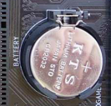

      - Set the multimeter to the voltage slightly higher than the expected voltage of the device being measured.
      - Place the battery on the table. Touch the tip of the red (positive) probe to the positive (+) side of a battery.
      - Touch the tip of the black (negative) probe to the other end of the battery.
      - The number on the display should be 3.0 more or less if the battery is fully charged.

What setting did you need?
What number is shown on the display when you test the battery?
If the number on the display is much smaller than 3 volts, what does this mean?

Power Supply Tester
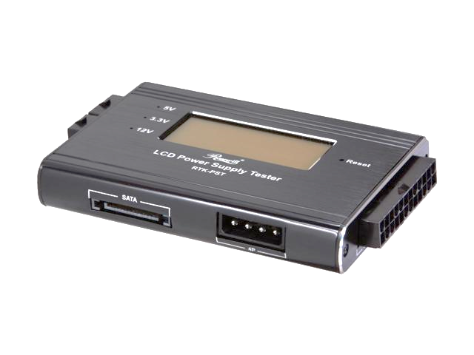
A computer power supply outputs the following range of voltages:
- +5 V, -5 V
- +12 V, -12 V
- +3.3 V
Power Supply Tester

Computer Power Supply Connectors
Use the images below to identify what you are testing.
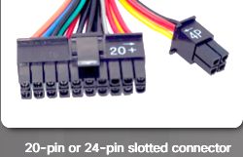 | 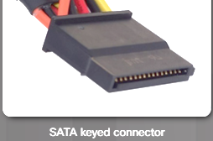 | 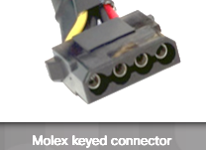
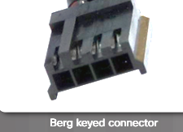 | 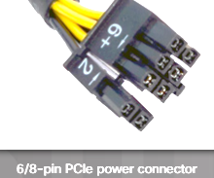 | 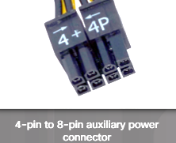

      - Start with the PC turned off. Remove the 20-pin or 24-pin AND 4-pin motherboard connectors from the motherboard and plug BOTH into the tester. Turn the PC on.

Which numbers on the display are illuminated?

Leave these two plugged in while you test each of the other connectors one at a time.
      - Plug the 4-pin Molex connector into the tester. Which LED lights are illuminated?
      - Plug the 6-pin PCI-E connector into the tester. Which LED lights are illuminated?
      - Plug the SATA connector into the tester. Which LED lights are illuminated?

      - Switch the computer off.
      - Plug all connectors back into the motherboard and PC components.
      - Turn the computer on and make sure the PC still boots up. If not – work out what you have done wrong and fix it!

lab 5 – Networking Concepts

Check Your Knowledge
Check your knowledge by answering the following questions.

Network components and types
Question | Your Answer
Make a list of host devices | 1.Laptop  2.Desktop  3.Printer  4.IP phone  5.Tablet | 6.Smart phone  7.Server  8.Camera  9.Game console
Make a list of intermediary devices | 1.Switch  2.Router  3.Access point | 4.Modem  5.Firewall
Describe the main general purpose of intermediary devices. | Switch: Connects multiple devices in a local network and forwards data only to the intended device, improving efficiency.  Modem: Converts digital data to signals for transmission over phone/cable lines and vice versa, enabling internet access.  Router: Directs data between different networks (like your home network and the internet) and assigns IP addresses.  Firewall: Monitors and filters incoming and outgoing traffic to protect the network from unauthorized access.  Access Point: Allows wireless devices to connect to a wired network using Wi-Fi.

Network tools
Question | Your Answer
Name the network tools in the images | 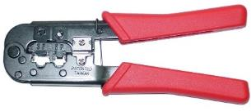 | 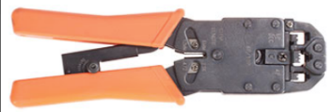
Name the network tools in the images | Cramping Tool | RJ-45 Crimper
Name the network tools in the images |  | 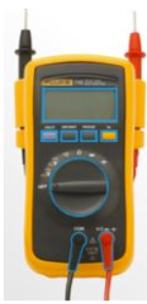
Name the network tools in the images | Punch Down tool | Digital Multimeter
Name the network tools in the images | 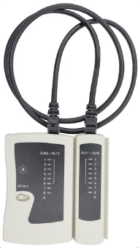 | 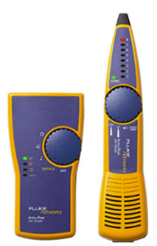
Name the network tools in the images | Cable Tester for NET WORK CABLE | Tone Generator and Probe
Name the three types of network cables in the images | 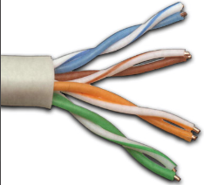 | 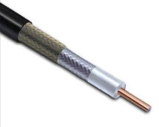
Name the three types of network cables in the images | CAT-5 | Coaxial cable or RG-cable
Name the three types of network cables in the images | 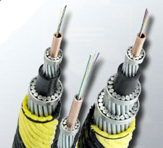.Fiber cable | Fiber cable

Basic concepts
The networking chapter contains a lot of learning material. Only the key points are captured here, and you should review all the chapter material to get a solid understanding of basic networking concepts.
Understanding all the networking concepts in this chapter, will be of great benefit before studying “Introduction to Networking” next semester.

Following are the key components that make up a network. It is important to understand the role of each component.
Host Devices  Any device that sends and receives information on the network (computer, printer, etc.)  A printer connected to your laptop is a peripheral. If the printer is connected directly to a network switch, it is acting as a host. | 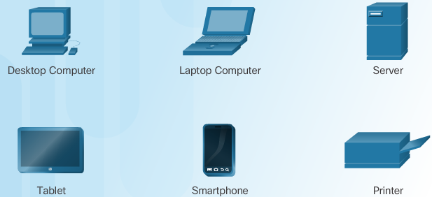
Intermediary Devices  Exist in between host devices (switch, router, access point, wireless router)  A switch connects Hosts to the network.  A router forwards traffic to other networks (such as your ISP)  A modem converts data to a form that can be transmitted onto the ISPs network  A wireless access point connects wireless devices to the network  An integrated router includes a router, switch, firewall and WAP in a single device, typically used in homes. | 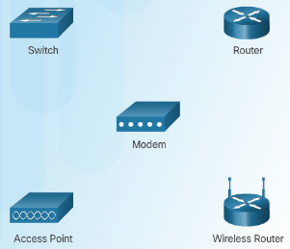
Network Media  Component over which the message travels from source to destination (copper, fiber-optic, wireless) | 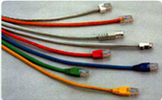

Wireless networks and collision avoidance
Is your WiFi at home rubbish when several people are using it?
Learn why.
- Wifi devices cannot send and receive at the same time (wired LANs can)
- Wifi devices take turns – only one device at a time (not a problem for wired LANs)
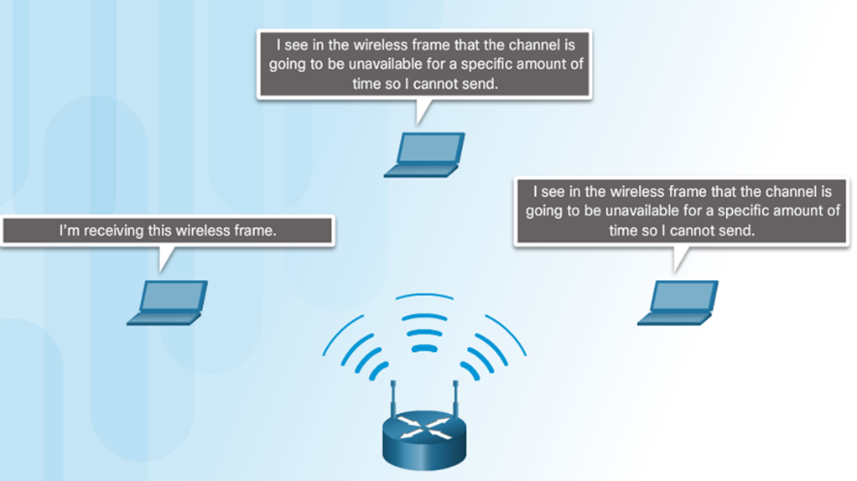
- Microwaves, baby monitors, cordless landlines – can interfere with the Wifi signals
- Wifi does not go through solid objects like brick walls very well
- Wifi loses its strength as the distance from the access point increases
- Some wireless access points have just one aerial. Having four aerials increases the number of devices that it can communicate with at the same time.

Now that you know this, what would you change in your home network?

Do you know about “Ethernet over Power” devices?

IP addressing
We are learning the addressing system used on almost all home and small office networks.
Basic Rules
- Every device needs the SAME network address as every other device
- Every device needs a DIFFERENT host address from every other device
- Every host needs to have the gateway address – which is the routers address
- The router, and devices like printers need a static IP address
Network address
- 192.168.1
Static addresses
- Router (gateway) .1
- Printer .2
DCHP addresses start at .100
- Smartphone .100
- PC .101
- Laptop .102
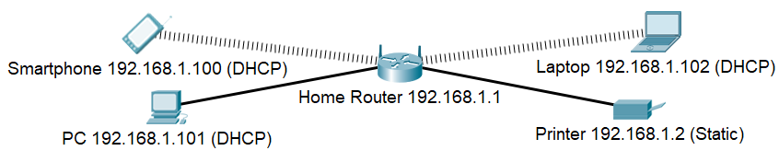

Important details
- The subnet mask for all devices is 255.255.255.0. This means that the first 3 sections are the network address and the last section is the host address.
- The network address is technically 192.168.1.0
- The address reserved to broadcast messages to all addresses is 192.168.1.255
- This leaves addresses 1 – 254 to be used on devices.
- If there are two Wifi routers in the same area (e.g. the classroom) then each has to use a different network address. For example, 192.168.2.0, 192.168.3.0, 192.168.4.0 etc.
Testing
- Ping – this is like phoning somebody. If there is no connection, then something is wrong.
- Tracert – this helps identify where the problem is by reporting each connection point along the way to the destination

Network cables

Build and Test a Network Cable

You will create an Ethernet patch cable and test it.
Do not spend more than 1 hour on the chapter 5 activities.

Equipment
- One piece of cable and two ends
- Crimping tool, wire cutters
- Cable testers need to be shared and should be left in the center of the room
- A coloured image of the T-568B wiring scheme displayed on your computer (from the internet)

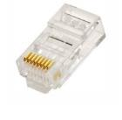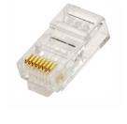 | 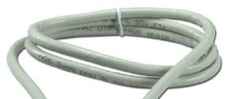
 | 

Instructions
- Remove a section of plastic  - Straighten the wires and place them in order  - Cut a very straight line across at a length that will allow the plastic casing to go inside the connector  - Carefully slide the wires inside the connector making sure they are pushing up hard against the end.  - Insert into crimping tool and crimp the metal pins down into the wires.  - When both ends are made and crimped – insert into cable tester and test. | 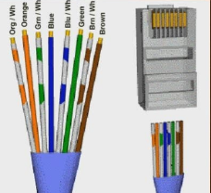  Both ends are the same from left to right. Do not make a mirror image!
Cable is fully enclosed in the RJ45 connector - no bare wires  Every wire reaches the end and is visible  Every wire is in the correct location | 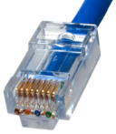

lab 6 – Applied Networking

Check Your Knowledge
Check your knowledge by answering the following questions.

network addressing
Question | Your Answer
How is a MAC address assigned?  What happens to the MAC address when the device moves to another network? | Mac address are assigned by the manufacturers because MAC address is directly link with the hardware component and each address included  manufactures ID  No matter what network a device connects to, its MAC address does not change because it is unique to the NIC’s hardware. Most of the time, the device will be assigned a new IP address by the new network’s DHCP server.
How is an IP address assigned?  What happens to the IP address when a device moves to another network? | Every electronic device on a network has an IP address that allows it to communicate online or on local networks. Most IP address assignments are handled by dynamic or static techniques.  An IP address usually changes whenever a device joins a new network. The reason for this is that IP addresses come from the network, not from within your device.

firewall settings
Question | Your Answer
What is UPnP  Why is it insecure? | UPnP (Universal Plug and Play) helps devices on a network recognize each other and start up services without help.  It can o[pen ports automatically without user permission of user, which can be exploited by malware or virus to bypass firewALL protection
What is a DMZ  What does it protect? | A DMZ (Demilitarized Zone) is a separate network area that contains public-facing services (e.g., web or mail servers) isolated from the internal LAN.  It protects the internal network by limiting access to critical systems while still allowing external access to certain services.
What is MAC address filtering? | MAC address filtering controls network access by allowing only devices with specific MAC addresses to connect.
What is whitelisting? | Whitelisting allows only approved or trusted devices, IP addresses, or applications to access a network or system.
What is blacklisting? | Blacklisting blocks specific devices, IPs, or applications known or suspected to be malicious or unauthorized.

Device to Network Connection

Configure a NIC to Use DHCP in Windows
In this lab, you will build a small network using a home router and two PCs. You will test connectivity between the two computers. Students should work in pairs, with one router between two people. If you do not have a partner then use two PCs that are next to each other.

Equipment
- 1 Wireless router and power cable
- Two PCs running Windows
- Ethernet patch cables (from the classroom computers)

Cabling
Plug in the power cable of the router. Press in the reset button in to set it back to factory default.
Student A
      - plug one end of the Ethernet patch cable into Port 1 of the router.
      - plug the other end of the Ethernet patch cable into the network port on the computer.
Student B
      - plug one end of the Ethernet patch cable into Port 2 on the back of the router.
      - plug the other end of the Ethernet patch cable into the network port on the computer.

Both students (on their own PC)

- Click Control Panel > Network and Sharing Center. The Network and Sharing Center window opens.  - Select Change adaptor settings.  - Disable any virtual adaptors – right click and select disable. | 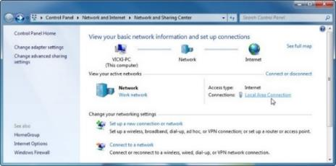
- Navigate to the TCP/IPv4 properties | 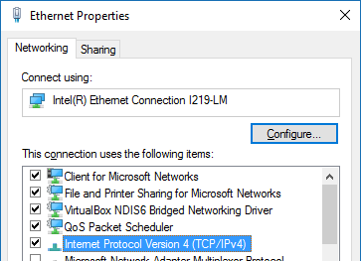
- Make sure the PC is set to obtain an IP address automatically.  This is normally the default setting. | 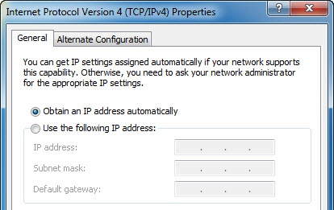
- Check the lights on the back of the NIC. These lights will blink when there is network activity.  - Open a command window.  - Type ipconfig /renew to request an IP address from the router and clear out the classroom settings.  - Type ipconfig /all, and then press the Enter key. This displays your settings. | 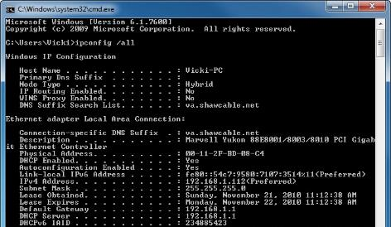
Record the IPv4 address | 192.168.1.45
Record the subnet mask | 255.255.255.0
Record the default gateway | 192.168.1.1
Record the DNS servers (if any) | 8.8.8.8.8.8.4.4
Record the MAC address (physical address) | 00-1A-2B-3C-4D-5E
When the lease was obtained | MONDAY, JUNE 24, 2025 08:30:00 AM
When the lease expires | TUESDAY, JUNE 25, 2025 08:30:00 AM

- Write the IPv4 address of the other student’s PC here | 192.168.88.255
- In a command window, test that your PC can communicate with the other student’s PC.  ping <other students IP address>  Note – both students should fully turn off their windows firewall for this to work.  If the ping was not successful, try to troubleshoot then ask the instructor for assistance. | 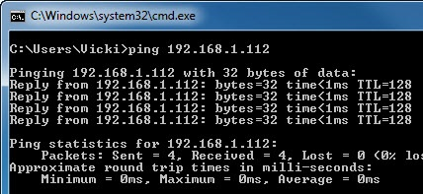

Network addressing
Network devices have a MAC address and an IP address
- The MAC address is hard coded into the network adaptor
- The IP address is assigned by the administrator or DHCP

The MAC address is used to transport frames from one device to the next device
The IP address is used to find the final destination – another local host, or across the internet
An IPv4 address has two parts:
  - The first part is the network address.
  - The second part is the host address.
- The subnet mask determines which part belongs to the network
- Hosts must be on the same network to communicate with each other.
- No device can have the same address as another device
192.168.10.1  192.168.10.2  192.168.10.240  All devices have a subnet mask of 255.255.255.0  All these devices are on the same network | 192.168.10.1  192.168.1.2  192.168.30.240  All devices have a subnet mask of 255.255.255.0  These devices are NOT on the same network and will not be able to communicate with each other

Configure a wireless network
In this lab, you will configure and test the wireless settings on a wireless router.
You do not need a partner for this lab.

Equipment
- A Windows PC
- A wireless dongle
- A wireless router

DO NOT plug in the wireless dongles or cables until the correct step in the instructions

Configure the router

Connect ONE PC to the Wireless Router
      - Plug in the power of the wireless router
      - Connect your PC to an Ethernet port on the router
      - Hold in the reset button on the bottom of the router to set it back to factory default (the lights will flash).
      - Open the command prompt on the PC. Type ipconfig /renew to force the computer to request an IP address from the wireless router via DHCP.
      - The gateway address should be 192.168.1.1 – if it isn’t then you have not reset the router back to factory default – go back and repeat from step c.

Log into the Wireless Router
Open a web browser, type the IP address of your default gateway 192.168.1.1 in the URL field, and then press Enter.
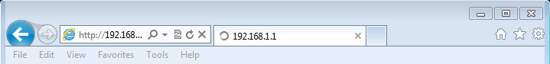
The Windows Security window opens. Type the username and password in the Password field then click OK.  The generic username and password after setting back to factory default is usually admin or administrator. | 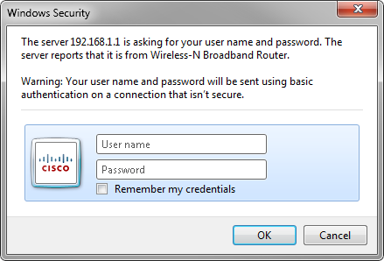

Configure the router
Use the information in the table below to fill in the fields for
- Router Address
- DHCP Server Setting

IP address  Subnet mask:  n is the number on the PC you are using.  Every student needs to be using a different number for “n” – or you will get interference from other students when you set up the Wifi. | 192.168. _n__. 1  255.255.255.0  e.g. 192.168.12.1
Router name: | Yourname (students name)
DHCP Server | Enabled  Start IP address: 2  Number of hosts: 10

Click Save Settings to save the changes.
Your router will re-boot – wait for it to start up again.

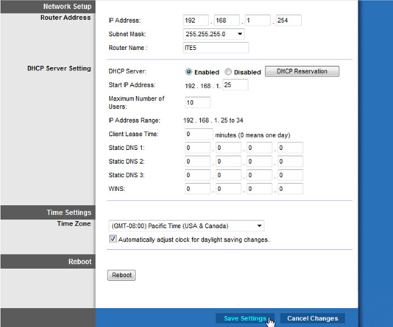
Run ipconfig /renew on the PC to get a new address from the router.
Your gateway address should match the new address on the router e.g. 192.168.12.1
With your browser, log back into the router using the IP address that you configured in the previous step. e.g. 192.168.12.1
Click the Wireless tab.  Select Mixed for the network Mode.  Channel should be set to Auto  Network Name (SSID) should be set to Yourname (students name)  Save your settings | 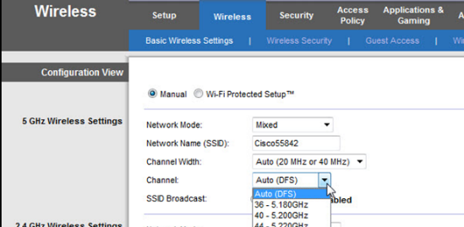
Select the Administration tab
Change the password to access the router.
This secures it from anyone just using the “admin” password to log into your router.
Save your settings.

Connect to your Wireless Network
Remove the ethernet cable from the PC and the router.
Insert the wireless dongle into the PCs USB port.
Locate the wireless settings.  You should be able to identify your wireless network from the SSID that is your name.  You may also see other wireless networks.  Choose Yourname, make sure Connect automatically is selected, and then click the Connect button.  If the Set Network Location window opens, select Public network > Close. | 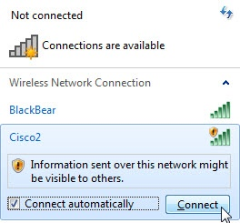

Add Security to the Wireless Network
Log into the router using a web browser.
Click the Wireless tab and then select Wireless Security.
In the Security Mode drop-down box, select WPA2 Personal.
Type ITEv6.0! for the Passphrase and save the settings.
How secure is WPA2?
Designed in 2004, WPA2 is more secure than its predecessors and becomes even better when used with security enhancements. But, it comes with well-known weaknesses. Thanks to its use of AES, WPA2 is able to block eavesdropping more effectively than WPA which uses TKIP.

What is the current best Wi-Fi standard?
The standard for Wi-Fi that is used today is Wi-Fi 6 (IEEE 802.11ax). It provides better performance and more capabilities than any of its previous versions. Even though Wi-Fi 7 is the new standard, most people haven’t switched from Wi-Fi 6 yet.
What is the risk of having an outdated standard for your Wi-Fi?
Older Wi-Fi standards and routers can make you vulnerable to more security problems and cause the internet to run slower. Because WEP and WPA are old and easy to break, your network is prone to being hacked and monitored. Even free WPA2 security which is now known to have vulnerabilities, can be compromised by the KRACK attack if your devices aren’t updated. Additionally, if your router is outdated, you may not receive any firmware fixes for new security problems. These devices may fall into the hands of cybercriminals who can use them for things such as attacking their victims with DDoS and stealing personal data. Older routers often cannot keep up with the speeds and features of newer equipment, causing the internet to be slower and adding issue with compatibility. To secure your network, you should consider WPA3 routers, always update the firmware and change any equipment older than five years

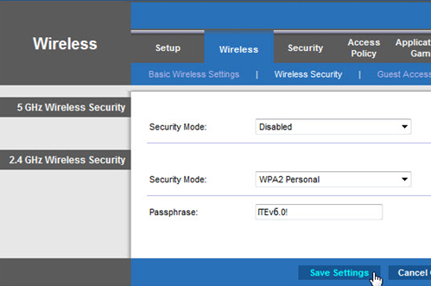
Your PC should lose its connection to the wireless router because it now requires a password.

Connect to the Secure Wireless Network
Reconnect to your Wifi Network using the Wifi passphrase that you set.
View wireless networks  Choose Yourname, make sure Connect automatically is selected, and then click the Connect button.  When the Connect to a Network window opens, type ITEv6.0! for the Security key, and then click OK. | 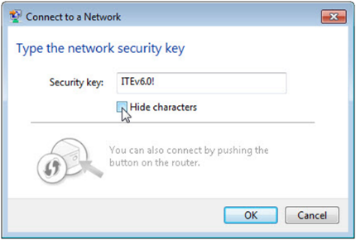

Hide the SSID
Hiding the SSID makes your network more secure. You can only connect if you know the SSID name.

Open a browser and connect to your router and log in. Use the new router password you configured in a previous step.

Navigate to Basic Wireless Settings. Select Disabled for the SSID broadcast.
Save the Settings
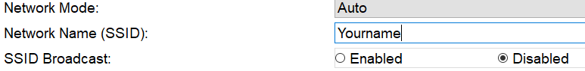
Because the wireless router is not broadcasting the SSID, the wireless network name does not appear in the wireless networks list detected by Windows.
To connect to a wireless network that does not broadcast its SSID, you must know the wireless network’s SSID to connect.

- Inside Network and Sharing Center select “Set up a new connection or network”
- Select “Manually connect to a wireless network” then “Next”
- Enter the Wifi password you set up in an earlier step, check the box that says “start this connection automatically” and “connect even if the network is not broadcasting”, then “Next”, then “Close”.

Challenge:
- Can you connect your cellphone or laptop to your Wifi network now?
- Can you connect your PC to another students Wifi network?

Lab - Test the Wireless NIC
In this lab, you will connect your router to the internet., check the status of your wireless connection and test connectivity.

Connect your router Internet or WAN port to the classroom Ethernet port (on the wall).  The router Internet LEDs will light up, indicating communication and there should now be internet access. | 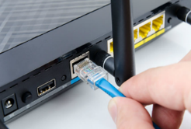
Open a command window and Ping 127.0.0.1 to test the loopback. (this is your wireless NIC)  Pinging the loopback address is a way of testing if your NIC is working. | 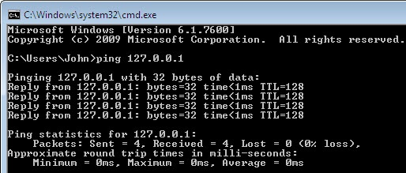
Use the ipconfig command to find your default gateway address.  The default gateway is the port on the router that gives your PC access to the internet. If no default gateway is configured, you will not have internet access. | 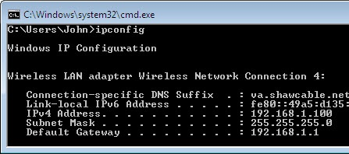
Ping the default gateway.  A successful ping indicates that there is a connection between the computer and the default gateway.  Pinging an internet address such as a website also tests the internet connection and DNS services are working. | 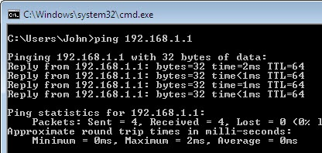
Use the ipconfig /all command.  You should see the DNS servers listed. If DNS servers are not configured, then you will not be able to access web pages using their name.  Ping a web address (e.g wintec.co.nz). A reply shows that DNS services are working. | 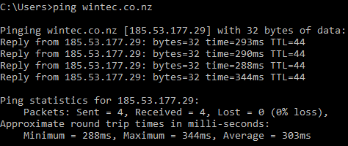

Test your Internet connection.
Use the tracert command to test internet connectivity.  tracert www.netacad.com  This shows the path that it follows step by step to get to the destination. | 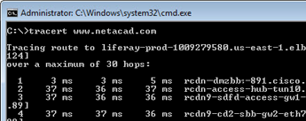
Use the nslookup command with a web address.  The first pair is the name and IP address of the DNS server processing the request.  The second pair is the public IP address of the address you looked up.  Now lookup the IP address with nslookup. This returns the name of the actual server where the site is hosted. | 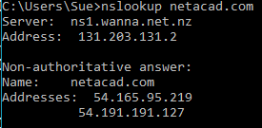  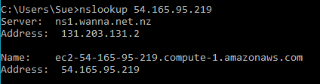
You have learnt to use the following important command line tools.
- ping
- ipconfig, ipconfig/all, ipconfig/renew
- traceroute
- nslookup

Check the status of your connection
Select Network and Sharing, Connections, then WiFi  Select Status.  You can see the signal quality, speed, state of the media and whether you have internet access. | 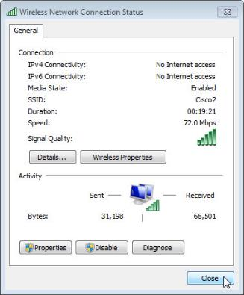

lab 7 – Laptops and other Mobile devices

Check Your Knowledge
Check your knowledge by answering the following questions.

Wireless configuration
Question | Your Answer
What is the most common Bluetooth network class (typically found on cell phones)  How is a Bluetooth connection authenticated?  Type of encryption used? | Class: bluetooth class 2  Approximate distance in meters: 10 meters  Authentication method: PIN/paring  Encryption method:AES
Name the connection that allows a device to connect to a cell phone.  Name the 3 ways a device can connect to a cell phone.  Name of connection of a Wifi device using the mobile data network of a phone to access the internet? | Name of connection between a device and a cell phone:  3 methods of connecting a device to a cell phone:  1. USB  2. BLUETOOTH  3. WiFi Hotspot  Name of connection for a device using a cell phones mobile data network.

scheduled maintenance for laptops and mobile devices
Question | Your Answer
What are the three basic maintenance tasks for laptops and mobile devices? | Software Updates  Upgrade and update of the operating system, applications, and antivirus frequently to maintain safety, speed and updated applications, and add-ons.  Data Backup  It is important to also regularly make backup of valuable data to the cloud or an external storage device in case of any data loss due to hardware failure, or loss or even deletion.  Care and Cleaning Physical  Wipe the screen, keyboard, ports and vents with the suitable materials (such as microfiber cloths and compressed air) to no accumulation of dust, overheat and harms. Moreover, use the device decently, so that it does not wear out physically.

Mobile characteristics

Lab – Mobile Device Information
Use the Internet to gather information about an Android and an iOS device. Use your own phone as the Android device, and any iPhone for the iOS device.
Record the hardware specifications in the boxes below.
Specifications: | Android Device: | iOS Device:
Model | Galaxy S23 | iPhone 15
Manufacturer | Samsung | Apple
Operating System | Android 13 (One UI 5.1) | iOS 17
Available Memory | 128 GB / 256 GB / 512 GB | 128 GB / 256 GB / 512 GB
Camera | Rear: 50MP + 12MP + 10MP  Front: 12MP | Rear: Dual 48MP + 12MP  Front: 12MP
Wi-Fi Connectivity | Wi-Fi 6E, dual-band, hotspot | Wi-Fi 6, dual-band, hotspot
Battery Information | 3900 mAh, fast charging 25W | 3349 mAh, fast charging 20W
Screen Size and Resolution | 6.1" FHD+ (2340 x 1080), AMOLED | 6.1" Super Retina XDR (2556 x 1179) OLED
Size and Weight | 146.3 x 70.9 x 7.6 mm, 168g | 147.6 x 71.6 x 7.8 mm, 171g

Laptop hardware

Disassemble a laptop

Collect a laptop from the cupboard. You can remove and reinstall the following components:
- Battery
- RAM
- Hard drive
- CMOS battery (if easily accessible)

Try at least 2 different laptops. Do not attempt to remove other components without getting permission from your tutor. If you do, you must reassemble the laptop completely before continuing (or leaving).

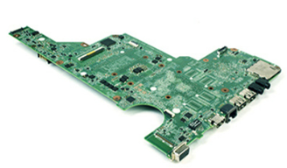  Laptop motherboards are proprietary and do not conform to any specific form factor. | 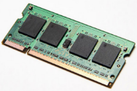  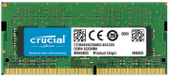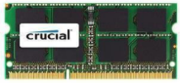  Laptops use SODIMM RAM modules.
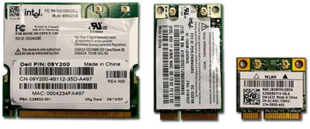  Expansion slots are Mini-PCI or Mini-PCIe or PCI Express Micro | 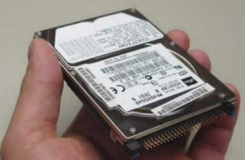  Laptop HDDs and SDDs generally have a form factor of 2.5”.
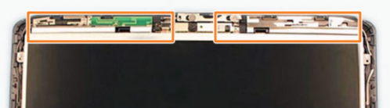  WiFi antennas are typically located above the screen | 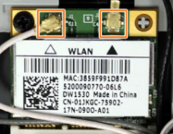  WiFi antennas are connected to the wireless PCI card

Research docking stations and port replicators
A docking station uses proprietary connectors that turn laptops into a desktop system by connecting to other peripheral devices, such as mice, keyboards, and external monitors.
A port replicator can provide some or all the functionality of docking station; however, it usually connects to the laptops via USB or Thunderbolt connection. Port replicators are more common than docking stations because one will work with almost any laptop.
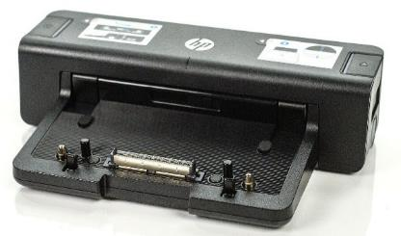  www.ebay.com/itm/HP-EliteBook-ProBook-Dock | 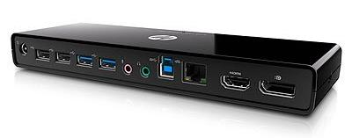  https://www.amazon.co.uk/HP-3005pr-USB-Port-Replicator-black
Docking station | Port replicator

Select either your own laptop or one of the classroom laptops. Find a docking station and a couple of port replicators on the internet (generic is fine).

Laptop model | HP ProBook 450 G9
 | Docking station  (if available) | Port replicator 1 | Port replicator 2
Model | HP USB-C G5 Essential Dock | WAVLINK USB-C Universal Docking Station | Dell D3100 USB 3.0 Docking Station
Price | NZD $240 | NZD $120 | NZD $120
Weight | 0.63 kg | 0.38 kg | 0.45 kg
Ports | 1x HDMI, 1x VGA, 2x USB-C, 3x USB-A, Ethernet, Audio | 2x HDMI, 1x DisplayPort, 3x USB-A, 1x USB-C, Ethernet, Audio | 2x HDMI, 1x DVI, 3x USB 3.0, 2x USB 2.0, Ethernet, Audio

lab 8 – Printers

Check Your Knowledge
Check your knowledge by answering the following questions.

Common printer features
Question | Your Answer
What are the main uses for each type of printer | Laser: high volume and fast to print  Inkjet: Photo quality  Dot matrix : Impact printing  Thermal : Labs  3D : Object creation
What are the 6 things to consider when calculating the total cost of ownership for a printer | 1.Inital Cost  2. Ink/ Toner  3.Mainetenance  4.Energy  5.Paper  6.Lifespan

Installing and configuring printers

Install a network printer
Using a classroom pull-apart computer, install the classroom networked printer.
Go to Control Panel->Hardware and Sound page and click Advanced printer setup. | 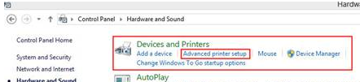
A window will pop out to search the printers automatically, ignore it and click Next button | 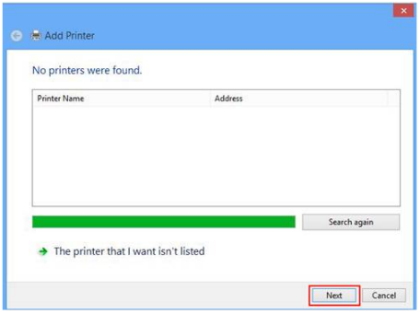
Add a Printer using a TCP/IP address or hostname, click Next.  On the next screen, type in the IP address of the printer.  Check the whiteboard for an address that looks something like:  10.150.1.52  Type this as the TCP/IP address. Follow through the rest of the menus but avoid printing a test page. | 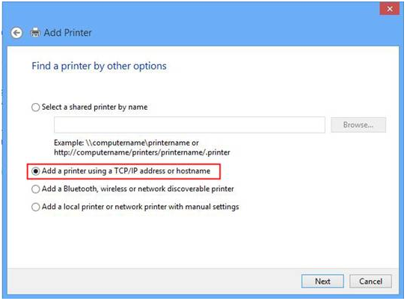
Because this is a shared printer, your PC should automatically get the correct driver from the network.
If not you may have to find and download the correct driver from the internet.
Create a document in notepad with your name on it. Print the document – so you know it is yours and not someone else’s. Note – you may have to press buttons to get the printer to start.

Install a USB printer

Challenge: Install one of the USB home inkjet printers and print a test page.

Lab 10.3.3.4 - Boot Methods
(Note: Some of these steps are a refresh/repeat of labs done earlier in the term. Check if you still remember how to use the BIOS and install Windows)

Objectives
In this activity, you will investigate some of the available Windows installation boot methods and boot into another operating system using a bootable USB flash or optical media.
Part 1: Research Boot Methods
Part 2: Access BIOS / UEFI
Part 3: Use a bootable USB media

Background / Scenario
The most common method to install an operating system on a new computer requires bootable media, such as DVD or USB. In this lab, you will investigate different ways to install windows: with and without bootable media.
To change the boot order on your system, you will need to access Unified Extensible Firmware Interface (UEFI) or the legacy Basic Input Output System (BIOS).
UEFI is the software that is designed to replace the legacy Basic Input Output System (BIOS). The UEFI comes with additional benefits, such as improved security, faster boot times, and large capacity hard drive support.
The Basic Input Output System (BIOS) is the low-level software that is located on one of the chips of the motherboard. The BIOS is responsible for essential functions, such as booting and keyboard control. The BIOS also configures the hard drive, CPU and memory and other related equipment.

Required Resources
- A computer where the BIOS or UEFI is accessible
- A USB flash drive with a minimum of 8 GB

Instructions

Research Boot Methods
A few of the available boot methods are USB optical media, USB flash media, and Preboot Execution Environment (PXE) network and internet-based, hard drive partition. In this part, you will review the process to create a bootable USB and optical media, use a network boot, and boot from a hard drive partition.
Perform an internet search to answer the following questions.

Questions:
Bootable USB and optical Media
  - What is the process to create a bootable USB or optical media?
  - In order to generate a bootable USB or optical media:

  - 1. Download ISO image The ISO image of operating system (e.g. windows, Linux) is distributed.
  - 2. Select the tool: In the case of USB, one can use such utilities as Rufus, balenaEtcher, or the official Microsoft Media Creation Tool. In case of DVD, make use of inbuilt burning software.
  - 3. Choose media and ISO: Insert your USB (at least 8GB, already existing data will be destroyed) or blank DVD, and then click it and the ISO file you have downloaded.
  - 4. Begin creation: Clicking on Start creation will begin creation, of which it formats the media and copies the required boot files.
PXE and Internet-Based Boot
  - PXE boot is a process where the device boots from its NIC.

Questions:
  - Where would you use PXE boot?PXE boot The use of PXE boot is mostly in the IT field; this is to effectively manage a network computer. It finds its key usage in automated deployment of the operating system (OSD) with new hardware or re-imaging old hardware, which can be installed on Windows or Linux systems without use of a media disc. It is also essential to the system recovery and diagnostics, allowing booting into the use of network-based troubleshooting operating systems in the case of the failure of local drives and the administration of thin client or diskless workstations that are fully dependent on the network to boot and operate. In general, PXE helps in simplification of the large scale computer provisioning as well as maintenance.
.
  - What are the components required for a PXE boot? To achieve a PXE boot successfully, there are some important elements that should exist and be appropriately set up: firstly, the client machine should have a PXE-capable Network Interface Card (NIC) equipped with a firmware enabling the machine to launch a network boot over the firmware being installed in advance of booting the operating system. Second, a DHCP server cannot be avoided; the server must assign an IP address to the client, and most importantly to PXE, it must give out the IP address of the server which provides access to PXE, (via DHCP option 66) and name of the first boot file (via DHCP option 67), commonly called the Network Boot Program (NBP). The third is that the TFTP server is needed to host and transfer this small initial set of the boot files to the client after using its lightweight protocol. Fourthly, what is needed is the Network Boot Program (NBP)** itself, a bootstrap program itself downloaded by TFTP, to tell the client how to download additional files, which are usually a basic operating system environment of some sort. Lastly a **deployment or installation server (usually built in to the TFTP server in small implementations) to provide the larger operating system images, drivers and copy files using more resilient protocols such as HTTP or SMB and handles the actual operating system installation process.
.
  - What are the advantages and disadvantages of using PXE boot?The main benefit of PXE boot is an efficient mass deployment of an operating system and central image administration which is relatively time and cost-saving as it does not imply the use of any physical media and, therefore, the trouble-shooting of non-booting computers is simplified. Yet, complex initial setup because of the requirement of properly configured network infrastructure, the possibility of security vulnerabilities appearance because of the usage of such unencrypted protocols as TFTP, the threat of the single point of failure in the case of PXE server failure can be considered as its drawbacks.
.
  - What is an Internet-Based Boot?An Internet based Boot is the act of booting a computer and loading its operating system off of a server on a network, the location of which can be located over the internet instead of a local computer. It is an expansion of conventional network booting (such as with PXE) to using protocols such as HTTP/HTTPS to remotely deploy OSes, manage them in a centralized fashion, and troubleshoot over systems at geographically distributed locations, necessitating initial bootloaders and secure networks.
.
Hard Drive Partition
After the operating system has been successfully installed on a hard drive partition, the bootable hard drive partition should be configured as the default boot device.

Question:
  - Under what circumstances would you boot to another internal hard drive partition?In a couple of specific conditions, you would normally boot to a different partition of an internal hard drive: usually to conduct management, recovery or testing of the system. This is both cases wherein you may have a dual-boot configuration in which you may select among different operating systems installed in separate partitions, as well as those when you must access a recovery partition with repair tools or a very lightweight operating system to fix a problem with the main OS partition. There is also the common use of booting into an installation of a new OS on a partition to debug new software, drivers or update, or to boot into a known-good state to troubleshoot a probable corrupt primary system.
.

Access BIOS / UEFI
BIOS / UEFI firmware allows you to change the advanced settings. Within the BIOS / UEFI firmware, you can change the boot order. There are two ways to access BIOS / UEFI: settings or boot keys. You should only access the BOS / UEFI when necessary.
Note: Be careful when accessing motherboard firmware. Incorrect firmware settings can prevent your computer from starting.

Enter BIOS / UEFI using boot key options
You could use the boot key sequence to access the motherboard firmware settings if you have an older device that uses legacy BIOS or no access to Windows 10 computer.
      - Restart the computer if you have access to a computer.
      - When the splash screen displays, press the key combination. Press the required key combination until you enter setup mode. The key combination usually consists of ESC, Delete or one of the Function keys, such as F12.

Question:
  - What is the key sequence you used to access the motherboard firmware?Motherboard firmware (BIOS/UEFI) firmware keys Our guide on how to access a motherboard dashboard typically starts with the key sequence to use, but this varies widely depending on motherboard manufacturer or particular computer platform, so it is here that it particularly varies. However, keys which can be pressed at boot to enter motherboard firmware insertion include F2, Del, F10, F12, or Esc repeated. Manufacturers on occasion use (not in any order) F2 or F12 (such as Dell), F10 or Esc (such as HP) and F1 or F2 (such as Lenovo). On windows 10/11 you can access it via Recovery options in the settings: Settings > System > Recovery > Restart now > Advanced startup > Troubleshoot > Advanced options > UEFI Firmware Settings.
.
      - If the boot process finished too quickly, restart the device again and press the same key sequence again until you have successfully entered the firmware settings.

Question:
  - List the devices that are available to boot from:
.

Enter UEFI using Windows settings
If you have access to a Windows 10 or later computer, you may be able to access UEFI via Windows settings.
      - Click Start and navigate to Settings.
      - Click Update & Security.
      - Click Recovery.
      - Under the Advanced startup heading, click Restart now.
Note: The following steps are shown as an example. Your menu items may be different.
      - Click Use a device.

Question:
  - List some of the devices that are available to boot from:Typical boot device media are internal hard disk (HDD) or Solid State Drive (SSD), USB flash memory, optical media (CD/DVDs) and a network location such as with PXE. Booting to an alternative internal hard disk partition is also possible to perform a multistentalling setup or during recovering.
.
      - Navigate back to Choose an option so you can click Continue to exit and return to Windows.

Use a bootable USB media
In this example, you create a bootable USB media using the media creation tool from Microsoft.
Note: if you do not have a blank USB, you can complete a PXE installation (lab 10.3.1.1) and complete the USB lab next week.

Create a bootable USB media.
Note: You will not be installing Windows on the PC in this activity.
      - Navigate to the Microsoft website to download a Windows 10 image using an internet search. Use keywords, such as download Windows 10.
      - At the time of writing, under the Create Windows 10 installation media, click Download Now to download the Media Creation Tool.
      - Open the Media Creation Tool.
      - In the setup wizard, accept the license and click Next.
      - Select Create installation media (USB flash drive, DVD, or ISO file) for another PC. Click Next.
      - Select the correct language, architecture, and edition as needed. Click Next.
      - Choose USB flash drive and insert a USB drive with at least 8GB capacity. Note that the drive will be erased. All the data currently on the drive will be erased. Click Next.
      - Select the desired drive and click Next to start the download.
      - Click Finish when the file is finished downloading.

Question:
  - What other media can you use to create a bootable media? Which boot device should be used to boot into this media?

.Boot using bootable USB media.
      - With the USB flash media still available on the PC, navigate back to Windows, click Start > Settings > Update & Security > Advanced startup > Restart now. In the Choose an option screen, select Use a device. Select USB HDD or the appropriate bootable device.
Note: If UEFI is not available or you are unable to select the desired boot device, restart Windows and enter the BIOS setting to change the boot order. Review your answers in the previous part of this activity for the key options to enter BIOS settings to change the boot order.
      - Now you should be in Windows 10 setup screen. This confirms that the PC has started up using the bootable USB drive. DO NOT click Next.
      - Exit the Windows installation by closing the setup window. Click Yes to confirm to cancel Windows installation.
      - During reboot, remove the USB drive and continue to boot to Windows.
      - Restore the boot order as configured prior to this activity.
      - Now that you have a Windows image on a bootable media. What can you do with Windows image?

Lab 10.3.1.1 – Windows Installation

Objectives
In this lab, you will install Windows 10.

Required Resources
A computer with a blank hard disk drive
Windows 10

Instructions
  - Installing from a network image
You will install windows over the network using PXE boot – this is the most usual way in industry.
    - As the computer boots up press the key to boot from the network when prompted (usually F12 or Enter)
Note:
- If the computer loads straight into Windows, check your network connection and boot order
- If you have more than one boot image, select the one that says STUDENTS USE THIS ONE
    - The computer starts loading files from the network image

LOGON Username: internal\student Password: router

Configuring Initial settings
    - The Windows Setup window opens. Click Next to continue unless you need to change the default settings.
    - Click Install now to continue the installation.

Collecting Information
    - In the Enter the product key to activate Windows window, click skip. You get an unlicensed grace period with Windows so we can save our keys for later.
    - The License terms window opens. Read and confirm that you accept the license by selecting the box I accept the license terms. Click Next.
    - Select Windows 10 Education (IT Operations) from the list
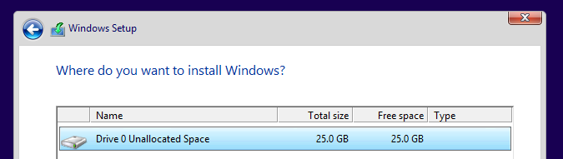
    - Delete ALL existing partitions so you only have “unallocated space” (you might have disk 0 and disk 1, this is because some PCs have two physical drives in them)

    - The Where do you want to install Windows? window opens. Select the hard drive or partition on which Windows will be installed. In this example, click to select Disk 0 Unallocated Space. Click Next to continue. Setup has finished collecting information for the installation.

Installing Windows
    - The Installing Windows window opens. Windows will take some time to copy the files and install the OS on your computer. During the setup, the computer might restart several times.
    - When the Windows needs to restart to continue window opens, your computer will automatically restart or you can click Restart now.
    - If you get the message Press any key to boot from CD or DVD… or Press Enter/F12 to network boot, do not press any key and Windows will boot from the internal drive to continue the installation.

Basics Setup
In this step, you will select your region and your keyboard layer.
Note: The personalisation sub-steps may be different depending on your Windows version.
    - Verify the region and select yes. If not, choose your region and select yes.
    - Verify the keyboard layout and select yes. If not, choose your keyboard layout and select yes.
    - Click Skip if you are not adding a second keyboard layout. Otherwise, click Add layout and answer the prompts to add a second layout.

Network Setup
In this step, the installation may continue without your input. If prompted, provide the installation with the necessary information.
Select Set up for personal use. Click Next to continue. Your instructor may ask you to choose to select Set up for an organization.

Account Setup
In this step, you will set up a local account to access the computer. You will not be creating a Microsoft account for this exercise. If you already have an account or choose to do so, you may use your Microsoft account for this step.
Note: The account setup sub-steps may be different depending on your Windows version.
    - Click Offline account to create a local account. If you already have a Microsoft account and choose to use it, enter the required information and click Next to continue.
    - Click No to continue using a local account, instead of a Microsoft account.
    - Enter a username and click Next to continue.
    - Create a password (use the password router) and confirm the password when prompted. Click Next to continue.
    - Answer all the security questions and click Next to continue.

Services Setup
In this step, you can give permission to use Cortana and select your privacy settings.
    - You can choose to use Cortana as your personal assistant. Click Yes or No to continue.
    - Read the privacy settings and click Learn More to find out more details. Then decide which features to use and click Accept to continue.

Finishing the Installation
    - When you are finished with the installation, Windows continues to finalize your settings.
    - After the installation is completed, the Desktop displays and you are logged into Windows for the first time.

Lab 10.3.1.4 – Finalize Windows Installation

Objectives
In this lab, you will add user accounts and finalize an installation of Windows 10.

Background / Scenario
After the initial installation of the Windows operating system, the installation needs to be finalized by creating any required additional user accounts, verifying that all hardware is installed correctly, and installing service packs, patches, and updates.

Required Resources
A computer with Windows 10 installed.

Instructions
  - User Account Creation
      - Click Start > Settings and click Accounts.
      - For Windows 10, in the Accounts utility, click Family & other users in the left side pane and then click Add someone else to this PC.
  - For Windows 11, click Family & others and click Add account.
  - If prompted for How will this person sign in, you can choose an email or phone number that they already use for other Microsoft products or choose I don’t have this person’s sign-in information. In this lab, we will choose the second option of not having sign-in information.
  - The next screen asks for a phone number or email address to create a Microsoft account for the user. Choose Add a user without a Microsoft account.
      - In the Create a user for this PC window, you will add a username and password for the account. There are also three required security questions to fill in. When all information is complete, click Next.
      - You are returned to the Other Users window and should now see the new Local account. You can now click the new account to see an option to change the account type or remove the account. If you click Change account type, you will have the option to change the account to an Administrator account.

Finalize the Installation

Check for Windows Updates
To update the OS after the initial installation, Microsoft Windows Update is used to scan for new software and install service packs and patches. (Note: you would do this on a new install for a customer, it is not required for these lab PCs as it will add extra time to the lab tasks)
      - To get to the Windows Update utility, type Update in the Windows search at the bottom of the desktop. Select Check for Updates.
      - In the Windows Update window, you can click Check for updates to scan for needed Windows updates. Instead of the Check for updates button, you may see a list of missing important updates that need to be installed or require a restart. You can select the updates to install and click Restart now or Schedule the restart to have the computer restart later.

Check for Device Problems
After installation, verify that all hardware is installed correctly. The Device Manager utility is used to locate device problems and install the correct or updated drivers
      - Open Device Manager by typing Device Manager in the Windows search.
      - In Device Manager, you will see a list of device categories. Click a category to expand it and see all devices within that category. A yellow triangle with an exclamation point indicates a problem with a device. To view a description of the problem, right-click the device and select Properties. A grey circle with a downward pointing arrow indicates that a device is disabled. To enable the device, right-click the device and select Enable.
      - Pick a device inside a category and double-click the device. The device properties window will open with tabs allowing you to view information about the device. Click the Driver tab. From here, notice that you have many options, such as viewing driver details, updating the driver, or uninstalling the device.

Question:
  - What options are available in the Driver tab? When you open the Properties dialog of a particular device in Windows Device Manager and select the Driver tab, it will show a range of options most of them aimed at the management of the driver software of this device. These usually have the Driver Details, where we can see the details of the driver files, Update Driver which enables us to conduct a search of the updated driver or look up on the computer for a driver software, Roll Back Driver which returns to the earlier installed version of the driver in case of problematic issues and Uninstall Device which removes the device in the system and removes its driver software though there is an option to delete the driver files too in the system. There is also a probability that other information on this tab that you can get to see, is that of the Driver Date, Driver Version, Digital Signer and the Provider of the device.
.

Reflection Question
After finalising the Windows installation, what else can you do to improve your experience?

Once you have Windows installed, there are some additional things to do to make your system run faster, remain safe and more personal:

1. Organize what applications open when you boot up the system in order to have everything boot up more quickly and runs smoother. You can do it by starting Task Manager (shortcut Ctrl + Shift + Esc) accessing the Startup tab and disabling the programs you do not need.

2. When you do not want to bother yourself in the evening, Night Light will take care of your eyes as it turns the screen colors to soft. This feature can be turned on by the Display settings.

3. Modify your experience by choosing the apps you prefer to use and setting them as the predetermined choices to utilize the web, email, media and other functions. Click Settings, and then Apps and lastly the option Default apps.

4. Create or create a Recovery Drive: in case you have rescue drive it will be ready to assist you in event your computer is not running smoothly. You can repair and reinstall windows in case there are some problems of this kind.

Lab 10.2.1.8 - Create a Partition in Windows

Introduction
In this lab, you will create a FAT32 formatted partition on a disk. You will convert the partition to NTFS. You will then identify the differences between the FAT32 format and the NTFS format.

Recommended Equipment
Computer running Windows
Un-partitioned space of at least 1 GB on the hard disk drive

Instructions
  - Open Disk Management.
Disk Management is located inside the Computer Management utility. Disk Management is a utility to manage disk drives installed in the computer, such as internal and external hard drives and flash drives.
Right-click Start and select Disk Management.

Create free space as necessary.
If the hard drive does not already have at least 2 GB of unpartitioned space, then perform the following steps to create free space which can be partitioned. In this lab, the default C: drive is used as an example.
      - Right-click the C: drive NTFS volume and select Shrink Volume from the menu.
      - In the Shrink C: window, enter an amount of 2048 in the Enter the amount of space to shrink in MB: box and then click Shrink. You should now see 2 GB of Unallocated disk space.

Create a new disk volume in the free space
      - Right-click the block of Free Space or Unallocated space. Click New Simple Volume.
      - The New Simple Volume Wizard window opens. Click Next.
      - Type 2048 or all the maximum disk space in the Simple volume size in MB field, and click Next.
      - Click the Assign the following drive letter: radio button. Select I from the drop-down menu. Click Next to continue.
Note: You may need to substitute different drive letters for the letters shown in this lab.
      - Click the Format this volume with the following settings: radio button. Select FAT32 from the File system drop-down menu and click Next.
      - Click Finish to complete the New Simple Volume Wizard.
      - The Disk Management window will display the status of the NEW VOLUME. Close the Disk Management window.

Open the This PC window to review information about the new disk partition.
      - Open File Explorer and click This PC to view the list of the devices and drives.
      - Right-click on the NEW VOLUME (I:) drive and then select Properties from the drop-down menu.

Question:
What type of File System is used on the NEW VOLUME (I:)?
.
How much Free Space is shown?
.
List the tabs found in the NEW VOLUME (I): Properties window.
.
      - On the General Tab, rename the volume from NEW VOLUME to ITE, and then click OK.

Create a text document and save it to the ITE drive.
      - Double-click on the ITE (I:) disk icon to view the contents of the drive. You should see a message in the middle of the screen stating that this folder is empty. Right-click anywhere in the white space below that message to bring up a drop-down menu. Click New>Text Document.
      - Rename the New Text Document to ITE Test Document and press Enter.
      - Right-click on the ITE Test Document and choose Properties. This opens the ITE Test Document Properties window.

Question:
  - What tabs are listed in the ITE Test Document Properties window?
.
      - Click OK to close the ITE Test Document Properties window. Close the ITE (I:) window.

Convert the ITE volume from FAT32 to NTFS without losing data.
In this step, you will convert the ITE volume from FAT32 to NTFS using the command line. The file system conversion can be done using the Disk Management tool. Unfortunately, the conversion requires the reformat of the drive and all the data will be lost. By using the command line, the file system can be changed from FAT32 to NTFS without losing data.
Note: In a production environment, the data should always be backed up before attempted to change the file system to prevent data loss.
      - Click Start, then type cmd (the search field will pop up as soon as you start typing). Right-click the Command Prompt program that appears, and then click Run as administrator.
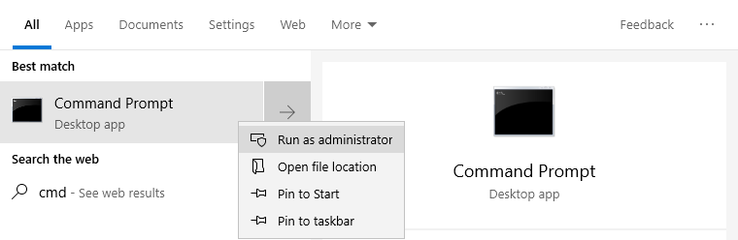
      - The User Account Control window opens asking if you want to allow the following program to make changes to this computer. Click Yes.
      - In the Administrator: Command Prompt window, type convert I: /fs:NTFS at the prompt.

Question:
What happens if you do not run as administrator when you open the command prompt?
.
      - You will be prompted to enter the current volume label for drive I:. Type ITE and press Enter.
      - Review the information displayed by the convert command. When finished, enter exit at the prompt to exit the command prompt window.

Open the This PC window to work with the ITE Volume.
      - Open File Explorer and click This PC.
      - Right-click the ITE (I:) volume, and select Properties from the drop-down menu.

Questions:
What type of File System is used for the ITE (I:) drive?
.
What are the tabs in the ITE (I:) Properties window?
.
When the volume was FAT32, there were six tabs. What are the names of the new tabs that were added after the volume was converted to NTFS?
answers here.
      - Click Cancel to close the ITE (I:) Properties window.

Display the properties of the ITE Test Document.
      - Open the ITE (I:) drive. Right-click on the ITE Test Document, then select Properties from the drop-down menu.

Questions:
What are the tabs in the ITE Test Document Properties window?
.
When the volume was FAT32, there were three tabs. What is the name of the new tab that was added after the volume was converted to NTFS?
.
      - Close all open windows.

Reflection Question
Why is there an additional Security tab in the properties window of documents stored on an NTFS volume?

The documents on an NTFS partition have the Security tab in Properties, which is provided to users to set elaborate controls on file permissions. NTFS allows precise protection of files, by providing Access Control Lists (ACLs), using which a user can specify what users or groups can perform on a file. Using this tab, the users are able to give permission to files and folders to be viewed, edited or changed by who is able to enhance their safety.

.

Upgrading Windows 10 to Windows 11 (optional)
  - Upgrade Considerations before Installation
Upgrading to a newer OS can be exciting. However, there are a few things you can do to make sure the upgrade will go smoothly.
    - Product Lifecycle
The product lifecycle starts when a product enters the marketplace and becomes established then eventually retires and is removed from the marketplace.
      - Perform an internet search using keywords, such as Windows lifecycle, to determine the retirement data for Windows 10 Home and Pro edition.

Question:
What is the retirement date?
.
      - To determine which release version is running on your Windows 10 PC, click Start > Settings > System.
      - Select About under the System heading in the left panel. Scroll down to the Windows specifications heading.

Question:
What is the currently installed Windows version?
.
    - Determine Windows 11 requirement
Before starting the process to upgrade to Windows 11, you should determine if the PC hardware meets the minimum requirements.
      - Using an internet search, determine the minimum hardware requirement to run Windows 11 successfully. Use keywords, such as Windows 11 System Requirements.
      - Compare the minimum requirements to your current computer.

Question:
Does your current computer meet the requirement? If not, what is missing?
.
If the PC does not meet the requirements, can you upgrade the hardware to meet the requirements?
.
    - Use Windows Update
You may also verify that the current system meets the minimum Windows 11 requirements using Windows Update on a PC running Windows 10.
      - On the Windows 10 PC, navigate to Settings > Update and Security > Windows Update.
      - Scroll down the page. If your PC is up to date and meets the minimum Windows 11 requirement, you will see a message indicating that the PC can run Windows 11. Otherwise, you will receive a message notifying you that your PC does not currently meet the system requirements to run Windows 11.
    - What should I do before upgrade?
Review unsupported OS features
As operating system evolves, some of the familiar features will be deprecated. Before you upgrade to the newest OS version, you should be aware of impact of the removed features.

Question:
Using an internet search, determine some of the deprecated features in windows 11 and document any impact for your experience.
.
Check your applications and hardware drivers
Inventory your applications and hardware drivers to ensure they are available in Windows 11. For example, the driver for a USB to serial cable may not be functioning in Windows 11. You should check with the manufacturer’s website to determine if there is an updated driver that is compatible with Windows 11.
For most software applications, running the program in compatibility mode will resolve the issue.
      - Locate the program executable. The program folder is usually located in C:\Program Files (x86) or C:\Program Files.
      - Search within the program folder until the executable associated with the program name is located. For example, the executable for Cisco Packet Tracer is PacketTracer.exe located in C:\Program Files\Cisco Packet Tracer\bin folder.
      - Right-click the executable file and select Properties.
      - Navigate to the Compatibility tab. Review the options in the tab.
      - Click OK when done.
Review advantages and disadvantages of upgrading to Windows 11

Questions:
  - List some of the advantages of upgrading.
.
  - List some of the disadvantages of upgrading.
.
In place upgrade vs. fresh installation

Questions:
  - List some of the advantages and disadvantages of upgrading versus a fresh installation.
.

.

Note: There are lots of labs in chapter 11, the ones marked as optional are good background information if you are not already familiar with those parts of Windows, but they are not likely to be directly in the practical test. You can choose the parts of chapter 11 that will help you; the labs that are not marked as optional will support your learning for the test. Compare the labs with the practice practical test to get a rough idea of what areas you should give extra attention to.
Lab 11.1.2.5 – Explore the Windows Desktop - Optional

Introduction
In this lab, you will explore the Windows Desktop, Start Menu, and Taskbar.

Required Resources
Windows PC

Instructions
  - Explore the Windows Desktop.
After logging into Windows, you are presented with the Windows Desktop.

Questions:
  - List some of the icons that are on the Desktop.
.
  - What type of information is available on the Desktop and Taskbar?
.
Explore the Start Menu.
The Start Menu is where you can locate your installed program and find files or folders.
      - Click Start.

Question:
  - Name a few applications listed in the Start Menu.
.
      - Right-click an application or a Windows tile from within the Start Menu.

Question:
  - What are some of the available options?
.

Explore the Taskbar.
      - To search for a program or file, enter the name in the Search bar. You could also use your voice to ask Cortana to search for the desired program or file.
In Windows 10 or 11, click Search (magnifier) and enter the name in the Search bar.
      - Right-click the Taskbar to select the Taskbar settings.

Question:
  - What are the available options in the Taskbar settings?
answers here.
  - Action Center has been redesigned in Windows 11 and it is changed to Notification Center and Quick Settings.
  - To access Notification Center, click the date and time in Taskbar. Right-click the date and time to adjust date and time and notification settings.
  - To access the Quick Settings, click the status icons that could include network, volume, or battery in the lower right corner, next to the date and time in the Taskbar.

Lab 11.1.3.4 - Work with Task Manager

Introduction
In this lab, you will explore Task Manager and manage processes from within Task Manager.

Required Resources
A computer running Windows

Instructions
  - Applications tab.
      - Log on to Windows as an administrator.
      - Open a web browser and a folder.
      - Click Start and type task manager in the search field. Press Enter to open the Task Manager utility.
      - Click Fewer details if available to view the list of open applications.
      - To force the web browser to close, highlight the browser, and click End task.

Question:
  - What happened?
.
      - Open the web browser again. Right-click the web browser in the Task Manager.

Question:
  - What options are available?
.

Services tab.
      - Click More Details at the bottom-left corner of Task Manager.
      - Click the Services tab. Use the scroll bar on the right side of the Services window to view all the services listed

Question:
  - What statuses are listed?
.
c. Right-click one of the services listed.

Question:
  - What are the available actions that can be taken?
.

Performance tab.
      - Click the Performance tab. Select CPU to view the utilization in the left panel.

Questions:
  - What is the current utilization of the CPU?
.
    - How many streams of instructions (i.e. Threads) are currently running?
- .
  - How many Apps, Background processes, and Windows processes (i.e. Processes) are currently running?
- .
    - Click on the Memory Chart in the left panel of the Performances tab

Question:
  - What is the total physical memory (MB)?
- .
  - What is the available physical memory (MB)?
- .
  - How much physical memory (MB) is being used by the computer?
- .
    - Click the Ethernet Chart in the left panel of the Performances tab.

Questions:
  - What is the link speed? What type of Ethernet Adapter is in use on this computer?
- .
  - What type of network connection (i.e. Connection type) is in use?
- .
  - What is the IPv4 address of the PC?
- .
Note: You can click Open Resource Monitor to bring up the Resource Monitor utility from the Performance tab in Task Manager to view the individual processes, services, and applications utilizing system resources.

Startup, App history and Details tabs.
      - The Startup tab lists the processes that are started automatically during Windows startup. Click the Startup tab. Right-click a process.

Question:
  - How do you stop a program from automatically starting up when your computer turns on?
- .

.Reflection Question
Why is it important for an administrator to understand how to work within the Task Manager?

Lab 11.1.4.11 - Working with File Explorer

Introduction
In this lab, you will explore and use the File Explorer to navigate the Windows file system.

Required Resources
Windows PC

Instructions
  - Explore File Explorer
File Explorer is a file management application in Windows, and you could use the menu bar to copy, move, delete, or create new folders.
      - Click Start. Search for File Explorer or click the Folder icon in the Taskbar.
      - Click Desktop on the left panel.
      - In the right panel, right-click New > Folder to create a new folder on the Desktop. Name this new folder, Folder1.
      - Create another folder and name it Folder2.
      - Move Folder2 into Folder1. Click Folder2 and use your mouse to drag-and-drop Folder2 into Folder1.

Question:
  - What happened with Folder1 and Folder2 on the Desktop?
- .
      - Open Folder1 and create a new text document in Folder1. Right-click New > Text Document. Name the new text document.
      - The file extension is hidden by default.
In Windows 10, click View > Select File name extensions.
In Windows 11, click View > Show > Select File name extensions.
Another way to show the file extension is to navigate to the Control Panel. In the small icon view, click File Explorer Options. Click the View tab and unselect Hide extensions for known file types. Click OK to continue.
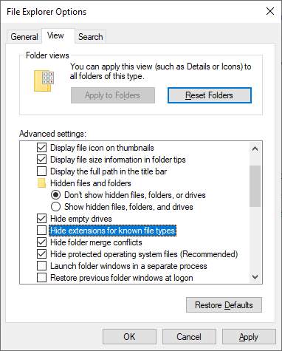

Question:
  - What is the file extension for the text document?
- .
      - Make a copy of the text document and place it in Folder2.

Question:
  - How would you do it?
- .
      - Right-click the text document > click Properties. Click the Details tab.

Question:
  - What are the attributes associated with this file?
- .
      - Now create a folder named Folder3 inside Folder2.

Questions:
  - What is the complete path to Folder3? (Hint: One way to find this information is in the Folder properties.)
- .
  - Which directories are listed under Quick access?
- .
      - Navigate to the Desktop within File Explorer.
      - Drag and drop Folder1 onto Quick access if it is not already listed under Quick access.

Question:
  - What happened? Why would you want to do this?
- .
      - Within the File Explorer, navigate to the Local Disk (C:). Click This PC > Local Disk (C:).

Question:
  - What are folders listed in the Local Disk (C:)?
- .
      - Open the Users folder. List all the folders in the directory.
- .
      - Open the folder associated with your username.

Question:
  - Were you able to open it? Explain.
- .
      - Open the folder associated with another username if it is available on the PC.

Question:
  - Were you able to open it? Explain.
- .
      - Notice the Public folder. This folder is accessible to any local users on the PC. Furthermore, it can be configured to be accessible for networked users.

Question:
  - Open the Public folder. List all the folders in the directory.
- .

Windows Libraries
Windows Libraries is a centralized location for related files from different locations on the PC or network. For example, the Videos library is a collection of all the videos from different locations on your PC and on a network drive. This acts as a short cut to all those videos.

Access Libraries Windows 10
      - To access Windows Libraries, click Start > File Explorer.
      - Click View > Navigation pane > Show libraries.
Another way to show the Window Libraries, navigate to the Control Panel. Select File Explorer Options in the small icons view > click View > select the Show libraries checkbox. Click OK to continue.
      - Expand the Libraries.

Question:
  - Which folders or files listed under the Libraries heading?
- .
      - A new library can also be created. Right-click Libraries > click New > click Library. Provide a name for the new library.
      - Folder1 on the Desktop can be added to the Libraries. Navigate to the Desktop. Right-click Folder1 > click Include in library > select the new library you created.
      - Select the library you created in the left panel. Click the Library Tools tab and select Manage library.

Question:
  - How would you remove the directory of Folder1 from the library without deleting Folder1 and its contents from the computer?
- .

Access Libraries in Windows 11
      - To access Windows Libraries, click Start > File Explorer.
      - Click See more (…) > Options. In the Folder Options window, click View > select the Show libraries checkbox. Click OK to continue.
Another way to show the Window Libraries, navigate to the Control Panel. Select File Explorer Options in the small icons view > click View > select the Show libraries checkbox. Click OK to continue.
      - Expand the Libraries.

Question:
  - Which folders or files listed under the Libraries heading?
- .
      - Right-click Libraries. Click Show more options > click New > click Library. Provide a name for the new library.
      - Folder1 on the Desktop can be added to the Libraries. Right-click the newly created library. Select Properties. Click Add. Locate and select Folder1 and click Include folder. Click OK to continue.

Question:
  - How would you remove the directory of Folder1 from the library without deleting Folder1 and its contents from the computer?
- .

Lab 11.2.1.5 – Explore Control Panel Categories - Optional

Introduction
In this lab, you will investigate the options provided in the various commonly used Control Panel items.

Background / Scenario
The Control Panel allows you to view and change system settings as necessary. You can add and remove hardware and software, modify user accounts, change accessibility options and configure network settings.

Required Resources
Windows PC

Instructions
  - Control Panel Views
By default, the Control Panel is divided into categories. Each category controls a group of related function in Windows.
      - To open the Control Panel, click Start and search for Control Panel.
      - In the Control Panel, click the View by: drop-down box.

Question:
  - What are the viewing options?
- .
      - Select the Category view as necessary.

Questions:
  - Name a few of the Control Panel categories.
- .

System and Security
The System and Security category provides computer system information and settings and configures the computer security settings.
Navigate to the System and Security category in the Control Panel. Use the subcategories to answer the following questions.

Questions:
  - Which subcategory would help you troubleshoot common problems?
.
  - Which subcategory allow a program through Windows Firewall?
.

Network and Internet
The Network and Internet category allows you to view the network status and configure network related setting and preferences.

Question:
  - Which subcategory allows you to view the basic network information and set up connections?
.

Hardware and Sound
The Hardware and Sound category allows you to add and configure hardware devices including printers and Bluetooth capable devices, customize power options, and adjust sound related settings.

Questions:
  - Which subcategory allows you to choose what happens when you insert a media or device?
.
  - Which subcategory allows you to add a printer?
.

Programs
The Programs category provides program installation and uninstallation and the selection of specific programs that the Windows operating system will use by default. This category also allows you to install/uninstall windows features such as remote access and file transfer clients.

Questions:
  - Which subcategory would you use to have a specific file type always open in a specified program?
.
  - Which subcategory would you use to uninstall a program?
.
  - Which subcategory would you use to install the Windows telnet client?
.

User Accounts
The User Accounts category allows you to adjust user settings, such as account types and change passwords.

Questions:
  - Which subcategory would you use change the account type from administrator to standard?
.
  - Which subcategory would you use to view, edit, or remove the web and Windows credentials?
.

Appearance and Personalization
The Appearance and Personalization category allows you to configure the look and feel of Windows, such as the taskbar, navigation, and File Explorer options.

Questions:
  - Which subcategory would you use to customize the Taskbar?
.
  - Which subcategory would you use to show hidden files and folders?
.
  - Which subcategory would you use to show extensions for known file types?
.

Clock and Region
The Clock and Region category allows you to change the date, time, and region settings.

Questions:
  - Which subcategory would you use to change the time zone?
.
  - Which subcategory would you use to change date format?
.
  - Which subcategory would you use to synchronize the time on a computer with a specific web server on the Internet?
.

Ease of Access
The Ease of Access category allows you to customize the Windows operating system for all types of users. This category also provides the configuration of voice control of the computer.

Questions:
  - Which subcategory would you use to configure the computer to read aloud any text on the screen?
.
  - Which subcategory would you use to improve the computer’s ability to understand your voice and improve the dictation accuracy?
.

Lab 11.2.2.3 - User Accounts

Introduction
In this lab, you will create user accounts in Windows.

Recommended Equipment
PC with Windows installed.

Instructions
  - Account Creation
- In this part, you will create a new local user account. Windows does allow local account creation using online Microsoft accounts, but this will not be done in this lab.

Open the User Account Tool.
      - Log on to the computer with an Administrator account.
      - Click Control Panel. Change to the small icons view in the Control Panel. Click User Accounts.

Create a local user account
      - The User Accounts window opens. Click Manage another account.
      - The Manage Accounts window opens. Click Add a new user in PC settings.
      - In Family & other users window, click Add someone else to this PC.
Windows 11: In Family & other users window, click Add account.
      - In the How will this person sign in? window, click I don’t have this person’s sign-in information.
      - Click Add a user without a Microsoft account.
      - In the Create a user for this PC window, enter a username and password provided by your instructor in the field. Choose your security questions and provide the answer to the selected questions. Click Next to continue.

Change the Account Type
      - Navigate to the Control Panel. In the small icons view, click User Accounts > Click Manage another account.
      - Select the newly created account.
      - Click Change the account type.
      - Select Administrator as the account type and click Change Account Type.

Question:
  - What is the advantage of having most users work within a Standard user account?
- .

Delete the Account
      - Navigate to the Control Panel. Change back to the Category view, click User Accounts.
      - Click Remove user accounts.
      - Select the account to be deleted. Click Delete the account.

Question:
For this lab, select Delete Files. What are the other options? When would you choose the other options?
- .
      - Click Delete Account to confirm the account deletion.
      - Notice the account is no longer listed. Close all open windows.

Reflection Questions
Why is it important to protect all accounts with strong passwords?
.
You should also make sure that you use strong and special passwords on all your accounts to prevent unwanted access of your details by other people. In case you have a simple or easily identifiable password, cybercriminals can steal your login, and afterwards, try to use it with other accounts. By using complex, lengthy and unique passwords you will minimise your chances of such hacks. A password manager will assist you to generate and store all your passwords to every account. In case you have enabled the two-factor authentication, then chances are very high that no one can access your accounts.

Why would you create a user with Standard privileges?
Ty
Standard user accounts prevent unexpected issues and viruses due to the ‘least privilege policy. These accounts are more secure because users cannot install new programs, control the system and view data of other users. Through such a system, users are well equipped with resources that they require to perform their work. The Standard account will make your system more secure and Stable, so use the Administrator account when you have to perform system administration.

e your answers here.

Lab 11.2.2.4 - Permissions

Objectives
In this lab, you will explore the difference between running as administrator and standard user. You will also review the inherited permission of files and folders and encrypt files and folders.
Part 1: User Account Control (UAC)
Part 2: Permission Inheritance
Part 3: Encrypting File System (EFS)

Recommended Equipment
A Windows device

Instructions

User Account Control (UAC)
User Account Control (UAC) is a Windows security feature that helps prevent malware from causing damage to your PC by exploiting the privileges of the Administrators group. UAC also allows standard users to perform tasks that require elevated privileges within their session.

Create a regular user account.
      - Log in to Windows using an account with administrative privileges. To verify that the account has administrative privileges, click Start > Settings > Accounts > Your info. Under your username, you should see Administrator to indicate that this account is part of the Administrators group.
      - Click Family & other users to add another user account.
      - Click Add someone else to this PC (or Add account in Windows 11) if there is not a standard user account on this PC. Provide the information necessary to create a new user account.

Run as administrator vs. standard user
      - Still logged as the user with administrative rights, run Windows PowerShell as an administrator. Click Start > expand the Windows PowerShell folder > right-click Window PowerShell > select Run as Administrator.

Question:
  - Did you need to provide your password to allow this app to make changes? Explain your answer.
- .
      - Click No to exit the UAC prompt.
      - Now log in as a standard user and run Windows PowerShell as an administrator.

Question:
  - Did you need to provide your password to allow this app to make changes? Explain your answer.
- .
      - Click No to exit the UAC prompt.

Permission Inheritance

Review folder permissions
      - Log in to an administrative account. Navigate to C:\ with File Explorer and create a folder with a name of your choice.
      - Right-click the newly created folder and select Properties.
      - Navigate to the Security tab.

Questions:
  - Which group or usernames have full control of the folder?
- .
      - Click Advanced to review permissions in detail.
      - Click Effective Access. Click Select a user.
      - Enter the username of current account in the Enter the object name to select (example). Click Check Names to verify the object name is correct. Click OK to continue.
      - Click View effective access to view the current permission. Note this user has full control of this folder. Click OK when done.
      - Click Select a user and enter the username of newly created user in this activity. Click Check Names to verify and click OK. Click View effective access to view the current permissions. Note this user does not have the same permissions. Click OK.
      - Click OK to exit the Properties window.

Inherited permission
      - Within your newly created folder, create a new text file. Right-click the blank space and select New > Text Document. Name the file.
      - Right-click the newly created file and select Properties. In the Security tab, click Advanced > Effective Access > Select a user. Review the permissions of both users.

Question:
  - How do the file permissions compare to the folder permissions? Where did the file get the permission?
- .
      - Click the Permission tab.

Question:
  - What else can you do in this tab?
- .
      - Click OK to exit Advanced Security Settings.
      - Login as the other user.

Question:
  - Does the permission align with the effective permission? What did you try to do?
- .

Encrypting File System (EFS)
- You can encrypt individual files and folders.
- Note: EFS is not available in Home edition.
      - Create a new folder in C:\ and add a file to the new folder.
      - Right-click the new file. Navigate to the General tab in the Properties window. Click Advanced.
      - In the Advanced Attributes window, select Encrypted contents to secure data and click OK.
      - Click OK to close the Properties window. Select Encrypt the file and its parent folder (recommended) and click OK when prompted by the Encrypted Warning. The folder and its contents are now encrypted.
      - Log in to another user’s account.
      - Attempt to make edits to the newly encrypted file with the other user.

Question:
  - What happened when you attempted to make edits to the file?
- .

Cleanup
Remove any files, folders or user accounts that were created during this activity.
      - Log in with the accounts and navigate to C:\ and remove any files or folders during this activity.
      - Delete the new local user account. Click Start > Settings > Accounts > Family & other users. Select and remove the local user account that was created for this activity.

Lab 11.2.6.2 – Use Device Manager

Introduction
In this lab, you will open Device Manager to display devices listed on your computer. You will also display the monitor settings.

Recommended Equipment
A computer running Windows

Instructions
  - Open Device Manager
- Log on to the computer as an administrator.
- Click Control Panel. In the Small icons view, select Device Manager.

Questions
  - What information is listed in the Device Manager window? Why would you use it?
- .
  - Browse through the menus displayed at the top of the Device Manager window. Ho would you install driver software for an older device that may not be automatically recognized by the Windows operating system?
- .

Display the monitor settings on your computer.
As an administrator, there are times when you will need to resolve hardware issues on a computer. Device Manager makes it easy to locate and install new drivers for your devices. You will use Device Manager to review the device driver information for your computer’s monitor and to review driver options available to you.
Note: Check with your instructor before making any device changes on the computer.
    - Click the arrow to the left of Monitors.
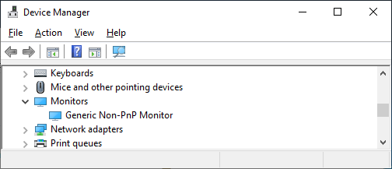
    - Right-click the device, Generic Non-PnP Monitor in the example, and select Properties from the dropdown menu.
    - In the Generic Non-PnP Monitor Properties window, select the Driver tab. This window displays the software driver information that is currently installed for this monitor.

Question:
  - What additional information does Driver Details provide?
- .
    - Click Update Driver.

Question:
  - What two options do you have for updating the driver?
- .
    - From the Update Driver Software window, click Cancel to return to the Monitor Properties window.

Questions:
  - What does the Roll Back Driver button do? The Roll Back Driver can be grayed out on your computer, why would it be grayed out?
- .
  - What are the other available options?
- .
    - Close all open windows.

Lab 11.2.7.4 - Region and Language Options

Introduction
In this lab, you will examine region and language options in Windows.

Recommended Equipment
A computer running Windows.

Instructions
  - Region Options

Open the Region Tools.
      - Log on to the computer.
      - Click Control Panel and view by Category. Click Clock and Region.
      - Click Region.

Explore the Region settings.
      - In the Formats tab, change the format in the Format: dropdown list. Note the examples at the bottom of the screen.
      - Under the Date and time formats heading, change the format for the long date using the drop-down options. Note the changes in the examples.
      - Click Additional settings. What can you customize?
- .
The answer may vary. Numbers, Currency, Time Date
      - Click Cancel to exit the Additional settings window.

Language Options
In this part, you will install an additional language on Windows. After you are done with the additional language, you will remove the additional language. Furthermore, instructions for different Windows version are included in this part.
      - Click Language preferences in the Region Window.
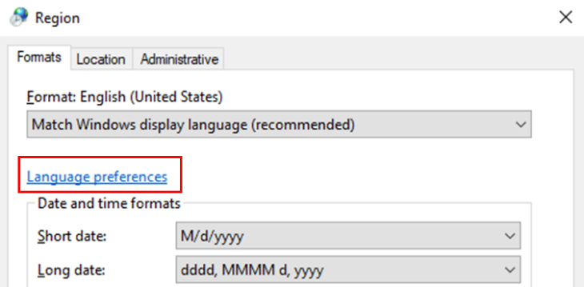
      - Click Add a language.
      - Select the desired language. Click Next to continue.
      - Notice the language features. Click Install to install the language package. This may take a few minutes.
      - Under the Windows display language drop-down list, verify that default display language is correct. Note: Be careful when you choose a foreign language as the default display language.
      - Close the Language window. Click Cancel in the Region window to continue.
      - A language bar is now displayed on the taskbar. Click the language button to switch the keyboard to the additional language.
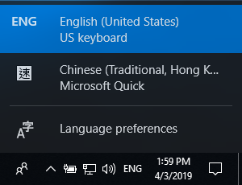
      - Depending on the additional languages, you will see one of the following changes in the Taskbar:
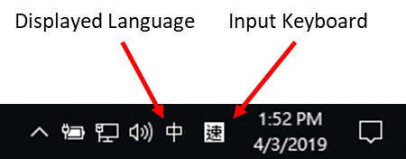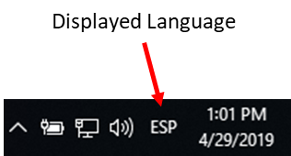
      - If you see both displayed language and input keyboard in the Taskbar, you can toggle between displaying the primary and the additional language. Click Start and search for the Control Panel by typing Control Panel.
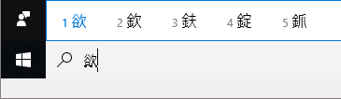
      - If only the displayed language icon is shown in the Taskbar or you want to change the default displayed language to an additional language, click the displayed language icon and select Language preferences. In the Settings window, under the Windows display language drop-down list, select the additional language. Log out and log back into Windows.
Note: If you were logged off the computer and a foreign language became the default display language, click the displayed language button in the taskbar. Select the Language preference option. Note the symbol associated with Language preference option.
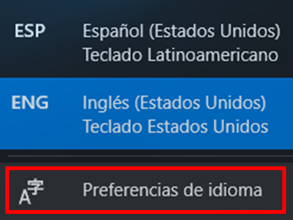
This will navigate you to the Settings window. Now select a default display language that you are familiar with in the drop-down box. Log out and log back into the PC.
      - Click Start > search for Language or click the Language icon in the taskbar and select Language preferences. Restore the default language as necessary. Log out and log back into Windows.
      - Navigate to the language settings and select the additional language and click Remove. If you cannot remove the additional language because it is marked as the default language, click Remove to remove the language.
      - Can you add the keyboard for Te Reo Māori and insert a macron over a letter?

Reflection Question
Why would a user wish to change the input language of the operating system?
Ty
A reader would wish to switch the system language to (or) French instead of English. Why is this so? This is because when you are discussing input language of an operating system, it is not just research that would transform the input language of the operating system to research in Urdu but it would transform the system language totally. It is also useful with bilingual or multilingual users and programs which require language-specific input. Input language change enhances the input speed, accuracy in typing and general comfortable feeling in typing and interacting with the system.

pe your answers here.
How would a user easily switch between multiple installed languages within the operating system?

To switch between any of the installed languages, a user just needs to press a Windows key + Space or Alt + Shift (depends on your system region and language settings). Another method of changing the language is by clicking on the language icon situated at the task bar then choose the desired input language on the list. This aids easy and quick switching particularly to the multi language users as they type in their preferred languages.

.

Lab 11.3.1.11 - Monitor and Manage System Resources - Optional

Introduction
In this lab, you will use administrative tools to monitor and manage system resources.

Recommended Equipment
A computer running Windows with internet access.

Instructions
  - Event Viewer
In this part, Windows Defender is used to explore the Event Viewer when the status of a service changes. Windows Defender is the built-in anti-malware component in Windows.

Verify Windows Defender is running.
Note: Some antivirus or antispyware programs must be uninstalled on the computer for Windows Security to work.
      - Log on to Windows as an administrator.
      - To determine if Windows Defender service is stopped, click Start, search for Windows Security.
      - Click Virus & threat protection. Scroll down to the Virus & threat protection settings. Click Manage settings.
      - Under the Real-time protection heading, verify that it is On. Keep the Windows Security window open.

Explore the Services console.
      - Right-click Start > click Computer Management. In the Computer Management window, select Services and Applications > Services.
      - Scroll down to Windows Defender Antivirus Network Inspection Service.

Question:
  - What is the status of the service?
- .
      - Keep the Computer Management window open.
      - Navigate back to Windows Security. Turn off Real-time Protection by clicking the slider to turn it off. Click Yes to allow this app to make changes to the device.
      - Navigate back to Services. Click Action > click Refresh.
      - Look for Windows Defender Antivirus Network Inspection.
  - Record the Windows Defender status.
- .
      - Close the Computer Management window.

Explore the Event Viewer.
      - Navigate to the Event Viewer. Right-click Start > select Event Viewer.
      - Expand Windows Logs > select Application.
      - In the Application pane, you can find the most recent events related to Windows Defender. Right-click Application > select Find. Enter defender to search Windows Defender related entries and click Find Next.
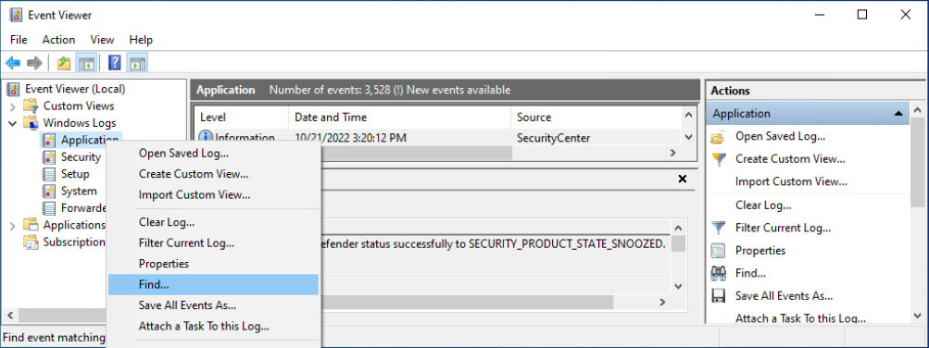

Questions:
  - In the General tab, what is listed as the Source of the event? What is the severity level?
- .
  - What is the status of Windows Defender?
- .
      - Navigate to Windows Security and re-enable Real-time protection. Close Windows Security window.
      - Navigate to the Event Viewer to review the most recent event entries that are related to Windows Defender. Close the Event Viewer window when done.

Explore the Impact of Services.
In this part, you will stop Print Spooler service to explore the impact in the system. The print spooler is responsible for managing the printer jobs and handling the interaction with the printer. With this service turned off, you will not be able to print or see your printers.

Verify printing service.
      - Open Notepad. Click Start and search for Notepad.
      - In Notepad, click File > Print. Record a listed printer below. Note: You do not need to install a physical printer.
- .
      - Click Cancel to exit the print dialog. Leave Notepad open.

Stop print spooler.
      - Right-click Start > select Computer Management. Expand Services and Applications > select Services to open the Services console.
      - Right-click Print Spooler and select Stop.
      - Navigate to Notepad. Attempt to print.

Question:
  - What message did you receive? How would you fix this?
- .
      - Click No in the message window and click Cancel to exit the Print window.

Restart print spooler
      - Navigate to the Services console and restart the print spooler. Right-click Print Spooler and select Start.
      - Verify that you can print and close Notepad.

Explore DHCP Client service.
- The DHCP Client service registers and updates the IP addresses and DNS records for the PC. If this service is stopped, the PC will not receive a dynamic IP address and DNS updates.
      - In the Services console, search for DHCP Client. Right-click DHCP Client and select Stop.

Question:
  - When DHCP Client stops, what other services will also be stopped?
- .
      - Click No in the Stop Other Services window.

Question:
  - Why is it important to exercise care when managing services?
- .
      - Verify that DHCP Client is still running.

Monitor and Record System Usage with System Tools
You will configure System Tools features and monitor the usage of system resources of the computer.

Create a new data collector set.
      - Right-click Start. > select Computer Management > expand System Tools.
      - Expand Performance > expand Data Collector Sets.
      - In the left pane, right-click User Defined > select New > click Data Collector Set.
      - In the Create new Data Collector Set window, type Memory Logs in the Name field. Select the Create manually (Advanced) and click Next to continue.
      - In the What type of data do you want to include? window, select Performance counter and click Next.
      - In the Which performance counters would you like to log? Window, click Add. From the list of available counters, locate and expand Memory. Select Available MBytes > Add and click OK to continue.
      - Set the Sample interval: field to 4 seconds. Click Next to continue.
      - In the Where would you like the data to be saved? Window, click Browse. Select Local Disk (C:) > PerfLogs. Click OK to continue.
      - Verify the correct root directory path is displayed (C:\PerfLogs) and click Finish to continue.

Format the data collector set.
      - Expand User Defined and select Memory Logs in the left pane. Right-click Data Collector01 and right-click Properties.
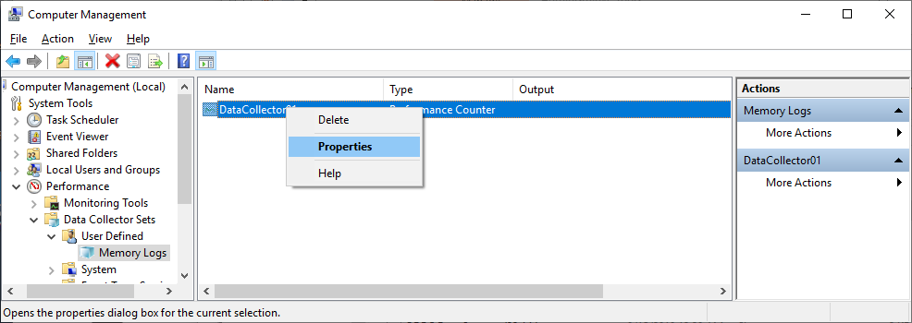
      - In DataCollector01 Properties window, change the Log format: field to Comma Separated.
      - Click the File tab.

Question:
  - What is the full path name to the example file name?
- .
      - Click OK to continue to close the Properties window.

Collect and view the data.
      - To start data collection, right-click Memory Logs and select Start.
      - To force the computer to use some of the available memory, open and close a browser.
      - Right-click Memory Logs and select Stop to stop the data collection set.
      - Navigate to Local Disk (C:)\PerfLogs. Click Continue in the Windows warning messages.
      - Open the folder that was created to store the memory log. Click Continue on the Windows warning messages.
      - Open the DataCollector01.csv file. Select Notepad or another program that can read comma-separated files (.csv) to open the file if Windows cannot open the file message is displayed.

Question:
  - What does the column farthest to the right show?
- .
      - Close the DataCollector01.csv file.

Clean up.
      - Navigate to the Computer Management window. Right-click Memory Logs and select Delete. Click Yes to confirm the deletion.
      - Navigate to the Local Drive C: > PerfLogs folder. Delete the stored memory logs folder (folder with the DataCollector01.csv) created from this lab.
      - Close all opened windows.

Lab 11.3.2.7 - System Utilities - Optional

Introduction
In this lab, you will use Windows utilities to configure operating system settings.

Recommended Equipment
A computer running Windows.

Instructions

Custom Management Console
  - Explore the management console.
      - To open the Microsoft Management Console, click Start, and search for mmc. Click Yes to allow Microsoft Management Console to make changes to the computer.
      - In the Console1 - [Console Root] window, you can build a custom console. Click File > Add/Remove Snap-in.
      - In the Add or Remove Snap-ins window, you can add a folder snap-in. Scroll down the Available snap-ins: pane to locate the Folder snap-in. Select Folder and click Add>.
      - To add the Link to Web Address snap-in, scroll down the Available snap-ins: pane and select Link to Web Address. Click Add>. In the Link to Web Address wizard window, enter http://www.cisco.com in the Path or URL: field, click Next> to continue.
      - In the Friendly name for the Link to Web Address snap-in box, enter Cisco and click Finish to continue.
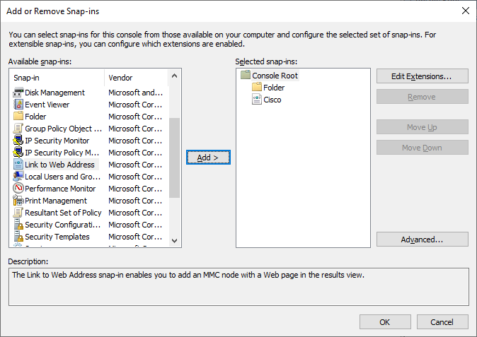

Create a custom management console.
      - To add snap-ins to the Folder snap-in, click Advanced.
      - In the Advanced window, select Allow changing the parent snap-in. Click OK.
      - A drop-down menu appears for Parent snap-in. In the Parent snap-in box, select Folder.
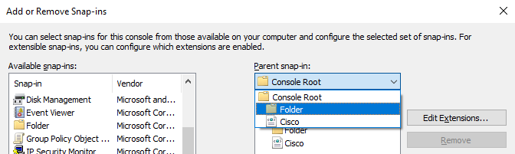
      - Add the following snap-ins from the Available snap-in: pane: Computer Management, Device Manager, and Disk Management. In each of the snap-in windows, click Finish to select to use the snap-in to manage the Local Computer or This computer.
      - Click OK to continue to exit the Add or Remove Snap-ins window.
      - In the Console1 window, right-click the Folder icon and select Rename. Change the name of the folder to Management Tools.
      - To save the custom console, click File > Save As. Change the file name to your name. Example: John’s Console. Change the Save in box to Desktop. Click Save.
      - Close all open windows.
      - On the desktop, double-click the Console icon that contains your name to re-open the console with your snap-ins. Click Yes to allow this application to make changes to your device as necessary.
      - Review the Management Tools folder by double-clicking on the tools.
      - Within your custom console, navigate to the Event Viewer.

Question:
  - What was the path you use to navigate to the Event Viewer?
- .
      - Close the Console window when you finish your review. Click No when prompted to save the changes.

Registry Editor
Note: (Don’t do this task on your own device, it is easy to corrupt a PC with incorrect changes to the registry)

Change your desktop background settings.
      - Right-click the Desktop > select Personalize.

Question:
  - What is the background picture?
- .
      - In the Background settings, select Solid color in the Background drop-down list. Choose a blue background color.
      - Close all open windows.

Open the registry editor.
    - To open the Registry Editor, click Start and type regedit. Click Yes to allow Registry Editor to make changes to the computer.
    - Select and expand the HKEY_CURRENT_USER entry.
    - Expand Control Panel. Click Colors. Click Background in the right panel.
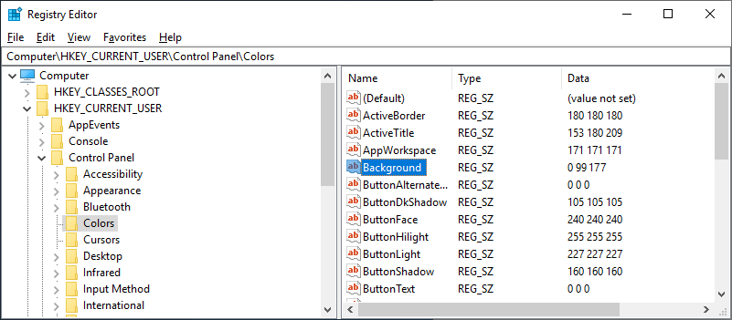

Question:
  - What is the data value of the Background (hint – it has three numbers that correspond to red, green, and blue)?
- .

Export a registry key.
- You will export the HKEY_CURRENT_USER\Control Panel\Colors folder.
      - In the left pane, select the Colors folder and click File > Export.
      - Save the file to the Desktop with the name BlueBKG.
      - At the desktop, right-click the BlueBKG.reg icon and select Open with > Notepad.
      - Notepad opens displaying the contents of BlueBKG.reg.

Question:
  - What is the data value of the Background?
- .
      - Close the BlueBKG.reg – Notepad window.
      - Open the Personalization window by right clicking the Desktop > Personalize and select a red background color.
      - The desktop background should be red. Click the Registry Editor window. On your keyboard, press F5 to refresh the Registry Editor window.

Question:
  - What is the data value of the Background? Compare the new value in the Registry to the value saved in BlueBKG.reg.
- .

Import a registry file.
- You will import the BlueBKG.reg file to change the Desktop background back to blue.
      - Click the Registry Editor window.
      - Click File > Import. Locate and click the BlueBKG.reg file then click Open.
      - The Registry Editor informational message opens letting you know that keys and values have been successfully added to the registry. Click OK.
      - Select the Registry Editor window.estions:
What is the data value of the Background?

What is the color of the desktop?
- .
Restart the computer?

What is the color of the desktop?
- .
      - Reset Display Properties Background to the original settings.
      - Close all open windows.
      - Delete the custom console and BlueBKG file on the desktop.

Reflection Question
Why would it be beneficial to add snap-ins to the mmc that are for other computers on the network?
In migrating snap-ins into the MMC on networked machines we are not just enhancing administrative power but creating a built-in highway to enhanced remote administration and help. It is the act of creating the fabric of sameness in constructions such that every node fits well in its niche. It is not just a matter of efficiency, it is a matter of making use of resources at our disposal at our distributed arrangement where every step counts. Whether it is streamlining operations or offering better security, every snap-in is the wake-up call toward prompt and responsive network management strategy.

.
After restarting the computer, why was the desktop color changed?
Desktop background or wallpaper automatically changes due to various reasons that include: reset system settings, a Windows update, or a corrupted user profile that can not save personalization settings. This might also occur when the system was logged in to some other user account or a third party software modified the theme settings. Bugs in old display drivers, and new display drivers, may restore color profiles to their defaults. To repair it, go to the personalization setting and ensure that you have the correct theme and account.

.

Lab 11.4.1.5 - Work in the Windows Commands Shell

Introduction
In this lab, you will use CLI commands to manage files and folders in Windows.

Recommended Equipment
A computer running Windows.

Instructions
  - Access the Windows command prompt.
      - Log on to a computer as a user with administrative privileges. The account ITEUser is used as the example user account throughout this lab.
      - To access the Windows command prompt, click Start and type cmd. Select Command Prompt to continue.

Display command help from the command prompt.
- You can display command line help using the help command. For more information on a specific command, type the command followed by /?.
      - At the command prompt, type help and press Enter. A list of commands is displayed.
      - The results from the help command are too long to display on one page so you can only readily see the last portion. To allow you to see it one page at a time, enter the command help | more at the prompt. The more command can paginate the results of another command when combining with | (pipe) and more.
C:\Users\ITEUser> help | more
For more information on a specific command, type HELP command-name
ASSOC Displays or modifies file extension associations.
ATTRIB Displays or changes file attributes.
BREAK Sets or clears extended CTRL+C checking.
BCDEDIT Sets properties in boot database to control boot loading.
CACLS Displays or modifies access control lists (ACLs) of files.
CALL Calls one batch program from another.
CD Displays the name of or changes the current directory.
CHCP Displays or sets the active code page number.
-- More --
      - To see the next page, press the spacebar. What happens when you press enter?
- .
      - Press q or Ctrl-C to exit after filling out the functions of the following commands:
Command | Function
CD | Change Directory – it Navigates between folders to open any folder. Example: cd Documents
CHKDSK | Check Disk – it will scan the system and disk for error check Example: chkdsk C:
COPY | Copy files to copy and move something from one location to another. Example: copy file1.txt D:\Backup
DEL | Delete files. To delete files or folder direct from CP command Example: del file1.txt
DIR | List contents of a directory. Example: dir
DISKPART | Disk Partition Tool – to divide disk into sub partition like 50 gb to 25 25 two different. Partition and it is Advanced tool to manage disk partitions.
EXIT | To close command prompt windows
FORMAT | Format a drive – Erases everything on a drive and sets up a file system. Example: format E:
GPRESULT | Group Policy Result – Shows applied Group Policies for the computer/user. Example: gpresult /R
MD | Make Directory – to Creates a new folder. Example: md NewFolder
TASKLIST | Lists running processes, like Task Manager in command-line.
RD | Remove Directory – Deletes an empty folder. Example: rd OldFolder
ROBOCOPY | Robust Copy – Advanced file and folder copying, often used in scripting and backup.
SHUTDOWN | Shuts down or restarts the computer. Example: shutdown /s
XCOPY | Extended Copy – Used to copy entire directories and subfolders. More powerful than copy.

      - Type md /? at the prompt to display additional information and switches that can be used with this command.
C:\Users\ITEUser> md /?
Creates a directory.

MKDIR [drive:]path
MD [drive:]path

If Command Extensions are enabled MKDIR changes as follows:

MKDIR creates any intermediate directories in the path, if needed.
<some output omitted>
  - Use the information provided by help command about md.

Questions:
  - How would you create these folders C:\Users\ITEUser\a\b\c if your current directory is C:\Users\ITEUser?
- .
  - What command would you use to verify the creation of the nested directories?
- .
      - Clear the screen using the command line.

Question:
  - What command did you use?
- .
      - Press F7 on the keyboard for the command history.

Question:
  - What is the last command that you have used? Press Esc on the keyboard to exit the dialog box.
- .
      - Press up arrow to display the last command used.

Question:
  - What is the last command?
- .
      - To exit the command prompt, enter exit at the prompt.

Lab 11.4.2.7 – File System Commands (optional)

Introduction
In this lab, you will use CLI commands to manage files and folders in Windows.

Recommended Equipment
A computer running Windows.

Instructions
  - Access the Windows command prompt.
      - Log on to a Windows computer. The account ITEUser is used as the example user account throughout this lab.
      - To access the Windows command prompt, click Start and enter cmd. Select Command Prompt or cmd.exe to continue.

Create and change directories.
In this step, you will use the change directory (cd), make directory (md), and directory (dir) commands.
Note: A directory is another word for folder. Directory and folder are used interchangeably throughout this lab.
      - Type cd at the command prompt.

Question:
  - What is the current directory?
- .
      - Type dir at the command prompt to list the files and folders that are in the current folder.
C:\Users\ITEUser> dir
Volume in drive C has no label.
Volume Serial Number is 9055-35E9

Directory of C:\Users\ITEUser

04/27/2019 09:21 AM <DIR> .
04/27/2019 09:21 AM <DIR> ..
04/25/2019 11:39 AM <DIR> 3D Objects
04/25/2019 11:39 AM <DIR> Contacts
04/26/2019 10:29 AM <DIR> Desktop
04/25/2019 11:39 AM <DIR> Documents
04/25/2019 11:39 AM <DIR> Downloads
<some output omitted>
0 File(s) 0 bytes
15 Dir(s) 32,671,969,280 bytes free
      - In the current directory, use the md command to create three new folders: ITEfolder1, ITEfolder2, and ITEfolder3. Type md ITEfolder1 and press Enter. Create ITEfolder2 and ITEfolder3. (Note: The command mkdir performs the same function as the command md.)
C:\Users\ITEUser> md ITEfolder1
C:\Users\ITEUser> md ITEfolder2 ITEfolder3
      - Type dir to verify that the folders have been created.
      - Type cd ITEfolder3 at the command prompt and press Enter.

Question:
  - Which folder are you in now?
- .
      - Create ITEfolder4 in the current directory. Within the ITEfolder4 folder, create a folder named ITEfolder5. Use the dir command to verify the folder creation.

Question:
  - What command or commands did you use to create the nested folders?
- .
      - Change directory as necessary until you are in ITEfolder5.
      - Type cd .. to change the current directory. Each .. is a shortcut to move up one level in the directory tree.

Question:
  - After issuing the cd .. command, what is your directory now?
- .
  - What would be the current directory if you issue this command at C:\Users\ITEUser\ITEfolder3\ITEFolder4?
- .

Create text files.
      - Navigate to the C:\Users\ITEUser\ITEfolder1 directory. Type cd ..\ITEfolder1 at the prompt.
      - Type echo This is doc1.txt > doc1.txt at the command prompt. The echo command is used to display a message at the command prompt. The > is used to redirect the message from the screen to a file. For example, in the first line, the message This is doc1.txt is redirected into a new file named doc1.txt. Use the echo command and > redirect to create these files: doc2.txt, file1.txt, and file2.txt.
C:\Users\ITEUser\ITEfolder1> echo This is doc1.txt > doc1.txt
C:\Users\ITEUser\ITEfolder1> echo This is doc2.txt > doc2.txt
C:\Users\ITEUser\ITEfolder1> echo This is file1.txt > file1.txt
C:\Users\ITEUser\ITEfolder1> echo This is file2.txt > file2.txt
      - Use the dir command to verify the files are in the ITEfolder1 folder.
C:\Users\ITEUser\ITEFolder1> dir
<some output omitted>
04/29/2019 08:05 AM 19 doc1.txt
04/29/2019 08:06 AM 19 doc2.txt
04/29/2019 08:08 AM 20 file1.txt
04/29/2019 08:08 AM 20 file2.txt
4 File(s) 78 bytes
2 Dir(s) 32,625,397,760 bytes free
      - Use the more or type command to view the content of the newly created text files.
C:\Users\ITEUser\ITEfolder1> more doc1.txt
This is doc1.txt

C:\Users\ITEUser\ITEfolder1> type doc2.txt
This is doc2.txt

Copy, delete, and move files.
      - At the command prompt, type move doc2.txt C:\Users\ITEUser\ITEfolder2 to move the file doc2.txt to the C:\Users\ITEUser\ITEfolder2 directory.
C:\Users\ITEUser\ITEfolder1> move doc2.txt C:\Users\ITEUser\ITEfolder2
1 file(s) moved.
      - Type dir at the prompt to verify that doc2.txt is no longer in the current directory.
      - Navigate to C:\Users\ITEUser\ITEfolder2 to change the directory to ITEfolder2. Type dir at the prompt to verify doc2.txt has been moved.
      - Type copy doc2.txt doc2_copy.txt to create a copy of doc2.txt. Type dir at the prompt to verify a copy of the file has been created.
C:\Users\ITEUser\ITEfolder2> dir
<some output omitted>
Directory of C:\Users\ITEUser\ITEfolder2

04/30/2019 09:07 AM 19 doc2.txt
04/30/2019 09:07 AM 19 doc2_copy.txt
2 File(s) 38 bytes
2 Dir(s) 31,753,068,544 bytes free
      - Use the move command to move doc2_copy.txt to ITEfolder1. Type move doc2_copy.txt ..\ITEfolder1.
C:\Users\ITEUser\ITEfolder2> move doc2_copy.txt ..\ITEfolder1
1 file(s) moved.
      - A copy of the file doc2.txt can be created in a new location using the copy command. At the prompt, enter the copy doc2.txt ..\ITEfolder1\doc2_new.txt.
C:\Users\ITEUser\ITEfolder2> copy doc2.txt ..\ITEfolder1\doc2_new.txt
1 file(s) copied.
      - The file doc2.txt can also be moved to a new location with a new filename using the move command. Type move doc2.txt ..\ITEfolder1\doc2_move.txt at the prompt.
C:\Users\ITEUser\ITEfolder2> move doc2.txt ..\ITEfolder1\doc2_move.txt
1 file(s) moved.
      - Type dir ..\ITEfolder1 to view the content in ITEfolder1 without leaving the current directory.
C:\Users\ITEUser\ITEfolder2> dir ..\ITEfolder1
<some output omitted>
Directory of C:\Users\ITEUser\ITEfolder1

04/29/2019 12:08 PM <DIR> .
04/29/2019 12:08 PM <DIR> ..
04/29/2019 08:05 AM 19 doc1.txt
04/29/2019 08:06 AM 19 doc2_copy.txt
04/29/2019 08:06 AM 19 doc2_move.txt
04/29/2019 08:06 AM 19 doc2_new.txt
04/29/2019 08:08 AM 20 file1.txt
04/29/2019 08:08 AM 20 file2.txt
6 File(s) 116 bytes
2 Dir(s) 31,467,700,224 bytes free
      - Change the current directory to ITEfolder1. Type cd ..\ITEfolder1 at the prompt.
      - Move file1.txt and file2.txt into ITEfolder3. To move all the files that contain the word file into ITEfolder3 with one command, use a wildcard (*) character to represent one or more characters. Type move file* ..\ITEfolder3.
C:\Users\ITEUser\ITEfolder1> move file* ..\ITEfolder3
C:\Users\ITEUser\ITEfolder1\file1.txt
C:\Users\ITEUser\ITEfolder1\file2.txt
2 file(s) moved.
      - To view the content of the file doc2_new.txt, use the type or more command at the prompt.
C:\Users\ITEUser\ITEfolder1> type doc2_new.txt
This is doc2.txt
      - Use the ren command to rename doc2_new.txt to file.log. Use the dir command to display the content in the directory.
c:\Users\ITEUser\ITEfolder1> ren doc2_new.txt file.log
      - Use the type or more command to view the content of the newly rename file file.log.
C:\Users\ITEUser\ITEfolder1> more file.log
This is doc2.txt
      - To delete a file or multiple files, use the del command with the file names at the prompt.

Question:
  - What single command would you use to delete all the files with doc2 in the filename? Use the command to remove the files with doc2 in the filename.
- .
  - What command would you use to delete all the files in the directory? Use the command to remove the files.
- .

Use the xcopy and robocopy commands.
- In this step, the xcopy and robocopy commands are used to copy the content in a directory.
      - View the content of ITEfolder3.
C:\Users\ITEUser\ITEfolder1> dir ..\ITEfolder3
<some output omitted>
Directory of c:\Users\ITEUser\ITEfolder3

04/29/2019 03:11 PM <DIR> .
04/29/2019 03:11 PM <DIR> ..
04/29/2019 03:05 PM 20 file1.txt
04/29/2019 03:05 PM 20 file2.txt
04/29/2019 03:01 PM <DIR> ITEfolder4
2 File(s) 40 bytes
3 Dir(s) 31,492,157,440 bytes free
      - Type xcopy ..\ITEfolder3 . at the prompt to copy the content of ITEfolder3 to ITEfolder1. Note the . at the end of the command. It is a shortcut for the current directory.
C:\Users\ITEUser\ITEfolder1> xcopy ..\ITEfolder3 .
..\ITEfolder3\file1.txt
..\ITEfolder3\file2.txt
2 File(s) copied
      - At the prompt, type dir to display the content of ITEfolder1. Only the files in the ITEfolder3 were copied into ITEfolder1. The directory ITEfolder4 was not copied into ITEfolder3.
C:\Users\ITEUser\ITEfolder1> dir
<some output omitted>
Directory of C:\Users\ITEUser\ITEfolder1
04/29/2019 03:16 PM <DIR> .
04/29/2019 03:16 PM <DIR> ..
04/29/2019 03:05 PM 20 file1.txt
04/29/2019 03:05 PM 20 file2.txt
2 File(s) 40 bytes
2 Dir(s) 31,491,321,856 bytes free
      - Use help xcopy or xcopy /? to determine which switch would allow the xcopy command to copy all the files and directories.

Question:
  - What option allows you to copy all the files and directories, including the empty directories?
- .
      - Because ITEfolder4 is a subfolder and ITEfolder5 is both a subfolder and an empty folder, /E is needed to copy all the contents of ITEfolder3 and the empty subfolder.
Type xcopy /E ..\ITEfolder3 . at the prompt to copy the files. When prompted, type a to allow overwriting the existing files.
c:\Users\ITEUser\ITEfolder1> xcopy /E ..\ITEfolder3 .
Overwrite C:\Users\ITEUser\ITEfolder1\file1.txt (Yes/No/All)? a
..\ITEfolder3\file1.txt
..\ITEfolder3\file2.txt
2 File(s) copied
      - Verify that the ITEfolder4 and ITEfolder5 were also copied in ITEfolder1.
c:\Users\ITEUser\ITEfolder1> dir
<some output omitted>
Directory of c:\Users\ITEUser\ITEfolder1

04/29/2019 04:41 PM <DIR> .
04/29/2019 04:41 PM <DIR> ..
04/29/2019 03:05 PM 20 file1.txt
04/29/2019 03:05 PM 20 file2.txt
04/29/2019 04:41 PM <DIR> ITEfolder4
2 File(s) 40 bytes
3 Dir(s) 31,493,193,728 bytes free

c:\Users\ITEUser\ITEfolder1> dir ITEfolder4
<some output omitted>
Directory of c:\Users\ITEUser\ITEfolder1\ITEfolder4

04/29/2019 04:41 PM <DIR> .
04/29/2019 04:41 PM <DIR> ..
04/29/2019 03:00 PM <DIR> ITEfolder5
0 File(s) 0 bytes
3 Dir(s) 31,493,193,728 bytes free
      - The robocopy command can also be used to copy the content of a directory to a new destination. The robocopy command has more capabilities than the built-in Windows copy and xcopy command, such as resume copying after a network interruption, skip files that appear to be identical to the files in the destination folders, and mirror a directory by keeping the destination directory in sync with the source directory.
Copy the ITEfolder4 content to ITEUser folder using the robocopy command.
C:\Users\ITEUser\ITEfolder1> robocopy /E C:\Users\ITEUser\ITEfolder3\ITEfolder4\ C:\Users\ITEUser
Note the information provided by the command during the copying process.
      - Navigate to C:\Users\ITEUser to verify that the folder ITEfolder5 is copied.

Delete directories.
In this step, you will delete an empty and a non-empty directory using the rd command.
      - Use the rd ITEfolder2 to delete the empty directory and verify that the directory was deleted.
C:\Users\ITEUser> rd ITEfolder2
      - Use the rd ITEfolder1 to delete the directory. Verify the directory removal using the dir command.
  - Were you able to delete the directory? Explain.
- .
      - Use rd /? command to determine the switch that allows the deletion of a non-empty directory.
C:\Users\ITEUser> rd /S ITEfolder1
ITEfolder1, Are you sure (Y/N)? y
      - Use the appropriate commands to delete all the text files and folders that you have created in this lab. Type exit to close the command prompt window.

Reflection Question
What are the advantages of using CLI vs. GUI?
.
The advantages of command line interface (CLI) are high-performance, the control over the use, and the possibility of automation and script building, which explains why it is preferable to go with the command line interface when choosing it as advanced users and administrators. It is also not resource-demanding and will be used to handle servers or use batches of information. Conversely, the GUI is easier to use, easy to learn, it provides a visual feedback and is more suitable to the inexperienced people who work with the drag-and-drop or image guided systems. Both of them are strong in their way depending on the task and users knowledge.

Lab 11.4.3.2 – Disk CLI Commands - Optional

Introduction
In this lab, you will work with disk CLI commands.

Required Resources
A Windows PC
An additional partition with an NTFS file system

Instructions
  - The chkdsk Command Options
In this part, you will explore the Windows command that allow you to scan and repair disks.

Explore the chkdsk command
      - Open a command prompt.
      - Open the help page the command chkdsk. Enter help chkdsk or chkdsk /? at the prompt to answer the following questions:

Questions:
What is the option to fix errors on the drive?
- .
What is the option to force the volume to dismount first if necessary?
- .
What is the option to locate bad sectors and recover readable information?
- .
      - Enter the chkdsk command to check the C:\ drive with the options from the questions in the previous step.

Question:
  - What happened? Explain.
- .

Use the chkdsk command options.
      - Open a Command Prompt window with elevated privileges. Click Start and search for Command Prompt. Within the search results, right-click Command Prompt and select Run as administrator.
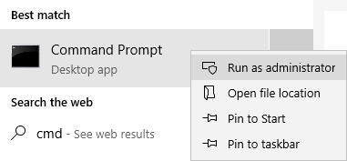
      - In the Command Prompt window with elevated privileges, enter the command chkdsk C: /F /X /R to check the status of this drive. Enter y when prompted. Note the change in the prompt.
C:\Windows\system32> chkdsk C: /F /X /R
The type of the file system is NTFS.
Cannot lock current drive.

Chkdsk cannot run because the volume is in use by another
process. Would you like to schedule this volume to be
checked the next time the system restarts? (Y/N) y

This volume will be checked the next time the system restarts.
Note that the volume will be checked when the system restarts that next time because the volume is in use and it cannot be checked at this time.

Question:
  - What is the file system of the drive?
- .
      - A second partition was created in a previous lab. You can perform the chkdsk command on the second partition. The I: drive will be used in this example.
C:\Windows\system32> chkdsk I: /F /X /R
The type of the file system is NTFS.
Volume label is ITEINFO.

Stage 1: Examining basic file system structure ...
256 file records processed.
File verification completed.
0 large file records processed.
0 bad file records processed.
<some output omitted>

Create a new partition using DiskPart
In this part, you will shrink the second partition on the hard drive and create a third partition.
Note: Please back up any data from the drives before proceeding in this part. Because a new partition will be created by shrinking a volume and the new partition will be formatted. All data will be erased during the formatting process.

List the disks, partitions, and volume.
      - Using a command prompt with elevated privilege, enter diskpart at the prompt.
C:\Windows\system32> diskpart

Microsoft DiskPart version 10.0.17763.1

Copyright (C) Microsoft Corporation.
On computer: DESKTOP-PUU52R2

DISKPART>
      - Notice the prompt indicated that you are in the diskpart utility. Enter help at the DISKPART> prompt to list the available commands within the diskpart utility. You can also use the help command anytime while you are in the diskpart utility. For example, enter help list disk at the prompt to view more information about the list disk command.
DISKPART> help list disk

Displays a list of disks.

Syntax: LIST DISK

Displays a list of disks and information about them, such as their
size, amount of available free space, whether the disk is a basic
or dynamic disk, and whether the disk uses the master boot record
(MBR) or GUID partition table (GPT) partition style. The disk marked
with an asterisk (*) has focus.
      - Enter list disk at the DISKPART> prompt to list all the disks in the PC.
DISKPART> list disk

Disk ### Status Size Free Dyn Gpt
-------- ------------- ------- ------- --- ---
Disk 0 Online 50 GB 1024 KB
Disk 1 Online 5120 MB 1024 KB

Question:
  - Enter list partition to list all the partitions on the disk. How many partitions are on the disk?
- .
      - Enter list partition command to list the partitions on the disk. Note: If you only have 1 disk, the disk is selected by default. If you have more than 1 disk in your PC as listed in the list disk command, you will need to select the desired disk. If you are interested in disk 0, enter select disk 0.
DISKPART> select disk 0

Disk 0 is now the selected disk.
      - Enter list partition to list all the partition on the selected disk.
DISKPART> list partition

Partition ### Type Size Offset
------------- ---------------- ------- -------
Partition 1 Primary 549 MB 1024 KB
Partition 2 Primary 47 GB 550 MB
Partition 3 Primary 2047 MB 47 GB
      - Enter list volume to list all the volumes on the computer. This will include the volumes on all the disks.
DISKPART> list volume

Volume ### Ltr Label Fs Type Size Status Info
---------- --- ----------- ----- ---------- ------- --------- --------
Volume 0 E CD-ROM 0 B No Media
Volume 1 System Rese NTFS Partition 549 MB Healthy System
Volume 2 C NTFS Partition 47 GB Healthy Boot
Volume 3 I ITEINFO NTFS Partition 2048 MB Healthy
Volume 4 D SecondDisk NTFS Partition 5117 MB Healthy
      - Select the volume that will be used to create a new partition in the next step.
DISKPART> select volume 3

Volume 3 is the selected volume.

Shrink a volume.
      - Review the shrink command. Enter help shrink at the DISKPART prompt.
DISKPART> help shrink

Reduces the size of the volume with focus by the specified amount. Makes
free disk space available from unused space at the end of the volume.

Syntax: SHRINK [DESIRED=<N>] [MINIMUM=<N>] [NOWAIT] [NOERR]
SHRINK QUERYMAX [NOERR]
<some output omitted>

Question:
  - What option is used to determine the maximum number of bytes that the volume can be shrink by?
- .
      - Use the shrink command with the option querymax to determine the maximum number of bytes that the volume can be shrink by.

Question:
  - What is the maximum number of reclaimable bytes?
- .
      - Enter shrink desired=500 to reduce the size of volume by 500 megabytes.
DISKPART> shrink desired=500

The maximum number of reclaimable bytes is: 500 MB

Create a new partition.
In the previous step, you have create 973 MB free space on the disk. In this step, you will create a primary partition with 500 MB with an NTFS file system.
      - Enter create partition primary at the DISKPART prompt.
DISKPART> create partition primary

DiskPart succeeded in creating the specified partition.
Note: If there are already 3 primary partitions, you will need to create logical partition, instead of primary partitions.
DISKPART> create partition extended
DISKPART> create partition logical
      - List the partition to verify that you have created a new partition. Notice the asterisk (*) next to partition 4 to indicate the partition is currently selected.
DISKPART> list partition

Partition ### Type Size Offset
------------- ---------------- ------- -------
Partition 1 Primary 549 MB 1024 KB
Partition 2 Primary 47 GB 550 MB
Partition 3 Primary 1548 MB 47 GB
* Partition 4 Primary 501 MB 49 GB
      - List the volumes to verify that a new volume was created and is automatically selected. Note the file system is listed as RAW.
DISKPART> list volume

Volume ### Ltr Label Fs Type Size Status Info
---------- --- ----------- ----- ---------- ------- --------- --------
Volume 0 E CD-ROM 0 B No Media
Volume 1 System Rese NTFS Partition 549 MB Healthy System
Volume 2 C NTFS Partition 47 GB Healthy Boot
Volume 3 I ITEINFO NTFS Partition 1548 MB Healthy
Volume 4 D SecondDisk NTFS Partition 5117 MB Healthy
* Volume 5 RAW Partition 501 MB Healthy
      - The new volume needs to be formatted with an appropriate file system before it can be used. The new volume will be format as NTFS and it will be labeled as new.
DISKPART> format fs=ntfs label=new

100 percent completed

DiskPart successfully formatted the volume.
      - The new volume will be assigned as drive letter w.
DISKPART> assign letter=w

DiskPart successfully assigned the drive letter or mount point.
      - List the volume to verify the new modification.
DISKPART> list volume

Volume ### Ltr Label Fs Type Size Status Info
---------- --- ----------- ----- ---------- ------- --------- --------
Volume 0 E CD-ROM 0 B No Media
Volume 1 System Rese NTFS Partition 549 MB Healthy System
Volume 2 C NTFS Partition 47 GB Healthy Boot
Volume 3 I ITEINFO NTFS Partition 1548 MB Healthy
Volume 4 D SecondDisk NTFS Partition 5117 MB Healthy
* Volume 5 W new NTFS Partition 501 MB Healthy
      - Enter exit at the DISKPART> to exit the DiskPart utility.

Format the new volume as a FAT file system.
- Formatting can also be done outside of the DiskPart utility.
      - In an elevated command prompt, enter the format command to reformat w: to use an FAT32 file system. When prompted, enter new as the current volume label. Enter the NewVol as the new volume label.
C:\Windows\system32> format /fs:fat32 w:
The type of the file system is NTFS.
The new file system is FAT32.
Enter current volume label for drive W: new

WARNING, ALL DATA ON NON-REMOVABLE DISK
DRIVE W: WILL BE LOST!
Proceed with Format (Y/N)? y
Formatting 500.0 MB
Initializing the File Allocation Table (FAT)...
Volume label (11 characters, ENTER for none)? NewVol
Format complete.
496.0 MB total disk space.
496.0 MB are available.

4,096 bytes in each allocation unit.
126,975 allocation units available on disk.

32 bits in each FAT entry.

Volume Serial Number is 90C2-A65F
      - Navigate to the newly created W: drive and create folders and files, if desired.

Clean up
After you have verified that the new partition is working, you will delete the newly created volume and the free space will rejoin the original second partition.
      - At the elevated command prompt, enter diskpart to return to the DiskPart utitliy.
      - List all the disks for the computer by issuing the list disk command.
DISKPART> list disk

Disk ### Status Size Free Dyn Gpt
-------- ------------- ------- ------- --- ---
Disk 0 Online 50 GB 0 B
Disk 1 Online 5120 MB 1024 KB
      - Select the appropriate disk that has the newly created volume.
DISKPART> select disk 0

Disk 0 is now the selected disk.
      - List all the volume for the computer by using the list volume command.
DISKPART> list volume

Volume ### Ltr Label Fs Type Size Status Info
---------- --- ----------- ----- ---------- ------- --------- --------
Volume 0 E CD-ROM 0 B No Media
Volume 1 System Rese NTFS Partition 549 MB Healthy System
Volume 2 C NTFS Partition 47 GB Healthy Boot
Volume 3 I ITE NTFS Partition 1148 MB Healthy
Volume 4 W NEWVOL FAT32 Partition 500 MB Healthy
Volume 5 D SecondDisk NTFS Partition 5117 MB Healthy
      - Select the volume that should be deleted.
DISKPART> select volume 4

Volume 4 is the selected volume.
      - Delete the volume using the delete volume command.
DISKPART> delete volume

DiskPart successfully deleted the volume.
      - Verify that the volume has been deleted by using the list volume command.
DISKPART> list volume

Volume ### Ltr Label Fs Type Size Status Info
---------- --- ----------- ----- ---------- ------- --------- --------
Volume 0 E CD-ROM 0 B No Media
Volume 1 System Rese NTFS Partition 549 MB Healthy System
Volume 2 C NTFS Partition 47 GB Healthy Boot
Volume 3 I ITE NTFS Partition 1148 MB Healthy
Volume 4 D SecondDisk NTFS Partition 5117 MB Healthy
      - Now you can recover the free space from the deleted volume 4 by extending volume 3 to include the free space. Select volume 3 and use the extend command to extend volume 3.
DISKPART> select volume 3

Volume 3 is the selected volume.

DISKPART> extend

DiskPart successfully extended the volume.
      - Use the list partition command to verify that the newly created partition was deleted and the shrunk partition is back to the original capacity.
DISKPART> list partition

Partition ### Type Size Offset
------------- ---------------- ------- -------
Partition 1 Primary 549 MB 1024 KB
Partition 2 Primary 47 GB 550 MB
Partition 3 Primary 2049 MB 47 GB
      - Enter exit at the DISKPART> to exit the DiskPart utility.

Lab 11.4.4.2 – Task and System CLI Commands - Optional

Introduction
In this lab, you will work with task and system CLI commands.

Required Resources
1 PC with Windows installed

Instructions
  - Task CLI Commands
The tasklist command shows the running processes on a computer while the taskkill command terminates running processes. These two commands can be used on a remote computer. These commands can be filtered and targeted using the available options for the commands. In this lab, the username ITEUser is used in the examples.

The tasklist command
      - Open notepad. Open Microsoft Edge.
      - Open a command prompt. At the prompt, enter the tasklist command.
C:\Users\ITEUser> tasklist

Question:
  - What command would you use to display the results of tasklist one page at a time?
- .
      - Enter the tasklist help command to review the syntax and options for the tasklist command.
C:\Users\ITEUser> tasklist /?
Or
C:\Users\ITEUser> help tasklist

Questions:
What is the option to list the modules that are associated with a task?
- .
  - What command would you use if you want to find all the tasks that use the module oleaut32.dll? List a few tasks that uses oleaut32.dll.
- .
  - Using the options available with tasklist, you can filter the tasklist results for specific image name, such as notepad.exe for notepad. Record the PID for the next step.
C:\Users\ITEUser> tasklist /FI "imagename eq notepad.exe"

Image Name PID Session Name Session# Mem Usage
========================= ======== ================ =========== ============
notepad.exe 3128 Console 1 14,016 K

Questions:
  - What command would you use to find out all the tasks that are associated with your username?
- .
  - What command would you use to find out all the processes that have been running for more than 1 hour and 40 minutes?
- .

The taskkill command
The Task Manager can be used to terminate a process. However, sometimes a rogue process may need to be terminated manually using the CLI command taskkill. The taskkill command may save you from having to force an unscheduled reboot of the system.
      - Use the taskkill help command to review the command syntax and the available options.
C:\Users\ITEUser> taskkill /?

Question:
  - What command would you use if you wanted to terminate all process owned by a particular user?
- .
Note: If you ran the command from the previous step, reopen the command prompt, Notepad and Microsoft Edge. Use the tasklist command to list the PID for notepad.exe.
      - Use the PID for notepad.exe that you have recorded in the previous step. The PID 3128 is used in this example.
C:\Users\ITEUser> taskkill /PID 3128
SUCCESS: Sent termination signal to the process with PID 3128.
      - The Notepad application should be closed. Also, use the tasklist command to verify that the process has been terminated.
      - Use the /IM option to use the name of the process with the taskkill command to end the process, Microsoft Edge (McrosoftEdge.exe or msedge.exe).
C:\Users\ITEUser> taskkill /IM MicrosoftEdge.exe
SUCCESS: Sent termination signal to the process "MicrosoftEdge.exe" with PID 3916.
Microsoft Edge may not be closed. You may need to add /T to terminate the associated child process.
C:\Users\ITEUser> taskkill /IM MicrosoftEdge.exe /T
SUCCESS: Sent termination signal to process with PID 3916, child of PID 2828.
      - Sometimes, you may have to forcefully terminate a process. To forcibly terminate a process, add the /F option to the taskkill command.
C:\Users\ITEUser> taskkill /IM MicrosoftEdge.exe /T /F
SUCCESS: The process with PID 3916 (child process of PID 2828) has been terminated.
      - Verify that Microsoft Edge is closed.

System CLI Commands

The sfc command
When you encounter random errors, issues during boot, or some of the Windows components are not working properly, the System File Checker (sfc) can scan the integrity of the system and replace any corrupted or missing system files with a known good version.
      - Open a command prompt with administrative privileges.
      - Review the syntax and options of the sfc command.
C:\Windows\system32> sfc /?

Question:
  - What option would you use if you only wanted to scan the integrity of all the protected system files?
- .
      - Use the /scannow option when you want to scan and repair all the protected system files.
C:\Windows\system32> sfc /scannow

Beginning system scan. This process will take some time.

Beginning verification phase of system scan.
Verification 2% complete.
<output omitted>

The dism command
Deployment Image Servicing and Management (DISM) is a Windows command line utility that is used to service and prepare Windows images. For example, you can use DISM to manage the information included within the Windows image or service the image itself, for example adding or removing drivers or upgrading to a higher Windows edition.
In this step, you will be reviewing the options with this command and list all the available drivers without making changes to the operating system.
      - To see the available options for the dism command, enter dism at a command prompt with administrative privileges. The available options are different depending on your Windows version.
C:\Windows\system32> dism

Deployment Image Servicing and Management tool
Version: 10.0.17763.1

DISM.exe [dism_options] {Imaging_command} [<Imaging_arguments>]
DISM.exe {/Image:<path_to_offline_image> | /Online} [dism_options]
{servicing_command} [<servicing_arguments>]
<output omitted>
      - To learn more information about the running operating system, enter dism /online /? to see the available options.
C:\Windows\system32> dism /online /?
      - While using dism, you can learn more information about the 3rd party drivers in the running operating system, enter dism /online /get-drivers at the prompt.
C:\Windows\system32> dism /online /get-drivers
      - To see all the drivers, the /all options can be added to the command.
C:\Windows\system32> dism /online /get-drivers /all
      - To make easier to read, you can format the output into a table by adding /format:table option.
C:\Windows\system32> dism /online /get-drivers /all /format:table

Question:
  - What would you add to the command so you can view the output one page at a time?
- .
      - The driver results can be saved to a text file if necessary. Using the >, a new file C:\Users\ITEUser\Drivers_Results.txt is created and the results are written into this new file. If you want to append more results to this file, you will replace > with >> so the file is not overwritten with new information.
C:\Windows\system32> dism /online /get-drivers /all /format:table > C:\Users\ITEUser\Drivers_Results.txt
      - Use the more or type command to verify the creation of the text file.
C:\Windows\system32> more C:\Users\ITEUser\Drivers_Results.txt

Deployment Image Servicing and Management tool
Version: 10.0.17763.1

Image Version: 10.0.17763.475
<some output omitted>

The shutdown command
If your computer becomes unable to shut down via the Start menu, the command line shutdown command can come in handy.
      - In a command prompt, enter shutdown at the prompt. Review the syntax and available options for shutting down the computer via the command line.
C:\Windows\systme32> shutdown
Usage: shutdown [/i | /l | /s | /sg | /r | /g | /a | /p | /h | /e | /o] [/hybrid] [/soft] [/fw] [/f]
[/m \\computer][/t xxx][/d [p|u:]xx:yy [/c "comment"]]
<output omitted>
  - Notice the options to shut down or restart a remote computer, add comments regarding the reason for restart or shutdown, and the ability to set a time-out period before the shutdown.

Question:
  - Enter the command to log off your computer. Record the command below.
- .
      - Log back into the computer and shut it down in 120 seconds using the command line.

Questions:
  - Record the command below. What warning message did you see?
- .
  - What command would you use to abort the shutdown?

Lab 11.5.2.4 - Share Resources

Introduction
In this lab, you will work with another student. You will create and share a folder. You will also set permissions for the share so your partner will only have read access.

Recommended Equipment
2 Windows computers on the same local network

Instructions
  - Verify Network Settings for Sharing
- In this part, you will set up the Windows computer for sharing. For the computer to share its resources using the default sharing setting provided by Windows, the network settings need to be set to private network.
      - Navigate to the Control Panel. In the Small icons view, select Network and Sharing Center.
      - Under the View your active networks heading, verify that the network is listed as private.
- If the network is not listed as private network, click Start, search for Settings. In the Settings window, select Network & Internet > click Properties for the desired network. Under the network profile, select Private.
      - In the left panel, click Change advanced sharing settings. Verify that Network discovery and File and printer sharing are turned on in the Private profile.
      - Expand the All Networks profile as necessary. Select Turn off password protected sharing. Click Save changes to continue.

Sharing Resources
In this part, you will prepare a folder to be shared on the local network. The other users, for example, your partner, on the local network will only have read access to your shared folder.

Prepare to share a folder in Windows.
      - Click Start > Control Panel > File Explorer Options
      - Click the View tab. Uncheck the Use Sharing Wizard (Recommended) check box, and then click OK.

Create the Folder to be Shared.
      - Right-click any empty area on the Desktop, and then choose New > Folder to create a new folder on the Desktop.
      - Name the folder ShareXX, where XX are your initials. Create a text file named Brief.txt in the folder with the following text: This is an example document.

Allow access for the build-in group Everyone
In this step, you will configure the ShareXX folder to allow read and write access for the build-in group Everyone.
      - Right-click the ShareXX folder and select Properties.
      - Click the Security tab. Click Edit > Add. Under the Enter Everyone in the Enter the object names to select. Click Check Names to verify the object name is valid.
If it is not valid, the Name Not Found dialog box opens. Correct the object name and click OK to continue.
      - Click OK to add the group in the Select Users or Groups window.
      - With the group Everyone selected, click the checkbox for Modify under the Allow column to add Modify and Write permissions for the folder. Close the Permissions window to continue.

Share the Folder.
      - While still in the Properties window for the ShareXX folder, select the Sharing tab.
      - Click Advanced Sharing. Select the Share this folder check box. Close the Advanced Sharing folder. Close the ShareXX Properties window.
      - Click Start > Control Panel > System.

Questions:
  - What is the name of your computer? Provide your computer name and shared folder name to your partner.
  - Once you have navigated to Start > Control Panel > System you would check in the properties of the system window and find the computer name, full computer name or the device name in the window feat.
  - What is the name of your partner’s computer and shared folder from your partner? My partner computer name is PC233 and folder is public.

Access a Shared Folder on a Remote Computer.
      - Click Start > enter the shared folder name, for example, \\PartnerComputer\ShareXX. Notice that PartnerComputer is the name of your partner’s computer and ShareXX is the name of the shared folder.
When you have successfully accessed the resource, the content in the folder ShareXX is displayed.

Questions:
  - Can you open the Brief file?This depends. Providing your user account has been given the NTFS Read or Read & Execute permission in the file and folder, and also the Read share access to ShareXX, then you should be in a position to open it. In case of restricted permissions (such as read access denied), the error message you would get is Access Denied.
- .
  - Can you delete the Brief file? What happens?YES if user account has the NTFS character and permission-ups "Modify" or "Full Control" on the file and folder, and at least share-character and permission- chatters " Change" or " Full Control" on the folder and share-name " ShareXX", you ought to delete it. Without these permissions, you will get an error message which displays either access denied or action cannot be performed because you must have permission. In case you attempt to delete it while its permission to you is set as a "Read" one, the system would not give you the privilege to delete and would instead display a message that you do not have any rights to do so.
- .
      - Click Cancel to continue.

Change the permissions of a shared folder.
      - Right-click the ShareXX folder, and then choose Properties > select the Sharing tab > click Advanced Sharing > click Permissions.

Questions:
  - What are the default permissions?
- .
  - What needs to be changed to allow any remote users to make changes in the ShareXX folder?
- .
      - Allow Everyone to change the contents of the ShareXX folder by checking the box under the Allow column for Change. Click OK to close the Permissions window. Click OK to close the Advanced Sharing window. Close the Properties window.
      - After your partner has also made the same permission changes for their shared folder, navigate to the ShareXX folder again using the same path.

Questions:
  - Can you open the Brief file?
- .
  - Can you delete the Brief file? What happens?
- .
  - What can you do to assign a drive letter to your partner’s shared folder?
- .
      - Delete the shared folder ShareXX and close all the open windows.

Lab 11.5.6.2 – Windows Remote Desktop and Assistance - Optional

Introduction
In this lab, you will partner with another student so you can configure a Remote Desktop connection for your partner and invite your partner to provide assistance on your computer via a Remote Assistance connection.

Required Resources
2 Windows computers on the same local network.

Instructions
  - Windows Remote Desktop
Windows Remote Desktop is a feature that allows a remote user to initiate a connection at any time and sign on to a local machine using an authorised account. This allows the user to work as if physically connected to the local machine. Remote Desktop can be useful for someone working from home who needs to access files and resources on the computer at work.

Enable Remote Desktop.
      - Click Start and search for remote desktop settings.
      - Click the Enable Remote Desktop button to the On position. You may be prompted with a message to confirm enabling remote desktop. Click Confirm. When Remote Desktop is enabled, you will have access to more settings related to Remote Desktop connections.
      - Scroll down to locate the name for this PC.

Question:
  - Record the host name or IP address of this computer.192.168.1.12
- .
      - Click Advanced settings in Windows 10 or expand Remote Desktop in Windows 11.

Question:
  - What is the current Remote Desktop Port? 3389

Add a user that can remotely access the computer.
- In this step, you will add a user account that will be authorized to access this computer through remote desktop.
      - Add a local user to your computer. This new user will not be associated with online Microsoft accounts. Create a username and password combination and record it below:

Question:
  - Username:
- .
  - Password:
- .
      - Return to the Remote Desktop window.
  - In Windows 10, click Select users that can remotely access this PC under User accounts.
  - In Windows 11, click Remote Desktop users. This opens the Remote Desktop Users window.
      - Click the Add button and type in the name of the new user account you created in the Enter the object names to select box then click OK.

Connect to your partner’s computer using Remote Desktop.
In this step, you will switch computers with your partner. You will need to take turns to log into your computer using your partner’s computer.
      - Click Start and search for Remote Desktop Connection.
      - In the Remote Desktop Connection window, enter the host name or IP address of the computer you recorded in a previous step, and then click Connect.
      - In the Windows Security window, enter the username and password for the account created in a previous step. If you are prompted with a certificate warning message, click Yes.
      - You will also be prompted with a message if another user is currently logged into the computer. The message will let you know another user is signed onto the computer and the user will be disconnected, do you want to sign in? Click Yes.

Question:
  - What message is displayed on the remote computer and how much time is mentioned?
- .
  - The remote desktop connection should now be established. You will have full control of your computer as if you are physically using that machine.

End Remote Desktop Connection
End the Remote Desktop connection by either clicking on the “x” at the top of the Remote Desktop screen or click the Windows power button on the Remote Desktop and select Disconnect.

Reflection Questions
What type of scenarios are most appropriate for Remote Assistance in contrast with Remote Desktop?
The most suitable use of Remote Assistance occurs when users require guidance during problem-solving because they need to maintain visual contact with their screen and perform session interactions. The primary purpose of **Remote Assistance** is **IT support** **combined with training** **and guided task execution** in user scenarios without complete system control. Users should turn to **Remote Desktop** when they need complete system control from remote locations because it allows them to manage servers and access files without requiring local user participation. The use of Remote Assistance requires collaboration between users while Remote Desktop operates as a single-user system.

.How many simultaneous users can access a Windows computer at a single time?
Using the client operating systems, only an individual can be logged in either locally or remotely, at a time. In the event that another person attempts to log in when an in-session exists in the computer, they will terminate the in-session. Conversely, Windows Server editions can run several sessions of Remote Desktop simultaneously and such is possible based on how many Remote Desktop Services (RDS) Client Access Licenses (CALs) are installed. The server editions are therefore appropriate in instances that demand multi-user access.

herWhat type of security components are implemented with Windows Remote Desktop?
Windows Remote Desktop has some inbuilt security features used to secure remote sessions. It is performed using Network Level Authentication (NLA) to conduct a user authentication prior to creating a session thereby reducing exposure to unauthorized use. Security measures such as encryption (TLS) guarantee enhanced security of the information shared between the client and host. To guard against brute-force attacks, secure password policies, firewalls configuration and account lock out policies are implemented. They may also impose access limits through remote desktop gateway, group policies and multi-factor authentication (MFA) to provide a higher level of security.

your answers here.
How could remote desktop be used as a beneficial technology in the workplace?
The remote desktop technology enables employees and IT staffs to operate on the workstations and servers remotely at any location which helps to facilitate the flexible working environment, immediate assistance any time, and maintain business operation despite an emergency. It is economical in that it reduces the necessity of being there, enables the assets to be centrally managed, and facilitates cross-site cooperation. When it is followed with the correct security policies then data security is guaranteed and productivity and efficiency of the new work place is increased.

.

Lab 11.6.1.2 – Manage the Startup Folder

Introduction
In this lab, you will customize the Startup Folder and the Run Key in the Registry to manage what applications are started automatically when Windows starts. You will also use the Startup tab to manage the programs already added to the Startup Folder.

Recommended Equipment
A computer running Windows

Customise the Startup Folder
- In this part, you will configure the built-in Microsoft Edge to start automatically after a reboot.
      - To add a program to the Startup Folder, you must first locate it and create a shortcut. Open File Explorer and navigate to C:\Program Files (x86)\Microsoft\Edge\Application
      - Locate the Microsoft Edge executable file, msedge.exe. Right-click the msedge.exe file, click Send to > Desktop (create shortcut). This will create a shortcut to Microsoft Edge on the Desktop.
In Windows 11, Right-click the msedge.exe file and select Show more options. Click Send to > Desktop (create shortcut).
Note: Depending on your computer settings, the file extension may not be shown.
      - Close the File Explorer window.
      - To access the Startup Folder in Windows, click Start and search for Run.
      - In the Run window, enter shell:startup and click OK to continue.
      - Move the Microsoft Edge shortcut from the Desktop to the Startup Folder.

Question:
  - Now that the Microsoft Edge shortcut has been added to the Startup folder, what should happen after the computer is rebooted?
- .
      - Restart the computer.

Question:
  - Did Microsoft Edge automatically open after the boot process was complete? YES, but you need to set Microsoft edge shortcut after that set in startup folder now it will open while restart
- .
      - Close Microsoft Edge.

Review computer settings in Task Manager
      - Click Start and search for Task Manager.
Note: Only Desktop applications can be added to the Startup Tab. Windows Modern UI apps (Windows Apps) are not allowed to start automatically with Windows.
      - To access more features, click More details at the bottom of the Task Manager window. You should see the Processes tab of Task Manager.
      - Click the Startup tab. A list of applications is displayed that will be started automatically when Windows starts. Notice that Microsoft Edge is listed.
      - Close all windows.

Manage Startup Applications Using the Windows Registry
The Windows Registry is a tree-like structure that can be used to configure many different aspects of Windows.
      - To edit the registry, open regedit. Click Start and search for regedit. Click Yes in the UAC window to continue.
      - In the Registry Editor window, expand HKEY_CURRENT_USER > Software > Microsoft > Windows > CurrentVersion > Run.
Note: Incorrect changes to the registry can cause computer errors and/or instability.
      - Right-click anywhere in the white space in the right pane of the Registry Editor window.
      - Select New and click String Value to create a new string value.
      - Right-click New Value #1 and select Rename. Enter Notepad as the new name.
      - Right-click Notepad and select Modify….
      - Type C:\Windows\System32\notepad.exe in the Value data: field and click OK.
      - Close the Registry Editor window.
      - Restart the computer.

Question:
  - What happens when you log in?
- .
      - Close all open Windows.

Remove Applications from Startup
You can use the Startup tab to manage what applications continue to run automatically in future reboots.
      - Start the Task Manager app.
      - Click More details and select the Startup tab. The Startup tab now shows Microsoft Edge and Notepad.
      - Stop Microsoft Edge from automatically starting after reboots by right-clicking Microsoft Edge and selecting Disable. While Microsoft Edge is still listed under the Startup tab, it will no longer be automatically started after a reboot.
      - Do the same for Notepad by right-clicking Notepad and selecting Disable.

Question:
  - What does the Startup impact column indicate?
- .

Reflection Question
When booting your computer some programs are automatically opened. In case there are many, the computer will take long to boot fully. Windows will illustrate the programs that influence the speed at start up. You can verify which ones are slowing down by check Start up tab and disable those you would not need.

Why would a user want to stop programs from starting automatically?

Lab 11.6.2.4 - System Restore

Introduction
In this lab, you will create a restore point and use it to restore your computer. You will also configure a hard drive backup.

Recommended Equipment
A computer running Windows.
An external drive, such as a USB drive, or a network location.

Instructions

System Restore

Create a restore point.
      - Open Control Panel > select System > select System Protection.
      - In the System Protection tab, click Create.
      - Click the System Protection tab in the System Properties window and then click Create.
      - In the Create a restore point window, enter Application Installed and click Create.
      - You will be notified in the Systems Protection window when the restore point has been created successfully. Close the message window when done.
      - Click OK to close the System Properties window.

Work in the System Restore utility.
      - In the Control Panel, select Recovery. Click Open System Restore.
      - The System Restore window opens, click Next.
      - A list of restore points is displayed in the System Restore window. Search for the one named Application Installed if there is more than one in the list.

Question:
  - What type of restore point did you create in the previous step?
- .
      - Click Cancel in the System Restore window. Close all open windows.

Enable Windows web server.
In this step, you will enable the Windows web server, Internet Information Services.
      - Open the Control Panel. In the Small icon view, select Programs and Features Click Turn Windows features on or off in the left panel to access Windows Features.
      - In the Windows Features window, select the Internet Information Services. Click OK to continue.
      - When the message displays Windows completed the requested changes, click Close.
      - Close all remaining open windows.
      - Open a web browser. Navigate to http://localhost. The IIS default page will open.
      - Close the browser.
      - Verify that you successfully installed the IIS service. Click Start > search for IIS Manager, which stands for Internet Information Services (IIS) Manager.

Save a new document in the Documents folder.
      - Create a text document with the following text: This is a test for a Restore Point.
      - Save the document as Restore Point Test file in the Documents folder.

Restore the computer back to the restore point you created in a previous step.
      - Click Control Panel > click Recovery > click Open System Restore.
      - In the System Restore window, select the Application Installed restore point that was created in earlier step and click Next.
      - The Confirm your restore point window opens. Click Finish.
      - A warning message window opens telling you that the System Restore process should not be interrupted once it begins, and asks if you want to continue. Click Yes to start the system restore process.
Note: Windows will restart the computer to complete the System Restore process.

Verify that the System Restore process completed successfully.
The operating system restores to the point before the IIS application was installed. This can take several minutes to complete.
      - Log on to the computer if required.
      - Click Close when the System Restore window opens to inform you that the System Restore completed successfully.
      - From the Control Panel, click Administrative Tools.

Question:
  - Is the IIS Manager application listed?NO
- .
      - Open a web browser and navigate to http://localhost.

Question:
  - Did the IIS Server page display?NOT display the IIS Server page
- .
      - Close the web browser.
      - Open File Explorer, and navigate to the Documents folder

Question:
  - Is the Restore Point Test File.txt in this folder? If so, are the contents the same in this document? Why?
- .
      - Close all open windows.

Reflection Question
When would be a good time to create a manual restore point? Explain.

When it is good to come up with a manual restore point is before any major changes are done on the computer system that might result to instable computer or problem with the computer. This means updating new drivers, particularly important hardware; putting new large applications or other bulk updates, which may modify system files; changing the Windows Registry; or any system-level settings which are complicated or unknown. To ease the situation in case the changes cause unexpected consequences such as a crash alcohol triggers freezing point, errors, or degraded performance, I would create a manual restore point prior to making the change, so if these things happen, then I can recover easily to a stable working environment, without having to lose any of my data or replace my entire operating system.

Lab 13.1.2.6 - Operating System Security

Objectives
In this lab, you will configure Microsoft Defender Antivirus and Windows Defender Firewall.
Part 1: Microsoft Defender Antivirus
Part 2: Windows Defender Firewall

Recommended Equipment
A Windows device

Instructions

Microsoft Defender Antivirus
Microsoft Defender Antivirus is built into Windows and managed by Windows Security. It offers real-time protection against malware, viruses, and other security threats. It also receives the latest updates for virus and threat protection.

Activate/deactivate
      - Navigate to the Windows Security dashboard. Click Start > Settings > Update & Security > Windows Security.
Note: Windows 11: Click Start > Settings > Privacy & Security > Windows Security.
      - Click Virus & threat protection to view the options for device protection against threats.
      - Under the Current threats heading, you can start a quick scan and view the protection history.
      - Click Manage settings under the Virus & threat protection settings.
      - Within these settings, you can temporarily turn off real-time protection and access the latest threat protection with cloud-delivered protection. You can also modify the controlled folder access, notifications, and the exclusion settings by adding or removing files, folders, file types, and processes.
      - Click Back to exit Virus & threat protection settings when done exploring.

Updated definitions
The definitions are automatically downloaded as part of Windows Update, but you can download the definition manually.
      - Under the Virus & threat protection updates heading, click Check for updates.
      - In the Protection updates, click Check for updates.

Question:
  - Which version has security intelligence? When was the version created and last updated?
1.431.268.0, released on June 27, 2025

Windows Defender Firewall

Activate/deactivate
      - If needed, navigate to the Windows Security dashboard.
      - Click Firewall & network protection.

Question:
  - Name the three types of networks that can be protected and list their firewall status.
.
      - Click the Private network to view the settings.

Question:
  - What are the available settings?Microsoft Defender Firewall (On/Off toggle, Incoming connections,Connections to this network, Advanced settings (Link).
.
      - Click Back.

Application security
You can configure Windows Defender Firewall to allow or block a specific application through the Windows Defender Firewall.
      - In Firewall & network protection window, click Allow an app through firewall.
      - Click Change settings to select the network profile types where the app is allowed or blocked. Or click Allow another app to select the app using the executable file.
      - Close the window when done.

Port security
You can configure the firewall behavior for a specific protocol. For example, ping requests and replies are blocked by default. In this step, you will allow IPv4 pings (ICMPv4) through the firewall by creating a custom inbound filtering rule.
      - In Firewall & network protection window, click Advanced settings. Click Yes to allow changes to Windows Security when prompted.
      - Click Inbound Rules. Click New Rule.
      - Click Actions and select Properties to view the default policy for inbound and outbound traffic.
      - In the New Inbound Rule Wizard, click Custom. Click Next to continue.
      - Click Next to use the All-programs settings.
      - In the Protocol and Ports step, select ICMPv4 and click Next to continue.
      - In the Scope step, click Next to apply this rule to all IP addresses.
      - In the Action step, click Next to allow the connection.
      - In the Profile step, click Next to apply this rule to all the network profile types.
      - Enter a name for this rule and click Finish. Now you have a custom rule that allows ICMPv4 through the firewall. You can disable this rule as needed by right-clicking the rule and selecting Disable Rule.

Lab 13.2.3.7 - Bitlocker and Bitlocker To Go

Introduction
Encryption can protect the data on your device by making it only accessed by people who have authorization. If device encryption is not available on your device, you might be able to turn on standard BitLocker encryption instead.
Note: BitLocker is only available on these Windows versions:
Pro, Enterprise and Education editions of Windows 10 and 11
Windows 11 Home edition uses a limited version of BitLocker.
In this lab, you will enable BitLocker encryption on a removable data drive and on the computer system drive.

Recommended Equipment
PCs running Windows
A removable USB storage drive

Instructions

Use BitLocker to Go
In this part, you will use BitLocker to Go to encrypt a removable storage drive.

Encrypt the removable drive.
      - Insert removable drive, such as a USB drive into the computer.
      - BitLocker is off by default and must be turned on for each drive that needs encryption. To turn on and configure BitLocker navigate to Control Panel > in Small icons view, click BitLocker Drive Encryption.
      - Under Removable data drives, expand the list as needed. Select Turn on BitLocker for the desired removable drive.
      - In the Choose how you want to unlock this drive window, check the Use a password to unlock the drive and then enter a password. Click Next to continue.
      - In the How do you want to back up your recovery key, select either Print or Save to a file and then click Next.
      - In the Choose how much of your drive to encrypt window, select Encrypt entire drive and click Next.
      - If you are prompted with the Choose which encryption mode to use window, select Compatible mode and click Next to continue.
      - In the Are you ready to encrypt this drive window, click Start encrypting.
      - After a few minutes, the removable drive will be encrypted. It can now be removed.

Access the encrypted drive.
      - Insert the removable drive previously encrypted in the previous step into the USB port on the computer.
      - Navigate to the USB drive in File Explorer and attempt to open the USB drive. When prompted, enter the password and click Unlock Drive.)
      - Click the More options button. Notice there is an option to enter the recovery key. If the password is forgotten, the saved or printed recovery key from the previous step can be used to unlock the drive.

Question:
  - Why is it important to save a BitLocker recovery key? Saving a BitLocker recovery key is also of a vital necessity since only then it can be restored to access your encrypted data when your password/ PIN is forgotten, a corrupt operating system drive, or when any unauthorized alteration is made on the system boot files. In such a way, in the absence of this key, your data will be in the state of the encryption and will be lost forever.
.
      - Enter the password to unlock the USB drive. Now you are able to access the content on the encrypted drive.

Decrypt the drive.
      - Navigate to the Control Panel > in Small icons view, click BitLocker Drive Encryption.
      - Select the encrypted removable drive. If the drive is locked, enter the password to unlock it. Click Turn off BitLocker.
      - Click Turn off BitLocker when the message notifying you that the decryption process could take some time. Note the warning message so you do not damage the content on the drive.
      - Click Close when the decryption process is done.

Encrypt the Operating System Drive
In this part of the lab, you will use BitLocker to encrypt the operating system drive.

Turn on BitLocker.
      - Return to Control Panel in small icons view > BitLocker Drive Encryption to turn on BitLocker for the operating system drive.
      - Under Operating system drive, select Turn on BitLocker.
Note: If an error message appears stating the device cannot use a Trusted Platform Module, some additional steps must be taken to allow additional authentication at startup. Click Cancel and perform these additional steps:
        - Type gpedit.msc in the Windows search to open the Local Group Policy Editor.
        - Expand Administrative Templates in the left pane and click Windows Components.
        - In the Windows Components list, select BitLocker Drive Encryption. Select Operating System Drives. Select Require additional authentication at startup.
        - Inside the Require additional authentication at startup window, select the Enabled button, then click Apply and OK to close the window.
        - Close Local Group Policy Editor to return to the BitLocker Drive Encryption window and click Turn on BitLocker.
      - The Choose how you want to unlock this drive window will open. In this window check the Use a password to unlock the drive select Enter a password and then enter a password and click Next.
      - In the How do you want to back up your recovery key select either Print or Save to a file and then click Next.
      - In the Choose how much of your drive to encrypt window, select Encrypt used disk space only and click Next.
      - In the Choose which encryption mode to use window, select New encryption mode and click Next.
      - In the Are you ready to encrypt this drive window, make sure the Run BitLocker system check box is selected and click Continue. A message stating the computer must be restarted will appear.
      - Click Restart now to restart the computer.
      - When the computer restarts you will be prompted to enter your password to unlock the computer.

Question:
  - What is the function of a TPM in relation to BitLocker?
.
Trusted Platform Module (TPM) can be used to store the disk encryption key so it can tie use of the disk to a specific computer.

Turn off BitLocker.
      - To turn off BitLocker return to Control Panel > System and Security > BitLocker Drive Encryption to and select Turn off BitLocker.
      - Click Turn off BitLocker to decrypt the drive. This process may take a while depending on the size of the drive.

Lab 13.3.1.6 – Operating System Login - Optional

Objectives
In this activity, you will explore and configure different types of operating system logins.
Part 1: Type of Authentications
Part 2: Single sign-on (SSO)

Recommended Equipment
A computing device

Instructions

Type of Authentications
You can manage how you sign into your devices. In this part, you will use a local-only Windows account.
      - Click Start > Settings > Accounts > Sign-in options.
      - Review the sign-in options.

Question:
  - What are the available options?

  - When users enter the settings of the sign-in point using the menu options given as Start > settings > Accounts > sign-in options in a common Windows system, they will be provided with a variety of authentication options to control the way they log in to their gadgets. Typical ones are Windows Hello Face facial recognition (need a compatible camera), Windows Hello Fingerprint biometric fingerprint authentication (need a fingerprint reader), and Windows Hello PIN that provides the option of a convenient numerical PIN login. Also, the users are allowed to choose a FIDO2-based authentication that requires a physical Security Key, to use the Password option, or, less frequently nowadays, to create a Picture Password which requires gesturing on an image. Additional possibilities can be achieved via such options as the Dynamic Lock, which will auto-lock the gadget when a paired phone is out of range.
.
In the following steps, you will configure different types of authentication methods.
    - Password-login authentication
Password
      - Under the Sign-in options heading, click Password.
      - Now you can change your password or update your security questions. If you desire to change your password, click Change. Enter your current password and click Next.
      - Enter your new password and password hint. Click Next. Click Finish when asked to confirm that the password will be changed.

Windows Hello authentication
Windows Hello is another way to log in to Windows devices. It can use a PIN, facial recognition, or fingerprint. Note that the PIN is required to set up fingerprint and facial recognition.
Windows Hello PIN
      - Select Windows Hello PIN to set up sign-in with a PIN.
Note: Windows 11: Select PIN (Windows Hello).
      - Click Add or Set up to add a new PIN. Enter your password when prompted by the Windows Security pop-up window. In the Set up a PIN window, enter your new PIN. Click OK to continue.
      - To change a PIN, click Change. Enter the current PIN and your new PIN. Click OK to continue.
Window Hello Fingerprint
Note: This option is only available if you have a fingerprint reader on your device.
      - Select Windows Hello Fingerprint to set up sign-in with a fingerprint.
Note: Windows 11: Select Fingerprint recognition (Windows Hello).
      - Click Set up. Click Get started.
      - Enter your PIN or password if prompted.
      - Touch the fingerprint sensor as directed by Windows Hello Setup.
Windows Hello Face
Note: This option is only available if you have a compatible camera on your device.
      - Select Windows Hello Face to set up sign-in with a facial recognition.
Note: Windows 11: Select Facial recognition (Windows Hello).
      - Click Set up. Click Get started.
      - Enter your PIN or password if prompted.
      - Make sure your face is centered in the frame and keep looking directly at your screen as directed by Windows Hello Setup.

Single sign-on (SSO)
Single sign-on (SSO) allows a user to access multiple applications by authenticating once. For example, the user signs into Windows with a Microsoft account, and the user also gains access to OneDrive.
In this activity, you will create a new Microsoft account and access the documents in OneDrive using different methods. This account allows access to Microsoft’s cloud services and can synchronize desktop settings and user profile settings on multiple devices.

Create an account.
In this step, you will create a new Microsoft account.
      - Navigate to https://account.microsoft.com/account/outlook.
      - Click Create account.
      - Create a username and use outlook.com. Click Next.
      - Create a password and click Next.
      - Provide answers to Microsoft services when prompted.
      - Click Next to solve the puzzle to prove that you are not a robot.
      - With the Microsoft account, you also have access to other services.

Questions:
  - List some of the available Microsoft services.
  - Out look, one drive, Microsoft office, brings, etc……..
.out
  - What is another example of services that allow single sign-on?
Gmail
Google Drive
Google Docs, Sheets, Slides
Google Calendar
YouTube
What are the advantages and disadvantages of single sign-on?
The Microsoft account can be used to access several services such as Outlook.com, OneDrive, Microsoft 365 applications (Word, Excel), Xbox, Skype and Windows sign in capabilities. Other than Microsoft, one notable example in which single sign-on (SSO) can be found is Google Workspace, which specifically enables users to log in once to enjoy access to services to various services such as Gmail, Drive, Docs, and YouTube. Positives of SSO involve user convenience because users need to log in with only single set of credentials, security because strong passwords and centralized control is available and the efficiency in terms of reduced logins and IT support request. Nevertheless, SSO brings its own share of drawbacks, including introducing a point of single failure that makes it possible to shut down the entire system, which can block access to any of the linked applications, making a compromise of credentials more significant, affecting many applications simultaneously, and introducing some complexities of implementation, especially in heterogeneous IT environments.complexities of implementation, especially in heterogeneous IT environments.

Log in to your Microsoft account from your PC.
In this step, you will add the newly created Microsoft to your PC.
      - Log in to your PC using your local user account.
      - Click Start > Settings > Accounts > Family & other users.
      - Click Add someone else to this PC and provide the email address that was created in the previous step.
Note: In Windows 11, click Add account.
      - Log in using the email address. Follow the steps on the screen to log into the PC with the SSO account.
      - Open File Explorer. You will have access to OneDrive without logging in again. Review the existing folder in OneDrive.
      - Add a new folder to your OneDrive.
      - Using a web browser, log in to your Microsoft account.
      - Click the Account manager for your account in the upper right corner. Click My Microsoft account.
      - While you are in your Microsoft account, click the App launcher in the upper left corner. Select OneDrive. You should see the newly added folder or file.
      - You can also access these files from other computers or web browsers.

Lab 13.3.3.6 – Configure Users and Groups in Windows

Introduction
In this lab, you will create users and groups and delete users using the Local Users and Groups Manager. You will also assign group and user permission to folders.

Recommended Equipment
A computer with Windows installed

Instructions
  - Create New Users
New users can be created individually or you can create a list of new users and groups with the Local Users and Groups Manager.

Access Local Users and Groups Manager.
In this step, log on the computer using an account with administrative privileges provided by the instructor. In this lab, the initial user ITEUser is used and Studentxx and Staffxx accounts will be created.
      - Right-click Start > select Computer Management. Click Local Users and Groups.
      - Expand Local Users and Groups, select the Users folder.

Question:
  - What are the names of the accounts listed?
.
      - Select the Groups folder. Name five groups from the list.
.
      - Click the Users folder. Right-click your account and select Properties. Click the Member Of tab.

Question:
  - Which group does your account belong to?
.
      - Click OK to close the Properties window.

Create new users.
In this step, you will create a few more local users using the Local Users and Groups Manager.
      - In the Computer Management window, expand Local Users and Groups with the Users folder selected, click Action > New User.
      - In the New User window, enter Student01 as a new username and cisco12345! as the password. If desired, provide a full name and description for the user. Click Create.

Question:
  - What is Student01 required to do when logging in the first time?
.
      - Create users Student02, Staff01, and Staff02 or a list of usernames provided by the instructor. Use cisco12345! as the password for these users. Unselect User must change password at next logon for each user. Click Close when finished creating all the users.
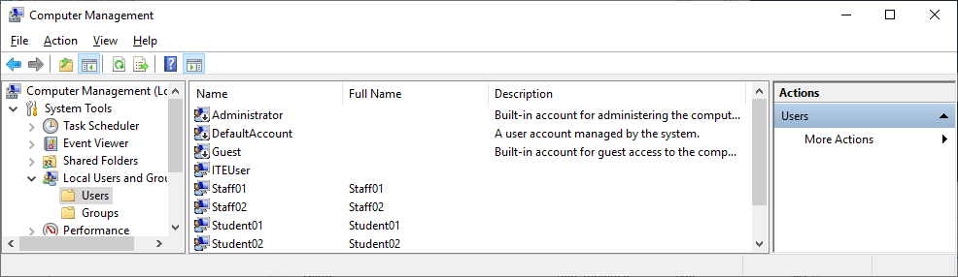
      - Double-click Student01. Unselect the User must change password at next logon.

Question:
  - What group does Student01 belong to?
.
      - Click OK.
      - Click the Groups folder. Double-click the Users group.

Questions:
  - From the description, can the members of the Users group make system wide changes? What can the Users group do on the computer?
.
  - Who are the group members?
.
      - Click OK to continue.

Verify user and group permissions.
- The permission for the Users group allows the members to run most applications on the local computer. The group member inherited the permission when they joined the group during the creation of the account. These members cannot make any system-wide changes. In this step, you will try to create another new user as a member of the Users group and use Microsoft Edge to navigate to www.cisco.com.
      - Log off the computer.
      - Log on as any member of the Users group.
      - Navigate to Local Users and Groups in Computer Management. Click Users.
      - Create a new user account using the name Test and password cisco12345!.

Question:
  - Were you successful in creating the new account? Explain.
.
      - Navigate to www.cisco.com using a web browser.

Question:
  - Were you able to navigate to www.cisco.com? Explain.
.

Create New Groups
In this part, you will create new groups named ITEStudent and ITEStaff and add members to the group. You will also create folders and assign permissions.

Create new groups.
      - Log off the computer. Log on to the computer using an account with administrative privileges. In this example, the account ITEUser has administrative privileges.
      - Navigate to the Local Users and Groups Manager.
      - Right-click the Groups folder and select New Group.
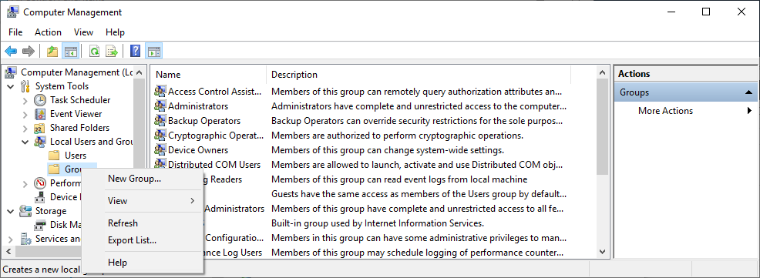
      - Enter ITEStaff as the group name. Click Add to add users to this group.
      - In the Select Users window, enter Staff01 under the heading Enter the object names to select. Click Check Names to verify the object was entered correctly. Click OK to add Staff01 to the group ITEStaff. Repeat this procedure to add Staff02 to the group ITEStaff.
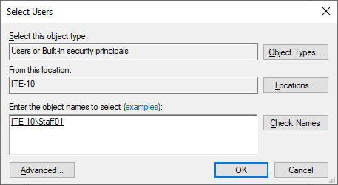
      - Click Create to complete the group creation process.
      - Repeat the same procedure to add users Student01 and Student02 to the group ITEStudent. Click Create. Click Close when finished with new group creation.
      - Click Users and double-click each of the four users and verify they are members of the correct groups by clicking the Member Of tab. Click Cancel to close each user after verification.

Assign group permissions to folders.
      - Create folders named Staff and Students in the C:\ drive.
      - Select and then right-click the Students folder and select Properties.
      - Select the Security tab. Click Edit to change the permission for this folder.
      - Click Add to add group permission to this folder.
      - In the Select Users or Groups window, enter ITEStaff under the heading Enter the object names to select. Click Check Names for verification. Click OK to continue.

Question:
  - With the group ITEStaff highlighted, what can the members do in this folder?
.
      - Repeat the same procedure to add permissions for the group ITEStudent. In addition, the members of this group should have full control of this folder.

Question:
  - Which additional checkbox would you select?
.
      - Click OK to continue. Click OK to close the Properties window.
      - Select the Staff folder. Right-click the folder and select Properties.
      - Click the Security tab to add group permission as follows:
Allow the group ITEStaff Full control.
Deny Full control for the group ITEStudent
      - Click OK. Click Yes when prompted to deny permission to a group.
      - Click OK to close the Properties window.

Modify User and Group Permissions
In this part, you will verify the results of the group permission on the folders Staff and Students. You will also modify user and group permissions.

Verify and modify folder permissions.
      - Log off the computer. Log on the computer as Student02.
      - Navigate to the folder C:\Students. Create a folder named Student02 and create a text document in the folder.

Question:
  - Were you successful? Explain. YES, In a regular windows configuration the C:/Students folder would probably have the security settings set up such that the group or persons in the name of Users or a group of Students (if there exist one and Student02 is a member) could create other folders and files within it. It is common when the shared students directories are used, and every student requires his or her working space.
.
      - Navigate to the folder C:\Staff. Create a folder named Student02 and place a text file in the folder.

Question:
  - Were you successful? Explain. NO, The C:\Staff folder can normally be set with stricter permissions. Unless the user has permission specifically granted, standard users (unless otherwise named here) will only have Read or Read & Execute privileges to C:\Staff, and will not be allowed to create, edit, or delete anything in it. This is one of the security precaution to prevent confidential staff data. In all probability, you would get an access denied error message.
.
      - Now log off the computer and log on as Student01.
      - Navigate to C:\.

Question:
Can you place a text file in the Staff folder? Can you modify the text file in folder Student02? Explain.
.
      - Create a new folder named Student01 in the folder C:\Students and create a text document in the folder.
      - To prevent the user Student02 and other ITEStudent group members from modifying this folder and its content, right-click the folder Student01 and select Properties.
        - In the Security tab, click Advanced.
        - Click Disable inheritance. Select Convert inherited permission into explicit permissions on this object.
        - Click Add > click Select a principal. Enter Student01 as the object name and click OK to continue. Click Full control to give Student01 full control to this folder. Click OK to return to the Advanced Security Settings window.
        - Repeat the above step for the initial user in this activity. For example, ITEUser is the initial user.
        - Select the group ITEStudent and click Edit. Uncheck the checkboxes Full Control, Modify and Write under Basic permission. Click OK.
        - Select the group ITEStaff and click Edit. Select the checkbox Modify under Basic permission to grant ITEStaff more permission.
        - Select the group Authenticated Users and click Remove.
        - Verify that the following user and groups have the following access:
Access | User or Group
Full Control | Student01, ITEUser (the initial user in this example)
Read and execute | ITEStudent
Modify | ITEStaff

Blank line, no additional information
        - Leave other group permission as is. Click OK to exit Advanced Security Settings window. Click OK again to exit the Properties window.
      - Log off the computer and log on as Student02.
      - Navigate to the folder C:\Students.

Question:
  - Are you able to access the content in the Student01 and Student02 folders? Explain.
.
      - Log off the computer and log on as Staff01.
      - Navigate to the folder C:\.

Question:
Were you able to access the content in the folders Staff, Students\Student01 and Students\Student02? Explain.
.

Disable a user account.
At this time, the user account Staff02 is not being used. In this step, you will disable this account.
      - Log off the computer and log on as ITEUser or an account with administrative privileges.
      - Navigate to the Local Users and Groups Manager.
      - Select the Users folder. Double-click Staff02.
      - Check Account is disabled.
      - Click OK to continue.
      - Log off the computer.

Question:
  - Can you log on as Staff02? Explain.
.

Clean up.
In this step, you will delete the users, groups, files, and folders created in this lab.
      - Log on using an account with administrative privileges.
      - Navigate to C:\ and delete the folders Staff and Students.
      - Navigate to the Local Users and Groups Manager.
      - Select Users.
      - Right-click Staff01 and select Delete. Click Yes to confirm the user deletion. Repeat this for Staff02, Student01, and Student02.
      - Select Groups.
      - Right-click ITEStaff and select Delete. Click Yes to confirm the group deletion. Repeat this for ITEStudent.

Reflection Questions
How would you give administrative privileges on the local computer to all the members of ITEStaff?
1.1Open the Local Users and Groups management console in the computer.

2. 2. To find the group of Administrators; navigate the Groups folder.

3. 3. Double-clicking on this group in order to access the properties of the group enables us to gain access into the properties of "Administrators".

4. 4. To add groups or users click the add button.

5. 5. To check the group name, enter the group name which is itestaff in the text field and click the check names button.

6. 6. To add the "itestaff" group to the group of Administrators, press the button "OK."

7. 7. When all the modifications are made, close the properties window.

Meanwhile, the administrative access on the local computer will be granted to all members of the itestaff group who will be added to the Administrators one.

.
How would you deny access to a file for everyone except the owner?
Deny permissions will always supersede allow permissions no matter what user or group they pertain to. To employ deny permissions in preventing "everyone but you" from deleting items from your folder would require creating a security group where every domain user account is included, except you. This is not feasible unless you have a very small domain.

.

Lab 13.3.4.6 – Configure Windows Firewall

Introduction
In this lab, you will explore the Windows Firewall and configure some advanced settings.

Recommended Equipment
Two Windows PCs directly connected or connected over the network
Computers must be in the same workgroup and network

Instructions
  - Create and share a folder on PC-1.
      - Log on to PC-1 as a member of the administrator group. Ask your instructor for the username and password.
      - Verify that you can ping PC-2.
      - On PC-1, right-click the desktop, select New > Folder. Name the folder Cisco.
      - Right-click the Cisco folder, and then select Properties > Sharing > Advanced Sharing. The Advanced Sharing window opens. Click Share this folder and use the default name Cisco. Click OK. Close the Cisco Properties window.

Use File Explorer to view PC-1’s shared folder.
      - Log on to PC-2 as a member of the administrator group. Ask your instructor for the username and password.
      - Open File Explorer. In the left pane, under Network, expand PC-1.

Question:
Under PC-1, are you able to see the shared folder Cisco?
.
Note: If you answered no, ask the instructor for help.
      - Close File Explorer.

Open Windows Firewall on PC-1.
Note: Use PC-1 for the rest of the lab unless otherwise stated.
      - To open the Windows Firewall window, click Control Panel in Small icons view > Windows Defender Firewall.
      - The normal state for the Windows Firewall is On.

Question:
  - What are the benefits of Windows Firewall?
Windows Firewall (Microsoft Defender Firewall) has some of the following advantages:

Blocks incoming and outgoing unauthorized connections
Filters the network traffic.
Blocks unauthorized users
Avoids hacking access and rogue programs.
Lessens network security threats: Minimizes the risks of network by thwarting network attacks such as back door attack and remote log-ins.
Secures sensitive information: Is able to impose authenticated and secure communication by using IPsec.
Convenient and cost effective:As part of Windows and does not necessitate an additional procurement.
Configurations of various networks.
Adjusts security auto-magically between a public, a private, or a domain network.
Blocks external connections:
Stops malware in outbound connections.
.

Investigate the Windows Firewall Allowed Programs feature.
      - Click Allow an app or feature through Windows Defender Firewall.
      - In the Allowed apps window, programs and services that Windows Firewall is not blocking will be listed with a check mark. Click What are the risks of allowing an app to communicate? or What are the risks of allowing a program to communicate?
Note: You can add applications to this list. This may be necessary if you have an application that requires outside communications but for some reason the Windows Firewall cannot perform the configuration automatically.
  - Creating too many exceptions in your Programs and Services file can have negative consequences.
  - Describe a negative consequence of having too many exceptions.
.
      - Close Windows Support window.

Configure the Windows Firewall Allowed apps feature.
      - In the Allowed apps window, click Change settings. Remove the check mark from File and Printer Sharing. Click OK.
      - On PC-2, using File Explorer, attempt to open the network connect to PC-1.

Question:
  - Can you connect to PC-1 and view the Cisco shared folder?
  - No, you should not have access to PC- 1 and the shared folder.
.No, you should not have access to PC- 1 and the shared f
  - Did you receive an error message on PC-2? If so, what was the Error message?
"Network error: Windows cannot access \PC-1"
."Network error: Windows cannot access \PC-1"
      - Close all open windows on PC-2.
      - On PC-1, add a check mark to File and Printer Sharing. Click OK.
Note: You should be able to add the check mark without needing to click Change settings.
      - On PC-2, re-open File Explorer and attempt to connect to PC-1.

Question:
  - Can you connect to computer 1? Explain.
  - The answer is yes, and you should be in a position of connecting to PC-1 and viewing a shared folder.
Re-enabling file and printer sharing services checks the box "File and Printer Sharing" in the Windows Firewall of your PC-1, you are again allowing the firewall rules that allow inbound networks traffic to the file and printer sharing services. This will open the ports required and then PC-2 would be able to connect to the shared resources in PC-1 provided sharing permissions have also been set within the folder.
.
      - Close all open windows on PC-2 and Log off .
      - Close all windows on PC-1.

Explore Advanced Security features in Windows Firewall.
Note: Use PC-1 for the rest of this lab.
      - Click Control Panel in Small icons view > click Windows Defender Firewall > click Advanced Settings.
In the left panel of the Windows Defender Firewall with Advanced Security window, you can select items to configure Inbound Rules, Outbound Rules, or Connection Security Rules. You can also click Monitoring to view the status of configured rules.
      - Click Inbound Rules. In the middle panel, scroll down until you find the inbound rule named Files and Printer Sharing (Echo Request – ICMPv4-In). Right-click the rule and select Properties.
      - Select the Advanced tab. The Advanced tab displays the profile(s) used by the computer. Click Customize in the Interface Types area of the window.
      - The Customize Interface Types window displays the different connections configured for your computer. Leave All interface types selected, then click OK.
      - Click the Programs and Services tab. In the Services section, click Settings....
List the short name of four services that are available in the Customize Service Settnigs window.
.
      - Click Cancel to close the Customize Service Settings window.
      - Click the Protocols and Ports tab.
Note: There are many applications that users do not normally see that also need to get through the Windows Firewall to access your computer. These are the network level programs that direct traffic on the network and the internet.
      - For the ICMP settings, click Customize.
      - The Customize ICMP Settings window opens. Allowing incoming echo requests is what allows network users to ping your computer to determine if it is present on the network.
  - List four of the Specific ICMP types.Echo Request (Type 8) and Echo Reply (Type 0),Destination Unreachable (Type 3),Time Exceeded (Type 11),Redirect (Type 5).
.
      - Close all open windows on PC-1.
      - Right-click the Cisco folder on the Desktop, then select Delete.

Reflection Question
What are some possible reasons you may need to make firewall changes?
A good firewall guards your personal information and the internal networks against hackers meaning this is your fort against internet enemies. Outdated or poorly configured firewalls continue to present such security weaknesses that are exploited by cybercriminals to hack into networks, thus compromising the confidential data.

It happens specifically with outdated firewalls, the structure of which is full of weaknesses that are used by clever cyber-vandals to get unauthorized access. The importance of updating the firewall is that it eliminates these weaknesses, enhances your security and bolsters protection against emerging online attacks.

A well maintained firewall, in other words, is one of the first things and can be considered like the first line of shield, defending the digital possession and making you have a sufficiency that the world is turning into an ever enveloping global interaction.

.

