This book belongs to _____________________________________

COMP503 / COMP608 - Introduction to Networks

Lab Workbook
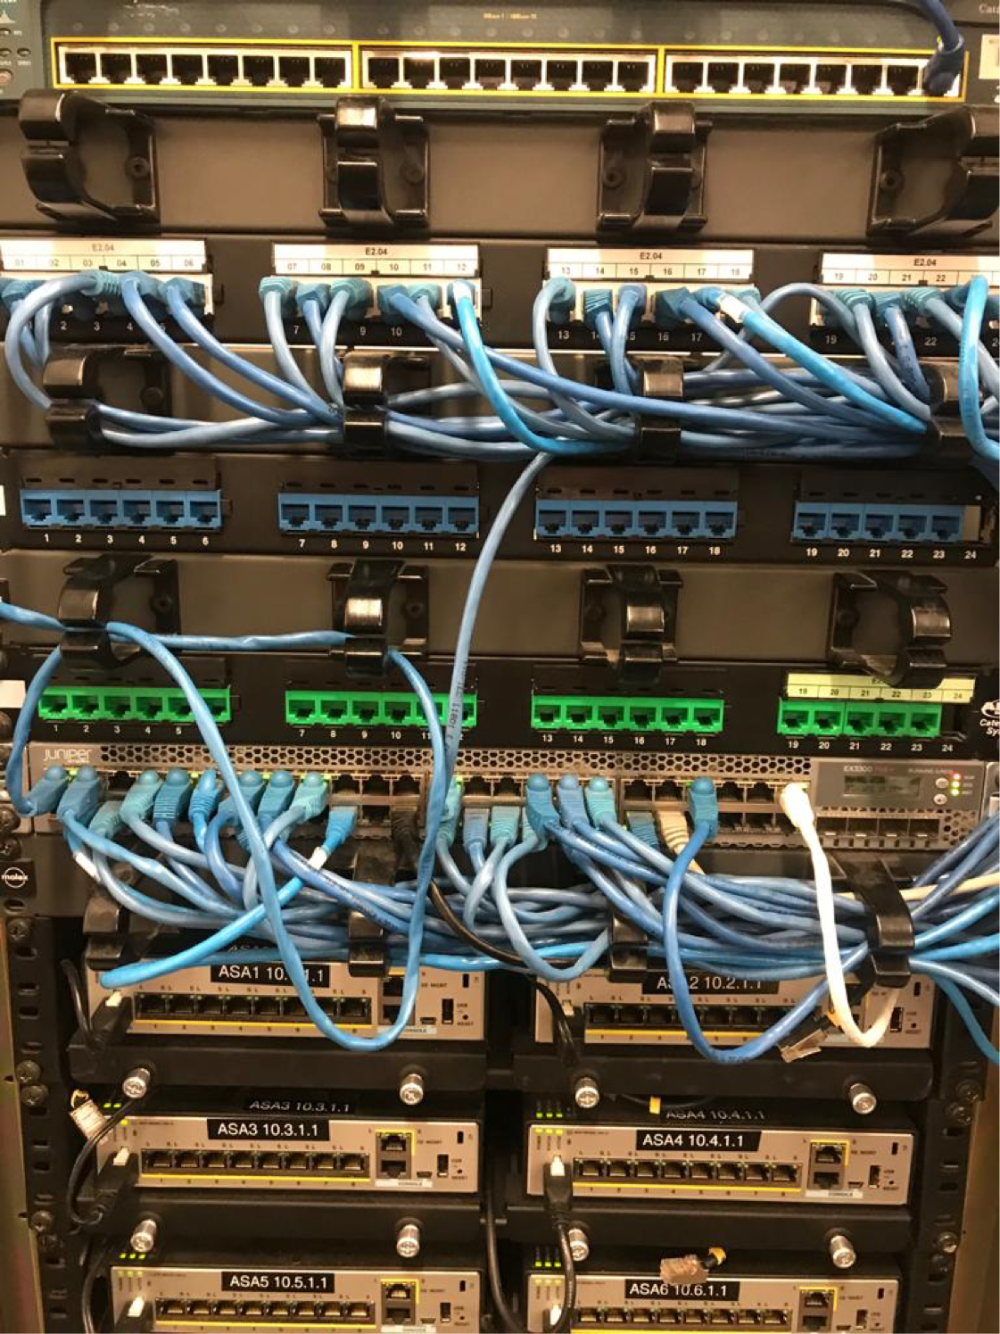


Student Name: _____Tirth_Patel_________________________
Sign off page
Demonstrate your work to your tutor and get it signed off, after you complete the practical tasks and finish answering the questions at the end of the lab.
There are several Cisco-1 classes each week. If you miss a class, you may be able to organise to complete the lab work in a different Cisco class.
Lab | Topic | Week | Tutor’s Signature
1 | Physical access to switch using Console | 1
2 | Introduction to the Cisco Command Line Interface | 2
3 | Securing administrative access to the Cisco CLI | 3
4 | Manage the configuration | 4
5 | Remote access to a router using Telnet | 6
6 | Remote access to a switch using Telnet | 7
7 | Setup a small IPv4 network using a switch and a router | 8
8 | Secured remote access using SSH | 11
9 | Backup and Restore Startup Configuration using TFTP | 12
10 | Setup a small IPv6 network using a switch and a router | 14

Note: The weekly plan is subject to change
Table of Contents

Lab 1 - Physical Access to a Switch using Console 5
Aim 5
Switch and Router Console Ports 5
Step 1: Console access to a switch in the Cisco Lab 6
Step 2: Configure Tera Term to establish a console session with the switch 6
Lab Reflection 8
Lab 2 - Introduction to the Cisco Command Line Interface (CLI) 10
Aim 10
Tasks to be completed 10
Step 1: Establish a Console session with a Cisco Switch 10
Step 2: Explore the CLI Help 10
Step 3: Use of the TAB key 11
Step 4: Introduction to the Privileged-Exec Mode 11
Step 5: Introduction to the Global Configuration Mode 12
Step 6: Introduction to the Line Mode (Sub-Configuration) 12
Step 7: Navigation through the Cisco CLI 13
Lab Reflection 13
Lab 3 - Securing Administrative Access to the Cisco CLI 15
Aim 15
Tasks to be completed 15
Step 1: Task 1 to Task 4 15
Step 2: Setup a Security Banner 15
Step 3: Securing access to the Console 16
Step 4: Securing access to the Privileged-Exec mode using an encrypted password 16
Step 5: Verification - Banner and Passwords 16
Lab Reflection 17
Lab 4 - Manage the Configuration 19
Aim 19
Tasks to be completed 19
Step 1: Task 1 to Task 7 19
Step 2: Check the Running Configuration 19
Step 3: Apply automatic Type-7 encryption to all clear text passwords 20
Step 4: Saving the Running Configuration 20
Step 5: Reboot the Device 20
Step 6: Erase the Configuration 20
Lab Reflection 21
Lab 5 - Remote Access to a Router using Telnet 23
Aim 23
Tasks to be completed 23
Step 1: Connect a PC to the Router 23
Step 2: Assign IP Configuration to the PC 23
Step 3: Configure the VTY line 24
2Step 4: Set a timeout on the VTY line 25
Step 5: Assign an IP Address and a Subnet Mask to the Router’s interface 25
Step 6: Enable the Router’s interface and set a description on it 25
Step 7: Ping the Router’s interface 26
Step 8: Troubleshoot connectivity problems 26
Step 9: Test Telnet 28
Lab Reflection 29
Lab 6 - Remote Access to a Switch using Telnet 31
Aim 31
Tasks to be completed 31
Step 1: Connect a PC to the Switch 31
Step 2: Task 2 and Task 3 31
Step 3: Configure the SVI 31
Step 4: Task 5 to Task 7 32
Lab Reflection 32
Lab 7 - Setup a small IPv4 network using a Switch and a Router 33
Aim 33
Tasks to be completed 33
Step 1: Default Gateway 35
Step 2: Impede Brute Forde Logins 35
Step 3: Ensuring reachability from PC to the Switch’s SVI 36
Lab Reflection 37
Lab 8 - Secured Remote Access using SSH 39
Aim 39
Tasks to be completed 39
Step 1: SSH configuration 40
Step 2: Test SSH 42
Step 3: Test the Login Block 43
Lab Reflection 44
Lab 9 - Backup and Restore Startup Configuration using TFTP 46
Aim 46
Tasks to be completed 46
Step 1: Backup the Router’s Startup Configuration to the PC 46
Step 2: Restore the Router’s Startup configuration to the PC 48
Lab Reflection 49
Lab 10 - Setup a small IPv6 network using a Switch and a Router 51
Aim 51
Tasks to be completed 51
Step 1: Assign the planned IPv6 Address, Prefix & Default Gateway to the PC 52
Step 2: Enable IPv6 Routing 52
Step 3: Assign the planned IP configuration to the Router’s interface 53
Step 4: Assign a Link-Local Address of FE80::1 to the Router’s interface 53
Lab Reflection 54
Feedback 56

Feedback.………………………………………………………………………………………………………………………………………………………………………43

Lab 1 - Physical Access to a Switch using Console

Aim
Routers and switches do not come with a monitor and keyboard. In order to program them, a user can access them either physically using a Console cable or remotely using protocols, such as Telnet and SSH.
The aim of this lab is to help the learners to demonstrate the ability to physically access a Cisco switch using a Console cable.

Switch and Router Console Ports
Routers and switches with default configuration can only be accessed physically by connecting a Roll-Over cable (Console cable) from the PC’s Serial or Usb port to the Console Port on the router or the switch.
A terminal emulation software is also required on the PC to transmit the commands. Terminal Emulation Software installed on the Cisco Lab computers are Putty and Tera Term.
This connection does not form part of the network – it is only for programming the device and can be disconnected when finished.
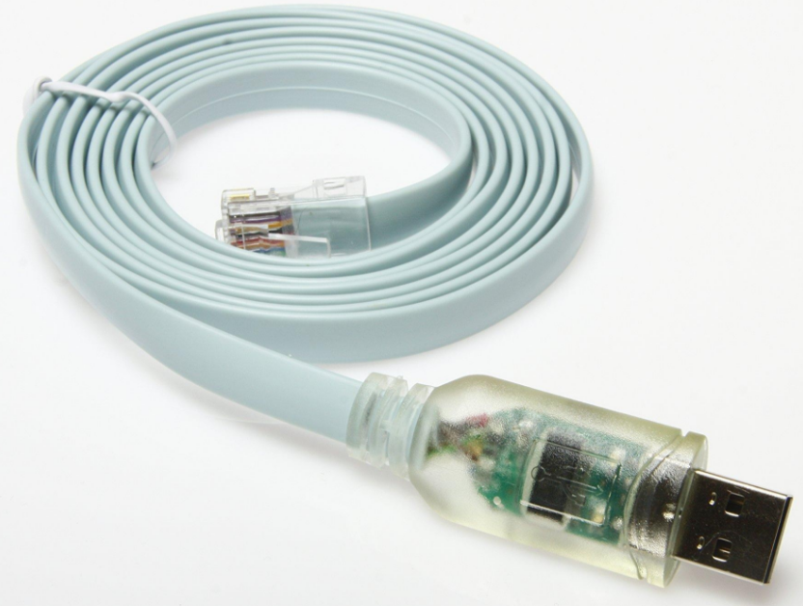Console Cable (USB) | 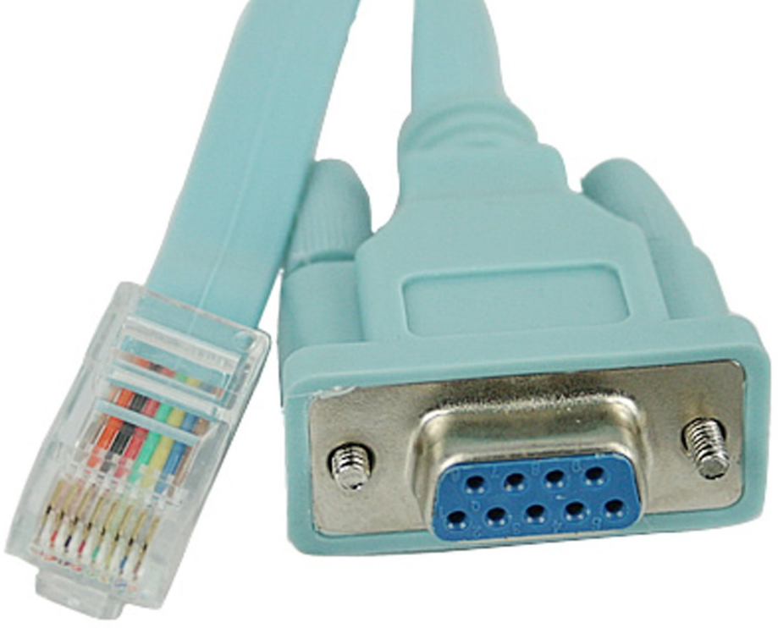Console Cable (Serial)

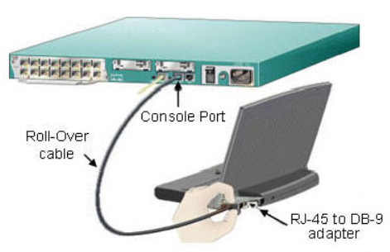

Step 1: Console access to a switch in the Cisco Lab
- Connect the blue patch panel port of your PC to the console port of your switch using a Blue or Green Ethernet cable.

- Make sure the switch is turned on.

Step 2: Configure Tera Term to establish a console session with the switch
- Start Tera Term by clicking the Windows Start button located in the task bar. Locate Tera Term under All Programs.

- In the New Connection dialog box, click the Serial radio button. Verify that the correct COM port is selected and click OK to continue.
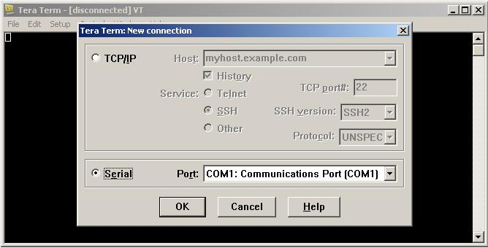

- From the Tera Term Setup menu, choose the Serial port… to verify the serial settings. The default parameters for the console port are 9600 baud, 8 data bits, no parity, 1 stop bit, and no flow control. The Tera Term default settings match the console port settings for communications with the Cisco IOS switch.
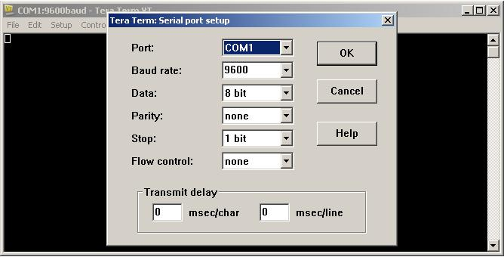

- When you can see the terminal output, you are ready to configure a Cisco switch. The following console example displays the terminal output of the switch while it is loading.
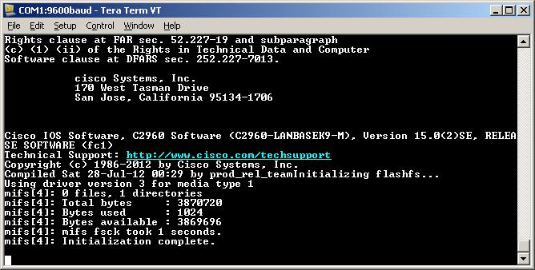

- When powering on a device with default configuration, the System Configuration Dialog will prompt you to continue with initial device configuration. Enter “no” to go access the Cisco Command Line Interface (CLI). Press the <enter> key once loading is complete to display the Switch> prompt.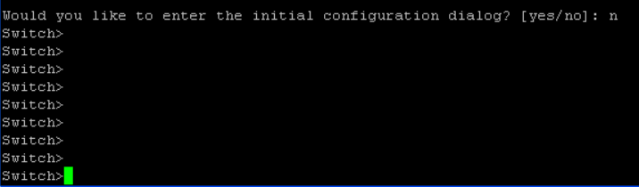

Lab Reflection

At the end of each lab there are some questions that you need to answer before demonstrating your work to the tutor:
- What did you learn in this lab?
During this lab, I got to learn about accessing a Cisco switch physically through the use of a console cable. I applied connections between a PC and the console port of the switch with a rollover (console) cable and configured Tera Term to create a serial link. I got to know also about the parameters of the console port (9600 baud, 8 data bits, no parity, 1 stop bit, and no flow control) and the way to move into the Cisco IOS Command Line Interface (CLI).

- What are the 4 different methods of accessing the Cisco CLI?
There are four ways of accessing Cisco CLI:
Console access Direct physical access with a console cable.
Remote access Network access via IP (not encrypted).
SSH (Secure Shell) access - Network access remotely but with encrypted transmissions.
AUX (Auxiliary) port access -Access using modem connection via the auxiliary port of the router.
- Which of these methods needs physical access to the equipment?
The mode of accessing the console is physical as it involves the issue of direct cable connection between the PC and the network device.

- Which of these methods encrypts the session data?
The SSH (Secure Shell) mode encrypts the data session and offers a rather secure remote access to the Cisco apparatus

Lab 2 - Introduction to the Cisco Command Line Interface (CLI)

Aim
The aim of this lab is to help the learners to explore various command modes, keyboard shortcuts and help features available in the Cisco CLI. This is necessary to demonstrate the ability to easily navigate through the command modes and do basic configuration on the Cisco gear.

Tasks to be completed
Follow the steps below to perform the given tasks and get your instructor to verify after you complete:
- Establish a Console session to a Cisco Switch
- Go from the User-Exec mode to the Privileged-Exec mode
- Configure the time on the device as 3:30 pm of 23rd February 2020
- Go from the Privileged-Exec mode to the Global Configuration mode
- Configure the hostname of the device as HAMILTON
- Disable DNS Lookups
- Go from the Global Configuration mode to the Line Configuration mode
- Go directly from the Line Configuration mode to the Privileged-Exec mode

Step 1: Establish a Console session with a Cisco Switch
- Establish a Console session to a Cisco Switch.
- If the device you are trying to access is booting, then you’d have to wait until you see the User Prompt >

Step 2: Explore the CLI Help

The IOS can provide help for commands depending on the level accessed. A question mark (?) can be used at any time to use what is called the Context Sensitive Help. The prompt displayed below is called the User-EXEC Mode, and the device is waiting for a command. User Mode is the first mode a user has access to after logging into a router or a switch. This mode allows the user to execute only the basic commands, such as those that show the system's status, ping, create or disconnect a session, etc.

- Switch> ?
What does a question mark at the User-Exec mode help with? This Means that it will suggest some commands which are in user EXEC Mode.

- Switch> t?
What does “t” followed by a question mark at the User-Exec mode help with?
It will suggest the commands which are start from t like telnet, terminal and traceroute.

- Switch> terminal ?
What does the command “terminal” followed by a space and a question mark help with?

When you type Switch> terminal ? Cisco switch when you type the question mark this is the context sensitive help about the terminal command.It lists all possible keywords or parameters which can be used after the command.This helps you to understand what the options are and the ways that you can complete the command.For instance, it may display options such as length, monitor or width and would mean that you can set screen length, enable monitoring or set display width.In short, the terminal ? displays the list of subcommands to which one can apply the terminal command.

Step 3: Use of the TAB key
When part of a command is typed, the Tab key can be used to complete the partial command. It works only if the characters typed are enough to make the command unique.
- Switch> e <Tab key>
- What does “e” followed by the Tab key at the User-Exec mode do? Why?
- Switch> en <Tab key>
What does “en” followed by the Tab key at the User-Exec mode do? Why?

Step 4: Introduction to the Privileged-Exec Mode
The hash sign below shows the Privileged-EXEC Mode. Privileged Mode is the second mode of the Cisco CLI. This mode gives the user access to all the User-Exec commands including other commands required for verification and troubleshooting. Apart from a few exceptions, this mode cannot be used for configuration purposes.
- The “enable” command is used to go from the User-Exec mode to the Privileged-Exec mode.
Switch> enable <Enter key>
To switch to Privileged EXEC mode (Switch#) instead of User EXEC mode (Switch>) in order to access more advanced configuration and monitoring commands, one uses the command enable.

Switch#
To switch to Privileged EXEC mode (Switch#) instead of User EXEC mode (Switch>) in order to access more advanced configuration and monitoring commands, one uses the command enable.

- The “clock set” command is used to set the time on the device.
Switch# clock set <time in hh:mm:ss> <1-31 Day of the month> <month> <year>

Step 5: Introduction to the Global Configuration Mode
The Global Configuration mode (config)# allows the user to modify the running system configuration. This is where most of the configuration is performed.
- Switch# conf <Tab key> this code gives me the access for the configuration for end devices like router and switches like we can set the password and change host name and soo.

- Command used to go from the Privileged-Exec mode to the Global Configuration mode:
Switch# configure terminal <Enter key>
Switch(config)#

- Command used to set the name of the network device:
(config)# hostname <name of the device>

- (config)# no ip domain-lookup or (config)# no ip domain lookup
A Global configuration command that disables DNS lookups on a device. DNS Lookup happens automatically if the user mis-spell a command. This lookup freezes the screen for a few seconds and prevents the user from typing for that duration.

Step 6: Introduction to the Line Mode (Sub-Configuration)
The Line mode is used for configuration related to the access methods, such as, Console, Telnet and SSH.
- (config)# line ?

Which keywords are displayed if the “line” command is followed by a space and a question mark?
I can see <0-16> means first line number
Console primary terminal line
Vty Virtual terminal.
_______________________________________________________________________________

- The Console line is used for configuration related to the physical access of Cisco equipment.
(config)# line console 0
(config-line)#

Step 7: Navigation through the Cisco CLI
Quick navigation through the CLI modes is essential to efficiently configure and troubleshoot a given scenario within the provided timeline.
- Exit command
- Return from the Sub-Configuration modes to the Global Configuration mode.
- Return from the Global Configuration mode to the Privileged-Exec mode.
- Logout of the Console session from the Privileged-Exec mode.

- End command or CTRL+Z
Return from the Global Configuration mode and the Sub-Configuration modes to the Privileged-Exec mode directly.

- CTRL+A
Brings the cursor to the beginning of the command.

- CTRL+E
Brings the cursor to the end of the command.

- Up/Down arrow key
Allows the user to surf through the commands stored in the command buffer. The command buffer stores the last 10 commands typed in the current session. This is a very useful feature for re-using the commands without having to type them repeatedly.

Lab Reflection

Answer the questions given below:
- What did you learn in this lab?
The main thing that I learned during this lab is how to navigate the Cisco Command Line Interface (CLI) with the various command modes, keyboard shortcuts, and help commands. I also had a practice of switching between User EXEC, Privileged EXEC, Global Configuration modes and learned to use context-sensitive help (?), command completion (Tab key) and history navigation (arrow keys). I also got to know how to set simple device settings like hostname, clock and DNS lookup and also how to access sub-configuration mode such as the Line Configuration mode.
- List the commands covered in this lab with a brief explanation of what they help to achieve?
? - give me available commands or options
<command>? Shows the possible completions or options of a particular command
enable Switches User EXEC mode (Switch>) to Privileged EXEC mode (Switch#)
clock set hh:mm:ss rates the time of the system on the device.
configure terminal Transits Privileged EXEC to Global Configuration mode (Switch(config)#)
Hostname is to set the unique name for the end device like P C, ROUTER, SWITCH
no ip domain-lookup Turns off DNS lookup to avoid time wastage in typing in the wrong commands.
line ? Displays have options of line configuration (console, vty, etc.).
exit Starts moving down a level (e.g. across Line Configuration to Global Configuration).
end or CTRL+Z Goes straight back to Privileged EXEC mode in any configuration mode.

- List the three modes covered in this lab in the order that they appear to the user accessing the CLI and provide a brief explanation of what these modes are used for?

Mode Immediate Example Intention / Product
User EXEC Mode Switch
ideal mode immediately after access to the device. The simple commands, such as ping, show and managing sessions. Limited access - is not able to make changes to configuration.
Privileged EXEC Mode Switch# This mode grants access to all the monitoring and troubleshooting commands. Pre-requisite prior to going into configuration modes. This is done by commands such as show running-config and copy.
Global Configuration Mode Switch(config)# Allows configuration of device on a global basis (i.e. hostname, DNS, interface setup). Enables the access to sub-configuration modes such as Line, Interface or VLAN configuration.

____________________________________________________________________________________________

Lab 3 - Securing Administrative Access to the Cisco CLI

Aim
The aim of this lab is to help the learners to demonstrate the ability to secure access to the Cisco CLI.

Tasks to be completed
Establish a Console session to a Cisco Switch and follow the steps below to perform the given tasks:
- Configure the time on the device as 5:15 pm of 3rd March 2020.
- Configure the hostname of the device as WINTEC.
- Disable DNS Lookups.
- Configure a Banner message “Unauthorized access is prohibited...!!”
- Secure access to the Console using “cisco” as the password.
- Secure access to the Privileged-Exec mode using a MD-5 encrypted password of “cisco12345”.
- Verify that the Banner and the Password Security is working.

Step 1: Task 1 to Task 4
Refer to Lab-2 for the required steps.

Step 2: Setup a Security Banner
A Banner displays a message to everyone accessing the network equipment physically or remotely. The idea of the message is to display a temporary notice to users, such as issues with system availability or to display legal notices regarding unauthorized access to the network equipment.
- (config)# banner motd #message#
The Banner command is applied at the Configuration mode command. # used in the command is known as the delimiting character. The delimiting character can be any character, as long as it does not occur in the message. For this reason, symbols such as the "#" and “@” are often used.

Step 3: Securing access to the Console
Access to the Console can be secured with a password. By doing so, a user is prompted to enter the password before getting access to the Console session.
- Command used to go from the Global Configuration mode to the Line mode.
(config)# line console 0
(config-line)#

- Configure the password to be used.
(config-line)# password <password to be used>

- Enable password checking. Without this command, the password will not take effect.
(config-line)# login

Step 4: Securing access to the Privileged-Exec mode using an encrypted password
Access to the Privileged-Exec mode can also be secured with a password. By doing so, a password required in order to go from the User-Exec mode to the Privileged-Exec mode.
- (config)# enable secret <password to be used>

Step 5: Verification - Banner and Passwords
- To verify that the Banner is working, the user must completely log out of the Console session and then start a new session. The Banner should show up as soon as the new session begins.

- If the Console password is correctly configured, the user would also be prompted to enter this password.
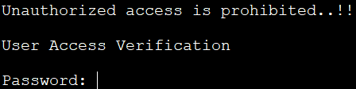
- If the Privileged-Exec mode has been secured, the user would also be prompted to enter a password, to go from the User-Exec mode to the Privileged-Exec mode.
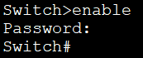

Lab Reflection

Answer the questions given below:
- What did you learn in this lab?
I got to know the procedure of accessing administrative privileges of a Cisco switch through Command Line Interface (CLI). I also trained on how to use passwords to secure the Privileged EXEC mode and the Console line. I also came to know how to configure a Message of the day (MOTD) banner to show security warnings and the procedure of ensuring that the security settings were functioning as intended. These measures will prevent the unauthorized physical and remote access of the switch.

- List the commands covered in this lab with a brief explanation of what they help to achieve?

clock set 17:15:00 3 March 2020
- it will set the time for the device

Show running configuration- it will verify the current passwords

- What message is displayed as a result of the configuration given below?
Unauthorized access is prohibited...!!

- Which CLI mode does the password on the Console line secure?
The Console line password is used to control the access to the User EXEC mode by the Console line.
This implies that a user should key in the console password before being allowed access to any CLI access of the device.

Lab 4 - Manage the Configuration

Aim
The aim of this lab is to help the learners to demonstrate the ability to save the configuration and reset the Cisco equipment to its default configuration.

Tasks to be completed
Establish a Console session to a Cisco Switch and follow the steps below to perform the given tasks:
- Configure the time on the device as 7:45 pm of 17th March 2020
- Configure the hostname of the device as CCNA
- Disable DNS Lookups
- Configure a Banner message “Authorized access only...!!”
- Secure access to the Console using “cisco12345” as the password
- Secure access to the Privileged-Exec mode using a MD-5 encrypted password of “cisco”
- Verify that the Banner and the Password Security is working
- Check the Running Configuration
- Apply automatic Type-7 encryption to all clear-text passwords
- Save your Running Configuration and Reboot the device
- Erase the configuration and Reboot the device

Step 1: Task 1 to Task 7
Refer to Lab-2 and Lab-3 for the required steps.

Step 2: Check the Running Configuration
All the changes made to the configuration go to the Running Configuration file stored in the RAM and affects the operation of the device immediately.
- Command used to check the Running-Configuration:
# show running-config

- The changes made to the configuration in Tasks 1 to 4 should now reflect in the Running Configuration.

Step 3: Apply automatic Type-7 encryption to all clear text passwords
Check the Running Configuration for the Console line, the password is in clear text.
- A command that can automatically encrypt all the clear text passwords:
(config)# service password-encryption

- Password for the Console line in the Running Configuration should now be encrypted.

Step 4: Saving the Running Configuration
To save the changes made to the configuration, the user must copy the Running Configuration file from the RAM to the Startup Configuration file in the NVRAM.
- After the device reboots, configure the hostname again and then save your Running Configuration:
# copy <source> <destination>
# copy running-config startup-config (copy run start)

- The Running Configuration will stay, if you reboot the device again.

Step 5: Reboot the Device

- Command used to reboot the device:
# reload

- Since, the Running Configuration was saved in step 4, your configuration is going to stay after the reboot.

Step 6: Erase the Configuration
In order to reset a switch to its default configuration, the user must erase the startup configuration in the NVRAM and the VLAN database file in the Flash.
- Command used to remove the Startup Configuration:
# erase startup-config
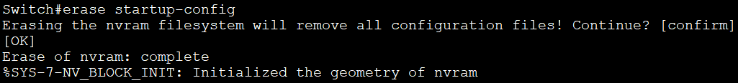
- Command to remove the VLAN database file:
# delete vlan.dat
Note: This command is only required if you are working on a switch.
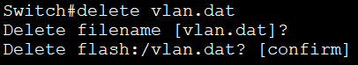
- The device must also be rebooted to clear the Running Configuration:
# reload

Lab Reflection

Answer the questions given below:
- What did you learn in this lab? How to save configs, encrypt passwords, reboot, and reset the device
During this lab I got to know the steps required to work with configurations in a Cisco switch such as saving, encrypting, rebooting and resetting the switch.I trained checking the running configuration, setting auto password encryption, storing configurations in NVRAM, rebooting the switch, and lastly clearing all configurations to use a switch as it is in the default condition.The skills are important in the maintenance, security and troubleshooting of Cisco network devices.

- List the commands covered in this lab with a brief explanation of what they help to achieve?
Commands like, show running-config, service password- encryption , copy running-config startup-config, erase startup-config, reload

- Which file does the changes made to the configuration immediately go to? RAM
Any changes in configuration automatically change to a Running Configuration file that is in RAM.

- Where is the configuration stored after it has been saved? NVRAM
It will save in Startup Configuration file which is located in NVRAM.

- What is different about resetting routers to their default configuration compared to switches?
Switches also need to remove the VLAN database (delete vlan.dat)

In the case of resetting of routers, all that is required is to delete the startup setup and then restart the system.
But when switches are being reset, besides destroying the startup configuration, also the VLAN database file(vlan.dat) in Flash memory must be destroyed to restore the device to its factory default.

Lab 5 - Remote Access to a Router using Telnet

Aim
The aim of this lab is to help the learners to demonstrate the ability to remotely access a Cisco Router using Telnet.

Tasks to be completed
Establish a Console session to a Cisco Router and follow the steps below to perform the given tasks:
- Connect a PC to the Router
- Assign IP Configuration to the PC
- Configure the VTY line (all passwords used must be “cisco”)
- Set a timeout of 5 minutes and 30 seconds on the VTY line
- Assign an IP Address and a Subnet Mask to the router’s interface
- Enable the router’s interface and set a description on it
- Ping the router’s interface from the PC
- Troubleshoot connectivity problems
- Test Telnet

Step 1: Connect a PC to the Router
Connect the green patch panel port of your PC to Gigabit Ethernet 0/1 port of the router using a Red Ethernet cable (Cross-Over cable).

Step 2: Assign IP Configuration to the PC
In this scenario, only the IP Address and the Subnet Mask is required.

- Click on the Windows Icon
- Go to the Network and Sharing Center
- Click on Change Adapter Settings
- Right Click on the LAN Adapter (Gigabit CT in the Cisco lab) and click on Properties
- Select Internet Protocol Version 4 (TCP/IPv4) and click on Properties.
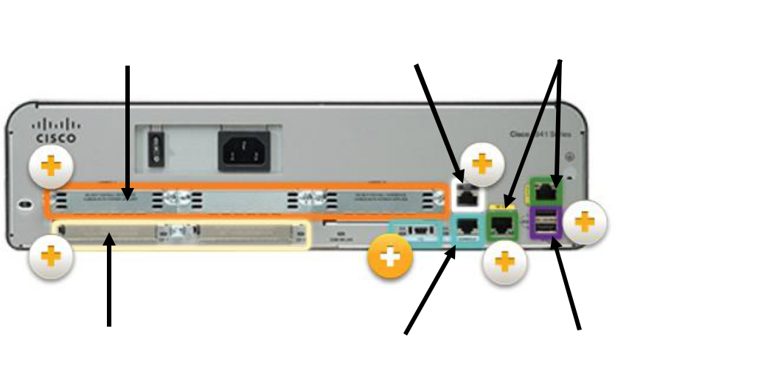
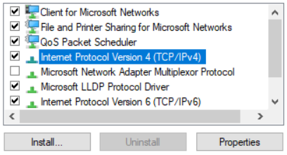
- Choose the option Use the following IP address.
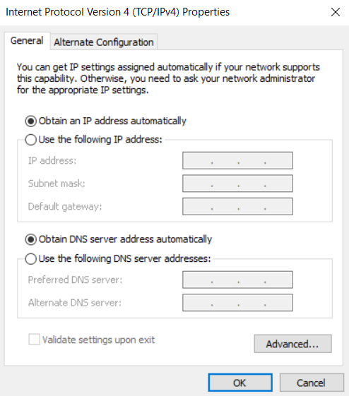
- Set the IP Address and the Subnet Mask.
Ip Address: 192.168.1.2
Subnet Mask: 255.255.255.0

Default Gateway is not needed in this scenario because the router is directly connected to the PC. There is no DNS server in this network, so DNS isn’t required either. Click on OK to confirm the settings.

- Disconnect the white network cable of the PC (only needed in the Cisco lab).
The PCs in the Cisco Lab have dual network adapters. The green Ethernet cable that goes to the Gigabit CT LAN adapter of the PC connects to the Cisco rack and the white cable connects to the Wintec network and the Internet. With both the adapters connected at the same time, the PC may start sending traffic towards the Wintec network instead of the lab network.

Step 3: Configure the VTY line
The VTY line needs to be a configured to allow remote access using Telnet.

- Command used to go to the VTY line mode:
(config)# line vty <first line number> <last line number>
Example: (config)# line vty 0 15

Most of the Cisco Operating System versions support line numbers from 0 to 15
Total number of simultaneous Telnet sessions = Last line number - First line number + 1
- You also need to activate telnet by the command:
(config-line)# transport input telnet

- Configure the password to be used:
(config-line)# password <password to be used> ….use “cisco” as the password

- Without this command, the password will not take effect and Telnet will not be allowed:
(config-line)# login

2Step 4: Set a timeout on the VTY line
For practice in the lab, a user may choose to disable the timeout, but it is good for remote sessions due to security reasons.
- Command used to disable the idle timeout:
(config-line)# no exec-timeout

- Command used to set a timeout:
(config-line)# exec-timeout <minutes> <seconds>

Step 5: Assign an IP Address and a Subnet Mask to the Router’s interface

The IP Address assigned to the Router’s interface and the PC must be in the same network.

- Command used to go to the Interface mode:
(config)# interface <interface type> <interface number>
(config-if)#

In this scenario, the “interface type” is Gigabit Ethernet and the “interface number” is 0/1.

- Command used to assign the IP Address and the Subnet Mask:
(config-if)# ip address <IP address to be assigned> <Subnet Mask>

Step 6: Enable the Router’s interface and set a description on it
Router’s interfaces are disabled by default.
- Command used to enable the interface:
(config-if)# no shutdown

Description is an optional feature, generally used to describe what an interface is used for. It works as a reminder.
- Command used to set the description:
(config-if)# description <message>

Step 7: Ping the Router’s interface
It is good practice to check reachability before trying to remotely access the device. if the device is unreachable, Telnet or any other remote access method doesn’t work, unless “ping” has been intentionally blocked for security reasons.
- Go to the Command Prompt of the PC
- Type ping <IP Address of the Router>

- Reply in the output below shows that the Router is reachable:
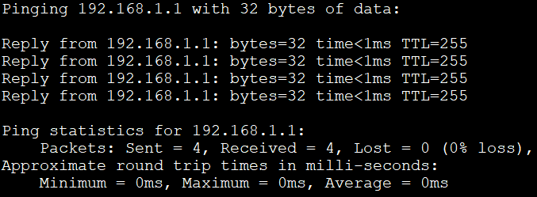
- Request Timed Out in the output below shows that the Router is unreachable:
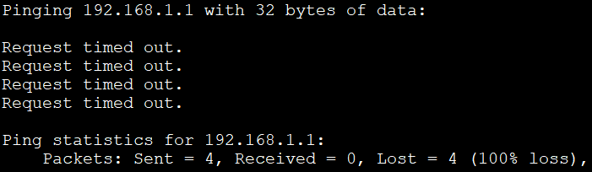

Step 8: Troubleshoot connectivity problems
Network troubleshooting can be stressful at the best of times. Having clear steps to follow, and a list of best practices can make the job much easier. Skip to step 9 if ping replies are received.
- Check the IP configuration of the PC
Go the PC’s Command Prompt, use the command ipconfig /all
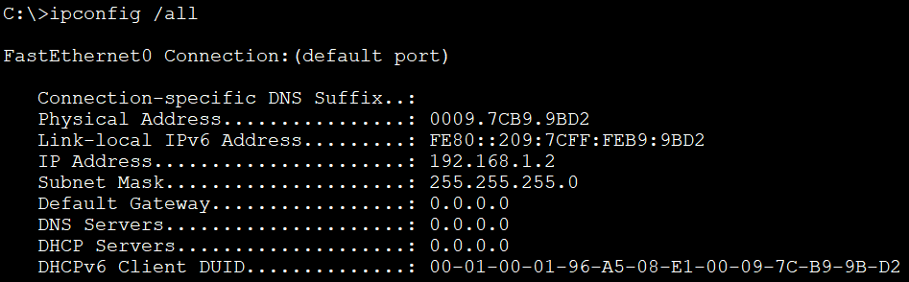
- Check which LAN adapter is the IP configuration is assigned to
Make sure the IP configuration is assigned to the correct Adapter (Gigabit CT in the Cisco Lab)

- Check the PC’s Ethernet cable connections
- Green Ethernet cable should be connected to the PC.
- White Ethernet cable should not be connected to the PC.

- Check the physical connection between the PC and the Router
- Router to the PC connection should a Cross-Over cable (Red cable).
- The green patch panel port of your PC should be connected to the Gigabit Ethernet 0/1 port of the router.

- Check the Router’s interface
- Cisco devices use light emitting diode (LED) indicators to provide status information. An interface LED indicates the activity of the corresponding interface.

- If the LED is off, check the interface configuration. Command used for it: # show ip interface brief

This command shows the IP Address assigned to the interface, method how the IP was assigned (manual or dynamic), Layer 1 is up or down (Status), and Layer 2 is up or down (Protocol).
If the Status is administratively down, then enable it using the “no shutdown” command.

Step 9: Test Telnet
- Go to the Command Prompt of the PC. Alternatively, if telnet is not activated in Windows, use Putty or Tera Term terminal emulator to telnet to the Cisco Equipment.
- Type telnet <IP Address of the Router>
- To go to the User-Exec mode, type the password configured on the VTY line, “cisco” in this scenario.
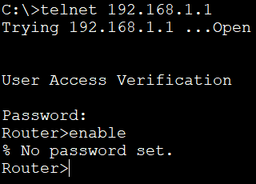
- In this scenario, the “enable” command results in an error message “No password set”.
This is for security reasons. Privileged-Exec mode should also be secured to prevent this problem.

Lab Reflection

Answer the questions given below:
- What did you learn in this lab?
In this lab, I learned how to use Telnet to remotely access a Cisco router.I had experience creating IP configurations on the router and the PC connected to it, creating VTY lines for Telnet login, and password protecting those lines as well as setting idle timeout for itself.I also learned to check connectivity with immigrate ping command, fix connection errors, and the significance of securing admins for unauthorised remote access.

- List the commands covered in this lab with a brief explanation of what they help to achieve?
line vty 0 15 - Enter Virtual Terminal Line conf. mode for up to 16 simultaneous Telenet sessions
transport input telnet - Enables the utility to e.g. Telnet access to the VTY lines
password cisco - Defines the password that must be presented to use telnet to the device
login - Enables the checking of passwords on the VTY lines.Without this password will not be enforced.
exec-timeout 5 30: - Sets the exec-timeout to 5 minutes and 30 seconds which disallows Telnet sessions when they hang for an extended period of time.
no exec-timeout Removes time out (used only for practice/testing).
interface gigabitEthernet 0/1 - Goes into interface configuration mode at the router's Gigabit Ethernet 0/1 interface port.
ip address 192.168.1.1 255.255.255.0 2.0 Progressive addressing assigns the IP address and subnet mask to the network router interface
no shutdown - Enables the interface of the router (brings up).
description <message> - Inserts a description - of the interface so that it can record its purpose or connection.
show ip interface brief-To see a summary of all the interfaces, their IP addresses and their status as operational or not.
ping IP address in order to see the connection between machines on the network.
Telnet <IP address> - Opens Telnet session to remotely access a network device

- Why is it necessary to secure the Privileged-Exec mode with a password to defend against attacks from remote locations?
The mode known as Privileged-EXEC has to be password protected because it gives full administrative access to the device including configuration, management, and troubleshooting.
If attackers obtained Telnet access remotely without a secured enable password, attackers would be able to change configurations, disable security settings, or disrupt operations on the network.
Priveleged EXEC access use of enable secret (MD5 encrypted password) used to guard the device from unauthorised access and ensure only those with authorisation can make configuration changes.

- List the type of Ethernet ports on the routers and switches of the Cisco lab racks. What is the bandwidth supported by each of these ports?

Device Port Type Bandwidth Supported
Router Gigabit Ethernet ( e.g., Gi0/0, Gi0/1 ) 1 Gbps (1000 Mbps)
Switch – Access Ports Fast Ethernet ( Fa0/1 – Fa0/24 ) 100 Mbps
Switch – Uplink Ports Gigabit Ethernet ( Gi0/1, Gi0/2 ) 1 Gbps (1000 Mbps)

Lab 6 - Remote Access to a Switch using Telnet

Aim
The aim of this lab is to help the learners to demonstrate the ability to remotely access a Cisco Switch using Telnet.
Note: use Putty or Tera Term to telnet if telnet is not active in Windows cmd

Tasks to be completed
Establish a Console session to a Cisco Switch and follow the steps below to perform the given tasks:
- Connect a PC to the Switch
- Assign IP Configuration to the PC
- Configure the VTY line
- Configure the SVI
- Ping the switch’s SVI from the PC
- Troubleshoot connectivity problems
- Test Telnet

Step 1: Connect a PC to the Switch
Connect the green patch panel port of your PC to Fast Ethernet 0/1 port of the switch using a Blue or a Green Ethernet cable (Straight-Through cable).

Step 2: Task 2 and Task 3
Refer to Lab-5 for the required steps. Password to be used is “cisco”

Step 3: Configure the SVI
Switch is a layer-2 device and it does not allow to assign an IP Address to its physical interfaces, but IP Address is required for a user to remotely access a device. To resolve this problem, a user can create a virtual interface on the switch to which an IP Address can be assigned. This is known as the Switched Virtual Interface (SVI).
- Create the SVI
(config)# interface vlan 1

- Assign IP Address and Subnet Mask to the SVI. IP Address assigned to the SVI and the PC should be in the same network.
(config-if)# ip address <IP Address to be assigned> <Subnet Mask>

- Enable the SVI
(config-if)# no shutdown

Step 4: Task 5 to Task 7
Refer to Lab-5 for the required steps.

Lab Reflection

Answer the questions given below:
- What did you learn in this lab?

- List the commands covered in this lab with a brief explanation of what they help to achieve?

- Why is it necessary to create a virtual interface on the switch?

ANSWER 1-
During this lab, I was able to learn how to access a cisco switch remotely via telnet through the proper configuration of a switch and a PC that is connected to it.I also trained on how to create a console session, allocate an IP address to the PC, and configure the Switch Virtual Interface (SVI) in such a way that the switch can be administered via the network.I also got to know how to activate and lock the VTY lines using a password to regulate the remote access.I also checked the connectivity by typing the ping command and undertook the process of troubleshooting to achieve successful communication.On the whole, this laboratory made me learn how remote device management in a realistic network setting is performed.

ANSWER 2-
interface vlan 1- Entering vlan configuration mode of VLAN 1 which was default SVI mode of management.
ip address - ip assigns the switch virtual interface with IP address and subnet mask, which allows interacting with other devices in the network.
no shutdown- Activates the SVI interface, making sure it is working.
line vty 0 4 - Opens the virtual terminal lines (0–4) used for Telnet or SSH remote sessions
Password- SET password for the device
Login- make sure that password is set.

ANSWER 3-
A Switched Virtual Interface (SVI) should be developed due to inability of a Layer 2 switch to allocate IP address to its physical ports.The SVI offers a rational interface on which the switch can converse on the network and be controlled through Telnet or SSH.The switch would not be able to be configured by a different device, and could only pass the frames without an SVI.The IP addressing of the SVI enables the switch to be accessed remotely to manage it, monitor it, and troubleshoot it using network tools.It simply provides the switch with a network motion to control it administratively.

Lab 7 - Setup a small IPv4 network using a Switch and a Router

Aim
This lab introduces some new configuration commands and brings together all the concepts covered in the previous labs. The aim of this lab to help the learners to demonstrate the ability to design and setup a small LAN.

Tasks to be completed
Note: All passwords must be “cisco” and the network to be used is 192.168.1.0/24

Design the Network Topology:
- Make the connections according to the topology given below
- Use appropriate Ethernet cables for the connections
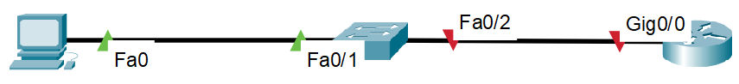
PC Configuration Tasks:
- Assign the Last Host IP and Subnet Mask of the given network address………Refer to Lab 5, Step 1
- Assign the appropriate Default Gateway……………………………………………………..Refer to Step 2 below

Router Configuration Tasks:
- Clock time as “4:15 pm of 3rd April 2020”…………...………………………………………..Refer to Lab 2, Step 4
- Hostname as “R_your first name”…………………………………………………………………Refer to Lab 2, Step 5
- Disable DNS Lookups…………………………………………………………………………………….Refer to Lab 2, Step 5
- Banner message “Unauthorized access is prohibited!!”………………………………..Refer to Lab 3, Step 2
- Secure access to the Console………………………………………………………………………..Refer to Lab 3, Step 3
- Secure access to the Privileged mode using a MD-5 encrypted password……..Refer to Lab 3, Step 4
- Verify that the Banner and the Password Security is working……..…………………Refer to Lab 3, Step 5
- Configure first 2 VTY lines to support Telnet……..…………………………………………..Refer to Lab 5, Step 3
- Timeout of 5 minutes and 30 seconds on these VTY lines …………..…………………Refer to Lab 5, Step 4
- Assign First Host IP of the given network address to the Router’s interface…..Refer to Lab 5, Step 5
- Enable the Router’s interface.……………………………………………………………………….Refer to Lab 5, Step 6
- Description on the router’s interface as “Connects to S_your first name"………Refer to Lab 5, Step 6
- Ensure reachability between the Router’s interface and the PC………………Refer to Lab 5, Step 7 & 8
- Test Telnet…………………………………………………………………………………………………….Refer to Lab 5, Step 9
- Block for 5 minutes after 4 wrong login attempts within 2 minutes………………Refer to Step 2 below
- Save the configuration…………………………………………………………………………………..Refer to Lab 4, Step 5
Switch Configuration Tasks:
- Hostname as “S_your first name”………………………………………………………………….Refer to Lab 2, Step 5
- Disable DNS Lookups…………………………………………………………………………………….Refer to Lab 2, Step 5
- Secure access to the Privileged mode using a MD-5 encrypted password……..Refer to Lab 3, Step 4
- Configure first 2 VTY lines to support Telnet……..…………………………………………..Refer to Lab 5, Step 3
- Description on the physical interface as “Connects to R_your first name"…….Refer to Lab 5, Step 6
- Assign 2nd Host IP of the given network address to the SVI and enable it………Refer to Lab 6, Step 3
- Setup an appropriate Default Gateway for the switch…..………………………………Refer to Step 1 below
- Ensure reachability between the Switch’s SVI and the PC…………………………….Refer to Step 3 below
- Test Telnet…………………………………………………………………………………………………….Refer to Lab 5, Step 9
- All clear text passwords should be automatically encrypted………………………….Refer to Lab 4, Step 3
- Block for 3 minutes after 3 wrong login attempts within 1 minute……………….Refer to Step 2 below
- Save the configuration…………………………………………………………………………………..Refer to Lab 4, Step 5

Reset the devices to default configuration after completing the lab:
- Reset the Router and Switch configurations to default………………………………….Refer to Lab 4, Step 6
- Reset the LAN Adapter on the PC to Dynamic Addressing……………………………..Refer to Lab 5, Step 2
- Re-connect the White Ethernet cable to the PC…………………………………………….Refer to Lab 5, Step 2

Step 1: Default Gateway
Default Gateway works as a gateway to external networks, such as the Internet. In this scenario, the router is the only exit point for the network, so the IP Address of the Router’s interface Gigabit 0/0 should be the Default Gateway for the PC and the Switch.
Command to apply Default Gateway on the switch:
(config)# ip default-gateway <Gateway IP Address>

Step 2: Impede Brute Forde Logins
Remote access methods, such as Telnet & SSH allow multiple wrong attempts at login without locking out the user completely. Hackers can Brute Force attacks to get access to Telnet or SSH enabled devices. In this attack, the hacker lets a computer do the work of trying different combinations of usernames and passwords until they find the one that works. Key to succeed in these types of attacks is how complex the credentials are and how quickly the software used for this attack can try different combinations to find out the correct one.
The two most common defence techniques used by network administrators against such types of attacks are:
- Complex credentials
Combination of special characters, numbers, uppercase and lowercase letters.

- Login Blocks
It blocks the user from attempting remote access to a device, for a certain amount of time, if there are some number of unsuccessful login attempts, within a specified time period. All these attributes can be configured in one command which only applies to failed remote access attempts due to incorrect credentials supplied.

- Command used to apply a Login Block:
(config)# login block-for <time in sec> attempts <no. of failed attempts> within <time in sec>

Step 3: Ensuring reachability from PC to the Switch’s SVI
- Ping from the PC to the Switch’s SVI.
- If unreachable, check PC’s settings (Refer to Lab 5, Step 8).
- Check the cabling. Both the Ethernet cables in this topology should be Straight-Through.
- Router’s interface should be up and correctly configured.
- Switch’s SVI should be up and correctly configured.
- Appropriate Default Gateway should be configured on the switch.

Lab Reflection

Answer the questions given below:
- What did you learn in this lab?
During this lab, I was able to learn to plan and set up a small Local Area Network (LAN) comprising of a router, a switch, and a PC.I had been practicing the assignment of IP addresses, configuration of hostnames and banners, and the use of passwords in order to protect the entry.I have also set up Telnet to be able to remote management, a Default Gateway, security measures such as blocking of login so that people cannot access the system using brute force.Moreover, I checked the connections between different devices with ping and checked that everything was correctly set up.This lab made me realize the fact that the network components interact with each other to create an operational and safe LAN.

- List the commands covered in this lab with a brief explanation of what they help to achieve?
Hostname- it will set new name or new host name for the devices
Banner motd - it will display security message like #Unauthorized access is prohibited!!#.
enable secret cisco- it will set password for privileged EXEC mode
line vty 0 4 - It enter configuration for virtual line terminal used for telnet access
password cisco / login- enables password protections for Privileged mode
ip default-gateway - It will setup the router ip for the device to communicate or to reach other networks

- What is Default Gateway used for?
A Default Gateway is the point of departure of the devices on a local network to interact with those that are not on the same subnet.The interface IP address of the router in this lab acts as a default gateway to both the switch and PC.In case the destination of a packet is not in the same network it is sent to the gateway which will relay it to the network in which the destination is.The devices were only able to communicate in the local area and not external or remote networks without a default gateway.

- Briefly explain what the command given below will help to achieve:
(config)# login block-for 120 attempts 5 within 30

This order allows to secure the logins in a more efficient way blocking them (120 seconds 2 minutes) once the number of failed logins exceeds 5 in a 30 second timeframe.It assists in avoiding brute force attacks, in which attackers continuously attempt to crack passwords.This is the reason why on the occasions of several failed attempts, the device denies all the attempts of logging in temporarily, which safeguards the network device against unauthorized entry, decreasing the possibility of intrusion.

Lab 8 - Secured Remote Access using SSH

Aim
The aim of this lab is to help the learners to demonstrate the ability to perform IPv4 subnetting, implement the planned addressing scheme to design, and configure the network to support secured remote access via SSH.

Tasks to be completed
Note: All usernames must be “admin” and passwords must be “cisco”

Design the Network Topology:
- Make the connections according to the topology given below
- Use appropriate Ethernet cables for the connections
Subnetting and Plan for IPv4 Addressing:
- Divide the network 192.168.1.0/24 in two equal size sub-networks
- Use the second sub-network for IP Addressing of the network
- Assign the last host IP to the PC
- Assign the first host IP to the Router’s interface
- Assign the second host IP to the Switch’s SVI

PC Configuration Tasks:
- Assign the planned IP configuration………………………………………………………………Refer to Lab 5, Step 2
- Assign the appropriate Default Gateway……………………………………………………….Refer to Lab 7, Step 1

Router Configuration Tasks:
- Disable DNS Lookups……………………………………………………………………………………..Refer to Lab 2, Step 5
- Secure access to the Privileged mode using a MD-5 encrypted password……..Refer to Lab 3, Step 4
- Assign the planned IP configuration to the Router’s interface……………………….Refer to Lab 5, Step 5
- Enable the Router’s interface.……………………………………………………………………….Refer to Lab 5, Step 6
- Ensure reachability between the Router’s interface and the PC………………Refer to Lab 5, Step 7 & 8
- Block for 3 minutes after 3 wrong login attempts within 3 minutes………………Refer to Lab 7, Step 2
- Configure the router to support remote access via SSH…….………………………….Refer to Step 1 below
- Test SSH………………………………………………………………………………………………………..Refer to Step 2 below
- Save the configuration…………………………………………………………………………………..Refer to Lab 4, Step 5
Switch Configuration Tasks:
- Disable DNS Lookups……………………………………………………………………………………..Refer to Lab 2, Step 5
- Secure access to the Privileged mode using a MD-5 encrypted password……..Refer to Lab 3, Step 4
- Assign the planned IP configuration to the Switch’s SVI………………………..………Refer to Lab 6, Step 3
- Setup an appropriate Default Gateway for the switch…..………………………………Refer to Lab 7, Step 1
- Ensure reachability between the Switch’s SVI and the PC……………………………..Refer to Lab 7, Step 3
- Configure the switch to support remote access via SSH…….………………………….Refer to Step 1 below
- Test SSH………………………………………………………………………………………………………..Refer to Step 2 below
- All clear text passwords should be automatically encrypted………………………….Refer to Lab 4, Step 3
- Block for 1 minute after 2 wrong login attempts within 1 minute……….…………Refer to Lab 7, Step 2
- Test the login block………………………………………………………………………………………Refer to Step 3 below
- Save the configuration…………………………………………………………………………………..Refer to Lab 4, Step 5

Reset the devices to default configuration after completing the lab:
- Reset the Router and Switch configurations to default………………………………….Refer to Lab 4, Step 6
- Reset the LAN Adapter on the PC to Dynamic Addressing……………………………..Refer to Lab 5, Step 2
- Re-connect the White Ethernet cable to the PC…………………………………………….Refer to Lab 5, Step 2

Step 1: SSH configuration
Telnet was designed to work within a private network and not across a public network where threats can appear. All the Telnet session data, including passwords is clear text. This is a major security issue and the developers of SSH used encryptions to make it harder for other people to sniff the password and other relevant session data.
- SSH uses a key for data encryption

- Hostname is necessary for the key to be generated

- Domain name is also mandatory for the key to be generated. Command used to specify a domain name:
(config)# ip domain name <domain name in use>

- Command used to create the key:
(config)# crypto key generate rsa
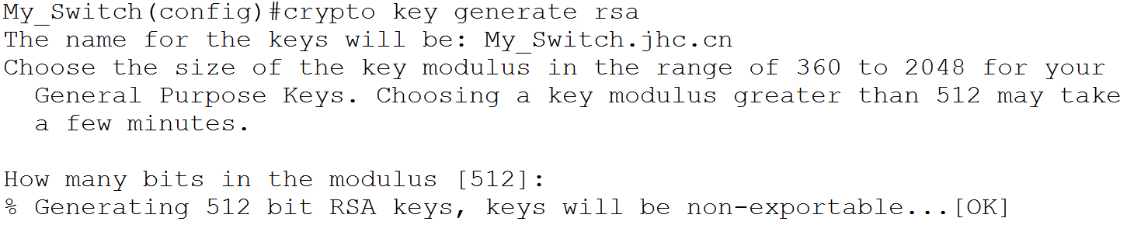
- Modulus specifies the number of bits used to create the key. 512 is default.
Higher the Modulus, stronger is the key.
- Create a local database of usernames and passwords for authentication

Command used to create a username and password:
(config)# username <username to be used> privilege <0-15> password|secret <password>

- Use of Privilege is optional

Privilege level 0 - includes the disable, enable, exit, help, and logout commands
Privilege level 1 - includes all user-level commands at the user-exec prompt (default)
Privilege level 15 - includes all enable-level commands at the privileged-exec prompt

- Password is clear text, Secret is encrypted

- Configure the VTY lines

- Enter the VTY line mode:
(config)# line vty <first line number> <last line number>

- Set the device to use the local database for authentication:
(config-line)# login local

- Specify the protocols to be allowed on the VTY lines:
(config-line)# transport input <ssh|telnet|all>

- SSH versions

Command used to configure the SSH version:
(config)# ip ssh version <1 or 2>

- Cisco IOS supports two versions of SSH.

- Version1 is the default and less secure compared to version 2.

Step 2: Test SSH
The SSH connection can be tested from the PC’s command prompt or from the Termination Emulation software installed on the PC.
- Testing SSH from PC’s Command Prompt

Command Prompt> ssh -l <username> <IP Address>
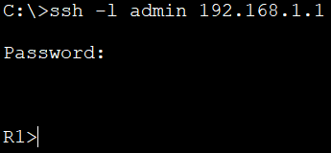
- Testing SSH from a Termination Emulation Software (Tera Term)
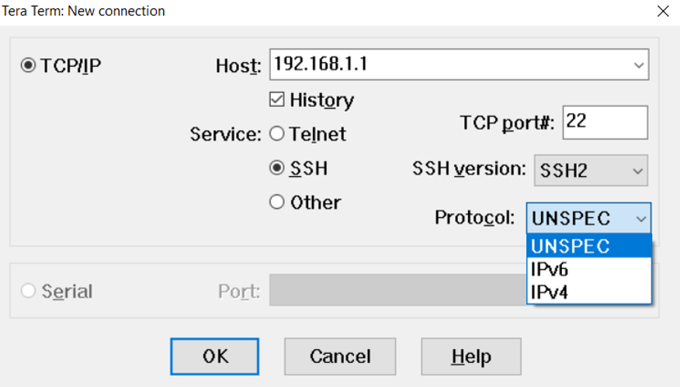
- Host
Type in the IP Address of the device to be accessed

- Service
Select SSH

- SSH version
Select SSH1 or SSH2 based on the version in use

- Protocol
Select IPv4 or IPv6 based on version in use

Step 3: Test the Login Block
According to the current configuration, the login block should be enforced for 1 minute if there are 2 unsuccessful attempts within 1 minute.

Lab Reflection

Answer the questions given below:
- What did you learn in this lab?
In this lab, I set up secure remote access with SSH on both a router and a switch. First, I worked through IPv4 subnetting, assigned IP addresses, and mapped out an addressing plan for all the devices on the network. For the SSH setup, I gave each device a hostname and domain name, generated an RSA key for encryption, and built a local user database for authentication. I also figured out how to limit login attempts to keep out brute-force attacks, and I double-checked that SSH actually encrypted my connections. Overall, this lab really showed me why encryption and secure remote management matter so much in network security.

- List the commands covered in this lab with a brief explanation of what they help to achieve?
ip domain name <domain> →It will set the domain name which required to setup SSH encryption password
crypto key generate rsa →RSA is a key to secured the SSH for crypto.
username admin password cisco → it will Creates a local user account for SSH authentication.
line vty 0 4 → this is for virtual remote access like ssh or telnet
login local → Enables authentication using the password or username
transport input ssh → Restricts remote access to SSH only, disabling Telnet.
ip ssh version 2 → it will enable v 2 for more security for SSH
login block-for <time> attempts <no.> within <time> → Prevent brute-force login attempts by temporarily blocking access after multiple failures.
service password-encryption →it will Automatically encrypts all plain-text passwords in the encrypted file.

- What is SSH an abbreviation for? What is the advantage of using SSH over Telnet?

SSH, or Secure Shell, lets you log in to network devices remotely and run commands—safely. The big thing that sets SSH apart from Telnet is encryption. With SSH, every bit of data—your username, password, everything—gets scrambled before it travels over the network. That means attackers can’t just grab your info by listening in. Telnet doesn’t do this. It sends everything out in plain text, so anyone snooping on the network can see your credentials and whatever else you type. SSH also gives you more robust authentication, including key-based access, so it’s just a stronger, smarter way to manage devices across a network.

Lab 9 - Backup and Restore Startup Configuration using TFTP

Aim
The aim of this lab is to help the learners to demonstrate the ability to backup and restore the startup configuration using a TFTP server.

Tasks to be completed
Perform the tasks given below and get your instructor to verify after you complete:
- Connect a PC to the Router……………………………………………………………………………Refer to Lab 5, Step 1
- Assign IP Configuration to the PC…………………………………………………………………..Refer to Lab 5, Step 2
- Assign an IP Address and a Subnet Mask to the Router’s interface………………..Refer to Lab 5, Step 5
- Enable the router’s interface…………………………………………………………………………Refer to Lab 5, Step 6
- Ensure connectivity between the PC and the Router’s interface……………..Refer to Lab 5, Step 7 & 8
- Save the Router’s configuration…………………………………………………………………….Refer to Lab 4, Step 5
- Backup the Router’s Startup configuration to the PC…………………………………….Refer to Step 1 below
- Reset the Router to its default configuration…………………………………………………Refer to Lab 4, Step 6
- Restore the Router’s Startup configuration to the PC……………………………………Refer to Step 2 below
- Reset the Router to its default configuration after you complete………………….Refer to Lab 4, Step 6
- Reset the LAN Adapter on the PC to Dynamic Addressing……………………………..Refer to Lab 5, Step 2
- Re-connect the White Ethernet cable to the PC…………………………………………….Refer to Lab 5, Step 2

Step 1: Backup the Router’s Startup Configuration to the PC
Trivial File Transfer Protocol (TFTP) is a simple File Transfer Protocol which allows a client to get a file from or put a file onto a remote host.
- Setup a TFTP Server

- Open the “Tftpd” software installed on the PC
- This software creates a TFTP Server on the PC
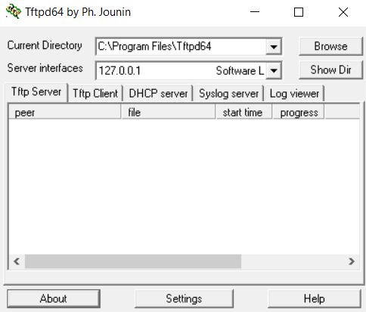
- Change the Current Directory to allow saving the file to the “Desktop”
- Choose the Server interface with the IP Address assigned to the LAN adapter of the PC
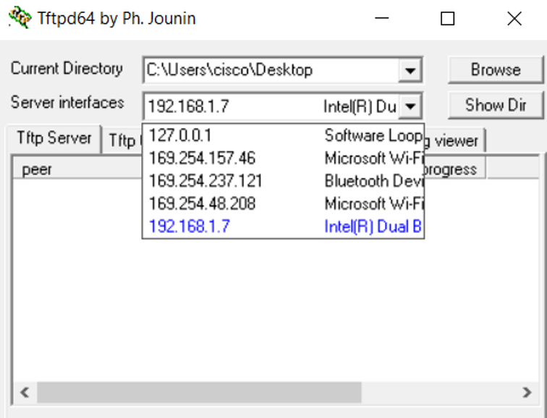

- Copy the Startup Configuration from the Router to the TFTP Server

Use the copy command to backup the startup configuration:
# copy <source> <destination>
# copy startup-config tftp:

- Address or name of the remote host - IP Address of the TFTP server

- Changing the name of the destination file is optional, press enter to use the default name
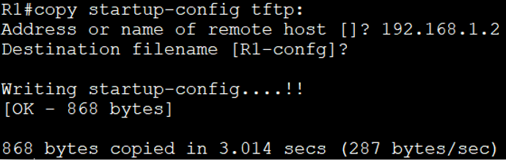

Step 2: Restore the Router’s Startup configuration to the PC

In order to restore the configuration on the TFTP server, first the existing startup configuration in the router must be removed followed by a reboot. IP connectivity between the Router and the PC hosting the TFTP server is essential for restoring the configuration. After removing the router’s startup configuration, repeat Task 3 to Task 6 to reinstate IP connectivity between the Router and the PC.

Commands to restore the configuration:

Sequence of steps | Option 1 | Option 2
1 | # copy tftp: startup-config | # copy tftp: running-config
2 | # copy startup-config running-config | # copy running-config startup-config

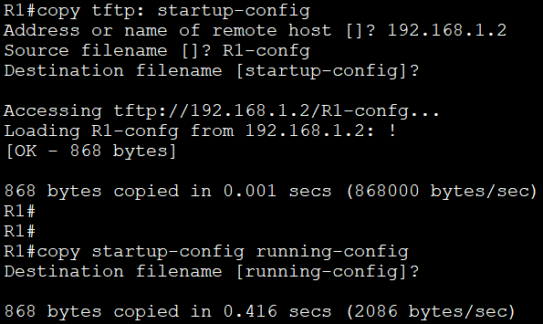 | 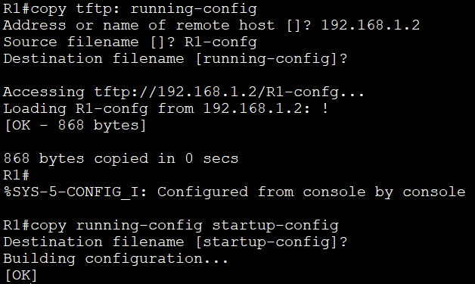

Lab Reflection

Answer the questions given below:
- What did you learn in this lab?

I got practice setting up a TFTP server on a PC and moving configuration files from the router to the server as well as back the other way.
I also learned that it is very important for the backup and restoration process to have reliable IP connectivity from the router to the TFTP server.
Finally, I re-emphasized that the use of configuration before changes and resets to start with clean testing conditions was very important.

- List the commands covered in this lab with a brief explanation of what they help to achieve?
backup startup-config tftp: - Backs up the startup configuration from the router onto the TFTP server.
copy running-config tftp: - Backs up the running configuration from the router to the TFTP-server.
copy tftp: startup-config-Gets the startup configuration from the TFTP server into the router.
erase startup-config - erases the startup-config present in NVRAM.
hide vlan.dat - Used to erase the VLAN database file (to be used on switches).
reload - reloads the router or switch.
show running-config - outputs the active configuration that is present in RAM
DSSH show startup-config: Generic command to display saved configuration located in NVRAM.

- What is TFTP an abbreviation for?
TFTP is an abbreviation for Trivial File Transfer Protocol.
It is a very simple protocol for transferring files such as configuration backups and IOS images between network devices and servers. TFTP on UDP port 69 is also unencrypted, which is very lightweight, but woefully insecure compared to FTP or SCP.

Lab 10 - Setup a small IPv6 network using a Switch and a Router

Aim
The aim of this lab is to help the learners to demonstrate the ability to perform IPv6 subnetting, implement the planned addressing scheme to design, and configure the network to support remote access via Telnet and SSH.

Tasks to be completed
Note: All usernames must be “admin” and passwords must be “cisco”

Design the Network Topology:
- Make the connections according to the topology given below
- Use appropriate Ethernet cables for the connections
Subnetting and Plan for IPv6 Addressing:
- Subnet the network 2001:1111:2222::/48 to /64
- Use the second sub-network for IP Addressing of the network_____________________________
- Assign the 3rd host IP the PC________________________________________________________
- Assign the 2nd host IP to the Router’s interface_________________________________________

PC Configuration Tasks:
- Assign the planned IPv6 Address and the Prefix……………………………………………Refer to Step 1 below
- Assign the appropriate Default Gateway………………………………………………………Refer to Step 1 below

Router Configuration Tasks:
- Disable DNS Lookups……………………………………………………………………………………..Refer to Lab 2, Step 5
- Secure access to the Privileged mode using a MD-5 encrypted password……..Refer to Lab 3, Step 4
- Enable IPv6 routing……………………………………………………………………………………….Refer to Step 2 below
- Assign the planned IP configuration to the Router’s interface……………………….Refer to Step 3 below
- Assign a Link-Local Address of FE80::1 to the Router’s interface……………………Refer to Step 4 below
- Enable the Router’s interface.……………………………………………………………………….Refer to Lab 5, Step 6
- Ensure reachability between the Router’s interface and the PC………………Refer to Lab 5, Step 7 & 8
- Configure the router to support remote access via Telnet and SSH…….………..Refer to Step 5 below
- Test Telnet and SSH………………………………………………………………Refer to Lab 5, Step 9 & Lab 8, Step 2
- Save the configuration………………………………………………………………………………….Refer to Lab 4, Step 5
Reset the devices to default configuration after completing the lab:
- Reset the Router and Switch configurations to default………………………………….Refer to Lab 4, Step 6
- Reset the LAN Adapter on the PC to Dynamic Addressing……………………………..Refer to Lab 5, Step 2
- Re-connect the White Ethernet cable to the PC…………………………………………….Refer to Lab 5, Step 2

Step 1: Assign the planned IPv6 Address, Prefix & Default Gateway to the PC
- Click on the Windows Icon.

- Go to the Network and Sharing Center.

- Click on Change Adapter Settings.

- Right Click on the LAN Adapter (Gigabit CT in the Cisco lab) and click on Properties.

- Select Internet Protocol Version 4 (TCP/IPv6) and click on Properties.
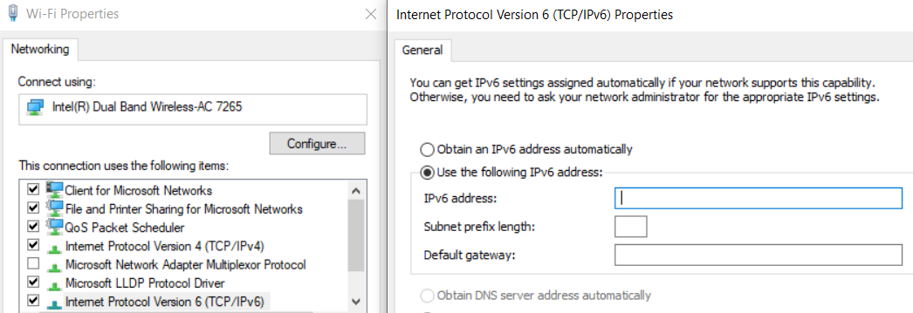
- Type the IPv6 address, Subnet prefix length & Default Gateway as per the planned scheme.

Step 2: Enable IPv6 Routing
IPv6 Routing is mostly disabled by default on Cisco routers. This is required for the routers to route IPv6 traffic from one network to another.
- Command used to enable IPv6 routing:
(config)# ipv6 unicast-routing

- The current scenario has only one IPv6 network, therefore, this command is not necessary here.

Step 3: Assign the planned IP configuration to the Router’s interface

The IPv6 Address assigned to the Router’s interface and the PC must be in the same network.

- Command used to go to the Interface mode:
(config)# interface <interface type> <interface number>
(config-if)#

In this scenario, the “interface type” is Gigabit Ethernet and the “interface number” is 0/1.

- Command used to assign the IP Address and the Subnet Mask:
(config-if)# ipv6 address <IPv6 address to be assigned/Prefix Length>

Step 4: Assign a Link-Local Address of FE80::1 to the Router’s interface
- All devices that support IPv6 addressing are automatically assigned an IPv6 Link-Local address.

- Link-Local addresses begin with “FE80”.

- Link-Local addresses allow communication between devices on the same network.

- Command to assign IPv6 Link-Local address to an interface: (config-if)# ipv6 address <IPv6 address to be assigned> link-local

Lab Reflection

Answer the questions given below:
- What did you learn in this lab?
This lab gave me a real hands-on feel for working with IPv6. I set up and tested IPv6 addresses on routers and PCs, sorted out subnetting, and made sure to use the right prefix lengths. I worked with link-local addresses so devices could talk to each other on the same network. I also set up remote access with Telnet and SSH, and got a handle on locking things down with encrypted connections. After running through all this, I feel much more comfortable with IPv6 setups, configuring router interfaces, and making sure everything connects smoothly from end to end.

- List the commands covered in this lab with a brief explanation of what they help to achieve?

ipv6 unicast-routing - Enables an router to router IPv6 this allows the router to forward IPv6 packets between interfaces.
Enter interface gigabitethernet 0/1: Placing the router into interface configuration mode for Gigabit Ethernet 0/1 on the router.
ipv6 address <IPv6 address>/<prefix length> - Apply a global unicast IPv6 address and prefix to the router interface.
IP address FE80::1 link-local - uses a link-local IP address which is manually applied to the router interface.
no shutdown -- Brings the interface of the router (enables the interface).
hostname <name> - Sets the hostname of the router (e.g. "R1" or "IPv6Router."
no ip domain-lookup - disables DNS resolution to avoid slowing down the commands that are based on hardware triggers
enable secret cisco -- Provides security at the Privileged EXEC mode using an MD5 encrypted password.
line vty 0 15 - Enters in VTY line configuration mode to allow remote (Telnet/SSH) access
password cisco -- Sets "cisco" for the login password of access to the VTY
login - Enables the function of password checking to VTY lines.
Telnet Input SSH - Allows both Telnet and SSH remote access protocols
username admin password cisco - Creates a local username (can be lexicographically blocked from being used as a host in router configurations) password cisco - Password for this local user IDE
ip domain-name wintec.local - Defines a domain name that is needed for key generation (SSH).
crypto key generate rsa - Generates the RSA encrypted keys for the SSH access.
show ipv6 interface brief - Shows IPv6 address and status information for all the interfaces.
ping <IPv6 address> - To test the connectivity on iov6.
copy running-config startup-config -- Saves the configuration on NVRAM
erase startup-config - Erases their saved configuration from NVRAM and resets the device

- How many bits is an IPv6 address made of?
An IPv6 address is 128 bits long, split into eight groups of 16 bits, and you’ll see it written in hexadecimal. That’s a huge upgrade from IPv4’s 32-bit system. With 128 bits, IPv6 can handle about 3.4×10³⁸ unique addresses, so there’s plenty of room for all the new devices joining the Internet now and in the future.

- What is the benefit of using an IPv6 Link-Local addresses?

An IPv6 Link-Local address lets devices on the same local network talk to each other right away—no need for a global IPv6 address or a router. Every IPv6-enabled device gets one of these addresses automatically. They handle important stuff like finding other devices nearby, setting up addresses, and managing basic routing. Link-local addresses make local connections smoother and help a lot when you’re setting up a network or trying to fix something that’s not working.

Feedback

Well done! You've reached the end of the lab sessions. We hope you have enjoyed your time working on the lab gear and found the learning valuable.
Please give us some feedback on this workbook and the lab sessions.

- What did you like the most about this workbook and the lab sessions?
What I loved about this workbook was how it walked me through everything, step by step. The explanations made networking concepts actually click for me. The labs? Super practical. I got to mess around with real-world setups—routers, switches, PCs—all talking to each other. And the best part? Each lab built on the last one, so things just made sense as I went along. Learning felt natural, not overwhelming.

- Did you find any errors in this workbook and/or is there anything you would like to change?
The workbook’s layout made sense, and the instructions were spot on. Still, some commands need clearer examples or maybe a few more screenshots, especially for people just starting out. And honestly, a quick summary or a checklist at the end of each lab would really help make sure everything’s set up the right way

- Was there anything you felt the tutor did really well / could improve on?
The tutor broke down the labs in a way that actually made sense. You always knew why you were doing something, not just how. The demos were straightforward, too—easy to keep up with. To make things even better, adding quick recap sessions or a few quizzes after each big topic would really help the material stick

- Are there any additional notes you'd like to add?
These lab sessions really boosted my confidence with networking and configuration. I can handle Cisco IOS commands and subnetting on my own now, which feels great. Honestly, I appreciate all the work that went into setting this up. I’d recommend these sessions to anyone who wants to learn.

