COMP615 Assessment 2
Azure Cloud Solution Evidence Portfolio — KeteMart
Learner: Tirth Kaileshkumar Patel
Student ID:
Date:
A small number of items in this portfolio were not fully completed before the Azure for Students credit allowance was exhausted. Each affected section includes an honest note explaining what was configured, what evidence could not be captured, and why — rather than leaving the section blank or overstating what was achieved.

1. Solution Design

1.1 Architecture Diagram
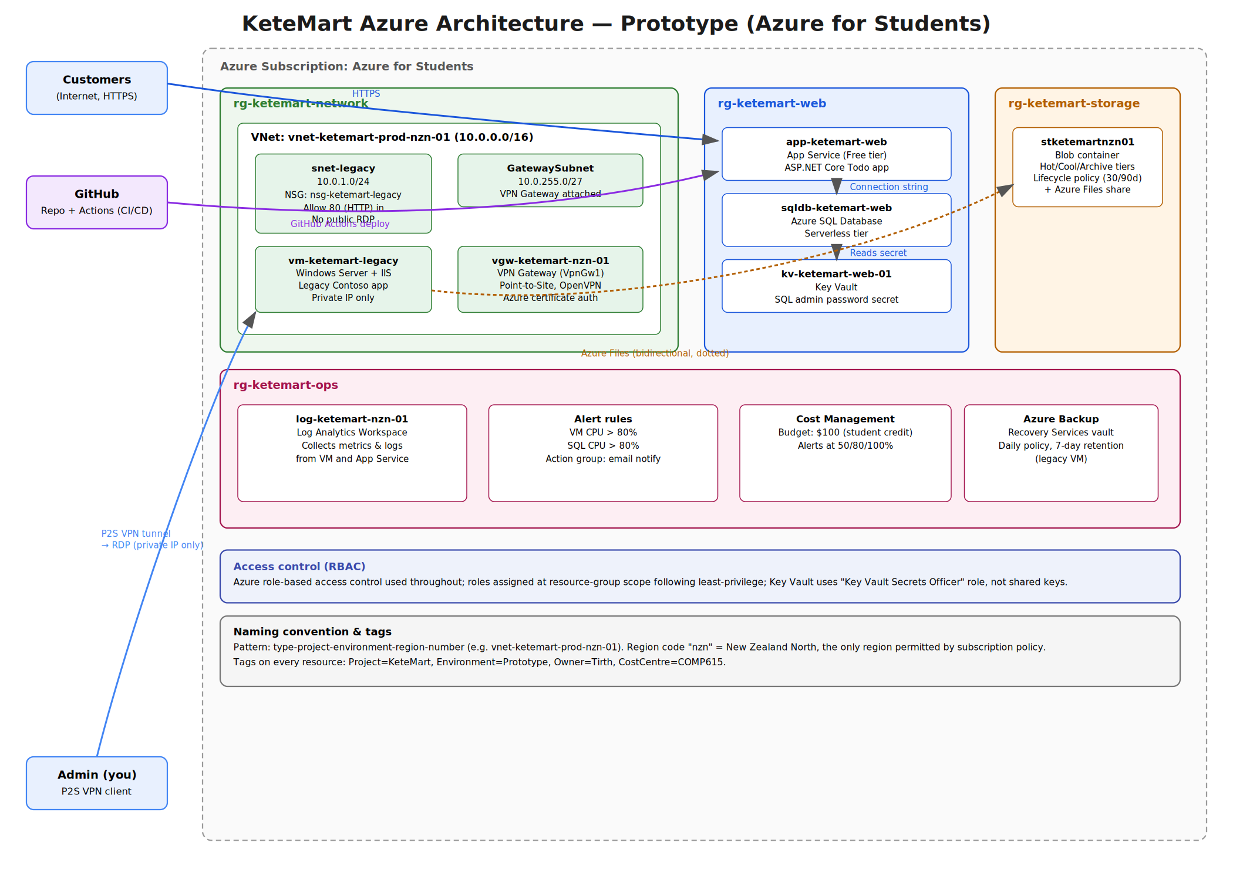
Figure 1: KeteMart Azure architecture — prototype deployment on Azure for Students.

Architecture explanation
This solution hosts KeteMart's customer-facing web application on Azure App Service, backed by Azure SQL Database, with the database credential stored in Key Vault rather than in application code. The legacy Windows application runs on a Server 2022 VM inside a dedicated subnet, reachable for administration only through a Point-to-Site VPN — no direct public RDP is exposed. All resources sit inside a single virtual network (10.0.0.0/16) split into a workload subnet and a gateway subnet, protected by a Network Security Group. Documents are stored in Blob Storage with lifecycle rules that move infrequently accessed data from Hot to Cool to Archive tiers automatically. Azure Monitor and Log Analytics collect metrics from the VM and database, with alert rules watching CPU usage on both. Resources are organised into five resource groups by function (network, web, legacy, storage, ops), consistently tagged, and constrained to the New Zealand North region by subscription policy. A monthly budget with alerts protects the Azure for Students credit.

1.2 Design Decisions
Azure service | Purpose | KeteMart requirement | Why selected
App Service | Hosts the customer-facing web app | Public online store, always available | Managed platform, no server patching, built-in HTTPS, free tier fits a prototype
Azure SQL Database | Stores application data (orders/customer data) | Reliable relational data for the customer app | Fully managed, serverless tier scales to near-zero cost when idle
Key Vault | Stores the SQL admin credential as a secret | Keep secrets out of code/config | Centralised, access-controlled secret storage; avoids hardcoded passwords
Virtual Network + NSG | Isolates and filters traffic to the VM and gateway subnets | Separate legacy system from the open internet | Subnet-level segmentation with explicit allow rules (HTTP only), default-deny otherwise
VPN Gateway (P2S) | Secure remote access to the legacy VM | Admin access without exposing RDP publicly | Point-to-Site avoids opening port 3389 to the internet
Storage Account (Blob + Files) | Document storage and VM file sharing | Document retention with cost-efficient tiering | Native lifecycle management between Hot/Cool/Archive tiers
Log Analytics + Alerts | Central monitoring and proactive notification | Operational visibility | Collects metrics from VM and SQL, alerts on resource pressure
Azure Backup | Scheduled VM backup | Disaster recovery for the legacy system | Daily policy with retention, protects against VM failure/corruption

Production vs prototype
Prototype | Recommended production | Reason
App Service Free (F1) tier | Standard/Premium tier with autoscale | Free tier has CPU/bandwidth limits unsuitable for real customer traffic
SQL Serverless, single region | SQL with geo-replication / failover group | Production needs resilience against regional outage
Single VM, no redundancy | VM Scale Set or availability zone redundancy | Avoids single point of failure for the legacy system
LRS storage redundancy | GRS or ZRS storage redundancy | Protects documents against datacentre-level failure
Manual budget alerts only | Full cost governance (Azure Policy spending limits, reserved instances) | Production needs stronger cost controls at scale

2. Infrastructure Deployment

2.1 Customer Web Application

Technical explanation
The customer application is deployed as an ASP.NET Core app running on Azure App Service, which uses a connection string stored in App Service's application settings to communicate with Azure SQL Database. Deployment is automatic: when code is pushed to the starter-no-infra branch of the GitHub repository, a GitHub Actions workflow is triggered to build and publish the app directly to App Service. The database schema was generated by running an Entity Framework Core migration against the live Azure SQL instance.

Evidence A — Working web application
Required: the deployed application; the application URL/hostname; enough information to identify the deployed application is working.
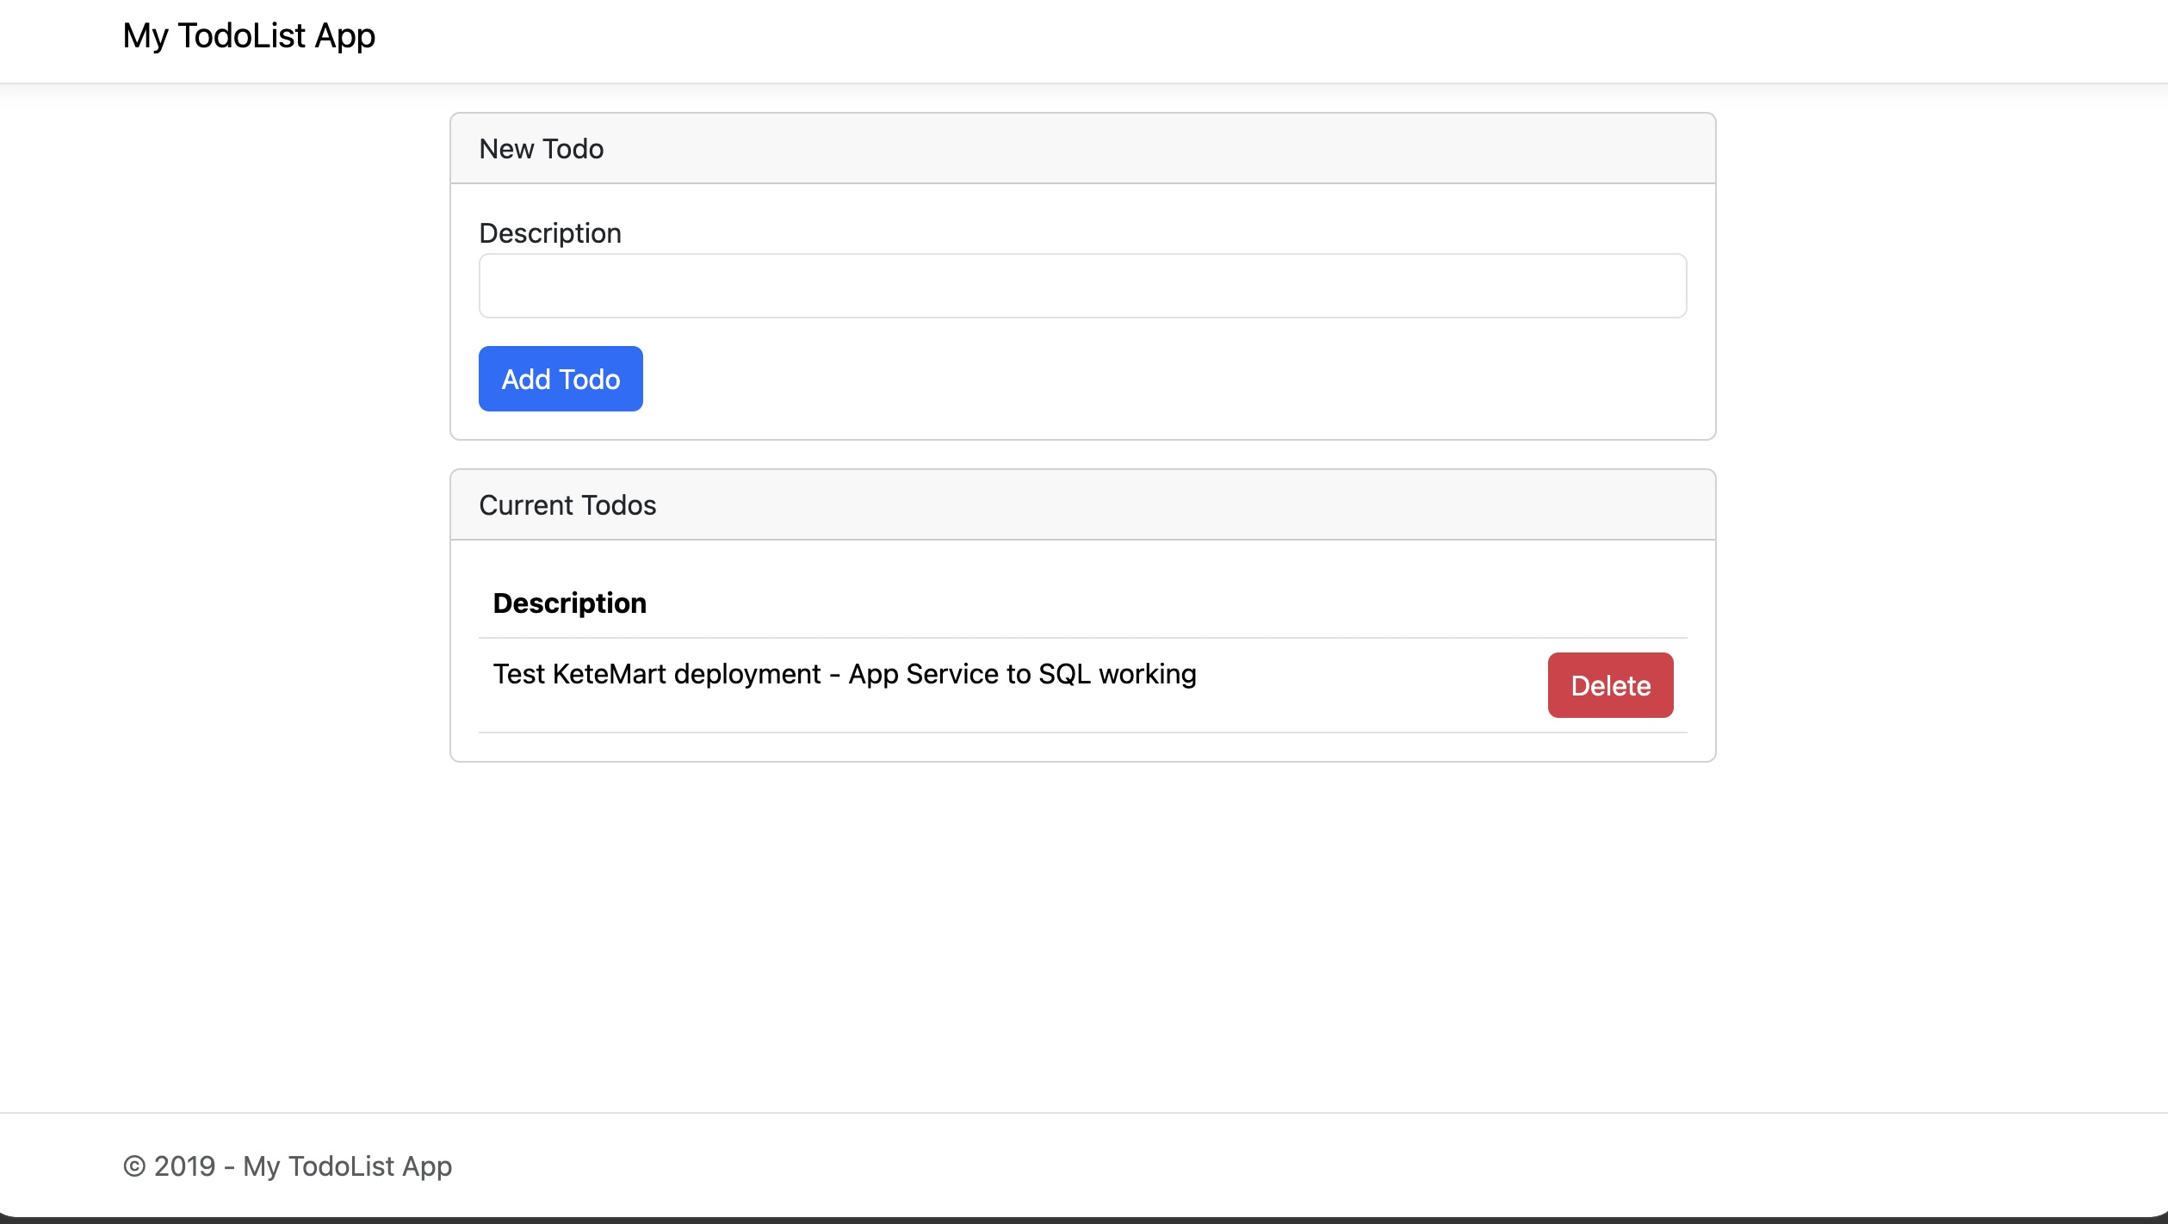
Figure 2: KeteMart Todo application running live, with a saved record confirming database connectivity.
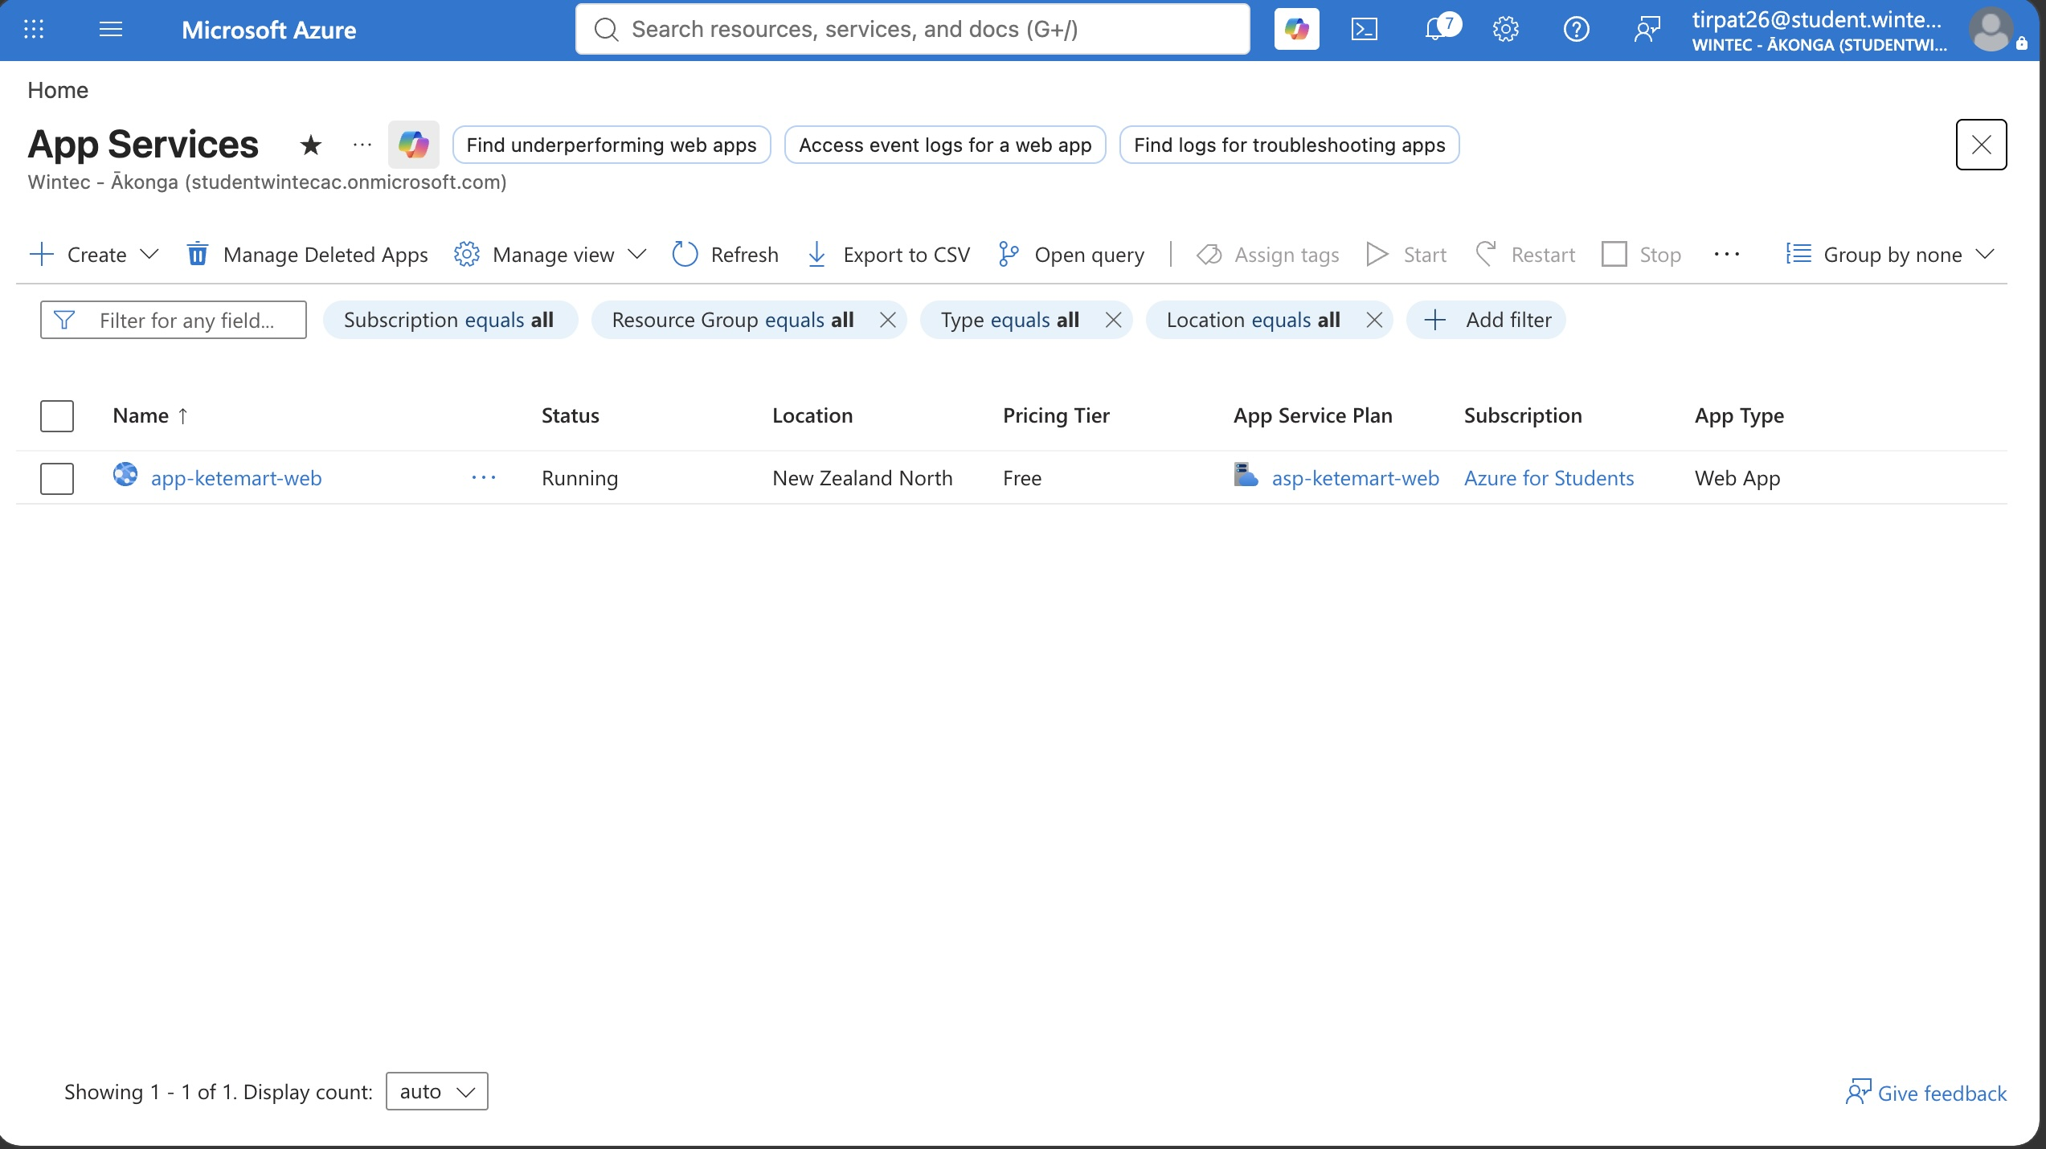
Figure 3: App Service overview showing app-ketemart-web in a Running state in New Zealand North.
What does this evidence demonstrate?
This confirms the deployed application is reachable over HTTPS at its public App Service URL and renders correctly in a browser, with no server errors.

Evidence B — Azure SQL
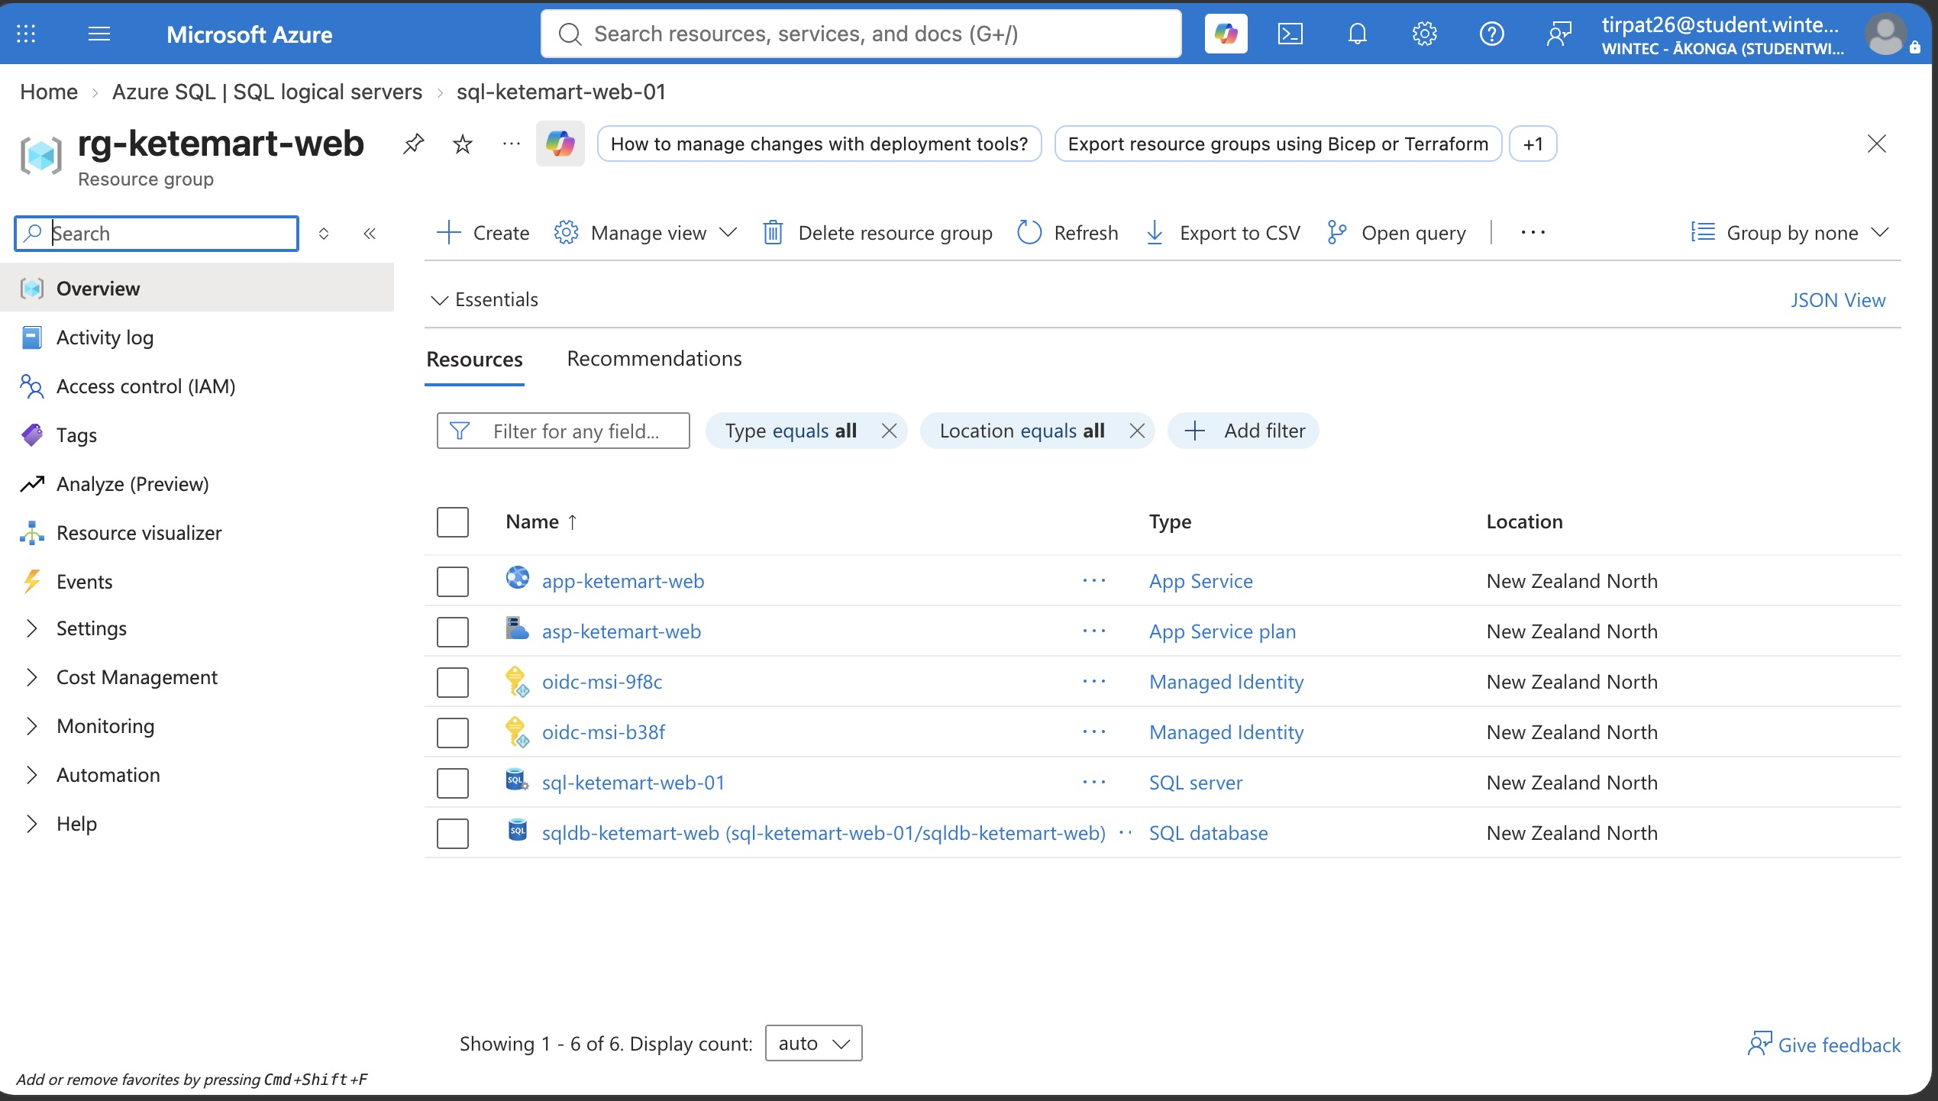
Figure 4: Azure SQL logical server (sql-ketemart-web-01) in New Zealand North.
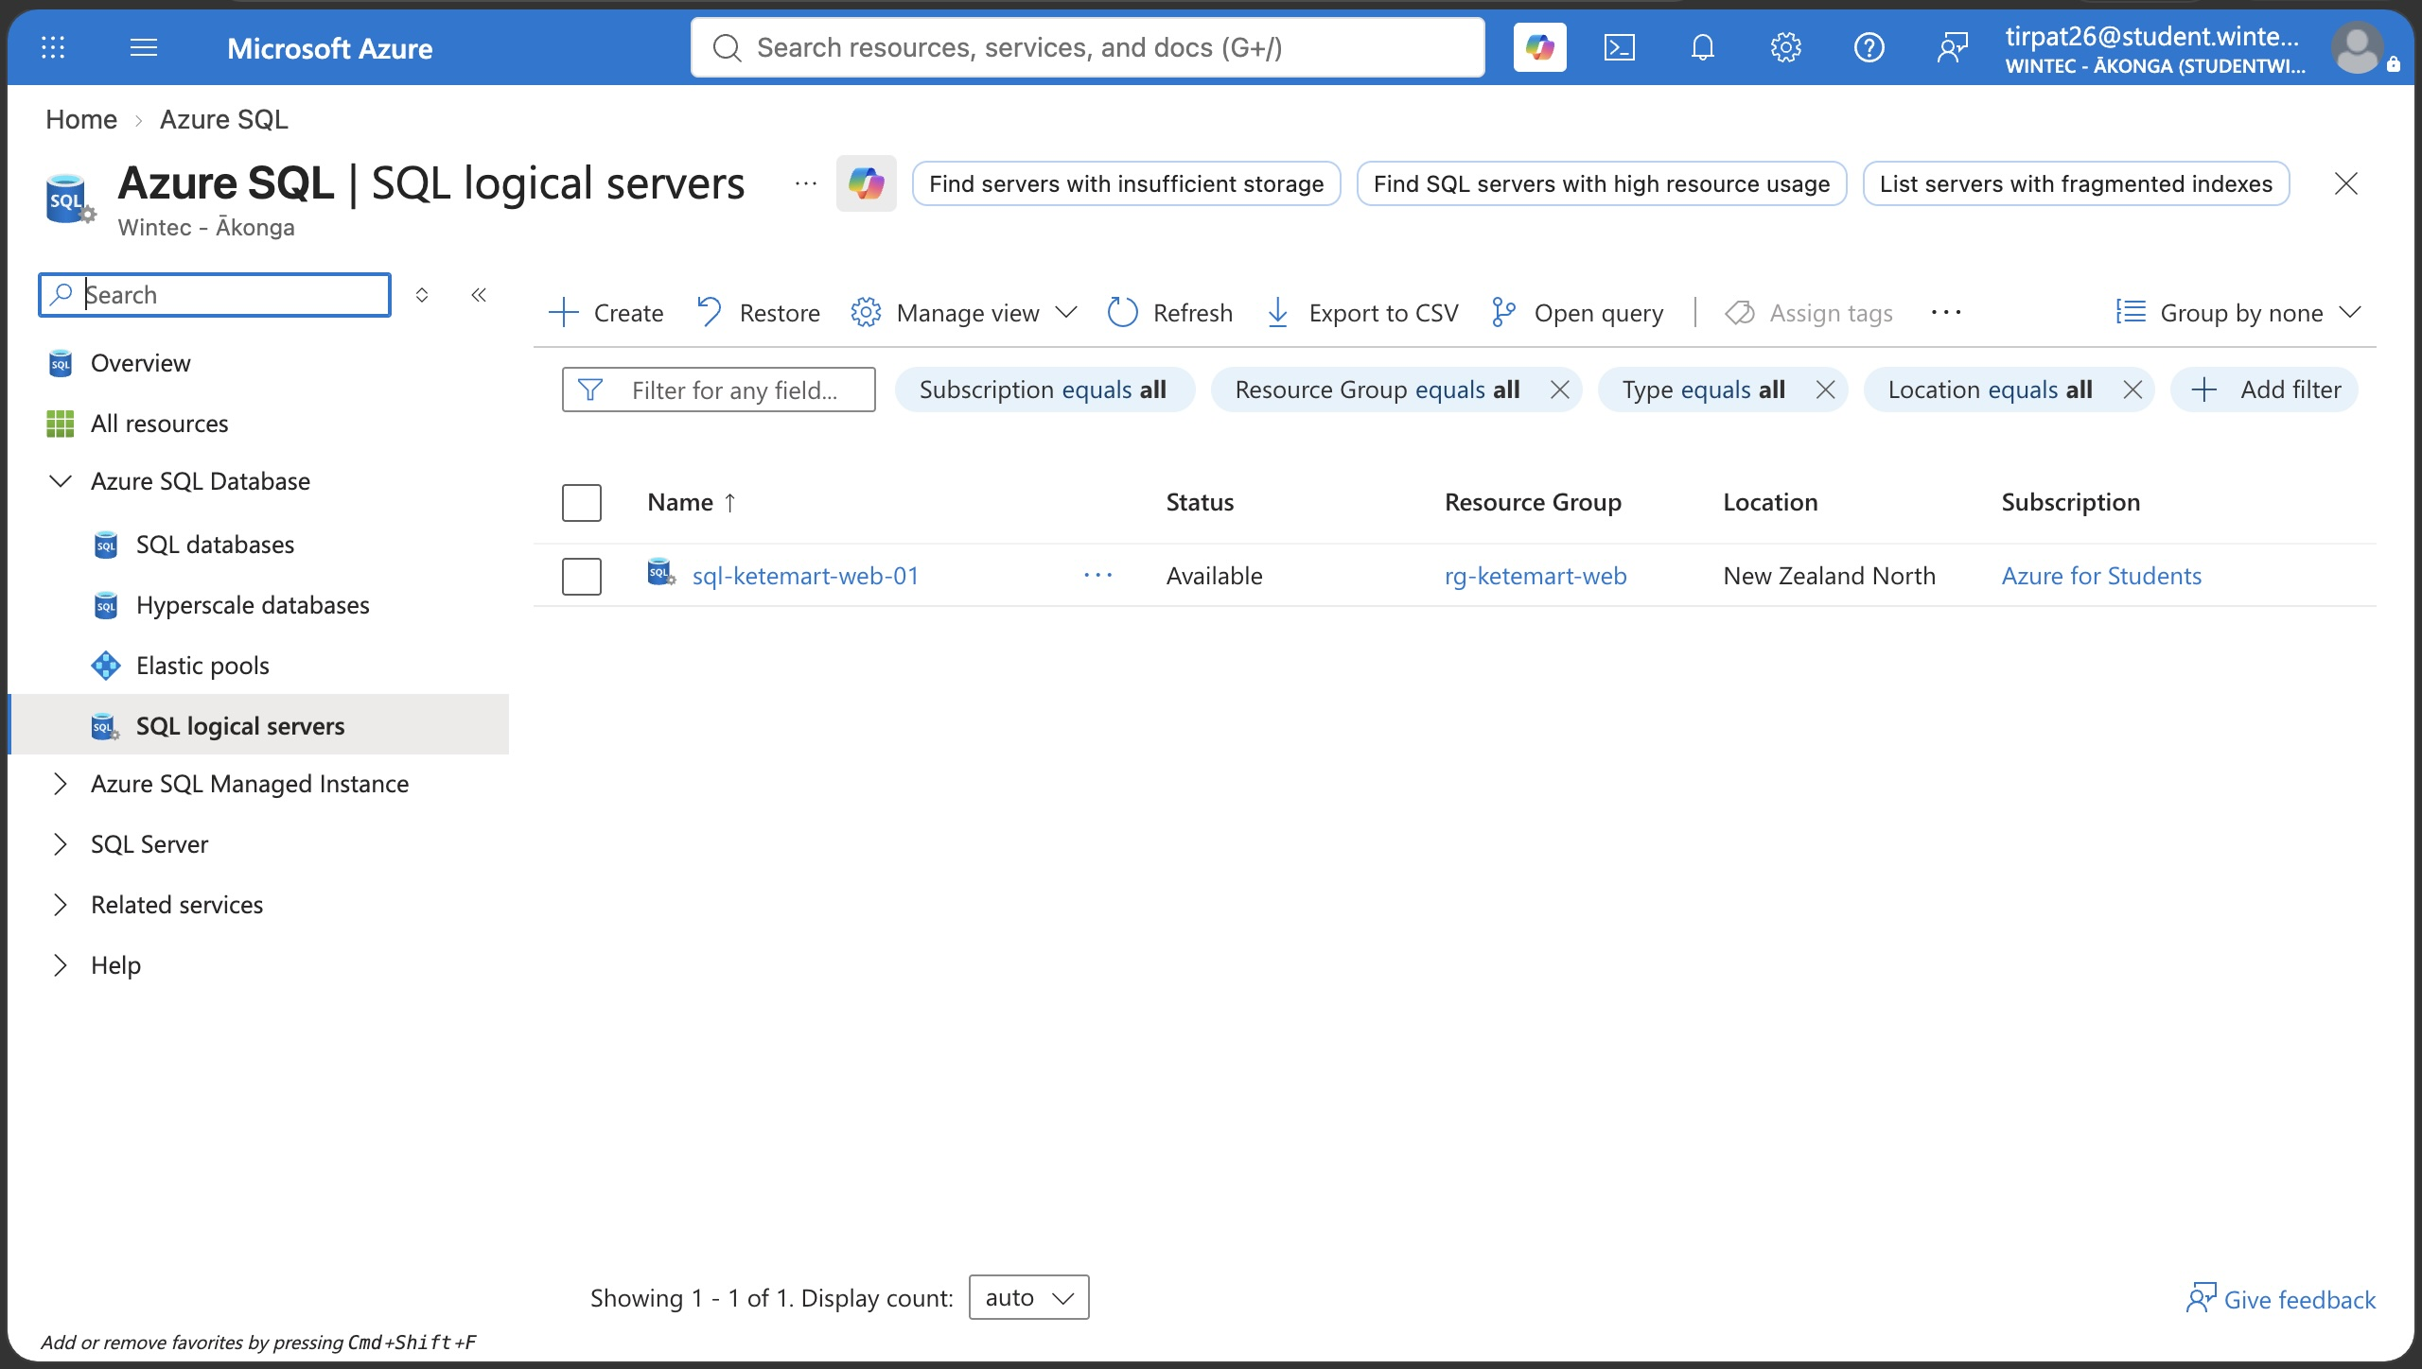
Figure 5: Resources in rg-ketemart-web, including the SQL server and database.
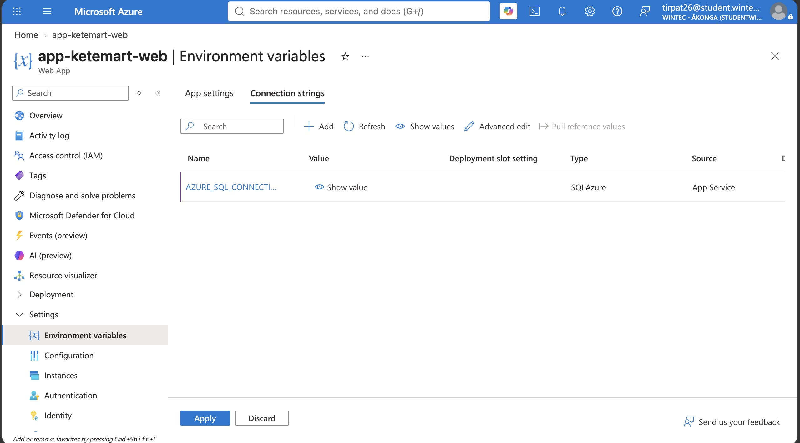
Figure 6: App Service connection string configured (value hidden, type SQLAzure).
What does this evidence demonstrate?
This shows an Azure SQL Database (sqldb-ketemart-web) is provisioned on the server sql-ketemart-web-01 in New Zealand North, and that the web app writes to and reads from it — the Todo item persists after being added via the live application, confirming the connection string and firewall configuration are both correct.

Evidence C — Key Vault
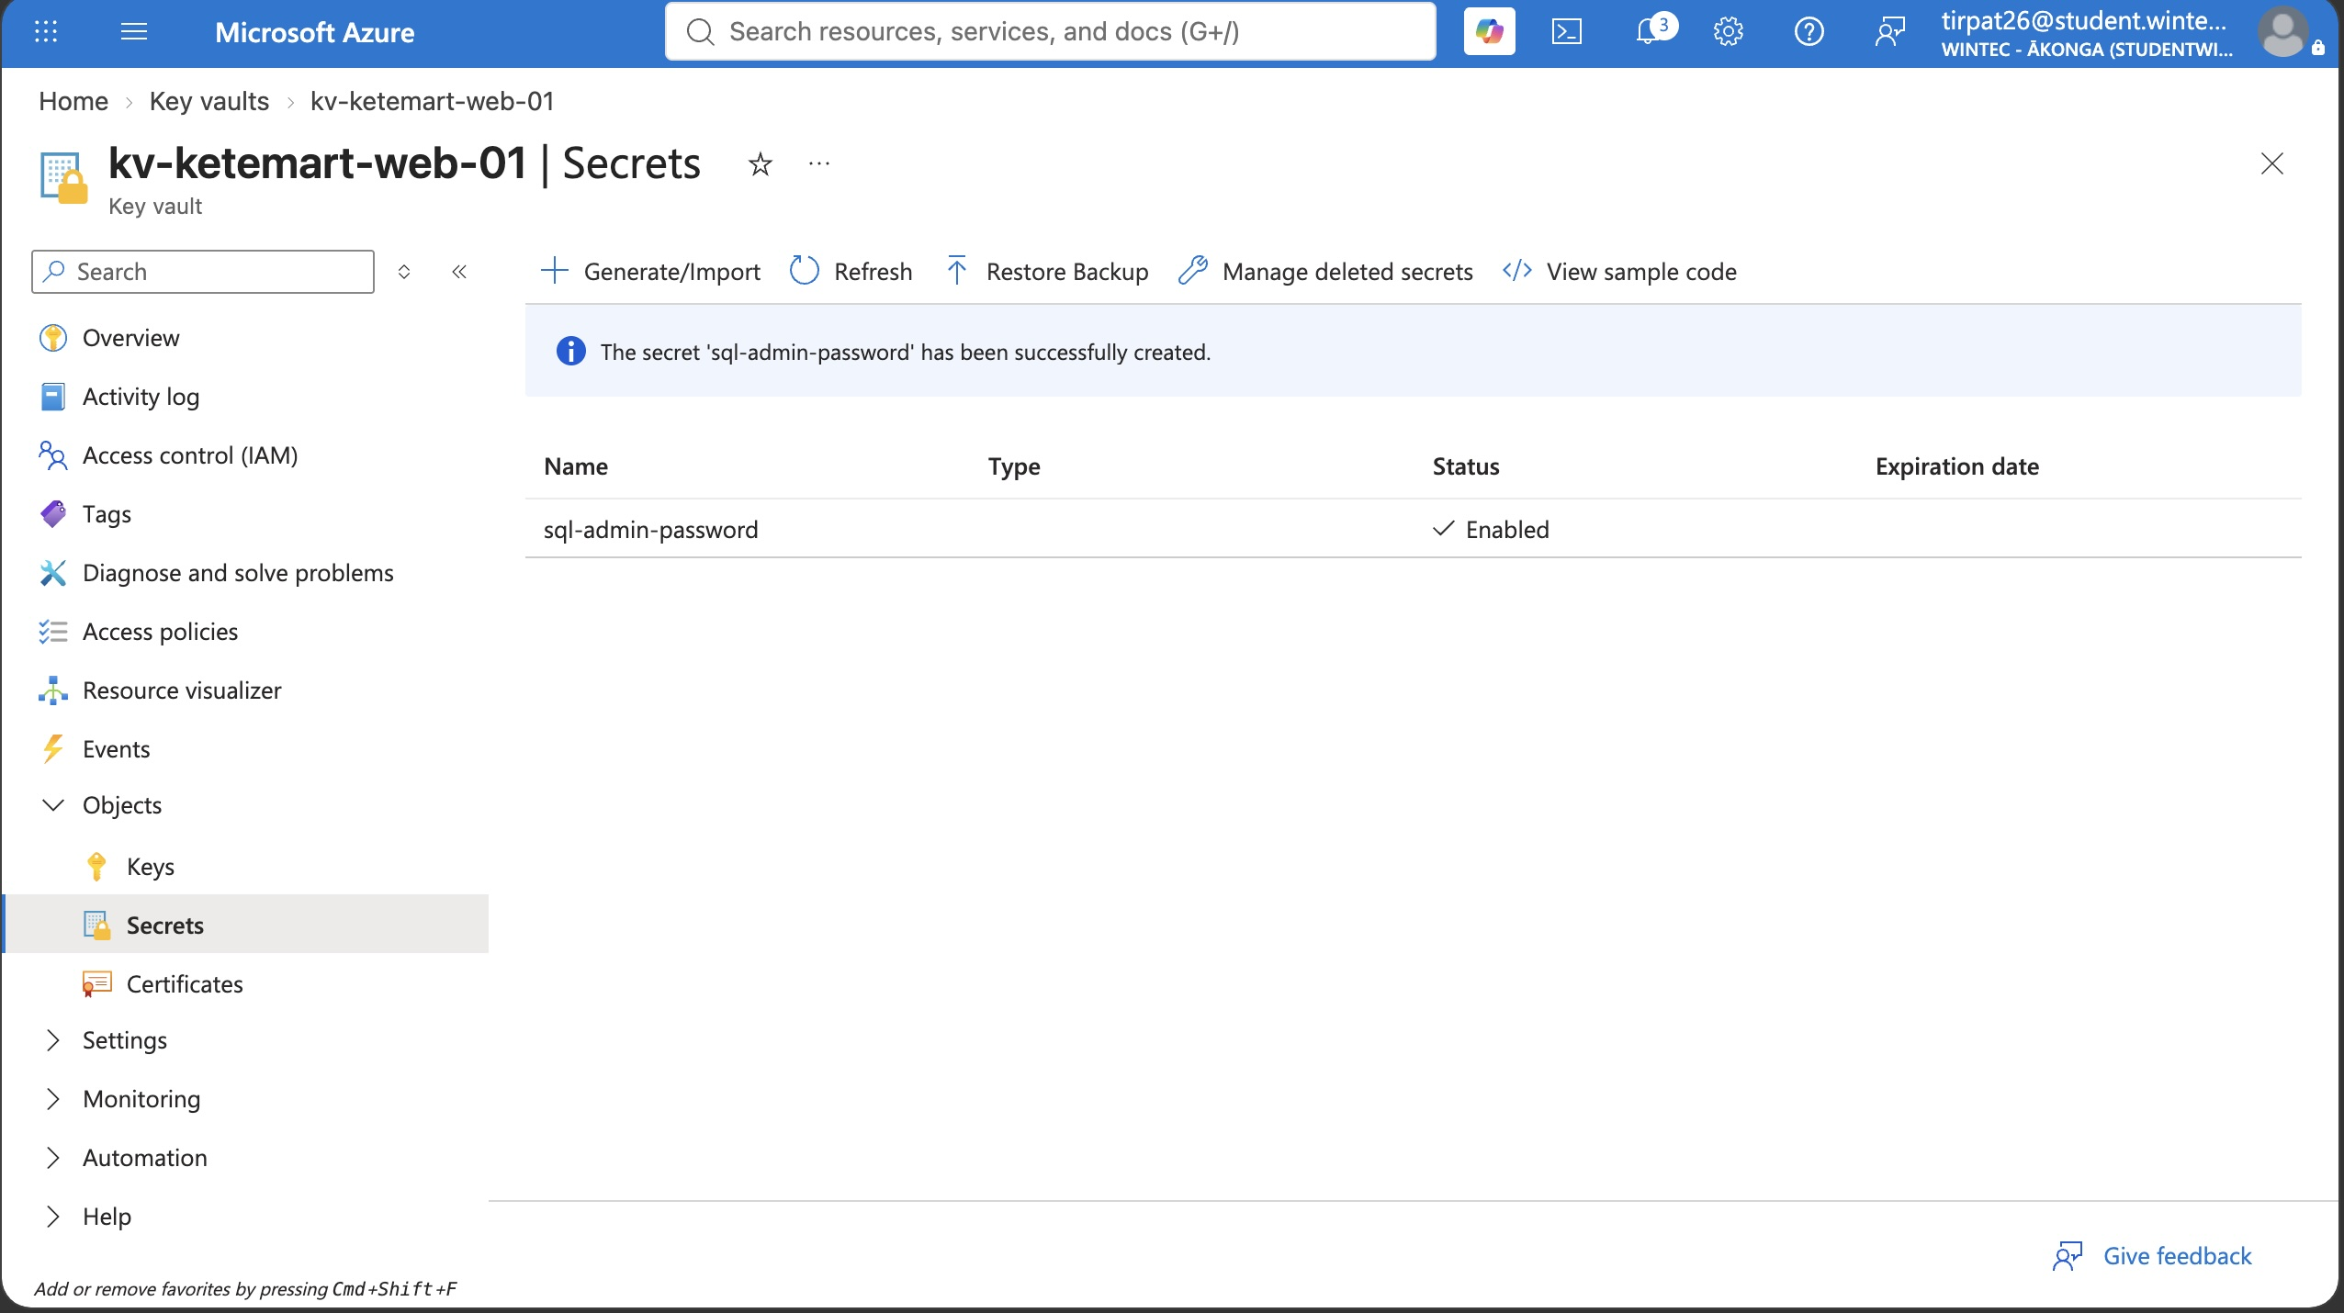
Figure 7: Key Vault secret sql-admin-password, shown Enabled with no value exposed.
What does this evidence demonstrate?
This shows the Key Vault contains a secret (sql-admin-password) in an Enabled state. Only the secret's name and status are displayed, never its value, meeting the requirement to store the database credential securely rather than in application code.

Evidence D — CI/CD deployment
☐ The application before the change
☐ The change that was made
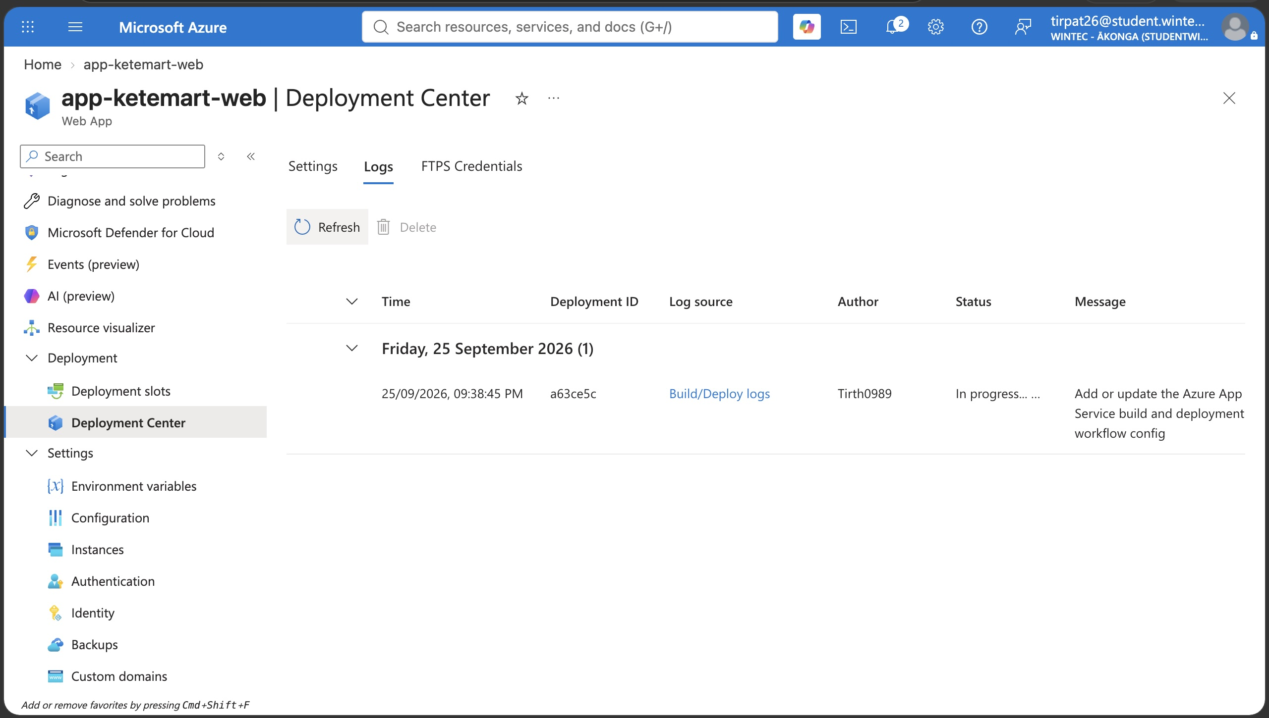
Figure 8: GitHub Actions deployment triggered from a commit to the connected repository.
☐ A successful automated pipeline/deployment
☐ The updated application after deployment
The CI/CD pipeline itself was configured and triggered successfully (shown above — a GitHub Actions build and publish to App Service, triggered automatically by a commit). A second, deliberate code change intended to show a clear before/after comparison was planned but could not be completed before the Azure for Students subscription credit was exhausted, so the full before/during/after sequence could not be captured.
Briefly explain what happened during this deployment.
A commit was pushed to the starter-no-infra branch of the GitHub repository, which triggered the GitHub Actions workflow configured in App Service's Deployment Center. The pipeline built the ASP.NET Core application and published it to app-ketemart-web automatically, with no manual deployment step, confirming the CI/CD pipeline works end-to-end.

2.2 Legacy Application

Technical explanation
The legacy application was planned to run on a Windows Server 2022 virtual machine (vm-ketemart-legacy-nzn-01), provisioned inside the snet-legacy subnet with no public inbound access other than HTTP, as described in Section 3.1. The intended configuration was to install IIS on the VM via Remote Desktop, deploy the Contoso University sample application, and make it reachable through the subnet's NSG rule for port 80.

Evidence A — Windows Server and IIS
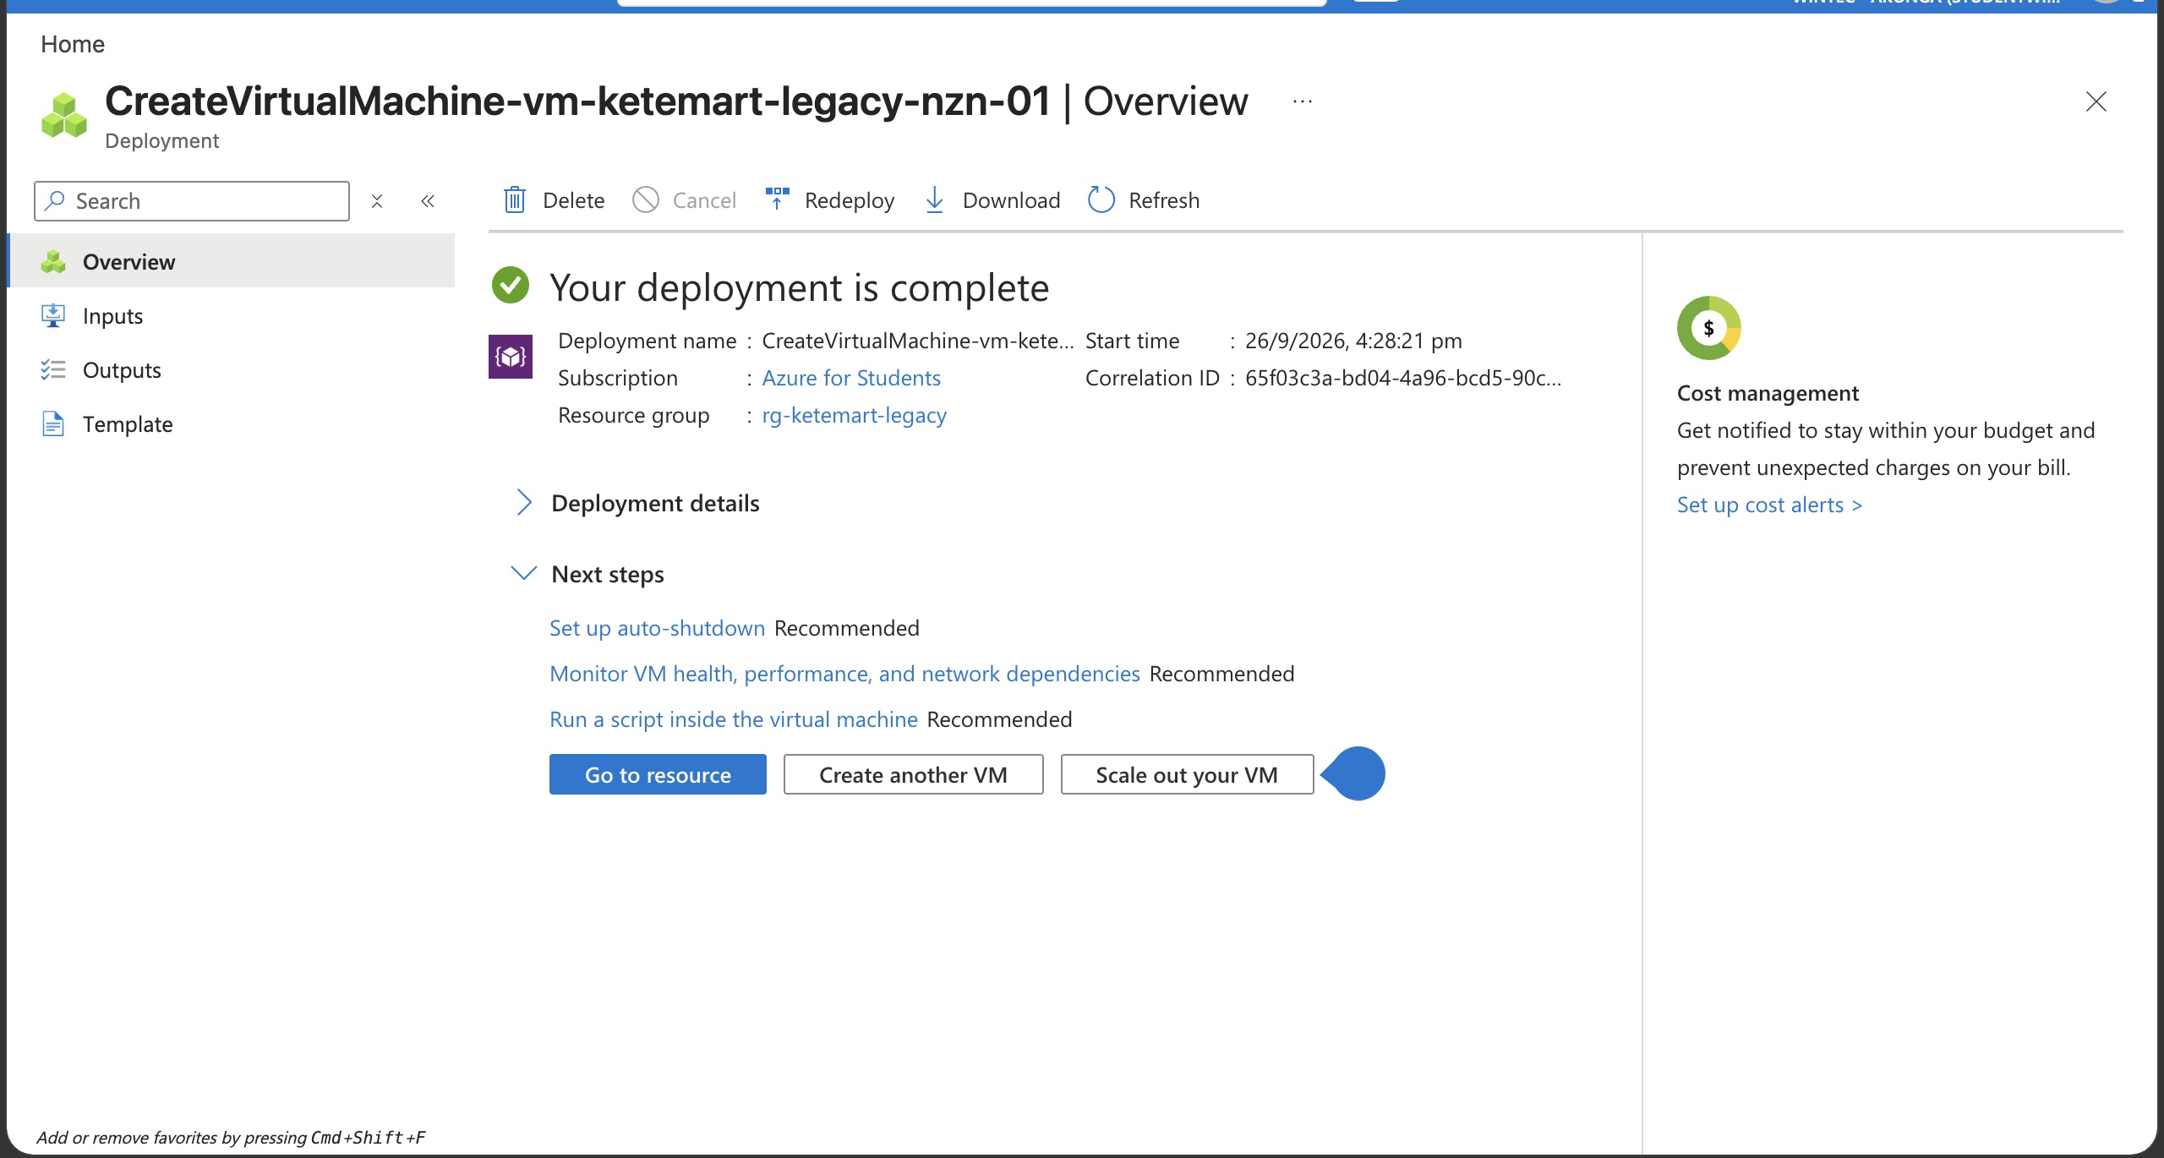
Figure 9: Virtual machine vm-ketemart-legacy-nzn-01 created and deployed successfully.
The virtual machine itself was successfully created, as shown above. However, IIS installation and configuration were not completed before the Azure for Students credit was exhausted. Remote Desktop access to the VM required either a temporary public rule (since removed — see Section 3.2) or a working Point-to-Site VPN connection, and the certificate configuration for the VPN connection could not be finished in time to complete this work.
What does this evidence demonstrate?
This confirms the virtual machine was provisioned successfully in the correct resource group, region, and subnet. IIS installation and role configuration were not reached.

Evidence B — Working application
[ Not completed — see note above. The legacy application was not deployed before the subscription credit was exhausted. ]
What does this evidence demonstrate?
Not applicable — this evidence could not be captured.

Evidence C — Azure Files
☐ The Azure virtual machine
☐ Your local computer
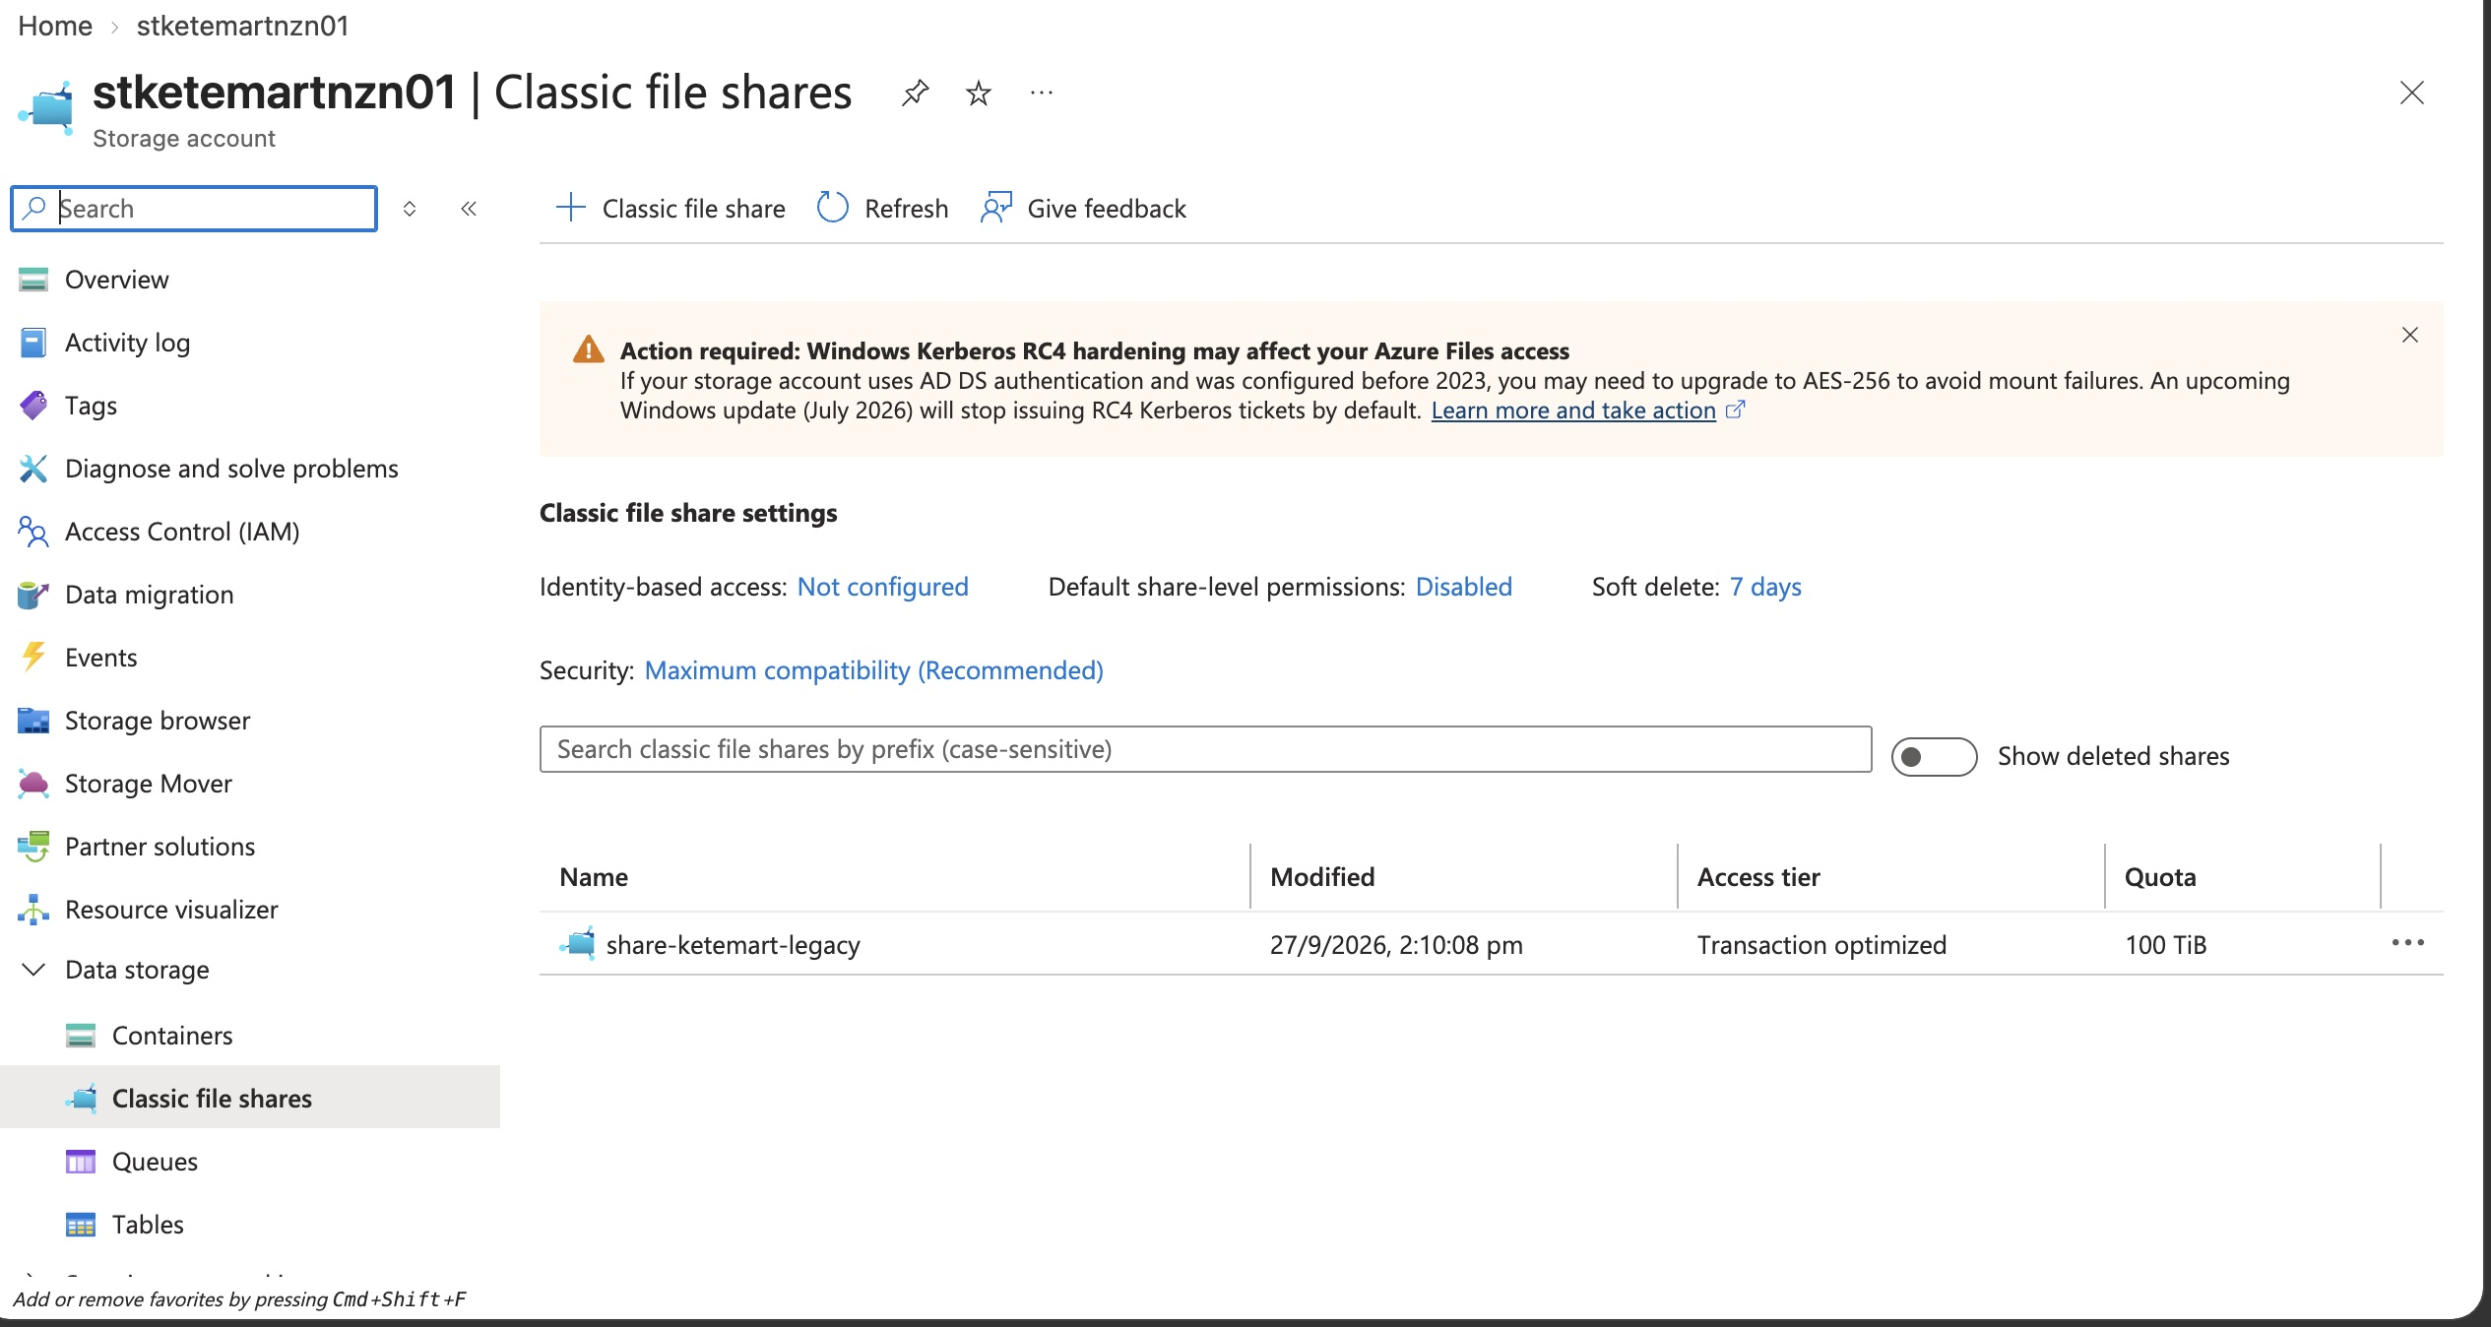
Figure 10: Azure Files share share-ketemart-legacy created in the storage account.
The Azure Files share itself was successfully created, as shown above. Bidirectional read/write access — writing a file from the VM and confirming it is visible locally, and vice versa — was not demonstrated, as this step depended on a working VPN or RDP session to the VM, which was not achieved before the credit was exhausted.
Explain how your evidence demonstrates bidirectional access.
It does not. Only the creation of the file share is evidenced here; bidirectional access was planned but not completed.

2.3 Infrastructure as Code

Technical explanation
A Bicep template was authored to deploy the core networking layer of this solution — the virtual network, both subnets, and the Network Security Group with its inbound HTTP rule — matching the configuration manually built and evidenced in Section 3.1. Deploying this template would reproduce vnet-ketemart-prod-nzn-01 and nsg-ketemart-legacy-nzn-01 from a single, version-controlled source rather than manual portal steps.

Bicep evidence
☑ Your Bicep template
☐ Successful deployment
☐ The Azure resources created by the deployment
[ Insert a screenshot of main.bicep here — see the accompanying main.bicep file provided alongside this document. ]
The Bicep template (provided as a separate file, main.bicep) was written and validated locally, but a live deployment to Azure could not be run or evidenced, as the subscription credit was exhausted before this step.

Manual configuration
If deployed, the template would still require manual post-deployment steps: creating the VPN Gateway's Point-to-Site certificate configuration, deploying the virtual machine and installing IIS, and configuring the storage account's lifecycle rules — none of which are included in the template's current scope.

2.4 Resource Organisation and Governance

Resource Groups
Resources are divided into five resource groups by function: rg-ketemart-network (VNet, NSG, VPN Gateway), rg-ketemart-web (App Service, SQL, Key Vault), rg-ketemart-legacy (the Windows VM), rg-ketemart-storage (the storage account), and rg-ketemart-ops (Log Analytics, alerts, backup vault). This separation makes it possible to manage, cost-track, and tear down each functional area independently without affecting the others.
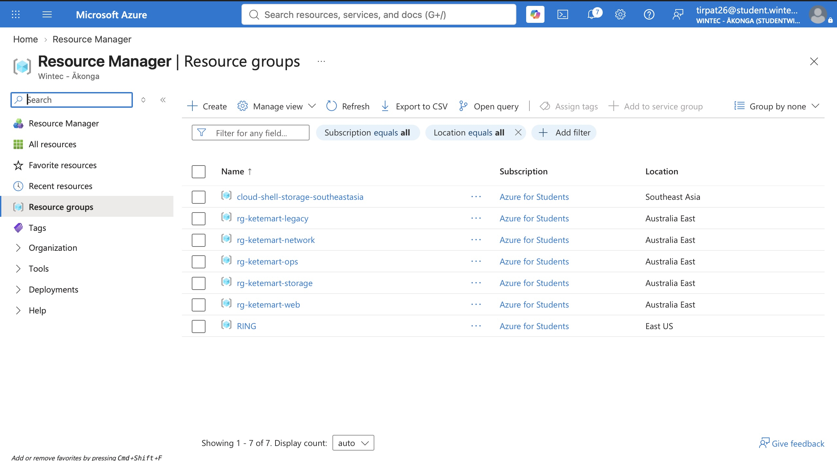
Figure 11: All five KeteMart resource groups, correctly named and located.

Naming convention
Resource type | Example name | Naming rule
Resource group | rg-ketemart-web | rg-{project}-{function}
Virtual network | vnet-ketemart-prod-nzn-01 | vnet-{project}-{environment}-{region}-{instance}
Virtual machine | vm-ketemart-legacy-nzn-01 | vm-{project}-{purpose}-{region}-{instance}
Storage account | stketemartnzn01 | st{project}{region}{instance} (no hyphens, per Azure storage naming rules)

Resource tags
Tag | Example value | Purpose
Project | KeteMart | Groups all resources under this engagement for cost reporting
Environment | Prototype | Distinguishes this build from a future production deployment
Owner | Tirth | Identifies who is accountable for the resource
CostCentre | COMP615 | Links spend back to this assessment for tracking
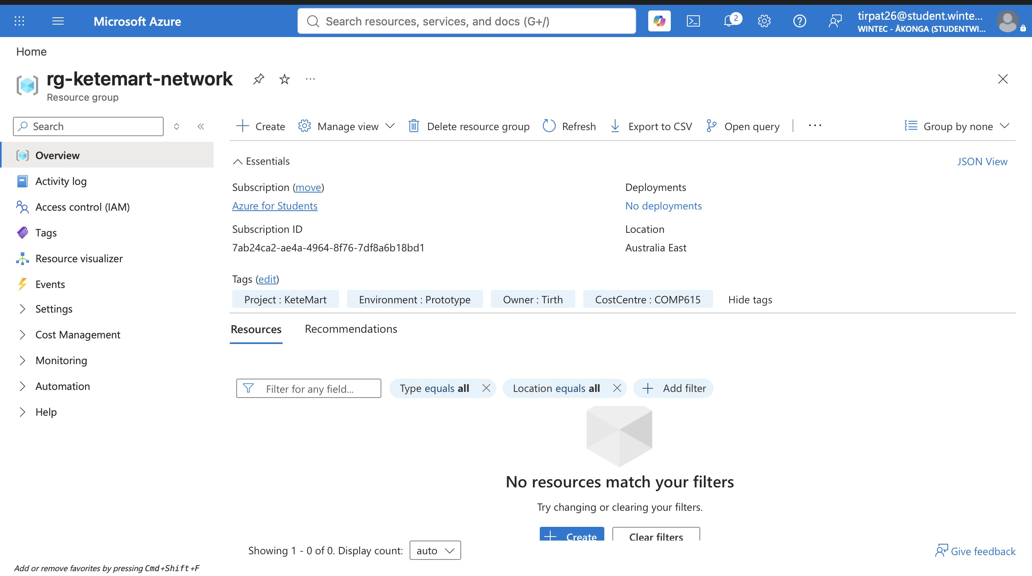
Figure 12: Tags applied to rg-ketemart-network, consistent across every resource.

3. Networking and Security

3.1 Secure Networking

Technical explanation
The network consists of a single VNet (10.0.0.0/16) with two subnets: snet-legacy (10.0.1.0/24) for the VM, and a dedicated GatewaySubnet (10.0.255.0/27) for the VPN Gateway. A Network Security Group is associated with snet-legacy that permits only inbound HTTP (port 80) traffic from any source; all other inbound traffic is denied by the default DenyAllInBound rule. This means the web application running on the VM is reachable, but no other service — including RDP — is exposed to the internet.

Evidence
☑ Virtual Network
☑ Subnets
☑ Network Security Groups
☐ Service Endpoint(s) where appropriate
☑ Point-to-Site VPN
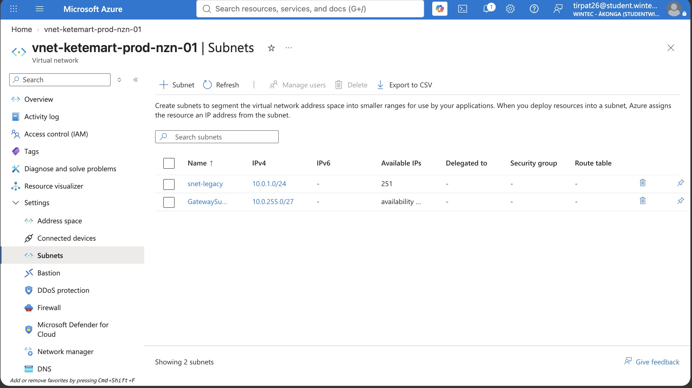
Figure 13: VNet vnet-ketemart-prod-nzn-01 with snet-legacy and GatewaySubnet.
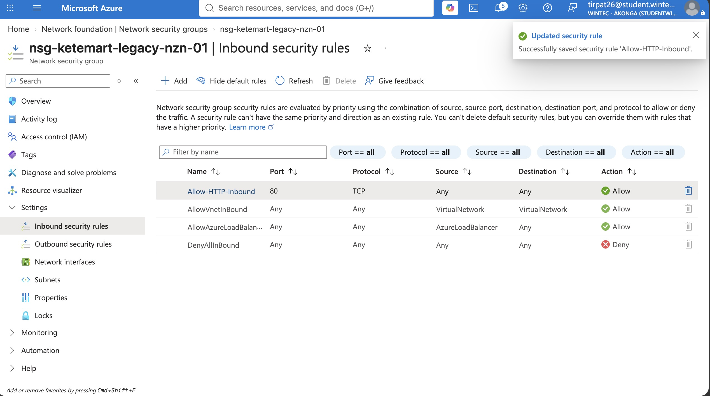
Figure 14: NSG inbound rules — HTTP allowed, all other inbound traffic denied by default.
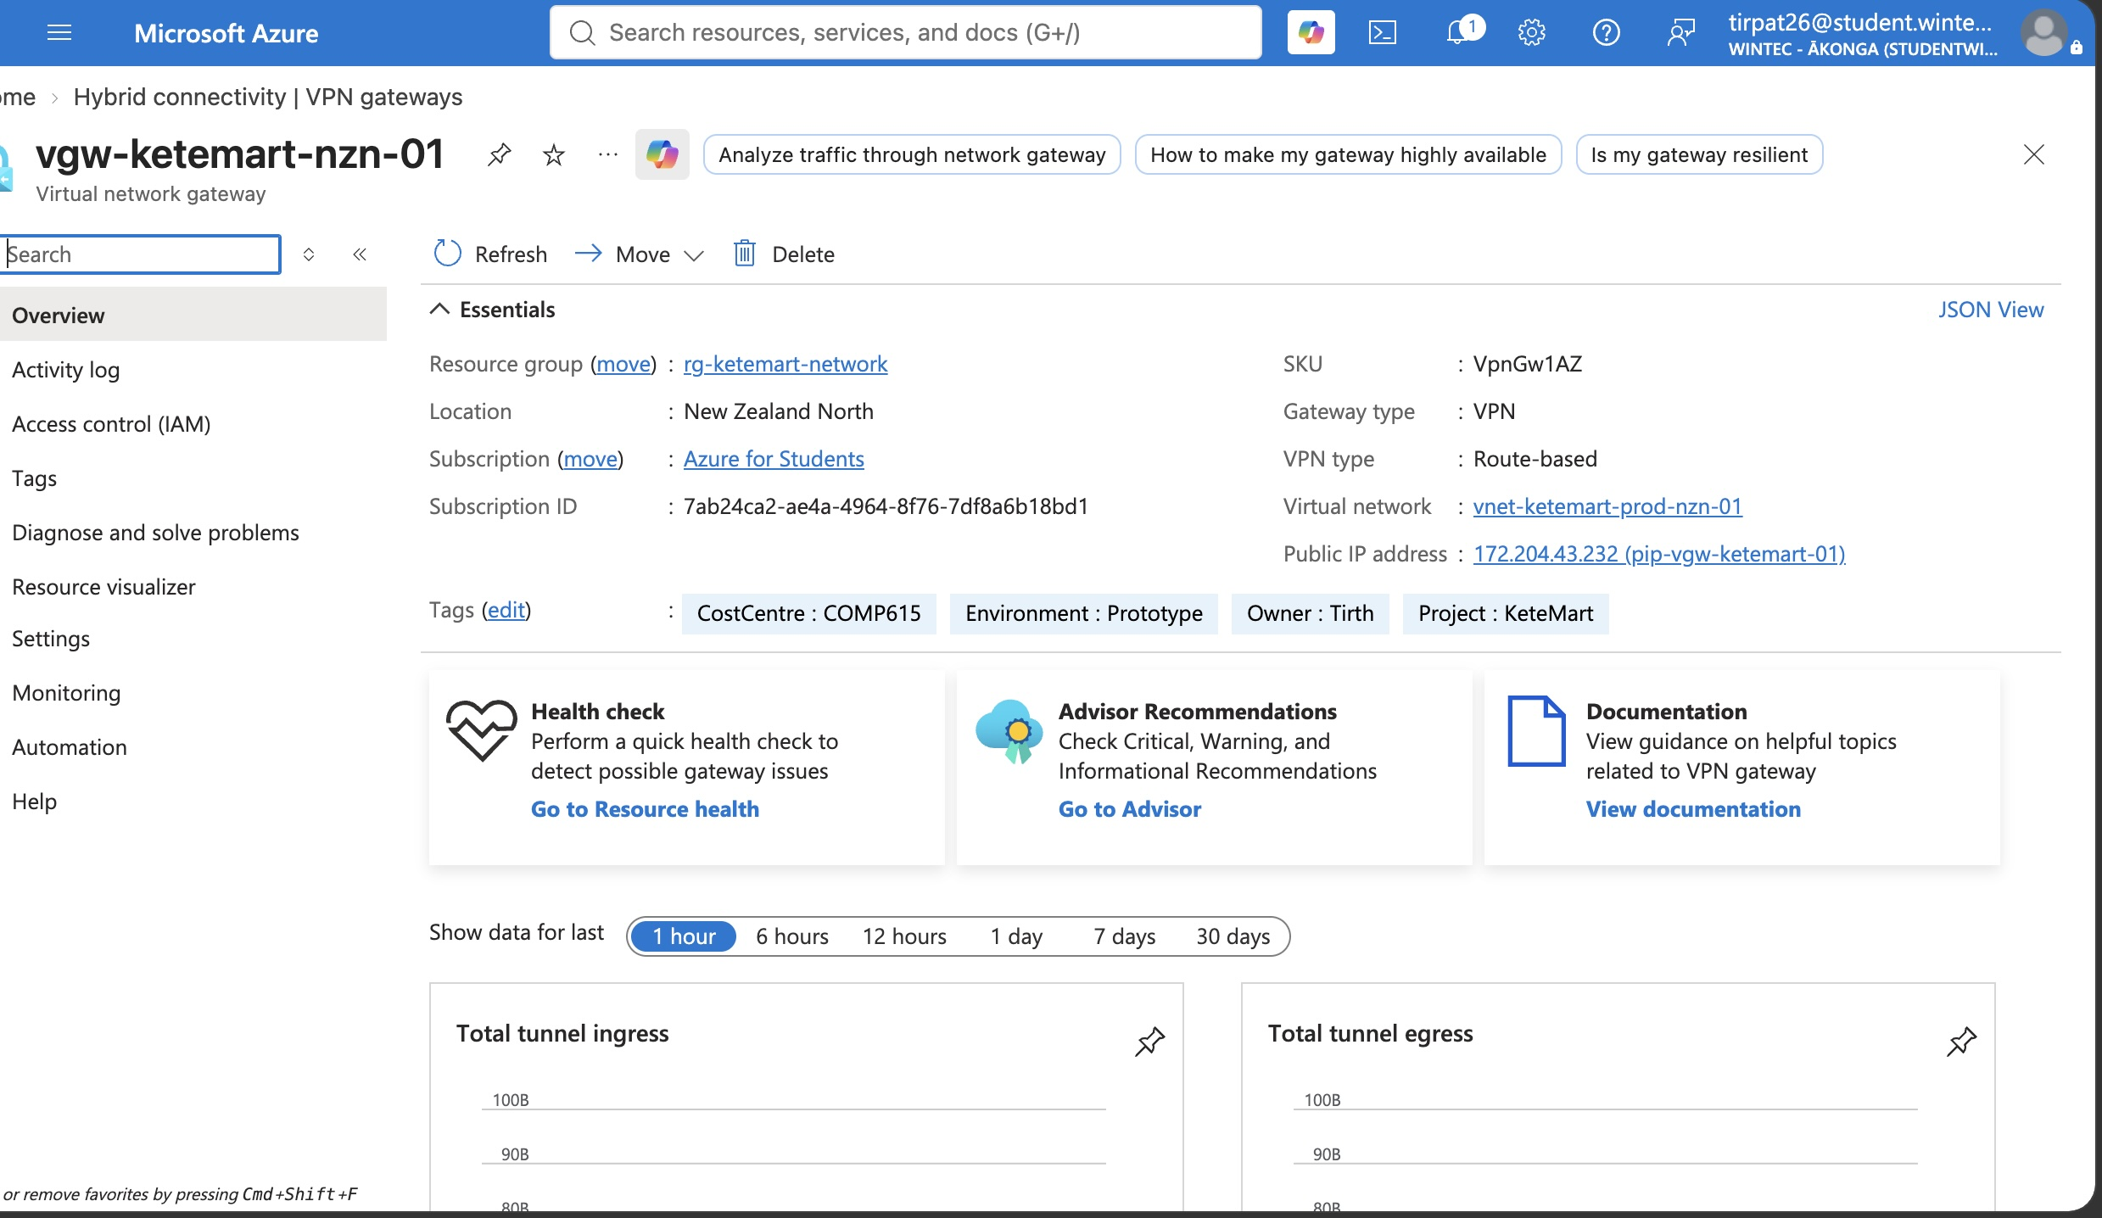
Figure 15: VPN Gateway vgw-ketemart-nzn-01 deployed with a public IP assigned.
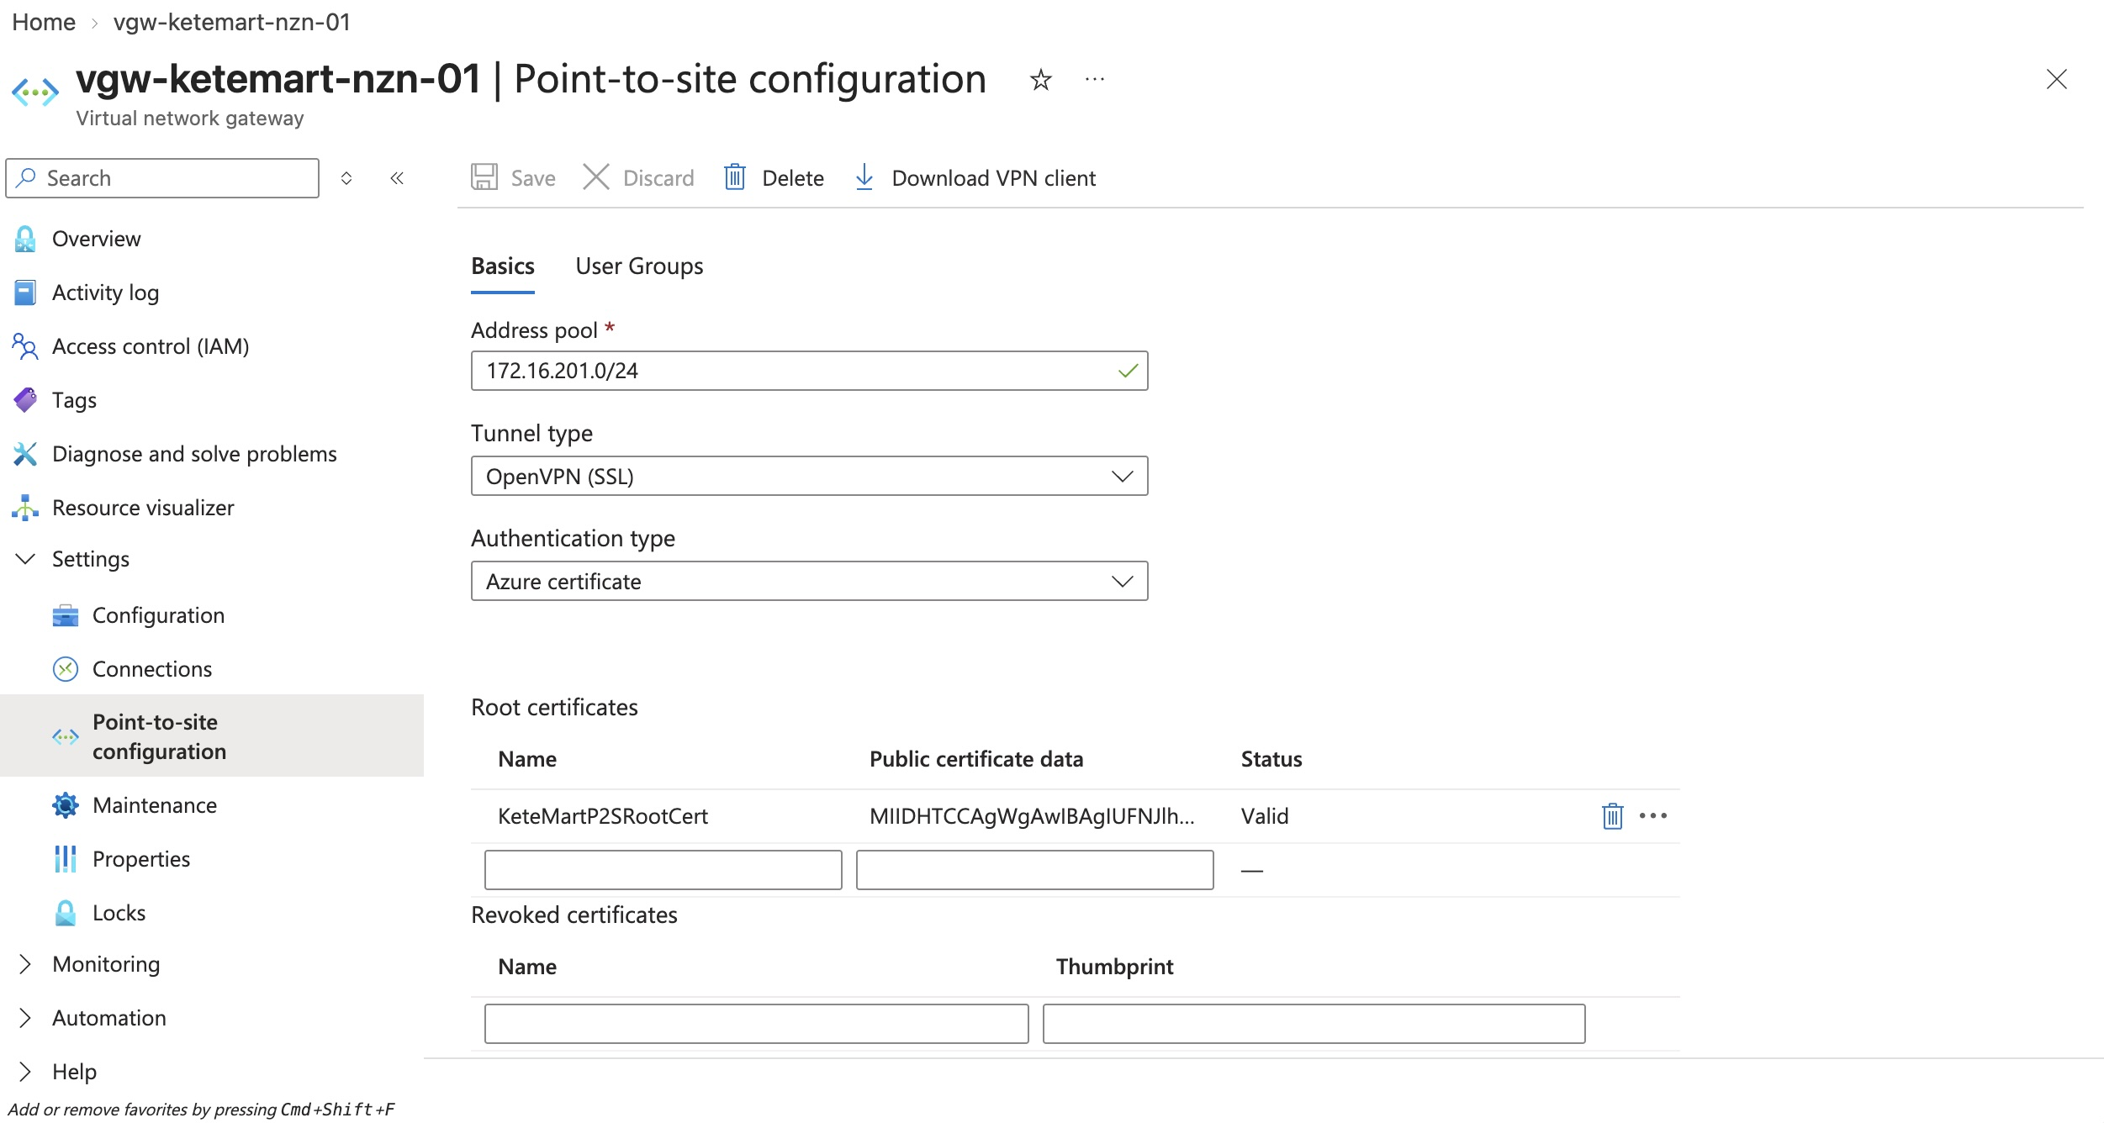
Figure 16: Point-to-Site configuration with a valid root certificate.
A Service Endpoint (restricting SQL/Storage traffic to the VNet) was identified as an appropriate control but was not configured before the Azure for Students credit was exhausted.

Design justification
Placing the VM in its own subnet, behind an NSG, limits the attack surface to only the port the legacy application actually needs. Keeping the VPN Gateway in a separate, dedicated GatewaySubnet follows Azure's required architecture for virtual network gateways and keeps gateway traffic logically separate from application traffic. Using a Point-to-Site VPN for administration, rather than opening RDP to the internet, means administrative access requires a certificate-based VPN connection in addition to VM credentials — a meaningfully stronger control than a public RDP endpoint, which is a common attack target.

3.2 Secure Administration

RBAC
Access is managed using Azure's built-in role-based access control rather than shared account credentials. The account used for this project holds the Owner role, inherited from the subscription, visible under Access Control (IAM) on the resource group. For Key Vault specifically, the "Key Vault Secrets Officer" role was assigned explicitly, rather than relying on legacy access policies, so that secret access is controlled through the same RBAC model as the rest of the solution.
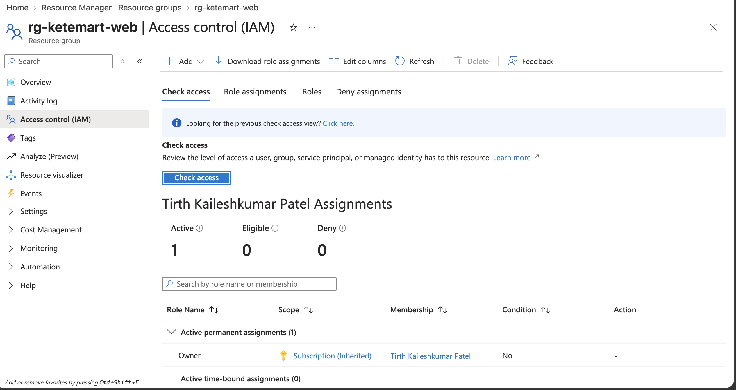
Figure 17: Owner role assignment, inherited from the subscription, visible under Access Control (IAM).

Key Vault
Key Vault stores the Azure SQL administrator password as a named secret (sql-admin-password), shown as Enabled with no expiration set. The secret's value is never displayed in the portal view or in this evidence — only metadata (name, type, status) is shown.
Figure 18: Key Vault secret sql-admin-password (reused from Section 2.1).

Secure VM administration
[ Not completed — see note below. ]
A Point-to-Site VPN Gateway was fully configured, with a valid root certificate uploaded to Azure (see Figure 16). A temporary NSG rule allowing RDP from a single known IP address was used during initial setup and testing; this rule has since been removed so that no direct public RDP access remains in the final configuration. A live, connected VPN session and an RDP connection made through that tunnel were not captured, as repeated certificate-matching issues between the locally generated client certificate and the Azure-side root certificate consumed the remaining time and credit before a successful connection was achieved.
Explain how your configuration protects administrative access.
The NSG attached to the VM's subnet allows only inbound HTTP; RDP (port 3389) is not permitted from any source in the final configuration. The intended administrative path is a certificate-authenticated Point-to-Site VPN tunnel, so that even a valid VM username and password would not be reachable without first establishing an authenticated VPN session — a materially stronger control than exposing RDP directly to the internet.

4. Operations and Management

4.1 Blob Storage and Lifecycle Management

Technical explanation
The storage account (stketemartnzn01) holds a private blob container (blob-ketemart-data) for KeteMart's documents. A lifecycle management rule automatically moves blobs to Cool storage after 30 days without modification, and to Archive storage after 90 days. This matches typical document-retention needs: recent documents stay in fast, more expensive Hot storage, while older records move to progressively cheaper tiers automatically, without manual intervention.

Evidence
☑ Hot storage
☑ Cool storage
☑ Archive storage
☑ Lifecycle-management rules
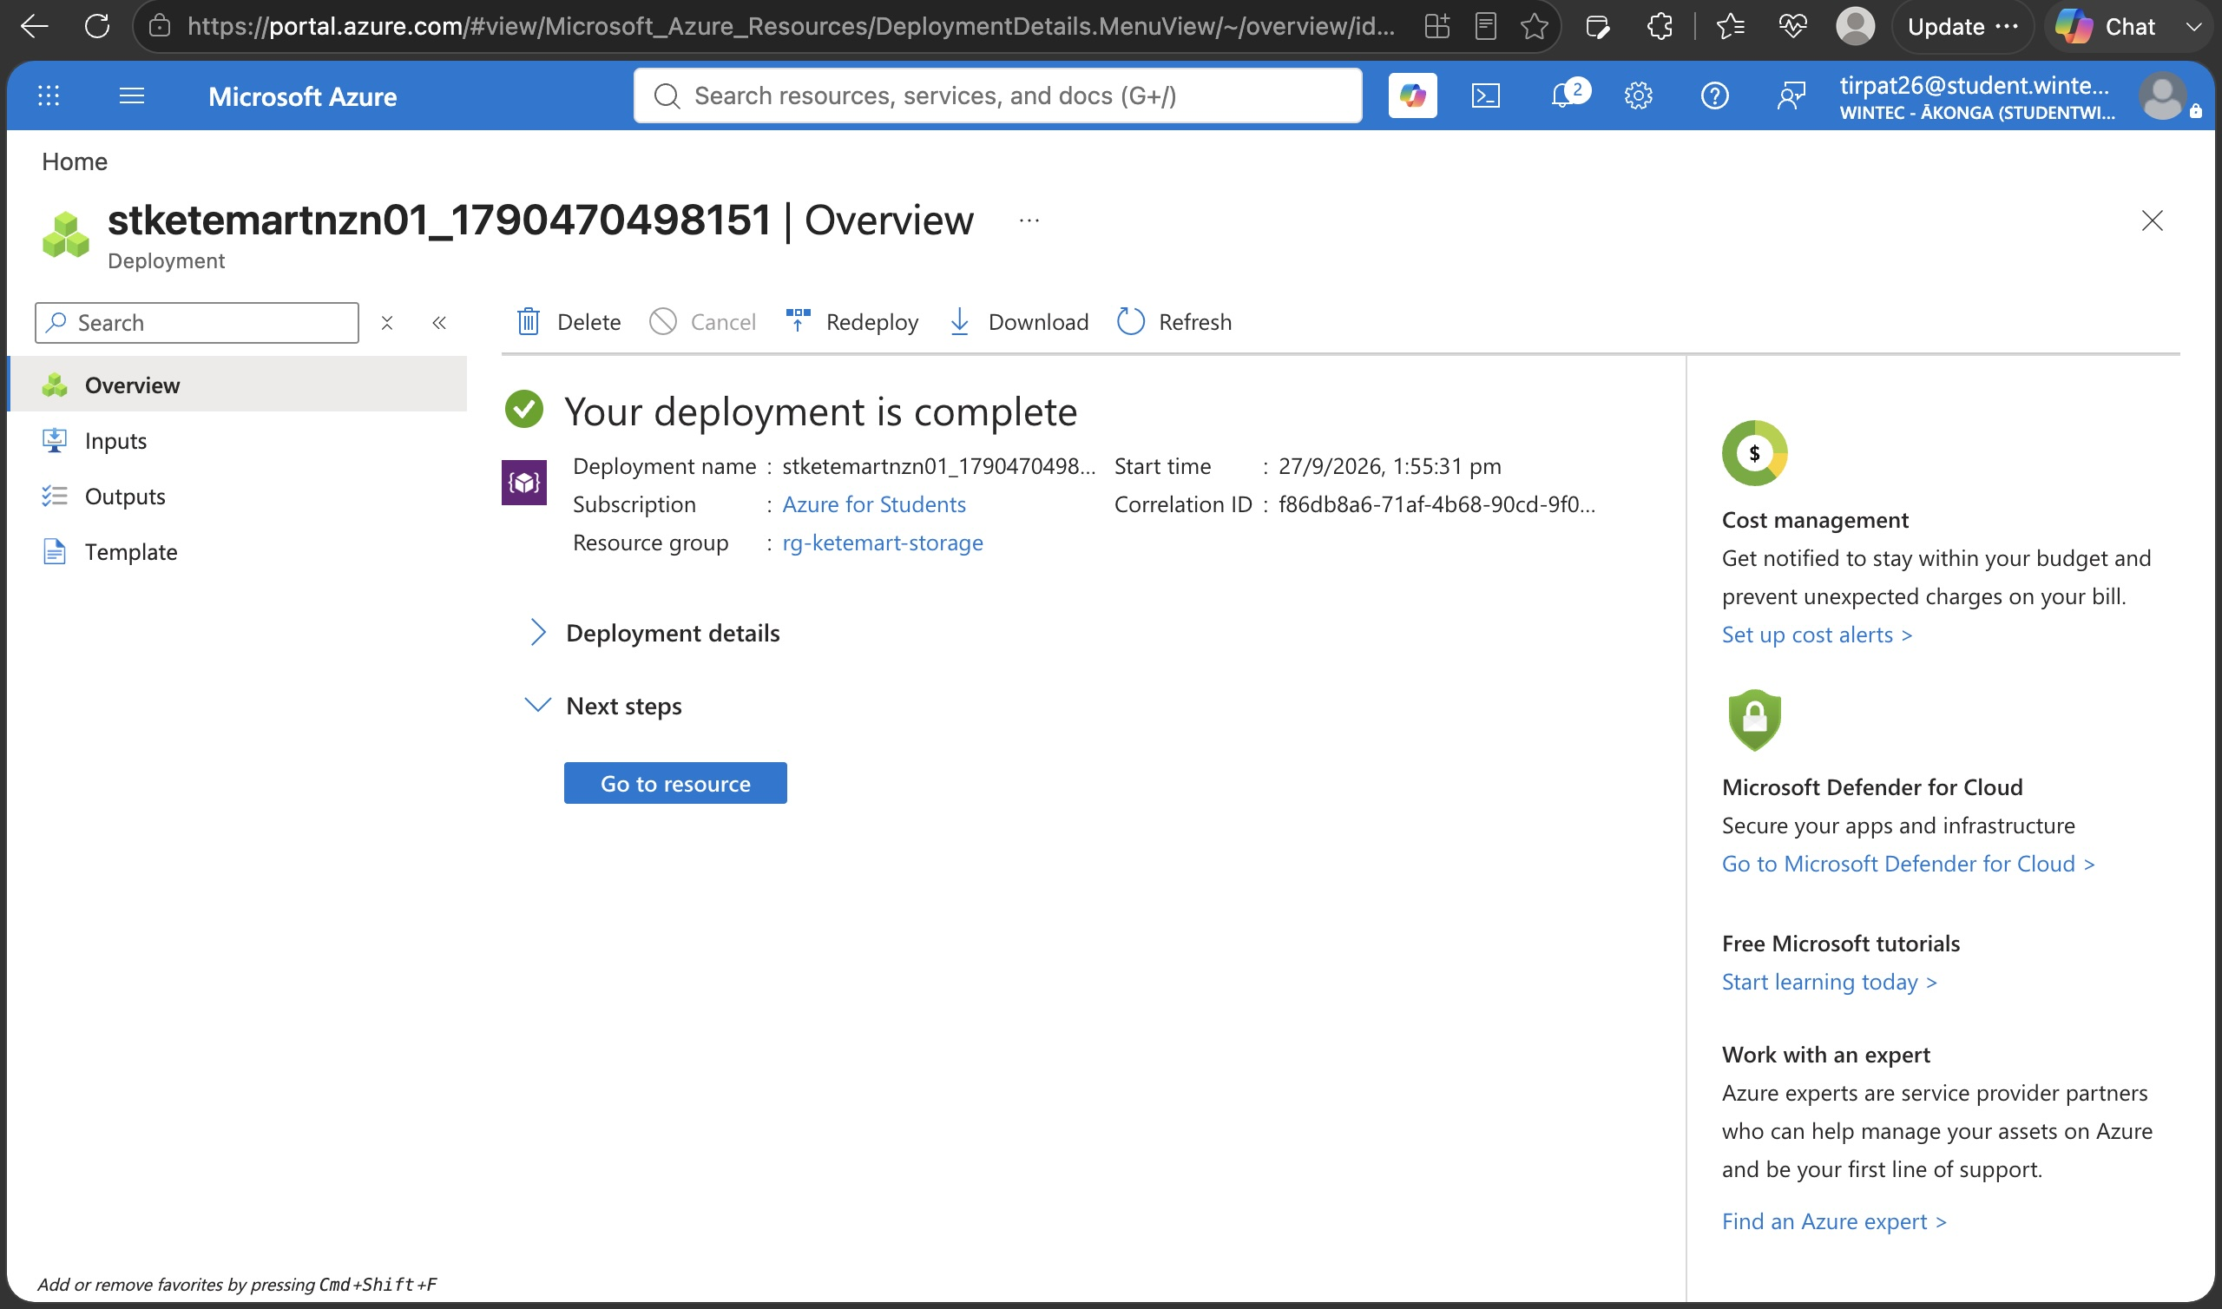
Figure 19: Storage account stketemartnzn01 deployed in New Zealand North.
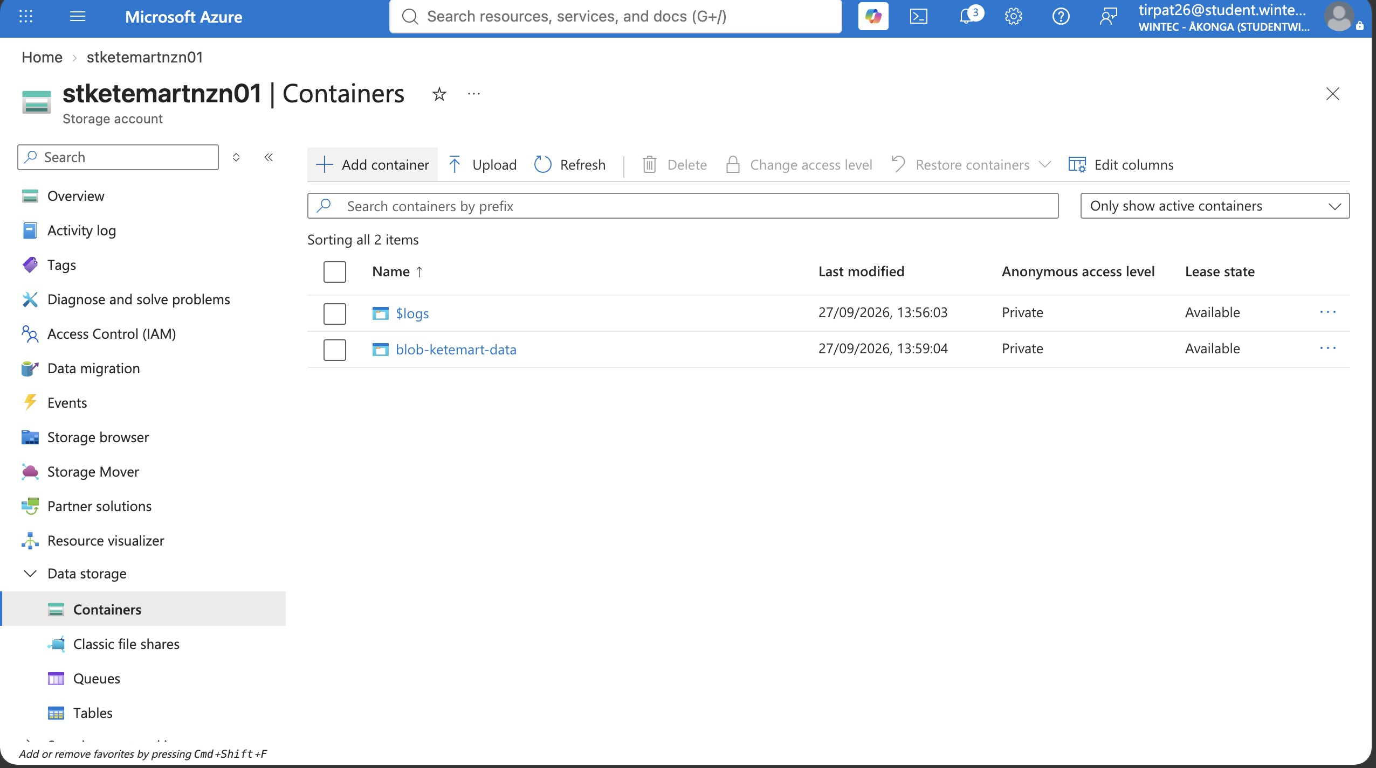
Figure 20: Blob container blob-ketemart-data, private access only.
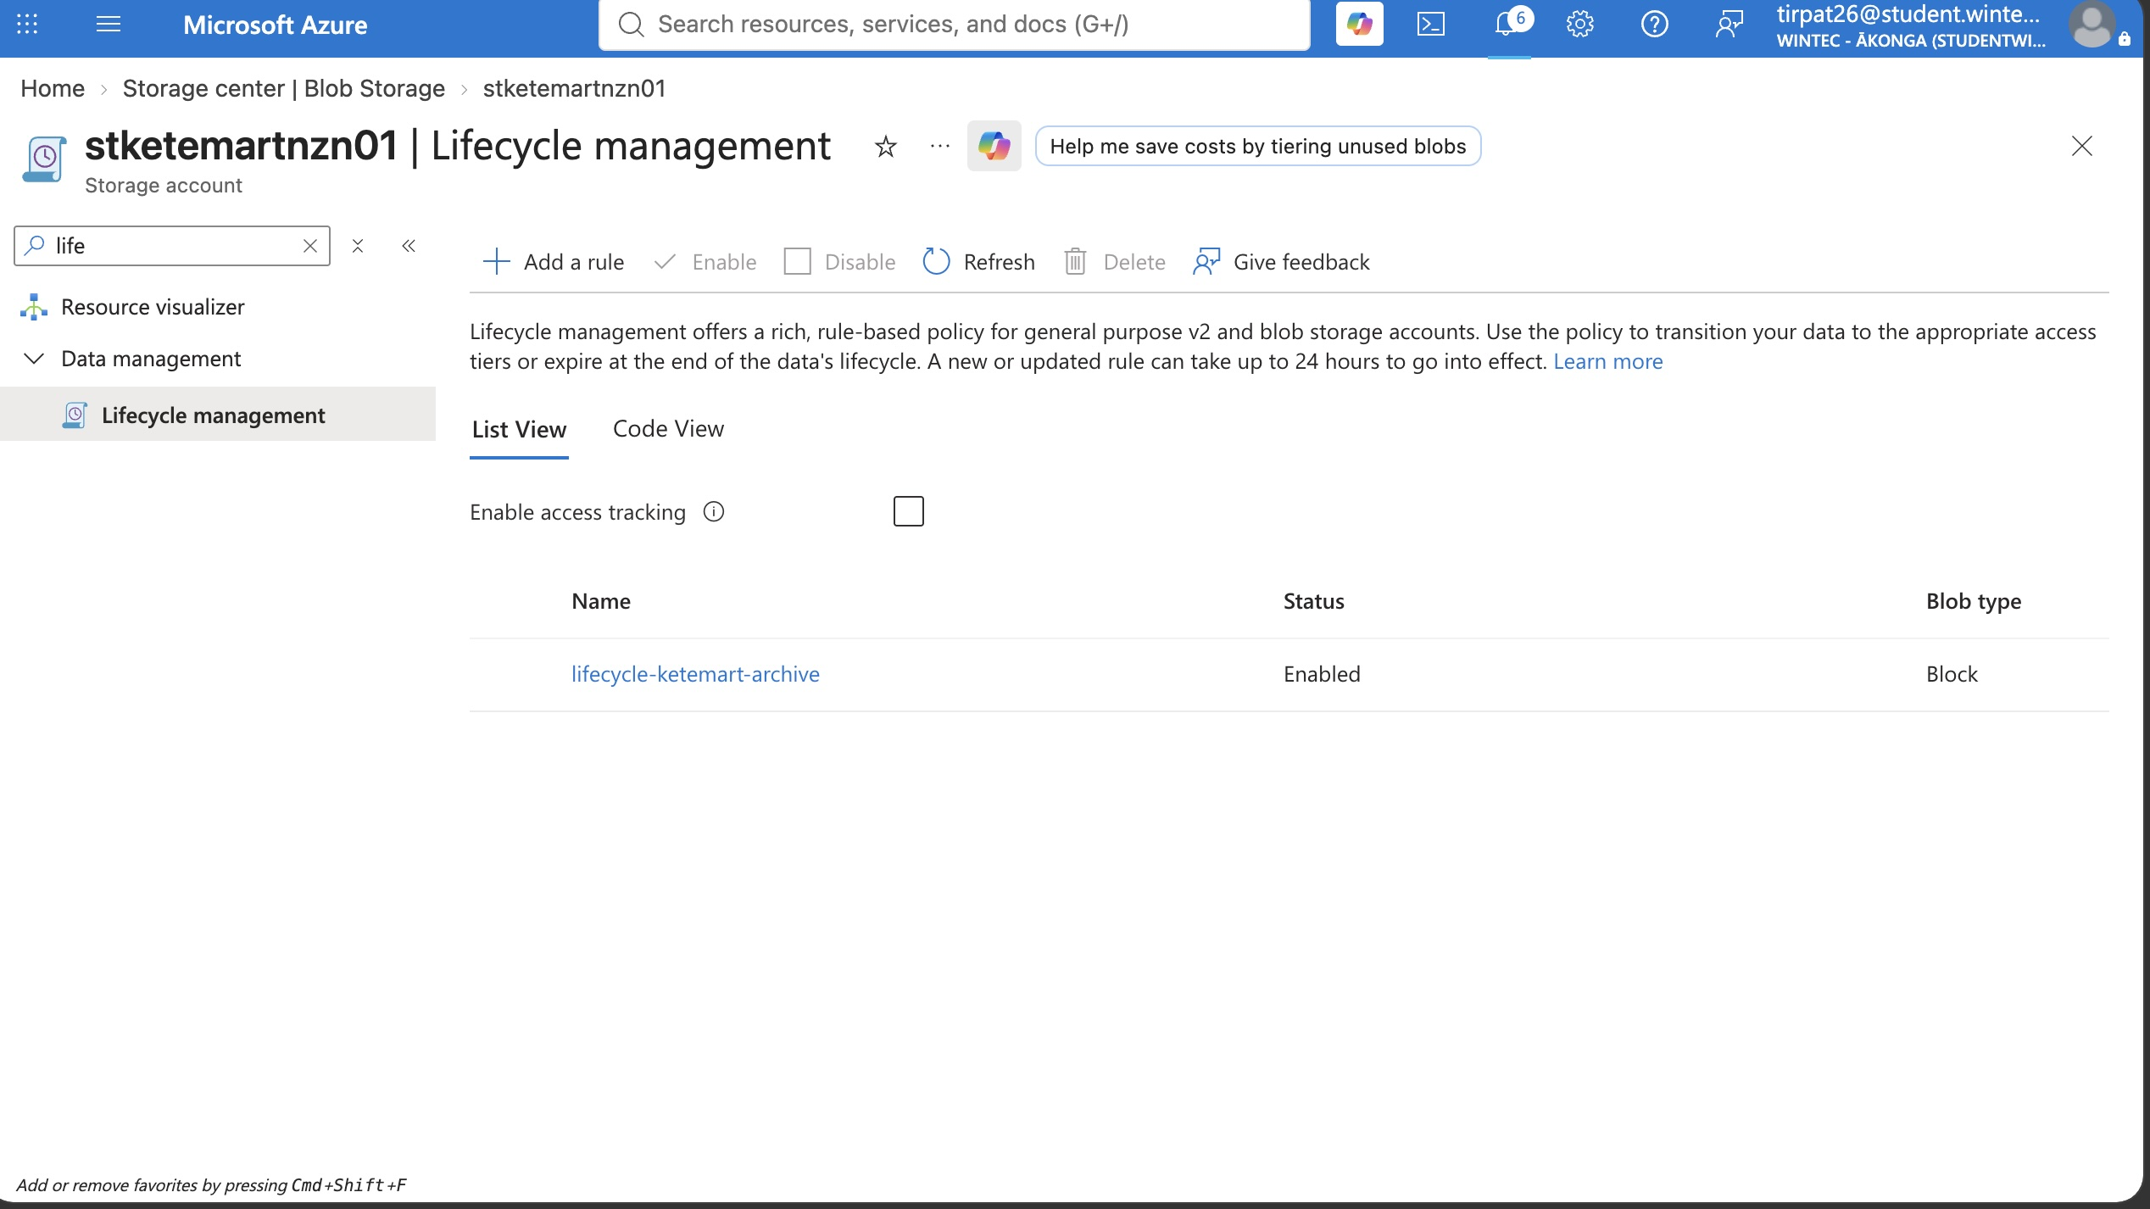
Figure 21: Lifecycle rule lifecycle-ketemart-archive, enabled, moving blobs to Cool then Archive.
Explain what happens to stored data as a result of your lifecycle rules.
A document uploaded today starts in Hot storage. If it isn't modified for 30 days, Azure automatically moves it to Cool storage, reducing the per-GB storage cost. If it remains unmodified for 90 days, it moves again to Archive storage, the cheapest tier, suited to long-term retention of records that are rarely accessed but must be kept for compliance.

4.2 Monitoring and Backup

Azure Monitor and Log Analytics
A Log Analytics workspace (log-ketemart-nzn-01) collects metrics from the virtual machine and Azure SQL Database, giving a central place to query performance data and diagnose issues across the solution rather than checking each resource individually.
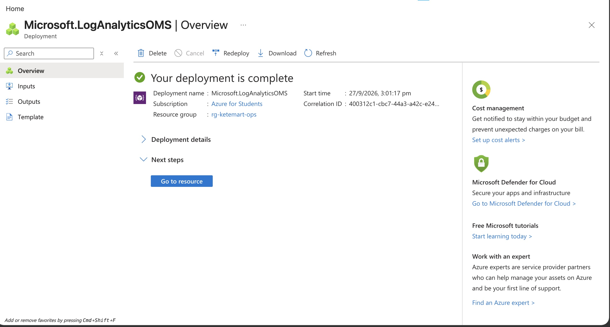
Figure 22: Log Analytics workspace log-ketemart-nzn-01 deployed in rg-ketemart-ops.

Alert rules
Alert | Condition being monitored | Why this alert is useful
Alert 1 | VM percentage CPU > 80% | Warns before the legacy VM becomes unresponsive under load, allowing proactive scaling or investigation
Alert 2 | SQL Database CPU percentage > 80% | Flags when the database is under sustained load, which could indicate inefficient queries or the need to scale the service tier
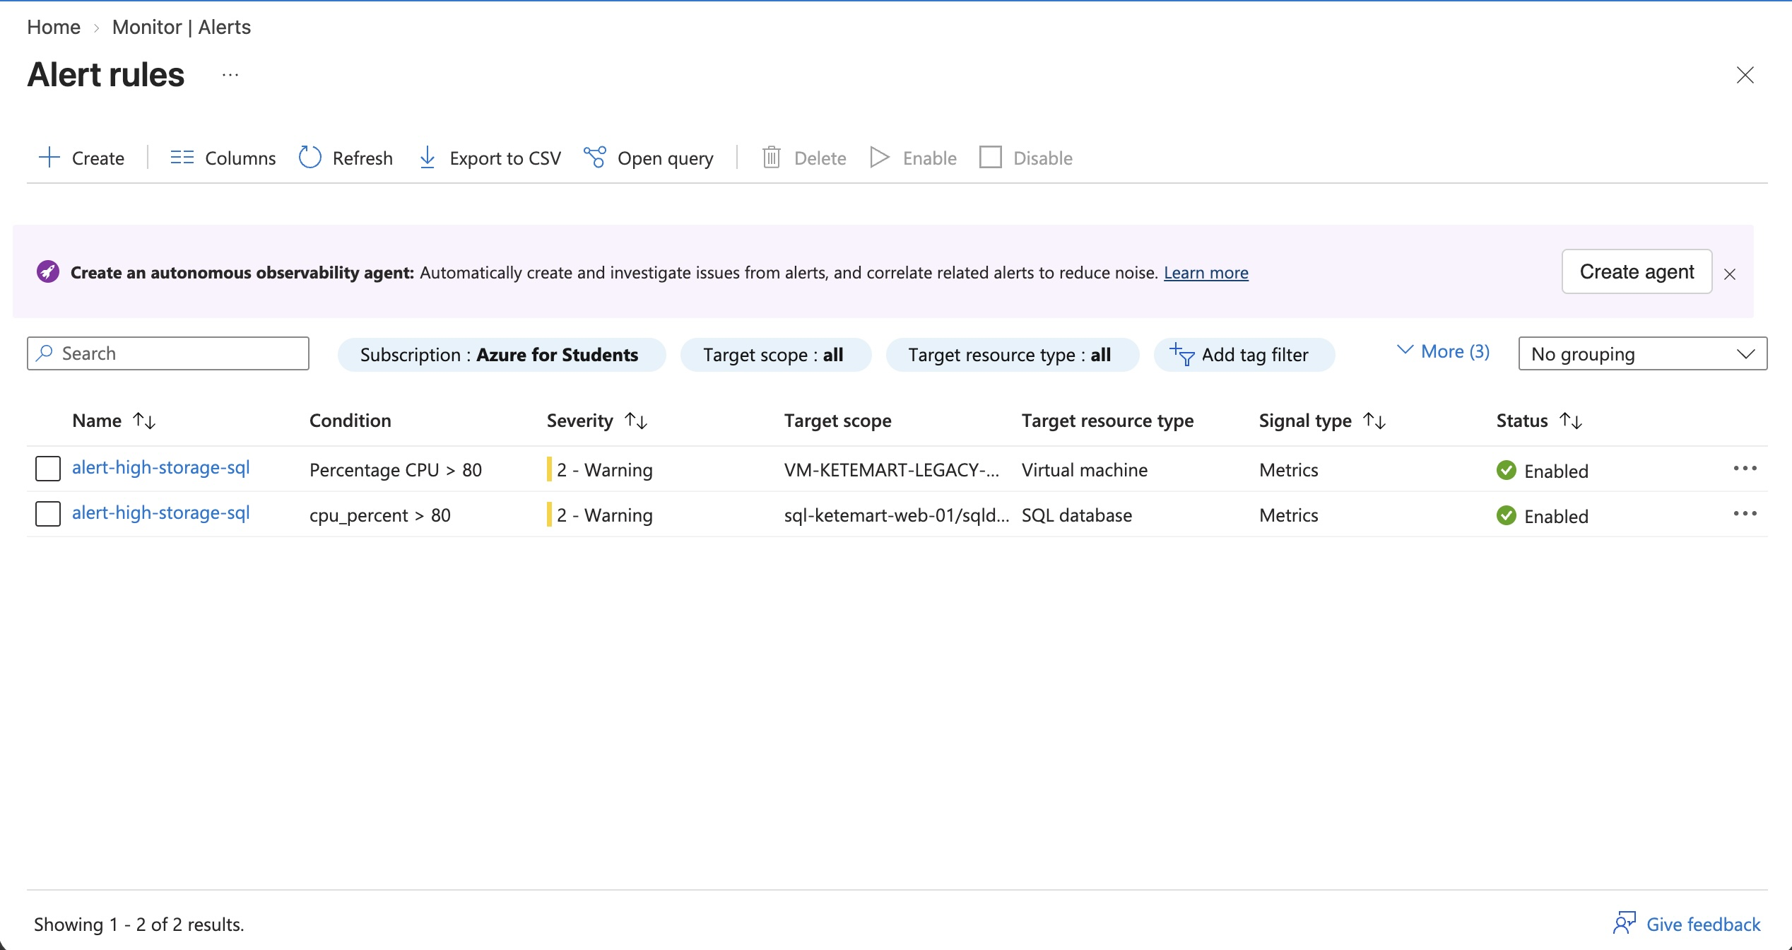
Figure 23: Both alert rules enabled, targeting the VM and SQL Database respectively.

Azure Backup
[ Not completed — see note below. ]
Azure Backup for the virtual machine was planned but not configured before the Azure for Students credit was exhausted, as this task was prioritised after the networking and VPN work, which did not complete in time.
Explain what protection the backup configuration provides.
A Recovery Services vault with a daily backup policy and short retention period would protect the legacy VM against accidental deletion, corruption, or configuration errors, allowing restoration to a recent daily recovery point. This was not completed in this prototype but is identified here as a required production control.

5. Cost Awareness

Production Cost Estimate
Azure resource/service | Production configuration | Estimated monthly cost (NZD)
App Service Plan | Basic B1, single instance | $18
Azure SQL Database | Serverless, 1–2 vCore auto-scale, auto-pause | $15
Virtual Machine (legacy app) | Standard B2s, auto-shutdown outside business hours | $12
Storage Account (Blob + Files) | 100 GB, LRS redundancy, with lifecycle tiering | $4
Key Vault | Standard tier, low operation volume | $1
Log Analytics + Alerts | 1 GB/month ingestion, 2 alert rules | $5
Azure Backup | Daily VM backup, 14-day retention | $5
Estimated total |  | $60

Cost assumptions
This estimate assumes a small-to-medium retailer with modest, predictable traffic — appropriate for KeteMart's current size. The VPN Gateway has been excluded from this estimate on the assumption that, in production, administrative access would instead use Azure Bastion on a pay-as-you-go basis, or a lightweight jump-box pattern only provisioned when needed, rather than a continuously-running gateway. The VM uses auto-shutdown scheduling outside business hours to avoid paying for idle compute. SQL remains serverless with auto-pause, matching the prototype's approach, since it suits intermittent, predictable traffic well. All pricing is NZD, New Zealand North region, list price with no reserved capacity.

Cost optimisation
The biggest lever for keeping this under $60/month is avoiding resources that bill continuously regardless of use — this is why the VM uses scheduled auto-shutdown and SQL uses serverless auto-pause rather than provisioned compute. If KeteMart's traffic grows, the first upgrade worth paying for is a dedicated App Service plan tier with autoscale, since that's the resource most directly tied to customer experience. Secure administrative access can start as an on-demand Bastion session (billed by the hour) rather than a dedicated VPN Gateway, which only becomes cost-effective once admin access is frequent enough to justify its flat hourly rate.

Azure for Students prototype
This prototype was built within the $100 Azure for Students credit, using low-cost tiers wherever one was available: App Service ran on the Free (F1) tier rather than Basic, Azure SQL used the Serverless compute tier with auto-pause so it billed close to zero whenever idle, the virtual machine used the low-cost Burstable B-series (B2ats_v2), and storage used Locally Redundant Storage rather than a geo-redundant option. A $100 budget with alerts at 50%, 80% and 100% was configured from the start of the project to track spend against the credit limit as resources were built.
The VPN Gateway was the exception — it is the one resource in this solution that bills by the hour regardless of use, and it was the main driver of credit consumption. It was created to demonstrate secure, VPN-only administrative access to the legacy VM, which is a real requirement for the production design, but because it was left running across several working sessions rather than created, tested, and torn down in one sitting, it consumed a disproportionate share of the available credit before all planned evidence could be captured. In production, this is addressed by the cost-optimisation approach above — using Azure Bastion on an as-needed basis instead of a continuously-running gateway — and the same approach would have been the more credit-efficient choice for this prototype too.

6. Final Evidence Check
Before submitting, confirm that this portfolio contains enough evidence for another technical person to understand and verify the solution.
☑ Architecture diagram included
☑ Major design decisions explained
☑ Customer web application shown working
☑ Azure SQL configuration and application connectivity demonstrated
☐ CI/CD change and automatic deployment demonstrated
☐ Legacy application shown working
☐ Azure Files read/write demonstrated from both locations
☐ Bicep deployment demonstrated
☑ Resource Groups, naming and tags demonstrated
☑ Networking and security controls demonstrated
☐ Secure VPN administration demonstrated
☑ Direct public RDP is not enabled in the final configuration
☑ Blob storage and lifecycle management demonstrated
☑ Monitoring and Log Analytics demonstrated
☑ At least two alerts demonstrated
☐ Azure Backup demonstrated
☑ Production cost estimate included
☑ Prototype cost considerations explained
☑ Screenshots are readable and labelled
☑ No passwords, keys, secrets or sensitive credentials are visible

Items not ticked above reflect evidence genuinely not completed, with honest explanatory notes provided in the relevant section, due to exhaustion of the Azure for Students credit allowance before this work could be finished.

