**GANPAT UNIVERSITY**

**U.V. PATEL COLLEGE OF ENGINEERING**

B.Tech 6th Semester CE/IT

2CEIT6PE1: Web Technology

**Practical-4**

**Aim: Perform following programs of PHP form handling.**

**Exercise-1:**

Write a program to use of following global Variables:

$_REQUEST

**Code:**

<!DOCTYPE html>

<html lang="en">

<head>

<meta charset="UTF-8">

<meta name="viewport" content="width=device-width, initial-scale=1.0">

<title>Document</title>

</head>

<body>

<form action= " <?php echo $_SERVER['PHP_SELF'];?>" method="POST">

NAME: <input type="text" name="name"><br><br>

<input type="submit">

</form><br><br>

<?php

if($_SERVER["REQUEST_METHOD"] == "POST")

{

$name = $_REQUEST["name"];

if(empty($name))

{

echo "Name is empty";

}

else

{

echo "Hello ". $name;

}

}

?>

</body>

</html>

**Output:**

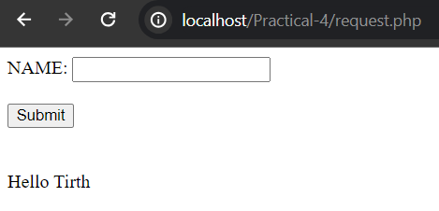

$_POST:

**Code (Post.php):**

<!DOCTYPE html>

<html lang="en">

<head>

<meta charset="UTF-8">

<meta name="viewport" content="width=device-width, initial-scale=1.0">

<title>Document</title>

</head>

<body>

<form action= "./post1.php" method="POST">

NAME: <input type="text" name="name"><br><br>

Bloodgroup: <input type="text" name="bloodgroup"><br><br>

<input type="submit">

</form><br><br>

</body>

</html>

**Code (Post1.php):**

<?php

if($_SERVER["REQUEST_METHOD"] == "POST")

{

$name = $_POST["name"];

$bloodgroup = $_POST["bloodgroup"];

if(empty($name) || empty($bloodgroup))

{

if (empty($bloodgroup))

echo "Name is " . $name . ". Your bloodgroup is empty";

elseif (empty($name))

echo "Name is empty and bloodgroup is " . $bloodgroup;

else

echo "Name and Bloodgroup are empty";

}

else

{

echo "Hello ". $name . ". Your blood group is" . $bloodgroup;

}

}

?>

**Output:**

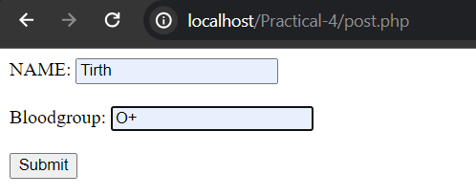



$_GET:

**Code (get.php):**

<!DOCTYPE html>

<html lang="en">

<head>

<meta charset="UTF-8">

<meta name="viewport" content="width=device-width, initial-scale=1.0">

<title>Document</title>

</head>

<body>

<form action= "./get1.php" method="GET">

NAME: <input type="text" name="name"><br><br>

Bloodgroup: <input type="text" name="bloodgroup"><br><br>

<input type="submit">

</form><br><br>

</body>

</html>

**Code (get1.php):**

<?php

if($_SERVER["REQUEST_METHOD"] == "GET")

{

$name = $_GET["name"];

$bloodgroup = $_GET["bloodgroup"];

if(empty($name) || empty($bloodgroup))

{

if (empty($bloodgroup))

echo "Name is " . $name . ". Your bloodgroup is empty";

elseif (empty($name))

echo "Name is empty and bloodgroup is " . $bloodgroup;

else

echo "Name and Bloodgroup are empty";

}

else

{

echo "Hello ". $name . ". Your blood group is" . $bloodgroup;

}

}

?>

**Output:**

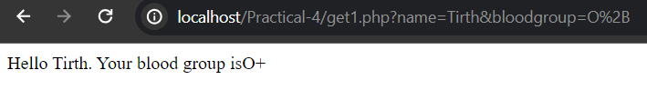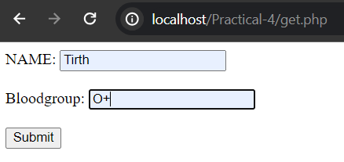

$_ENV

**Code:**

<?php

print_r(getenv());

?>

**Output:**

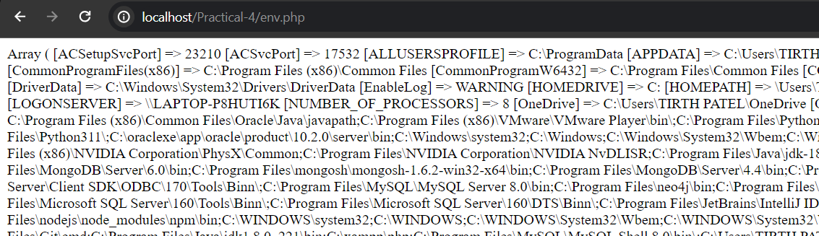

$_GLOBAL

**Code:**

<?php

$x = "Hermil";

$y = "Permil";

function addition() {

$GLOBALS['z'] = $GLOBALS['x'] . $GLOBALS['y'];

}

addition();

echo $z;

?>

**Output:**



$_SERVER

**Code:**

<?php

echo $_SERVER['PHP_SELF'];

echo "<br>";

echo $_SERVER['SERVER_NAME'];

echo "<br>";

echo $_SERVER['HTTP_HOST'];

echo "<br>";

echo $_SERVER['REQUEST_METHOD'];

echo "<br>";

echo $_SERVER['HTTP_USER_AGENT'];

echo "<br>";

echo $_SERVER['SCRIPT_NAME'];

?>

**Output:**

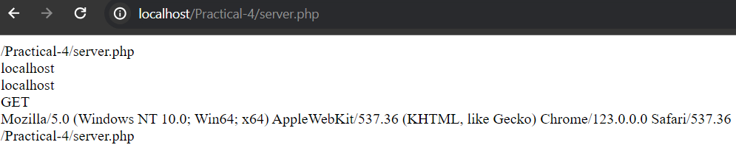

**Exercise-2:** Create a PHP script that implements a Billing Module with order and confirmation pages. The order page should collect the Buyer's Name and

Mobile Number with validation and display the confirmed order details

on a separate page.

Note: Refer to the attached figure for a visual representation

**Code (index.php):**

<!DOCTYPE html>

<html>

<head>

<title>Billing Software</title>

<script>

function validateForm() {

var mobileNumber = document.getElementById("mobileno").value;

var regex = /^[6-9]\d{9}$/; // Regular expression to match Indian mobile numbers

if (!regex.test(mobileNumber)) {

alert("Please enter a valid Indian mobile number.");

return false;

}

return true;

}

function clearForm() {

document.getElementById("billingForm").reset();

}

</script>

</head>

<body>

<form id="billingForm" method="post" action="order.php" onsubmit="return validateForm()">

<center>

<h2>Welcome to U-Shop</h2>

<table>

<tr>

<td>Name</td>

<td><input type="text" name="name" id="name" required></td>

</tr>

<tr>

<td>Mobile Number</td>

<td><input type="text" name="mobileno" id="mobileno" required></td>

</tr>

</table>

<table name="in">

<tr>

<td><h4>Product Name</h4></td>

<td><h4>Price</h4></td>

<td><h4>Quantity</h4></td>

</tr>

<tr>

<td>Wafers</td>

<td>10</td>

<td><input type="number" value="0" name="f0" min="0"></td>

</tr>

<tr>

<td>Slice</td>

<td>15</td>

<td><input type="number" value="0" name="f1" min="0"></td>

</tr>

<tr>

<td>Cadbury Chocolate</td>

<td>85</td>

<td><input type="number" value="0" name="f2" min="0"></td>

</tr>

<tr>

<td>Kitkat Chocolate</td>

<td>30</td>

<td><input type="number" value="0" name="f3" min="0"></td>

</tr>

<tr>

<td>Coco</td>

<td>60</td>

<td><input type="number" value="0" name="f4" min="0"></td>

</tr>

</table>

<h4>Payment Method</h4>

<input type="radio" name="Payment" value="cash">Cash

<input type="radio" name="Payment" value="online">Online<br><br>

<input type="submit" name="submit" value="Submit Order">

<input type="button" name="Cancel" value="Cancel Order" onclick="clearForm()">

</center>

</form>

</body>

</html>

**Code (order.php):**

<!DOCTYPE html>

<html>

<head>

<title>Order Confirmation</title>

<style>

body {

font-family: Arial, sans-serif;

text-align: center;

}

table {

margin: 0 auto;

border-collapse: collapse;

width: 50%;

}

th, td {

padding: 8px;

border-bottom: 1px solid #ddd;

}

th {

background-color: #f2f2f2;

}

h2, h3 {

margin-bottom: 5px;

}

p {

margin: 5px 0;

}

</style>

</head>

<body>

<?php

$buyer_name = $_POST['name'];

$phone = $_POST['mobileno'];

$payment_method = $_POST['Payment'];

$totalPrice = 0;

$Quantity = array($_POST['f0'],$_POST['f1'],$_POST['f2'],$_POST['f3'],$_POST['f4']);

$Price = array(3,32,20,25,60);

$items = array("Twisties", "Milk", "Cadbury Chocolate", "Kitkat Chocolate", "Dairy Milk");

echo "<h2>Order Details</h2>";

echo "<h3>Your order is placed</h3>";

echo "<h4>Buyer details</h4>";

echo "<p>Buyer's Name: $buyer_name</p>";

echo "<p>Phone Number: $phone</p>";

echo "<table>";

echo "<tr><th>Item</th><th>Price</th><th>Quantity</th><th>Total</th></tr>";

for ($i = 0; $i < 5; $i++) {

$temp = $Quantity[$i] * $Price[$i];

$totalPrice += $temp;

echo "<tr><td>$items[$i]</td><td>$Price[$i]</td><td>$Quantity[$i]</td><td>$temp</td></tr>";

}

echo "<tr><td colspan='3'><strong>Grand Total</strong></td><td>$totalPrice</td></tr>";

echo "</table>";

//Print selected payment method

if (!empty($payment_method)) {

echo "<p>Payment Method: $payment_method</p>";

} else {

echo "<p>No payment method selected.</p>";

}

echo "<h2>Thank you!</h2>";

?>

</body>

</html>

**Output:**

