**GANPAT UNIVERSITY**

**U.V. PATEL COLLEGE OF ENGINEERING**

B.Tech 6th Semester CE/IT

2CEIT6PE1: Web Technology

**Practical-6**

**Aim:** **Perform following programs of PHP file handling.**

**Exercise-1:**

Write a PHP program to create a student registration form with validation for fields including Enrollment No., Full Name, Gender, Mobile, Email, Address, and Profile Photo. Implement validation for Full Name, Mobile, Email, and Profile Photo inputs. Store all submitted data in a CSV file.

**Code:**

<?php

function validateFullName($name) {

return preg_match("/^[a-zA-Z ]*$/", $name);

}

function validateMobile($mobile) {

return preg_match("/^\d{10}$/", $mobile);

}

function validateEmail($email) {

return filter_var($email, FILTER_VALIDATE_EMAIL);

}

function validateProfilePhoto($file) {

$allowedExtensions = array("jpg", "jpeg", "png", "gif");

$fileExtension = strtolower(pathinfo($file['name'], PATHINFO_EXTENSION));

return in_array($fileExtension, $allowedExtensions) && getimagesize($file['tmp_name']);

}

function saveToCSV($data) {

$file = fopen("students.csv", "a");

fputcsv($file, $data);

fclose($file);

}

if ($_SERVER["REQUEST_METHOD"] == "POST") {

$errors = [];

$enrollmentNo = $_POST['enrollmentNo'];

$fullName = $_POST['fullName'];

$gender = $_POST['gender'];

$mobile = $_POST['mobile'];

$email = $_POST['email'];

$address = $_POST['address'];

$profilePhoto = $_FILES['profilePhoto'];

if (!validateFullName($fullName)) {

$errors[] = "Invalid full name";

}

if (!validateMobile($mobile)) {

$errors[] = "Invalid mobile number";

}

if (!validateEmail($email)) {

$errors[] = "Invalid email address";

}

if (!validateProfilePhoto($profilePhoto)) {

$errors[] = "Invalid profile photo. Please upload a valid image file (jpg, jpeg, png, gif)";

}

if (empty($errors)) {

$data = array($enrollmentNo, $fullName, $gender, $mobile, $email, $address);

saveToCSV($data);

echo "Data saved successfully!";

} else {

foreach ($errors as $error) {

echo $error . "<br>";

}

}

}

?>

<!DOCTYPE html>

<html lang="en">

<head>

<meta charset="UTF-8">

<meta name="viewport" content="width=device-width, initial-scale=1.0">

<title>Student Registration Form</title>

</head>

<body>

<h2>Student Registration Form</h2>

<form method="post" enctype="multipart/form-data">

Enrollment No.: <input type="text" name="enrollmentNo" required><br><br>

Full Name: <input type="text" name="fullName" required><br><br>

Gender: <input type="radio" name="gender" value="male" checked> Male

<input type="radio" name="gender" value="female"> Female

<input type="radio" name="gender" value="other"> Other<br><br>

Mobile: <input type="text" name="mobile" required><br><br>

Email: <input type="email" name="email" required><br><br>

Address: <textarea name="address" rows="4" cols="30"></textarea><br><br>

Profile Photo: <input type="file" name="profilePhoto" accept="image/*" required><br><br>

<input type="submit" value="Submit">

</form>

</body>

</html>

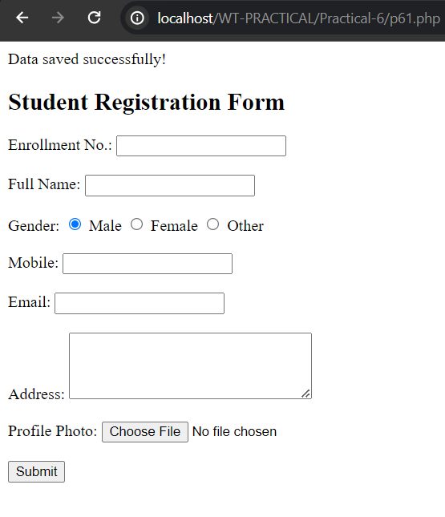**Output:**

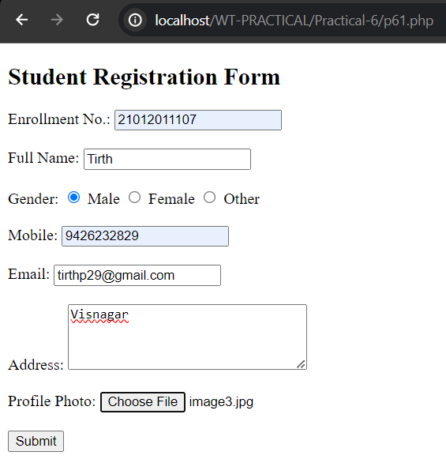

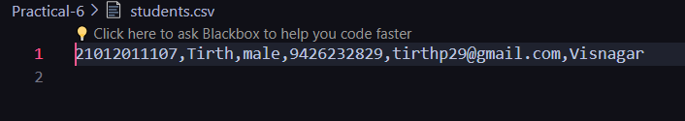

**Exercise-2:**

Create a form with a file input field to allow users to upload files.Implement server-side PHP code to handle the uploaded file:

1. Validate the file type and size to prevent malicious uploads and ensure server resource management.
2. Move the uploaded file to a secure location on the server.
3. Provide feedback to the user on the success or failure of the upload process.

**Code:**

<?php

function generateUniqueFileName($originalName, $uploadDirectory) {

$extension = pathinfo($originalName, PATHINFO_EXTENSION);

$basename = basename($originalName, '.' . $extension);

$basename = preg_replace('/[^a-zA-Z0-9]/', '_', $basename);

$basename = preg_replace('/_{2,}/', '_', $basename);

$basename = trim($basename, "_");

$uniqueName = $basename . '_' . uniqid() . '.' . $extension;

$filePath = $uploadDirectory . '/' . $uniqueName;

return $filePath;}

function validateFile($file) {

$allowedTypes = array('jpg', 'jpeg', 'png', 'gif');

$maxFileSize = 5 * 1024 * 1024; // 5MB

$fileExtension = strtolower(pathinfo($file['name'], PATHINFO_EXTENSION));

$fileSize = $file['size'];

if (!in_array($fileExtension, $allowedTypes)) {

return "Invalid file type. Allowed types: jpg, jpeg, png, gif";

}

if ($fileSize > $maxFileSize) {

return "File size exceeds the maximum limit of 5MB";

}

return true;

}

if ($_SERVER["REQUEST_METHOD"] == "POST") {

if (isset($_FILES['file']) && $_FILES['file']['error'] === UPLOAD_ERR_OK) {

$uploadDirectory = 'uploads';

$filePath = generateUniqueFileName($_FILES['file']['name'], $uploadDirectory);

$validationResult = validateFile($_FILES['file']);

if ($validationResult === true) {

if (!file_exists($uploadDirectory)) {

mkdir($uploadDirectory, 0777, true);

}

if (move_uploaded_file($_FILES['file']['tmp_name'], $filePath)) {

echo "File uploaded successfully.";

} else {

echo "Error occurred while uploading the file.";

}

} else {

echo $validationResult;

}

} else {

echo "Error occurred during file upload.";

}

}

?>

<!DOCTYPE html>

<html lang="en">

<head>

<meta charset="UTF-8">

<meta name="viewport" content="width=device-width, initial-scale=1.0">

<title>File Upload</title>

</head>

<body>

<h2>Upload a File</h2>

<form method="post" enctype="multipart/form-data">

Select file: <input type="file" name="file" required><br><br>

<input type="submit" value="Upload">

</form>

</body>

</html>

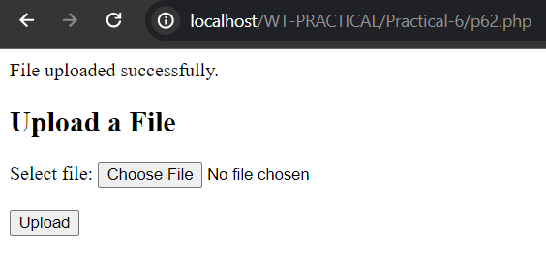**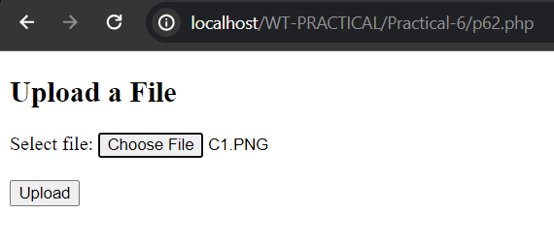Output:**

**Exercise-3:**

Develop functionality to manage uploaded files:

1. List uploaded files with options for viewing, downloading, or deleting them.

**Code:**

<?php

function listUploadedFiles($uploadDirectory) {

$files = [];

if (is_dir($uploadDirectory)) {

if ($handle = opendir($uploadDirectory)) {

while (($file = readdir($handle)) !== false) {

if ($file != "." && $file != "..") {

$files[] = $file;

}

}

closedir($handle);

}

}

return $files;

}

function deleteFile($fileName, $uploadDirectory) {

$filePath = $uploadDirectory . '/' . $fileName;

if (file_exists($filePath)) {

if (unlink($filePath)) {

return true;

} else {

return false;

}

} else {

return false;

}

}

if ($_SERVER["REQUEST_METHOD"] == "POST" && isset($_POST['delete']) && isset($_POST['filename'])) {

$fileName = $_POST['filename'];

$uploadDirectory = 'uploads';

if (deleteFile($fileName, $uploadDirectory)) {

echo "File '$fileName' deleted successfully.";

} else {

echo "Failed to delete file '$fileName'.";

}

}

$uploadDirectory = 'uploads';

$files = listUploadedFiles($uploadDirectory);

?>

<!DOCTYPE html>

<html lang="en">

<head>

<meta charset="UTF-8">

<meta name="viewport" content="width=device-width, initial-scale=1.0">

<title>Manage Uploaded Files</title>

</head>

<body>

<h2>Uploaded Files</h2>

<?php if (count($files) > 0): ?>

<ul>

<?php foreach ($files as $file): ?>

<li>

<?php echo $file; ?>

[<a href="<?php echo $uploadDirectory . '/' . urlencode($file); ?>" target="_blank">View</a> |

<a href="<?php echo $uploadDirectory . '/' . urlencode($file); ?>" download>Download</a> |

<form method="post" style="display:inline;">

<input type="hidden" name="filename" value="<?php echo $file; ?>">

<input type="submit" name="delete" value="Delete" onclick="return confirm('Are you sure you want to delete this file?')">

</form>]

</li>

<?php endforeach; ?>

</ul>

<?php else: ?>

<p>No files uploaded yet.</p>

<?php endif; ?>

</body>

</html>

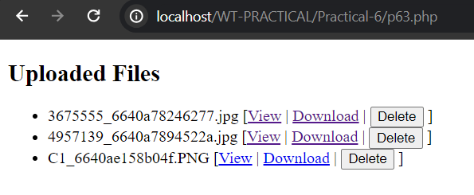**Output:**



