**GANPAT UNIVERSITY**

**U.V. PATEL COLLEGE OF ENGINEERING**

B.Tech 6th Semester CE/IT

2CEIT6PE1: Web Technology

**Practical-7**

**Aim:** **Perform following programs of PHP with database.**

**Exercise-1:**

How do you create a connection between PHP and MySQL explain its step by step Procedure?

**Code:**

<?php

$servername = "localhost";

$username = "root";

$password = "";

$dbname = "Pr7";

$conn = mysqli_connect($servername, $username, $password, $dbname);

if (!$conn) {

die("Connection failed: " . mysqli_connect_error());

}

echo "Connected successfully";

$sql = "create table student1 (id INT AUTO_INCREMENT, name VARCHAR(20) NOT NULL, ennrollment INT NOT NULL, primary key (id))";

if(mysqli_query($conn, $sql)){

echo "Student table created successfully";

}else{

echo "Could not create table: ". mysqli_error($conn);

}

mysqli_close($conn);

?>

**Output:**



**Exercise-2:**

Write a PHP Program to create database at run time by passing database name in text box.

**Code:**

<!DOCTYPE html>

<html>

<head>

<title>Create Database</title>

</head>

<body>

<h2>Create Database</h2>

<form method="post" action="">

Database Name: <input type="text" name="dbname">

<input type="submit" name="submit" value="Create">

</form>

<?php

if ($_SERVER["REQUEST_METHOD"] == "POST" && isset($_POST['submit'])) {

// Collect database name from the form

$dbname = $_POST['dbname'];

// Database connection parameters

$servername = "localhost";

$username = "root";

$password = "";

// Create connection

$conn = mysqli_connect($servername, $username, $password);

// Check connection

if (!$conn) {

die("Connection failed: " . mysqli_connect_error());

}

// Create database

$sql = "CREATE DATABASE IF NOT EXISTS $dbname";

if (mysqli_query($conn, $sql)) {

echo "Database created successfully";

} else {

echo "Error creating database: " . mysqli_error($conn);

}

// Close connection

mysqli_close($conn);

}

?>

</body>

</html>

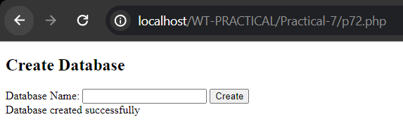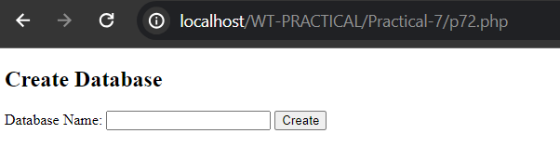**Output:**

**Exercise-3:**

Write a PHP Program to create Customer table at run time with C_Id, C_name, Name_Item_purchased and review_product fields.**Code:**

<?php

// Database connection parameters

$servername = "localhost";

$username = "root";

$password = "";

$dbname = "Pr7";

// Create connection

$conn = mysqli_connect($servername, $username, $password, $dbname);

// Check connection

if (!$conn) {

die("Connection failed: " . mysqli_connect_error());

}

// SQL to create customer table

$sql = "CREATE TABLE IF NOT EXISTS Customer1 (

C_Id INT(6) UNSIGNED AUTO_INCREMENT PRIMARY KEY,

C_name VARCHAR(30) NOT NULL,

Name_Item_purchased VARCHAR(50) NOT NULL,

review_product TEXT

)";

if (mysqli_query($conn, $sql)) {

echo "Customer table created successfully";

} else {

echo "Error creating table: " . mysqli_error($conn);

}

// Close connection

mysqli_close($conn);

?>

**Output:**

**Exercise-4:**

Write a PHP program to create ‘customer feedback form’ and store data

into Customer table.**Code:**

<!DOCTYPE html>

<html>

<head>

<title>Customer Feedback Form</title>

</head>

<body>

<h2>Customer Feedback Form</h2>

<form method="post" action="">

<label for="name">Name:</label><br>

<input type="text" id="name" name="name"><br>

<label for="item">Item Purchased:</label><br>

<input type="text" id="item" name="item"><br>

<label for="review">Review:</label><br>

<textarea id="review" name="review" rows="4" cols="50"></textarea><br><br>

<input type="submit" name="submit" value="Submit">

</form>

<?php

// Check if form is submitted

if ($_SERVER["REQUEST_METHOD"] == "POST" && isset($_POST['submit'])) {

// Retrieve form data

$name = $_POST['name'];

$item = $_POST['item'];

$review = $_POST['review'];

// Database connection parameters

$servername = "localhost";

$username = "root";

$password = "";

$dbname = "Pr7";

// Create connection

$conn = mysqli_connect($servername, $username, $password, $dbname);

// Check connection

if (!$conn) {

die("Connection failed: " . mysqli_connect_error());

}

// SQL query to insert feedback into Customer table

$sql = "INSERT INTO Customer (C_name, Name_Item_purchased, review_product) VALUES ('$name', '$item', '$review')";

// Execute query

if (mysqli_query($conn, $sql)) {

echo "Feedback submitted successfully";

} else {

echo "Error: " . $sql . "<br>" . mysqli_error($conn);

}

// Close connection

mysqli_close($conn);

}

?>

</body>

</html>

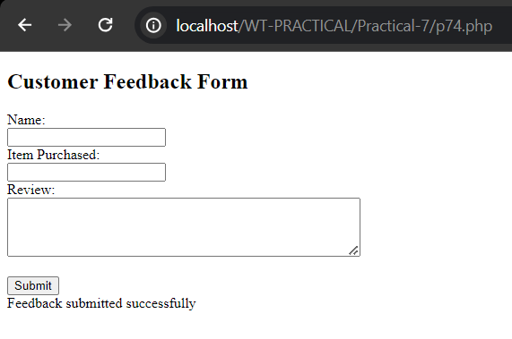**Output:**

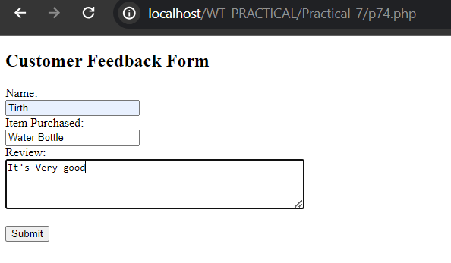

**Exercise-5:**

Write a PHP program to display information of Customer table with

well formatting (table form) on output screen.**Code:**

<!DOCTYPE html>

<html>

<head>

<title>Customer Information</title>

<style>

table {

border-collapse: collapse;

width: 100%;

}

th, td {

border: 1px solid black;

padding: 8px;

text-align: left;

}

th {

background-color: #f2f2f2;

}

</style>

</head>

<body>

<h2>Customer Information</h2>

<table>

<tr>

<th>C_Id</th>

<th>C_name</th>

<th>Name_Item_purchased</th>

<th>Review_product</th>

</tr>

<?php

// Database connection parameters

$servername = "localhost";

$username = "root";

$password = "";

$dbname = "Pr7";

// Create connection

$conn = mysqli_connect($servername, $username, $password, $dbname);

// Check connection

if (!$conn) {

die("Connection failed: " . mysqli_connect_error());

}

// SQL query to select all records from Customer table

$sql = "SELECT * FROM Customer";

$result = mysqli_query($conn, $sql);

// Check if there are records

if (mysqli_num_rows($result) > 0) {

// Output data of each row

while($row = mysqli_fetch_assoc($result)) {

echo "<tr>";

echo "<td>" . $row["C_Id"] . "</td>";

echo "<td>" . $row["C_name"] . "</td>";

echo "<td>" . $row["Name_Item_purchased"] . "</td>";

echo "<td>" . $row["review_product"] . "</td>";

echo "</tr>";

}

} else {

echo "<tr><td colspan='4'>No records found</td></tr>";

}

mysqli_close($conn);

?>

</table>

</body>

</html>

**Output:**

