**GANPAT UNIVERSITY**

**U.V. PATEL COLLEGE OF ENGINEERING**

B.Tech 6th Semester CE/IT

2CEIT6PE1: Web Technology

**Practical-9**

**Aim:** **Create Country State City Dropdown using Ajax in PHP MySQL.**

**Exercise-1:**

Create Country State City Dropdown using Ajax in PHP MySQL.

**Code:**

**Index.php**

<!DOCTYPE html>

<html>

<head>

<title>Country State City Dropdown</title>

<script src="https://ajax.googleapis.com/ajax/libs/jquery/3.5.1/jquery.min.js"></script>

</head>

<body>

<h1>Select Country, State, and City</h1>

<form id="myForm" method="post">

<label for="country">Country:</label>

<select id="country" name="country">

<option value="">Select Country</option>

<?php

$servername = "localhost";

$username = "root";

$password = "";

$dbname = "Pr9";

$conn = new mysqli($servername, $username, $password, $dbname);

if ($conn->connect_error) {

die("Connection failed: " . $conn->connect_error);

}

$sql = "SELECT id, name FROM countries";

$result = $conn->query($sql);

while($row = $result->fetch_assoc()) {

echo "<option value='" . $row['id'] . "'>" . $row['name'] . "</option>";

}

$conn->close();

?>

</select>

<label for="state">State:</label>

<select id="state" name="state">

<option value="">Select State</option>

</select>

<label for="city">City:</label>

<select id="city" name="city">

<option value="">Select City</option>

</select>

<button type="submit">Submit</button>

</form>

<br>

<h2>Selected Data</h2>

<table border="1" id="selectedData">

<tr>

<th>Country</th>

<th>State</th>

<th>City</th>

</tr>

</table>

<script>

$(document).ready(function() {

$('#country').change(function() {

var country_id = $(this).val();

$.ajax({

url: 'get_states.php',

type: 'GET',

data: {country_id: country_id},

dataType: 'json',

success: function(response) {

$('#state').empty().append('<option value="">Select State</option>');

$.each(response, function(index, state) {

$('#state').append('<option value="' + state.id + '">' + state.name + '</option>');

});

}

});

});

$('#state').change(function() {

var state_id = $(this).val();

$.ajax({

url: 'get_cities.php',

type: 'GET',

data: {state_id: state_id},

dataType: 'json',

success: function(response) {

$('#city').empty().append('<option value="">Select City</option>');

$.each(response, function(index, city) {

$('#city').append('<option value="' + city.id + '">' + city.name + '</option>');

});

}

});

});

$('#myForm').submit(function(e) {

e.preventDefault();

var country = $('#country option:selected').text();

var state = $('#state option:selected').text();

var city = $('#city option:selected').text();

$('#selectedData').append('<tr><td>' + country + '</td><td>' + state + '</td><td>' + city + '</td></tr>');

});

// Trigger country change to fetch states if a country is pre-selected

$('#country').trigger('change');

});

</script>

</body>

</html>

**Get_cities.php:**

<?php

$servername = "localhost";

$username = "root";

$password = "";

$dbname = "Pr9";

$conn = new mysqli($servername, $username, $password, $dbname);

if ($conn->connect_error) {

die("Connection failed: " . $conn->connect_error);

}

$state_id = intval($_GET['state_id']);

$sql = "SELECT id, name FROM cities WHERE state_id = $state_id";

$result = $conn->query($sql);

$cities = array();

while($row = $result->fetch_assoc()) {

$cities[] = $row;

}

$conn->close();

echo json_encode($cities);

?>

**Get_states.php:**

<?php

$servername = "localhost";

$username = "root";

$password = "";

$dbname = "pr9";

$conn = new mysqli($servername, $username, $password, $dbname);

if ($conn->connect_error) {

die("Connection failed: " . $conn->connect_error);

}

$country_id = intval($_GET['country_id']);

$sql = "SELECT id, name FROM states WHERE country_id = $country_id";

$result = $conn->query($sql);

$states = array();

while($row = $result->fetch_assoc()) {

$states[] = $row;

}

$conn->close();

echo json_encode($states);

?>

**Submit_data.php:**

<?php

$servername = "localhost";

$username = "root";

$password = "";

$dbname = "Pr9";

// Create connection

$conn = new mysqli($servername, $username, $password, $dbname);

// Check connection

if ($conn->connect_error) {

die("Connection failed: " . $conn->connect_error);

}

// Retrieve selected data from the form submission

$country = $_POST['country'];

$state = $_POST['state'];

$city = $_POST['city'];

// Insert the selected data into a table

$sql = "INSERT INTO selected_data (country, state, city) VALUES ('$country', '$state', '$city')";

if ($conn->query($sql) === TRUE) {

echo "Data inserted successfully";

} else {

echo "Error: " . $sql . "<br>" . $conn->error;

}

$conn->close();

?>

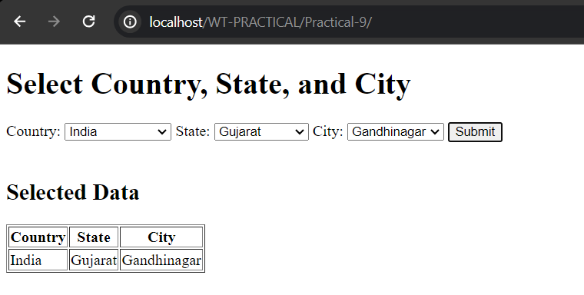**Output:**