Step 1: Create Simple Node.js App

1. Create a Project

C:\tirth-3093>mkdir load-balance-demo
C:\tirth-3093>cd load-balance-demo

C:\tirth-3093\load-balance-demo>npm init -y
(node:12140) ExperimentalWarning: CommonJS module C:\Program Files\nodejs\node_modules\npm\node_modules\debug\src\node.js is loading ES Module C:\Program Files\nodejs\node_modules\npm\node_modules\supports-color\index.js using require().
Support for loading ES Module in require() is an experimental feature and might change at any time
(Use `node --trace-warnings ...` to show where the warning was created)
Wrote to C:\Yash EX5\load-balance-demo\package.json:
{
"name": "load-balance-demo",
"version": "1.0.0",
"main": "index.js",
"scripts": {
"test": "echo \"Error: no test specified\" && exit 1"
},
"keywords": [],
"author": "",
"license": "ISC",
"description": ""
}

C:\tirth-3093\load-balance-demo>npm install express
(node:7004) ExperimentalWarning: CommonJS module C:\Program Files\nodejs\node_modules\npm\node_modules\debug\src\node.js is loading ES Module C:\Program Files\nodejs\node_modules\npm\node_modules\supports-color\index.js using require().
Support for loading ES Module in require() is an experimental feature and might change at any time
(Use `node --trace-warnings ...` to show where the warning was created)

added 65 packages, and audited 66 packages in 4s

22 packages are looking for funding
run `npm fund` for details
found 0 vulnerabilities

2. Create server.js

Terminal 1:

C:\tirth-3093\load-balance-demo>notepad index.js

Edit index.js:

const express = require("express");
const app = express();
const PORT = process.env.PORT || 3000;

app.get("/", (req, res) => {
res.send(`Response from Server running on port ${PORT}`);
});

app.listen(PORT, () => {
console.log(`Server running on port ${PORT}`);
});

3. Run the application node server.js

C:\tirth-3093\load-balance-demo>node index.js
Server running on port 3000
C:\tirth-3093\load-balance-demo>node index.js
Server running on port 3000

4. Create a Folder Load balancing

Terminal 2:

C:\tirth-3093\load-balance-demo>notepad index1.js

Edit index1.js:

const express = require("express");
const app = express();
const PORT = process.env.PORT || 3001;
app.get("/", (req, res) => {
res.send(`Response from Server running on port ${PORT}`);
});
app.listen(PORT, () => {
console.log(`Server running on port ${PORT}`);
});
Step 2: Run Multiple Servers

Open 2 terminals:

Terminal 1:

C:\tirth-3093\load-balance-demo>node index.js
Server running on port 3000
C:\tirth-3093\load-balance-demo>node index.js
Server running on port 3000

Terminal 2:

C:\tirth-3093\load-balance-demo>node index1.js
Server running on port 3001
C:\tirth-3093\load-balance-demo>node index1.js
Server running on port 3001

So we have now:

http://localhost:3000

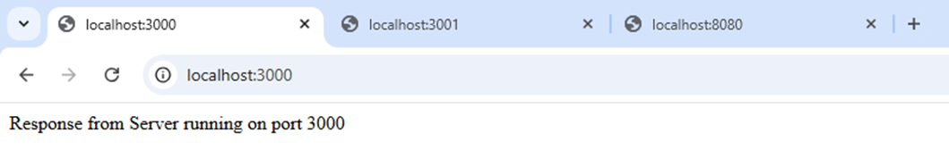
http://localhost:3001
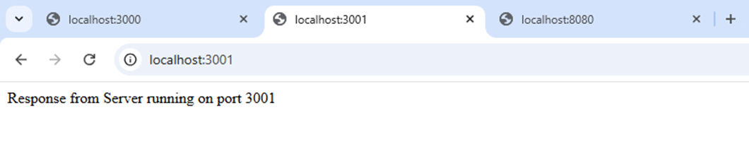
Step 3. Configure NGINX for Load Balancing

(Open nginx.conf and Modify http block)
events {
worker_connections 1024;
}
http {
upstream myapp {
server localhost:3000;
server localhost:3001;
}

server {
listen 8080;
server_name localhost;

location / {
proxy_pass http://myapp;
}
}
}
Step 4: Restart NGINX

Terminal 3:

C:\nginx-demo\nginx\nginx-1.28.2>nginx -s stop
C:\nginx-demo\nginx\nginx-1.28.2>nginx

Now open: http://localhost:8080
Refresh multiple times. You can check:



Step 5: Make Server 1 Slow

Modify Server running on PORT 3000:
const express = require("express");
const app = express();
const PORT = process.env.PORT || 3000;
app.get("/", (req, res) => {
setTimeout(() => {
res.send("Slow Server - Port 3000");
}, 5000);
});
app.listen(PORT, () => {
console.log(`Server running on port ${PORT}`);
});

Keep Server 2 normal:

const express = require("express");
const app = express();
const PORT = process.env.PORT || 3001;
app.get("/", (req, res) => {
res.send("Fast Server - Port 3001");
});
app.listen(PORT, () => {
console.log(`Server running on port ${PORT}`);
});

Step 6. Do Testing

Server 1 need 5 second to load on 3000

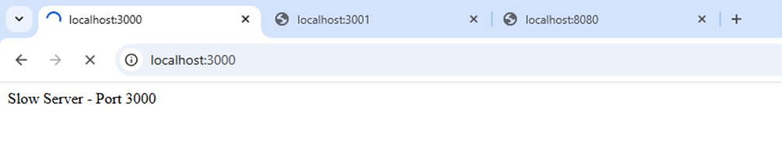
Server 2 as it is Fast on 3000

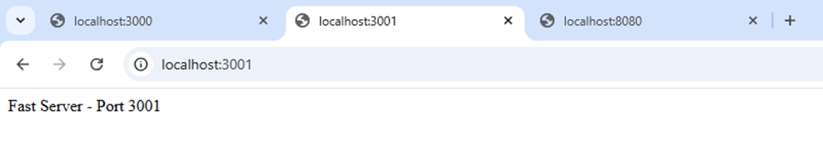
Open: http://localhost:8080 Now refresh quickly multiple times.
Even though server 3000 is slow, NGINX still keeps sending every alternate request to it.
Server 1 need 5 second to load
Server 2 as it is Fast


Step 7: Now Change default algo of nginx(i.e. from round robin) to Least Connections and test again

Modify nginx.conf file:
events {
worker_connections 1024;
}
http {
upstream myapp {
least_conn;
server localhost:3000;
server localhost:3001;
}
server {
listen 8080;
server_name localhost;

location / {
proxy_pass http://myapp;
}
}
}

Restart NGINX:

C:\nginx-demo\nginx\nginx-1.28.2>nginx -s stop
C:\nginx-demo\nginx\nginx-1.28.2>nginx

Open: http://localhost:8080 Refresh quickly multiple times quickly.
When slow server (3000) is busy for 5 seconds:
It has an active connection.
So NGINX sees:
Server 3000 → 1 active connection
Server 3001 → 0 active connections

So it sends new requests to:
Fast Server (3001)



