Test API
Get:https://jsonplaceholder.typicode.com/posts
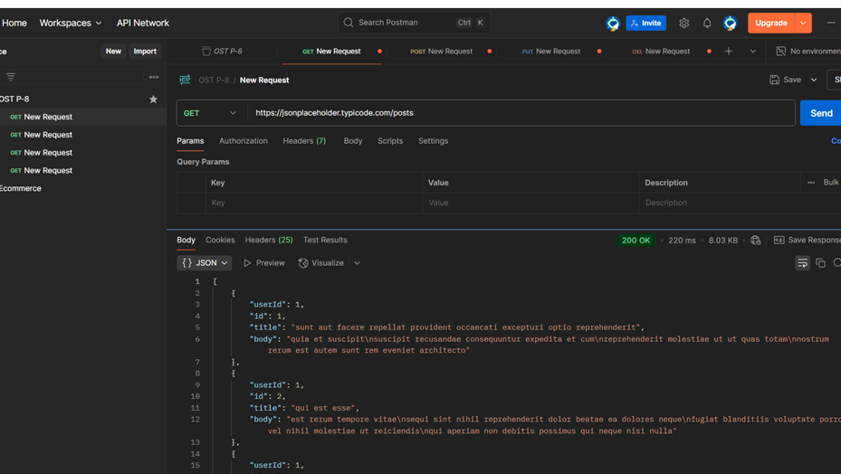
Post:https://jsonplaceholder.typicode.com/posts
{
"title": "Tirth-093",
"body": "This is a sample post",
"userId": 1
}
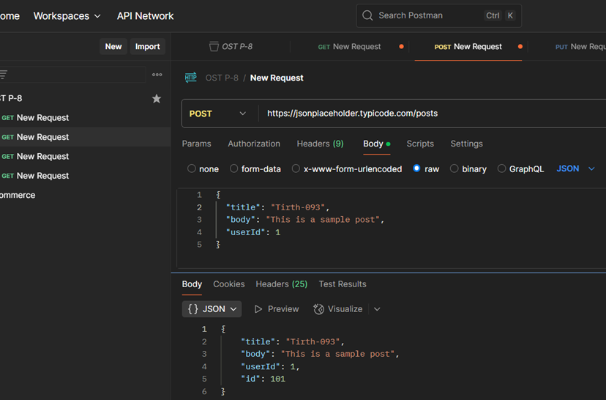
Put:https://jsonplaceholder.typicode.com/posts/1
{
"id": 1,
"title": "Updated Title",
"body": "Tirth Bhut-3093",
"userId": 1
}
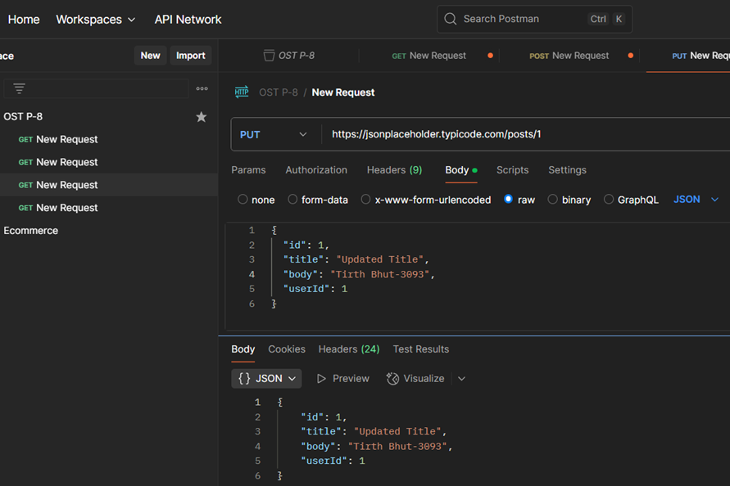

Delete:https://jsonplaceholder.typicode.com/posts/1

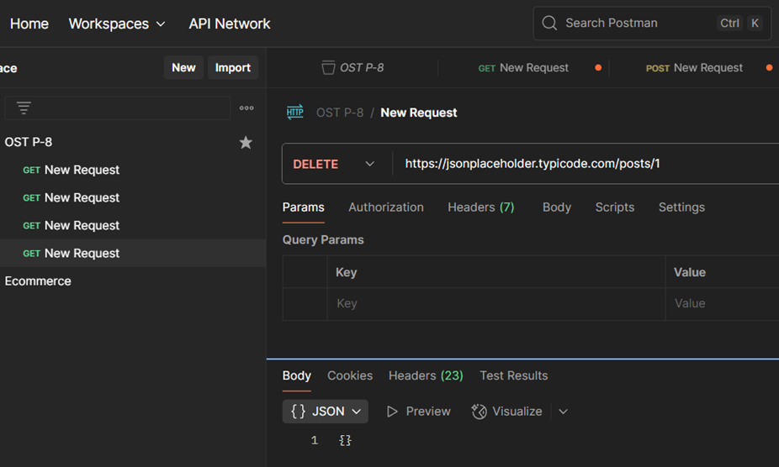
Create node.js API
C:\Users\tirth\OneDrive\Desktop\tirth-3093>mkdir simple-api

C:\Users\tirth\OneDrive\Desktop\tirth-3093>cd simple-api

C:\Users\tirth\OneDrive\Desktop\tirth-3093\simple-api>npm init -y
Wrote to C:\Users\tirth\OneDrive\Desktop\tirth-3093\simple-api\package.json:
{
"name": "simple-api",
"version": "1.0.0",
"main": "index.js",
"scripts": {
"test": "echo \"Error: no test specified\" && exit 1"
},
"keywords": [],
"author": "",
"license": "ISC",
"description": ""
}

C:\Users\tirth\OneDrive\Desktop\tirth-3093\simple-api>npm install express

added 65 packages, and audited 66 packages in 4s

22 packages are looking for funding
run `npm fund` for details

found 0 vulnerabilities

C:\Users\tirth\OneDrive\Desktop\tirth-3093\simple-api>notepad server.js

const express = require('express');
const app = express();

// Middleware to parse JSON bodies
app.use(express.json());

// In-memory data (acts like our database)
let students = [
{ id: 1, name: "Viraj", branch: "CE" },
{ id: 2, name: "Ravi", branch: "CE" }
];

// 1. GET all students
app.get('/students', (req, res) => {
res.json(students);
});

// 2. GET single student
app.get('/students/:id', (req, res) => {
const student = students.find(s => s.id == req.params.id);
res.json(student);
});

// 3. POST - Add student
app.post('/students', (req, res) => {
const newStudent = {
id: students.length + 1,
name: req.body.name,
branch: req.body.branch
};
students.push(newStudent);
res.status(201).json(newStudent);
});

// 4. PUT - Update student
app.put('/students/:id', (req, res) => {
const student = students.find(s => s.id == req.params.id);
if (student) {
student.name = req.body.name;
student.branch = req.body.branch;
res.json(student);
} else {
res.status(404).json({ message: "Student not found" });
}
});

// 5. DELETE - Remove student
app.delete('/students/:id', (req, res) => {
students = students.filter(s => s.id != req.params.id);
res.json({ message: "Student deleted" });
});

// Start server
app.listen(3000, () => {
console.log("Server running on http://localhost:3000");
});

C:\Users\tirth\OneDrive\Desktop\tirth-3093\simple-api>node server.js
Server running on http://localhost:3000

Procedure TEST using postman

1.GetAll:

Get:http://localhost:3000/students
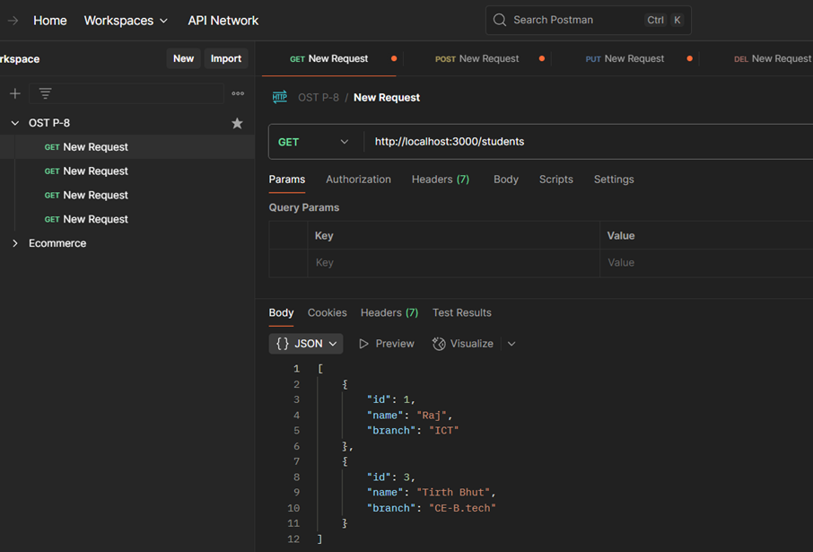
2. Post:http://localhost:3000/students
Body:
{
"name": "Tirth Bhut",
"branch": "CE-B.tech"
}
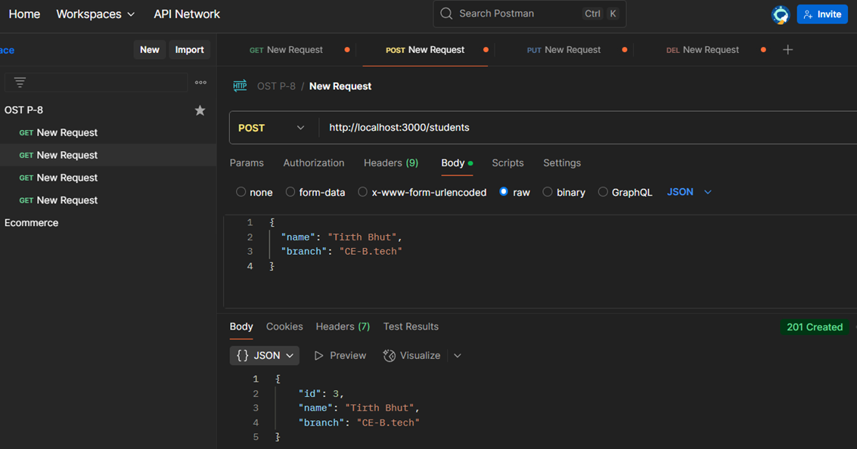
3. Put request:http://localhost:3000/students/1
Body:
{
"name": "Raj",
"branch": "ICT"
}
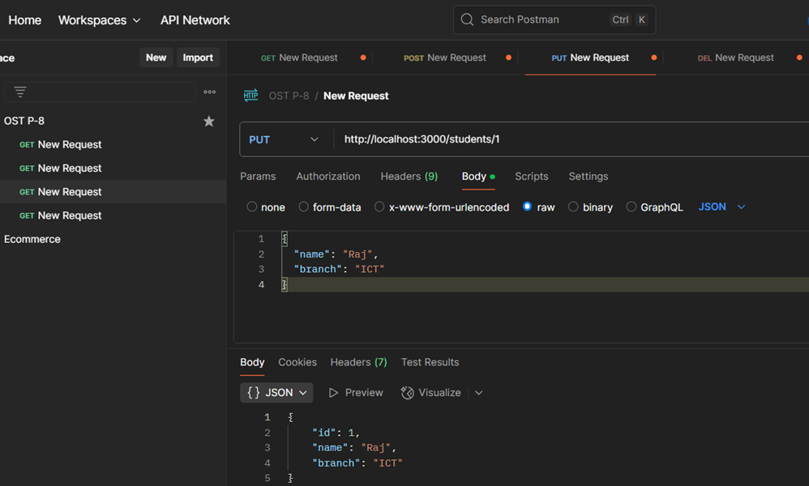
4. Delete request:http://localhost:3000/students/2
