C:\Users\tirth\OneDrive\Desktop\tirth-3093>pip install pytest
Defaulting to user installation because normal site-packages is not writeable
Requirement already satisfied: pytest in c:\users\tirth\appdata\local\packages\pythonsoftwarefoundation.python.3.13_qbz5n2kfra8p0\localcache\local-packages\python313\site-packages (9.0.2)
Requirement already satisfied: colorama>=0.4 in c:\users\tirth\appdata\local\packages\pythonsoftwarefoundation.python.3.13_qbz5n2kfra8p0\localcache\local-packages\python313\site-packages (from pytest) (0.4.6)
Requirement already satisfied: iniconfig>=1.0.1 in c:\users\tirth\appdata\local\packages\pythonsoftwarefoundation.python.3.13_qbz5n2kfra8p0\localcache\local-packages\python313\site-packages (from pytest) (2.3.0)
Requirement already satisfied: packaging>=22 in c:\users\tirth\appdata\local\packages\pythonsoftwarefoundation.python.3.13_qbz5n2kfra8p0\localcache\local-packages\python313\site-packages (from pytest) (26.0)
Requirement already satisfied: pluggy<2,>=1.5 in c:\users\tirth\appdata\local\packages\pythonsoftwarefoundation.python.3.13_qbz5n2kfra8p0\localcache\local-packages\python313\site-packages (from pytest) (1.6.0)
Requirement already satisfied: pygments>=2.7.2 in c:\users\tirth\appdata\local\packages\pythonsoftwarefoundation.python.3.13_qbz5n2kfra8p0\localcache\local-packages\python313\site-packages (from pytest) (2.20.0)

[notice] A new release of pip is available: 25.3 -> 26.0.1
[notice] To update, run:
C:\Users\tirth\AppData\Local\Microsoft\WindowsApps\PythonSoftwareFoundation.Python.3.13_qbz5n2kfra8p0\python.exe -m pip install --upgrade pip

C:\Users\tirth\OneDrive\Desktop\tirth-3093>pytest --version
pytest 9.0.2

C:\Users\tirth\OneDrive\Desktop\tirth-3093>mkdir PythonDemo

C:\Users\tirth\OneDrive\Desktop\tirth-3093>cd PythonDemo

C:\Users\tirth\OneDrive\Desktop\tirth-3093\PythonDemo>notepad pythondemo.py

# pythondemo.py

def add(a, b):
return a + b

def subtract(a, b):
return a - b

def multiply(a, b):
return a * b

def divide(a, b):
if b == 0:
raise ValueError("Cannot divide by zero")
return a / b

def is_even(num):
return num % 2 == 0

C:\Users\tirth\OneDrive\Desktop\tirth-3093\PythonDemo>notepad test_pythondemo.py

# test_pythondemo.py
import pytest
import pythondemo

# Passing test
def test_add():
assert pythondemo.add(2, 3) == 5

# Failing test (Written to fail on purpose as per the manual)
def test_multiply_fail():
assert pythondemo.multiply(4, 3) == 11

# Exception test
def test_divide_by_zero():
with pytest.raises(ValueError):
pythondemo.divide(10, 0)

# Logical test
def test_is_even():
assert pythondemo.is_even(4) is True
assert pythondemo.is_even(5) is False

# Parametrized test
@pytest.mark.parametrize("a,b,result", [
(1, 2, 3),
(2, 2, 4),
(5, 5, 11) # failing case
])
def test_add_param(a, b, result):
assert pythondemo.add(a, b) == result

C:\Users\tirth\OneDrive\Desktop\tirth-3093\PythonDemo>pytest -v
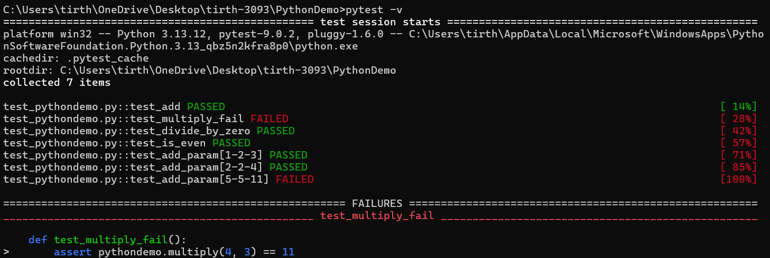

Task 1:
Add a function:

def factorial(n):

def factorial(n):
if n < 0:
raise ValueError("Factorial is not defined for negative numbers")
if n == 0 or n == 1:
return 1

result = 1
for i in range(2, n + 1):
result *= i
return result

Write test cases:

import pytest
import pythondemo

# Task 1: Normal test case
def test_factorial_normal():
assert pythondemo.factorial(5) == 120

# Task 2: Test case for negative numbers (Exception handling)
def test_factorial_negative():
with pytest.raises(ValueError):
pythondemo.factorial(-5)

# Task 2: Test case for large inputs
def test_factorial_large_input():
assert pythondemo.factorial(10) == 3628800

