PS C:\Users\student\Desktop\tirth-3093> pip install django
Defaulting to user installation because normal site-packages is not writeable
Collecting django
Downloading django-6.0.3-py3-none-any.whl.metadata (3.9 kB)
Collecting asgiref>=3.9.1 (from django)
Downloading asgiref-3.11.1-py3-none-any.whl.metadata (9.3 kB)
Collecting sqlparse>=0.5.0 (from django)
Downloading sqlparse-0.5.5-py3-none-any.whl.metadata (4.7 kB)
Collecting tzdata (from django)
Downloading tzdata-2025.3-py2.py3-none-any.whl.metadata (1.4 kB)
Downloading django-6.0.3-py3-none-any.whl (8.4 MB)
━━━━━━━━━━━━━━━━━━━━━━━━━━━━━━━━━━━━━━━━ 8.4/8.4 MB 869.7 kB/s eta 0:00:00
Downloading sqlparse-0.5.5-py3-none-any.whl (46 kB)
Downloading tzdata-2025.3-py2.py3-none-any.whl (348 kB)
Installing collected packages: tzdata, sqlparse, asgiref, django
WARNING: The script sqlformat.exe is installed in 'C:\Users\student\AppData\Roaming\Python\Python313\Scripts' which is not on PATH.
WARNING: The script django-admin.exe is installed in 'C:\Users\student\AppData\Roaming\Python\Python313\Scripts' which is not on PATH.
Consider adding this directory to PATH or, if you prefer to suppress this warning, use --no-warn-script-location.
Successfully installed asgiref-3.11.1 django-6.0.3 sqlparse-0.5.5 tzdata-2025.3

[notice] A new release of pip is available: 24.3.1 -> 26.0.1
[notice] To update, run: python.exe -m pip install --upgrade pip

PS C:\Users\student\Desktop\tirth-3093> python -m django startproject myproject

PS C:\Users\student\Desktop\tirth-3093> cd myproject

PS C:\Users\student\Desktop\tirth-3093\myproject> python manage.py runserver
Watching for file changes with StatReloader
Performing system checks...

System check identified no issues (0 silenced).

April 02, 2026 - 12:00:13
Django version 6.0.3, using settings 'myproject.settings'
Starting development server at http://127.0.0.1:8000/
Quit the server with CTRL-BREAK.
For more information on production servers see: https://docs.djangoproject.com/en/6.0/howto/deployment/
[02/Apr/2026 12:01:14] "GET / HTTP/1.1" 200 12068
Not Found: /favicon.ico
[02/Apr/2026 12:01:15] "GET /favicon.ico HTTP/1.1" 404 2211

Open browser:
http://127.0.0.1:8000/
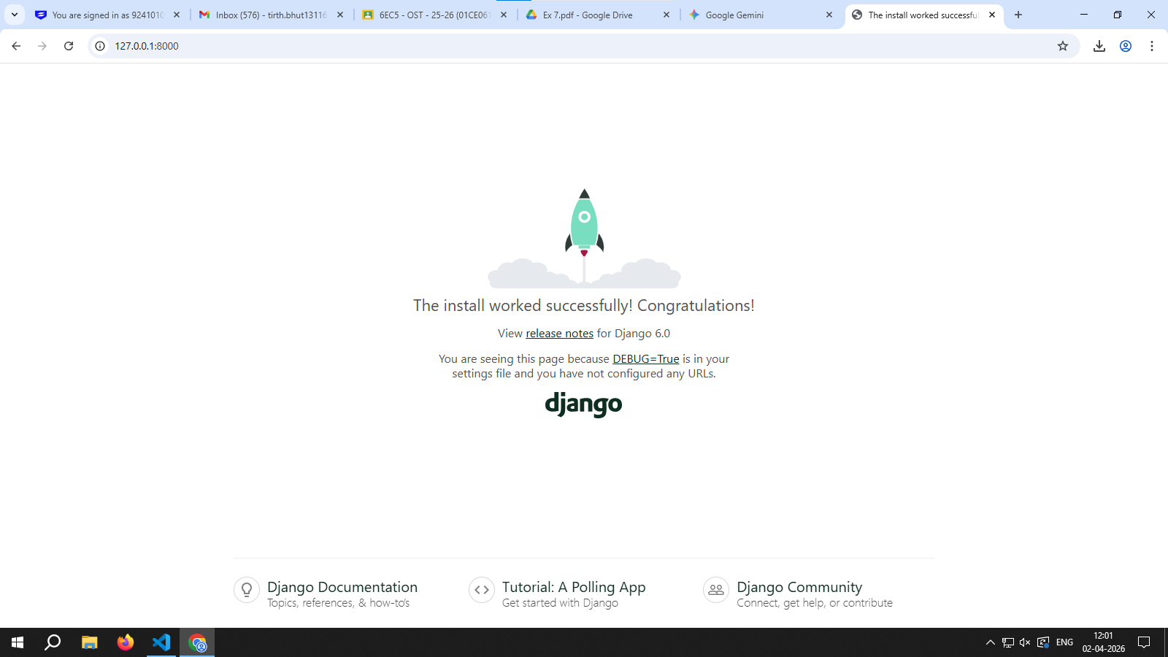

PS C:\Users\student\Desktop\tirth-3093\myproject> python manage.py startapp myapp

Register App:
Open: myproject/settings.py and include the below code:

INSTALLED_APPS = [
'django.contrib.admin',
'django.contrib.auth',
'django.contrib.contenttypes',
'django.contrib.sessions',
'django.contrib.messages',
'django.contrib.staticfiles',
'myapp', # your app
]

Create Simple View
Open: myapp/views.py and include below code:

from django.http import HttpResponse
def home(request):
return HttpResponse("Hello from VS Code Django!")

Create URL File
Create file: myapp/urls.py and include below code:

from django.urls import path

from . import views
urlpatterns = [
path('', views.home),
]

Connect URLs
Open: myproject/urls.py include below code:

from django.contrib import admin
from django.urls import path, include
urlpatterns = [
path('', include('myapp.urls')),
path('admin/', admin.site.urls),
]

PS C:\Users\student\Desktop\tirth-3093\myproject> python manage.py runserver
Watching for file changes with StatReloader
Performing system checks...

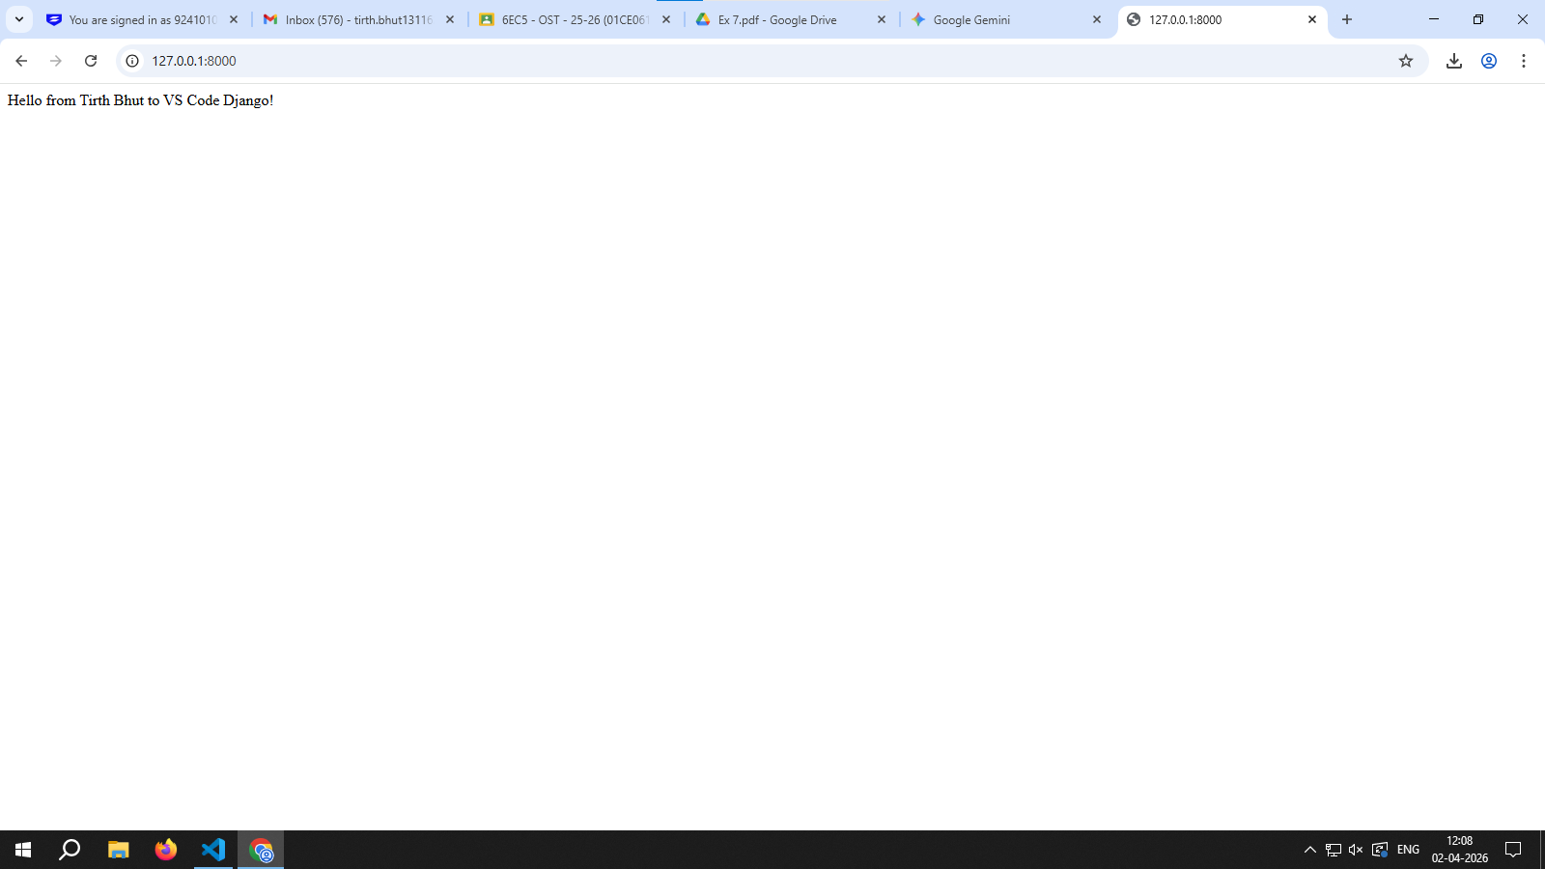
add GUI:

Create Template Folder
Inside this new templates folder, create an HTML file named home.html

<!DOCTYPE html>
<html>
<head>
<title>Django GUI Demo</title>
</head>
<body style="font-family: Arial; text-align: center;">
<h1 style="color: blue;">Welcome to Django GUI - Tirth Bhut(3093)</h1>
<p>This is a simple interface created using HTML</p>
<button onclick="alert('Hello!!!')">
Click Me
</button>
</body>
</html>

Update views.py
Open: myapp/views.py and include below code:

from django.shortcuts import render
def home(request):
return render(request, 'home.html')

PS C:\Users\student\Desktop\tirth-3093\myproject> python manage.py runserver
Watching for file changes with StatReloader
Performing system checks...

