Download, install, and open the OWASP ZAP application, then navigate to the Quick Start tab on the main screen and click on Automated Scan.

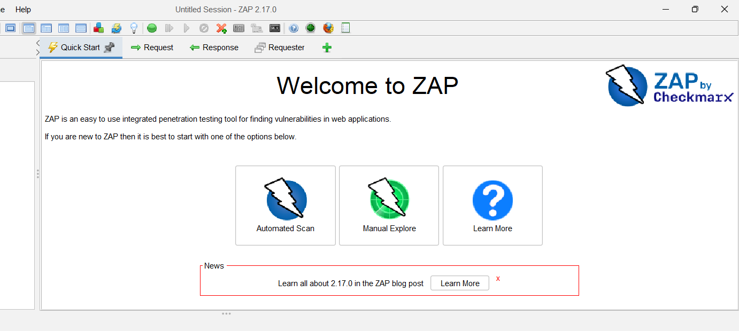

In the URL field, enter the safe demo site (http://zero.webappsecurity.com) and click the Attack button.

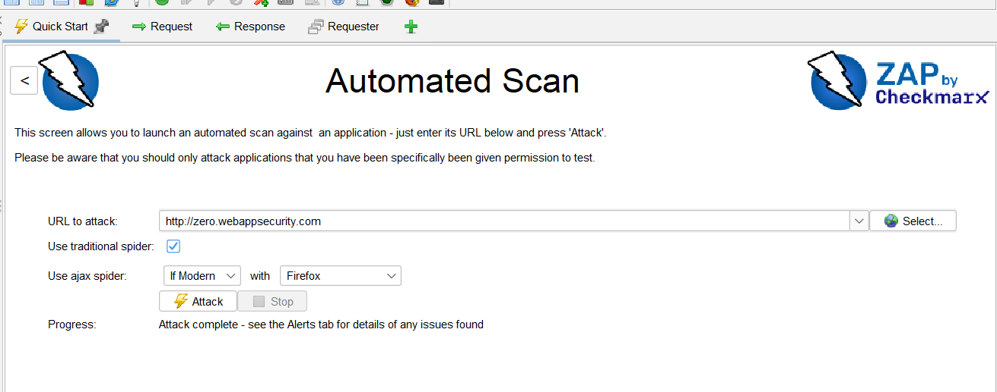

Review Results Once the scan is complete, review the bottom panel using the following tabs:

Active Scan
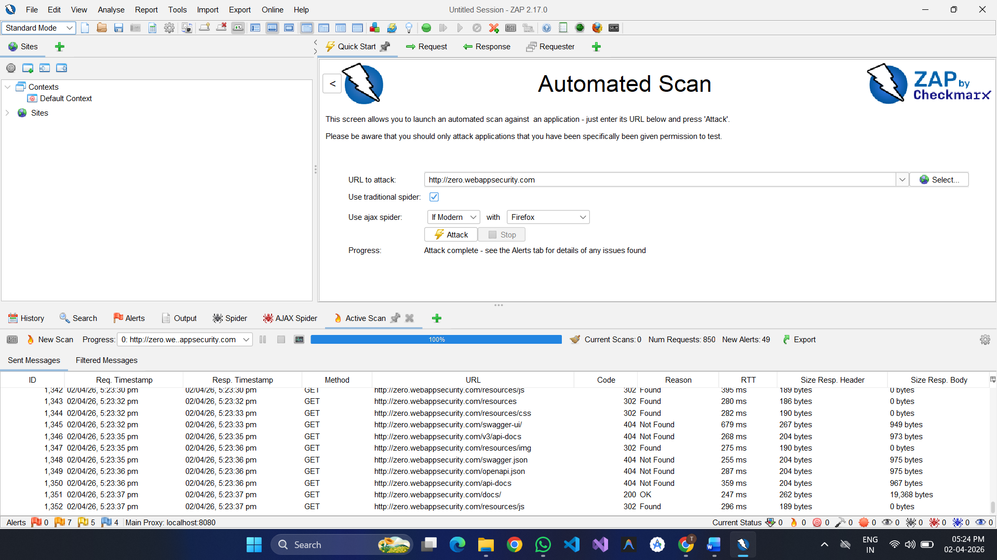

Alerts

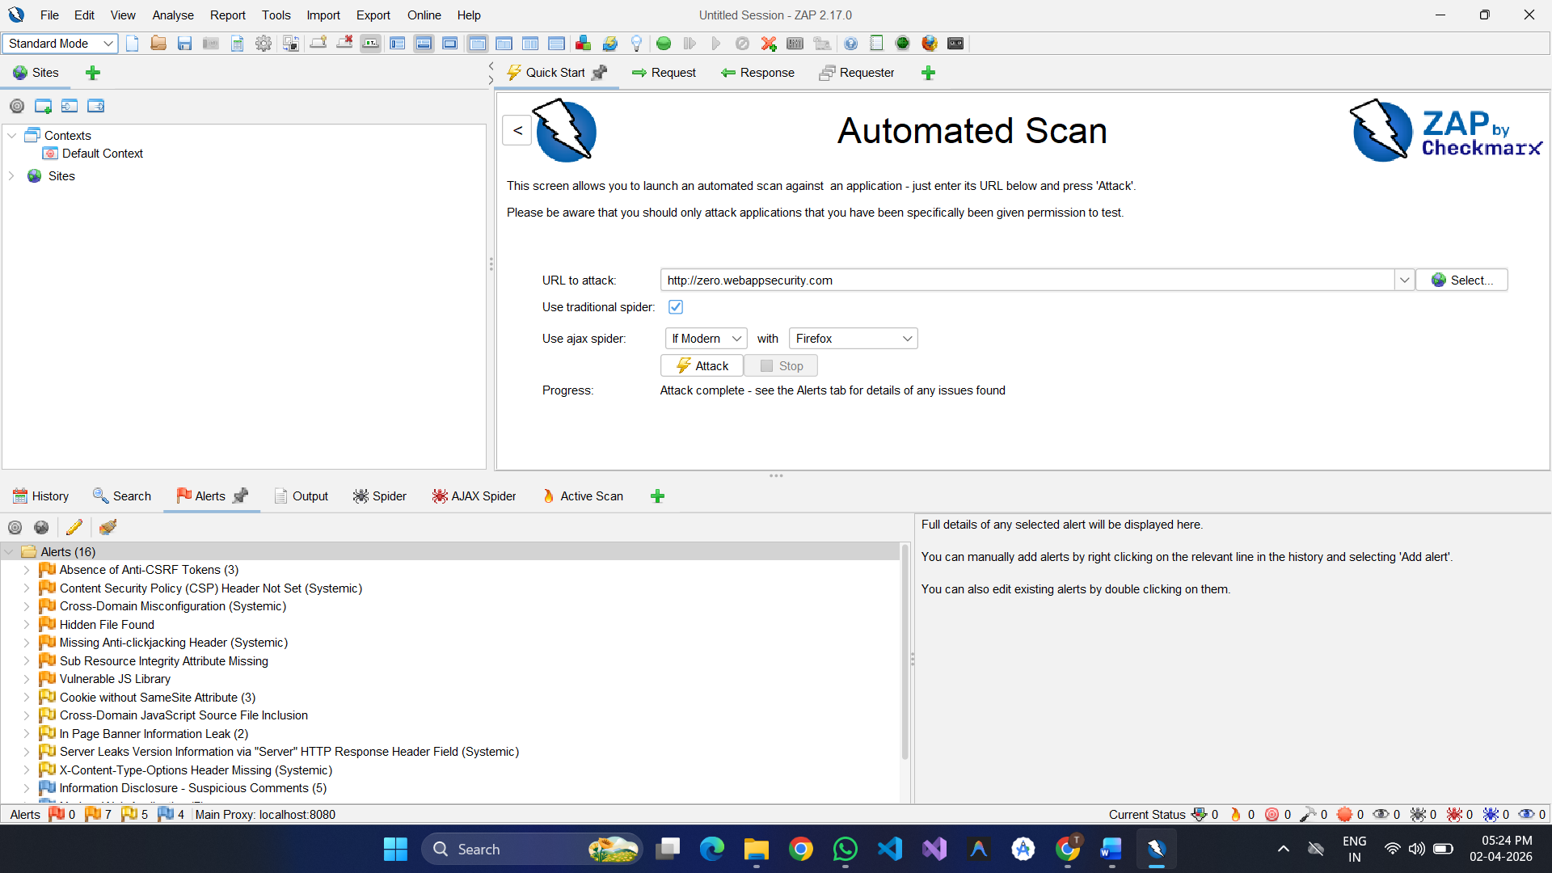

Risk levels:
High
Medium
Low
