**Lab Practical #8:**

Study & Survey of Institute organization network infrastructure.

**Practical Assignment #8:**

1. **Identify type of network in your institute. Draw a design of network in your institute (Any Lab/Floor/Building).**

Lab No: C- 302s

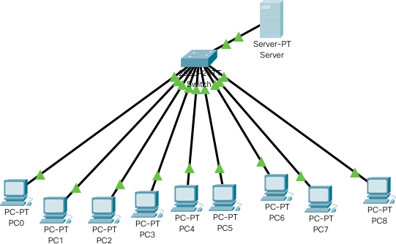**Topology:** Star Topology

1. **List how many network devices and types of cable used and give its details.**

**Network Devices:**

1. **Router**
   * Connects different networks and routes data packets between them, such as between a local network and the internet.
2. **Switch**
   * Connects multiple devices within the same network and directs data to the correct destination device.
3. **Firewall**
   * Provides network security by monitoring and controlling incoming and outgoing traffic based on predetermined rules.
4. **Access Point (AP)**
   * Provides wireless network connectivity for devices to connect to a wired network.
5. **Network Interface Card (NIC)**
   * Hardware installed in devices to enable network connectivity.
6. **Modem**
   * Modulates and demodulates signals for internet access over telephone lines or other communication mediums.
7. **Load Balancer**
   * Distributes network or application traffic across multiple servers to ensure reliability and performance.

**Types of Cables:**

1. **Ethernet Cable (Twisted Pair - Cat5e, Cat6, Cat6a)**
   * Used for wired network connections; twisted pairs reduce interference and support high-speed data transfer.
2. **Fiber Optic Cable**
   * Uses light to transmit data at very high speeds over long distances with minimal signal loss.
3. **Coaxial Cable**
   * Used in some legacy network setups; carries data via electrical signals within a single conductor surrounded by shielding.
4. **Console Cable (RJ45 to Serial)**
   * Used to connect network devices like switches and routers to a computer for configuration.