

Group - 28
SYSTEM TESTING
Testers: Kirtan Chauhan and Ruchir Joshi

BlackBox Testing : Dashboard page

1. Dashboard Constraints
Total Expenses
- It Should display the total expenses for the current month by default.
- It Should update when a valid date range is selected from the calendar.
- If there is no expenses in the selected range, total should show ₹0.
- Future dates cannot be selected.
You Owe
- Will show the amount the user owes.
- Value should always be >=0.
- If value is 0, message should show “All settled up”.
You Are Owed
- Will show the amount other owes to the user.
- Value should always be >=0.
- If value is 0, than the message should show “All settled up”.
Monthly Budget
- User can only save a positive budget.
- After saving, the progress ring and remaining amount should be updated.
Monthly Savings
- Should be 0 or above (cannot show negative savings).
- Will show over budget If you have spent more than your budget otherwise will show the remaining budget.
- Should be updated whenever expenses change.
Expense Categories (Pie Chart)
- Category-wise total expense should be displayed.
- If no categories exist, “No data for this month” message will be shown.
Daily Spend Trend (Bar Chart)
- Should show day wise total spendings for the curent month by default.
- The values on the chart must match the actual expense per day in that range.
- If there are no expenses in the selected range it should show “No data to display” or an empty chart (but no error).

2. Equivalence Class Partitioning (ECP)

Equivalence Class | Total Expenses | You Owe / You Are Owed | Budget | Categories | Result
E1 | valid | valid (≥0) | valid (>0) | valid data | success
E2 | valid | valid | invalid (empty / non-numeric / ≤0) | valid | budget error
E3 | no expenses in range | valid | valid | empty categories | show zeros / no-data
E4 | valid | invalid negative input | valid | valid | error (should not display negative)
E5 | invalid date selection | valid | valid | valid | error / no update
E6 | valid | valid | valid | no data for month | pie chart shows empty state

3. Boundary Value Analysis (BVA)

Input | Value | Expected Output | Reason
Date Range | same start & end date | show that day’s total | single-day filter
Date Range | range with no expenses | total = ₹0 | empty result
Date Range | selecting future date | not allowed | future disabled
Budget | 0 | cannot save | must be > 0
Budget | minimal positive value (e.g., 1) | saved | lowest valid input
Budget | non-numeric | error | invalid input
You Owe | 0 | “All settled up!” | zero boundary
You Are Owed | 0 | “All settled up!” | zero boundary
Categories | all values zero | chart shows no-data state | empty data case
You Owe | ₹150.00 | Card shows ₹150.00 + “Settlement needed” | positive owe boundary
You Are Owed | ₹200.00 | Card shows ₹200.00 + “Awaiting repayment” | positive owed boundary
Daily Spend Trend | No expenses in range | Show “No data to display” | empty chart boundary
Daily Spend Trend | Single day expenses | Show single bar for that date | lowest valid data case
Monthly Savings | Budget = Expenses | Savings = ₹0 | zero boundary
Monthly Savings | Expenses exceed Budget | Show ₹0 | negative prevention boundary

Acceptance Testing — Dashboard Page

Test 1 — Default Month Total Display
Action: Open the Dashboard (no date range selected).
Expected Output:
- Total Expenses card shows the current month total (e.g., ₹1199.97).
- Subtext shows “This month's total”.
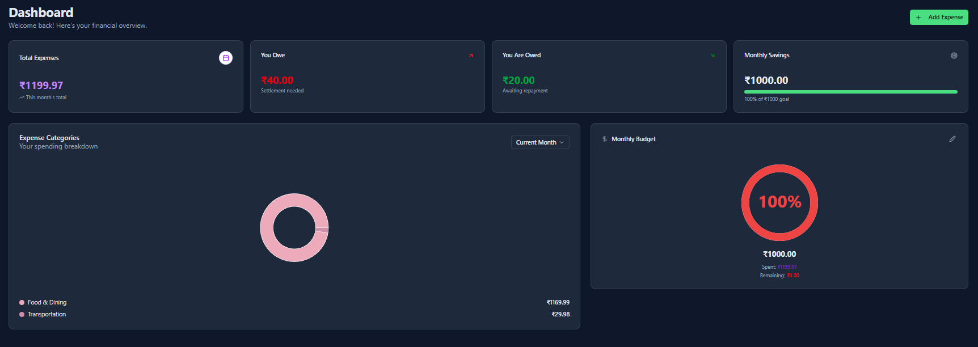

Test 2 — Date Range Filter (multiple days)
Action: Click calendar on Total Expenses → select a valid start date and end date (e.g., 17 Nov 2025 → 19 Nov 2025) → Apply.
Expected Output:
- Total Expenses updates to show the sum for that range.
- Right-side list in the calendar modal shows all transactions in that range and the total (e.g., shows 12 transactions and ₹1199.97).
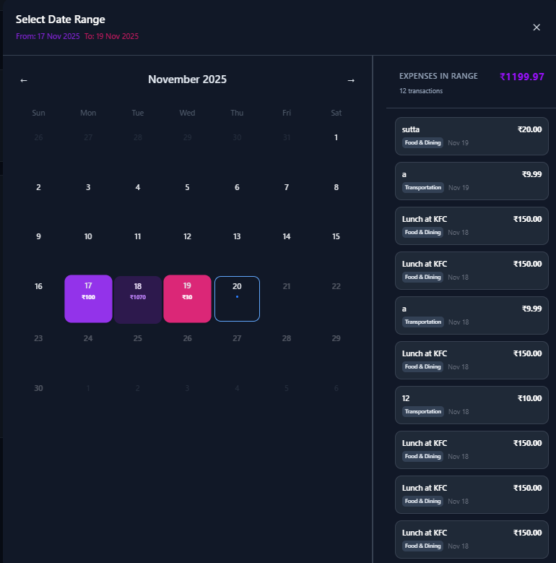

Test 3 — You Owe > 0
Precondition: Create or use a test group state where the user owes ₹40.00.
Action: Open Dashboard.
Expected Output:
- “You Owe” card shows ₹40.00.
- Subtext shows “Settlement needed”.


Test 4 — You Are Owed > 0
Precondition / Setup: Create or use a test group state where others owe the user ₹20.00.
Action: Open Dashboard.
Expected Output:
- “You Are Owed” card shows ₹20.00.
- Subtext shows “Awaiting repayment”.

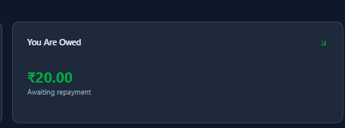

Test 5 — Monthly Budget Save (valid & invalid)
Step A — Valid Save:
Action: Click on Monthly Budget → enter 1000 → Save.
Expected Output:
- Budget saves successfully.
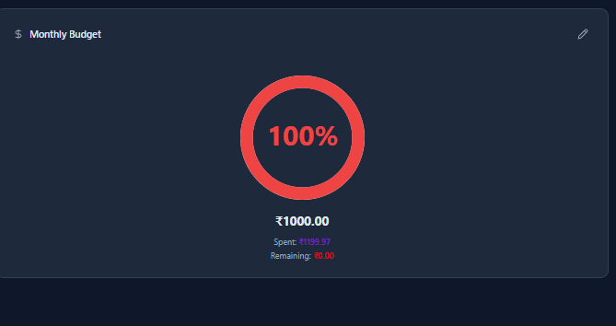

Step B — Invalid Save:
Action: Click pencil → enter 0 or abc → Save.
Expected Output:
- Save is rejected (alert message).
- Budget remains unchanged.
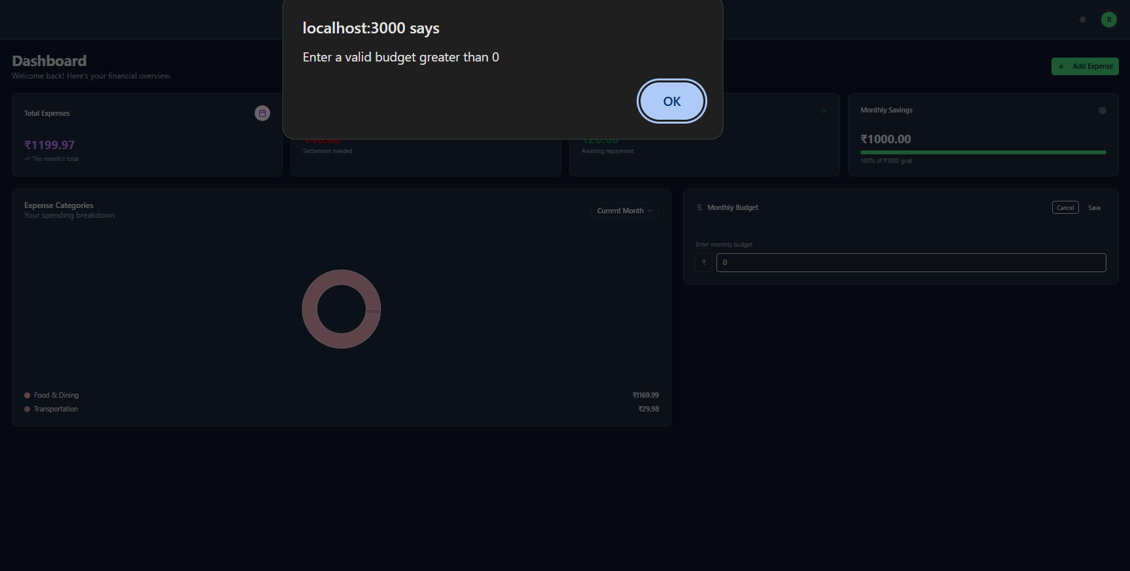

Test 6 — Monthly Savings

Precondition: Budget set to ₹2,000 and existing expenses = ₹1241.97
Expected Result:
- Monthly Savings should be ₹758.03.

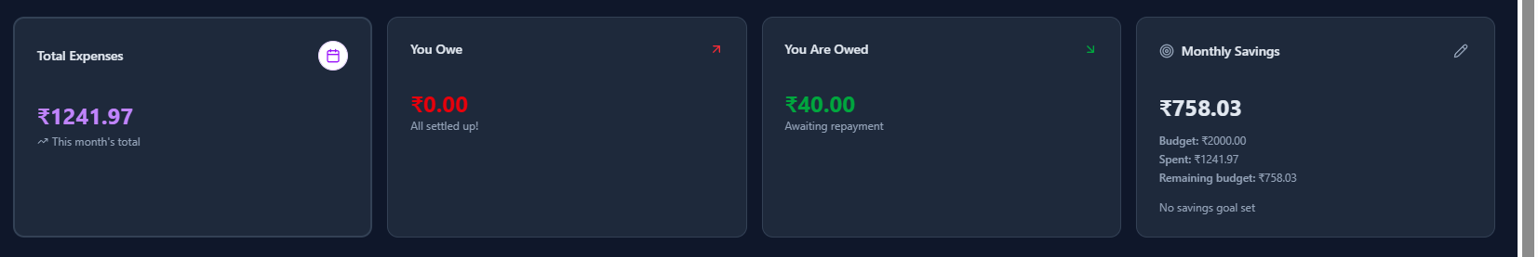

Test 7 — Expense Categories
Categories Display:
Action: On Dashboard, set the period to Current Month (or the Previous Month) by using the dropdown option.
Expected Output:
Pie chart gets updated to show the category divisons and the totals (if there is no data than it will “No data for this month” if empty).
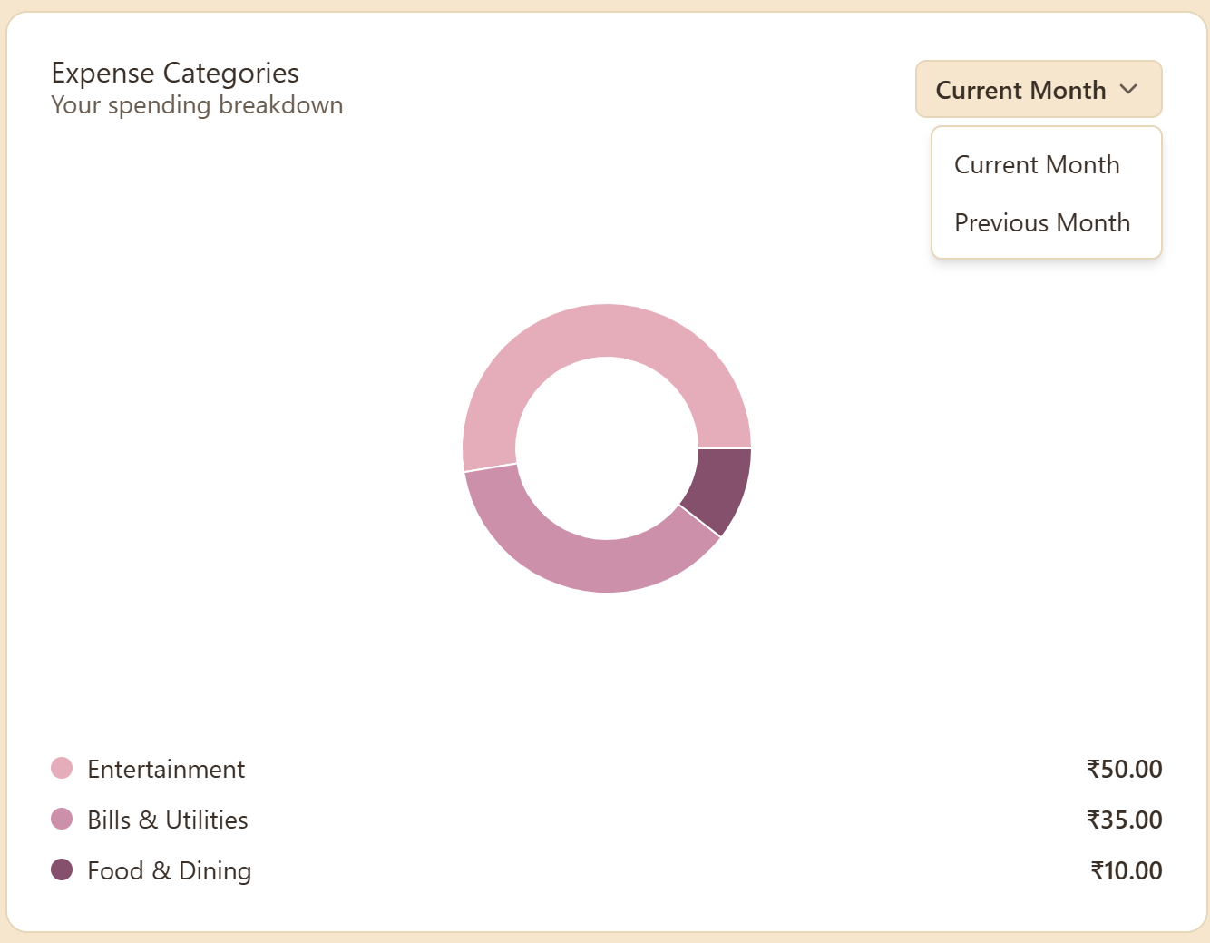
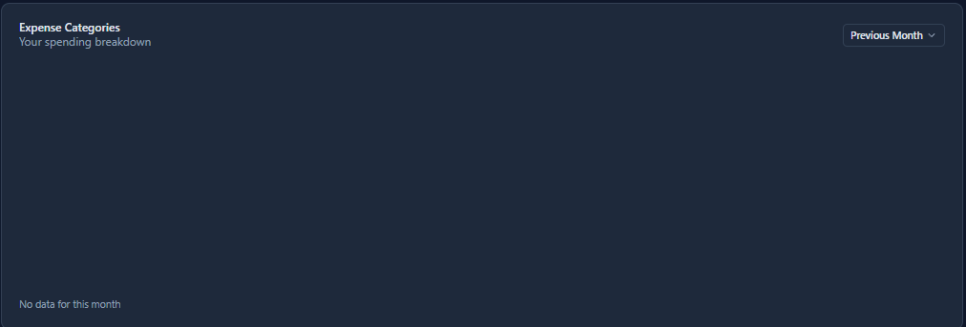

Test 8 – Daily Spend Trend
Precondition:
- Expense have been added by user on multiple days of the month.
Expected Result:
- No point is shown for days with no expense in that range.
- The bars should match exactly with the amount spend on that day.
- When Hovered over the Line , it shows the the amount
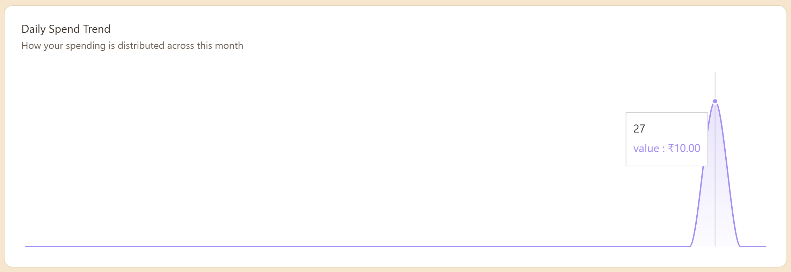
Test 9 —Add Expense Navigation
Add Expense Navigation:
Action: On clicking the Add Expense button
Output:
- App should navigate to the add expense page.
