
Groups - 28
SYSTEM TESTING – GROUPS SECTION
Testers: Kirtan Chauhan and Ruchir Joshi

1. Introduction
This document presents the system testing of the Groups module, which includes the Groups listing page and the Group Details page.

2. BlackBox Testing — Groups

2.1 Groups Test
UI Constraints
Create Group – Group Name
- Group Name cannot be empty.
- Must contain at least one non-space character.
Search Groups
- Any text input is valid
- If search box is empty , all groups are shown.
Delete Group
- Clicking the delete (trash) icon opens a confirmation dialog.
- “Cancel” → closes dialog and does not remove the group.
- “Delete” → removes that group from the list.
Navigation Buttons
- “View Details” → opens Group Detail page for that group.
- “Add Expense” → opens Add Expense page for that specific group.

2.2 Equivalence Class Partitioning (ECP) – Create Group

Equivalence Class | Group Name Input | Result
E1 | Valid text (e.g. "Trip") | success
E2 | Empty string | error
E3 | Only spaces (" ") | error

2.3 Boundary Value Analysis (BVA) – Groups Page

Group Name | Search Term | Delete Choice | Output |  | Reason
"" | none | – | Group not created, error shown |  | Name cannot be empty
" " | none | – | Group not created, error shown |  | Only spaces not allowed
"A" | none | – | Group created and listed |  | Minimum valid name
"Weekend Trip" | "" | – | New group listed, all groups visible |  | Empty search → no filter
"Trip" | "tri" | – | Only groups containing “tri” are shown |  | Case-insensitive search
any existing name | any | Cancel | Group remains visible in list |  | Delete cancelled
any existing name | any | Delete | Group removed from list after confirmation |  | Successful delete

3. BlackBox Testing — Group Details

3.1 Group Detail Test

Field & UI Constraints
General
- Page shows summary cards: Total Expenses, Members, Expenses count, Last Activity.
- Tabs: Expenses, Balances, Members.
- “Add Expense” button opens Add Expense page for that group.
Expenses Tab
- If no expenses → shows “No expenses yet” message and button “Add First Expense”.
- Each expense card shows: title, description, category, date, paid by, total amount, and per-person share (if split among members).
Balances Tab
- Settlements section:
  - Shows lines like “X owes Y amount .
  - “Settle Up” button is shown only for the user who owes in that line.
  - If there are no settlements → shows “All balances are settled!”.
- Individual Balances section:
  - Shows each member with name, email and balance.
  - Positive balance → user is owed money.
  - Negative balance → user owes money.
  - Zero balance → “settled”.
Members Tab
- Shows list of group members: avatar, name, email, and current balance text.
- “Add Member” button opens the Add Member dialog.
Add Member Dialog
- Full Name: cannot be empty.
- Email Address: cannot be empty.
- Email must look like a valid email (example: test@example.com).
- On valid input → A Group Invitation Notification is sent to the invited user.

3.2 Equivalence Class Partitioning (ECP) – Add Member

Equivalence Class | Full Name | Email | Result
M1 | valid | valid format | success
M2 | empty | valid format | error
M3 | valid | empty | error
M4 | valid | invalid format | error

3.3 Boundary Value Analysis (BVA) – Group Detail (Including add expense , add member)

Full Name | Email | Tab | Output |  | Reason
"" | friend@example.com | Members | Member not added, error shown |  | Name required
"J" | friend@example.com | Members | Invitation is sent successfully. Notification appears for invited user. |  | Minimum non-empty name
"John Doe" | "" | Members | Member not added, error shown |  | Email required
"John Doe" | "friend@" | Members | Member not added, error shown |  | Invalid email format
– | – | Balances | No settlements → “All balances are settled!” |  | Empty settlements list
– | – | Balances | Member with positive balance shown as +$X.XX |  | Positive means “is owed”
– | – | Balances | Member with negative balance shown as -$X.XX |  | Negative means “owes”

4. Acceptance Testing — Groups

Test 1 – Create Group Successfully
Input:
- Click Create Group.
- Enter Group Name: 1.
- Click Create Group.
Result:
- A new group card with name 1 appears in the groups list.

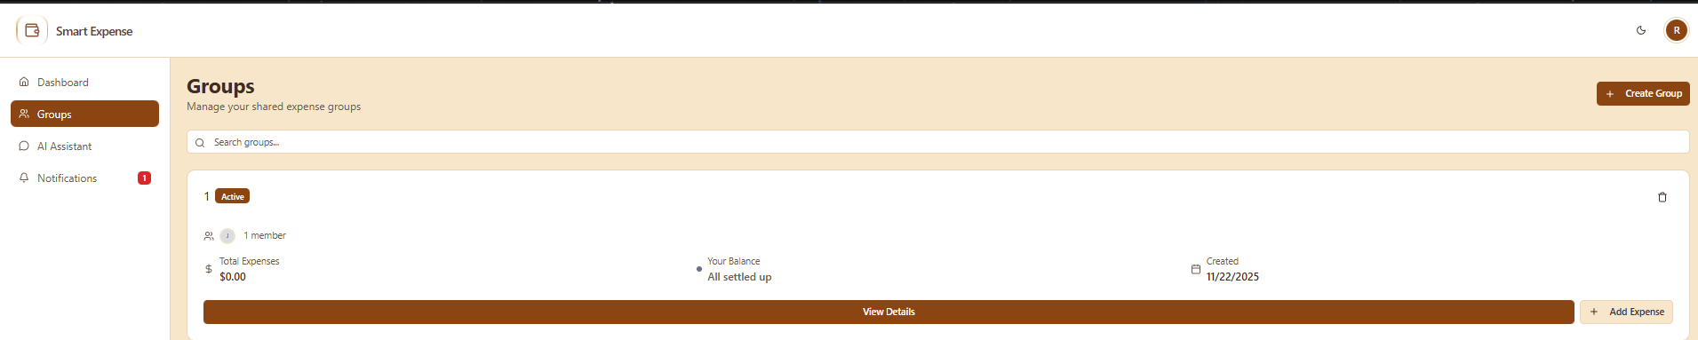

Test 2 – Create Group With Empty Name
Steps / Input:
- Click Create Group.
- Leave Group Name empty.
- Click Create Group.
Result:
- Group is not created.
- An error message is shown asking to enter a group name.
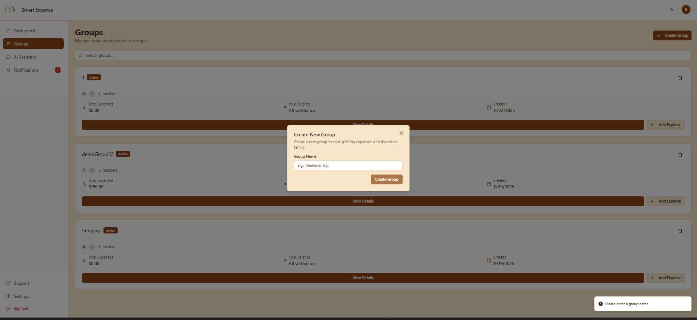

Test 3 – Search Groups

Precondition: Multiple groups exist, e.g. demoGroup32 and timepass.
Steps / Input:
- Type demo in the Search group box.
Expected Result:
- Only groups whose names contain “demo” (like demoGroup32) are shown.
- Other groups (e.g. timepass) are hidden
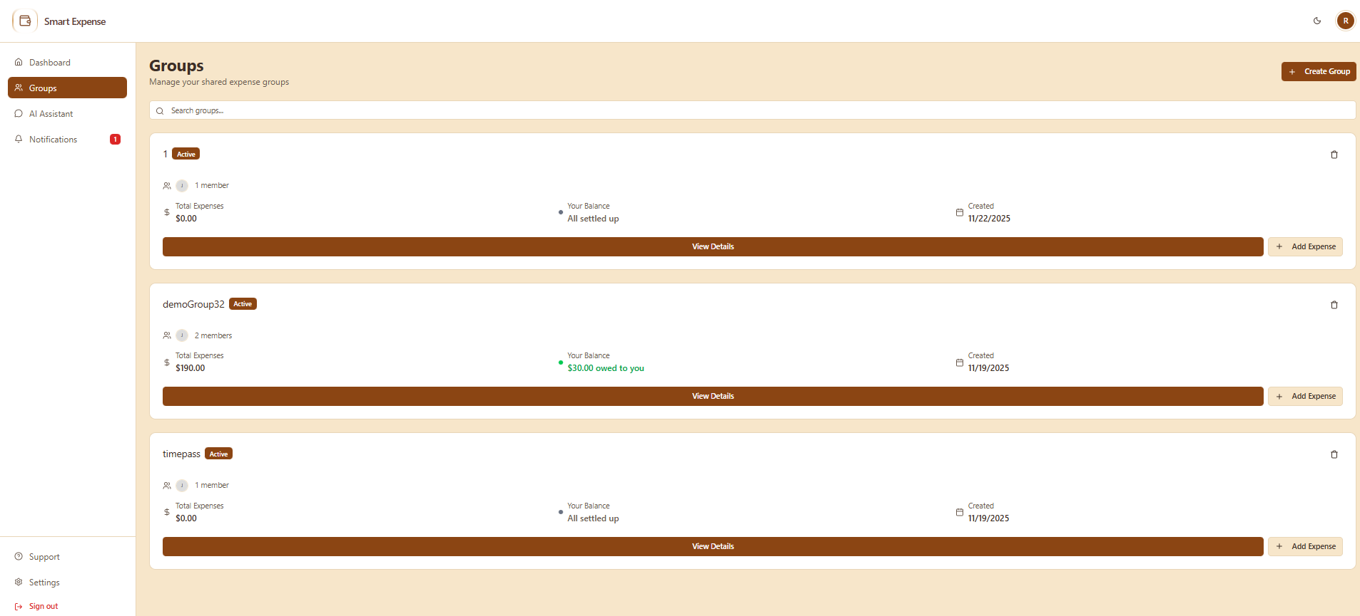

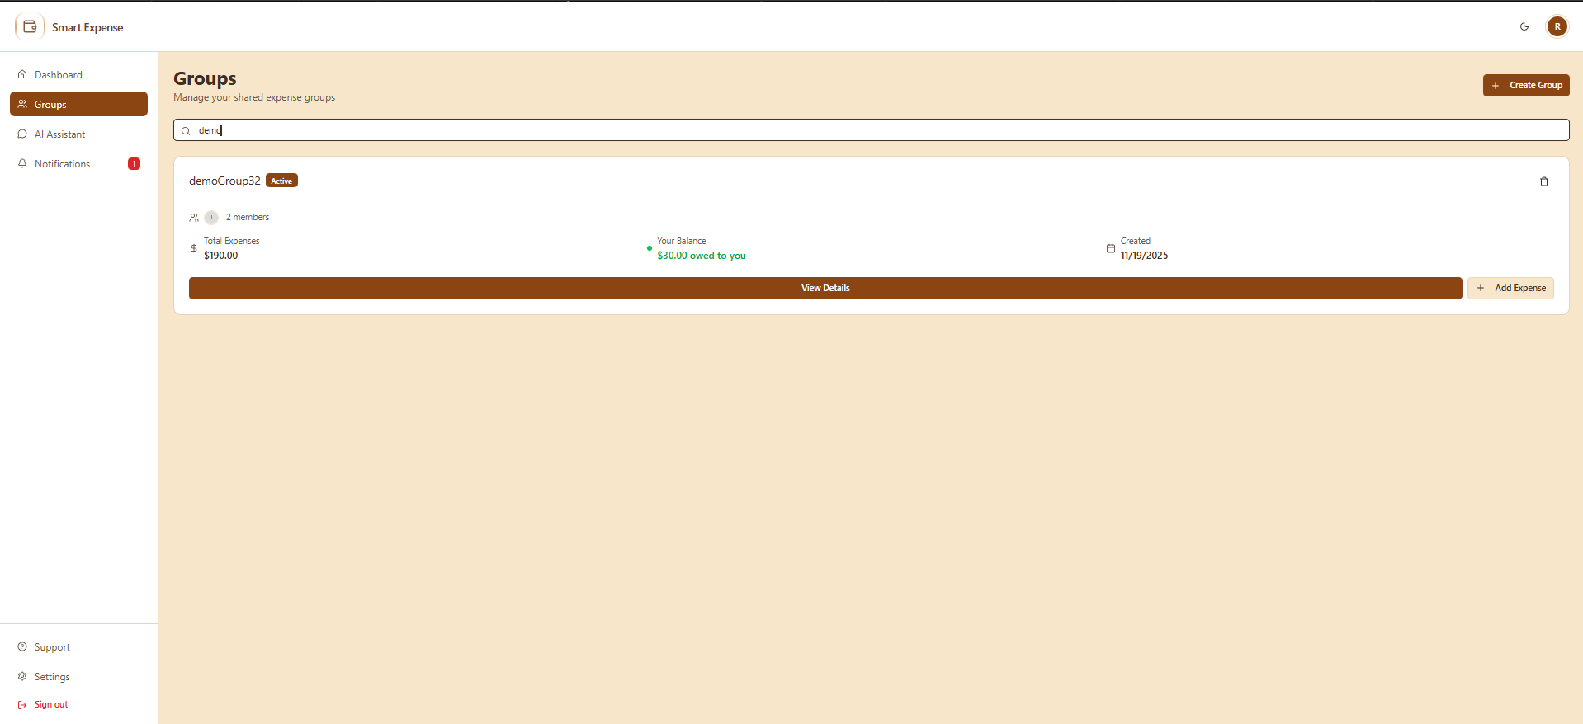

Test 4 – Delete Group

Steps / Input:
- Choose a test group (e.g. 1).
- Click the trash icon on that group.
- In confirmation dialog, click Delete.
Result:
- The selected group card is removed from the groups list.
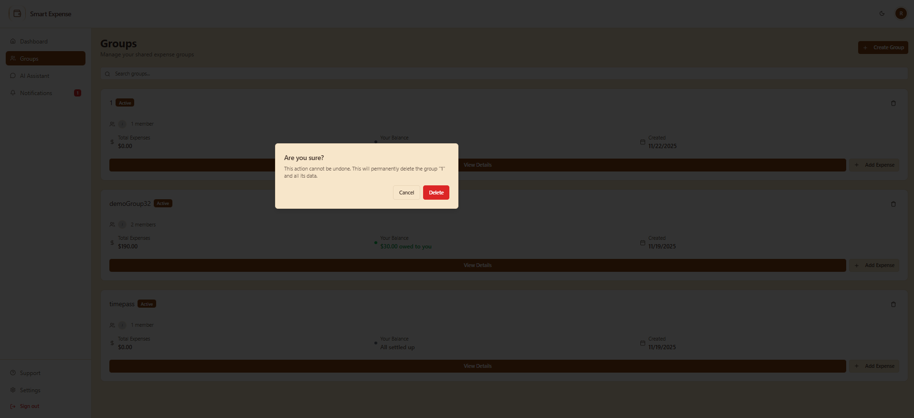
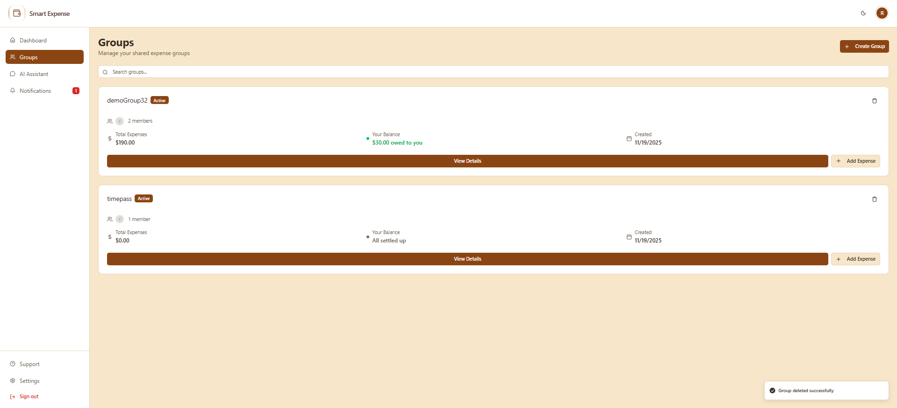
Test 4.1 – Delete Group Abort (cancel action )

Steps / Input:
- Choose a test group (e.g. 1).
- Click the trash icon on that group.
- In confirmation dialog, click Cancel.
Result:
Display Group page
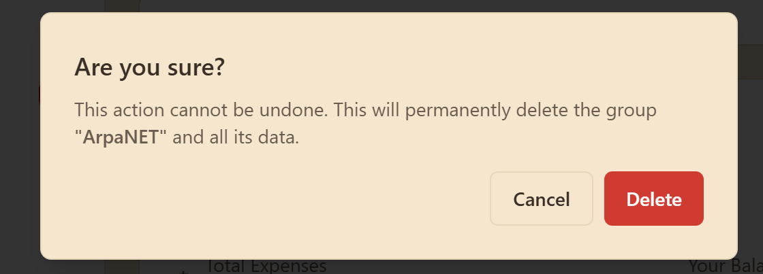Clicking Cancel
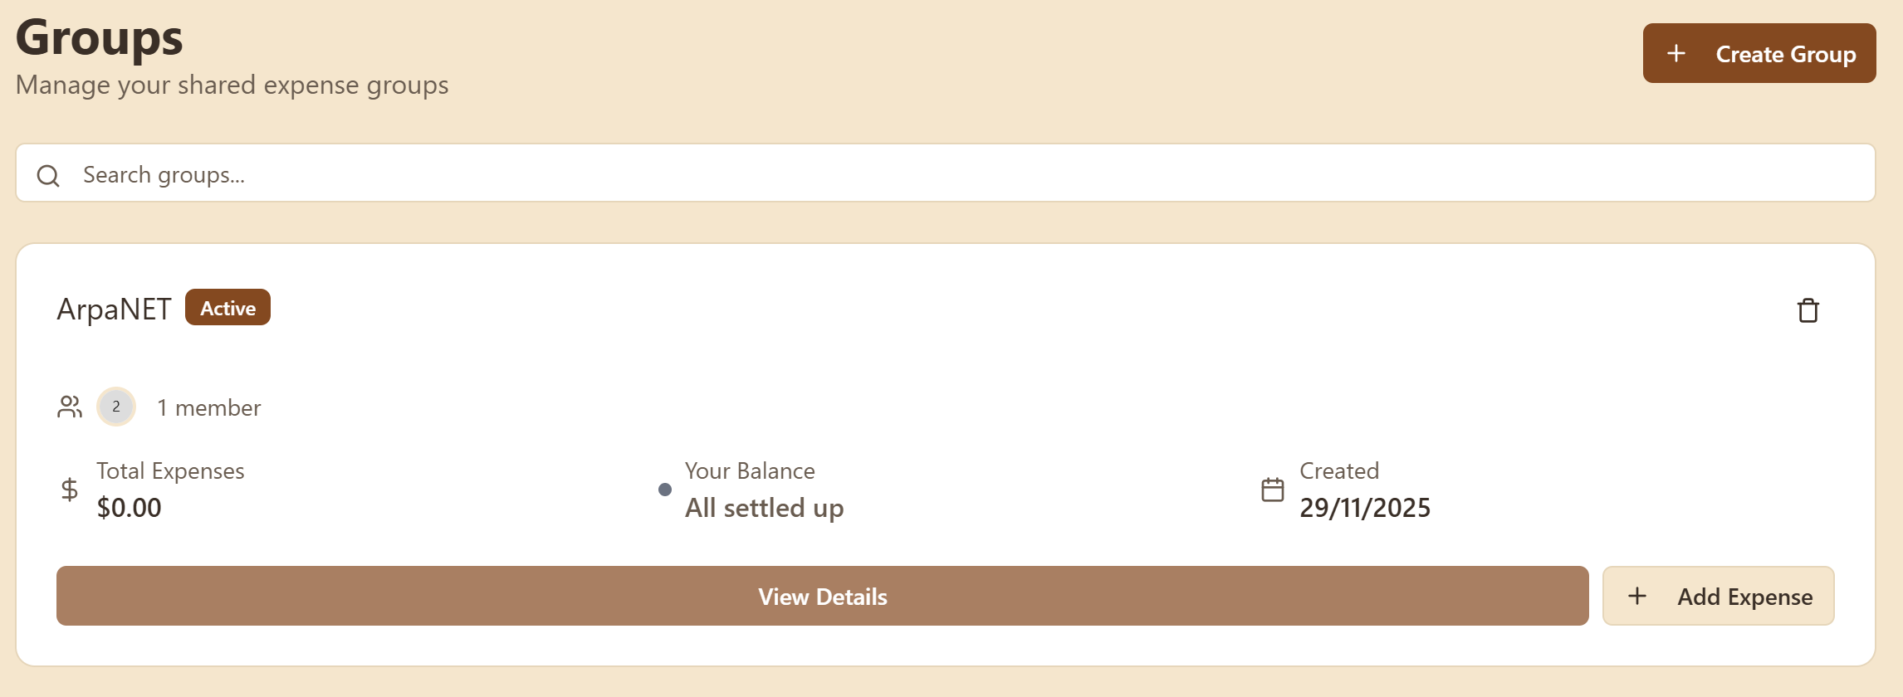

Test 5 – View Group Details and Expenses Tab

Steps / Input:
- On Groups page, click View Details for a group
- On the Group Detail page, stay on the Expenses tab.
Expected Result:
- Summary cards are visible (Total Expenses, Members, Expenses, Last Activity).
- If there are no expenses → “No expenses yet” message and “Add First Expense” button.
- If there are expenses → list of expense cards with title, category, date, paid by and amount.
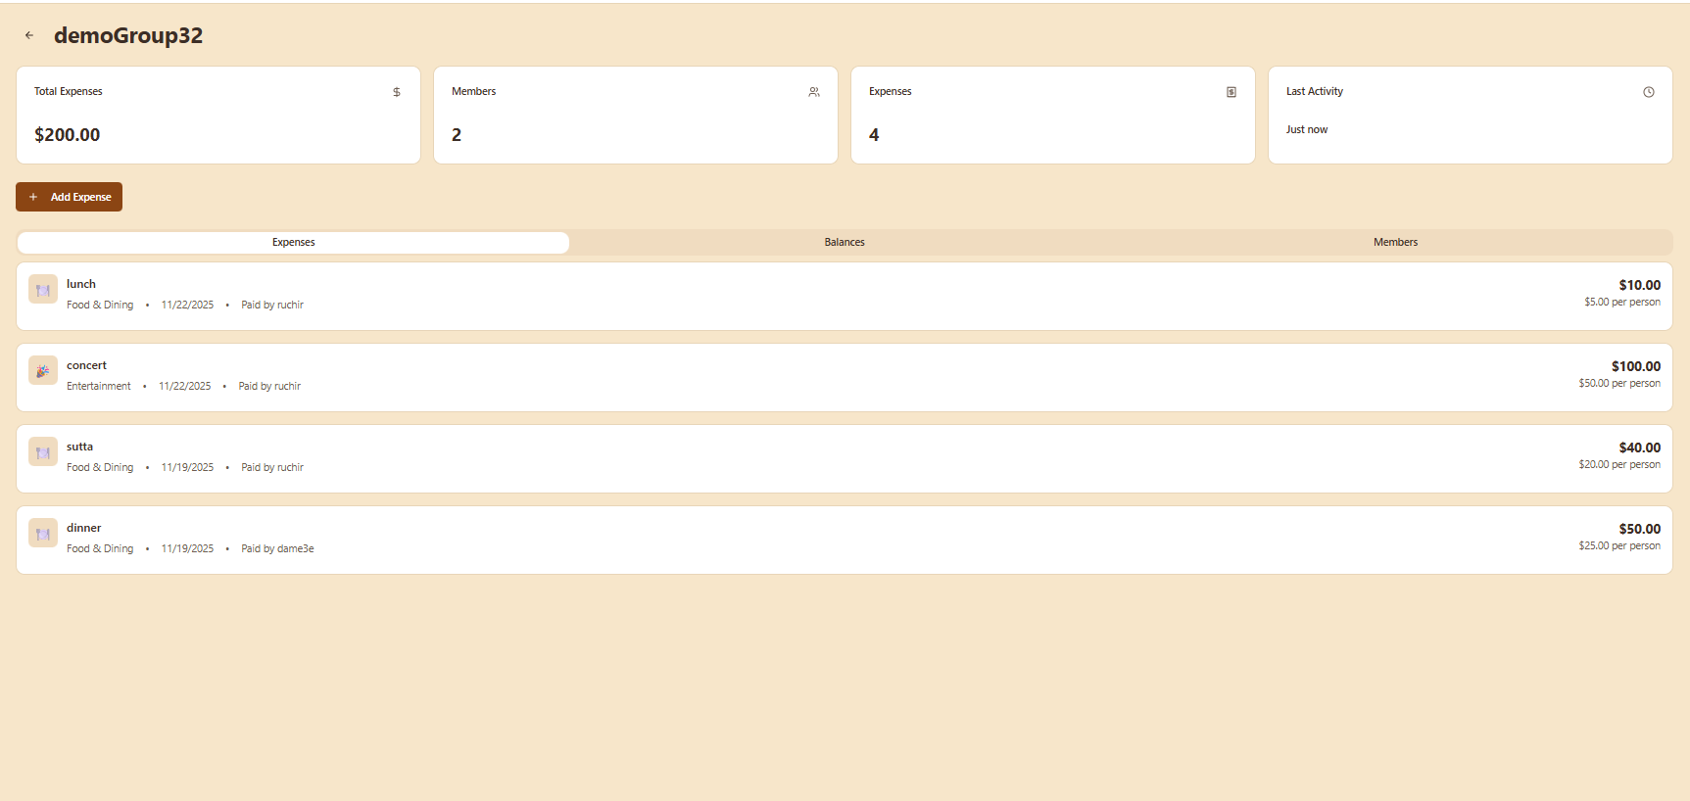

Test 6 – Add Member

Page: Group Detail → Members tab
Steps / Input:
- Click Members tab.
- Click Add Member.
- Full Name: ruchir.
- Email Address: joshiruchir35@gmail.com.
- Confirm/Add.
Expected Result:
- A group invitation is created.
- The invited user sees a notification under their Notifications page.
- Member does NOT appear in the group until the invitation is accepted.

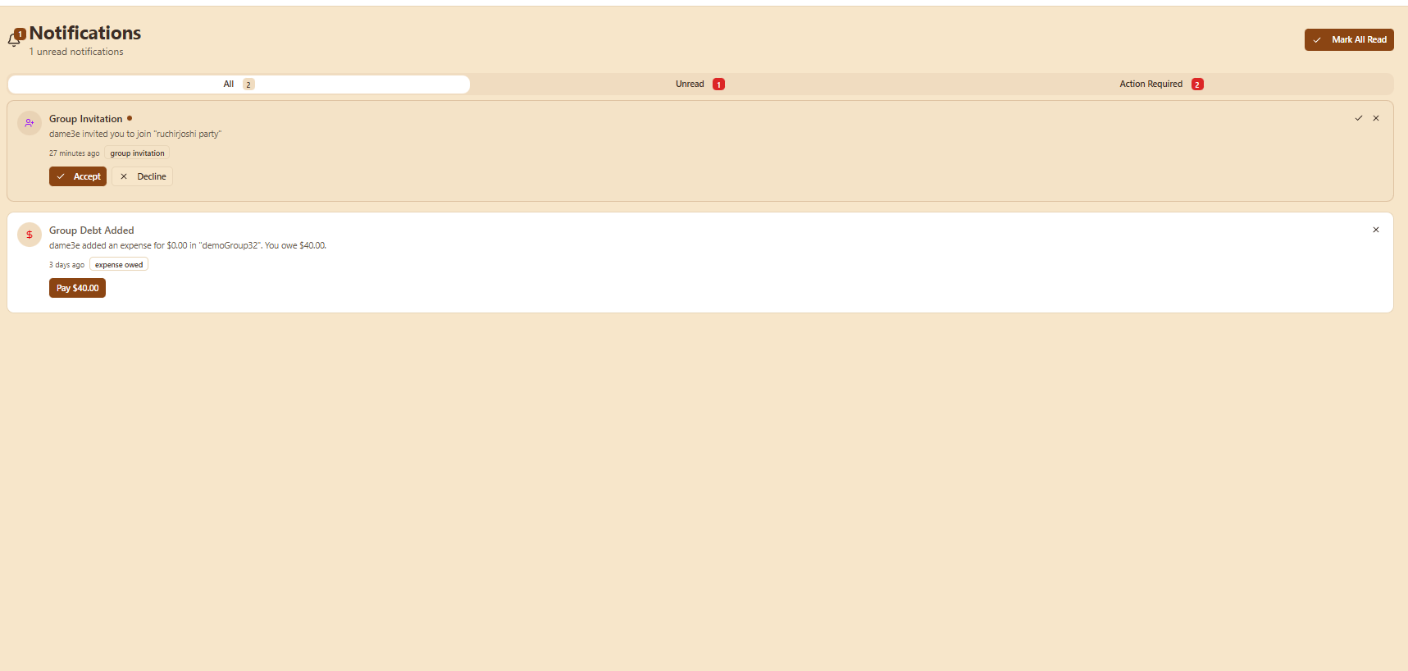
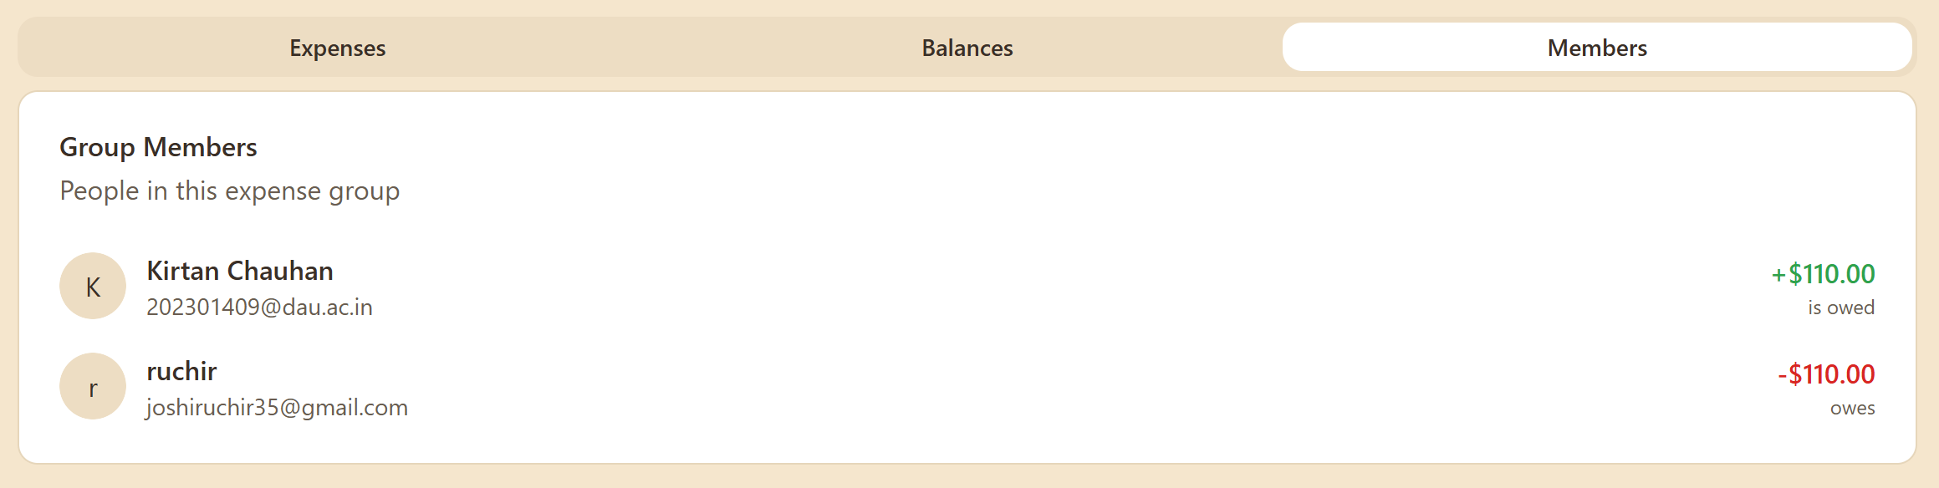
Test 7: Add Member with Invalid Email Format
Steps / Input:
- Open the Group Details page.
- Go to Members tab.
- Click Add Member.
- Enter:
  - Full Name: raj
  - Email: invalidgmail.com (no “@”)
- Click Add / Send Invitation.
Expected Result:
- Member invitation is NOT sent.
- An error message appears:
“Invalid email format”
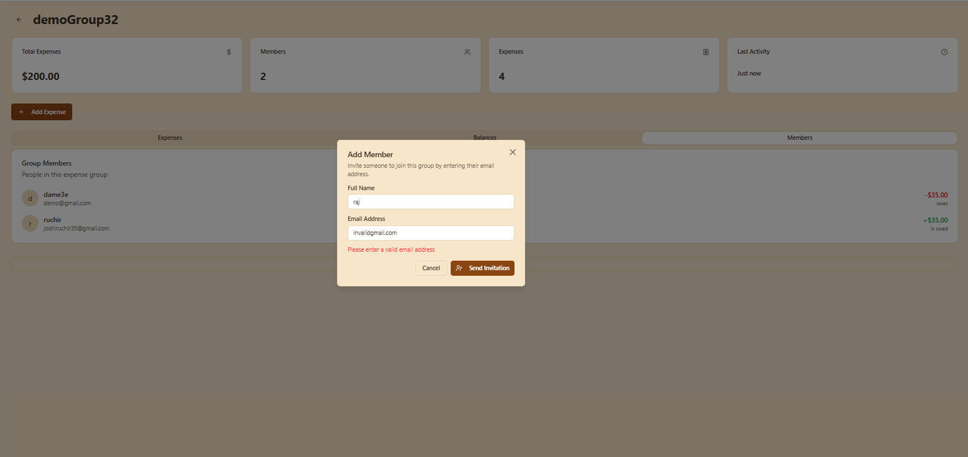
Test 8: Add Member who is not registered within the App (no account)
Steps / Input:
- Open the Group Details page.
- Go to Members tab.
- Click Add Member.
- Enter:
  - Full Name: raj
  - Email: notregistered123@gmail.com
- Click Add / Send Invitation.
Expected Result:

Test Case Name: View Balances When Group Has Unsettled Amounts
Steps / Input:
- Open the Group Details page for a group that has unsettled expenses.
- Click on the Balances tab.
Expected Result:
- Under Settlements, at least one row appears showing:
“X owes Y $Amount”
- Each settlement row shows two users and the amount owed.
- The “Settle Up” button should appear only for the logged-in user if they are the one who owes (X).
- If the logged-in user is not the debtor, the “Settle Up” button should not appear.
- The Individual Balances section should show:
  - Positive amounts → labeled as “is owed”
  - Negative amounts → labeled as “owes”
  - Zero amounts → “settled”
