

Group – 28

System Testing — Settings and Notifications Page

Testers : kirtan Chauhan and Ruchir Joshi.

BlackBox Testing — Settings Page

1. Appearance & Privacy

  - Field Constraints
Dark Mode
- Toggle ON/OFF should be allowed.
- Will switch the theme instantly.
Data Sharing
- Toggle ON/OFF allowed.
- If data sharing is off then you can’t use the ai assistant feature because it will share your data.
Auto save is implemented.

1.2 ECP
EC | Dark Mode | Data Sharing |  | Expected Result
E1 | ON | ON |  | Settings saved
E2 | OFF | ON |  | Settings saved
E3 | ON | OFF |  | Settings saved

1.3 BVA

Initial State | Action | Expected Result
Light Mode | Toggle to Dark | Theme switches
Dark Mode | Toggle to Light | Theme switches

2. Export Data (CSV files)

2.1 Field Constraints
- User can select date , either a single date or a range of date , where the order woudn’t matter
- Selection of furture date (w.r.t to current date) is not allowed
- Export button enabled only when:
  - at least 1 expense exists in selected range.
  - Else Export button would be unclickable
- On export go to downloads CSV to local browser's downloads

2.2 Equivalent class Portioning

EC | Dates Selected | Transactions Found | Export Button | Expected Result
E1 | None | – | Disabled | Cannot export
E2 | Valid date or range | 0 | Disabled | Cannot export
E3 | Valid date or range | >= 1 | Enabled | CSV is downloaded
2.3 BVA

Date Selection | Transactions | Expected Output
No date | – | Export disabled
Single day (0 transactions) | 0 | Export disabled
Single day (>=1 transactions) | >=1 | CSV fiule is downloaded
Range of date (>=1 transactions) | >=1 | CSV file download

3. Delete Account

- Clicking Delete Account opens confirmation box.
- Cancel, backdrop, or X → closes box.
- “Yes, delete my account” closes box.

3.2 ECP

EC | Delete Clicked? | Confirm Choice | Expected Result
D1 | Yes | Close(cross button) | box closes, nothing happens
D2 | Yes | X | box closes
D3 | Yes | Yes | Account gets deleted

3.3 BVA

User Action | Expected Output
Click Delete → Cancel | box closes
Click Delete → Close(cross button) | box closes
Click Delete → Confirm | Account deleted

Acceptance Testing — Settings Page

Test 1 — Dark Mode Toggle + Save
Initial State: Light mode
Action:
- Go to Settings → Appearance.
- Toggle Dark Mode switch to ON.
Expected Output:
- Theme switches to dark.
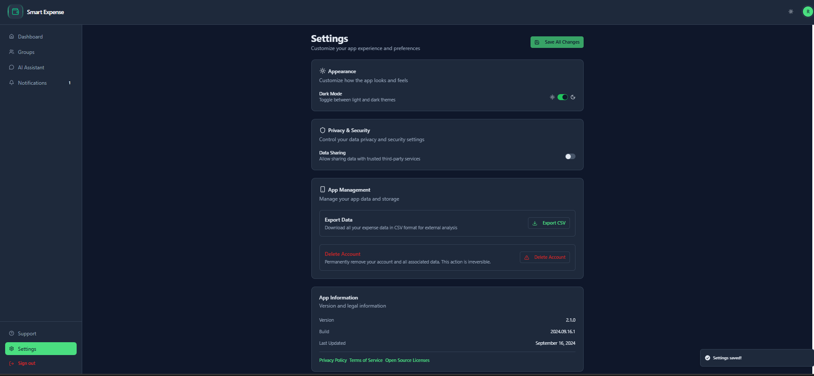
Test 2 — Data Sharing Toggle Will be auto-Save
Initial State: Data Sharing OFF
Action:
- Go to Settings → Privacy & Security.
- Toggle Data Sharing to ON from OFF.
- Navigate to another page (exg , Dashboard) and come back to Setting )
Output:
Data sharing will remain Off due to auto-save
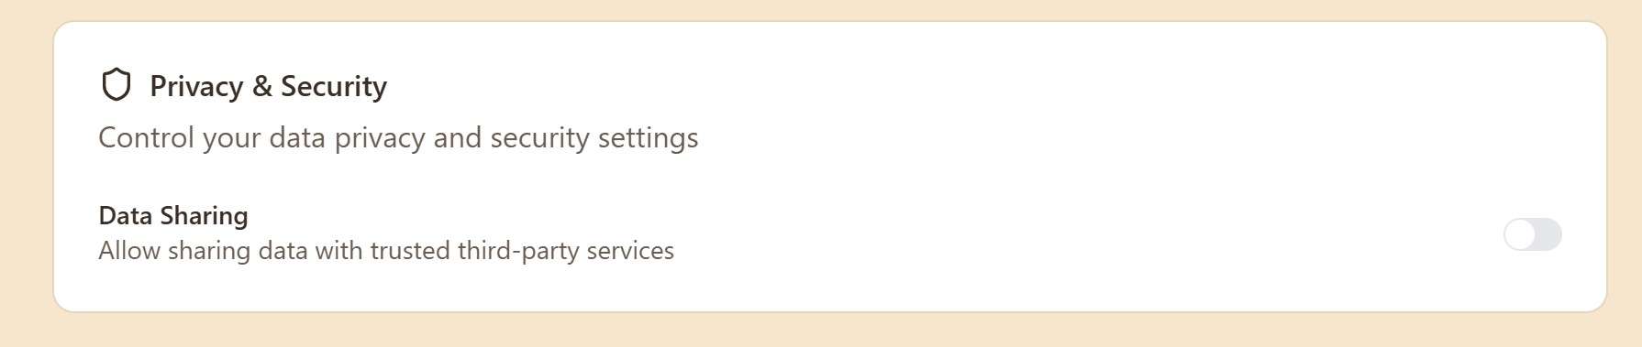
Test 2.1 — Data sharing functionality test
Initial State: Data Sharing OFF
Action:
- Go to Settings → Privacy & Security.
- Toggle Data Sharing to off state
- Navigate to “AI-assistant” to check wheater Chatbot is able to “use data” as a thrid – part based service
Output:
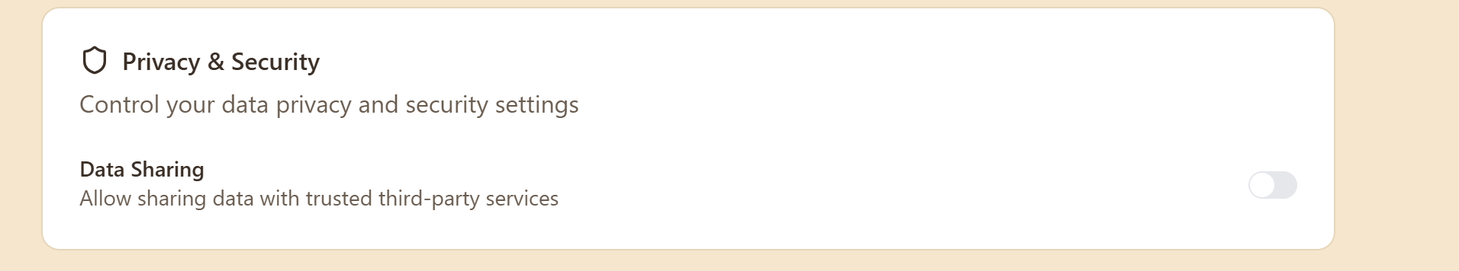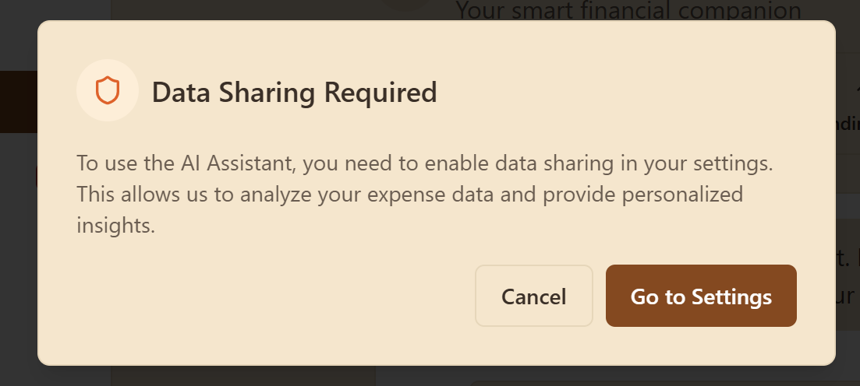Since the Data sharing was off , using the AI-chatbot is disabled .
Test 3 — Export Data: No Date Selected
Action:
- Go to Settings → App Management.
- Click “Export CSV” to open the Export data page (contains calender)
- Do not select any date on the calendar.
Expected Output:
- Export button will remain disabled.
- No file can be downloaded.

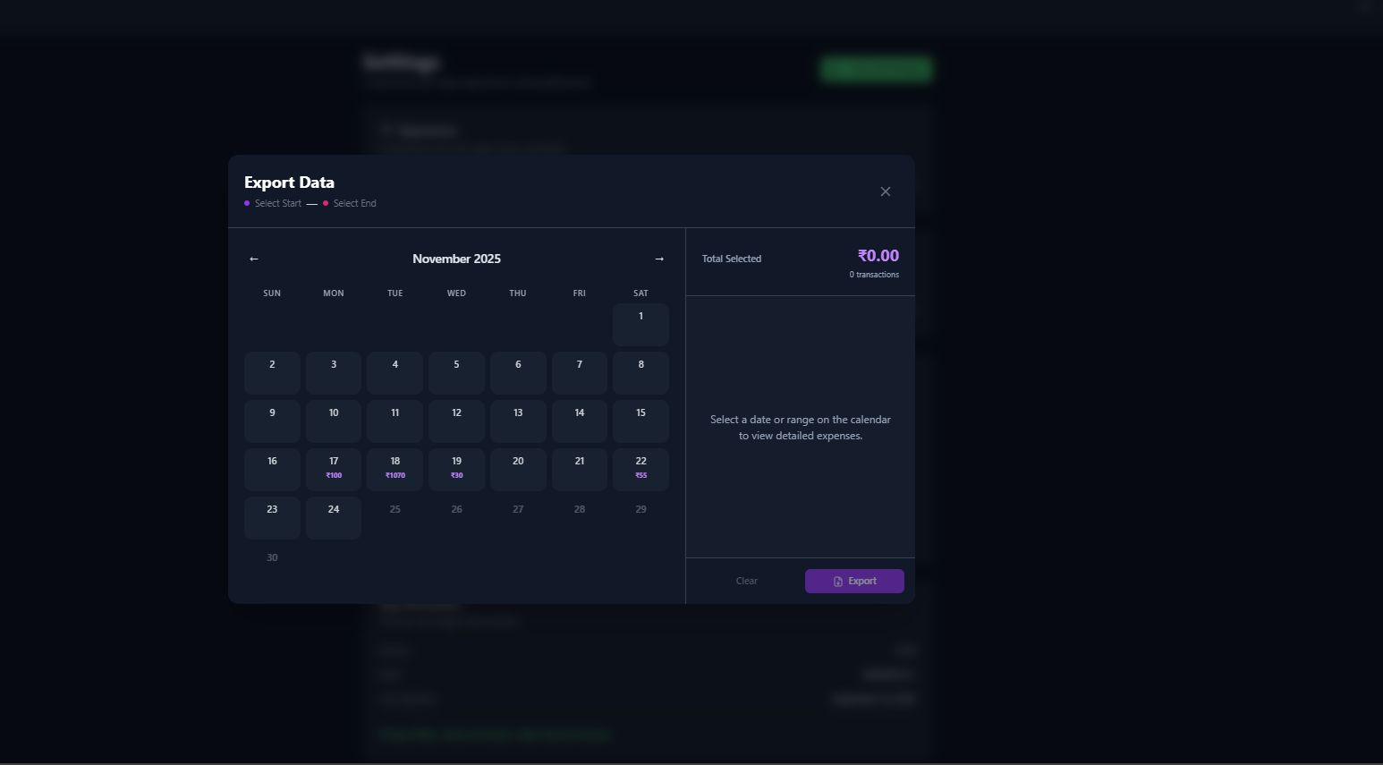

Test 4 — Export Data: Date With No Transactions
Precondition: Choose a day where your database has 0 expenses.
Action:
- Open Export Data page .
- Select that single date.
Expected Output:
- Right panel shows Total Selected: zero transactions
- Export button will remain disabled.
- No CSV file can be downloaded.

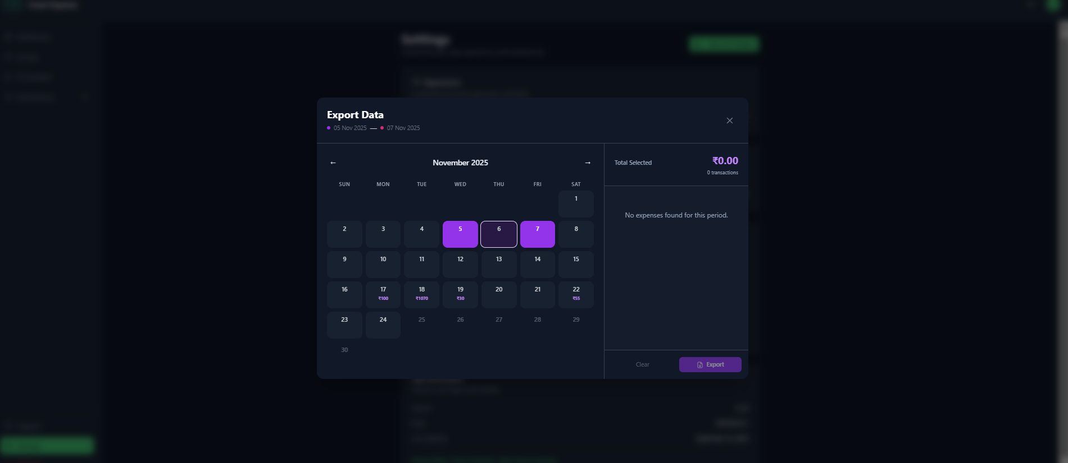

Test 5 — Export Data: Valid Date Range With Transactions
Precondition: There should be a range of dates that cover atleast more than one transactions
Action:
- Click ontp the export button (Export data model opens up)
- Select any date/dates that contains atleastone or more than one transactions of payments
- Click Export.
Expected Output:
- Right panel shows Total Selected > ₹0 and N transactions.
- Export button is enabled.
- A CSV file will be downloaded.
- Opening the CSV it will show columns like: Date, Title, Category, Amount, Type and rows corresponding to the selected period.
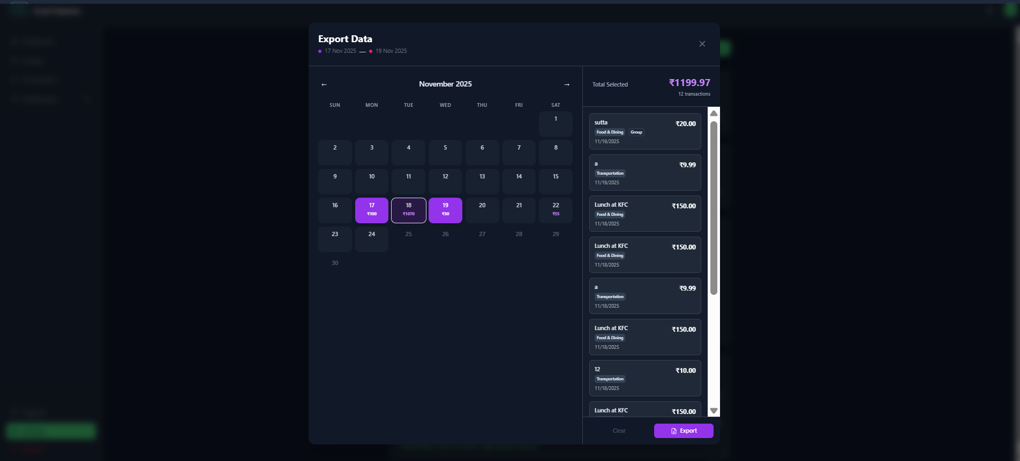

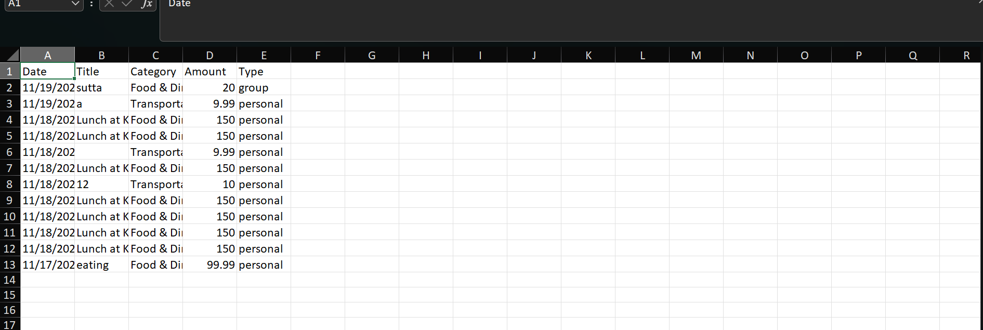

Test 6 — Delete Account Dialog: Cancel Path
Action:
- Go to Settings → App Management.
- Click on the “Delete Account” button.
- In the confirmation popup box, click “Cancel”.
Expected Output:
- Confirmation dialog closes.
- User stays on Settings page.
- No navigation occurs.
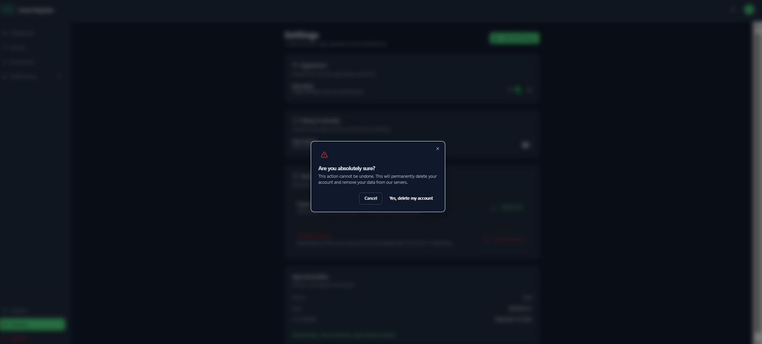

BlackBox Testing — Notifications Page

1. Notification’s page Constrains

- Notification list
  - Shows all notifications for the logged-in user.
  - Each item shows: icon, title, message, time (e.g. “6 days ago”),
  - Unread notifications have a highlighted background and a small dot.
- Tabs
  - All tab: shows every notification.
  - Unread tab: shows only unread notifications.
  - Action Required tab: shows only notifications that have action buttons (e.g. Accept / Decline
  - Counts beside each tab must match what is shown inside that tab.
- Unread count & Mark All Read
  - Total unread count is shown near the bell icon and shows a “x” number of unread messages
  - Mark All Read button appears only when there is at least one unread notification.
  - After clicking Mark All Read, all notifications become read and unread count becomes 0.
- Per-notification buttons
  - Mark as read (✓) appears only on unread notifications.
  - Delete (X) appears on all notifications.
  - Clicking Mark as read changes that notification to read and updates counts.
  - Clicking Delete removes that notification from all tabs and updates counts.

2. Equivalence Class Partitioning (ECP)

EC Class | Read? | Needs Action? (buttons) | Active Tab | Expected Behaviour
E1 | unread | no | All | Notification visible, highlighted, shows Mark as read and Delete.
E2 | unread | no | Unread | Notification visible with unread styling.
E3 | read | no | Unread | Notification not visible.
E4 | unread | yes (e.g. group invitation, expense owed) | Action Required | Notification visible with the correct action buttons (Accept/Decline or Pay).
E5 | read | yes | Action Required | Notification still visible with action buttons, but without unread highlight.
E6 | any | no | Action Required | Notification not shown because it has no actions.
E7 | any | any | All | All notifications always visible in All tab.
E8 | unread | any | All / Unread | Clicking the card (or action button for Pay) marks it as read and updates unread count.

3. Boundary Value Analysis (BVA)

Scenario / State | User Action | Expected Output |  | Reason (Boundary)
0 notifications | Open Notifications page | “No notifications” card in All tab, unread count = 0, Mark All Read hidden. |  | Boundary: zero items.
1 unread notification | Open page | Unread count = 1; notification shown in All & Unread; Mark All Read visible. |  | Smallest non-zero unread.
Several unread notifications | Click Mark All Read | All become read; unread count = 0; Unread tab shows “All caught up!”. |  | Boundary when unread goes from >0 to 0.
1 unread notification | Click Mark as read on that item | That item loses highlight; unread count decreases by 1; disappears from Unread tab. |  | Single-item change.
1 notification (read or unread) | Click Delete | Notification is removed; all tabs empty; counts become 0. |  | Deleting the last item.
1 group invitation (unread, action buttons visible) | Click Accept | Notification disappears from all tabs; unread and Action Required counts decrease. |  | Boundary for resolving an action.
1 expense_owed notification with group link | Click card or Pay ₹… | User is taken to that group’s Balances page; notification becomes read (if it was unread). |  | Navigation behaviour.

Acceptance Testing — Notifications Page

Test 1 — Mark All Read
Precondition: At least 1 unread notifications exist.
Steps:
- Open the Notifications page.
- Check that the unread count is greater than 0.
- Click “Mark All Read”.
Expected Result:
- All notifications lose the unread highlight.
- Unread count becomes 0.
- Unread tab shows the “All caught up!” message.
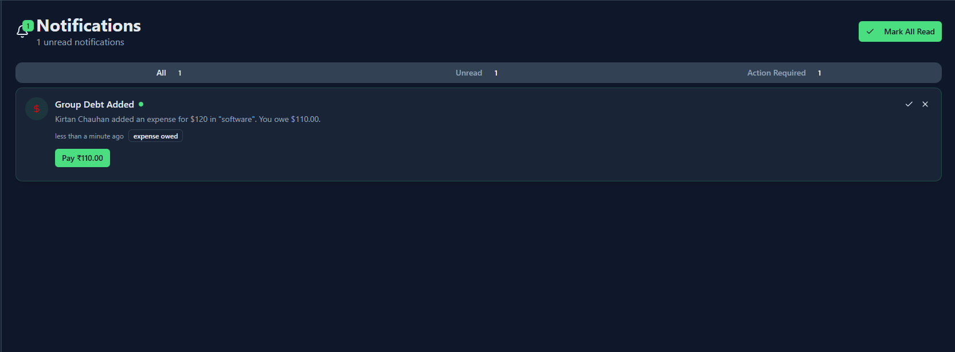
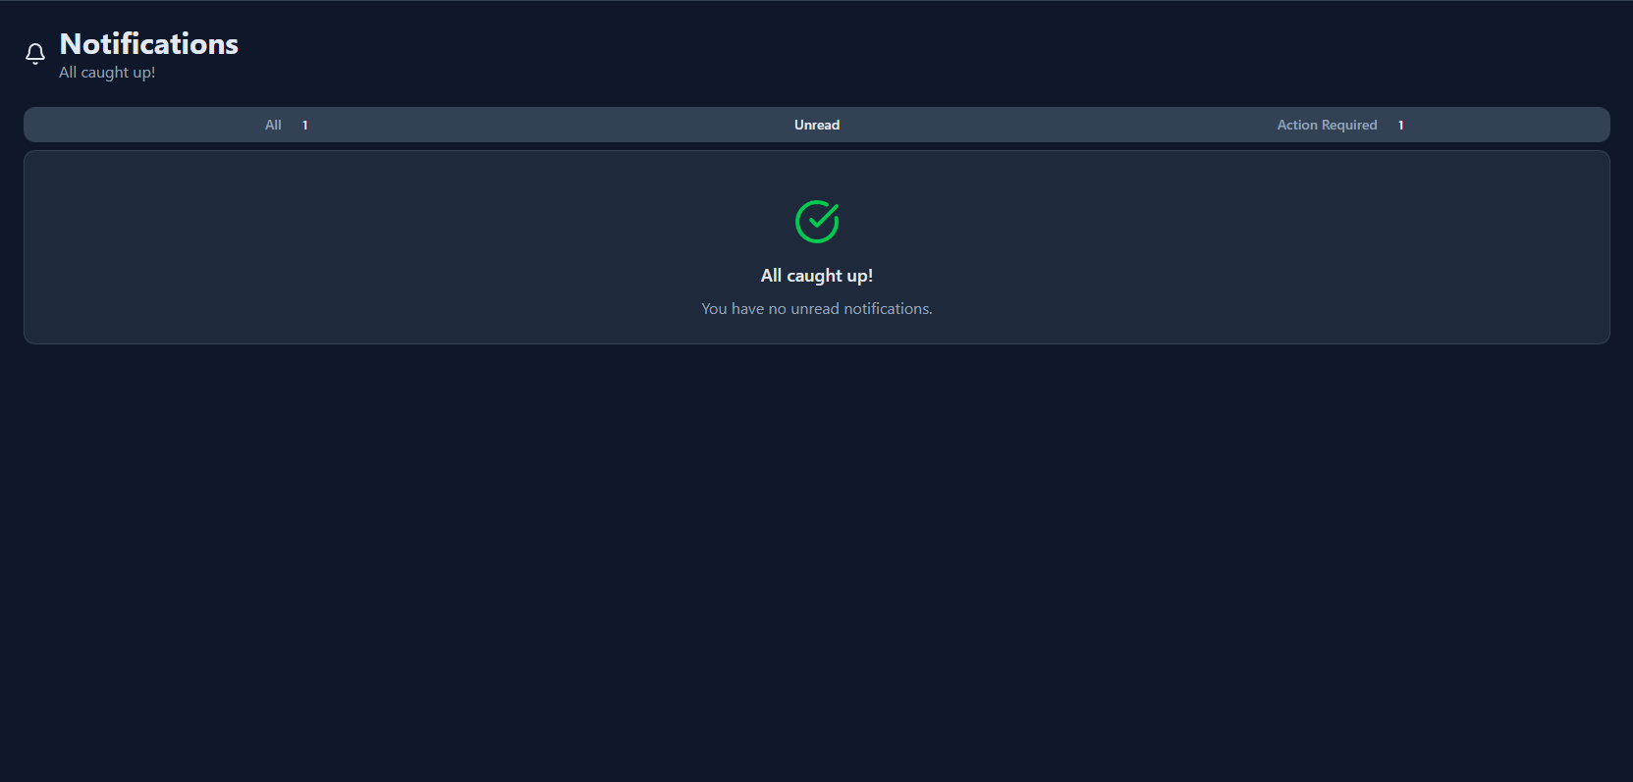

Test 2 — Mark Single Notification as Read
Precondition: At least 1 unread notification is visible in All tab.
Steps:
- Open All tab.
- On an unread notification, click the small tick button, which marks the messaghe as read .
Expected Result:
- That notification now looks “read” (no highlight, no unread dot).
- Unread count decreases by 1.
- That notification no longer appears in Unread tab.
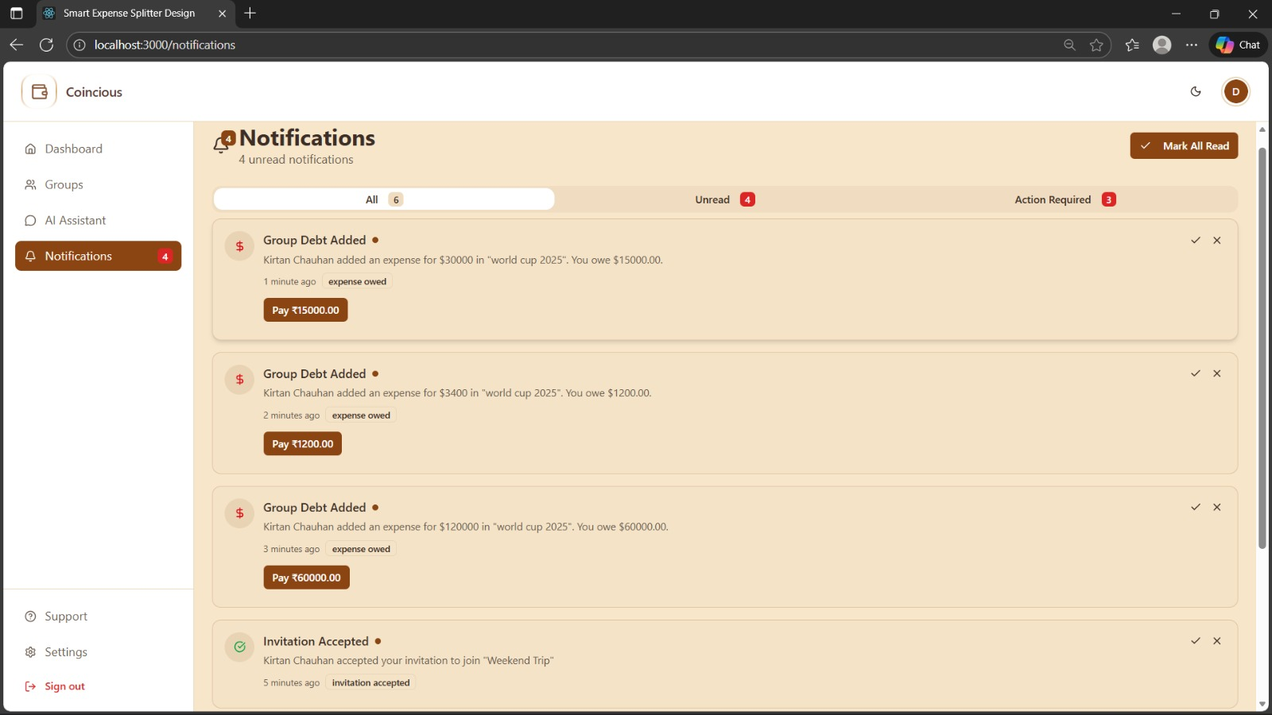

Test 3 — Delete a Notification
Precondition: At least 1 notification exists.
Steps:
- Open All tab.
- Click the X (Delete) button on any notification.
- Switch to Unread and Action Required tabs.
Expected Result:
- The deleted notification is gone from all tabs.
- Counts (total and unread) are updated correctly.
- 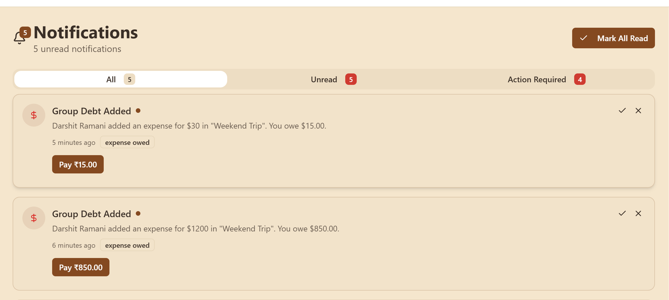
- 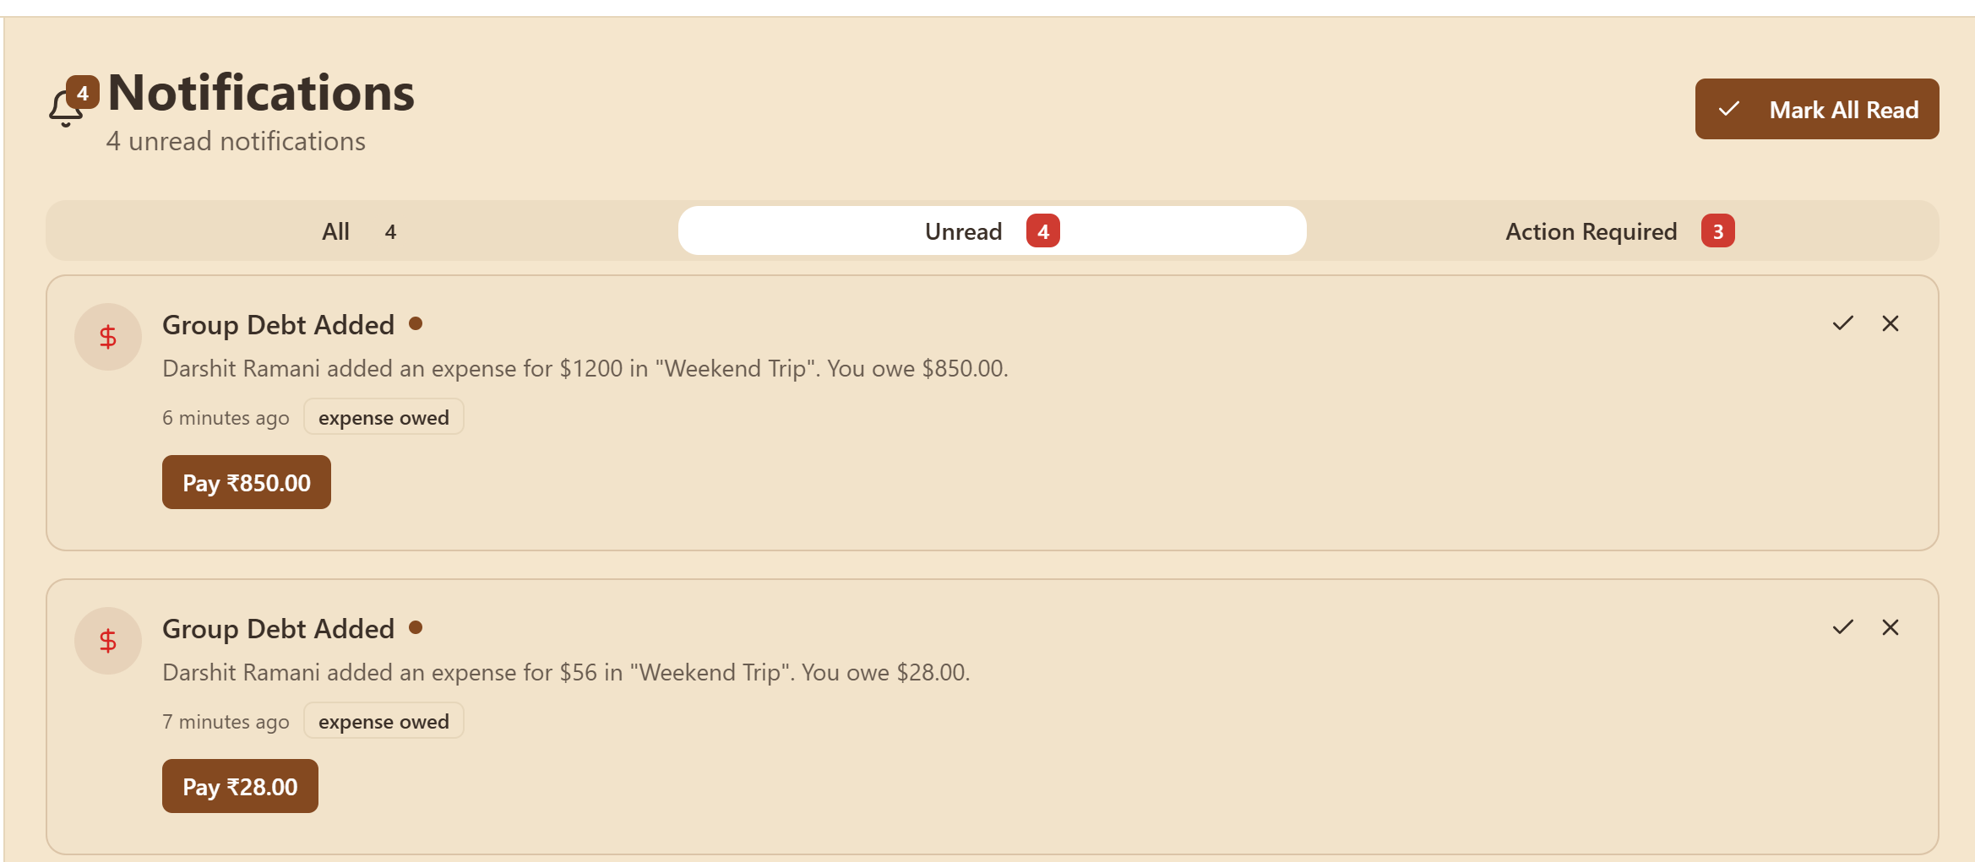
- 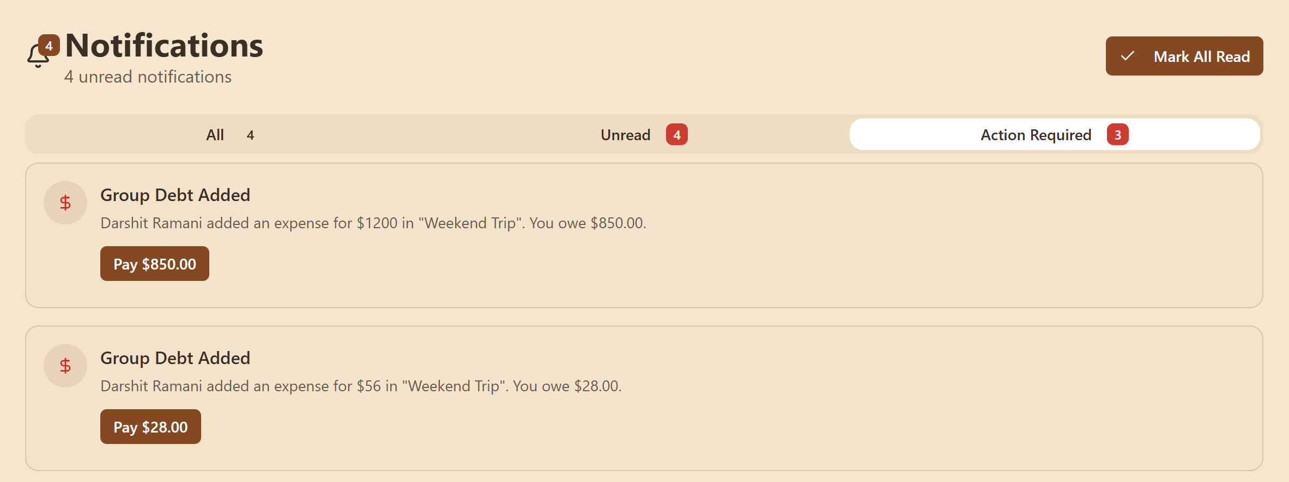

Test 4 — Accept Group Invitation
Precondition: A Group Invitation notification with Accept and Decline buttons is visible.
Steps:
- Go to Action Required tab (or All/Unread if it shows there).
- Click Accept on the group invitation.
Expected Result:
- A success message/popup is shown.
- The invitation notification disappears.
- Unread count and Action Required count decrease accordingly by the number times action is performed

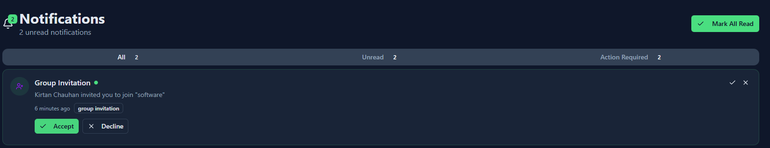

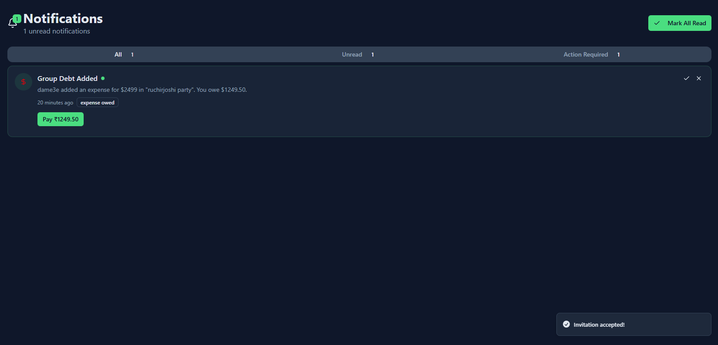

Test 5 — Open Group from Expense Notification
Precondition: An expense_owed / settlement / expense notification is visible with a Pay
Steps:
- Open Notifications page.
- Click on that notification card or the pay button.
Expected Result:
- The app opens the related Group page on the Balances tab.
- If the notification was unread, it becomes read and unread count decreases.
